Potential field Investigation of the Liberia Basin, West Africa

S. Morris Cooper

Institute of Geophysics and Geomatics

China University of geosciences

Wuhan, China

Email: smcooper2002@yahoo.com

Abstract.

Euler deconvolution is a useful tool for providing estimates of the localities and depth of magnetic and gravity sources. Wavelet analysis is an interesting tool for filtering and improving geophysical data. The application of these two methods to gravity and magnetic data of the Liberia basin enable the definition of the geometry and depth of the subsurface geologic structures. The study reveals the basin is sub-divided and the depth to basement of the basin structure ranging from 5km at its Northwest end to 10km at its broadest section eastward.

Keywords: Wavelet transform, Euler deconvolution, Potential field, Liberia basin

- Introduction

The Liberia basin is the larger of two basins found along the continental shelf offshore Liberia. It runs parallel to the margin bordering on the west by the Sierra Leone basin and to the east with the Harper basin and the so-called Liberia high (See figure 2).
The basin including the continental shelf and margin of the Liberian coast has been of great interest both in the past and present prompting several geological and geophysical investigations culminating into the drilling of several wells offshore along the coast. . Simultaneous block faulting occurred with deposition of Cretaceous or younger sediments (White, 1972; Thorman, 1972). The faults extend across the continental shelf with northwest and west- northwest trends. Inferred basement relief associated with faulted basins is up to 5km (Behrendt and Wortoson(1970)).
Three fracture zones (St. Paul, Cape Palmas, and Grand Cess) (figure 1) are located on the basis of magnetic and gravity data supported by bathymetric and seimic reflection data (Behrendt et al, (1974). The fracture zones appear as separate lineament near the cost of Liberia and maybe part of the same transform fault crossing the Atlantic (St Paul Fracture Zone). They also indicated that a thick section of sedimentary rock, possibly as great as 8km and could be associated with basins beneath the shelf.
In the advent of recent study revealing two distinct hydrocarbon basins (Kara and Don, 2002) off the coast of Liberia, the Liberia Basin being the larger of the two and coupled with the growing quest for mineral exploration, the need to understand the geometry and stratigraphy of said basin is of some importance.
Our investigation is aimed at helping to understand the distribution of shallow intrusives, intrasedimentary faulting, and basement geometry, all of which are integral to unraveling the structural development of the basin and reducing exploration risk. The wavelet decomposition and euler’s methods are being applied to achieve these goals.

2.0 Geological Setting

Liberia is on the edge of the West African Shield, dated 2.7 to 3.4 Ga. comprising mainly of granite, schist, and gneiss. In Liberia this shield has been intensely folded and faulted and is interspersed with iron-bearing formations known as itabirites. Beds of sandstone are common along the coast, with occasional crystalline-rock outcrops. Monrovia, a coastal city in Liberia, is a ridge of diabase (a dark-colored, fine-grained rock). It is a typical example of such an outcropping. Most of the crystalline rocks are of Precambrian age. The western half of country is typically of Archean age. In the eastern half of the country, lenses of Proterozoic greenstone belts occur surrounded by rocks of probable Archean age. Rocks of Pan African age extend northwesterly along most of the Liberian coastline from the Cestos shear zone.
R. W. White (1969) has discussed the geology of the sedimentary rocks of coastal Liberia in considerable detail; his work is briefly summarized here. Unmetamorphosed sedimentary rocks are known onshore mainly in the area between Buchanan and Monrovia. The sedimentary sequence along the coast is underlain by a northwest-trending belt of Precambrian crystalline basement rocks comprising granulite, granitic rock, quartzo-feldspathic gneiss, schist, amphibolite, and iron-bearing rocks. A strong gravity gradient is associated with the transition from granulite-facies to amphibolite-facies rocks along the coast. Overlying the crystalline basement near Monrovia is the Paynesville Sandstone which is assigned an early Paleozoic age considering similar rocks in other parts of West Africa. The thickness of this unit is not known, but geologic comparisons in West Africa and field evidence suggests a maximum of about 1 km. The Monrovia Diabase intrudes the Paynesville Sandstone and has been K/A dated at two locations as 176 and 192 m.y. (Early Jurassic) (White and Leo, 1969). This intrusive rock is quite magnetic and is the source of a number of magnetic anomalies in the area east of Monrovia.
Seven drill wells were realized on the continental shelf between 1970 and 1984 along the Liberian coast. Four of these wells were realized in 1971 off the shore of Monrovia and one was about 150km southeast of Monrovia, with depth ranged from 1.67km to 3.12km. They reached on volcanic rock of Jurassic age, or sedimentary rock of early cretaceous age, or sand stone inferred to be of Paleozoic age (Schlee et al, 1974).
The oldest sedimentary rock drilled at that time includes limestone, orthoquarztite, shale, and sand stone of early Devonian age based on spores analysis (Ayme 1965). Sheridan et al. (1969) and Lehner and Deruiter (1976) suggested that Paleozoic rocks extends as far as to the continental shelf-slope break which seems to fit well with the Mesozoic era continental breakup. The Paleozoic rocks have been intruded by dikes and sills, and are overlain by basalt flow of early Cretaceous and Jurassic age.
2.1 Liberia Basin

The origin of the basin (fig.1) is poorly known due to the limited number of studies in the area. The basins developed in two phases (Kara and Don 2002), a syn-rift phase followed by a phase of usual passive margin. They were both significantly overprinted by wrenching due to Atlantic Transform Fault Systems. The main rift phase, accompanied by continental to marginally marine sedimentation, took place during Lower Cretaceous Aptian to Middle Albian times.
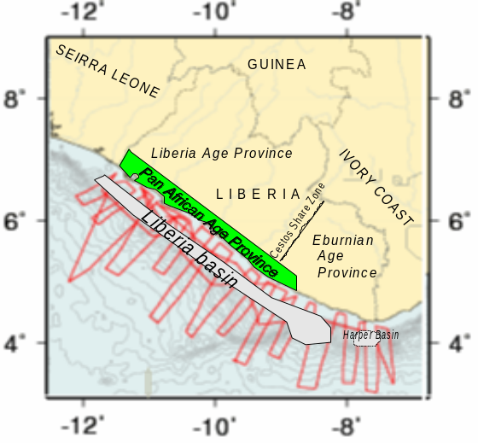

Figure 1: A diagram of the Liberia Basin (not to scale). The lines are the survey lines as conducted along the cost.

The passive margin coeval with wrenching, initiated with seafloor spreading, began in Late Albian time and continues to the present. The Liberia Basin is a long-standing depo-center, defined by faulting and basement highs to the northwest and southeast. From west to east, the Liberia Basin is affected by three distinct fault zones – Monrovia fault zone, Buchanan and Greenville fault zones. The Monrovia fault zone forms the boundary between the Sierra Leone and the Liberia. A fourth fault zone, the Liberia hinge fault zone, is present in the eastern part of the Liberia basin and forms the western border of the Liberia High, a basement-cored structural divide between the deep sedimentary Liberia Basin to the west and the Harper Basin to southeast.
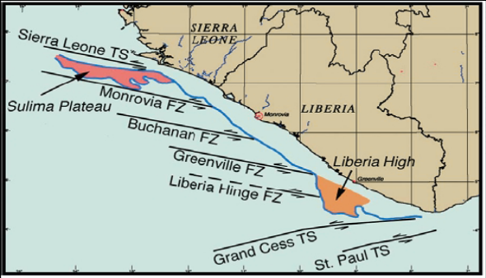

Figure 2: Fault zones (FZ) and transforms systems (TS) adopted from Kara and Don, (2002).
The Monrovia fault zone, associated with the Sierra Leone Transform (Fig. 2), is a complex series of strike-slip associated faults trending NW, which intersects the coast forming an angle of about 30°. The fault zone consists predominantly of low-angle faulting which has produced large rotation blocks. It is dominantly transtensional, with locally large transpressional accommodation zones (Kara and Don, 2002). The Buchanan fault zone, a narrow transpressional zone expressed as a positive flower structure, intersects the coast at about 32⁰ trending NW. The Greenville fault zone is a wide diffuse band of low-angle faults forming a bowl-shaped extensional flower structure that intersects the Liberia coast in the area of Greenville.

3.0 Data sources and analysis

3.1 Gravity data

The gravity data, used in this study were collected using a Lacoste-Romberg gravimeter, during the USGS cruise (Leg 5 – IDOE) conducted along the coast of Liberia. Gravity maps (Figures 3 & 6), derived from these data, reflect anomalies that may arise from contrasts in density due to contacts between different rock units, partial melting, or phase transitions. It clearly delineated the basinal region and structural highs, with gravity low of -100mgal and a high of -5mgal and interval of 5mgal (fig.3). Generally, long-wavelength anomalies with smooth gradients originate from sources at depths greater than sources of short-wavelength anomalies that display steep gradients. While short-wavelength anomalies must arise from sources at shallow depths, long-wavelength anomalies could arise from shallow, thin sources that have gently sloping sides.
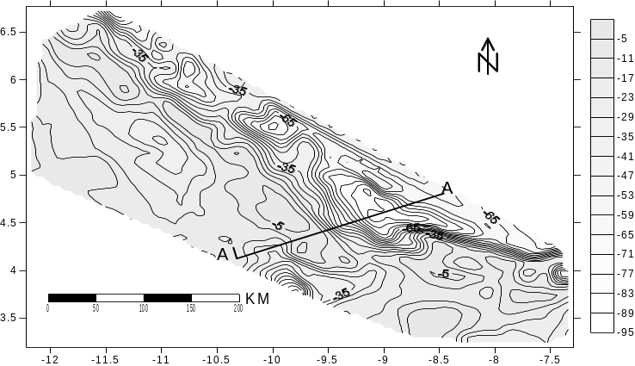
Figure 3: Bourger gravity map of the Liberia Basin grid using triangulation method with a contour interval of 5mgal. Vertical and horizontal axes are in degrees. AA’ is a profile across the basin.

In order to produce a gravity map reflecting lateral variations in density in the crust, raw gravity measurements were reduced using standard gravity reduction methods (Dobrin and Savit, 1988; Blakely, 1995). These reductions remove the effects of elevation, topography, total mass, rotation, and ellipsoidal shape of the Earth and yield the complete Bouguer gravity anomaly (CBA).

3.2 Magnetic data

The magnetic data, from the same source as the gravity data, was obtained using a Variam magnetometer with a profile spacing of about 15 miles. The magnetic anomaly (fig.4) shows that magnetic high is sporadic and marked around the southern end of the basin separating it from the Harper basin. These may be probably cause by magnetic substances within shallow depth due to their high frequencies and amplitudes. This area is observed to have the presence of sub marine canyon and steepened eroded slope as well as crumpling and faulting strata. The field inclination is horizontal since Liberia virtually lies on the magnetic equator. Generally, magnetic highs arise from mafic igneous and crystalline basement rocks, whereas lows arise from felsic igneous, sedimentary, or altered basement rocks. Igneous outcrops not associated with high-amplitude magnetic anomalies might be thin or contain low concentrations of primary magnetic minerals, or lost them due to alteration.

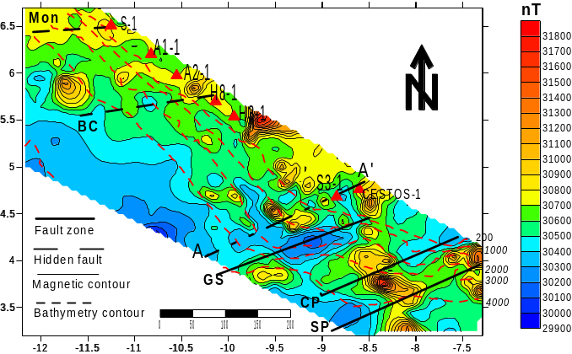

Figure 4: Total magnetic anomaly overlaid with bathymetry contour lines (with depths) and fault zones. Monrovia fault zone (Mon), Buchanan fault zone (BC), Grand Cess fault zone (GS), Cape Palmas Fault (CP) and St. Paul transform zone (SP). The axes are in degrees and the distance in kilometers. The triangles represent locations of experimental drill holes.

3.3 Wavelet Analysis

Wavelets are mathematical functions which split data into different frequency components and then each component is studied with a resolution to match its scale. Wavelet transforms have advantages to traditional Fourier methods in analyzing physical situations where the signal contains discontinued and sharp spikes. Wavelets were developed independently in the fields of mathematics, physics, electrica1 engineering and geophysics. Interchanges between these fields during the last ten years have led to many new wavelet applications such as image compression, turbulence, human vision, radar, earthquake prediction, and separation of gravity and magnetic anomalies. Some of the recent applications in geophysics are processing of potentia1 data (Davis et al, 1994; Li and Oldenburg, 1997; Fedi and Quarta, 1998; Ridsdill-Smith and Dentith, 1999) and processing of seismic data (Charraborty and Okaya, 1995; Grubb and Walden, 1997).
The wavelets, first mentioned by Haar in 1909 are not continuously differentiable. In the 1930s, representation of functions using scale-varying basis functions that can vary in scale and conserve energy has been researched by several researchers. Grossman and Marlet (1985) defined wavelets within the context of physics. Mallat (1989) elevated to digital processing by discovering pyramidal algorithms, and orthonormal wavelet basis. Daubechies (1990) applied Mallat's work to construct a set of wavelet orthonormal basis functions that are the cornerstone of wavelet application today. The schematic of this process is shown below in figure (5).
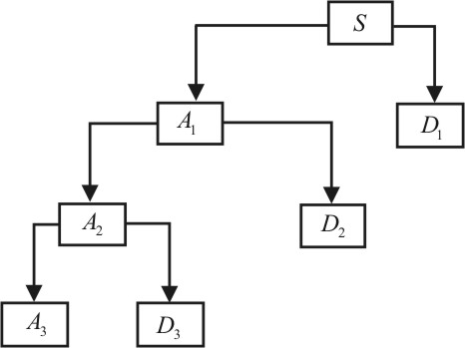
Figure 5: Structure of the multiscale wavelet analysis. S is the input signal, details are D1, D2, and D3 and approximations are A1, A2, and A3.

3.4 Euler Deconvolution

Euler deconvolution method is traceable to Hood (1965) who first formulated Euler’s homogeneity equation relative to the magnetic case and defined the rate of change of the field now known as the structural index. Thompson (1982) showed the first semi-automated method exploiting Euler’s differential homogeneity equation. It is essentially a statement of scaling relationships (controlled by the Structural Index (SI) and requires measured or calculated field gradients. He applied it to profiles, but also gave the equivalent equation for grids. Reid et al (1990) implemented the grid version, extended the theory to handle steps, and named the process Euler deconvolution by analogy with Werner deconvolution. The 3D Euler’s equation can be defined (Reid et al., 1990) as:
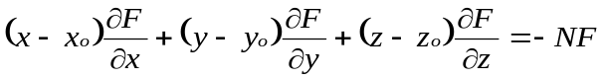
Where the homogeneous function F is the observed potential field at location (x, y, z) caused by a source at location (x₀, y_{0,} z₀) and N, denoted as the structural index, is a measure of the rate of change of the potential field with distance. The Euler deconvolution method is a constituent of techniques referred to as ‘automatic’ depth estimation methods. Two important parameters of Euler deconvolution are the choice of window and structural index. Other researchers (Williams et. al., 2005) and (Li and Morozov, 2006) suggested a structural index of 0.5 to obtain suitable results.
In our study, we seek to locate the magnetic contacts that may delineate sedimentary basins. Theoretically, a structural index of 0 is an appropriate value for contact models. However, this value usually gives unstable results. We found that a structural index of 0.5 was suitable to locate the possible magnetic contacts from the observed magnetic data. Reid et a1 (1990) and Ravat (1996) discussed adequately the effect of the size of the operated window on the estimation of source location using the Euler technique. Generally, selection of the window size is a function of the grid cell and should be selected to be large enough to incorporate substantial variation of the total field and their gradients (Ravat, 1996). Solutions calculated from larger windows would contain fewer artifacts due to the effects of noise.
Because the Euler method relies on the gradients of the magnetic field, the resulting depth readings relate primarily to the areas of basement heterogeneities identified as distinct sources of the field. These depth values from adjacent spatial windows are further interpolated to produce maps (fig. 10) showing the positions of magnetic sources and sources of high density contrast. Thus, by the nature of this interpolation favoring high depth values, only the local maxima in the resulting maps should be taken into consideration. Estimation of the absolute depth proved to be unreliable, and our model relies mainly on the constraints from well log within the proximity of the basin and seismic data.

4.0 Results and discussion

To determine the geometry of the Liberia basin, the bounding faults and lithology of the basement we derived several derivatives of the total magnetic anomaly and the gravity bouger anomaly maps. The horizontal and vertical derivatives as well as their functions are the most important tool for determining structure element boundary and revealing possible faults. A variety of derivatives and filtering techniques were employed in order to enhance the data sets. The horizontal derivative and the first vertical derivative are often used for definition of major element boundaries.
Wavelet decomposition is performed on both maps and correlated to determine the shape and orientation of the subsurface. A profile of the Basin is taken along the its broadest section(Fig. 3) to determine possible faults, high and low amplitudes and to construct a model of the subsurface using available well data and seismic profiles. Second, third and fourth order wavelet decomposition is carried out to infer the substructure orientation.
From the wavelet decomposition, one sees that there are several magnetic substances at shallow depth along the continental shelf and margin which maybe a direct consequence of rifting and volcanic activities due to their high frequencies/amplitudes. The date of intrusion (176 to 192 m.y.) is approximately that of the initial rifting associated with the separation of Africa from South and North America in this area; this date has been obtained from several lines of evidence (Dickson et al, 1968; Bullard et al, 1965; Gough et al, 1964; and Creer, 1965), although the active phase of drift possibly did not begin until 120 to 130 m.y. ago, at which time large-scale sedimentary deposition began (Allard and Hurst, 1969). Their depths range from 0.09km to 0.42km with an average depth estimated at 0.25km. The average depths of substances reflected in the third order wavelet decomposition of the magnetic data is put at 0.6km while the average depth of the fourth order decomposition is 1.7km. From the second and third order decomposition of the magnetic data, there seems to be a fault running northwest and southeast. This is probably reflected in the seismic line (fig. 11) as a deep hidden fault.
The wavelet decomposition (fig. 6) of the gravity data reveals the substructure of the basin suggesting it contains several smaller basins from east to west. These separations could possibly be attributed to basement uplift and fault systems interesting the basin. Basins are separated by basement ridges, or elevations inherited from geological evolution preceding rifting of Gondwanaland, and consisting of Precambrian, Pan-African or Paleozoic material. Some times basins are subdivided longitudinally by basement ridges, for example the Gabon basin. In the intermediate equatorial regions, basins are separated by ridges marking out fracture zones. These ridges serve as sedimentation dams by obstructing mass sedimentary transport. One may also infer that a larger portion of the basin may be in deep waters but overlaid as reflected by the wavelet decomposition during gravity analysis.
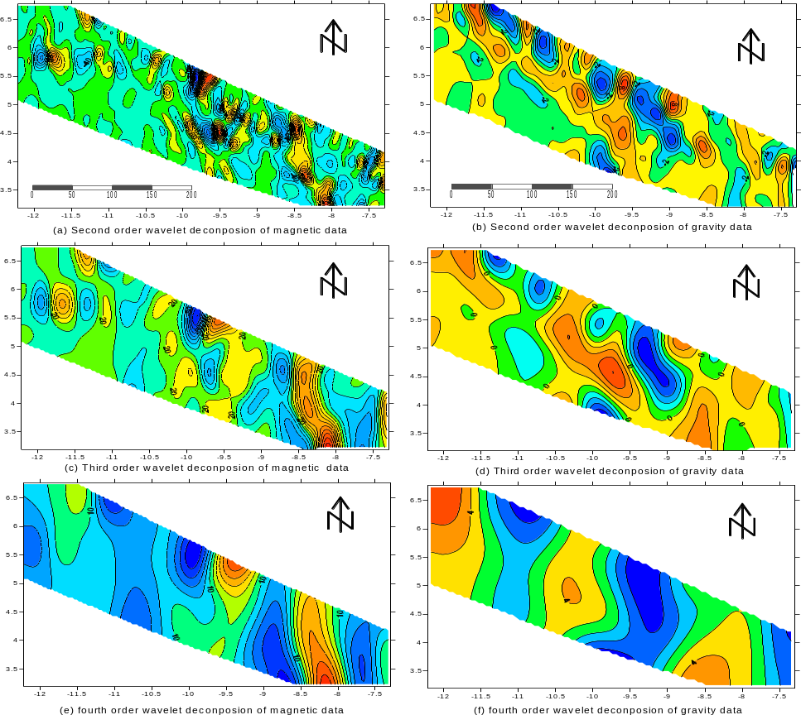
Figure 6: Wavelet decomposition of the gravity and the magnetic data at various depths to infer the sub structure of the continental shelf. Figures 6a,6c and 6d are second ,third and fourth orders wavelet magnetic decompositions respectively while 6b 6d and 6f are those of gravity data wavelet decompositions in the same order.

To determine the depth of the basin Euler deconvolution is carried out on both the gravity and magnetic data using a structural index of 0.5 and a window size of 10 grid cells on the magnetic data while a window size of 15 grid cells was selected for the gravity data and grids ( Fig. 9 ) created using a software. The structural index was chosen by inspecting the maps deduced from each structural index and the best depth estimates with tightest clustering considered. The choice of the window sizes depended on the wavelength of the studied anomalies.
To reduce the noise factor due to shallow structures and to increase the accuracy of depth estimate, a low pass filter is carried out on the data to enhance deeper structures before realizing the deconvolution. The Euler deconvolution results are given as figure (7) of the gravity and magnetic respectively.

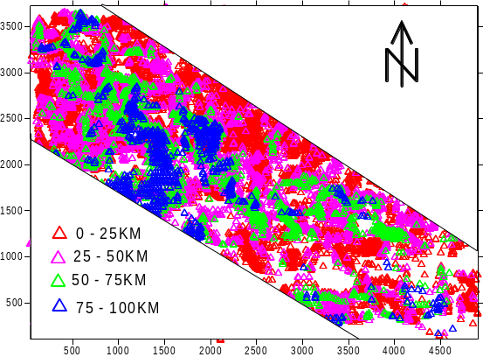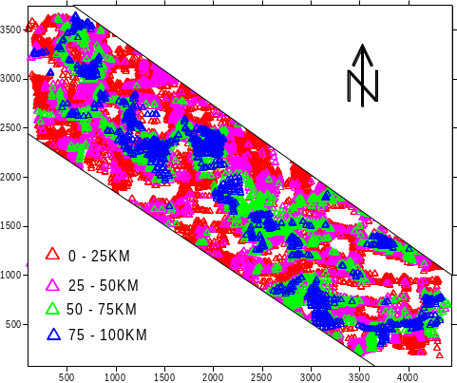
Figure 7: An Euler deconvolution of the (a) gravity and (b) magnetic maps showing various depths.
The high identified during magnetic deconvolution also correspond to high on the gravity map. These may be possible crustal intrusives with high density or crustal thickening/variations. The gravity grid of the decomposition delimits where the sediments thicken and their depth extent above the basement.

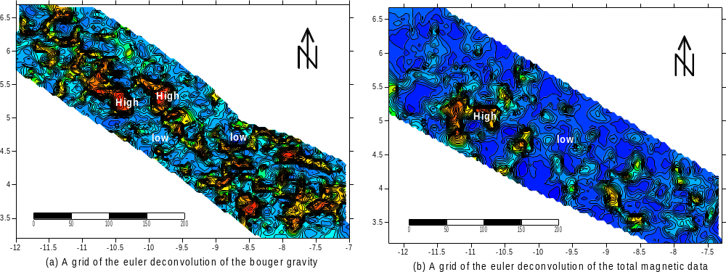
Figure 9: (a) grid of the euler deconvolution of the observer bouger gravity data and (b) the observed magnetic data contour intervals of 5 and 10 respectively.

Behrendt and Wortorson. (1970) and Behrendt et all (1974) showed magnetic basement maps of the continental shelf based on depth estimate from aeromagnetic profiles using the method of Vacquier et al (1951), which assumes semi-dike flat-topped bodies. In this investigation we use the Parker’s method (1974) to determine the depth to basement which shows some difference in terms of depth. The sedimentary rock seems too thickened on the slope and rise between Buchanan and Greenville. The depth to basement of the broadest section of the basin (figure 10) shows the structure of the basin with a depth estimated at over 10 km which is in agreement with previous studies (Behrendt and Wortorson, 1971 and Kara and Don, 2002). Two wells drilled within the proximity of the broadest portion of the basin in 1972 and 1986 by Frontier and AMOCO respectively reached a depth of a little over 3km even though they did not reach the basement. The deposition of sediment and the depth extent of the basin at this location could be attributed to the St. Paul Transform Zone and its subsequent fault system.

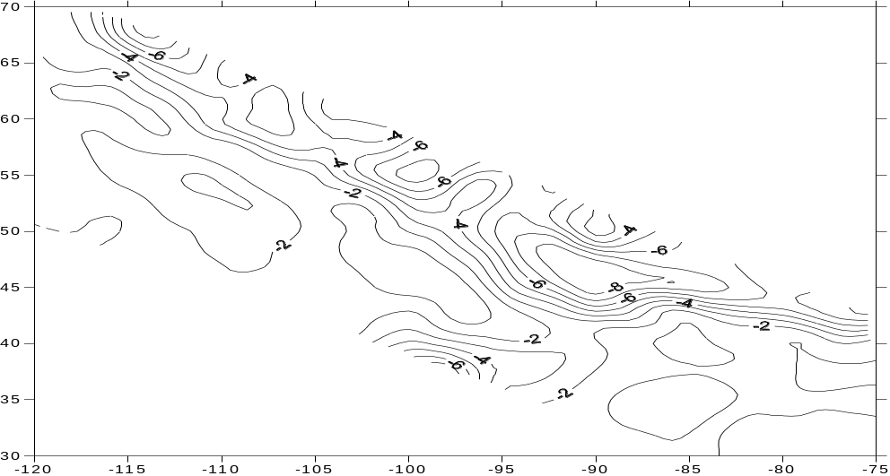

Figure 10: A depth to basement anomaly of the Liberia basin based on Parker’s method

A profile through the basin using one of the wells (S3-1) as a reference point and matching same to a seismic section along the direction of the profile shows some degree of disparity between the gravity and magnetic anomaly. The difference could be attributed to the low density of the upper strata due to deposition of sediments in the basin and the presence of shallow intrusive of high magnetic susceptibility (Fig. 11).
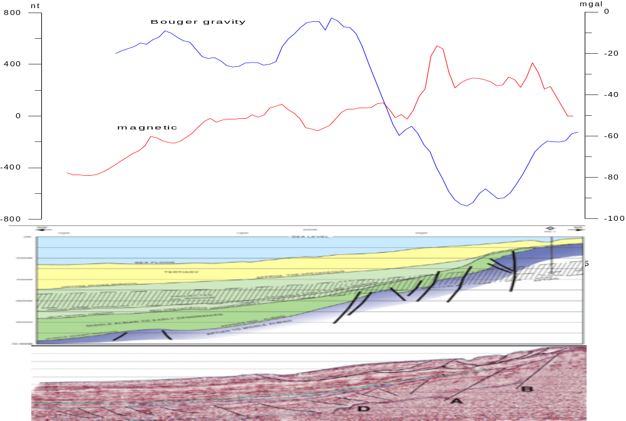
Figure 11: A profile across the basin intersecting one of the wells along its shoulder is compared to seismic section along the same line showing deep structure fault and entrapment of sediments and stratigraphy of the shelf.

5.0 Conclusion
The Liberia basin can be to be subdivided into three basins separated by uplifts and complex fault systems with the broadest and deepest section located at its eastern end. The depth to basement of the basin is estimated at over 10km at its broadest section. Analysis of the magnetic data indicates shallow intrusives ranging from a depth of 0.09km to 0.42 km with an average depth of 0.25km. Other intrusives can be found at average depths of 0.6km and 1.7km respectively within the confines of the basin. A Euler deconvolution showed that magnetic contacts were to a depth of 10km.

References

- Allard, G. O., and Hurst, V. J., 1969, Brazil Gabon geologic link supports continental drift: Science, v. 163, p. 528-532.
- Ayme, J. M.., 1965, The Senegal salt basin (Kennedy, W. Q., Salt Basins around Africa) London Institute of Petroleum, p. 83-90.
- Behrendt, J. C., and Wotorson, C. S., (1970)., Aeromagnetic and gravity investigations of the coastal and continental shelf of Liberia, West Africa, and their relation to continental drift :Geological Society American Bulletin , v 81, p 3563 -3574
- Behrendt, J. C., and Wotorson, C. S., 1974, Geophysical survey of Liberia with tectonic and geological interpretations: U.S. Geological Survey Prof. Paper 810.
- Blakely, R.J., 1995, Potential Theory in Gravity and Magnetic Applications: New York, Cambridge University Press.
- Bullard, E. C., Everett, J. E., and Smith, A. G., 1965, The fit of the continents around the Atlantic, in a symposium on continental drift Royal society London Philos. Trans , ser. A, no.1088, p41-51
- Chakraborty, A. and Okaya, D. (1995), Frequency-time Decomposition of Seismic Data Using the Wavelet Transform-based Methods, Geophysics 60, 1906-1916.
- Creer, K. M., 1965, Paleomagnetic data from the Gondwanic continents, in Symposium on continental drift: Royal Soc. London. Phil. Trans., ser. A, no. 1088, p. 27-40.
- Daubechies, (1990), The Wavelet Transform Time-Frequency Localization and Signal Analysis, IEEE Trans. on Information Theory 36.
- Davis, A., Murshak, A., and Wiscombe, W. Wavelet-base multi-Iractal analysis ofnon-stationary and/or intermittent geophysical signals. In Wavelets in Geophysical (eds. E. Foufoula Georgiou and P. Kumar). (Academic Press, Ine. 1994) pp. 249-298.
- Dickson, G. O., Pitman, W. C., Ill, and Heirtzler, J. R., 1968, Magnetic anomalies in the South Atlantic and ocean floor spreading: Jour. Geophys. Research, v. 73, p. 2087-2100.
- Dobrin, M., and Savit, C. H., 1988, Introduction to geophysical prospecting: Mc- Graw Hill Book Co.
- Fedi, M. and Quarta, T. (1998), Wavelet Analysis for the regional-residual and Local Separation at Potential Field Anomalies. Geophys. Prosp. 46, 507-525.
- Gough, D. I., Opdyke, N. D., and McElhinny, M. W., 1964, The significance of paleomagnetic results from Africa: Jour. Geophys. Research, v. 69, p. 2509-2519.
- Gromme, S., and Dalrymple, G. B., K Ar ages and paleomagnetism of dikes in Liberia [abs]: EOS (Am. Geophys. Union Trans), v. 53, no. 11, p 1130.
- Grossman, A. and Marlet J. Mathematics and Physics 2, (ed. L. Streit) (World Scientific Publishing, Singapore (1985)).
- Grubb, H. and Walden, A. (1997), Characterizing Seismic Time Series Using the Discrete Wavelet Transform, Geophys. Prosp. 45, 2, 183-205.
- Hood, P. J., Gradient measurement in aeromagnetic surveying. Geophysics 30 (5) 891-902.
- Hurley, P. M., Leo , G. W., white , R. W., and Fairbairn, H. W., 1871, The Liberian age province (ca. 2700m.y.) and adjacent provincesin Liberia and Seirra Leone: Geol. Soc. America, v. 82, p 3483 – 3490.
- Kara C. Bennet and Don Rusk (2002), 2D seismic interpretation and exploration potential deepwater Sierra Leone and Liberia, West Africa;, The Leading Edge.
- Lehner, P., and DeRuiter, P.A. D., 1976, Africa Alantic margin typified by string of basins: Oil nad Gas journal, v. 76, p. 252-266.
- Li, J. and Morozov, I.B. (2006): Structural styles of the Precambrian basement underlying the Williston Basin and adjacent regions – an interpretation from geophysical mapping; in Summary of Investigations 2006, Volume 1, Saskatchewan Geological Survey, Sask. Industry Resources, Misc. Rep. 2006-4.1, CD-ROM, Paper A-2, 18p.
- Li, Y. and Oldenburg, D. (1997), Fast Inversion of Large-scale Magnetic Data Using Wavelets, 67th Ann. Internat. Mtg., Soc. Exp. Geophysics., Expanded Abstract, 490-493.
- Mallat, S. (1989), A Theory for Multi-resolution Signal Decomposition the Wavelet Representation, IEEE Trans. Pattem Ana L. And Machine Intelligence 31, 679-693.
- Parker, R.L. (1974) Best bounds on density and depth from gravity data, Geophysics, 39: 644-649.
- Ravat, D., 1996, Analysis of the Euler method and its applicability in environmental magnetic investigations: J. Environ. Eng. Geophys., 1, 229–238.
- Reid, A.B., Allsop, J.M., Granser, H., Millett, A.J., Somerton, I.W., 1990. Magnetic interpretation in three dimensions using Euler deconvolution. Geophysics 55, 80–91.
- Ridsdill-Smith, T. A. and Dentith, M. C. (1999), The Wavelet Transform in Aeromagnetic Processing, Geophysics 64, 1003-1013.
- Schlee, J., Behrendt, J. C., and Robb, J.M., 1974, Shallow stratighaphy of the Liberian Continental margin: American Association of Petroleum Geologist Bulletin, v. 58, pp. 708 -728.
- Sheridan , R. E., Houtz, R. E., Drake, C. L., and Ewing , M., 1969, Structure of the continenetal margin off Seirra Leone, West Africa: Journal of Geophysicsl Reseach, v. 74, p . 2512 – 2530.
- Thompson, D.T., 1982. EULDPH: a new technique for making computer-assisted depth estimates from magnetic data. Geophysics 47, 31–37.
- Thorman, C. H., 1972, the boundary between the Pan African and Liberian age provinces, Liberia, West Africa: Geological society of America, Abs. with Programs (ann. Mrg), v.4 no. 7, p.690:
- White, R. W., and Leo, G. W., 1969, Geological reconnaissance in western Liberia: Liberian Geol. Survey Spec.
- White, Richard W. 1972. Stratigraphy and structure of basins on the coast of Liberia. Monrovia: Republic of Liberia, Ministry of Lands and Mines, Liberian Geological Survey, Special Papers - Liberia, Geological Survey.
- Williams, S. E., Fairhead, J. D., and Flanagan G., 2005, Comparison of grid Euler deconvolution with and without 2D constraints using a realistic 3D magnetic basement model: Geophysics, 70, 13–21.

