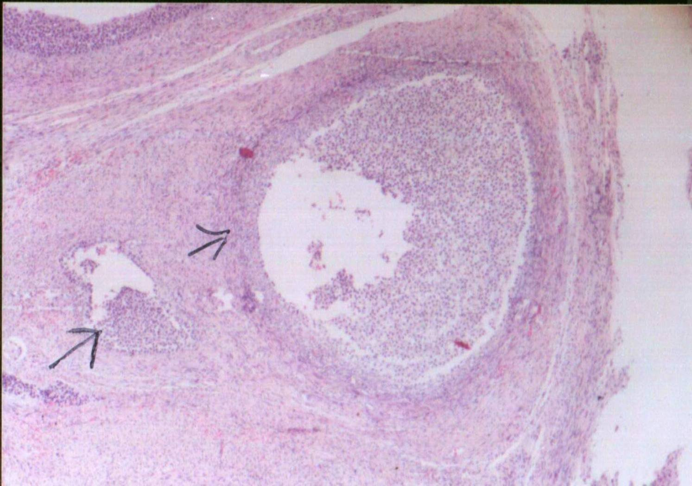
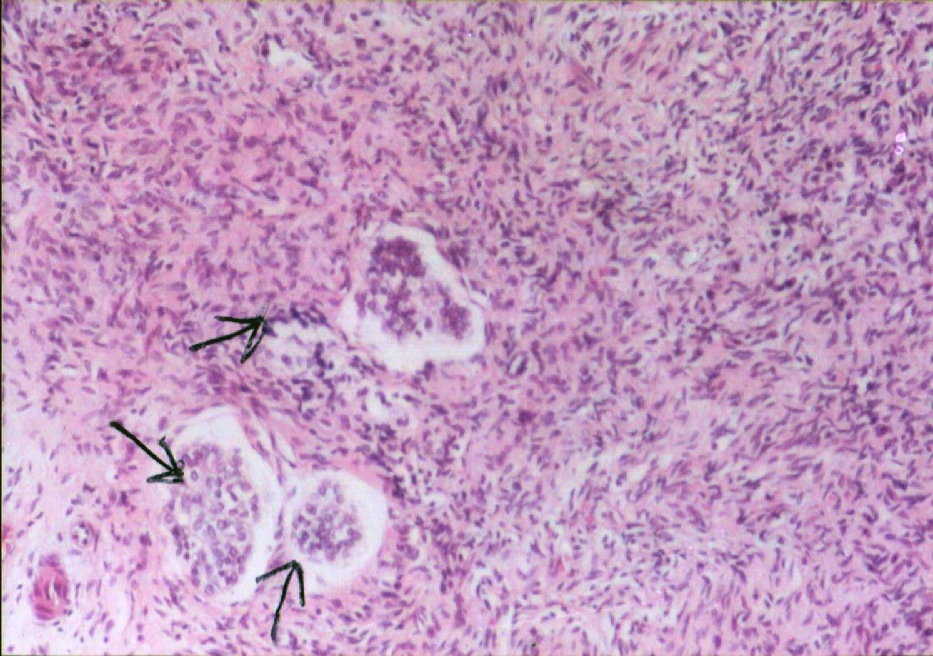
Plate 3. Cross section in the left ovary of she-camel during autumn showing a growing follicle
( Stained by H & E x 40).
Plate 4. Cross section in the cortex of left ovary of she-camel during summer primordial follicles
( Stained by H & E x 40).

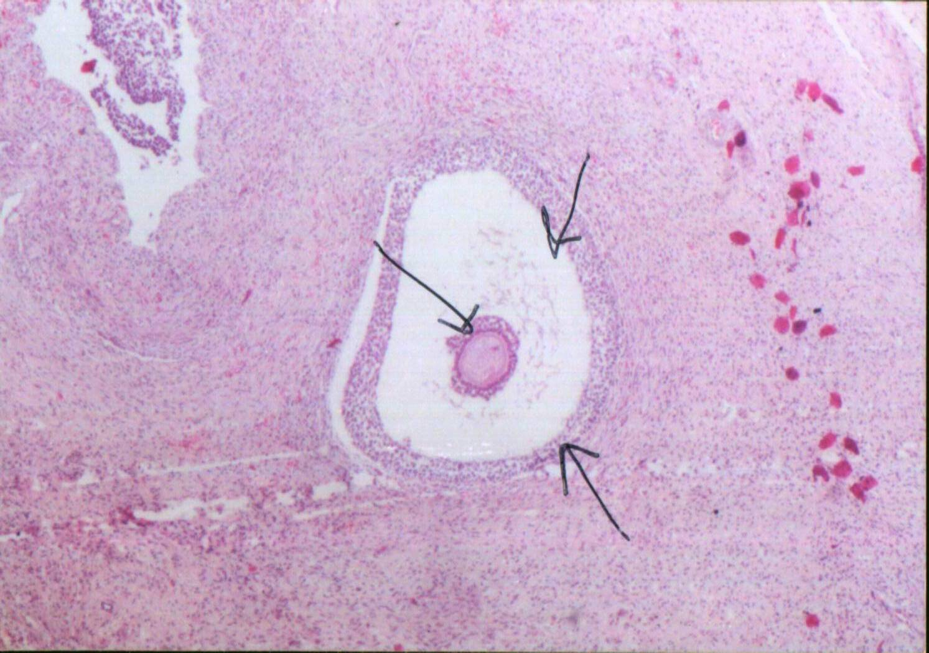
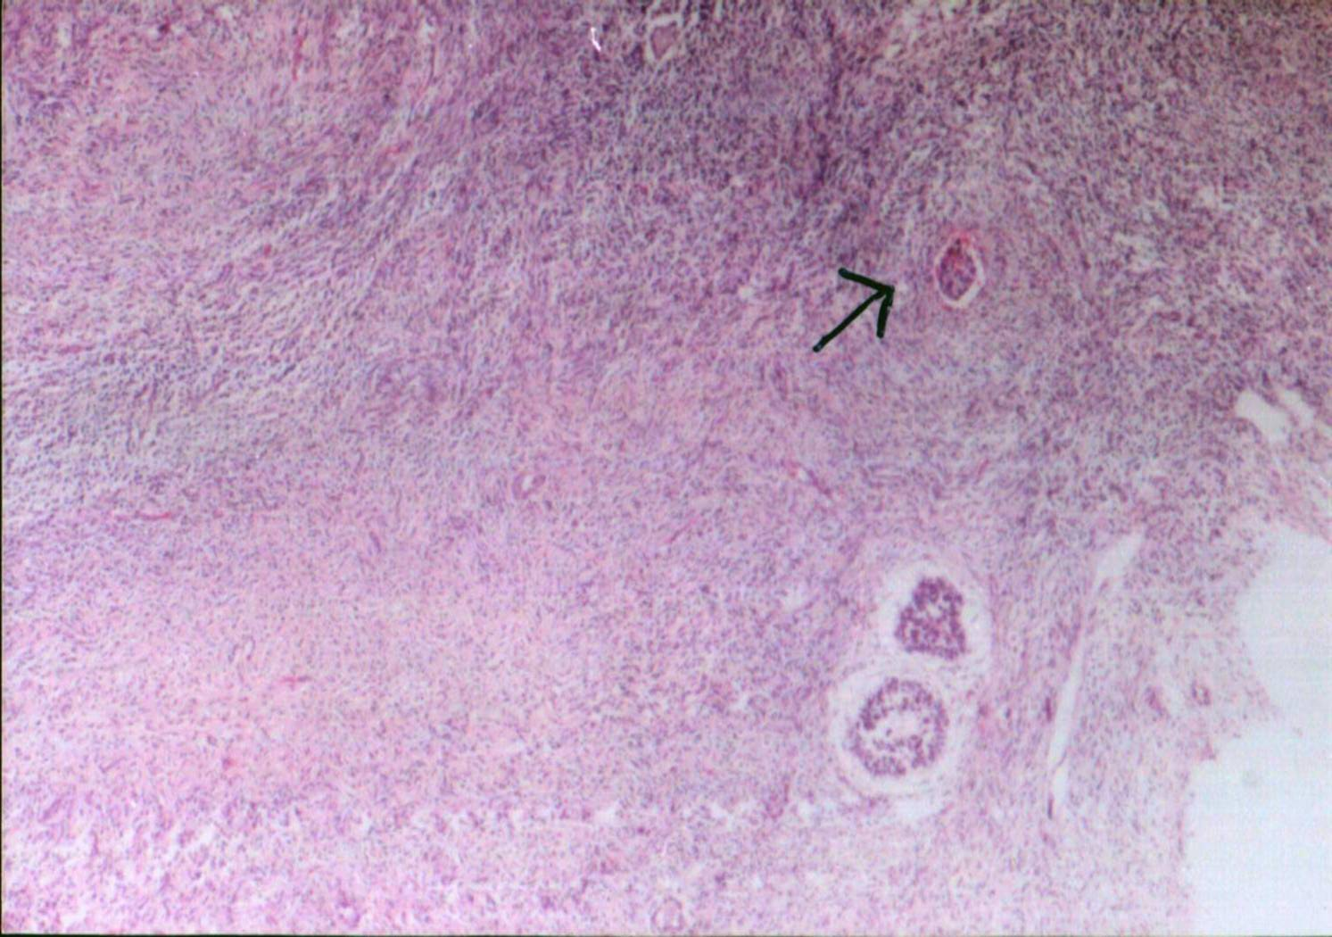
Plate 5. Cross section in right ovary of she-camel during winter showing degenerated follicles ( Stained by H & E x 40).
Plate 6. Cross section in right ovary of she-camel during spring showing secondary follicles (Stained by H & E x 40).
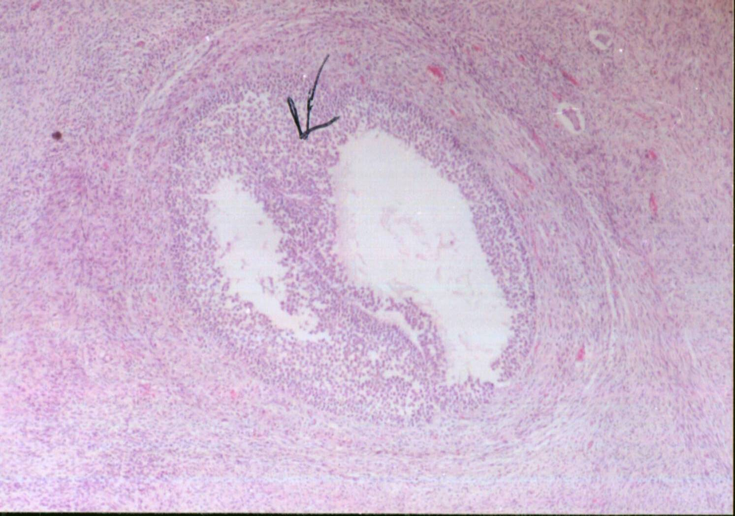
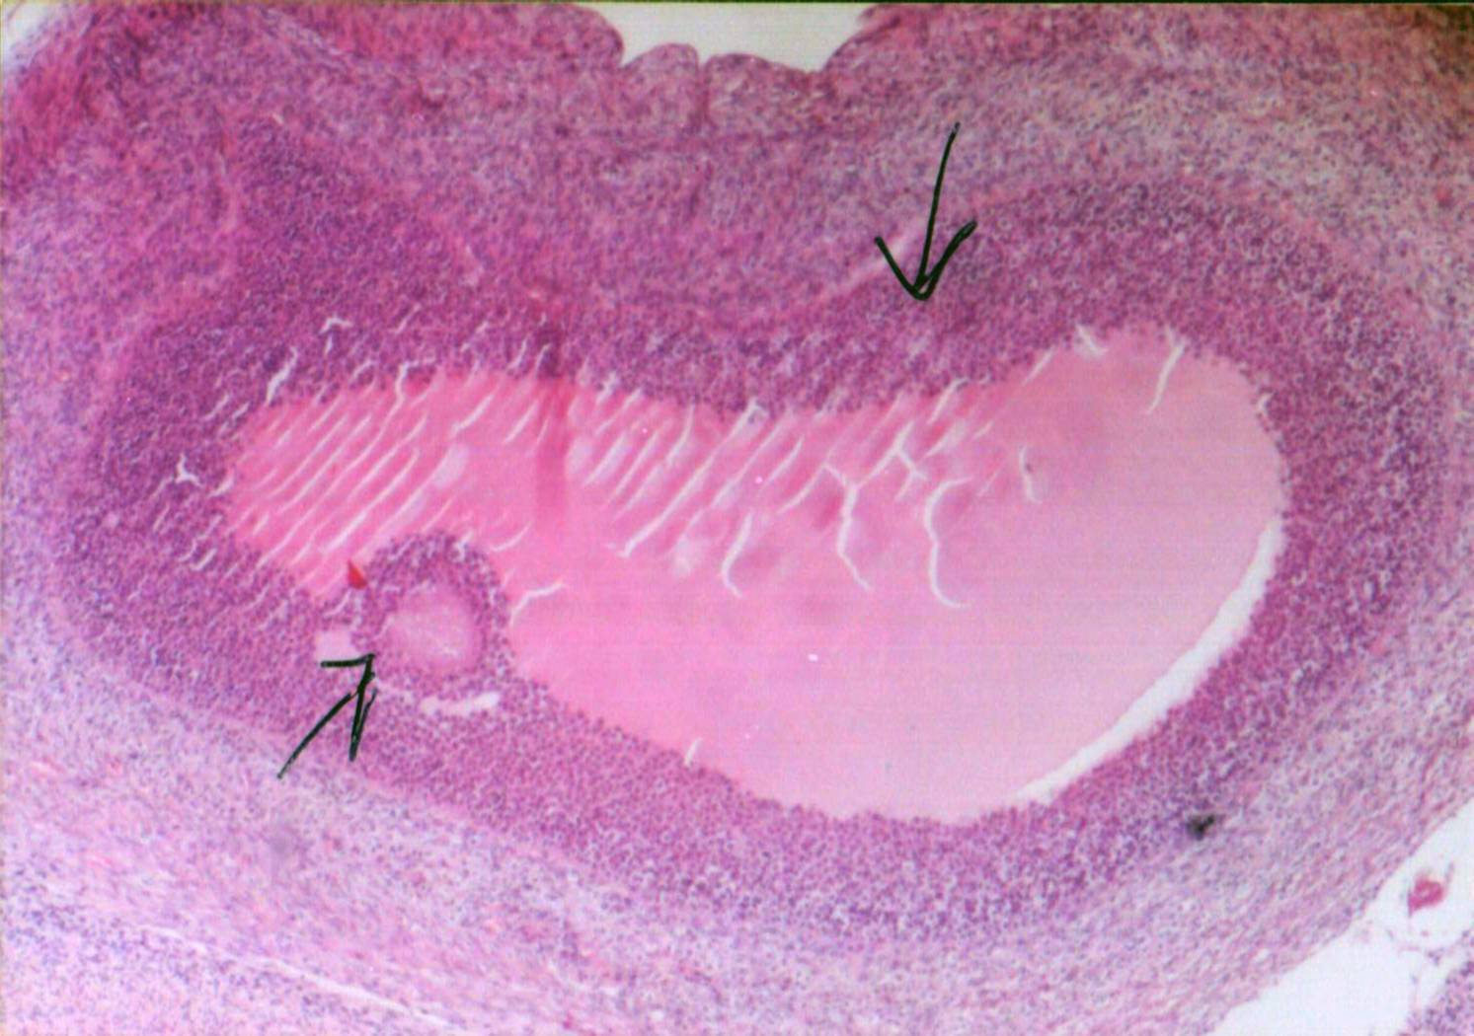
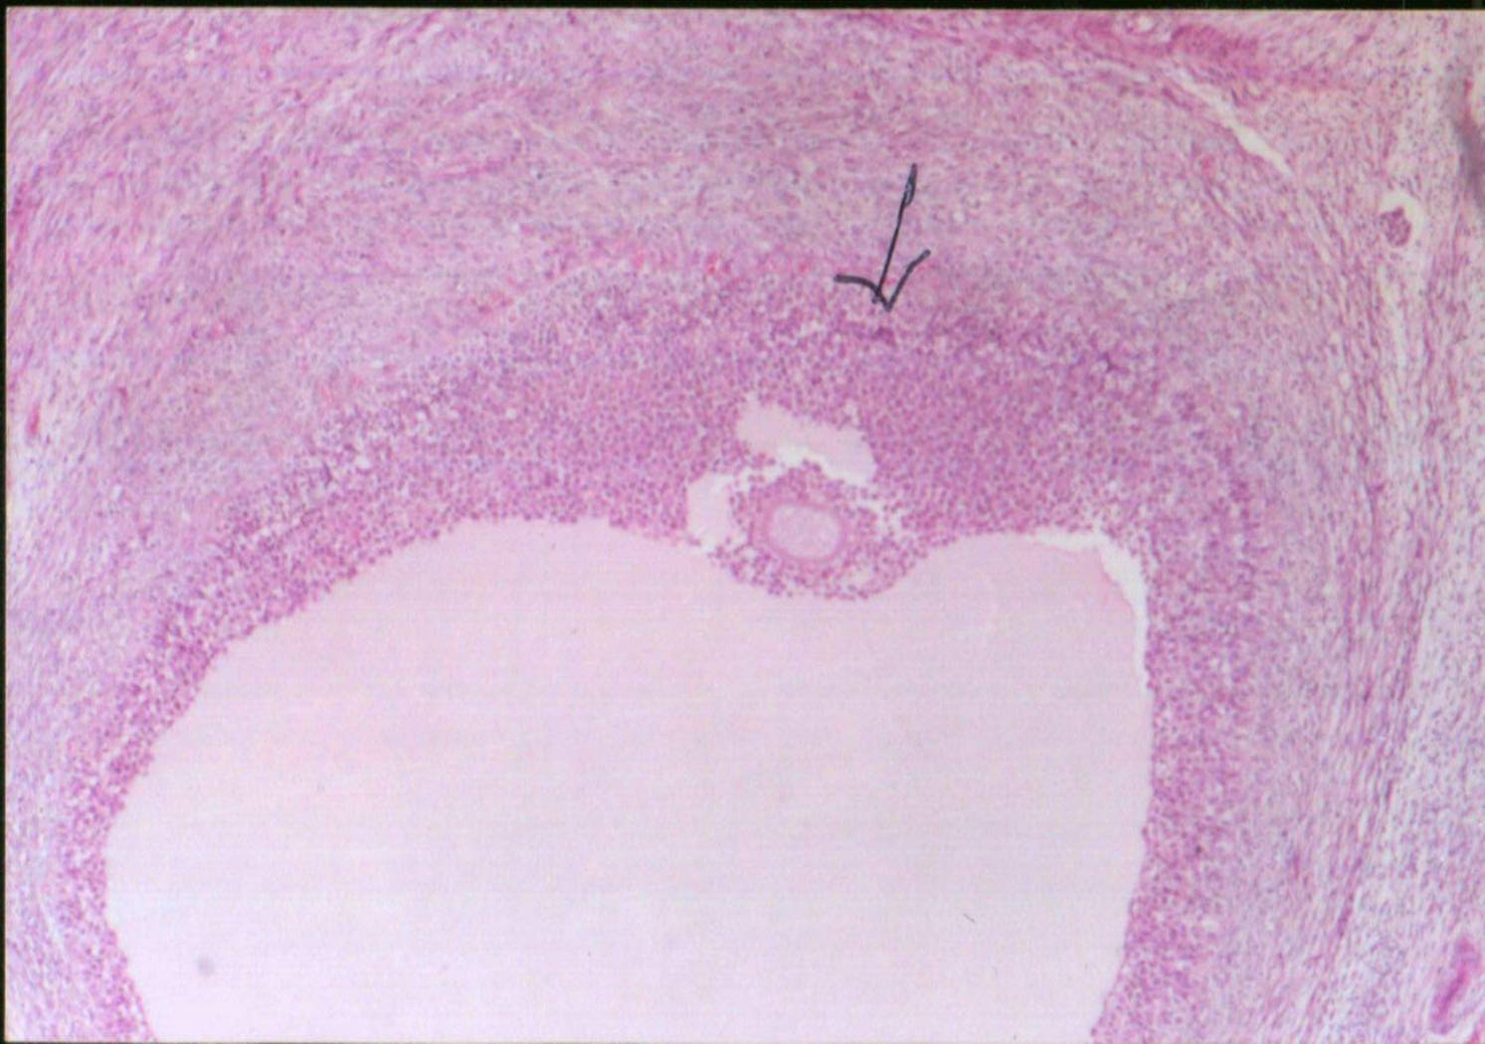
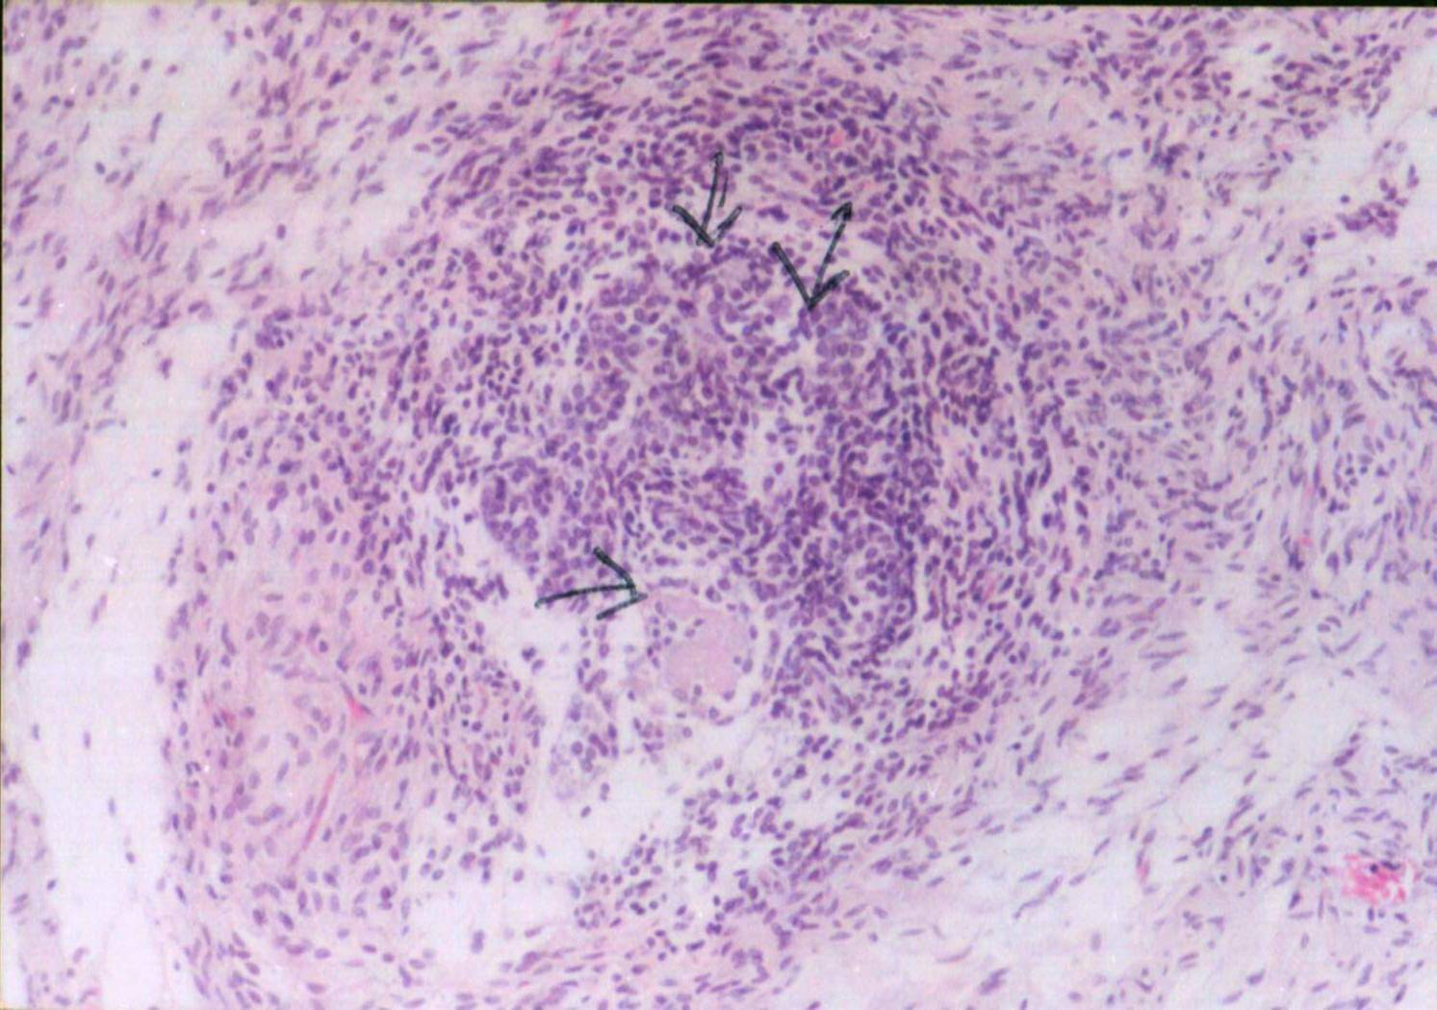
Plate 1. Cross section in the left ovary of she-camel during winter showing mature graffian follicles (Stained by H & E x 40).
Plate 2. Cross section in the left ovary of she-camel during spring showing growing follicles (Stained by H & E x 40).
Plate 7. Cross section in right ovary of she-camel during autumn showing mature follicles (Stained by H & E x 40).

Plate 8. Cross section in right ovary of she-camel during summer showing primordial follicles (Stained by H & E x 40).

