Practical Aspects and Immune response of Probiotics Preparations Supplemented to Nile Tilapia (Oreochromis Niloticus) Diets
H.M.Ali¹; A.A. Ghazalah¹; E.A. Gehad²; Y.A. Hammouda¹ and H.A. Abo-State¹
1- Animal Production Department, National Research Center, Dokki, Giza, Egypt
2- Animal Production Department, Fac. of Agric., Cairo University, Cairo Egypt

dr_mona_zaki@yahoo.co.uk
ABSTRACT
This study was carried out for 7 months at fish Laboratory of Animal Production Department, National Research Center, Dokki, Egypt. The experiment aimed to investigate the effect of two commercial probiotics (Premalac and Biogen) each at 1,2 and 3 g/Kg diet on growth performance and immune response of Nile tilapia fingerlings. Premalac is a dried fermented product of Lactobacillus acidophilus, Aspergillus oryzae extract, Bifedobacterium bifedum, Streptococcus faecium, Torula yeast, Skim milk, Vegetable oil and CaCo₃. Biogen is a dried natural product composed of Allicin, high unit hydrolytic enzymes, Bacillus subtilis and Ginseng extract. A total of 420 fingerlings with a uniform size and weight (1 gram) were used of which 60 fingerlings represent the control group. The rest (360 fingerlings) distributed randomly into two blocks (probiotics), each block included three treatments (probiotic levels). Each treatment in addition to the control one were represented in three replicates (aquaria) in which 20 fingerlings were kept in each aquarium.
The best results of growth and feed utilization of tilapia were obtained by fish diet supplemented with Biogen followed by those having Premalac, each at 2g/Kg diet. However, fish fed on Biogen-supplemented diets exhibited significantly higher values of nutrients digestibility. On the other hand, fingerlings fed either Premalac or Biogen at 2g/Kg had significantly higher total leucocytes count than the control which indicating highs immune response of tilapia fingerlings. In conclusion, it is suggested that the tested probiotics preparations are suitable for mixing with tilapia diets to improve their performance and immunity.
INTRODUCTION
The use of probiotic products as feed supplements has attracted considerable attention by feed manufactures as means of improving livestock performance. The diverse range of bacteria has been examined as probiotics for possible use in aquaculture (Watson et al, 2008).
Most studies concerned with the effects of probiotics on cultured aquatic animals have emphasized a reduction in mortality or, conversely, increased survival (Change and Liu, 2002), improved resistance against disease (Villamil et al., 2003); enhance the ability to adhere and colonize the gut (Vine et al., 2004; Abo-State 2009); improved the ability to antagonize other organisms (Burgents et al., 2004; Li et al., 2004; Brunt and Austin, 2005; Panigrahi et al., 2005 and Shelby et al., 2006) also, the ability to reduce the number of bacterial cells in kidneys (Park et al., 2001), the production of polyamines and digestive enzyme activity (Tovar et al., 2002 and Hidalgo et al., 2006) and the development of the non specific immune system by means of Cellular systems like increased phagocytic and lysozyme activities (Irianto and Austin, 2002).
The use of probiotics in aquaculture has been accompanied by an increase in nutrient utilization through providing enzymes capable of converting certain components of the diet into more digestible nutrients for the host. In this connection, Geovany et al., (2007) showed that feeding probiotics may improve appetite and growth performance of the farmed fish or what?? species. Hwever, the specific function of probiotics may differ depending on the host animal and more on the characteristics of the probiotics. Guillian et al., (2004) El-Haroun et al., (2006) and Eid and Mohamed (2008) found that Bacillus spp. may modulate the mucosal immune system enhancing their resistance to enteric pathogens and so improved survival and growth of tilapia. Also, Venkat et al., (2004)found that Lactobacillus spp. have an inhibitory effect on the harmless gram negative bacteria present in gut microflora of Macrobrachium rosenbergii post-larvae, and so reduced the mortality significantly.
The objectives of this study are to investigate the effect of two commercial probiotics (Premalac and Biogen) on growth performance and immune response of Nile tilapia fingerlings.
MATERIALS AND METHODS
This experiment was conducted for seven months, using Nile tilapia (Oreochromis niloticus) all male fingerlings, one gram average weight obtained from Kafr El-sheikh fish hatchery, Egypt.
A total number of (420) tilapia fingerlings were distributed at randoum into seven experimental dietary treatments including the control one, each in three aquaria (60x30x40 cm³) as replicates.
Water temperature ranged between 27.4-27.6ºC with photo period 12h light and 12 h darkness. The disolved oxygen level was 6.6 mg/L, while records for total ammonia, nitrite, nitrate and pH levels were appropriate for tilapia cultivation, being 0.07 mg/L, 0.06mg/L, 5.93mg/L and 7.6, respectively (APHA, 1992).
Experimental design:
A conventional corn-SBM-fish meal basal diet was formulated to meet the minimum requirements of fish (NRC, 1993), and used with supplementation representing the control unsupplemented group (Table 1). The basal diet was supplemented with two commercial probiotic preparations being Premalac and Biogen. Premalac is a dried fermentation product of Lactobacillus acidophilus, Aspergillus oryzae extract, Bifedobacterium bifedum, Streptococcus faecium, Torula, yeast, Skim milk, vegetable oil and CaCO₃. Biogen is a dried natural product composed of Allicin, high unit hydrolytic enzymes, Bacillus subtilis and Ginseng extract.
Each one of the tested probiotics was applied at 1, 2 and3 g/Kg diet as recommended by the producers. The viability of the tested probiotics were tested before using according to the method outlined by Martin et al., (1981) . The viable contents were determined by counting the CFU (Colony Forming Unit), which is considered as an indication for the viability of the microorganisms present viable in these commercial probiotics and so represents their growth promoting effect. Such determination showed the presence of 8.5x10⁶ and 2.5x10⁷ CFU, for Premalac and Biogen, respectively. Then, the feeding experiment started and durated for 7 months. Feeding level was 4% of the total biomass of the fish /day. The amount of feed was divided into three equal portions at 9 a.m , 1 p.m and 5 p.m. Every fourteen days, the fish in each aquarium were weighed and the amount of feed was corrected according to the new fish biomass (Annet, 1985).
At the end of the feeding period, digestibility trials were conducted using 8 fish /aquarium and offered the experimental diets at a rate of 2% of the total biomass/day. The collected feces were directly spread with 10% sulfuric acid and 10% formalin and kept in deep freezer at -4ºC. Analysis of CP, EE, CF and Ash in the collected feces were carried out in pooled dried samples. Proximate chemical analysis were made according to A.O.A.C. (1990) methods while their energy contents were calculated according to Jobling (1983). Apparent digestion coefficient (ADC %) of the nutrients were calculated using crude fiber as an inert marker as described by Tacon and Rodringus (1984) as follows:
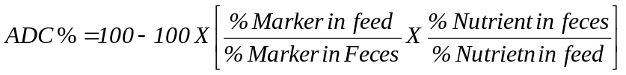
Data of the study include the growth performance parameters, feed utilization, nutrients digestibility of dietary treatments and the immune response of tilapia as affected by the tested probiotics.
The immune response test was done by subjecting the experimental fish prefed the tested probiotics to injection with one of the most common bacterial infection among cultured fish being Aeromonas hydrophilla for determining the differential count of blood film.
A total number of 168 fish (8 fingerlings/aquarium) obtained from the stock were used for immune response test. The fish were injected with A. hydrophilla inter-peritoneally (I.P.) at dose of 0.2 ml/fish representing 2x10⁸ bacterial cell /ml for each fish. After two weeks of injection, blood films from duplicate samples were prepared (Sakai et al., 1995) and examined at X400 to determine the number of leucocytes, being indicator for immunity.
Statistical analysis :
Growth performance and feed utilization efficiency parameters were statistically compared using the SAS programme (1992) SAS/STAT users guide, Release 6.03 Edition SAS inst. INC. Cary, NC. USA.
Duncan's New Multiple Range Test was conducted to determine the significant differences between means (Duncan, 1955).
RESULTS AND DISCUSSION
This experiment was extended for 7 months to study the effect of two commercial probiotics on performance and feed utilization as well as the immune response of tilapia fingerlings. These commercial probiotics were Premalac which is commonly used for poultry at 1g/Kg diet being the recommended level, however, because it would be applied in a different media being water, therefore, it is proposed to use Premalac in addition to Biogen which is specific for fish, each at 1,2 and 3g/Kg diet.
The average values of initial live weight, final weight, weight gain, specific growth rate and average daily gain of Nile tilapia are given in Table(2).
It appears that all dietary treatments have commenced with a nearly similar initial body weight which ranged between 1.10 to 1.33 g with slight (P>0.05) differences, so confirmed the appropriate randomization process.
Results indicated that Nile tilapia fingerlings which received diet supplemented with Biogen at 2g/Kg diet have highest final live body weight, weight gain, average daily gain (20.11, 18.88 and 0.12g), respectively compared to other treatments. However, there were no significant differences (P<0.05) between treatments in SGR (Table 2). Feed intake, feed conversion ratio and nutrients utilization are shown in Table (3). Results obtained indicated that feed intake increased gradually as the level of the probiotics incorporation increased. However, results of the values obtained for feed intake among all the experimental groups revealed that diet supplemented with Biogen at 2 or 3 g/Kg diets was superior than other dietary treatments.
The results indicated that there were no significant differences among most groups in FCR and nutrients utilization expressed as PER PPV, FPV and EU. Meanwhile, data obtained showed the superiority of dietary treatments having either Premalac or Biogen at the level of 2g /Kg diet compared to other dietary treatments. Moreover, increasing the supplemental level of any of the tested probiotics up till 3g/Kg diet become worth the feed conversion ratio to become the worst, besides, it lowered also the utilization of other nutrients (protein, fat and energy). Therefore, a dose effect relationship indicates that dosage of probiotics should be defined carefully to avoid over dosing with resultant lower efficiency and consequently unnecessary costs (Nikoskelainen et al., 2001).
This means that Nile tilapia fingerlings grew well when either Biogen or Premalac at 2g/Kg diet has been used as growth promoters in fish feeding.
However, by comparison, the probiotic Biogen (Specific for fish) was superior than Premalac (commonly used for poultry) in aquatic environments. Therefore, the intimate relationship between bacteria and their host should be considered. In this respect, Olafsen (2001) stated that the use of probiotics which has proven advantageous in domestic animal or poultry production and microbial management may also have a potential in aquaculture. This because the gastrointestinal microbiota of fish are peculiarly dependent on the external environment, due to the water flow passing through the digestive tract. Most bacterial cells are transient in the gut, with continuous intrusion of microbes coming from water and food (Gatesoupe, 1999). In addition, by feeding fish with probiotics bacteria, these bacteria will also be present in the surrounding water and also colonise the fish skin and other parts of the body (Nikoskelainen et al., 2001). The most likely explanation of the effective role of probiotics is their effect in suppressing pathogenic coli forms in the stomach and intestine and improving the absorption of nutrients by reducing the thickness of intestinal epithelium (Venkat et al., 2004).
The improvement in live body weight in probiotic treated groups of fish is mainly due to maintaining the beneficial bacteria such as Lactobacillus in the intestinal tract which can competes with the undesirable organisms for space and nutrients as reported by Jena et al., (1996). Such useful bacterial growth facilitates the fermentation process which is of nutritional significant such as producing various types of vitamins (Fuller, 1997) and organic acids which provide energy to the host as well as stimulate the growth.
Average apparent digestion coefficient (ADC) of DM, CP, EE, NFE and energy using CF method as an internal marker are presented in Table (4). Statistical analysis of these data showed significant differences (P<0.05) among all the treatments.
The highest figures of DM, CP, EE, NFE and energy digestibility were obtained form groups of fish fed diets supplemented with Biogen at level of 2g/Kg being (90.93, 88.42, 92.62, 97.31 and 91.95% respectively, while the corresponding values of the control group were 87.14, 85.89, 89.42, 93.50 and 88.17% at the same order, followed by Premalac .
The data obtained declared that tilapia were able to utilize dietary nutrients when the tested probiotics had been added particularly at 2g/Kg diet. However, the probiotic Biogen was found to be the most successful one followed by Premalac for Nile tilapia fingerlings.
This result go paralleled with the results obtained by De Schrijver and Ollevier (2000) who reported a positive effect on apparent protein digestion with supplementing turbot feeds with the bacteria Vibrio proteolyticus. They attributed this effect to the proteolytic activity of bacteria. In this connection, Lara Flores et al., (2003)found that the digestibility results for the control groups were lower than those having the probiotics supplemented diet.
Determining the immune response of experimental fish to tested Probiotics had been done by detecting the differential count of blood film, to asses the changes in blood content of white cells following spontaneous infection of tilapia to evaluate the serosity of the disease on the basis of blood alterations (Table 5). The results were listed in Table (5). Both Premalac and Biogen treated fish groups had significantly greater mean total leucocytes count than the control group, particularly when added to fish diets at 2g/Kg.
When Probiotics and control fish groups were challenged with Aeromonas hydrophilla, there probiotics which containing Lactobacillus and Bacillus sp. supplied fish with more immunity compared with the control. These findings are in agreement with those reported by Rengpipat et al., (2000) who stated that Bacillus sp provided disease protection to shrimp by activating both cellular and humoral immune defenses. Also, Nikoskolainen et al., (2001) found that Lactobacillus strain increased the immune response of rainbow trout challenged with Aeromonas salmonicida sp.
In general, the increase in leukocytes count during infection of tilapia fed either Premalac or Biogen probiotics, containing organism released defense against pathogens as indicated by Caruso et al., (2002) and Benli and Yildiz (2004) . However, the strength of immunity obtained depend to a large extent on the active microorganisms still viable after mixing with feed. The viability of the tested probitoics were 8.5x10⁶ and 2.5x10⁷ CFU for Premalac and Biogen, respectively.
In conclusion, all results obtained indicated that either Biogen or Premalac at 2g/Kg produced a positive effect on growth and feed utilization of tilapia fingerlings. In addition, the immune responses were substantial in both treatment groups following the challenge with bacterial infection. However, the probiotics Biogen when added to fish diet at 2g/Kg, produce a steady improvement of tilapia growth compared to Premalac.
Table (1): Composition and calculated chemical composition of the basal diet used in the experiment.
Ingredient | %
Yellow corn | 48.0
Soybean meal (44%) | 18.5
Fish meal (72%) | 26.0
Corn oil | 5.0
Vit.& Min. Mix. | 2.5
Total | 100
Calculated analysis (on DM basis) %
DM | 93.70
CP | 32.13
EE | 11.01
CF | 1.83
Ash | 5.59
NFE | 49.44
Nutritive value
GE kcal/kg ** | 4906.6
E:P ratio | 152.7
* each 1 kg. contains vitamin A, 4.8 mI.U.; vit D₂ 0.8 mI.U/ vit E, 4.0g/ vit. K, 0.8 g; vit B₁, 0.49 vit. B₂ , 1.6 g; vit. B₆, 0.6; vit. B₁₂, 4 mg; Pantothenic acid 4g; Nicotinc acid 8g; Folic acid, 4000 mg; Biotin 20 mg; Choline chloride, 200 mg; Copper, 4.0 g; Iodine, 0.4g; Iron, 12 mg; Manganese, 22g; Zinc 22 g and Selenium 0.04g.
** Gross energy value was calculated from their chemical composition, using the fac5os 5.65 , 9.45, 4.00 and 4.00 (k cal/g) for protein, fat, fiber and NFE, respectively (Jobling, 1983).
Table (2): Performance of Tilapia (O.n) as affected with the tested probiotics.
Treat | Initial weight  g | final wt.  g | Wt. gain  g | SGR | ADG  g
Cont | 1.15 ª  ±0.04 | 18.93 ^{ab}  ±1.14 | 17.78  ±1.15 ^{ab} | 1.80 ª  ±0.08 | 0.84 ^{ab}  ±0.01
P₁ | 1.11 ª  ±0.04 | 15.75 ^{bc}  ±21.14 | 14.64 ^{bc}  ±1.15 | 1.69 ª  ±0.01 | 0.07 ^{bc}  ±0.01
P₂ | 1.10 ª  ±0.04 | 13.51 ^{bc}  ±1.14 | 12.41 ^{c}  ±1.15 | 1.61 ª  ±0.08 | 0.06 ^{c}  ±0.01
P₃ | 1.18 ª  ±0.04 | 16.38 ^{c}  ±1.14 | 15.20^{abc} ±1.15 | 1.69  ±0.08 | 0.07 ^{c}  ±0.01
B₁ | 1.25 ª  ±0.04 | 16.07 ^{bc}  ±1.14 | 14.82^{bc} ±1.15 | 1.65 ª  ±0.08 | 0.07 ^{abc}  ±0.01
B₂ | 1.23 ª  ±0.04 | 20.11 ª  ±1.14 | 18.78ª  ±1.15 | 1.80 ª  ±0.08 | 0.89 ^{A}  ±0.01
B₃ | 1.23 ª  ±0.04 | 18.77 ^{ab}  ±1.14 | 17.54 ^{b}  ±1.15 | 1.71 ª  ±0.08 | 0.083 ^{Ab}  ±0.01
Proba | 0.0226 | 0.0132 | 0.0170 | 0.6912 | 0.0314
a, b: Means within column with different superscripts are significantly different (P<0.05).
P = Premalac, B = Biogen.
SGR = specific growth rate
ADG = average daily gain
Table (3): Feed consumption, feed conversion ratio and nutrients utilization of tilapia (O.n) as affected with probiotics supplementation.
Treat | Feed consump. g | FCR | PUE | PPV | FPV | EU
Cont | 35.59 ^{abc}  ±2.15 | 2.04 ª  ±0.14 | 1.83 ª  ±0.08 ª | 24.13 ª  ±1.278 | 55.83 ª  ±3.10 | 15.90 ª  ±0.85
P₁ | 33.79 ª  ±2.14 | 2.37 ª  ±0.14 | 1.51 ª  ±0.08 | 21.94 ª  ±1.27 | 50.28 ^{ab}  ±3.10 | 15.03 ^{ab}  ±.851
P₂ | 33.04 ª  ±1.154 | 2.18 ª  ±0.14 | 1.63 ª  ±0.08 ª | 20.55 ª  ±1.27 | 57.63 ª  ±3.10 | 15.53 ^{ab}  ±0.85
P₃ | 31.14 ^{c}  ±1.15 | 2.51 ª  ±0.14 | 1.41 ª  ±0.08 | 19.07 ª  ±1.27 | 44.55 ^{b}  ±3.10 | 12.91 ª  ±0.85
B₁ | 33.36 ª  ±1.15 | 2.24 ^{b}  ±0.17 | 1.55 ª  ±0.08 | 20.36 ª  ±1.27 | 44.67 ^{b}  ±3.10 | 13.45 ^{b}  ±.85
B₂ | 38.75 ^{ab}  ±1.15 | 2.06 ª  ±0.14 | 1.70 ª  ±0.08 | 21.47 ª  ±1.27 | 50.90 ^{ab}  ±3.10 | 14.40 ^{ab}  ±0.85
B₃ | 40.80 ª  ±1.16 | 2.33 ª  ±0.14 | 1.50 ª  ±0.08 | 19.28 ª  ±1.27 | 47.11 ª  ±3.10 | 13.06 ^{b}  ±0.85
Proba | 0.0674 | 0.2466 | 0.6912 | 0.0433 | 0.0650 | 0.1295
a, b: Means within column with different superscripts are significantly different (P<0.05).
P = Premalac, B = Biogen.
FCR = Feed conversion ratio
PUE = Protein utilization efficiency.
PPV = Protein productive value.
FPV = Fat productive value.
EU = Energy utilization.

Table (4): Apparent digestiion coefficient (ADC%) of nutrients of the experimental diets.
 | ADC %
 | DM | CP | EE | NFE | Energy
Cont | 87.14 ª  ±0.66 | 85.89 ª  ±0.914 | 89.42 ^{b}  ±0.28 | 93.50 ª  ±0.77 | 88.17 ª  ±0.69
P₁ | 85.07 ^{c}  ±0.66 | 74.08 ^{c}  ±0.91 | 80.41 ^{c}  ±0.58 | 93.14 ^{bc}  ±0.77 | 82.28 ^{c}  ±0.69
P₂ | 88.08 ªb  ±0.66 | 79.86 ^{b}  ±0.91 | 90.52 ^{b}  ±0.58 | 96.15  ±0.77 ª | 87.77 ^{b}  ±0.69
P₃ | 84.12 ^{c}  ±0.66 | 59.78 de  ±0.91 | 72.66 e  ±0.58 | 90.84 ^{cd}  ±0.77 | 75.40 e  ±0.69
B₁ | 85.52 ^{c}  ±0.66 | 61.67 ^{d}  ±0.91 | 76.94 ^{d}  ±0.58 | 93.79 ^{b}  ±0.77 | 78.49 ^{d}  ±0.69
B₂ | 90.93 ª  ±0.66 | 88.42 ª  ±0.91 | 92.62 ª  ±0.58 | 97.31 ª  ±0.77 | 91.95 ª  ±0.69
B₃ | 84.19 ^{c}  ±0.66 | 57.58 e  ±0.91 | 75.22 ^{d}  ±0.58 | 88.56 ^{d}  ±0.77 | 74.34 e  ±0.69
Proba | 0.0001
a, b: Means within column with different superscripts are significantly different (P<0.05).
P = Premalac, B = Biogen.
DM = Dry matter, CP= crude rpotein, EE= Ether extract,
NFE = Nitrogen free extract
Table (5): Mean immunity index values for Nile tilapia fed the experimental diets.
 | Differential count of white blood cells (1x10³ cell/ml)
 | Total | Hetero | Lympho | Mono | Eosino
Cont | 52.00 ^{d}  ±0.51 | 16.40 ^{d}  ±0.40 | 32.50 ^{c}  ±0.38 | 2.60 ^{bc}  ±0.13 | 0.69 ^{d}  ±0.03
P₁ | 52.30 ^{d}  ±0.51 | 23.80 ^{b}  ±0.40 | 24.30 e  ±0.39 | 3.30 ª  ±0.13 | 0.94 ^{c}  ±0.03
P₂ | 70.50 ª  ±0.51 | 29.90 ª  ±0.40 | 36.70 ª  ±0.38 | 2.10 ^{d}  ±0.13 | 1.73 ª  ±0.03
P₃ | 53.50 ^{b}  ±0.516 | 23.08 ^{b}  ±0.40 | 26.50 ^{d}  ±0.38 | 2.40 ^{cd}  ±0.13 | 1.60 ^{b}  ±0.03
B₁ | 52.70 ^{cd}  ±0.51 | 15.60 ^{d}  ±0.40 | 35.30  ±0.38 ^{b} | 1.10  ±0.13 e | 0.52  ±0.03 e
B₂ | 67.70 ^{b}  ±0.51 | 29.70 ª  ±0.40 | 34.40  ±0.38 ^{b} | 2.90  ±0.13 ^{b} | 0.66  ±0.03 ^{d}
B₃ | 54.00 ^{c}  ±0.51 | 19.13 ^{c}  ±0.401 | 32.90  ±0.38 ^{c} | 1.30  ±0.13 e | 0.53  ±0.03 e
Proba | 0.0001
a, b: Means within column with different superscripts are significantly different (P<0.05).
P = Premalac, B = Biogen.

REFERENCES

Abo-State, H.A.; El-Kholy, Kh. F. and Al-Azab, A.A. (2009): "Evaluation of probiotic (EMMH) as a growth promoter for Nile tilapia (Oreochromis niloticus) fingerlings. Egyptian J. Nutrition and Feeds. Vol 12(2): 347-358
A.O.A.C. (1990): "Association of Official Agricultural Chemists" Official methods of analysis. 15th Ed. Published by the A.O.A.C., Benjamin Franklin Station, Washington. D.C.
Annet, C.S., (1985): A model to facilitate optimal aquaculture production by quantitatively relating fish growth to feed and other environmental resources. Ph. D.Diss, Michigan State Univ., U.S.A.
APHA, (1992): Standard methods for the examination of water and wastewater. American Public Health Association. Washington, D.C.
Benli, A.C.K and Yildiz, H.Y. (2004): Blood parameters in Nile tilapia (Oreochromis niloticus L.)Spontaneously infected with Edwardsiella tarda. Aqua. Res., 35: 1388- 1390.
Brunt, J. and Austin, B. (2005): Use of probiotic to control Lactococcosis and strptococcosis in rainbowtrout, Oncorhynchus mykiss (Walbaum). J. Fish Dis. 28, 693-701.
Burgents, J.E.; Burnett. K.G. and Burnett, L.E. (2004): Diseases resistance of pacific white shrimp, Litopenaeus vannamei, following the dietary administration of a yeast culture food supplement. Aquaculture231: 1-6.
Caruso, D.; Schlumberger, O.; Dahm, C. and Proteau, J.P. (2002): Plasma lysozyme levels in sheat fish (Silurus glanis L.) Subjected to stress and experimental infection with E. tarda. Aqua. Res., 33:999-1008.
Chang, C.I. and Liu, W.Y. (2002): An evaluation of two probiotic bacterial strains, Enterococcus faecium SF 68 and Bacillus touoi for reducing edwardsiellosis in cultured European eel, Anguilla anguilla L. J. Fish Dis., 25: 311 – 315.
De-Schrijver, R. and Ollevier, F. (2000): Protein digestion in Juvenile turbot (Scophthalmus maximus) and effects of dietary administration of Vibrio proteolyticus. Aquaculture, 186:107–116.
Duncan, D. (1955): Multiple range tests and multiple F tests. Biometrics, 11: 1- 42.
Eid, A.H. and Mohamed, K.A. (2008): Effect of using probiotic as growth promoters in commercial diets for mono sex Nile tilapia (Oreochromis niloticus) fingerlings. 8th international symposium of tilapia in aquaculture. 241-253.
El-Haroun, E.R.; Goda, A.M. and Kabir Chowdhury, M.A. (2006): Effect of dietary probiotic biogen supplementation as a growth promoter on growth performance and feed utilization of Nile tilapia Oreochromis niloticus (L.) Aquaculture Research 37(14): 1473-1480.
Fuller, R. (1997): Probiotics 2. Applications and practical Aspects. Chapman and Hall. London.
Gatesoupe, F.J. (1999): The use of probiotics in aquaculture. Aquaculture, 180: 147 – 165.
Geovanny, G.R.; Luis, B.J. and Shen, M. (2007): Probiotics as control agents in Aquaculture. J. of Ocean University of China (English Edition) Vo.l 6(1).
Gullian, M.; Thompson, F. and Rodriguez, J. (2004): Selection of probiotic bacteria and study of their immunostimulatory effect. in Penaeus vannamei . Aquaculture, 233 : 1-14.
Hidalgo, M.c.; Skalli, A.; Abellan, E.; Arizcum, M. and Gardenete,G. (2006): Dietary intake of probiotics and maslinic acid in Juvenile dentex (Dentex dentex L.). effects on growth performance, survival and liver proteolytic activies. Aqua. Nutrition Vo. 12(4): 256-266.

Irianto, A. and Austin, B. (2002): Use of probiotics to control furunculosis in rainbow trout, Oncorhynchus mykiss (Walbaum). J. Fish Dis., 25: 333 – 342.
Jena, J.K.; Mukhopadhyay, P.K.; Sarkdr, S.; Aravindakshan, P.K.; Muduli, H.K. (1996): Evaluation of a formulated diet for nursery rearing of Indian major carp under field condition. J. Aqua. Tropics, 11: 299 – 305.
Jobling, M. (1983): A short review and critique of methodology used in fish growth and nutrition studies. J. Fish Biol., 23: 685 – 703.
Lara- Flores, M.; Olvera – Novoa, M.A.; Guzmán – Méndez, B.E. and López-Madrid, W. (2003): Use of the bacteria Streptococcus faecium and Lactobacillus acidophilus, and the yeast Saccharomyces cerevisiae as growth promoters in Nile tilapia (Oreochromis niloticus ) Aquaculture, 216: 193 – 201.
Li, P.; Gatlin, D.M. (2004): Deitary brewers yeast and the prebiotic grobiotic TM AE influence growth performance, immune responses and resistance of Striped bass (Morone chrysops x M. saxatilis) to Streptococcus iniae infection. Aquaculture 231: 445-456.

Martin, P.A.W.; Lohr, J.R. and Dean, D.H. (1981): Trans formation of Bacillus thuringiensis protoplasts by plasmid deoxyribonucleic acid J.Bacteriol; 145: 980 – 983.
National Research Council, (NRC) (1993): Nutrient Requirements of fish. National academy press, Washington, DC.
Nikoskelainen, S.; Ouwehand, A.; Salminen, S. and Bylund, G. (2001): Protection of rainbow trout(Oncorhynchus mykiss)from furunculosis by Lactobacillus rhamnosus. Aquaculture, 198: 229 236.
Olafsen, J.A. (2001): Interactions between fish larvae and bacteria in marine Aquaculture, Aquaculture, 200: 223 – 247.
Pangrahi, A.; Kiron, V.; Puangkaew, J.; Kobayashi,T.; Satoh, S. and Sugita, H. (2005): The viability of probiotic bacteria as a factor influencing the immune response in Rainbow trout Oncorhynchus mykiss. Aquaculture 243: 241-254.
Park, J.H.; Park, W.J. and Jeong, H.D. (2001): Immunological efficacy of Vibrio vulinficus bacterins given as an oral vaccine in the flounder, Paralichthys olivaceus Aquaculture, 201: 187- 197.
Rengpipat, S.; Rukpratanporn, S.; Piyatirativorakul, S. and Menasaveta, P. (2000): Immunity enhancement in black tiger shrimp (Penaeus monodon) by probiont bacterium (Bacillus S11). Aquaculture, 191: 271- 288.
Sakai, M.; Yoshida, T.; Atsuta, S. and Kobayashi, M. (1995): Enhancement of resistance to vibriosis in rainbow trout, Oncorhynchus mykiss (Walbaum), by oral administration of Clostridium butyricum bacterin. J. Fish Dis., 18: 187 – 190.
Shelby, R.A.; Lim, C.; Yildirim, M. and Klesius, P. H. (2006): Effects of probiotic bacteria as dietary supplements on growth and disease resistance in young channel catfish. Intalurus punctatus (Rafinesque). J. of Applied Aquaculture Vol. 18(2): 49-60.
Statistical Analysis System, SAS, (1992): SAS/ STAT User's Guide Release 6.03 edn. SAS institute, Cary, NC, 1028 PP.
Tacon, A.G.J. and Rodrigus, A.M.P.(1984): Comparison of chromic oxide, crude fiber, polyethylene and acid – insoluble ash as dietary markers for the estimation of apparent digestibility coefficients in rainbow trout. Aquaculture, 43: 391 – 399.
Tovar, D.; Zambonino, J.; ahu, C.; Gatesoupe, F.J. Vázquez- Juárez, R. and Lésel, R. (2002): Effect of live yeast incorporation in compound diet on digestive enzyme activity in sea bass (Dicentrarchus labrax ) Larvae. Aquaculture, 204: 113-123.
Venkat, H.K.; Sahu, N.P. and Jain, K.K. (2004): Effect of feeding lactobacillus – based probiotics on the gut microflora, growth and survival of post larvae of Macrobrachium rosenbergii (de man). Aqua. Res., 35: 501 – 507.
Villamil, L.; Figueras, A.; Planas, M. and Novoa, B. (2003): Control of Vibrio alginolyticus in Artemia culture by treatment with bacterial probiotics. Aquaculture, 219: 43- 56.
Vine, N.G.; Leukes, W.D.; Kaiser, H.; Dya, S.; Baxter, J. and Hecht, T. (2004): Competition for attachment of aquaculture candidate probiotic and Pathogenic bacteria on fish intestinal mucus. J. Fish. Dis. 27: 319-326.
Watson, A.K.; Kaspar, H.; Lategan, M.J. and Gibson, L. (2008): Probiotics in aquaculture. The need, principles and mechanisms of action and screening processes. Aquaculture 274: 1-14.
الملخص العربى

المظاهر التطبيقية والاستجابة المناعية لإضافة مستحضرات محفزات النمو الحيوية
إلى علائق إصبعيات البلطى النيلى
أجريت هذه الدراسة بمعمل الأسماك بقسم الانتاج الحيوانى بالمركز القومى للبحوث بالدقى- مصر، وذلك للتعرف على تأثير استخدام مستحضرين من محفزات النمو الحيوية (البريمالاك والبيوجين) كلُ بمستوى 1، 2، 3 جم/كجم عليقة على الأداء الانتاجى والاستجابة المناعية لإصبعيات البلطى النيلى. يحتوى مستحضر البريمالاك على أنواع مختلفة من البكتريا النافعة والخمائر والزيت النباتى وكربونات الكالسيوم بينما يحتوى البيوجين على مادة الأليسين وإنزيمات هاضمة وبكتريا الباسيلس ومستخلص نبات الجنسنج . استخدم فى التجربة عدد 420 إصبعية متماثلة تقريباً فى الحجم والوزن (1 جم) منهم 60 إصبعية تمثل مجموعة المقارنة أو الكنترول ينما تم توزيع بقية الاصبعيات بصورة عشوائية إلى قطاعين كل قطاع يشمل 3 مستويات وكل مستوى به 3 مكررات (أحواض) وكل مكرر به 20 إصبعية (فى الحوض).
سجلت أفضل نتائج النمو والاستفادة من المركبات الغذائية المختلفة فى الأسماك المضاف لها البيوجين يليها تلك المغذاة على البريمالاك كل عند مستوى 2جم/كجم عليقة، كما أظهرت الأسماك المضاف لها البيوجين فى الغذاء نتائج أفضل فى هضم العناصر الغذائية، ورغم ذلك فقد سجلت أسماك البلطى المغذاة على محفزات النمو البريمالاك والبيوجين كل بمستوى 2جم/كجم عدد من كرات الدم البيضاء أكبر معنويا من مجموعة الكنترول مما يعطى مستوى مناعى أفضل لهذه الأسماك.
يستخلص من هذه الدراسة ما يلى :
- يمكن للمنشطات الحيوية التى يثبت جدواها مع حيوانات المزرعة أن تعطى أو لا تعطى نتائج مماثلة فى البيئة المائية لذلك يجب الأخذ فى الاعتبار مدى التواؤم بين الكائنات الدقيقة المكونة لهذه المنشطات والبيئة التى يعيش بها العائل.
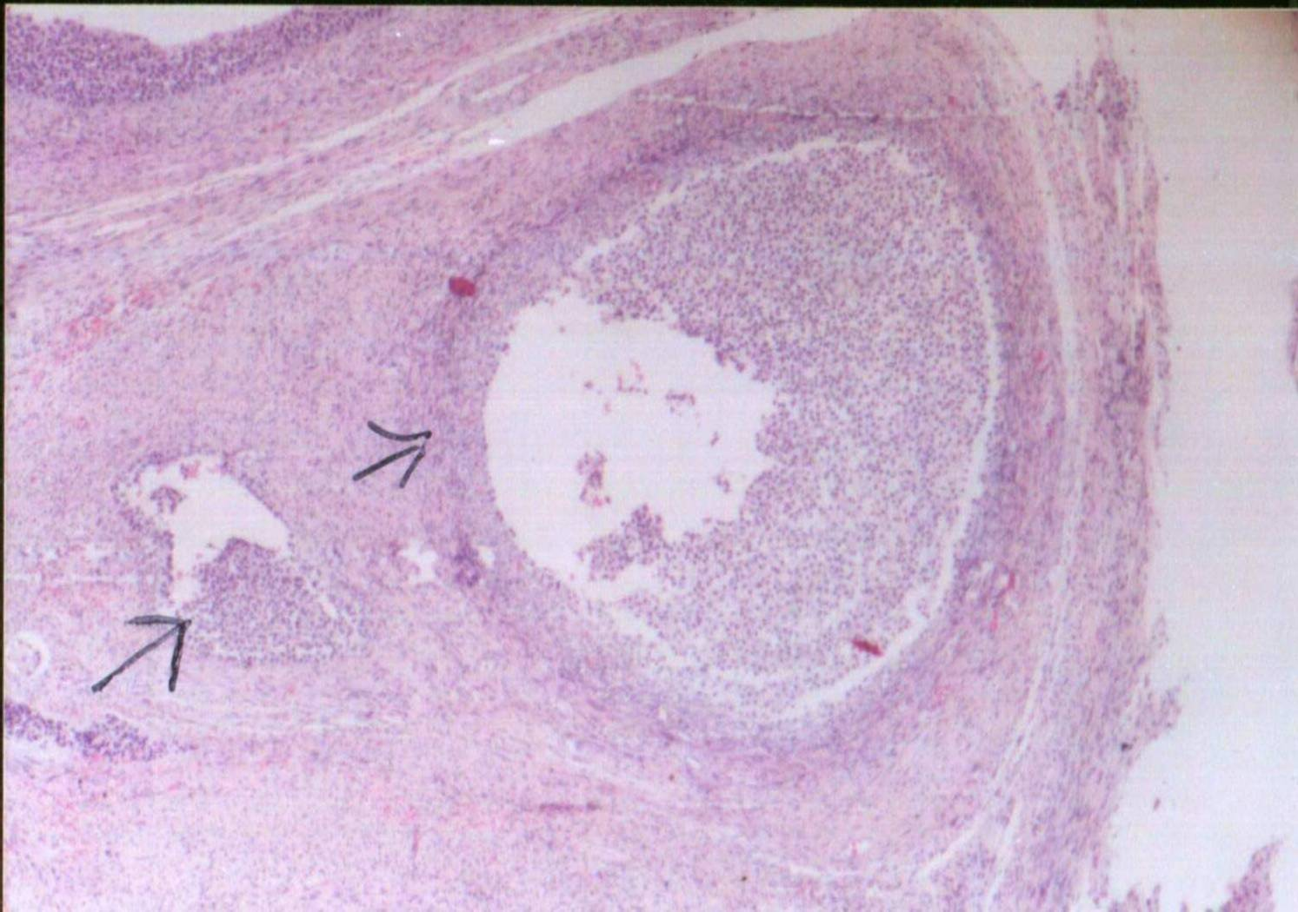
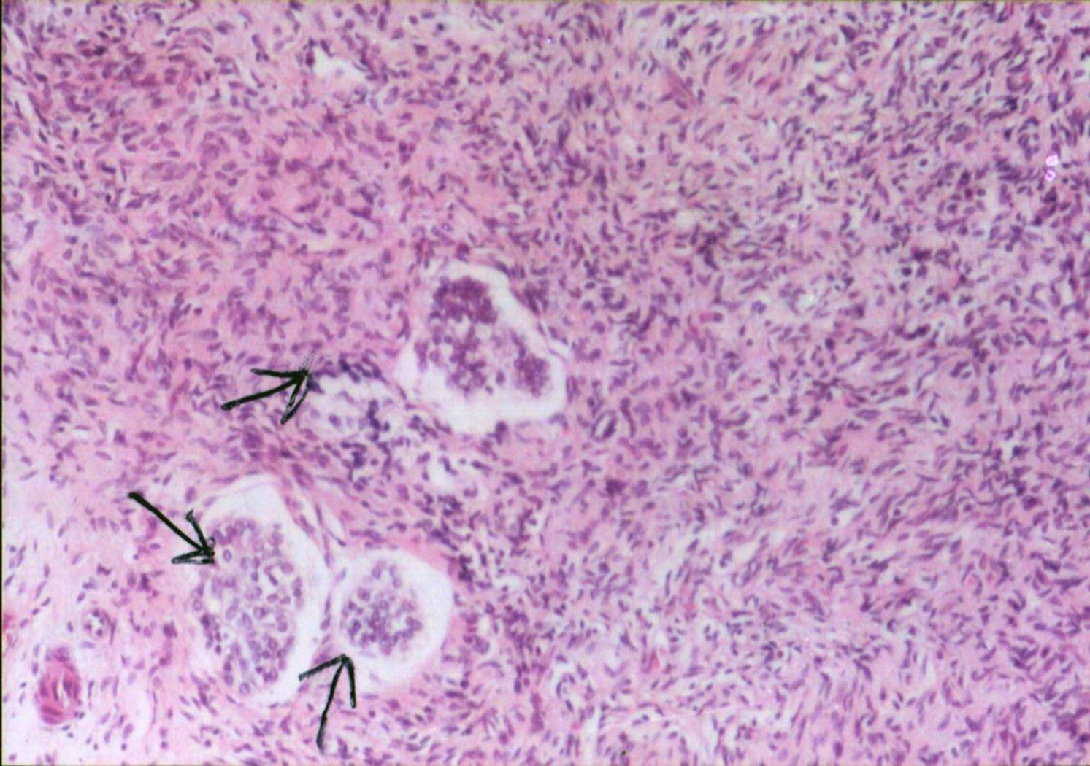
إضافة أى من البريمالاك أو البيوجين بمستوى 2جم/كجم عليقة كان مناسباً لتحفيز النمو وزيادة الاستجابة المناعية لإصبعيات البلطى النيلى ومع ذلك فقد تفوق البيوجين مقارنة
Plate 3. Cross section in the left ovary of she-camel during autumn showing a growing follicle
( Stained by H & E x 40).
Plate 4. Cross section in the cortex of left ovary of she-camel during summer primordial follicles
( Stained by H & E x 40).

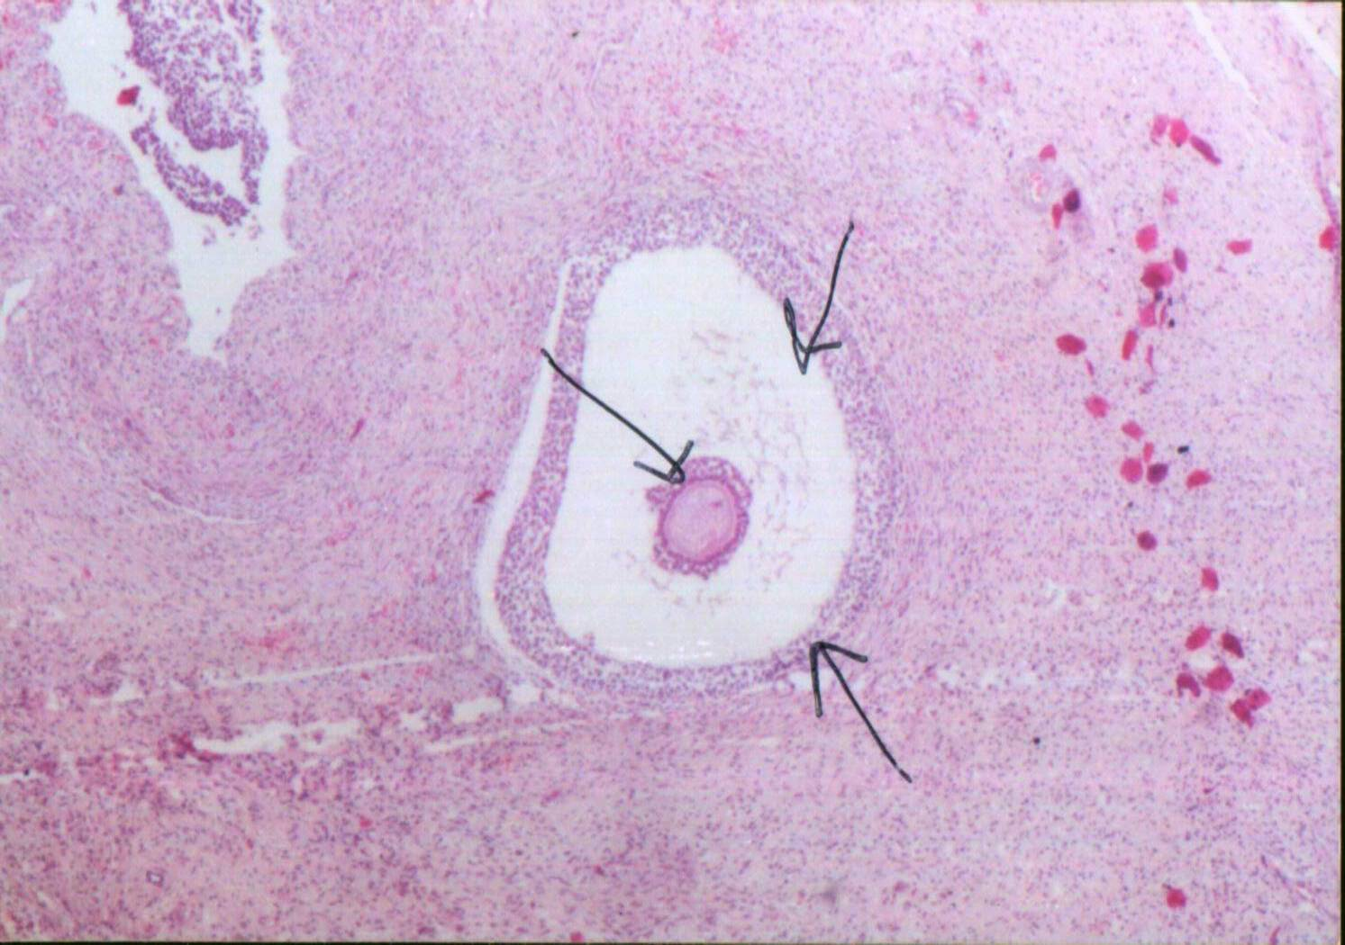
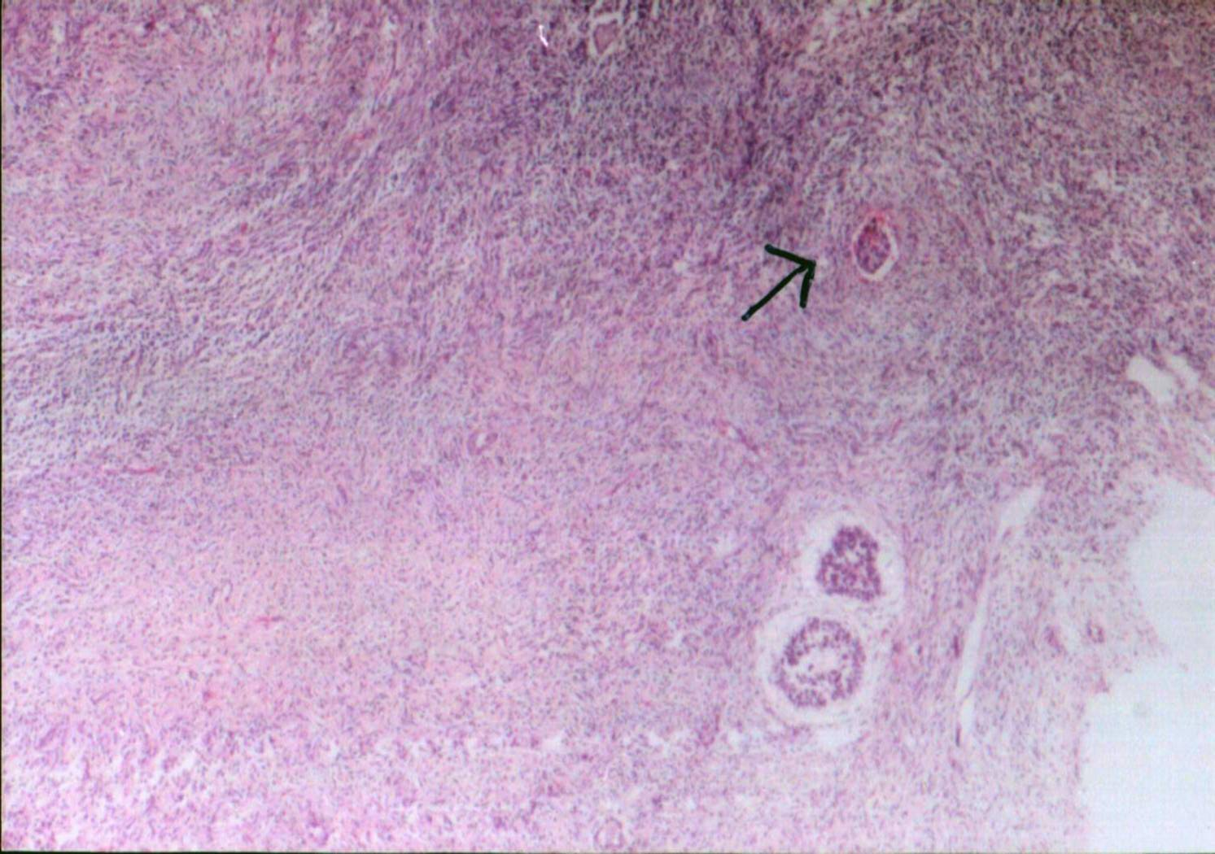
Plate 5. Cross section in right ovary of she-camel during winter showing degenerated follicles ( Stained by H & E x 40).
Plate 6. Cross section in right ovary of she-camel during spring showing secondary follicles (Stained by H & E x 40).
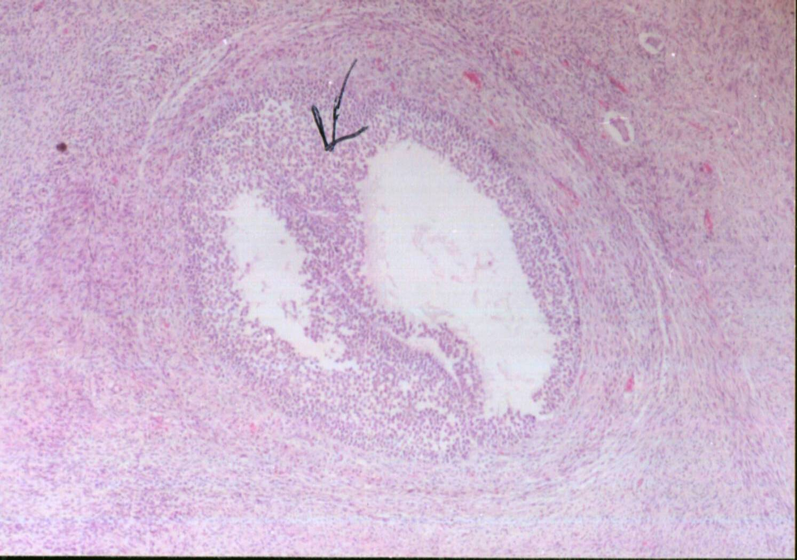
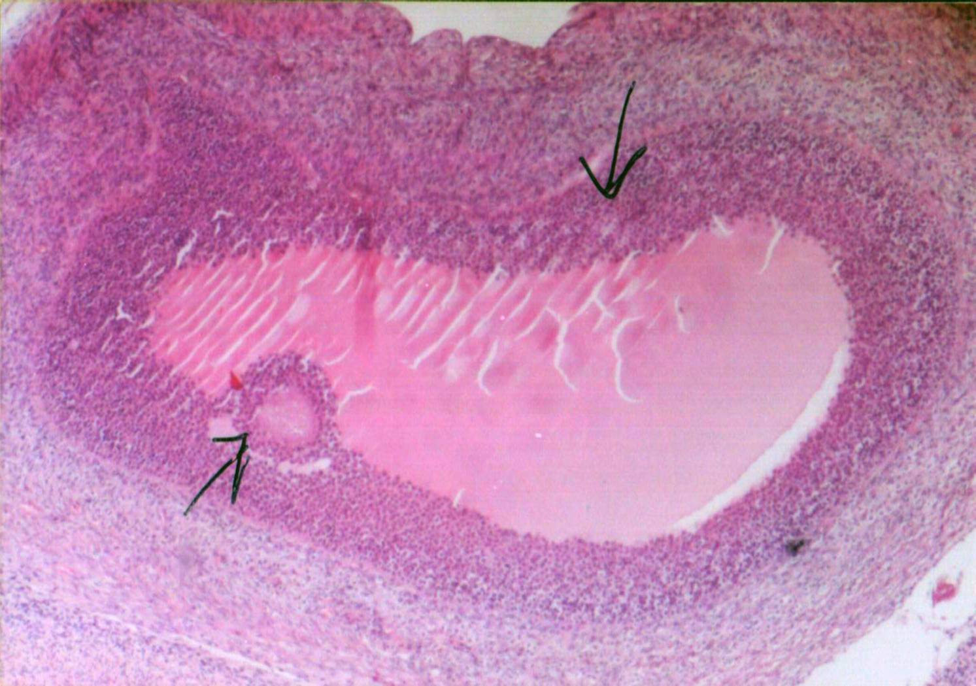
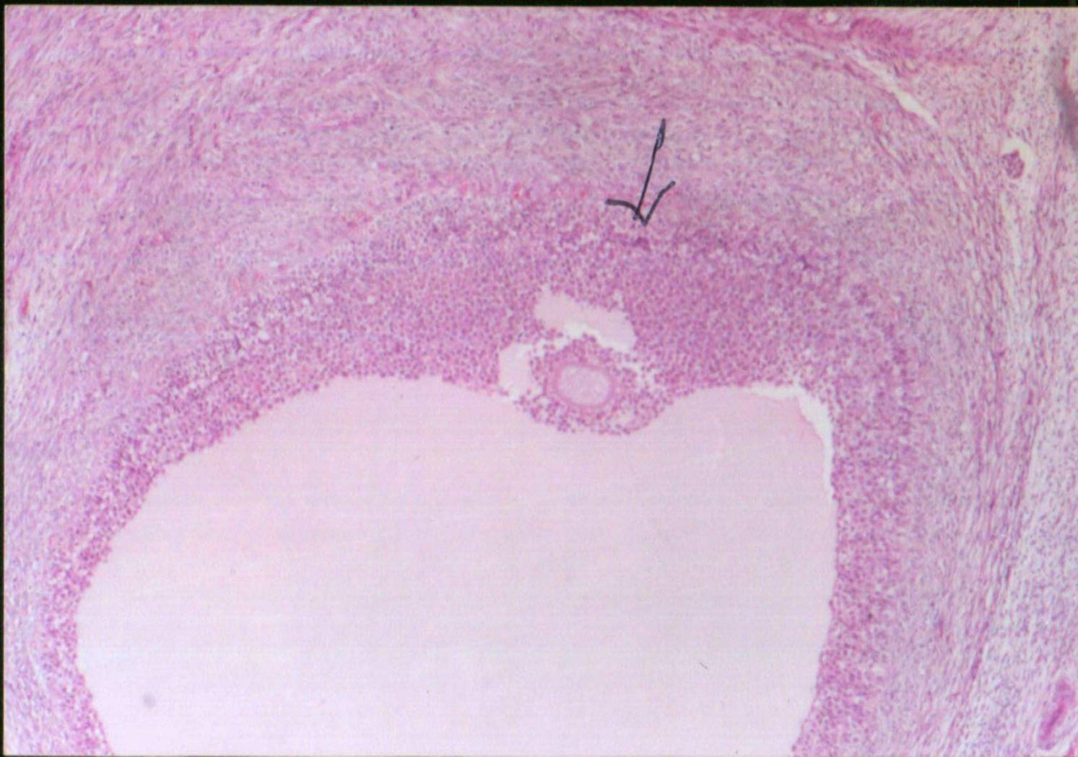
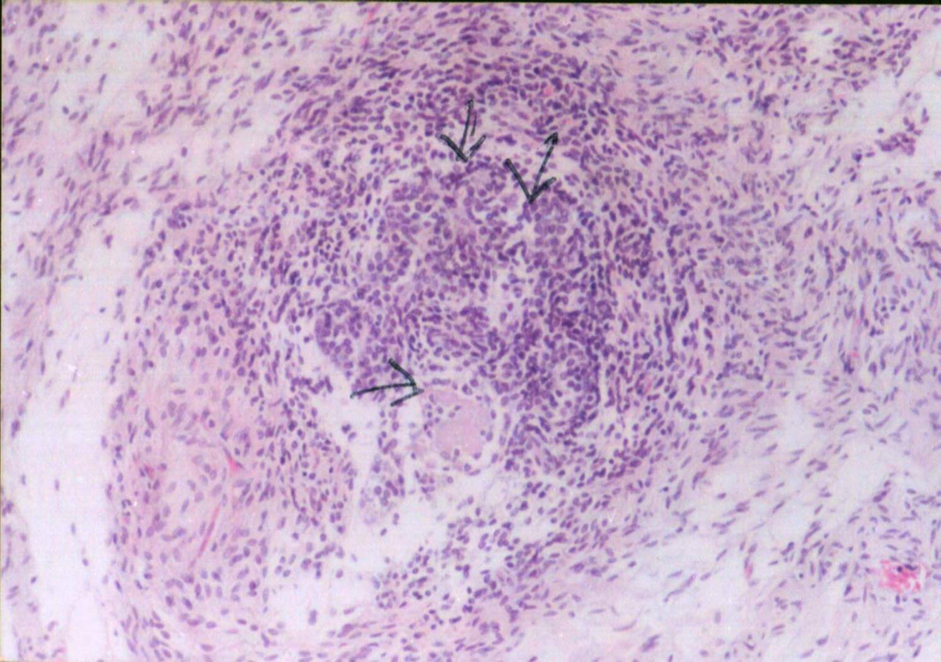
Plate 1. Cross section in the left ovary of she-camel during winter showing mature graffian follicles (Stained by H & E x 40).
Plate 2. Cross section in the left ovary of she-camel during spring showing growing follicles (Stained by H & E x 40).
Plate 7. Cross section in right ovary of she-camel during autumn showing mature follicles (Stained by H & E x 40).

Plate 8. Cross section in right ovary of she-camel during summer showing primordial follicles (Stained by H & E x 40).
- بالبريمالاك.

