Design and Simulation of a New Bevel Multi-Speed Gearbox for Automatic Gearboxes

M.Yaghoubi*; S.S. Mohtasebi; R. Alimardani; E. Mahmoodi
Department of Agricultural Machinery, Faculty of Engineering and Technology, University of Tehran, Karaj, Iran

*Corresponding author e-mail: yaghoub@ut.ac.ir

ABSTRACT

In this paper, a new mechanism was developed as a gearbox for power transmission between concentric shafts. With this approach, reduction ratios range from 10:1 to 200:1 for single-stage reducers, and also ratios of millions to one are possible for single-stage. The mechanism consists of one drive shaft and one driven shaft, conical gears which one of them is fixed and the others are driven. In this mechanism, with attention to the type of design, despite very small occupied space, by combination several ratios bevel gear can use as a gearbox. We first present the kinematics diagrams and then the equations of motion. Simulation results using Visual Nastran, Autodesk Inventor Dynamic, and COSMOS Motion software with three different input rotational speeds showed that this mechanism can have high reduction ratio. Finally, tension analysis of the mechanism using ANSYS workbench software showed that the highest tension occurred in the pinion gear No. 2.

Keywords: Kinematics diagram, reduced velocity, Visual Nastran, power transmission, gears.

Nomenclature
Axial forces in gears 1, 2, 3 and 4. | F_{a1}, F_{a2}, F_{a3}, F_{a4}
Radial forces in gears 1, 2, 3 and 4. | F_{r1}, F_{r2}, F_{r3}, F_{r3}
Tangential forces in gears 1, 2, 3 and 4. | F_{u1}, F_{u2}, F_{u3}, F_{u4}
Pitch conics of gears 2 and 3. | L₂, L₃
Number of gear branches. | n₃
Input power | P₁
Radius of gears 1, 2, 3 and 4. | R₁, R₂, R₃, R₄
Outer radius of gears 2, 3 and 4. | R_{2out}, R_{3out}, R_{4out}
Axial torque in input and output shafts respectively. | T_{a1}, T_{a2}
Occupied space of mechanism. | V
Linear velocity of center of gear No. 3. | v₃
Tangential velocity of gear No. 3 as rotating about itself. | v_{t2}
Linear velocity of pitch circles of gear 2 and 4. | v_{g2}, v_{g4}
Resultant of transitional and tangential velocity in gear No. 3. | v_{t3}
Pressure angle. | γ
Pitch cone angle of gears No 1 and 2. | δ₁, δ₂
Input shaft angular velocity. | ω_{in}
Angular velocity of gear 2 or 3. | ω₂
Angular velocity of output shaft or gear No. 4. | ω_{out}

- INTRODUCTION

In power transmission systems of the most automobiles, various types of mechanisms are used to reduce the input velocity to required value. The gear combinations are mainly used as gearbox in all automobiles. Because some gearboxes take up much space, they can not be used for small space. Planetary gearboxes have lower occupied space and more reduction velocity than the others [Bennett, 1979; Hojjati, 2000; Makevet et al, 2001; Martin, 1969]. As we all know, in gears systems to have more torque ratio, gears radius must be chosen larger or the number of gears must be increased. Therefore, because it takes up much space and also because of using ring gears in planetary gearboxes, these mechanisms have much production cost (Fig. 1) [Shirkhorshidian, 2004; Martin, 1969]. One of the other gearbox is worm gear which has much more reduction velocity ratio. It is also used in power transmission of some helicopters. But because of its much depreciation, for increasing its efficiency, hydrostatic lubrication is commonly used (Fig. 2) [Michael, 1987; Samuel, 1988; Samuel, 1975; Seth, 1986]. Another mechanism consists of a big sun gear and a ring gear which has high reduction ratio. But because of its sun gear off center, it produces slight pulsations in output [Oberto et al, 2000; Wright, 1993; Reimpel et al, 2002; Cantor, 2008]. Proposed mechanism consists of some conical gears that have smaller cost with respect to ring gears and it has high-ratio speed reduction in compact trains with concentric input and output shafts. Combining of some pinions with different ratios in the mechanism, it can be used as a multi-speed gear box.
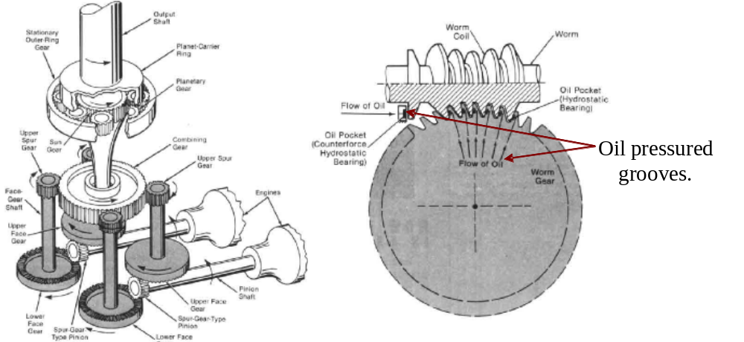
Fig. 2. Worn gear reducer with a hydrostatic lubrication.
Fig. 1. Steps of reducing velocity in a helicopter

2. MATERIALS AND METHODS

The proposed mechanism consists of 8 conical gears. Two of them are horizontal, one of them (gear No. 1) is fixed and the other one with more teeth is a driven gear (gear No. 4) that is connected to the output shaft. Input shaft is connected to the drive shaft. The pinion gears (gears 2 and 3) are connected to it by bearings. The two pinions are locked together and this is the basis of this principle in reducer speed. (Fig. 3) as explained later.
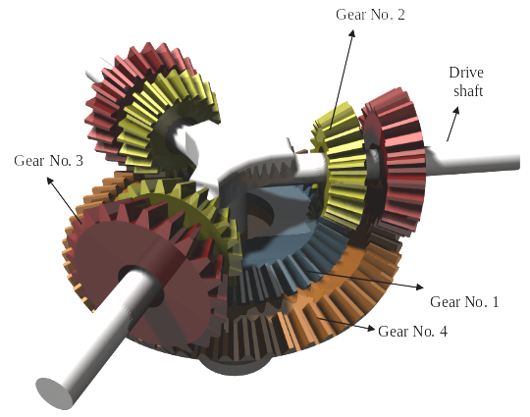
Fig. 3. A simple perspective diagram of the proposed mechanism
2. 1. Design and theory of mechanism
Objects have usually two types of velocity as linear and angular [Shirkhorshidian, 2004]. Total velocity is the resultant of the two velocities. As shown in Fig. 4, if L₂ and L₃ that are pitch cones of pinion gears are not homologous, each of them have different angular speed during rotation (The gear No. 1 is fixed and engages gear No. 2 and gear No. 4 is connected to output shaft and engages gear No. 3). As rotating of input shaft, the gear No. 2 has ω₂ angular speed, since the gears No. 2 and 3 are locked ω₂ is transferred to gear 3 and now gear No. 3 has two velocities. One of them is linear velocity resultant of being connected to drive shaft and the other one is tangential velocity (v_{t2}) resultant of ω₂. The resultant of these velocities is transferred to gear 4 (Fig. 5).
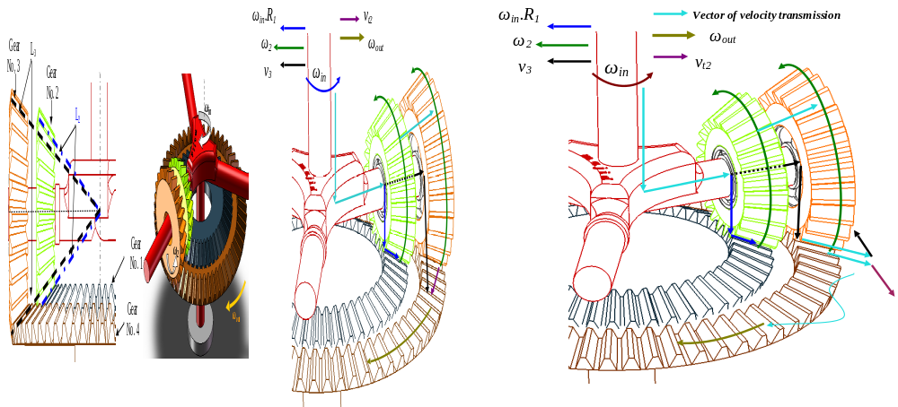
Fig. 4. A schematic of preliminary design of mechanism
Fig. 5. Transferring of motion to gear 4

2. 1. Kinematics analysis of the mechanism
From Fig. 6, kinematics equations of mechanism are following as:
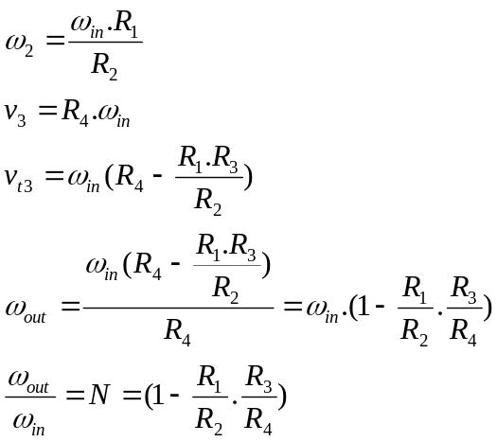
(1)
(2)
(3)

(4)
(5)

Considering the equation 5, if R₁, R₂ and R₄ are kept constant to limit space, designing any dimension R₂ can be achieved to desired speed. If N>0, the rotation direction of input and output shafts is the same and if N<0 rotation direction of them is in reverse to each other.

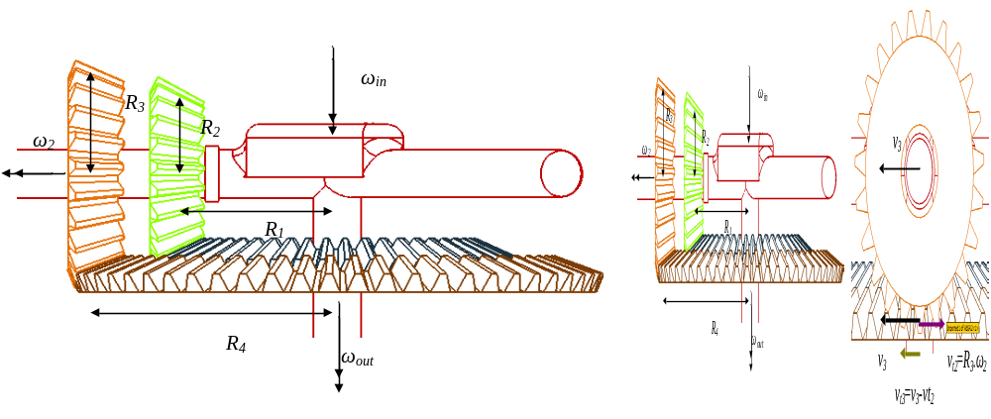
Fig. 6. Diagrams of dimensions and kinematics relations of the mechanism
2. 2. Dynamic analysis of the mechanism
Fig. 7 shows a schematic of whole mechanism and its main coordinate system. Due to mechanism symmetry, dynamic analysis carried out just on one drive shaft. From Fig. 8 and equations of straight teeth conical gears [Hojjati, 2000], equations of motion are obtained as follows:
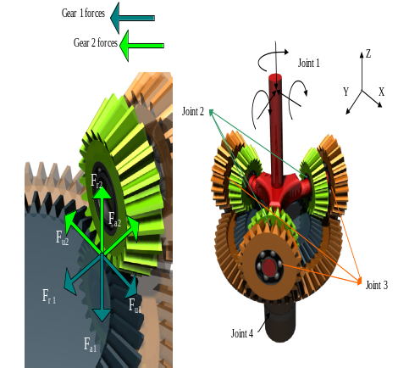
Fig. 7. Perspective view of mechanism with its joints and main coordinate system

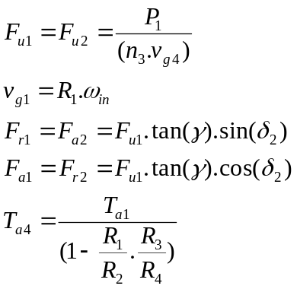
(6)
(7)
(8)
(9)
(10)

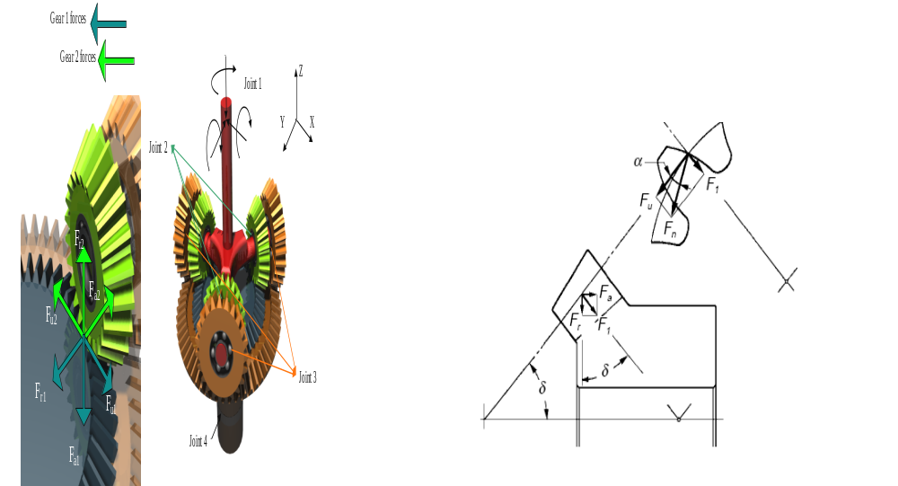
γ
Fig. 8. Force components in axial, tangential and radial
directions of gears No. 1 and 2.
Considering the work and energy law, powers of input and output shaft are equal. Then the above equations can be used for gears 3 and 4 as follows:
(11)
(12)
(13)
(14)
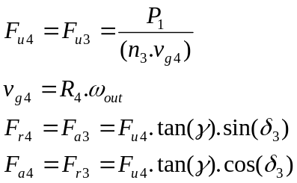
2.3. The space (volume) occupied by the mechanism
During rotation, the mechanism occupies a constant space which is equal to the value obtained from equations 15 and 16 (Fig. 9).
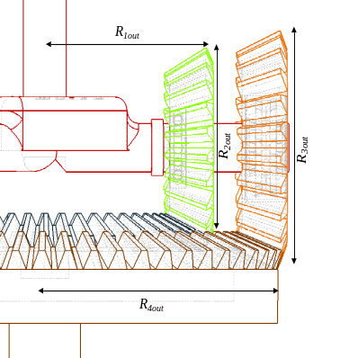
Fig. 9. The parameters for calculation of space occupied by the mechanism

If N>0(same rotation direction), equation is
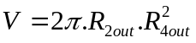
(15)
And if N<0(reverse rotation direction), space occupied is obtained as follows:
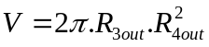
(16)
As shown in equations 15 and 16 to reach any speed ratio, R₁ and R₃ must be changed respectively. Thus, for any N, since the R_{2out}, R_{3out} and R_{4out} are constant, by changing R₁ in equation 16 and R₃ in equation 15, the occupied space remains constant. But always -1≤N≤1 for |N|>1 or increase at speed, a different configuration showed in Fig. 10 must be used.
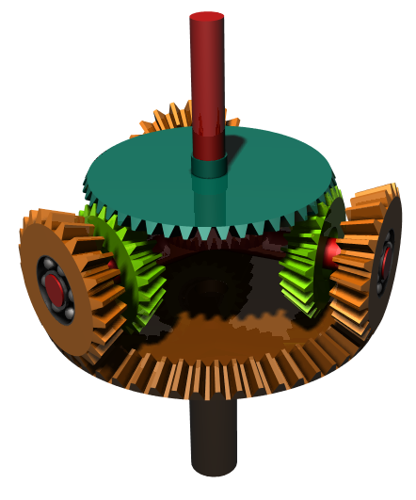
Fig. 10. New configuration for speed reducer
2.4 The generalized mechanism
By changing the mechanism configuration and combining several different ratio pinions and coupling that with a magnetic or hydraulic clutch a new multi-speed gearbox can be achieved, as showed in Fig. 11. One of the remarkable advantages of this gearbox is concentricity of the input and output shafts for compact power trains. For example: if the gearbox is used in a automobiles, by changing ratio of one pair of the pinions, reversed direction (N<0) in a direct power train line will be achieved for backward moves of the automobile. By a configuration that its diagram is shown in Fig. 11 four ratios between input and output shafts were obtained. It is also notable that by connecting pinions No.2 together more ratios can be achieved.
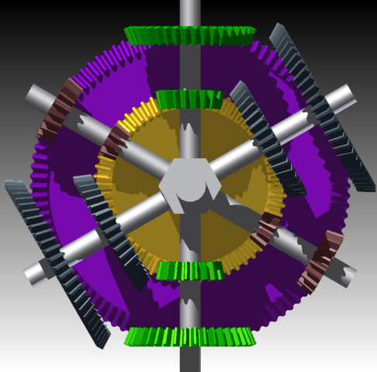
Gears No. 2
Fig 11. A multi-speed gearbox is obtained from a new configuration
3. RESULTS AND DISCUSSION

With respects to equation (5), if R₁.R₃=R₂.R₄ that lead to N=0, with every input angular speeds, the output has nothing to delivery. Thus, with precise designing and manufacturing, this mechanism is able to have infinite reduction speed ratio. Also with calculating axial and radial loads from equations 6, 8, 9, 11 and 13 designers will be able to select suitable bearings on gear No. 2, 3 and 4 which will be capable of tolerating the loads from catalogs in their spatial designs.
3. 1. Simulation and results
The greatest advantage of this reducer is its small space occupied. Just by changing R₃ or R₁ in preliminary design, a desired speed can be achieved. Simulations were carried out using powerful software COSMOS Motion, Autodesk Inventor and Visual Nastran. Fig. 12 shows simulation results. The simulations in Fig. 12 are (a) with ratio of 1/10000 by Visual Nastran, in Fig. 12-b with ratio of 1/1000 by Autodesk Inventor and in Fig. 12-c with ratio of 1/3600 by COSMOS motion. Also, with have precise attentions to Fig. 12, it is clear which the claims on this research have been confirmed. In Fig. 12-a and 12-c from Visual Nastran and COSMOS motion software respectively, the input and output have been printed separately but in Fig. 12-b from Autodesk Inventor, the input and output have been printed on one sheet to have better comparison. As can be seen, the results of all software simulations have been approved the research claims and the outputs have been changed to desired speed as expected.

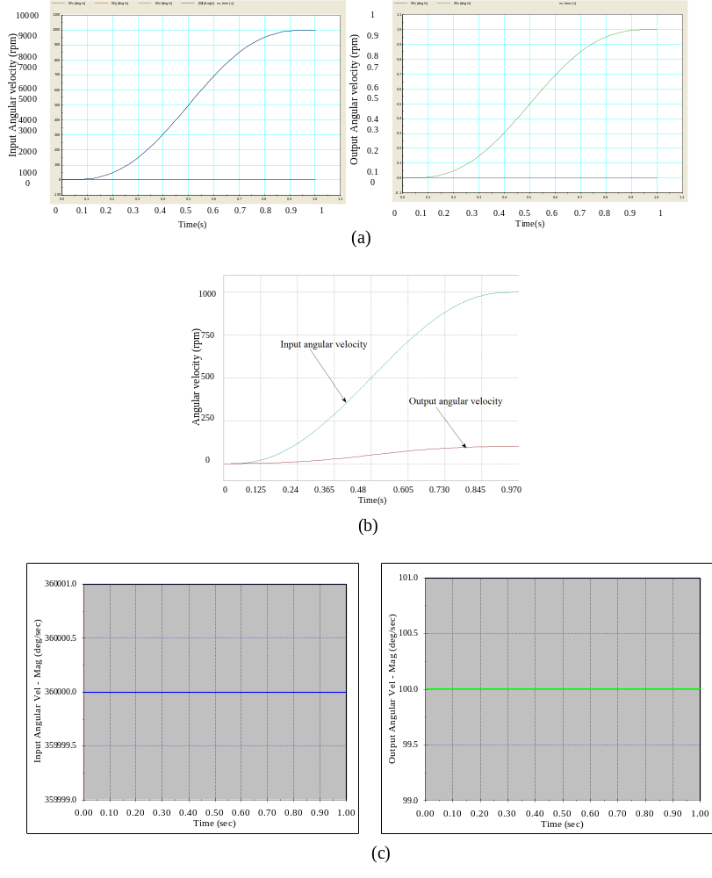
Fig. 12. (a): Speed ratio 1/10000 by Visual Nastran. (b): Speed ratio 1/1000 by Autodesk Inventor (c): Speed ratio 1/3600 by COSMOS motion

3. 2. Finite element analysis
The mechanism was analyzed using ANSYS Workbench software that the results of simulation have been shown in Fig. 13. The simulation results revealed that the maximum tension occurs in the gear No. 2 as shown in Fig. 13.Thus for transmission of more power, designers must have spatial and more attention and focus on gear No. 2 than the other components in this mechanism to have a safe and low maintenance cost power transmission.

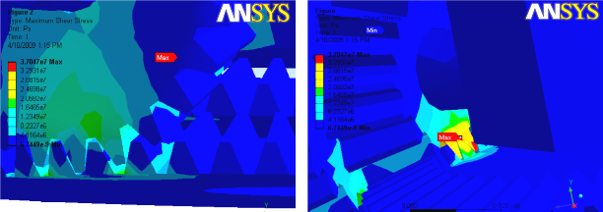
Fig. 13. Tension in all the parts of the mechanism by ANSYS Workbench software

4. CONCLUTIONS

- The proposed mechanism, in preliminary design with R₃/R₂ ratio can be used as reducing or increasing speed, same or reverse direction in compact trains and might be useful in other applications in which weight is critical.
- In power transmissions which very high reduction speed in a direct power train (concentricity of input and output shafts) is needed, the proficiencies of this mechanism can be realized very well.
- Dynamic analyses using engineering software were illustrated that only changing R₃ or R₁ value is necessary to obtain every speed ratios.
- Using ANSYS software, the maximum stress occurred in the gear No. 2. Thus, this part must be manufactured of the strengthen materials in a higher engineering production line that the other parts.
- Generalizing this mechanism, including combining several different ratio pinions and coupling with a magnetic or hydraulic clutch, leads to produce a new multi-speed gearbox that is very cheaper than planetary gears.

5. REFERENCES

Bennett. W. 1979. Vehicle final drive assembly. United State Patent. Patent NO 4,132,134
Cantor.B. Grant. P. Lohnston.C.2008. Automotive Engineering.New York: Taylor & Francis.
Hojjati. H. 2000. Design of Machine. University of Mazandaran publication
Makevet. E, Roman. I. 2001. Failure analysis of a final drive transmission in off-road vehicles. Engineering Failure Analysis
Martin, G.H. 1969. Kinematics and Dynamics of Machines, McGraw-Hill
Michael. E. 1987. Multistage planetary final drive mechanism. United State Patent. Patent NO 4, 662. 246
Oberto.O. Parmley.P.E.2000. Mechanical Components. McGraw Hill.
Reimpel.J. Stoll.H. Betzler.W.2002.The Automotive Chassis Engineering Principles.Society of Automotive Engineers.
Samuel. B. 1988. Final drives with load separating means. United State Patent. Patent NO 4,739, 852.
Samuel. I. 1975. Final drives mechanism for a vehicle. United State Patent. patent NO 3, 924, 485.
Seth. C. 1986. Planetary final drive mechanism. United State Patent. Patent NO 4, 574, 658.
Shirkhorshidian. A. 2004. Design of mechanisms for designer and machine makers. Nashretarrah publication (in Persian)
Wright. D. H. 1993. Testing automotive materials and component. Society of Automotive Engineers; 152:139-40.

