PLANT REGENERATION THROUGH IN VITRO SOMATIC EMBRYOGENESIS IN ASHWAGANDHA (Withania somnifera L. Dunal)
*Madan Mohan Sharma, Deevan Julfiquar Ali and Amla Batra

Corresponding author*:

Dr. *Madan Mohan Sharma

Research Associate
Lab. no. 5
Department of Botany
University of Rajasthan, Jaipur (Raj.)- India
Email: drmadansharma@gmail.com
Mob.: +91- 09887352966
Dr. Devan Julfiquar ali
Associate Professor
Surech Gyan Vihar University
Jagatpura, Jaipur (Raj.)- India

Prof. Amla Batra
Emeritus Professor
Lab. no. 5
Department of Botany
University of Rajasthan, Jaipur (Raj.)- India
E-mail: amlabatra@gmail.com
Mob.: +91-09829068425

PLANT REGENERATION THROUGH IN VITRO SOMATIC EMBRYOGENESIS IN ASHWAGANDHA (Withania somnifera L. Dunal)

ABSTRACT
Somatic embryogenesis and plantlet regeneration from leaf explants of Indian ginseng (Withania somnifera L. Dunal), a medicinally potent plant species is reported. Embryogenic callus was obtained from leaf explants on Murashige and Skoog medium supplemented with 2, 4-dichlorophenoxy acetic acid (0.5-5.0 mg l⁻¹) and N⁶-benzylaminopurine (0.5-5.0 mg l⁻¹⁾. High frequency of somatic embryo mass induction (10.89 ± 0.78) was noticed on 2, 4-D (0.5 mg l⁻¹), BAP (1.0 mg l⁻¹) along with casein hydrolysate (10.0 mg l⁻¹). This nodulated callus upon regular subculturing on the same medium and hormonal regime showed various typical stages of embryo development i.e. heart shaped, torpedo shaped and cotyledonary stages culminating into germination and maturity. Well-developed cotyledonary stage embryos were germinated on MS medium fortified with BAP (0.5 mg l⁻¹). Highest percentage of somatic embryo formed shoots on MS medium augmented with BAP (0.5 mg l⁻¹), but they did not show germination on MS medium without plant growth regulators. The shoots raised from somatic embryos were rooted on MS medium supplemented with indole-3- butyric acid (1.0 mg l⁻¹). The survival rate after transplantation of plantlets was 55%. Plants produced were morphologically similar to mother plants. The present protocol is an important path for genetic transformation studies in Withania somnifera.

Key words: Somatic embryogenesis, embryogenic callus, leaf explants, Withania somnifera etc.

Abbreviation: N⁶-benzylaminopurine (BAP); 2, 4-dichlorophenoxy acetic acid (2, 4-D); indole-3- butyric acid (IBA); indole-3- acetic acid (IAA), α - naphthalene acetic acid (NAA)
INTRODUCTION

Somatic embryogenesis offers an alternative and efficient protocol for plant regeneration. The technique of somatic embryogenesis has also contributed information for the genetic, morphological and physiological manipulation.
Withania somnifera L.(Dunal) commonly known as Ashwagandha belongs to the family Solanaceae, having enormous medicinal and aromatic properties and has been included in ancient text of Ayurveda. It is useful as an abortifacient, amoebocide, anodyne, bactericide, contraceptive, diuretic and spasmolytic (Kurup 1956; Asthana and Raina 1989). Biological assays label the plant as having the properties against different diseases e.g. leprosy, nervous disorders, diseases of respiratory and reproductory tract, venereal disorders, rheumatism, inflammation, psoriosis, bronchitis, asthma, consumption, ulcers, scabies, marasmus of children, insomnia, senile debility, alexipharmic, carbuncles, cancer, epilepsy, diabetes etc. (Asthana and Raina 1989; Tripathy et al 1996; Kirtikar and Basu 2001).
There are a number of reports regarding in vitro regeneration of Withania somnifera L. Dunal by using various explants such as shoot tips (Sen and Sharma 1991), nodal segments (Tiwari and Singh 1991; Kulkarni et al 2000), axillary meristems (Roja et al 1991), axillary shoots, and hypocotyls and root segments (Rani and Grover 1999). Besides, somatic embryogenesis is a preferred method for quick in vitro multiplication of plants and also for production of synthetic or artificial seeds (Bapat 1993). Since, there is no effective report on somatic embryogenesis in Withania somnifera. In the present research endeavour, an attempt was made to develop protocol for complete plantlet regeneration through somatic embryogenesis using leaf explants.

MATERIAL AND METHODS

Plant material

The plants of Withania somnifera L. (Dunal) grown in botanical garden, University of Rajasthan, Jaipur were used as an experimental material. The explants obtained from various sources viz., leaf and internodal segments, were used for callus induction. Explants were procured from four to five month’s old-field grown plants. The size of leaves and internodal segments was 1.0-1.5 cm. in width and 0.5-1.5 cm. in length, respectively.
Surface sterilization

Harvested leaves and internodal segments were kept under running tap water for about fifteen min., treated with labolene (1.0%; v/v) for 5-7 min. then rinsed with sterile double distilled water. Prior to inoculation, these explants were subsequently surface sterilized in the laminar airflow cabinet with 0.1% (w/v) aqueous mercuric chloride solution for 3-5 min. followed by 3-4 rinses in sterile distilled water.

Culture media

The surface sterilized explants were then aseptically inoculated on sterile medium consisting of salts and vitamins of Murashige and Skoog (1962) medium, B₅ and MSB₅ medium. Commercial grade sucrose, maltose and glucose (1.0-6.0%) were used as sole carbon source separately. The medium was gelled with 0.8% agar (Qualigens). Phytohormones like auxin (IAA, IBA, NAA, 2,4-D; 0.5-5.0 mg/l) and cytokinins (BAP and Kn; 0.5-5.0 mg/l) alone or in combinations along with additives (casein hydrolysate, KNo₃, glutamine etc.) were supplimented into the medium. The pH of the medium in all cases was adjusted to 5.8 before autoclaving at a pressure 1.06 kg/cm³.

Culture conditions

The cultures were incubated at 25±2°C temperature under cool, white fluorescent light (2000-3000 lux) and 55±5% relative humidity. 16/8 photo and dark period were maintained in growth chamber, respectively. 28 cultures were raised for each treatment and all experiments were repeated at least thrice. Data on embryogenic callus induction, multiple shoot stimulation and rooting were statistically analyzed and then mean was compared at the t _{0.05} level of significance. Observations were recorded periodically.

Induction of somatic embryos

Embryogenic callus induction was optimum with leaf explants on a combination of lower concentrations of 2,4-D and BAP.
Proliferation of somatic embryos

Stock callus maintained after subculturing on MS medium with 2, 4-D and BAP got converted into yellowish green nodulated callus. Further, after 5-6 weeks of subculturing of this nodulated callus on the manipulated MS medium fortified with 2, 4-D, BAP and casein hydrolysate, proliferated and passed through all the typical stages of embryo development. These stages were clearly observed in anatomical study of this embryogenic calli. Mature somatic embryos were then transferred to MS medium supplemented with BAP only for shoot induction and further development. The Shoots emerged from somatic embryos were then transferred to rooting medium (MS+IAA/IBA/2, 4-D/NAA alone) and then allowed to mature.

Hardening, acclimatization and transfer of plantlets to field

The plantlets developed in vitro were taken out from the rooting medium and washed thoroughly but delicately to remove adhering agar. The plantlets were then transferred to pots containing a mixture of vermicompost and sterilized soil (1:3), and then these pots were incubated in growth chamber for their hardening and acclimatization for about 2-3 weeks. Potted plants were covered with inverted glass beakers to ensure high humidity and watered every day, while with few drops of half strength of MS salt solution twice a week. After 2-3 weeks, inverted glass beakers were removed in order to acclimatize plants to field conditions. Plants were then transferred to earthen pots containing garden soil and watered with tap water.

RESULTS AND DISCUSSION
During the experimental setup, somatic embryos were stimulated from calli derived from in vivo leaf explants. However, the calli obtained through the culture of internodal segments did not show any significant results of somatic embryos. Embryogenic callus differed morphologically from non-embryogenic callus and was often covered with shiny globular structure, which simultaneously became enlarged to a detectable size.
Callus initiation was observed after 15-20 days of culture from the cut ends of leaves, which probably allows more absorption of nutrients leading to rapid cell division and subsequent callus formation. Unwhorling of the leaves observed along with swelling of explants after 5-7 days of culturing, may be due to rapid cell elongation primarily caused by 2, 4-D (0.5 mg l⁻¹).
However, 2,4-D (0.5 mg l⁻¹) was found to be optimum for obtaining high frequency of nodulated callus (Tabel-1). Further, other auxins viz., IAA, IBA and NAA did not evoke any significant responses (data not shown). Hence, 2,4-D (0.5 mg l⁻¹) was further tried in combination with different concentrations of BAP/Kn. Furthermore, embryogenic callus was formed on MS medium containing 2,4-D (0.5 mg/l) along with BAP (1.0 mg l⁻¹) after 2 weeks of subculture (Fig. 1 A, Tabel-1).
Reports of earlier scientists (Gill et al 2004; Kumari Jayashree and Thulaseedharan 2005; Choudhary et al 2009) on somatic embryogenesis in a diverse group of plants viz., Hevea ,Saccharum officinarum L. and Vigna aconitifolia (Jacq.) Marechal. etc. on the same hormonal regime (2,4-D and BAP)supported the results obtained by the author. In contrast to the above results, NAA in combination with BAP have been found beneficial for the induction of somatic embryos in different plant species i.e. Pinus tadea, Pinellia tripartite, Gossipium hirsutum, Solanum melongena etc. (Pullman et al 2005; Kim et al 2005, Khan et al 2008).
Further, embryogenic callus upon regular subculturing on the same medium and hormonal regime along with caseine hydrolysate (10.0 mg l⁻¹) passed through various stages of embryo development culminating in to maturation of embryos and leading to germination after three weeks of incubation. The promotory effect of caseine hydrolysate on maturation of somatic embryos was also reported by earlier workers in a number of plant species (Mohan and Krishnamurthy 2002, Kumari Jayashree and Thulaseedharan 2005). However, in contrast to above results, influence of gibberellic acid and paclobutrazol on induction and maturation of somatic embryos in wild type Centaurium erythraea Gillib. has been studied (Suboti et al 2009). Emergence of shoots from the mature embryos failed in single step. For this purpose, somatic embryos were subcultured on MS medium along with BAP (0.5 mg l⁻¹). After 4-5 weeks of subculture few shoot primordia (3-4) emerged (Fig. 1 B-C), which were dwarf in nature. However, BAP supported germination of shoots in a number of plant species e.g. Rosa indica, Cajanus cajan L., Saccharum officinarum L. etc. (Sarasan et al 2001; Dal and Guerra 2001; Gill et al 2004). In contrary to BAP, Kn proved satisfactory for the germination of embryos in Phyllanthus emblica L. and Hevea brasiliensis (Sebastian et al 2005). At the same time, Rani et al (2004) observed shoot regeneration on MS basal medium having BAP (1.0 mg l⁻¹) in combination with IAA (2.0 mg l⁻¹) in Withania somnifera L. (Dunal). However, embryo germination was also confirmed by taking microscopic photographs and the exposed view of the same (Fig. 2 A-B). The percentage response of embryos forming shoots and their length increased with increase in incubation period on the same media regime (Data not shown).
Individual tiny shoots were separated from the clump and transferred on MS basal medium containing 1.0 mg l⁻¹ IBA, about 70-75% cultures induced roots (Fig. 2 C). However, other auxins like NAA, IAA only induced root primordia, which was not suitable for plant survival (Data not shown). Similar results were also obtained in Vitex negundo L. (Sharma et al 2006), Withania somnifera L. (Rani et al 2004) and in Phyllanthus urinaria L. (Kalidass and Mohan, 2009). However, in oppugnance to this, Gill et al (2004) reported optimum rooting on NAA (0.5 mg l⁻¹) in Saccharum officinarum L. The plantlets regenerated through somatic embryos were taken out from culture vials, freed from agar and finally transferred to the field by the procedure mentioned in “Materials and Method” (Fig. 2 D). Plantlets have shown 55% survivability in natural environment.
The present study reveals a quick, reliable and reproducible protocol for in vitro clonal propagation of Withania somnifera L. through somatic embryogenesis. Which would enable plant scientists engaged in genetic transformation studies. Also protocol can be used for the conservation of germplasm.

Table-1. Effect of 2, 4-D alone and in combination with BAP on callus and somatic embryo induction in Withania somnifera L. (Dunal) from leaf explants

Plant Growth Regulators (mg l⁻¹ ) | Days taken for callus initiation | Nodulated callus having granular structure
2,4-D
0.5 | 15-20 | 8.2 ± 1.03
1.0 | 28 | 3.5 ± 1.08
2.0 | 25 | 3.2 ± 0.78
3.0-5.0 | 25 | NIL
2,4-D (0.5 mg l⁻¹) + BAP |  | Somatic embryos per  culture vessel
0.5 | 25-28 | 6.8 ± 0.14
1.0 | 15-18 | 10.89 ± 0.78
2.0 | 25 | 5.23 ± 0.23
3.0 | 28 | 4.50 ± 0.25
4.0 | 35 | 2.33 ± 0.12
5.0 | 35 | 0.12 ± 0.03

Values represent mean ± SE of 28 replicates per treatment in three repeated experiments.
Mean values within the column followed by the same letter are not significantly different by the Tukey’s test at 0.05% probability level.

LEGAND

FIGURE- 1

A-C: Somatic embryo induction and their germination in Withania somnifera L. (Dunal)
A: Callus induction from leaf explants on Murashige and Skoog (MS) medium with 0.5 mg l⁻¹ (2,4-D) and 1.0 mg l⁻¹ (BAP).
B: somatic embryo induction
C: Enlarged view of the same

FIGURE- 2

A-D: Further development of plantlets regenerated through somatic embryogenesis in Withania somnifera L. (Dunal)

A: Microscopic view of emerged shoot
B: Exposed view of germinated somatic embryo with shoot
C: Complete plantlet formation in in vitro conditions
D: Plantlet transferred to earthen pot

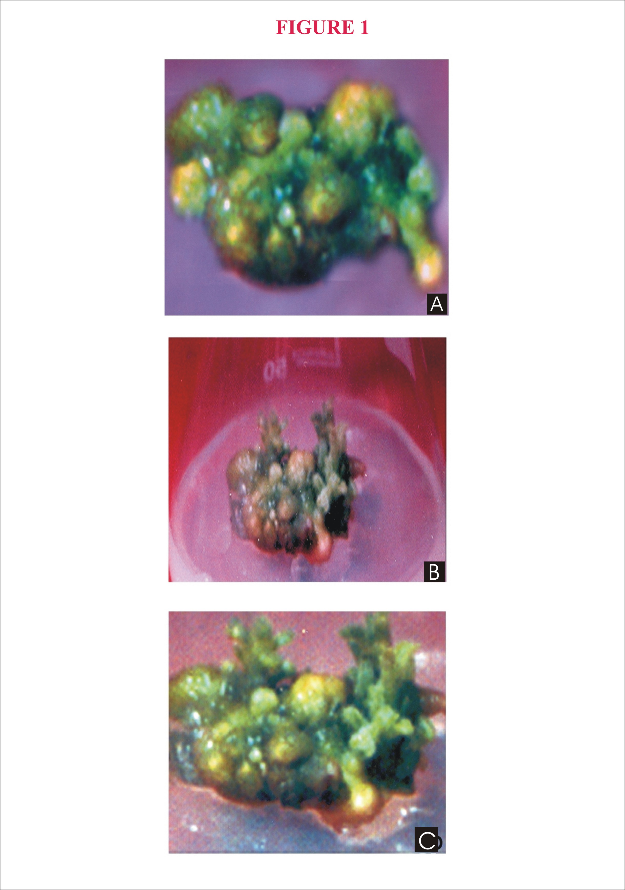
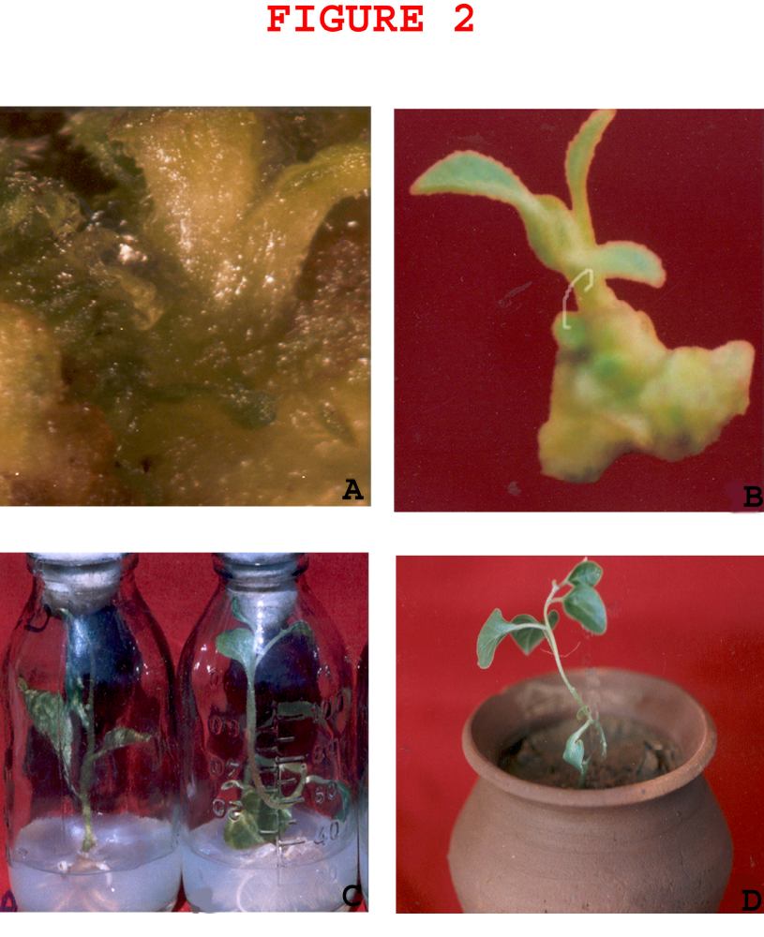
REFERENCES

- Asthana R, Raina MK. Pharmacology of Withania somnifera (Linn.) Dunal- A review. Indian Drugs 1989; 26: 199-05.
- Bapat V A. Studies on synthetic seeds of sandalwood (Santalum album L.) and mulberry (Morus indica L.). In: Redenbaugh K, ed. Synseeds: applications of synthetic seeds to crop improvement. CRC, Boca Raton, Fla, 1993: 381-07.
- Choudhary K, Singh M, Rathore M S, Shekhawa N S. Somatic embryogenesis and in vitro plant regeneration in moth bean [Vigna aconitifolia (Jacq.) Marechal]: a recalcitrant grain legume. Plant Biotechnology Report. 2009; 3: 205–11.
- Dal VLL, Guerra MP.. The effectiveness of nitrogen in feijoa somatic embryogenesis. Plant Cell Tissue and Organ Culture. 2001; 64: 19-25.
- Gill NK, Gill R, Gosal SS.. Factors enhancing somatic embryogenesis and plant regeneration in sugarcane (Saccharum officinarum L.). Indian Journal of Biotechnology. 2004; 3: 119-23.
- Kalidass C, Mohan VR. In vitro Rapid clonal propagation of Phyllanthus urinaria Linn. (Euphorbiaceae) A Medicinal Plant. Researcher. 2009; 1(4): 56-61.
- Khan H, Faisal M, Anis M. Plant regeneration via somatic embryogenesis in callus culture of Solanum melongena L. Phytomorphology. 2008; 58 (3&4): 153-57.
- Kim S, In D, Tae K, Liu J. Somatic embryogenesis and plant regeneration in leaf and petiole explant cultures and cell suspension cultures of Pinellia tripartite. Plant Cell Tissue and Organ Culture. 2005; 80 (3): 267-70.
- Kirtikar KR, Basu BD.. In: Basu LM, ed. Indian Medicinal Plants. Oriental Enterprises, Allahabad, India, vol. 8th. 2001: 2445-49.
- Kulkarni AA, Thengane SR, Krishnamurthy K V. Direct shoot regeneration from node, internode, hypocotyls and embryo explants of Withania somnifera. Plant Cell Tissue and Organ Culture. 2000; 62: 203-09.
- Kumari Jayasree P, Thulaseedharan A. In vitro germination of Hevea somatic embryos: effect of cytokinins. Plant Cell Biotechnology and Molecular Biology. 2005; 6 (1&2): 61-64.
- Kurup PA. Antibiotic principle of the leaves of Withania somnifera. Current Science. 1956; 25: 57-58.
- Mohan ML, Krishnamurthy KV. Somatic embryogenesis and plant regeneration in Pigeon pea. Biologia Plantarum. 2002; 45 (1): 19-25.
- Murashige T, and Skoog F. A revised medium for rapid growth and bioassays with tobacco tissue cultures. Physiology Plant. 1962; 15: 473-97.
- Pullman G, Johnson S, Tassel S, Zhang Y. Somatic embryogenesis in loblolly pine (Pinus taeda) and Douglas fir (Pseudotsuga menziesii): improving culture initiation and growth with MES pH buffer, biotin and folic acid. Plant Cell Tissue and Organ Culture. 2005; 80 (1): 91-03.
- Rani G, Grover IS. In vitro callus induction and regeneration studies in Withania somnifera. Plant Cell Tissue and Organ Culture. 1999; 57: 23-27.
- Rani G, Virk GS, Nagpal A. Somatic embryogenesis in Withania somnifera (L.) Dunal. Journal of Plant Biotechnology. 2004; 6 (2):113-18.
- Roja G, Heble MR, Sipahimalani AT. Tissue cultures of Withania somnifera: morphogenesis and withanolide synthesis. Phytotherapy Research. 1991; 5:185-87.
- Sarasan V, Roberts AV, Rout GR. Methyl laurate and 6-benzyladenine promote the germination of somatic embryos of hybrid rose. Plant Cell Report. 2001; 20: 183-86.
- Sebastian R, Karamthanan PV, Mathew MM. Somatic embryogenesis and plant regeneration in Phyllanthus emblica L. Plant Cell Biotechnology and Molecular Biology. 2005; 6 (3&4): 155-58.
- Sen J, Sharma AK. Micropropagation of Withania somnifera from germinating seeds and shoot tips. Plant Cell Tissue and Organ Culture.1991; 26: 71-73.
- Sharma MM, Jalootharia D, Khanna P, Batra A. An efficient in vitro mass propagation of a medicinally potent plant species Vitex negundo L. via nodal segments. Phytomorphology. 2006; 56 (1&2): 35-39.
- Suboti A, Jevremovi S, Trifunovi M, Petri M, Miloševi S, Grubiši D. The influence of gibberellic acid and paclobutrazol on induction of somatic embryogenesis in wild type and hairy root cultures of Centaurium erythraea Gillib. African Journal of Biotechnology. 2009; 8 (14): 3223-28.
- Tiwari SK, Singh SP. Micropropagation of Withania somnifera through tissue culture. Van Sand. 1991; 15: 19-20.
- Tripathy AK, Shukla YN, Kumar S. Ashwagandha [Withania somnifera Dunal (Solanaceae)]: A status report. Journal of Medicinal & Aromatic Plant Science. 1996; 18: 46-62.

Date of Submission: 13.02.2010



Dr. Madan Mohan Sharma

Research Associate
Lab. no. 5
Department of Botany
University of Rajasthan, Jaipur (Raj.)- India
Email: drmadansharma@gmail.com
Mob.: +91- 09887352966

