JOURANL OF AMERICAN SCIENCE

The Environmental Impact of Industrial Agriculture:

The Case of Mulindi Tea Plantations in Rwanda

JIWEN GE^{1,2} , MUPENZI JEAN DE LA PAIX¹*, GABRIEL HABIYAREMYE，JEAN DE DIEU BAZIMENYERA
E-mail: jeandelapaixmup@yahoo.fr & gejiwen2002@yahoo.com.cn

¹China university of Geosciences, Institute of Ecology and Environmental Sciences
School of Environmental Studies, 388 Lumo Road, Hongshan Administrative District,
Wuhan, Hubei 430074, China
²Hubei Wetland Evolution & Ecological Restoration Key Laboratory, 388 Lumo Road, Hongshan Administrative District,
Wuhan, Hubei 430074, China
Abstract: The aim of this study is to assess the impact of industrial agriculture on the environment in Rwanda taking at Mulindi tea plantations as a case study. Soil samples collected in three zones of Mulindi Valley were analyzed in the laboratory through PH Meter and the results showed that pH of all soil samples is less than 5 (pH<5), which implies that the soil in that valley is acidic. During this study, soil erosion caused by deforestation has been noticed and the sediments carried down and deposited in valley were became a peat after process of acidification. On the another hand, the analysis of water samples from the tank in polyethylene of three streams of Mulindi using spectroscopic techniques revealed a high concentration of elements like: Na, Ca NO³⁻, H⁺, H₂NO_{3,} Cu and S. and elements with low concentration : Fe, NO₃, K, and al^{3.} This pollution may be due to agrochemicals used. Finally we proposed the methods which can be applied in the country in order to ensure a sustainable tea agriculture and better environmental conservation.

Keywords: Environment, Soil degradation, Deforestation, Tea and Water pollution, Rwanda

INTRODUCTION

The environment which is defined as an area in which something exists or lives (WordNet3.0@ Princeton University 2006) must be imperatively protected and every effort is important. In Rwanda, one of the smallest countries in Africa with a land area of 26 338 km² (with water: 1,390 km² and land: 24,948 km²), many factors make it difficult to conserve the environment. The country’s hilly topography is the reason why it is called a land of thousand hills. Most of the Rwandan area lies at high altitudes. The average elevation throughout the country is about 5,200 feet; 1,585 meters above sea level .The Rwandan topography (Figure1) includes steep hills, densely forested mountains, plateaus and savannas. The country has five regions which are: (i) The Vilunga mountains region in the north-west with five volcanoes : KALISIMBI the highest point of the country with 4, 507m; BISOKE with 3,710m; SABYINYO with 3,636m, MUHABURA with 3500m and GAHINGA with 3300m
(ii) The Albertine Rift Valley region which is a branch of Great Rift Valley, it’s located at the western border of country with an altitude between 3000m and 3300m. (iii) The Congo-Nile Ridge with an altitude between 2500m and 3000m. (iv) The Central plateau which consists of gently hills with an altitude between 1500m and 2000m
(v) The Eastern savanna and Lowland of the south-west with an altitude between 900m and 1500m. (Thomas Streissguth 2000)
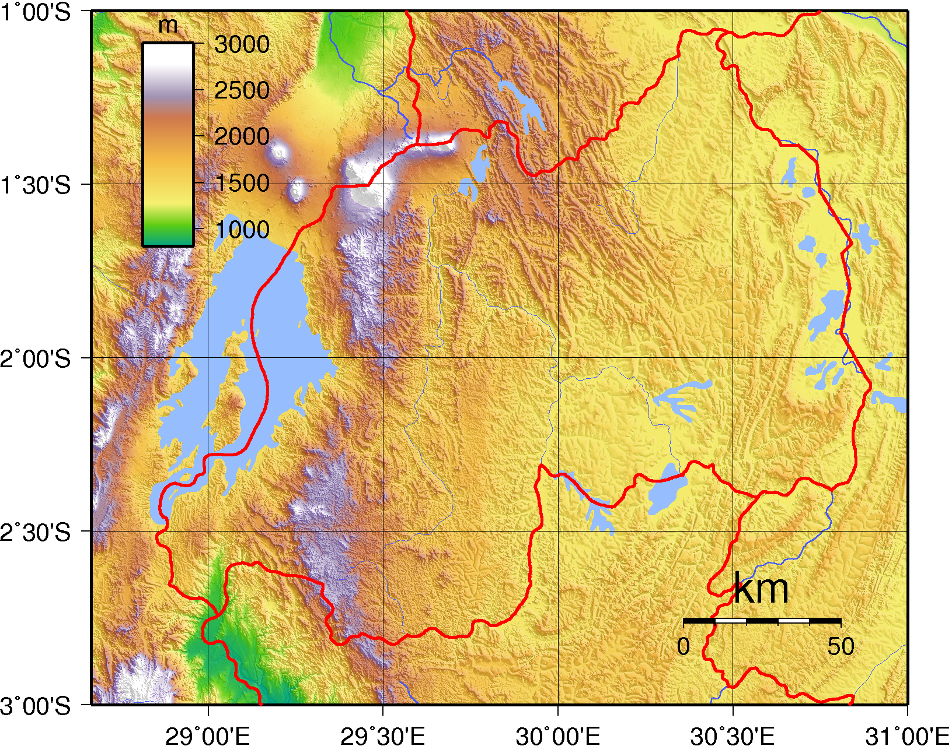
Figure 1 Topographic map of Rwanda (Wikipedia, 2009)

Another factor is the population density. Rwanda is one of the most densely populated countries in Africa with a population density of about 310 inhabitants per km² and an annual population growth rate of around 3.1% (MINISANTE/ONAPO 2003). In 1999, about 91% of her population earned their living, directly or indirectly, from agriculture; this is only applicable especially in some mountainside, in the alluvial valleys and in the volcanic soils of the northwest. About 1.1 million hectares (2.8 million acres) are under cultivation. Subsistence agriculture predominates, and the basic agricultural unit is the small family farm about one hectare (2.5 acres) (nationsencyclopedia.com/Africa2009). Rwanda’s industrial agriculture is dominated by tea, coffee and Pyrethrum.
Tea agriculture requires a large area, in 1999 the total area for tea cultivation was 12,541 ha and 14,394 ha in 2008 with 1,407ha not exploited (Rwanda Privatization 2009, Lawrence w. Reed 2002).
Although Rwanda had made modest attempts to grow tea since the Second World War, it was only in the 1960's that the industrial cultivation of tea was really established.
Under the impulse of the FED, which considered tea as "a major agricultural opportunity" for Rwanda; the first tea unit was created in 1960 at Mulindi (Ex Byumba province actual Northern Province). Ten years later, already six tea units were functioning.
In 1964, the Office for Industrial Cultivation in Rwanda (Office des Cultures Industrialles du Rwanda - OCIR) was established, with the mission to manage the tea and coffee branches. Mulindi Tea plantation covers the largest area with 1,909 ha and its factory is the biggest in the country. Tea agriculture has positive and negative impacts on the environment. This is why this paper intended to provide a preliminary investigation of the environmental impact of industrial agriculture in Rwanda, particularly the case of Mulindi tea Plantations. This study shows the impact of tea plantation in Rwanda through the following factors: soil degradation, deforestation and soil erosion, air pollution and water pollution in Mulindi river, agrochemical use, tea agriculture methods, and finally it proposes the methods and techniques or strategies which can be used for conserving the environment and ensure sustainable development.

MATERIALS & METHODS

The study area:
General state of Rwanda

The Rwanda is a small country located in Great lakes region of east central Africa, bordered by Uganda to the north, Tanzania to the East, Burundi to the South and Democratic Republic of Congo to the West where it is separated by Lake Kivu and Ruzizi river (Siuberski, Philippe 2008).This small country is also located near the centre of Africa, a few degrees south of the Equator. By this localization, the climate in Rwanda is cooled by the high altitude. It is warm throughout most of the country but cooler in the mountains. There are two rainy seasons: mid January to April and mid October to mid December (RICP 2008). The capital, Kigali, is located in the centre of the country. In 2006, it was announced that they had located the longest headstream of the River Nile in Nyungwe forest (Team researches Nile’s true source 2006); the relief is mountainous with altitude declining from west to east. The country has few natural resources and its economy is based mostly on agriculture by local farmers using simple tools. It is estimated that 90% of the active population are in the agriculture and this sector occupied about 39.4% of GDP in 2006 (Special report on Rwanda, 97). Crops grown in the country include coffee, tea, pyrethrum, bananas, beans, sorghum and potatoes; but tea and coffee are the major cash crops for export (WTO Doha Round Bulletin : 2004 )

Brief story of tea agriculture in Rwanda
Tea growing was introduced in Rwanda as an industrial crop and purely for export purposes to generate foreign income as early as 1960. Black tea manufacturing followed in 1965 at Mulindi tea factory in the actual Northern Province. Since then the tea sector has become the most important source of export earnings after the coffee market plunged in recent years. Tea is now number one export earner; contributing up to 34% of the total national exports. Today, the tea sector in Rwanda consists of six state owned production units, Gisovu, Kitabi, Mata, Mulindi, Shagasha, Gisakura and four private owned production units, Cyohoha (SORWATHE), Pfunda (Pfunda Tea Company), Nyabihu and Rubaya ( Rwanda Mountain tea). Nshili-Kivu is another private owned production unity with a factory which is still under construction. The current tea sector consists of 10 tea factories, 8 governments owned plantations known as Blocs Industrials (BI), 3 tea cooperatives known as Coopthés and 11 tea small holders associations known as Thé Villageois, spread in the country as indicated in Table 1.The total planted area is 12,989 ha but only 12,862 hectares are exploited. The factories installed capacity is 15,500 tones of made tea per annum. The tea sector provides employment to 52,838 people, tea farmers and workers together (OCIR –THE 2006)
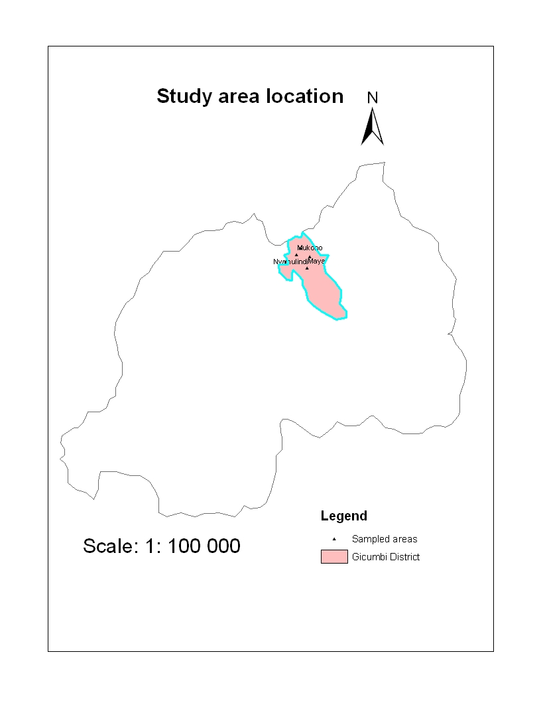
Figure 2 Study Area locations
Mulindi tea plantation is located in Gicumbi district in Northern Province and is home to about 47,000 people. Its capital is Byumba, which is also the ex provincial capital. The district lays due-north of Kigali, straddling the major road from Kigali to Kampala. It is a hilly district and is divided into 21 sectors called Imirenge in local language (Francis 2008). Tea plantations are located in eleven Administrative sectors among 21 sectors of Gicumbi district which are: Kaniga in which Mulindi tea factory is located, Mukarange, Cyumba, Rushaki, Bwisige, Nyankenke, Manyagiro, Byumba, Rubaya, and Shangasha.
Mulindi tea factory is located at 14km to Gatuna board and at a 1 hour journey from Kigali and at 5 km from Kigali-Gatuna road in Kaniga Sector. The factory is the biggest in terms of production but as it does not have its own plantations; it depends on COOPTHÉ and Village’s Tea which is called COOTHEVM for its green leaf supply. The COOPTHÉ constitute 35% with 585 ha exploited, and Village’s Tea, 55% with 1150 ha.
The industrial block has only 174.4045ha; it means a total of 1909.4045 ha. All these tea plantations are distributed around ten agriculture sectors (Nyamulindi, Rushaki I and II, Bushara, Kaniga, Maya, Ngondore, Muturirwa, Rubaya and Mukono). About 90% of this area is located in valley or swamp and 10% only is located on versants of mountains. The factory was built in 1962 with capacity of 3200T. During 1994-1996 the factory and tea plantations were rehabilitated following the war. The factory only has 224 ha of woodlands that are not sufficient, the reason why the factory is obliged to buy the wood fuel from the population around.
METHODS

The first phase of this study used a survey among the governmental and private tea factories through different plantation management companies (Coopthe, village’s tea and estates tea plantations which called B.I).
During this phase, a questionnaire was used to collect information about different activities carried out in tea plantations such as plucking, drainage, pruning, fertilization etc. This questionnaire was sent to 11 tea plantation managers, representing the total number of the tea factories in the country. This questionnaire was also helpful in getting information concerning pesticides and types of fertilizers used in Rwanda’s tea plantations. It was also designed in order to identify different techniques used to fight against erosion and to protect the environment. Lastly the questionnaire was used to get information about the evolution of tea production. All tea plantation managers submitted their completed responses.
The second phase of this project concerned particularly Mulindi tea plantation, where we took soil samples by dryer (or Terri ere in French) on three locations which are Nyamulindi, Maya and Mukono for getting information relating to soil degradation through laboratory analysis using pHMeter. We also took water samples by tank in polyethylene and we put on bottles very clean for a good transportation from three locations of Mulindi streams (Nyamulindi, Maya and Mukono) for analyzing and quantifying water pollution resulting from tea preparation activities in laboratory.
These water samples were acidified with purified nitric acid and were analyzed through atomic mass spectroscopy. The measure of pH in the solution used the followings elements: ammoniumacetae ammonia (pH 6-8), sodium acetate- acetic acid (pH 3-6), and hydrochloric acid-glycine (p h 1-3)
The analysis of the relationship between production and utilization of wood fuel in factory has been carried out using SPSS, Origin pro 7.5 and excel. The deforestation in that region is remarkable, and sediment deposition and different floods was a good indicator of the presence soil erosion in region.
The water samples taken in three streams of Mulindi River using the tank in polyethylene before rinsed with ultra pure water and it was taken 1L by location. This study started from 1st April 2008 and it was planned to get all responses of the questionnaire by 30th April 2009; by chance, all the respondents submitted their responses on time. The final report was completed by the 20th June 2009

RESULTS AND DISCUSSIONS

State of tea plantations and Evolution of production

Plantations:

Table 1. Tea plantations area and thei location in Rwanda

 |  |  |  | state factories
Factories | localization | started | state | coopthe | Vill.tea | BI | PRIVATE | TOTAL
MULINDI | N-Gicumbi | 1962 | Swamp | 867 | 1428 | 3 | 0 | 2298
SHAGASHA | W-Nyamasheke | 1969 | Hill/swamp | 515 | 1033 | 7 | 30 | 1585
GISAKURA | W-Nyamasheke | 1975 | Hill/swamp | 608 | 330 | 357 | 0 | 1295
MATA | S-Nyaruguru | 1981 | Hill/swamp | 0 | 475 | 610 | 0 | 1085
KITABI | S-Nyamagabe | 1977 | Hill | 0 | 650 | 350 | 0 | 1000
GISOVU | W-Karongi | 1983 | Hill | 0 | 732 | 340 | 0 | 1072
Sub-total |  |  |  | 1990 | 4648 | 1667 | 30 | 8335
 |  |  | private factories
SORWATHE | N-Rulindo | 1978 | Swamp | 0 | 880 | 0 | 261 | 1141
PFUNDA T.C | W-Ngororero | 1972 | Hill/swamp | 0 | 786 | 0 | 124 | 910
RUBAYA | W-Ngororero | 1979 | Hill | 0 | 342 | 0 | 647 | 989
NYABIHU | W-Nyabihu | 1950 | Hill/swamp | 0 | 31 | 0 | 627 | 658
NSHILI-KIVU | S-Nyamagabe | 1983 | Hill | 0 | 225 | 0 | 731 | 956
Sub-total |  |  |  | 0 | 2264 | 0 | 2390 | 4654
National Total |  |  |  | 1990 | 6912 | 1667 | 2420 | 12989

Tea plantations in Mulindi agriculture sector are divided in two categories. A big part of all tea plantations around 90% are for private sector which are called Cooperatives with COOPTHE and COOTHEVM, and the small part of tea plantations (10%) which are called BI are controlled by Tea factory headed by Rwanda Tea Authority (Ocir the). Coopthe Mulindi is a cooperative with one thousand members and produces about 35% of green leaves. Tea plantations in this Cooperative get a special treatment like regular sarclage, good table of plucking and regular drainage. It is the same for the small plantations under the control of the Tea factory.
The Coothe.VM is a villages’ cooperative with around three thousands members and every member has his field and he is responsible for all activities except plucking and transport. The coothevm produces about 55% of green leaves. In general, all tea plantations in these villages’ cooperatives do not receive good services and support such as drainage, plucking and pruning. Most of Mulindi tea plantations are composed by the stamps and few clones from Kenya. About 5000 workers are employed in tea plantations including those who work in the tea factory in different activities; accounting for about 10.64% of all people of Gicumbi District and 25% the active population of that District. Tea plucking is the first activity which employs many works, about 3500. Others activities (,pruning, drainage…) are occupied by about 1500 people. In Mulindi valley composed by Maya, Mukono, Nyamulindi, Ngondore and Muturirwa, they are many empty spaces caused by erosion and regular floods between April and May every year.

PRODUCTION, WOOD FUEL AND FERTILIZERS:

Table 2 Production, wood fuel, fertilizers, area in Mulindi Tea Plantations from 1996 to 2008

Years | Green leaves/kg | wood fuel used/T | fertilizers/kg | Area/ha
1996 | 3282152 | 3090 | 0 | 921.4
1997 | 3241815 | 9115 | 0 | 921.4
1998 | 4757300 | 11300 | 0 | 1026.9
1999 | 8853154 | 6847 | 165662 | 1614.7
2000 | 9238657 | 7732 | 153413 | 1642.2
2001 | 13750123 | 14406 | 450000 | 1772.5
2002 | 10072611 | 10629 | 370800 | 1762.5
2003 | 9286082 | 10896 | 166850 | 1770
2004 | 8731340 | 10581 | 470700 | 1909.4
2005 | 11271253 | 12492 | 470800 | 1909.4
2006 | 11148716 | 11945 | 235574 | 1909.4
2007 | 13904538 | 15836 | 514616 | 2298
2008 | 13678308 | 12774 | 370385 | 2298
Total | 121216049 | 137643 | 3368800

During 13 years from 1996 to 2008, the production of green leaves at Mulindi tea plantations increased by 10396156kg (316.74816%). During that period the using of wood fuel had an increase of 9684tones or 313.39806% while the use of fertilizers
increased from 0 kg in 1996 to 370385kg in 2008. The total area was around 1900ha in 1996 but only 921.4ha were rehabilitated, and it was 2298ha in 2008 including the young tea and empty area inside of tea plantations but only 1909.4045ha give a production.

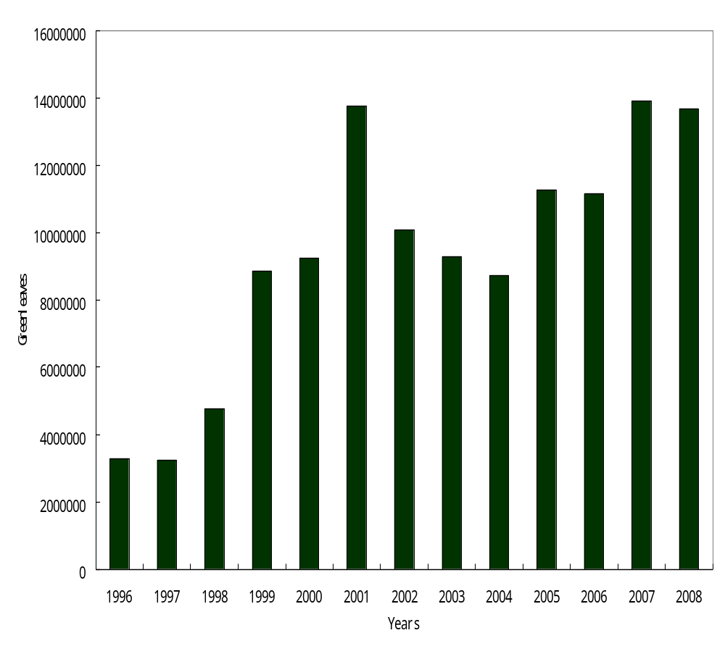
Figure 3 Evolution of tea Production / kg

By the Figure3 it was noticed that the years 2007, 2001 and 2008 were very productive with the following production respectively 13904538 kg in 2007, 13750123 kg in 2001 and 13678308 kg in 2008.The good climate with enough rainfall, high quantity of fertilizers and good plucking are the favorable factors which can explain that increase of production. Also we found that the first three years from 1996 to 1998, had low production of green leaves because of it was a short period after genocide; many tea plantations were not taken care, few workers and it was difficult for the country to get fertilizers

Agrochemical:
The use of chemical fertilizers led to the decline of soil fertility (Fared 1996). To determine the impact of fertilizers in addition to laboratory experiment, in this study, we tried to use previous studies carried out in other study areas. For example, studies in India have shown that as much as 70% of soil biota has been lost on tea plantations

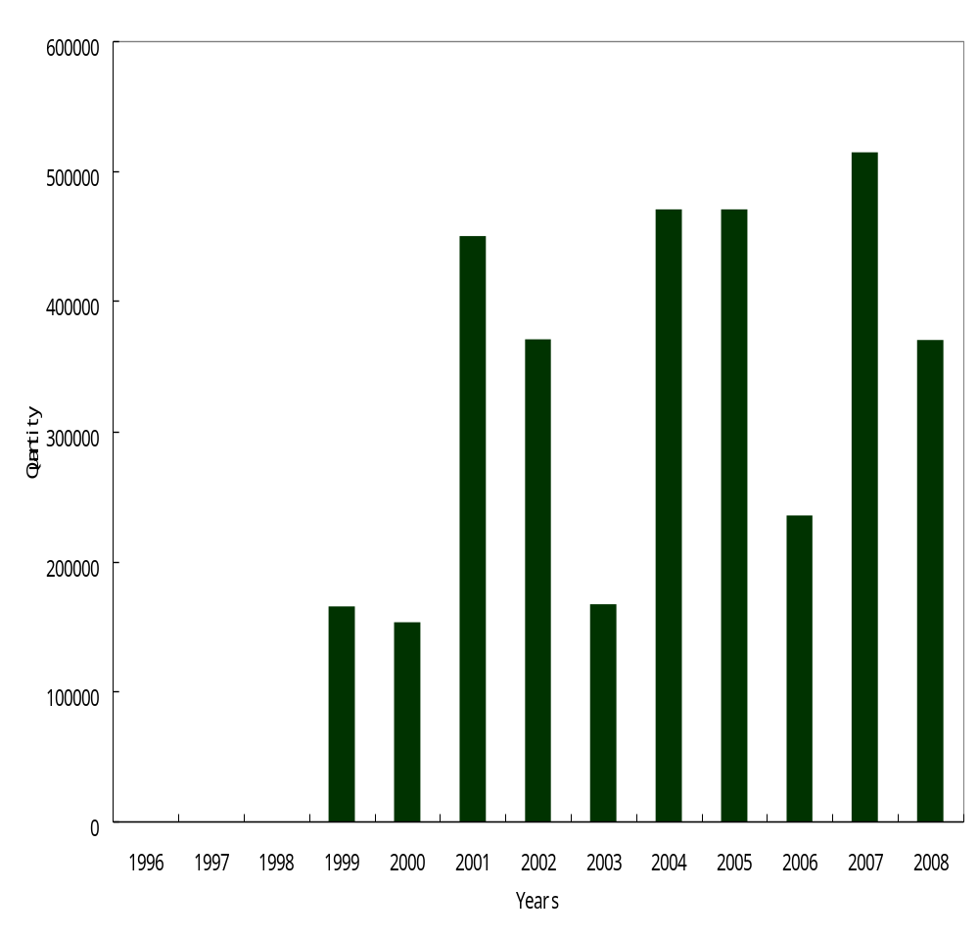

Figure 4 Fertilizers (NPK) used at Mulindi Tea Plantations from 1996 to 2008

The Figure 4 show that the use of fertilizers at Mulindi Tea Plantation was not regular; this can be explained by the following factors: Some farmers cannot afford the cost of fertilizers while others lack knowledge about the importance of fertilizers to nearby natural habitat, especially in areas that workers and machinery pass over (Senapati et al. 2002). In

general, Rwanda tea plantations and at Mulindi in particular, they use NPK 25-5-5 +1Mg and NPK 26-6-8 +2Mg very frequently as fertilizers. Other pesticides which are used in different tea plantations are Round up for eliminating of weed; urea, methane and dime thane for young tea or in nurseries

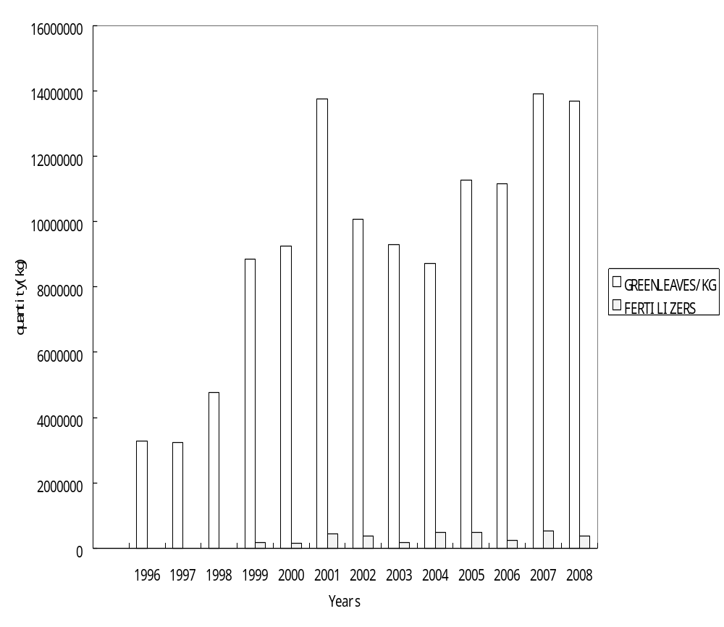
Figure 5 Relationship between product and fertilizers

It was found through the Fig. 5 that the high quantity of fertilizers implies high productivity of green leaves. During the three most productive years 2001, 2007 and 2008, the use of fertilizers was also at very high rate, carried out in other study areas. For example, studies in India have showed that as much as 70% of soil biota has been lost on tea plantations as compared to nearby natural habitat, especially in areas that workers and machinery pass over (Senapati et al. 2002). In general, in Rwanda tea plantations and at Mulindi in particular, the farmers use NPK 25-5-5 +1Mg and NPK 26-6-8 +2Mg frequently as fertilizers. Other pesticides which are used in different tea plantations are Round up for eliminating of weed; urea, dithane and dime thane for young tea or in nurseries

Soil Degradation

Soil Degradation at Mulindi was among the
Main objectives of this study; for its
measurements, we used pH as indicator. For that case pHMeter was used to analyze the soil acidity. It was found that the pH of soil samples collected on three locations of Mulindi valley was 5.2 at Nyamulindi, 4.8 at Maya and 4.6 at Mukono. This means that the pH of soil in all Mulindi valleys is less than 7 and all soils are classified among the acidic soils. This acidic of soil can be explained by the following factors. First, the rock in which the soil came from, Mulindi valley belongs to the sedimentary rock. And then the using of fertilizers with NO₃⁺ and an augmentation of aluminums ions and H⁺ in soil. (www.document: calibrate a pHMeter, 2009)

Analysis of Pollution

Table 3 Concentration of H⁺, Cu, H₂NO₃, Al³⁺, NO₃, NO₂, Mg, Ca, Fe, K, P, and S in Mulindi streams (mg/L) in 2008

Samples no | Na | H+ | cu | H₂NO₃ | Al³⁺ | NO₃ | NO₂ | Mg | Ca | Fe | K | P | S
1.Nyamulindi | 31.85 | 26.4 | 13.2 | 13.1 | 2.06 | 1.14 | 20.3 | 12.2 | 46.1 | 0.18 | 3.8 | 0.26 | 20.2
2.Maya | 28.3 | 38.6 | 6.3 | 11.6 | 3.15 | 1.64 | 19.6 | 13.1 | 51.9 | 0.14 | 9.3 | 0.65 | 18.9
3.Mukono | 33.3 | 21.9 | 8.4 | 10.8 | 4.04 | 0.96 | 26.4 | 14.5 | 41 | 0.09 | 8.1 | 0.48 | 19.3

The concentration of major elements in water at Mulindi valley varied by site. The result in table 3 showed that the concentration of Na, H⁺, H₂NO₃, Al³⁺, No₃, NO₂, Mg, Ca, Fe, K, P, and S were important in all sites with 31.85, 26.4, 13.2, 13.1, 2.06, 1.14, 20.3, 12.17, 46.12, 0.18, 3.8, 0.26, 20.18 respectively at Nyamulindi, with 28.3, 38.6, 6.3, 11.6, 3.15, 1.64, 19.6, 13.05, 51.87, 0.14,9.3, 0.65, 18.9 respectively at Maya, and with 33.3, 21.9, 8.4, 10.8, 4.04, 0.96,26.4, 14.46,41.04, 0.09, 8.1, 0.48, 19.3 respectively at Mukono. The study also showed that the concentration of Fe, NO₃, K, Al³⁺ were no important than other elements in all Mulindi valley, but the concentration of Ca, Na, H⁺, NO₂, S, H2NO₃ and cu ere highest in all valley and this concentration indicate that the water in Mulindi Valley are acidic and the pollution has its origin from oxide of nitrate (NO₂) and the use of many fertilizers with high level of MPK+ Mg . Note that this instrument (experimental) technique has been used by many researchers in environmental studies such as (Filgueiras et al; 2002) and several schemes are existing (Smichowski et al; 2005).

Deforestation impact on Soil Degradation

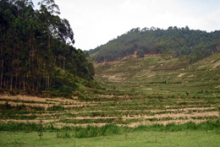
Figure 6 A floods in Rebero land in September 2008

Soil degradation is also associated with off-site problems of sedimentation, carbon emissions affecting climate change (Smyth and Dumanski 1993). Soil degradation accelerated by erosion is a big problem in Rwanda and the erosion is caused by not only the topography of the country but also by deforestation. At Gicumbi district, particularly on the mountains around Mulindi where the climate is classified as tropic, we observed serious erosion caused by deforestation. From 1996 to 2008, the use of wood fuel in Mulindi tea factory was increasing as the production increased.

Because of deforestation for example, over the years, the lands of Rebero (Figure 6) one among regions surrounding Mulindi tea plantation in Gicumbi District north of the Rwanda were washed away by rainfall. The study in India showed that the production of eucalyptus can vary from 11.9T/hm² in three year old plantation to 146T/hm² in 9 year old plantation in moist region and from 5.65t/ha in 5 year plantation to 135.5T/ha in 9 year old plantation in dry tropic region (Vijan Rawat, et. al, 2004) From 1996 to 2008, Mulindi tea factory used around 137 643 T of wood fires of eucalyptus, and it was noticed that the production of eucalyptus was 170t/ha for 7 year old plantation; it means that 809.66471ha of forests were cut in 13 years.
If we consider that a forest is able to give a good production after 7 years, it is clear that an area equals to 404.83235ha of forest were cutting after 7 years; Its means that 57.833193 ha of forest were cutting every year for only Mulindi tea factory. Because of the deforestation we found a high quantity of peat in all valleys which surrounding Mulindi tea plantations caused by soil erosion through many types of sediment from the mountains. Mulindi tea factory has 227ha of forest and the government of Rwanda tried to mobilize its population about forest protection and environmental protection.

In order to prevent soil erosion, this government tried also to mobilize its people to plant trees as a necessary call to restore the lost forest cover in Rwanda. Selected seedlings are planted in all provinces of the country by environmentalists in collaboration with all stakeholders and local community (Ministry of Lands, Resettlement and Environment 2003)

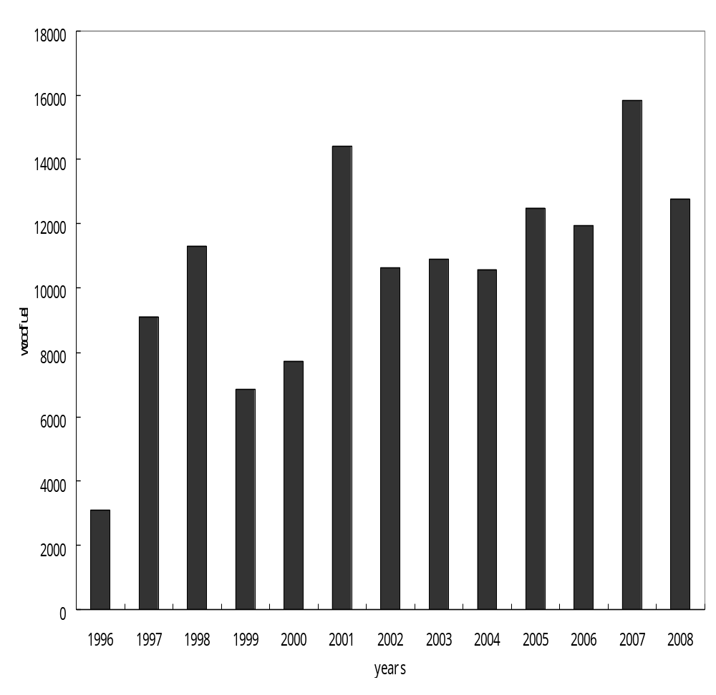
Figure7 Evolution of Wood fuel (on tones) used at Mulindi Tea Factory

This study through Figure 7 shows that the increase of quantity of wood fuel used is highly influenced by the increase of tea production and the deforestation is among the crucial problems that affect conservation in developing countries in which Rwanda is included. The human pressure on natural resources, poverty, low education level and lack of integration of local population in environmental protection activities are the major barriers for environmental conservation in those countries.

Note that the use of wood fuel is not only for the tea factories but also in general the rural population use wood fires in preparation of their food. Also wood fires are used by different institutions like schools, hospitals and prisons. In Gicumbi district the use of high quantity of wood fires was also identified in GIHEMBE Refugees Camp.

CONCLUSION&
RECOMMANDATIONS

Industrial tea agriculture introduced in Rwanda from 1960 has a negative impact on environment .The soil and water samples taken from Mulindi tea plantation indicate that this part of the country has been polluted by different contaminants.
The fertilizers used in the tea plantations were the cause of soil degradation and through those fertilizers the water was polluted. Also the deforestation resulted in soil erosion which led to floods and the deposit of sediments on the valley. For that case, some recommendations have been proposed. First, the government should apply lime on Mulindi tea plantations and on other tea plantations which have big quantities of peat. Second, anti-erosion canals should be dug around all tea plantations which are located on mountainside. Third, find alternative sources of energy for treating tea other than wood fuel in order to protect the environment. And finally to proceed by analysis of all rivers streams in order to ensure the quality of drinking water.

ACKNOWLEDGEMENTS

Our thanks go directly to the Government of Rwanda for their financial support, to National University of Rwanda and China university of Geosciences for laboratories, Prof Bukome Itangwa and Dr. Habumugisha Jean de Dieu (NUR) for their helpful comments and suggestions.

Abbreviations

- B.I: Blocs Industrials
- COOPTHE: Cooperative theicole or Cooperative of tea cultivation
- COOTHEVM: Cooperative du the villagois de Mulindi or Villagois tea cooperative of Mulindi
- Dr: Doctor
- FED: Federalism
- Fig: Figure
- GDP: Gross Domestic Product
- Ha: hectares
- Mg: Magnesium
- MINISANTE: Ministere de la santé/Ministry of health
- N.P.K: Sodium phosphate potassium
- NUR: National University of Rwanda
- OCIR: Office for Industrial Cultivation in Rwanda
- ONAPO: Rwanda’s national office of Population
- P h: potential of hydrogen
- RICP: Rwanda Investment Climate Project.
- SORWATHE: Rwanda society of tea
- T: Tones

References

Almeida, R.R et. Al. Veneer production from Eucalyptus grand is & Eucalyptus Urophylla hybrid clones wood. Forest Production Special, Dehradun / Indian 2004:5(2) 53-76.
Climate zone.com. Climate information of Rwanda: Energy Foe Development; The World Bank Perspectives 2008 and beyond. ESMAP -ASTAE, Washington 2008: 15-30
FAO and WFP (Special Report on Rwanda, July 1997, Crop and Food supply Assessment mission to Rwanda. Retrieved on 2009.02.04. 1997: 16-32.
Filgueiras, A.V, Filgueiras, I. Lavilla and C.Bendicho et al;. Chemical sequential extraction for metal partitioning in environmental solid samples.DOI:10.1039/b20.1514c 2002: 720-823
Francis. ICT Dream to the rural communities thanks to telecentres. Kigali. 2008: 1-2
Lawrence w. Reed. A Privatization Revolution-in a Most Unlikely Place. General Article. Mackinac Center 2002: 2-3
MINISANTE/ONAPO Politique Nationale de la population pour le developpement durable au Rwanda. Ministry of health/National office for Family planning. InterScience, Kigali /Rwanda 2003 : 8-16
Ministry of Lands, Resettlement and Environment. National environment policy in consultation with other state institutions, United Nations Agencies, NGOs and civil society. Kigali, 2003: 2-3.
Nationsencyclopedia.com/Africa. Rwanda agriculture. 2009:2
OCIR-THE . A New tea sector strategy for Rwanda year 2005-2010. Tea strategy. Kigali 2006:2-12.
RICP . Rwanda climate, weather, Temperature, Rainfall. World Travel Guide. Kigali 2008:1-2
Rwanda Privatization. Tea special in our magazine. Rwanda privatization No11.Kigali 2009:6.
Samuel Kanyamibwa. Impact of war on conservation: Rwanda environment and wildlife in agony. Biodiversity and Conservation 1998:7(11): 1399-1406.
Senapati, S., Keiper, J. S., DeSimone, J. M., Wagnall, G. D., Melnichenko, Y. B., Frielinghaus, H. and Berkowitz, M. L. Structure of Phosphate Fluor surfactant Based Reverse Micelles in Supercritical Carbon Dioxide. Langmuir 2002: 18(2): 7371.
Siuberski, Philippe . Women run the show in a recovering Rwanda. Washingtonpost.com Woman’s World 2008: 01
Smichowski, P., G. Polla and D. Gomez et al;. Metal fractionation of atmospheric aerosols via Sequential Chemical extraction: A review, Anal. Bioanal. Chem. 2005: 381:302-316
Smyth and Dumanski. Cited Ivan Good body, Elizabeth M. Thomas-Hope (1994) Natural Resource management for Sustainable Development in the Caribbean. Barbadon. Jamaica. Trinidad 1993: 323-372
Team researches Nile’s true source BBC. News (2006) Retrieved on 2006.12.04
Thomas streissgnth Juvenile Nonfiction. Rwanda in picture. 2007: 70-8

Vijay Rawat, Negi, J.D.S. Biomass production of Eucalyptus tereticornis
in different agro ecological regions of India. Cahiers Agricultures 2004: 130 (7):
6-12
Wikipedia,The free encyclopedia. Geography of Rwanda: Topographic map of Rwanda. Satellite image of Rwanda, generated from raster graphics data supplied by The Map Library. 2009: 2-3
WTO Doha Round Bulletin. Continued reforms and technical assistance should help Rwanda in its efforts to achieve a dynamic economy: Trade policy Review: Rwanda. World trade organization 2004: 2-3

