Recharge of the Quaternary Aquifer of Lake Chad Basin Estimated from Oxygen-18 (¹⁸O) and Tritium (³H) Isotopes

¹Massing Oursingbé, ¹Tang Zhonghua
¹ Department of Hydrogeology and Water Resources, School of Environment Studies,
China University of Geosciences, 430074-Wuhan, Lumo Road 388, Hubei, People’s Republic of China
massing.2@hotmail.com/massing_ii@yahoo.fr
Abstract: Water resource management in the arid to semi-arid areas requires not only exploration and assessment of the available reserves, but also determination of groundwater recharge in order to evaluate the sustainable yield of the resource. This study highlights the groundwater recharge on the Quaternary aquifer of Lake Chad Basin using oxygen (¹⁸O) and Tritium (³H) isotopes interpolation method. Tritium contents (³H) show a median annual renewal rate of 0.09% of which approximately 3mm/year of recharge, for a rainfall varying between 250 with 550mm. Although weak, these values are compatible with the contents of ¹⁸O and ²H of the Quaternary aquifer, which highlights the mixture of water infiltrated during the wet period (old water) and of water infiltrated under a dry climate (recent water). Indirect recharge to groundwater body is by seepage through the beds of Lake Chad, Rivers Logone-Chari, local ponds and non permanent rivers (Komadugu Yobe).

Key words: Lake Chad Basin, Isotopes, Groundwater renewal, water resource management.

1. Introduction
The total amount of water on this earth is virtually constant but its distribution over time and space varies to a great extent. Wherever people live, they must have a clean and continuous water supply as primary requirement to human being [3]. The assessment of quality, supply and renewal of water resource is a well known problem, but it is becoming critical with the growth of population and rapid industrialization.
In the Lake Chad basin (fig. 1) the use of groundwater as supply has increased dramatically. In order to assure the water supply to the growing population under human activities, changes in climate variability, growing demands and catchment degradation, groundwater recharge investigation is one of the main concerns for water managers in the coming decades. It is believed that such information can be of great use to all those concerned with the issues of water resources management in the arid and semi-arid areas.
One of the key components of the water balance is the evaluation of recharge rate in the recharge areas. The other component is the residence time of the groundwater that has implications for groundwater extraction and groundwater protection [21]. In this study, Oxygen-18(¹⁸O) and Tritium (³H) isotopes have been an integral part of the approach used to improve the knowledge and understanding of groundwater resources and their recharge areas of the Quaternary aquifer of Lake Chad basin. The use of isotopes in the framework of this study is based on their qualities of tracers of the chemical species on which they are intrinsically dependent.
Oxygen isotopes and the deuterium excess are excellent tools for monitoring hydrologic dynamics in terrestrial aquatic systems, because isotopic fractionation processes in regional and global water cycling are well understood [6]. In semi-arid and arid regions with seasonally varying and complex synoptic conditions e.g., [1], isotope ratios are a reliable instrument for characterizing the (i) impact of water from different sources such as precipitation, river and/or groundwater discharge, and (ii) to identify major processes like evaporation and mixing of surface and subsurface waters. Both water source features with subsequent mixing, and fractionation due to different processes will impact the isotopic balance of an endorheic lake system. Thus, isotopic ratios can make up for missing water monitoring needed to achieve a systematic understanding of the local hydrology [11].

The Lake Chad basin is a sedimentary basin formed in the Mesozoic era. Covering 500,000 km² in the central part of the Lake Chad Basin (Central and Western Africa), the Quaternary aquifer is phreatic and is composed by alternation of silts, clayey sands, sands, and clays. In most of the basin, it is isolated from the underlying artesian Pliocene aquifer by a thick clay layer.
The average thickness of the Quaternary aquifer is around 100 m, declining to 0 m at its edges and increasing in some parts of the Kanem region up to 180 m. The depth of water table varies from less than 1 m in the nearest vicinities of the Rivers Chari, Logone and Komadugu, to 90 m locally in the Kanem dunes. In these dunes, the water table can also be very shallow. Surface slopes in this area can reach 30% and the variations of water table depths are significant due to dunal relief. Seasonal variations of the water table reach 2 m near the rivers and are much lower elsewhere [4].
Over the last 40 years, much attention has been given to improving groundwater recharge investigation in the Lake Chad basin. Three groundwater flow models of the whole Quaternary aquifer were developed (Eberschweiler, 1993; Leblanc, 2002; Boronina et al., 2005) [15]. All the models are rather conceptual, since all traditional hydrogeological parameters are sparse, not homogeneously distributed in space, and highly variable in time – so it is difficult to upscale them over the whole aquifer.
All three models achieved reasonable fits of simulated and observed piezometry, however, they all operate with different zones of recharge and transmissivities and consequently result in three different water balances. In Boronina et al. (2005), the total steady state regional evaporation is 354.6 mm3; 83% of which occurs within a narrow (less than 5 km) band around the Lake Chad. Apart from infiltration from Lake Chad (which is almost totally evaporated in its surroundings), groundwater inflows in this model are relatively small: around 25mm³/year from the edges of the aquifer and 70mm³/year from diffuse recharge. In the Eberschweiler (1993) study, transmissivities, consequently recharges are higher [9]. In the model of Leblanc (2002), total water balance was not available for the present study, but spatial recharge distribution was quite different from that of Boronina et al. (2005).
This non-uniqueness might be unfortunately common for regional groundwater models when the same observed piezometry can be simulated with different water balances. The challenge to understanding recharge patterns over the Quaternary aquifer is thus mostly related to understanding the spatial distribution of actual evapotranspiration [5]. This term is crucial for arid and semi-arid regions and is very difficult to estimate since it is in complex relation with meteorological parameters, soil and vegetation properties, and the amount of water available for evapotranspiration.

- Lake Chad Background
Located in the center of the African continent, between 12 ° and 14 ° latitude north, Lake Chad is the fourth largest lake in Africa after lakes Victoria, Tanganyika and Nyassa [18]. The surface area of the lake varies considerably with the amount of annual rainfall, and the recent historical variation in the surface area of the lake has ranged approximately to 25,000 km² [18].
Unlike the six major African rivers, including the Nile, Niger, Congo, Zambezi and Orange who reach the Mediterranean Sea or the Atlantic and Indian oceans, Lake Chad Basin is an endoreic (closed) basin, that is, it does not flow into the ocean, and it altitude is about 280 m above sea level [14].
Situated at the southern edge of the Sahara desert, Lake Chad and its active basin constitute an important freshwater resource, and providing water to more than 20 million people living in the four countries which surround it; Chad, Cameroon, Niger and Nigeria. Lake Chad is fed by the Chari and Logone river systems, which flow northward from the highlands of Central African Republic and Cameroon (Adamawa) respectively, through southern Chad, supply approximately 95% of the lake's surface water flows. Likewise, the Komadugu-Yobe and Ngadda river systems which flow from north-eastern Nigeria fed the western and south-western part of the Lake are considered to be of minor significance to the entire watershed, yet locally momentous to the northern reaches of the wetlands [23].
Two strong air masses which greatly influence the climate of the Lake Chad region. There are a dry continental air mass and a humid, maritime air mass which oftentimes collide creating unexpected weather patterns. Precipitation usually occurs when a great depth of humid air mass gathers in the Chad. basin.The mean annual rainfall varies from 800 mm in the south to 15 mm in the north. Around 90% of the precipitation falls between July and September as short and heavy storms of local extent. Depending on location and method, most estimates of potential evaporation vary between 2000 and 3200 mm per year [19].

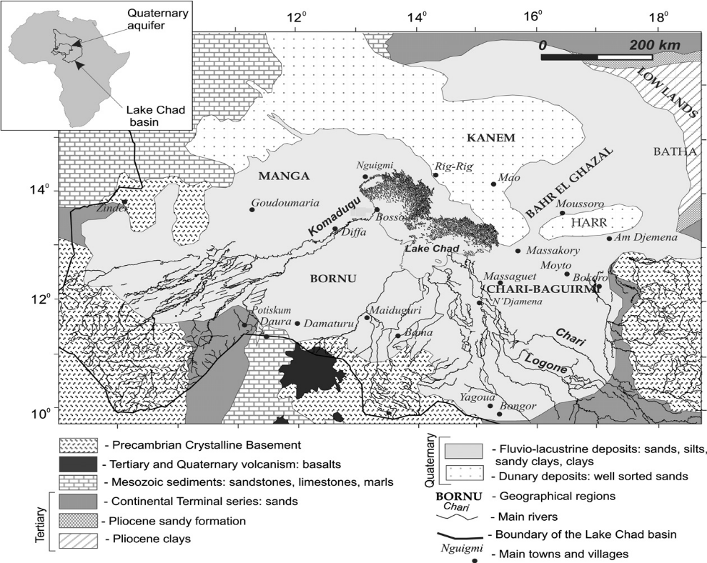

Figure 1: Simplified geography and geology map of the Quaternary aquifer and the surrounding areas (modified after Eberschweiler, 1993)

- Isotopes-general comments
The stable and radioactive isotopes of the common elements of oxygen, hydrogen, have a wide range of applications in hydrogeology. The stable isotopes of water (¹⁶O, ¹⁸O, ¹H, ²H) can be used as tracers of the origin of groundwater recharge. The radioactive isotopes of water, ³H (tritium) are useful in providing estimates of aquifer residence times that can assist in managing groundwater resources [13].
Modern double inlet, double collector mass spectrometers are capable of detecting small changes in relative isotopic abundances with the results expressed using the δ notation. In general, the δ notation, normally expressed in parts per thousand (per mil or ‰) with respect to a known standard, is written as follows:
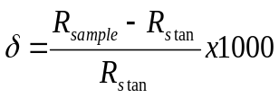

Where R_{sample} and R_{stan} are the isotopic ratios (for example ²H/¹H and) of the sample and standard, respectively. With this notation, an increasing value of δ means an increasing proportion of the rare, heavy

isotope. In this case, the sample is said to have a heavier, more positive or enriched isotope composition compared with another, isotopically lighter sample. For water, the accepted international standard is VSMOW (Vienna Standard Mean Ocean Water) with values of δ¹⁸O and δ²H equal to zero. Measurements of δ¹⁸O and δ²H can usually be determined to an accuracy of better than ± 0.2‰ and ± 2‰, respectively [13].
The relative abundances of oxygen-18 and hydrogen ²H (deuterium) isotopes found naturally in the water molecule are 0.1995% and 0.016% respectively. Meteoric water shows a wide range of δ¹⁸O and δ²H values reflecting the extent of isotope fractionation during successive cycles of evaporation and condensation of water originally evaporated from the sea. When condensation occurs to form precipitation, the isotopic concentration changes according to a Rayleigh distillation process for which the isotopic ratio, R, in a diminishing reservoir of reactant is a function of its initial ratio, Ro, the remaining reservoir fraction, f, and the fractionation factor, α, such that R = Ro f (α − 1) [13]. Craig (1961) showed that δ values for meteoric water samples of global distribution, for the most part, define a straight line on a cross-plot of δ²H against δ¹⁸O, represented by the approximate equation, known as the World Meteoric Water Line (WMWL): δ²H = 8δ¹⁸O + 10 [8].
The relation between δD and δ¹⁸O can be written in a standard form (equation for straight line) i.e. δD‰ = A δ¹⁸O + d. where A is the slope and d is the intercept of δD - δ¹⁸O line of fresh global meteoric waters. The use of oxygen-18 and deuterium relies on that the isotopic composition of the groundwater is a reflection of the average weighted-mean isotopic composition of the precipitation in recharge areas.
It is well known that the precipitation get depleted in the heavy isotope (O-18, H-2) as the air masses move from the coast into the interior of continent (continental effect). The same relationship is observed when the air masses move toward high altitude (altitude effect). Then, the coast precipitation is much more enriched isotopically than rains inside the continent and in the mountains. This isotopic fingerprint is transmitted to the groundwater in recharge areas. It is also important to highlight that the isotopic composition of the groundwater is conservative along the groundwater flow system.
Tritium (³H or T), the radioisotope of hydrogen, has a relative abundance of about 0-10⁻¹⁵ %. The unit of measurement is the tritium unit (TU) defined as 1atom of tritium occurring in 10¹⁸ atoms of H and equal to 3.19 pCi L⁻¹ or 0.118 Bq L⁻¹[13]. The half-life of tritium is 12.38 years for ³H decaying to ³He with the emission of a β particle. Tritium is produced naturally mainly in the upper atmosphere by interaction of cosmic ray produced neutrons with nitrogen. After oxidation to ¹H³HO, tritium becomes part of the hydrological cycle [13]. Analysis of tritium requires distillation followed by electrolytic enrichment of the tritium content. Natural levels of tritium in precipitation are estimated to be between 0.5 and 20 TU. Since 1952, the background value of natural tritium increased considerably due to the input of large amount of manmade tritium, injected into the stratosphere during thermonuclear tests, reaching the maximum level in 1963[14].
Owing to the nature of atmospheric input and circulation pattern wide variations are observed in tritium concentrations in precipitation geographically. Accordingly, the tritium content of meteoritic precipitation in the northern hemisphere (about 5 and 30 TU) is higher than compared with the southern hemisphere (2 and 10 TU) [12]. Similarly continental precipitation is in general much higher in tritium than marine precipitation. However in recent years, tritium concentrations of precipitation at most marine stations have returned to the presumed natural level.
Because of the complex problem of defining tritium concentration at the time of groundwater recharge, most studies using tritium make only a qualitative estimation of groundwater age. Generally, absence of tritium in the groundwater sample indicates that the water recharged prior to 1952 (the natural tritium) has undergone decay for about five decades. Presence of tritium is a clear indication for component of modern recharge. However, in such cases it is often difficult to decide whether the water concerned as a whole is young or it is a mixture of old tritium-free water and young water having a relatively high tritium content [12].

- Methodology
Groundwater samples were collected at various depths and locations. On the whole, 19 water points (recent data) were selected for analysis of oxygen-18 and Deuterium. For the contents Tritium we had exploited the former data by a simple model that seems adapted to the mode of sahelian aquifers recharge. Laboratory tests were related to oxygen-18 and deuterium. The oxygen-18 contents and deuterium were measured by mass spectrometry. The data obtained are recorded in Table 1 and the values are expressed in δ ‰ VSMOW. The precise details to the measures are ± 0.1 δ ‰ for oxygen-18 and ± 1 δ ‰ for deuterium. The contents tritium (Table 2) were measured by counting of scintillations of phase liquid and expressed of units tritium (TU) with an uncertainty is ± 0.5 TU (PNUD-FAO-CBLT [21]).
Previous studies carried out by IAEA [20] in the Quaternary aquifer in Niger side have shown that ³H levels vary between 0.4 and 256 TU whose median reached 5.2 TU with 76, 168, 256 TU as exceptional values. The measurements made in the same aquifer of the Chad part, has a moderate distance of Niger has identical values between 0.5 and 143 TU with a median 3.8 TU.
N'Djamena, during this period showed an isotopic beyond 120 TU, with a rainfall exceeding 1,000 in 1963. This shows clearly that the Quaternary aquifer contained a very small proportion of recent water after one decade of strong precipitations in the Sahel. The content of ³H in Chad and Niger reached a median value of 3.5 TU removing values greater than 100 TU, whose representativeness is uncertain.

Table I. Main characteristics of recent samples from the Quaternary aquifer in Niger part

Locations | Longitude | Latitude | Conductivity  Electric  (μScm⁻¹) | Water  Level  (m) | δ¹⁸O  (‰ vs. SMOW) | δ²H  (‰ vs. SMOW)
A | 13°08 | 14°40 | 223 | -23.3 | -5.83 | -38.9
B | 13°12 | 15°20 | 409 |  | -4.04 | -34.1
C | 13°12 | 15°20 | 625 | -10.4 | -3.98 | -35.4
D | 13°02 | 15°21 | 774 | -12.3 | -3.68 | -35.5
E | 12°58 | 15°23 | 1090 | -11.9 | -4.57 | -39.8
F | 12°43 | 15°27 | 1150 | -10.6 | -5.22 | -49.2
G | 12°52 | 15°32 | 915 | -9.6 | -6.16 | -45.6
H | 13°08 | 15°40 | 876 | -7.2 | -3.23 | -44.2
I | 13°07 | 15°45 | 762 | -8.4 | -5.21 | -46.0
J | 13°12 | 15°59 | 980 | -10.2 | -5.63 | -46.1
K | 12°39 | 16°33 | 125 | -55
L | 13°06 | 15°48 | 79 | -30
M | 11°20 | 13°59 | 1240 | -14.2 | -2.97 | -26.2
N | 11°11 | 13°43 | 2210 | -5.4 | -3.39 | -27.6
O | 12°39 | 13°30 | 1340 | -44.5 | -3.00 | -26.8
P | 12°17 | 13°38 | 210 | -24.1 | -4.04 | -30.8
Q | 11°44 | 13°33 | 380 | -9.6 | -4.00 | -28.1
R | 12°01 | 13°13 | 530 | -28.4 | -5.12 | -33.7
S | 13°07 | 13°40 | 3840 | -26.1 | -2.15 | -19.5

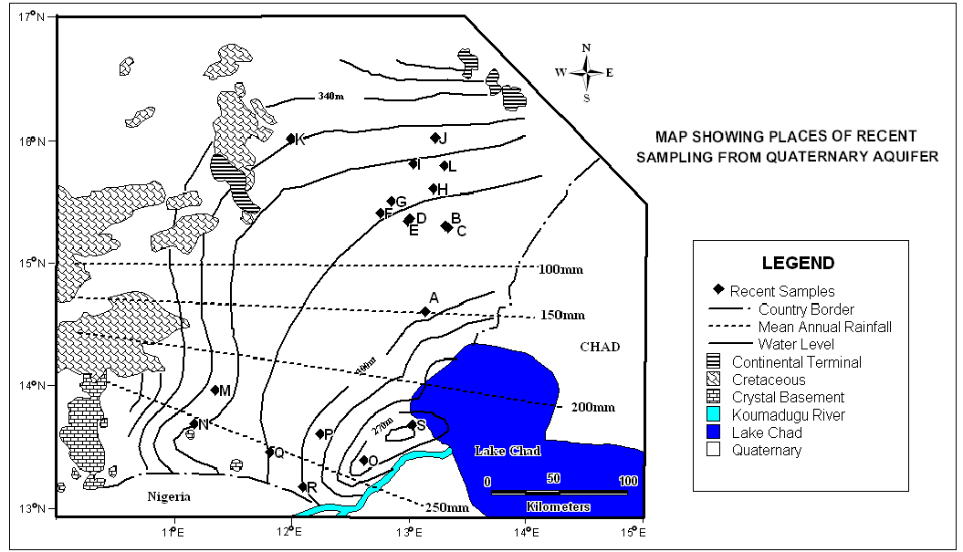

Figure2. Map showing recent samples distribution from quaternary aquifer, water level isolines (every 10 m) and mean annual rainfall (every 50 mm)

Table II. Main characteristics of former samples from the Quaternary aquifer in Niger side [12]

Locations | Longitude | Latitude | Conductivity  Electric  (μScm⁻¹) | Water Level  (m) | δ¹⁸O  (‰ vs. SMOW) | δ²H  (‰ vs. SMOW) | ³H  (TU)
1 | 12°18 | 13°39 | 236 | -19 | -6.92 |  | 0.4
2 | 12°02 | 13°13 | 1143 | -45 | -4.55 |  | 0.8
3 | 12°00 | 14°04 | 3106 | -10.7 | -6.02 |  | 168
1 | 11°44 | 14°16 | 607 | -6.6 | -4.41 |  | 5.4
5 | 11°20 | 13°59 | 571 | -16.2 | -4.12 |  | 75.6
6 | 11°12 | 13°13 | 183 | -12 | -4.31 |  | 0.8
7 | 12°02 | 13°45 | 325 | -19.5 | -4.99 |  | 1.1
8 | 11°31 | 15°38 | 377 | -30 | -5.48 |  | 7.8
9 | 11°15 | 16°06 | 631 | -12 | -8.59 |  | 2
10 | 13°18 | 15°03 | 180 | -13.3 | -5.20 |  | 1.7
11 | 13°12 | 15°19 | 520 | -10.3 | -4.41
12 | 13°12 | 15°59 | 324 | -8.6 | -6.26
13 | 13°13 | 16°09 | 507 | -21.9 | -6.02 |  | 0.9
14 | 13°19 | 16°46 | 956 | -2.8 | -5.50 | -47 | 5.2
15 | 13°43 | 16°32 | 2320 | -7.6 | -5.10 | -48 | 5.8
16 | 13°10 | 15°06 | 219 | -18.7 | -4.70 | -35 | 5.7
17 | 13°22 | 15°25 | 939 | -9.5 | -3.10 | -30 | 256
18 | 12°19 | 13°24 | 1515 | -36.9 | -5.80
19 | 12°27 | 13°18 | 223 | -34.7 | -3.31
20 | 11°13 | 13°46 | 570 | -10 | -4.33
21 | 12°01 | 13°46 | 1040 |  | -5.26
22 | 12°31 | 15°01 | 476 | -15.5 | -5.18
23 | 13°06 | 14°19 | 167 | -6 | -6.85
24 | 13°10 | 15°30 | 913 | -6.7 | -5.70
25 | 13°09 | 15°45 | 965 | -5 | -3.85

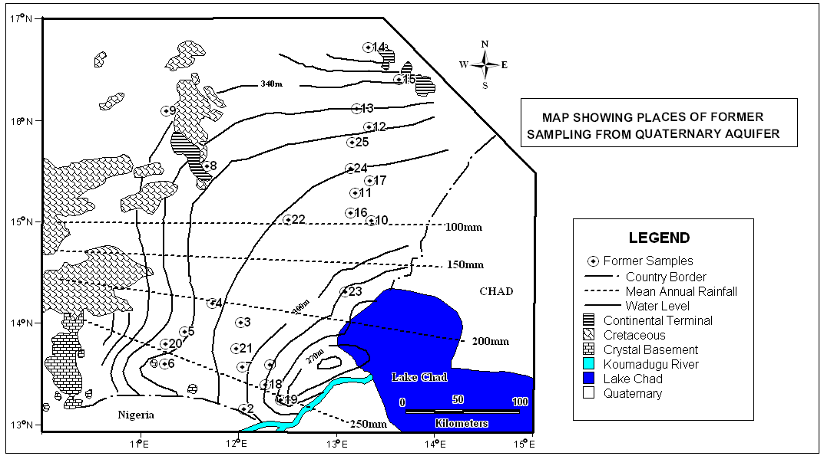

Figure3. Map showing former samples distribution from quaternary aquifer, water level isolines (every 10 m) and mean annual rainfall (every 50 mm)

Thus, the data that we have been exploiting by a model adapted to the mode of recharge of major Sahelians aquifers [16]. The content of tritium in the aquifer during the year i is calculated by:
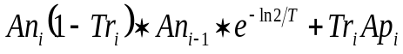

With An_{i} the tritium content in aquifer during year i, An_{i-1} the aquifer tritium content during year i, T the tritium half life (12.32 years), Ap_{i} the rain tritium content during year i and Tr_{i} the renewal rate for the year i. The model takes into account the radioactive decrease of tritium and represents the annual evolution of the isotopic composition of the aquifer and rain infiltrated until the date of sampling, i.e. 1968. It allows a calculation of renewal rate on each elementary volume assumed homogeneous and of depth equal to the wet thickness of the aquifer. The catch of load or not of horizontal transfers does not modify the results significantly because of their weakness. Excluding the values greater than 100 TU, the median renewal rate of the aquifer calculated is 0.09% for an average of 0.25%. The transcription rates of renewal blade of infiltration yearly require an evaluation of the water stock present in the aquifer. Thus, assuming a porosity of 10%, a thickness of 35m in the Lake Chad Basin, it would recharge from 2 to 3mm/year. Based on the model of perfect blend cited above, the ³H median content of the aquifer in 2009 should be 2.57 TU.

- Discussion
The isotopic abundance of precipitations represents the current function “in put” of the aquifers and thus constitute a reference for the interpretation of the isotopic content of groundwater. Not having isotopic measurements of precipitations, we filled this gap by referring to the monthly chronicle of the IAEA in N’Djamena between 1965 and 1978 (IAEA, 1992). The rains of N’Djamena are aligned approximately on a straight line δ ²H = 6.3 δ¹⁸O + 4.2 (B. Ngounou). The intersection of this line with the global meteoric line (δ²H = 8δ¹⁸O +10) gives the average content of ¹⁸O (- 3.40 ‰) of the moist air mass which is at the origin of precipitations falling on the studied area.
The first indicator of the former water presence in the arid and semi arid-regions is the content of stable isotopes. The isotopic seal very impoverished of some groundwater samples correspond to the episodes of groundwater recharge occurred under climatic conditions colder and wetter than those currently prevailing in the study area.
In view of the results of Table 1, we distinguish three groups of water on the basis of ¹⁸O content. (1) The impoverished water with a content of ¹⁸O variable between -5.12 to -6.16 δ ‰ VSMOW. These very negative samples (in relative values) are the reflect of: (i) water from relief’s, (ii) an effect that reflects a palaeoclimatic recharge during colder climatic conditions, (iii) a selection in the rains, (iv) the combination between these various parameters. (2) Group water content of ¹⁸O ranging between -4.00 to -5.12 δ ‰ VSMOW. This group corresponds to the water recharged significantly from same altitude. (3) Group of water enriched with ¹⁸O and content ranges between -2.15 to -4.00 δ ‰ VSMOW. For this water, we consider two subgroups: surface water evaporated (Koumadugu River, water of Lake Chad) and water from the crystalline. Content of tritium in the waters of the first subgroup shows well exchange with surface water, or the rainfall or even with atmosphere. For water crystalline can be distinguished the family of water in the crystalline of granite type and the family of water in the metamorphic zones, more schistose where circulations are more difficult therefore slower.
The results show that in the Quaternary aquifers in the study area, the contents of ¹⁸O are established between -6.16 and -2.15 ‰ VSMOW and contents of ²H between -49.6 and -19.5 ‰ VSMOW, with a median of -4.04 ‰ and -35.45 ‰ respectively. In the diagram δ²H vs δ¹⁸O, the contents of isotopes are distributed along a straight regression line δ²H = 5.65δ¹⁸O - 11.95 with R² = 0.5726 (Figure X) from which the slope is different from the rains of N’Djamena. This slope (5.65) is lower than global meteoric water line (GMWL). It attributes the different slopes to the enrichment phenomenon due to the evaporation of precipitation during his fall towards the ground. Moreover, in the area, the distribution of precipitations due to monsoon can be strongly modified by the lines of grains which move from east to west and the conditions of appearance of the corresponding downpours can deeply modify the isotopic composition of precipitations and groundwater [22].
Moreover, the slope of the δ²H vs ¹⁸O line is less than that global meteoric water line and higher than the slope of N’Djamena precipitation suggests that the waters of the quaternary aquifer were infiltrated very briefly under a colder climate and at a temperature lower than that in 1965-1978, or it is fossil water which does not depend on the current hydrological cycle [10]. Thus, water which contributed to the recharge of the deep water did not undergo evaporation during fall. Consequently, impoverishment in heavy isotopes of shallow groundwater towards deep levels testifies a lower contribution of current rainfall recharging the deep aquifer, and therefore the presence of a stock of water probably older.
Thus, assuming a porosity of 10%, a thickness of 35m in the quaternary aquifer of the Lake Chad Basin, it would recharge from 2 to 3mm/year. Based on the model of perfect mixture cited above, the median of ³H content of the aquifer in 2009 should be 2.57 TU, value obtained by extrapolating from former data. The tritium activity less than 4 TU corresponds to the contents in precipitation before the thermonuclear tests, and thus recharge before 1953. These waters can be associated with oxygen-18 relatively impoverished. This phenomenon could be linked to the infiltration of these waters during the heavy rains of 1940-1950 years or more old, a period marked by less evaporation and more mass effect. These waters are characteristic of aquifer with reduced permeability and very slow flow related to a low renewal rate and consequently a longer residence time. To the north-west of Lake Chad Basin (Niger oriental) the order of magnitude renewal rate (0.10%) obtained from the ³H model would lead to a median duration of residence in the aquifer of 1, 000 years. This is coherence with stable isotopes that indicate a mixture of water more recent and older than 4, 000 years.
Various studies have been done in other semi-arid areas with various estimates and annual recharge has been proposed based on: (i) profiles of chloride and Tritium in the Kalahari, 9 to 22mm/year for annual precipitation between 400 and 450mm, (ii) according to Tritium profiles in Senegal, 22 to 26mm/year for an annual rainfall of about 330mm [2]. This variability is related to the multiplicity of topographic conditions, climate, and biological. The values which I have got (2 to 3mm/year) according to the model of reconstitution seem weaker. However, they or they are closer to those proposed by Allion and Huges in Australia, obtained from profiles of chloride and tritium (0.1 to 3mm/ year) for an annual rainfall of 335mm. Piezometric observations made some ten years in the Niger part of Lake Chad Basin show that the Quaternary aquifer has evolved very slowly despite the severe drought of the mid 70's and 80 [17].
- Conclusion
The study of isotopes composition of the water molecule thus constitutes a temporal marking which made it possible to approach in a qualitative recharge of the Quaternary aquifer. In the Sahelien zone, direct infiltration from rainfall through the non-saturated zone is usually very small. This is the case in the Lake Chad drainage basin, where the very difficult climatic conditions (alternating wet and dry phases during the last millennia) gave signals of contrasting isotopic rainy still discern in the aquifer. Indeed, the proportion of old and recent water is an indication of the renewal in the Quaternary aquifer. However the evaporating indices are less rare in the Quaternary aquifer of the Lake Chad Basin. The recharge into the quaternary aquifer is due mainly to seepage through beds of Lake Chad, Rivers Logone-Chari, local ponds and non permanent rivers (Yobe Komadugu) largely exposed to the evaporation.

Acknowledgement
This research was supported by China Scholarship Council and China University of Geosciences (Wuhan), School of Environmental Studies. We wish to thank the China Scholarship Council and the Hydrogeology and Water Resources Department of the School of Environmental Studies of China University of Geosciences in Wuhan for their support.

Correspondence to:
Massing Oursingbé
Department of Hydrogeology and Water Resources, School of Environment Studies, China University of Geosciences, 430074-Wuhan, Lumo Road 388, Hubei, People’s Republic of China
Telephone: (+8627)59723504
Emails: massing.2@hotmail.com/massing_ii@yahoo.fr

References
[1] Aizen, E.M., Aizen, V.B., Melack, J.M., Nakamura, T., Ohta, T., 2001. Precipitation and atmospheric circulation patterns at mid-latitudes of Asia. Int. J. Climatol. 21, 535–556.
[2] Aranyossy J.-F., Caye C.-B., 1992. The research of thermonuclear tritium peak in deep unsaturated under semi-arid climate for measurement of the recharge of groundwater: first application in the Sahel, C. R. Acad. Sci. Paris, série II 315; p637-643.
[3] Bhishm Kumar and M. Someshwar Rao., 2005. Mathematical Models in Hydrogeochemistry: Assessment of Groundwater Quality and Management. AL. Ramanathan, S. Chidambaram, A.K. Keshari eds: Application of Nuclear methods for Groundwater Assessment, p189-193
[4] Boronina, A., Favreau, G., Coudrain, A., Dieulin, C., Zairi, R., 2005. Data scarcity in the large semiarid Lake Chad basin: incorporating environmental tracers as a priori information for groundwater modeling. In Proc. of Int. Conf. ModelCare’2005, Den Haag, The Netherlands.
[5] Boronina Anastasia., Guillaume Ramillien., 2007. Application of AVHRR imagery and GRACE measurements for calculation of actual evapotranspiration over the Quaternary aquifer (Lake Chad basin) and validation of groundwater models. J. Hydrol., (2008) 348, 98– 109.
[6] Boyle, E.A.,1997. Cool tropical temperatures shift the global δ¹⁸O–T relationship: An explanation for the ice core record ¹⁸O-borehole thermometry conflict? Geophys. Res. Lett. 24, 273–276.
[7] B. Ngounou Ngatcha., J. Mudry., J. F. Aranyossy., E. Naah., J. Sarrot Reynault. 2007. Apport de la géologie, de l’hydrogéologie et des isotopes de l’environnement à la connaissance des «nappes en creux» du Grand Yaéré (Nord Cameroun). Revue des sciences de l'eau / Journal of Water Science, vol. 20, n° 1, 2007, p. 29-43. http://id.erudit.org/iderudit/014905ar
[8] Craig, H., 1961. Isotopic variations in meteoritic water, Science 133; p1702-03
[9] Eberschweiler, C., 1993b. Monitoring and management of groundwater resources in the Lake Chad Basin: mapping of aquifers water resource management. Final report R35985. BRGM, Orleans, France.
[10] Edmunds W., E. Fellman., I.B. Goni., Prudhomme., 2002. Spatial and temporal distribution of groundwater recharge in northern Nigéria. Hydrogeol. J., 10, 205-215.
[11] Fröhlich, K., Gibson, J.J., Aggarwal, P., Deuterium excess in precipitation and its climatological significance. J Geophys Research-Atmosphere (submitted for publication).
[12] IAEA/WMO., 1998 Global Network of Isotopes in Precipitation. The GNIP Data base. http://isohis.iaea.org/.
[13] Kevin M. Hiscock., 2005. Hydrogeology: Principles and Practice, Environmental isotope hydrogeology. ISBN0-632-05763-7;BlackwellScience Ltd. P122-140www.blackwellpublishing.com
[14] LCBC (Lake Chad basin Commission)., WAEA (Water for Agriculture and Energy in Africa)., 2008. High level conference on water for Agriculture and Energy in Africa: The Challenges of Climate Change; Round Table: to save Lake Chad Background paper
[15] Leblanc, M., 2002. The use of remote sensing and GIS for water resources management of large semi-arid regions: a case study of the Lake Chad Basin, Africa. Ph.D. thesis, Department of Geosciences, University of Glamorgan, UK.
[16] Leduc C., Taupin J.-D., Le Gal La Salle C., 1996. Recharge of Continental Terminal water-table (Niamey, Niger) estimated from tritium measurements and modeling, C. R. Acad. Sci. Paris, série Ila 323 p599-605.
[17] Leduc C., Salifou O., Leblanc M., 1998. Evolution of water resources in Diffa department (Lake Chad Basin, South-East Niger), in : Servat E., Hughes D., Fritsch I.M., Hulme M. (éds), Water resources variability in Africa during the XXth century, AlSH publ. no 252, Wallingford, CB, pp. 281-288.
[18]Muhammad Sani ADAMU., 2007. Groundwater as part of the work of Lake Chad basin Commission (LCBC)
[19] Olivry, J.C., Chouret, A., Vuillaume, G., Lemoalle, J., Bricquet, J.P., 1996. Hydrologie du Lac TchadMonographie Hydrologique, vol. 12. ORSTOM Publication, Paris, France.
[20] PNUD-FAO-CBLT, Study of the water resources of Lake Chad Basin for a development program. Volume I. Hydrogeology, FAO Technical Report, Roma, 1973, 95 p. + cartes.
[21] R.K. Singhal., 2005. Mathematical Models in Hydrogeochemistry: Assment of Groundwater Quality and Management. AL. Ramanathan, S. Chidambaram, A.K. Keshari eds: Application of Stable and Radioactive Isotopes in Groundwater Geochemistry, pp219-223
[22] Taupin J.-D., Callaire R., Fontes J.-C., 1995. Isotopic study of rainfall in the Sahelian zone (Niger) along two sections, east-west (Lake Chad- Niamey) and north-south (Agadez-Niamey), in: Adar E.M., Leibundgut C. (éds), Application of tracers in arid zone hydrology, AlSH publ. no 232, Wallingford, CB, pp. 285-292.
[23] Touchebeuf de Lussigny P., 1969, Monographie hydrologique du Lac Tchad, ORSTOM, Paris, 169 p.

01/02/2010

