Effect of drought stress on corn root growth

Tayeb Saki Nejad^{1*}, Abdolmahdi Bakhshande², Saeed Bromand Nasab³, Khoshnaz Payande¹
1- Assistant Professor Department of Agronomy Physiology, Islamic Azad University, Ahvaz branch
2- Professor Department of Physiology, Ramin Agriculture University
3- Professor Department of Irrigation, Shahid Chamran University
*Corresponding Arthur: Tayebsaki1350@yahoo.com
Abstract: Research in Islamic Azad University research farm in southwest and 3 kilometers away the city of Ahwaz with an average rainfall of 256 mm was performed. A split plot design experiment in randomized complete block design (treatments main plot: different amounts of irrigation (I) and sub-plots: plant growth phases(S)) was performed with four replications. Drought conditions, important parameters such as root length, number, weight and root volume, decreased if mild water stress to some extent in root length was increased, but severe water stress conditions root length was significantly reduced, but treatment mild water stress during root 16.7 cm g soil to control increased weight, root length and number of roots unlike the mild stress can be increased to some extent, by applying the smallest levels of water stress, decreased in severe water stress treatments 17.7 grams per plant almost half the root weight without stress treatment was water, full size dependence root growth components such as the number and weight of roots decreased in the past two components of stress, volume Root also decreasing trend has provided four tests mean Duncan will provide that treatment (control) and treated with 151cc highest volume I₃ with severe water stress 81cc scaled lowest water cylinder size showed. The ratio of root to shoot in different levels of water stress decreased shoot and root weight decreased, but both decreasing trend in shoot weight of so much more stress the process of root weight was reduced. Comparing two-phase vegetative and reproductive growth period (respectively S₁ and S₂) of root weight reduction process at different levels of water stress, it was clear that root weight decreasing trend in the treatment of stress treatment, S₂ very more S₁ was in treatment S₂, percentage of root weight significantly decreased 47% in treatment S₁, but this value was 24%, respectively.
Keywords: corn root, drought stress, growth

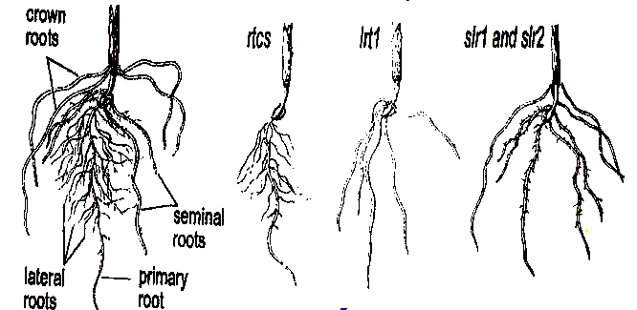
1.Introduction
Status of soil and water is one of the most important factors that affected on root growth and the genetic analysis of maize roots (Frank Hvldyngr Hach, 2008), announced the following results:
1 - Gene Rtcs, the formation of seed roots and they are expanding, expanding process may be vertical or horizontal expansion that this process completely dependent temperature and soil moisture is, the growth of corn root temperature C º 18 to about 30 degree horizon and the temperature C º 36 with angle is 61 degrees.
2 - Gene Lrt1, the growth of corn roots is horizontal and a high dependence of soil moisture, the moisture deficiency, the effect of this gene is limited, the horizontal expansion of corn roots, reduced root growth of vertical continues.
3 - Slr1 and Slr2 genes, that if water deficiency, the effect of higher gene Lrt1 and all growth is vertical roots (Figure 1).
Many studies have Any soil that is dry root value will be less if the soil is wet for a long time, longitudinal growth and slower root dry reverse the long, longitudinal growth of roots down is faster (Doerr and colleagues, 2004). Between root depth and soil moisture and soil used are related in that That planting corn, soybeans, barley gross soil water storage capacity less Microweave soil have deeper roots in (Bltrans, 2003 ). Some researchers used to estimate soil moisture regime quickly have used the root system (Svdvng and colleagues 2004). Generally observed that root growth potential of blue artifacts MPa 50 - and started to decrease to about MPa 1500 - would continue to slow (Padvna, 2003), this year oats plants, gramineous species of corn, peas, grapefruit juice, tomatoes and soybeans has been achieved (Syang 2003).

Figure 1.Effect genes on root growth
If part of the roots of corn and tomatoes should be in the proper humidity, other parts of the roots can be less than potential moisture MPa 4 - must grow as well (Tamhyda , 2001). Tajayy root growth in soil moisture that can be enough ventilation is limited (Sblny, 2001).
The relationship between soil water potential and plant water potential is also found. (Lvgzdan and colleagues 1999) that the moisture of the root of corn low matric MPa 09/1- did not decrease. More root part of plants that soil moisture will have been gathering (Narsyna, 2001), if the soil is dry roots in soil depth profiles draw more development. In general, the soil with little water storage capacity, depth of roots, stem and soil storage capacity above the roots are shallow. Soil moisture on significantly affect the root morphology. The results of the growth of corn in a silty soil by Lvm (Mac When and Barber 2004) can be reported for example be mentioned. Increase soil moisture of 22 (MPa 1730 =) to 32 percent (MPa 8 / 7 =) significantly increased total root length, length of hairy roots, hairy root density and root surface from the hairy roots level are, respectively. Dryness and excessive soil moisture development of hairy roots prevent the house.
Figure 2.Effect drought on corn root
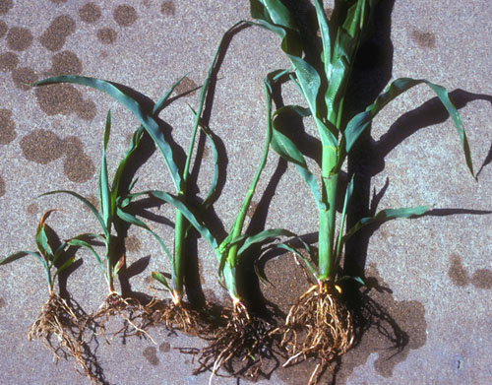
2.Materials and Methods
In this experiment a split plot design in randomized complete block design with four replications was tested in the field of Islamic Azad University research and distance 3 km southwest of Ahvaz city with an average rainfall of 256 mm was performed. Location experiment and semi-arid climate is dry and the 40-year Meteorological Data Ahvaz 94/213 mm average annual rainfall, mean annual temperature of 24/25, 92/32 annual average maximum temperature, mean minimum degree temperature annual 4 / 18 ° C is. Minimum temperature in agronomic 87-86 5 / 6 in January and maximum temperature in September 53 has been reported.
Before running experiments, to study farm soil, the depth of samples of 30-0 and 60-30 cm was performed (Table 1). The three parameters fixed 22/21 = FC, 7 / 13 = PWP and 19 / 1 = Pa g cm cubic method and cylinder pressure plates gauge size was measured.
Table 1: Results of soil analysis
soil | Deep (cm) | EC | Organic matter (%) | PH | Nitrogen  (ppm)
Silty | 0-15 | 6.5 | 0.6 | 7.7 | 635
Silty | 15-30 | 6.6 | 0.3 | 7.6 | 648
Clay loam | 30-60 | 5.7 | - | 7.3 | 211

Table 2: Review of different treatments tested
Main plot:  Drought stress Levels | Sub-plots:  Different growth phases
I₀ : Full irrigation point of FC, control, without water stress | S₀: growing phase, the establishment of the plant stem to the emergence
I₁ : 75% of the amount of irrigation treatments I₀, mild stress | S₁: natal phase: to stem the rise of coffee being resilient and end silk pollination
I₂ : 50% of the amount of irrigation treatments I₀, severe stress | S₂: grain filling phase: the end of pollen grain maturity and the emergence of black layer
I₃ : 25% of the amount of irrigation treatment I₀, very severe stress and point of PWP | -
2.1. Morphological characteristics calculated root
2.1.1. Root dry weight: washing with distilled water and drying the roots by placing 20th in Avon for 10 hours (depending on thickness and succulent roots) in the temperature of the root dry weight of 75 grams per plant was calculated.
2.1.2. The root length: root for the measurement using the drill sampling (15 Mthhay cylinder height and diameter of 7 cm) soil samples with roots were obtained after separating the roots, soil samples were immediately weight, then using the formula Newman and application of millimeter graph paper address the networking, the root length of root per unit cm g soil, respectively.
2.1.3. Number and size of root: root volume measure water movement and graduated cylinder for counting the number of notes taken root and were used.

Figure 3.Effect drought on root length

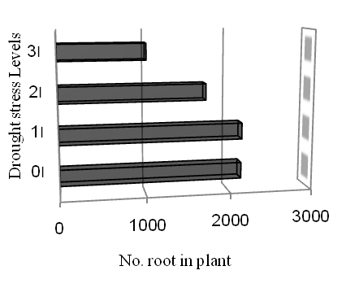
3. Results
Analysis of variance showed that the effects of water stress treatments, periods of growth and interaction of these two length, number, weight and root volume, were significant. Drought conditions, important parameters such as root length, number, weight and root volume, decreased although mild water stress to some extent I₁ root length was increased, but severe water stress reduced root length I3 can clear all but the mild treatment Water stress root length 20.11 cm of soil to warm control unit with increased 19.11 Duncan test showed that mean 21.14 treated with the highest root length I1 and I₃ treatment with the lowest root of 10.87 were present (Figure 2)
During phases of growth, treatments S₂ and S₃ that have done their full growth in terms of statistical difference, although not with each other on the study of root length data, which had root treatment S₃ (grain filling period) than treatment 2 S₂ probably because of the elimination of aging is part of the plant root, growth period S₁ (before the advent of double ring) lack of complete root development offers very little but what to plant to plant by the rapid growth stage, treatment S₂ goes, with increasing age of plant increased root length. Maximum root growth during the S₂ and S₃ was that although the terms of the two treatments did not show statistically different, but treatment 2 S will provide more of the root, the lowest growth in root length with treatments S₁ mean 0.17, respectively (Table 3) Growth phases of treatment, the highest number of roots in treatment S₃ (grain filling period) and treatment S₂ (reproductive growth period and after the formation of double ring) was obtained due to the completion of that plant and root growth occurred.

Figure 4.Effect drought on number root

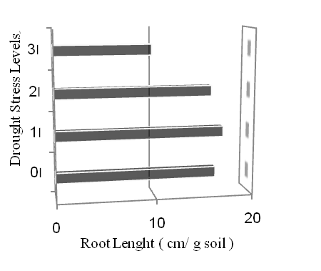
Table 3: Comparison of mean length, number, weight and volume of root Duncan test method
Treatment | root volume  cc | root weight  g/plant | root number  in plant | root length cm/g soil
I_{o} | 152a | 29.12a | 2275b | 19.11a
I₁ | 131b | 26.14b | 2282a | 20.01a
I₂ | 122c | 22.08c | 1823c | 17.23a
I₃ | 81d | 15.17d | 1117d | 10.7c
S₁ | 5b | 0.85b | 9b | 0.17b
S₂ | 132a | 25.8a | 2044a | 12.8a
S₃ | 132a | 25.81a | 2047a | 12.1a

Number of roots similar trend root offers various water stress and mild water stress increased the number of roots Duncan test, different treatment irrigation (I) to four groups can mean separation, treatment group I1 with the highest numerical average 2276 higher plant roots rest Water stress treatments were applied to the other with mild stress root number significantly with control (without water stress) was all the controls were. imposing severe water stress treatment, the number of significant reduction in plant roots can be found, but each What will increase the severity of stress, number of roots showed significant reduction in severe water stress (treatments 3I) Total root number per plant 2157 (without water stress) to 1016 numbers per plant decreased, following comments can specify the causes of this phenomenon must. Thus reducing the pressure necessary growth mechanical resistance of soil dryness, the number and root length reduction become. Different phases of increased root growth in S₂ above the other two were treated in S₁ in terms of number of roots in the lowest group mean

showed the number of roots in other words, much
less period of growth and full reproductive growth period the grain (Table 3).

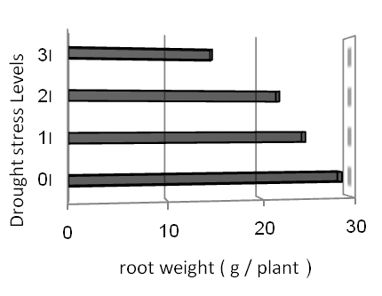
Figure 5.Effect drought on root weight

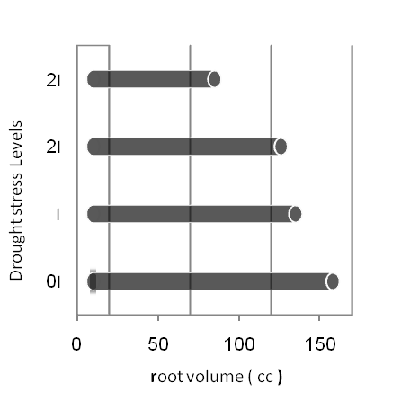
Unlike root weight and length, number of roots that mild stress can be increased to some extent, by applying the smallest levels of water stress, decreased so that the severe water stress treatments 7 / 14 grams per plant, almost half the root weight control was 5% level Duncan's test showed different levels of water stress were divided into four groups the highest mean average control group without stress and water lowest average treatment group 3I (severe treatments water) were other words with increasing Water stress significantly reduced root weight demonstrated. Holdyngr (2001) except that the relationship between root weight and root length is a negative relationship with increasing unfavorable environmental conditions the regression trend more negative self-will, as seen in this experiment, the different levels of water stress intensity of water stress (mild stress such as treatment) increased root length, but root weight decreased growth phases Duncan's test, two groups mean that they provide treatment group 2 S and 3S in the second group of treatments 1 S root weight limit were very low, showed the (Table 3)
Size dependence of root growth complete with components such as root number and root weight are two factors that reduce the effects of recent drought stress, root size reduction process has provided the Duncan test four groups to provide mean that treatment (control) with the highest volume and 151cc treated with I₃, 81 cc lowest graduated cylinder of water showed root size. And growth phases of the test can identify two groups mean that in group S₂ and S₃ treatments that had the highest root size and the second group treated with S₁ root size were lowest growth restriction and development of corn root stress drought by different models such as models Avrtly (1996), Boyer (2001) and Richard (1992) is presented as the Hgy these models has been limited development of lung water roots in soil is limited, especially "in the high tensions develop vocal been very deadly and the number of vocal intensity decline to find that this reduces root size and the absorption radius is rooted in the soil is limited (Table 3).
Figure 6.Effect drought on root volume
Investigated physiological parameters shoot to root ratio was observed both component weight and shoots decreased with water shortage but decreasing trend in shoot weight of drought much more than root weight was decreasing trend Boyer (1991) announced the change of root stress and environmental conditions such as less than body Air is the result of these factors, shoot to root ratio decreased, the amount of moisture near the root intake and water source, i.e. soil and roots of sweating, lack of light and temperature environment, and ultimately root less than in terms of environmental changes is to shoot and so much slower than changes in root depth is caused shoot. Comparing two growth periods 1 S and S₂ of root weight reduction process at different levels of water stress, it was clear that the trend of decreasing root weight water stress treatments S₂ very more treatments S₁ was in treatment S₂, percent weight loss treatments to control root 47%, but treatment S₁ this value was 24%, respectively.

4. Discussion
Drought conditions, important parameters such as root length, number, weight and root volume, decreased if mild water stress to some extent in root length was increased, but severe water stress conditions root length was significantly reduced, but treatment mild water stress during root 7 / 16 cm g soil to control increased weight, root length and number of roots unlike the mild stress can be increased to some extent, by applying the smallest levels of water stress, decreased in severe water stress treatments 7 / 17 grams per plant, i.e. almost half the root weight without stress treatment was water, shoot to root ratio at different levels of water stress decreased shoot and root weight of both the decreasing trend of decreased body weight Air stress caused much greater reduction of root weight in the process of root size dependence with complete root growth components such as the number and weight of roots decreased in the past two components of stress, the process of root volume decreased.

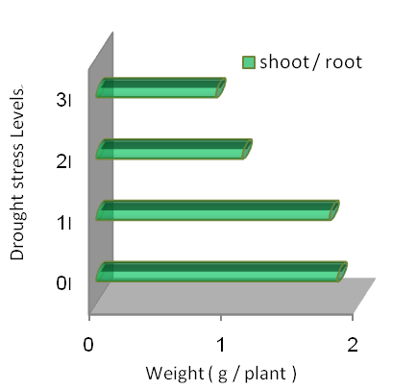

References
- Azaizeh, Hassan.; Steudle, Ernst. Effects of Salinity on Water Transport of Excised Maize (Zea mays L.) Roots . Plant Physiol. 1991 Nov;97(3):1136–1145
- Almekinders CJM, De Boef W (2000) Encouraging diversity. The conservation and development of plant genetic resources. Intermediate Technology Publications, London
- Almekinders CJM, Elings A (2001) Collaboration of farmers and breeders: participatory crop improvement in perspective. Euphytica 122(3):425–438
- Badstue LB, Bellon MR, Berthaud J, Ramírez A, Flores D, Juárez X, Ramírez F (2005) Collective action for the conservation of on-farm genetic diversity in a center of crop diversity: an assessment of the role of traditional farmers’ networks. IFPRI-CAPRi, Washington, DC
- Boef W de, Amanor K, Wellard K, Bebbington A (1993) Cultivating knowledge. Genetic diversity, farmer experimentation and crop research. Intermediate Technology Publications, London
- Borcard D, Legendre P (2002) All-scale spatial analysis of ecological data by means of principal coordinates of neighbour matrices. Ecological Modelling 153(1):51–68
- Borcard D, Legendre P (2004) SpaceMaker2 – Users’ guide. Département de sciences biologiques, Université de Montreal, Montréal www.fas.umontreal.ca/biol/legendre
- Borcard D, Legendre P, Drapeau P (1992) Partialling out the spatial component of ecological variation. Ecology 73(3):1045–1055
- Braak CJF ter, Šmilauer P (2002) Canoco for Windows Version 4.5. Biometris – Plant Research International and Microcomputer Power, Wageningen and Ithaca
- Brush SB (2004) Farmers’ bounty. Locating crop diversity in the contemporary world. Yale University Press, New Haven & London
- Cleveland DA, Soleri D (2002) Farmers, scientists and plant breeding: integrating knowledge and practice. CABI, Wallingford
- Felsenstein J (2005) PHYLIP (Phylogeny Inference Package) version 3.65, Department of Genome Sciences, University of Washington, Seattle http://evolution.genetics.washington.edu/phylip.html
- Fu YB 2000. Effectiveness of bulking procedures in measuring population-pairwise similarity with dominant and co-dominant genetic markers. Theor Appl Genetics 100(8):1284–1289
- Fuentes MR (1997) Desarrollo de germoplasma de maíz para el Altiplano de Guatemala. Agronomía Mesoamericana 8(1):8–19
- Fuentes MR (2002) El cultivo de maíz en Guatemala. Una guía para su manejo agronómico. ICTA, Guatemala Fuentes MR n.d. ICTA B-7 (ts). ICTA, Guatemala
- Greene SL, Gritsenko M, Vandemark G, Johnson RC (2002) Predicting germplasm differentiation using GIS-derived information. In: Engels JMM et al (eds) Managing plant genetic diversity. IPGRI, Rome, pp 405–412
- Guarino L, Jarvis A, Hijmans RJ, Maxted N (2002) Geographic Information Systems (GIS) and the conservation and use of plant genetic resources. In: Engels JMM et al (eds) Managing plant genetic diversity. IPGRI, Rome

