Flowering of basal culms of thorny bamboo in the agroforestry system of Kanyakumari - Tamil Nadu, South India

Solomon Jeeva and Bental Daisy Sheeja*
Department of Botany, N.M. Christian College, Marthandam – 629 165, Kanyakumari, Tamil Nadu, India; E-mail: solomonjeeva@gmail.com

*Department of Botany, Womens Christian College, Nagercoil – 629 001, Kanyakumari, Tamil Nadu, India

Abstract: Bamboo has the peculiarity of flowering and seeding at the end of a very long vegetative growth phase. The length of the vegetative and reproductive phase is considered to be species specific. During the present study, we found that the gregarious flowering of Bambusa arundinacea in the coconut based agroforestry system at Vavarai village of Kanyakumari district and provides an opportunity for reforestation and natural regeneration of this potential resource.

Key words: Bambusa arundinacea, edible uses, Kanyakumari district, Tamil Nadu, India.

Flowering in angiosperms is a phenomenon through which the succeeding generation is sustained. Some members of the family Poaceae have the suicidal habit, where the parent plants die after flowering. Bamboos, a member of the sub-family Bambusoideae of Poaceae exhibit similar characteristics (Kiruba et al., 2007; Singha et al., 2008; Jeeva et al., 2009). On the basis of the flowering behaviour, bamboos are also been classified as: (a) those which flower periodically or gregariously, (b) those which flower annually and (c) those which flower irregularly (Brandis, 1906).

Most of the commercially important bamboo species belong to the first category i.e. those, which flower periodically in gregarious manner. They grow for decades and reproduce vegetatively and at the end of a definite period, flowering starts synchronously in all the daughter clumps originated from one parent clump even if they are widely separated geographically. Patches of such geographically separated bamboo forests which have same parental origin (may be several generations earlier) are called ‘cohorts’. In majority of the bamboo species, the flowered bamboo clumps die after seed setting. Gregarious flowering generally progresses from one end of forest to the other in waves. In a period of 2 to 3 years, the entire forest area would have flowered and all the bamboo clumps would be dead.
The exact physiological mechanism of bamboo flowering is yet not known precisely. Different evolutionary hypothesis are put forward to explain bamboo flowering. They are (i) Parental competition hypothesis – Bamboos form extensive continuous stands with very little canopy gaps. When flowering and seeding occurs competition from parent clumps will be very high for development of seedling. Hence the evolutionary trend is the death of parent clumps giving space to the offspring. (ii) Consumer satiation hypothesis – very large numbers of seed predators are reported for bamboos and this hypothesis suggests that bamboo produces large quantity of seeds, storage of food reserves takes long time. (iii) Climatic periodicity hypothesis- Bamboo flowering is associated with climatic factors like drought. All these hypotheses remain controversial. But it is a fact that there is a periodicity for flowering that is species specific. The present observations reveal that the physiological mechanisms associated with the flowering of bamboo needs no initiation or regulatory mechanism from the shoot apex or terminal bud, as the apical part of all the culms of the clumps were removed one year before the onset of flowering and yet the basal part of the culms alone started flowering.
Bamboos form an important component of the homestead agroforestry system in western part of Kanyakumari district. The people of Kanyakumari district utilize the bamboo for various purposes. During the present study flowering of Bambusa arundinacea was observed in the coconut based agroforestry system along the Neyyar left river bank stream side at Vavarai, located near the south west coast of Kanyakumari district at an elevation of 60m. As the mature culms are chopped for household purposes the blooming was seen around the basal culms of the clumps (Figure 1).

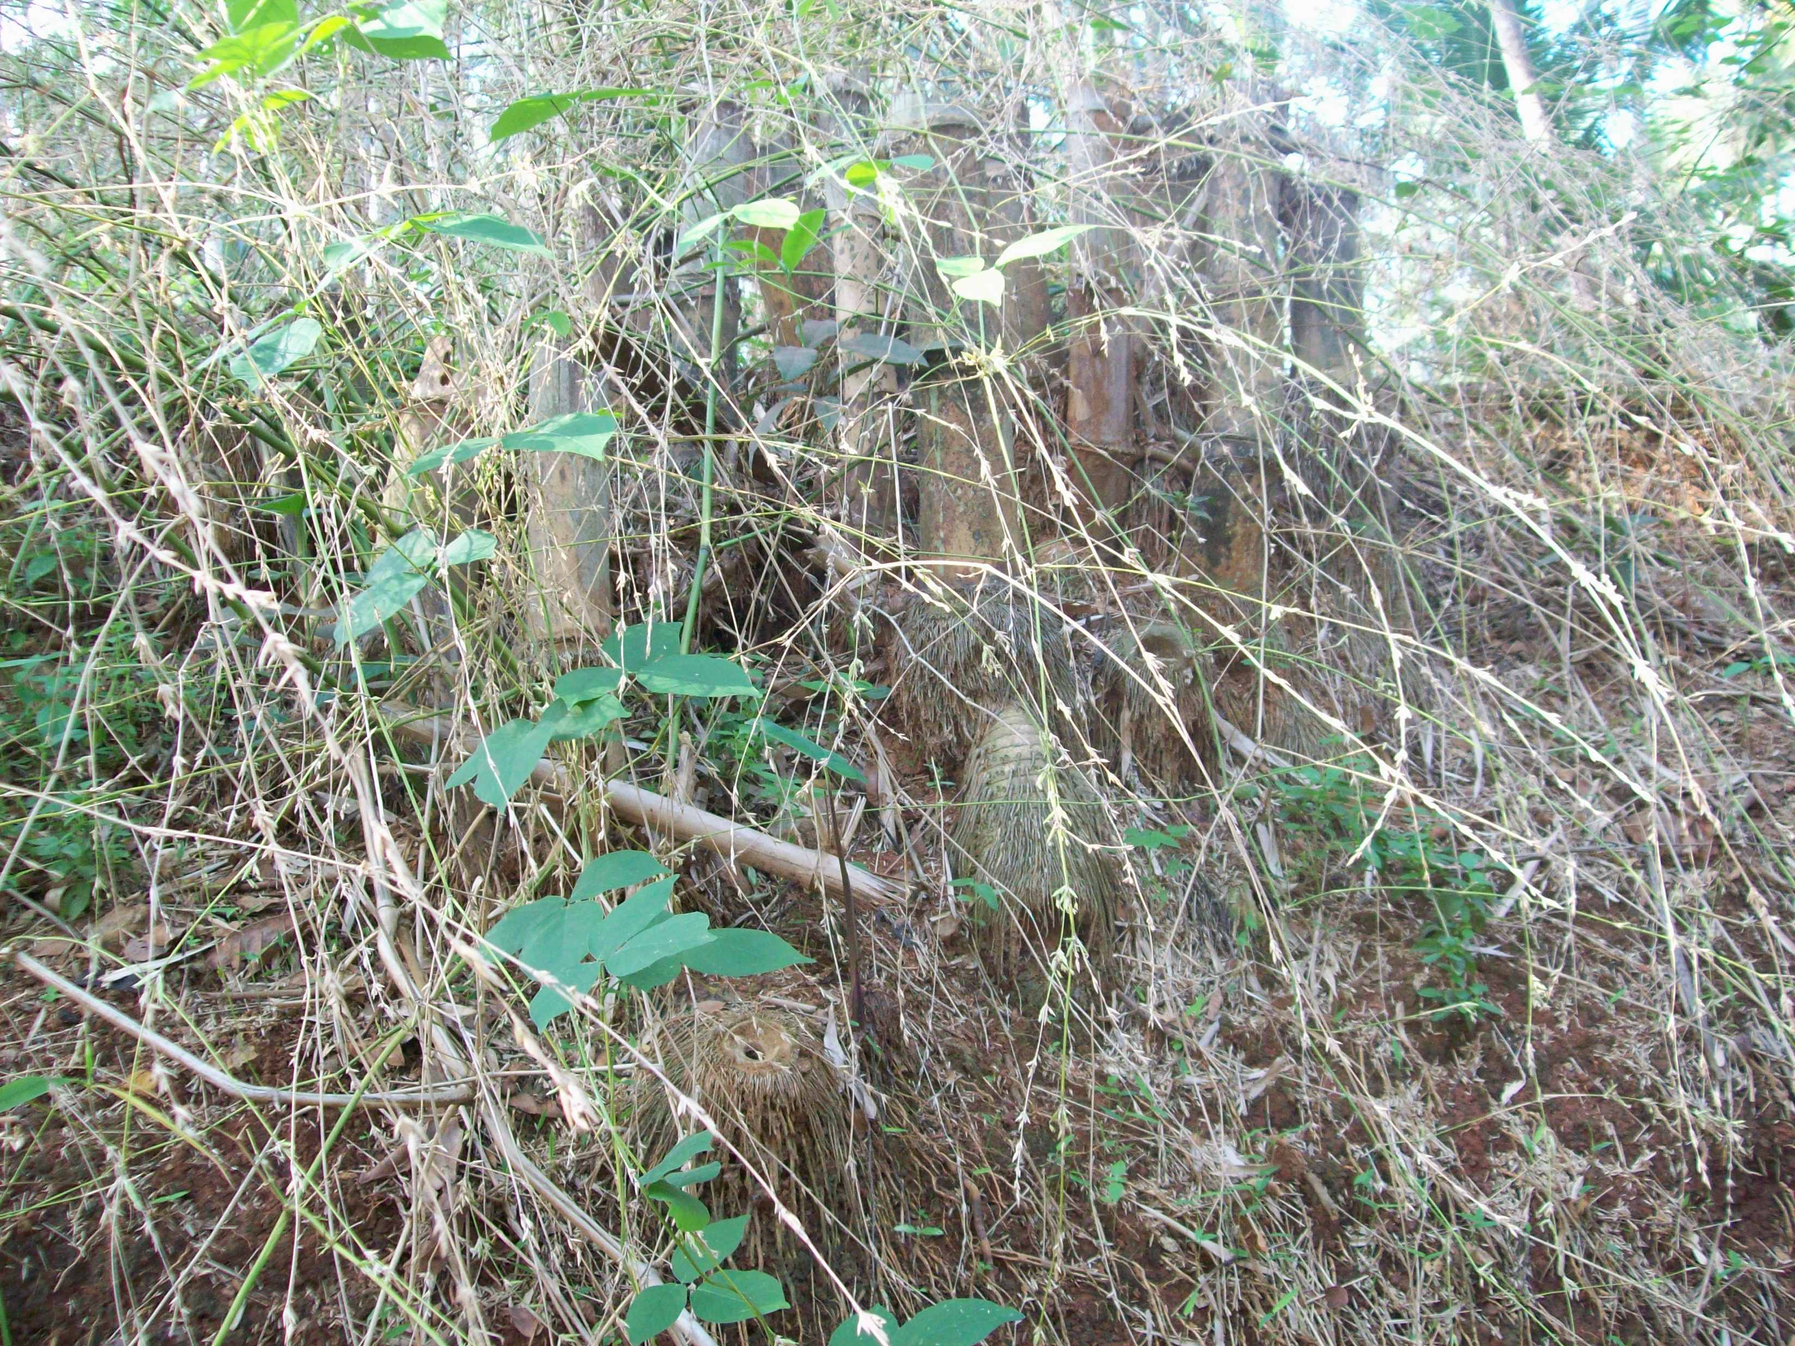

Brief Description of the Genus

Bambusa arundinacea Willd. belongs to the family Gramineae. This is one of the most common bamboos in the region, commonly called Mungil (in Tamil), and attains a height of 80 - 100 ft.; a diameter of 6 to 7 inch; inter nodes up to 18 inch long and having thick walls. Bambusa arundinacea is easily identified by its thorns and large yellow culm -sheaths. The culms are green and attain a straw yellow color on drying. It is indigenous throughout India (except in the North), Burma and Ceylon, ascending the hills up to 3000 ft. and abundant in the plains. Bambusa arundinacea flowers at long intervals and then dies down completely, reproducing itself from seed (Bourdillon, 1908).

Though bamboo flowering results in production of large quantities of seeds which in turn supports population explosion in rats, the quantity of seeds available for rats’ consumption diminishes soon after the germination of seeds following rains. The resultant short supply of bamboo seeds, on the one hand, and a large population of rats on the other, leads to a scenario where the rodents en masse march towards farmlands in adjoining areas causing wide spread loss of crops thereby raising the potential to trigger a famine. Many millions of people who depend directly or indirectly on bamboo for their livelihoods will suffer, and if famine strikes the whole populace of the region could be at risk. Therefore, Governments should take necessary steps to prevents famine and also for reforestation and natural regeneration of this potential bamboo resources.

Corresponding Author
Dr. S. Jeeva
Department of Botany
N.M. Christian College
Marthandam
Kanyakumari – 629 165
Tamil Nadu, India
E-mail: solomonjeeva@gmail.com; Tel.: +91-9952202112

References

Bourdillon, T.F. 1908. The forest trees of Travancore. The Travancore Government Press, Trivandrum.
Brandis, D. 1906. Indian Trees. Bishen Singh Mahendra Pal Singh, Dehra Dun, India.
Jeeva, S., Kiruba, S., Lalhruaitluanga, H., Prasad, M.N.V. and Rao, R.R. 2009. Flowering of Melocanna baccifera (Bambusaceae) in northeastern India. Current Science, 96(9): 1165-1166.
Kiruba, S., Jeeva, S., Das, S.S.M. and Kannan, D. 2007. Bamboo seeds as a means to sustenance of the indigenous community. Indian Journal of Traditional Knowledge, 6 (1): 199−203.
Singha, L.B., Bhatt, B.P. and Khan, M.L. 2003. Flowering of Bambusa cacharensis Mazumder in the southern part of North-East India: a case study. Journal of Bamboo and Rattan, 2(1): 57-63.

