Environmental Flow Modeling As A Tool For Water Resources Management

Mohd Ekhwan Toriman

School of Social Development and Environmental Study, Faculty of Social Sciences and Humanities, 43600. Universiti Kebangsaan Malaysia, Bangi Selangor Malaysia
ikhwan@pkrisc.cc.ukm.my

Abstract: In Detailed Environmental Impact Assessment (DEIA), modeling of environmental flows is one of the main studies that need to be delivered in the final DEIA report. The model is important to the project proponent to engage suitable designs that can be suited to environmental needs, particularly on future water resources management. In this respect, Environmental Flow Assessment (EFA) is used to estimate the quantity and timing of flows to sustain the ecosystem values. The proposed of hydropower projects in Sg Pelus, Perak was studied aimed to evaluate existing river flow characteristics and to model EFA due to river diversion of Sg Pelus. Daily river flow (m³/s) recorded at Sg Pelus (Station No. 6035) and Sg. Yum (Station No. 6044) gauging stations were used to design the flow duration curve. The low flow then calculated using the 7Q10 equation to estimate the lowest 7-day average flow that occurred on average once every 10 years. The results indicate that the average daily flows for both stations (6035 and 6044) are 5.080 m³/s and 11.391 m³/s, respectively. The flow duration curve shows that 50 percent of 4 m³/s of discharge will be exceeded/ equaled in Station 6044 while 8.2 m³/s of discharge will be exceeded or equaled in Station 6035. The requirement environmental flows for both parameters are 0.613 and 0.426 m³/s for Environmental Flow Assessment, respectively. The results obtained in this model are important to managing the river at least in Class II after river diversion project.

Keywords: Environmental Flow Assessment; Detailed Environmental Impact Assessment; Low flow; Flow duration curve.

- Introduction

Recent developments of legislation in Malaysia tend to consider environmental flows in the context of environmental sustainability (Mohd Ekhwan et al. 2009). It is considered a basic principle in sustainable development and in the search for ways to reconcile multiple and competing water uses with environmental protection. One important tool for implementing this approach in the water allocation process is multi-criteria analysis, wherein an environmental flow assessment provides a way to quantify the environment criteria (Hafizan et al. 2008).

Practically, the concept of environmental flows was implemented for a very specific purpose, i.e. protecting the aquatic fauna downstream river diversion (Arthington et al. 1992). Since then several different applications and interpretations have evolved that extend the original meaning. In some recent cases, it is considered to be an instrument to achieve water quality targets - together with other measures. In Malaysia, environmental flows are not prescribed in the national legislation in general terms, as framework laws. Current norms consider environmental flows only in the form of a minimum instream flows to be present downstream of water diversions. Eventually, this approach is part of the Detailed Environmental Impact Assessment (DEIA), to be presented by the developers in their Water Protection Plans.

This case study describes a scheme to integrate Environmental Flow Assessments (EFA) with hydrologic modeling tools in the Sg. Pelus, Perak Malaysia. The purpose is mainly for hydropower generation. It shows how environmental objectives were incorporated in multi-criteria analysis to develop flow regulation policies, particularly the portion where the river flow will be diverted. Typically the main challenge in such circumstances is to define an environmental score that can be computed for different scenarios – one that is inaccessible to experimentation and measure. The approach described overcomes this problem by using existing low flow methodology, namely the 7Q10 equation to define EFA.

The main aim of this study was to study the flow characteristics of Sg Pelus and the development of environmental flows requirement as related to river diversion project. The information is important to stakeholder and project proponent to estimate how much waters can be diverted that also can fully supply at all times without deteriorating the water quality and quantity as a whole.

- Conceptual Framework

In Malaysia, the total available electricity generating capacity was estimated at 19.3 GW in 2003, a jump of 23 % from 15.6 GW in 2002 due to the commissioning of several coal and gas based independent power plants in Perak, Perlis and Perai. The electricity generation in 2003 was 82,406 GWh, which represented an increase of 6 % from 77,501 GWh in 2002. The electricity generation in 2003, which was basically from thermal generation, contributed about 87 %, while hydroelectric only contributed 13 %. Out of 87 % thermal generation, 65 % was from gas turbine/ combined cycle block, 11 % was from coal-fired plant and 11 % was from gas/oil plant, which suggested that our electricity generation was highly dependant on natural gas (Hafez et al. 2009).

With increases in fuel (oil) prices, which was almost doubled in two years (2005 and 2006), hydropower is becoming increasingly appealing. Thus, hydropower is one of the alternatives to solve energy shortage in years to come. Despite the clean energy hydroelectric power plants can provide as an alternative of reducing dependence on non-renewable source, the government is constantly under criticisms for high cost of building dam, as well as environmental impacts of the dams (Mohd Ekhwan et al. 2009).

In certain activities which involved natural environment, particularly river diversion project, Environmental Impact Assessment is required by Department of Environment (DOE) to protect water source areas in headwater regions from degradation. A detailed Environmental Impact Assessment (DEIA) study must be carried out by the consultant at various perspectives, i.e. physical, biological, socio-economic including tourism, archeology and health to ensure that the impacts from the project are minimal.

One of the main criteria in DEIA, particularly in hydrological section is the need to EFA requirement. The idea is to address acceptable water quality for flow diversion, and at a same time to protect flora and fauna below the downstream river diversion. In a case of river diversion project, dry season become a subject matter where by water level normally at a minimum level. Therefore, the need to study minimum or low river flow characteristics is essential so that full hydropower electric can be supply at all times.

The most common low flow analyses for streams are twofold, namely minimum annual minimum flow and 7Q10 model analysis (Loneragan & Bunn, 1999; Rosenfeld et al. 2007). This study engages 7Q10 as this model is widely used throughout the world. In a case of Sg. Pelus, the 7Q10 was selected as a representative low streamflow value for regulatory and modeling purposes, particularly with respect to point-source pollution and concentration due to river flow diversion. Simply, the 7Q10 means “seven-day, consecutive low flow with a ten year return frequency; [or] the lowest stream flow for seven consecutive days that would be expected to occur once in ten years,” (Mohd Ekhwan & Shukor 2006). According to the World Meteorological Organization, low flow is the “flow of water in a river during prolonged dry weather”. Again, hydrologists use design flow statistics such as the 7Q10 or the lowest 7-day average flow that occurs on average once every 10 years to define low flow for the propose of setting permit discharge limits.

When the river is considered as unregulated natural river, the reliability of water availability is a function of the low flow characteristics (Petts 1984). The three main characteristics of low flow are:

- Duration - reflect the tolerance of the user to periods of water deficits.
- Magnitude - Low flow for specific duration will determine the amount of water that is available to the user (Pyrce 2004).
- Frequency of occurrence - The frequency of occurrence of low flow reflects the risk associated with the failure of water supply.

For this study, the 7Q10 flow was adopted as this method is the most commonly used single flow index (Table 1).

Table 1: Uses of the 7Q10 Flow

To protect/ regulate water quality ( to prevent adverse biology/ecological impacts)
General indicator of prevalent drought conditions which normally cover large areas
Total maximum daily load to assess aquatic life protection
Minimum quantity of streamflow necessary to protect habitat during a drought situation
Considered as the wroth case scenario in water quality modelling
To compare the impacts of climate change and irrigation on low surface streamflows

- Materials and Methods

The Sg. Pelus hydroelectric scheme is considered a mini-hydro utilizing Run-of-river type of hydroelectric power plant located within the Sg. Perak catchment. The scale of the project is considered relatively small, with minimal impact on already degraded natural environment of Sg. Pelus sub-catchment. The similar Sg. Perak catchment is currently exploited by hydroelectric power plants, such as Temengor, Bersia, Kenering and Chenderoh.

The Pelus river catchment is a sub-catchment of the Upper Perak River, which flows from its source near the Thailand boarder, southwards through Perak State. On the east site of the Perak River, lies the Sg. Piah Basin, this is part of the Kenering sub-catchment. The Pelus catchment is similar in size and physiographic characteristics to the Piah catchments and lies directly to the south. The Sg. Pelus discharges into the Perak River about 10km downstream of Chenderoh. Total catchments size for Yum and Pelus are estimated at 135 km² to 170 km², respectively (Figure 1).

The bifurcation ratios as the ratio of the number of streams of one order to the number of streams of next highest order (n + 1). In this catchment, the average value of bifurcation ratio was 5.35. This value is within the threshold for the upper catchment as studied by Mohd Ekhwan & Shukor (2006) for Peninsular Malaysia where mean bifurcation ratio of most of the catchment in the Peninsular Malaysia tends to be approximately 5-7.

The rivers of this catchment are relatively short courses. Their gradients in the upper courses are steep. Some river reach can drop to more than 50 m creating gorgeous waterfall.

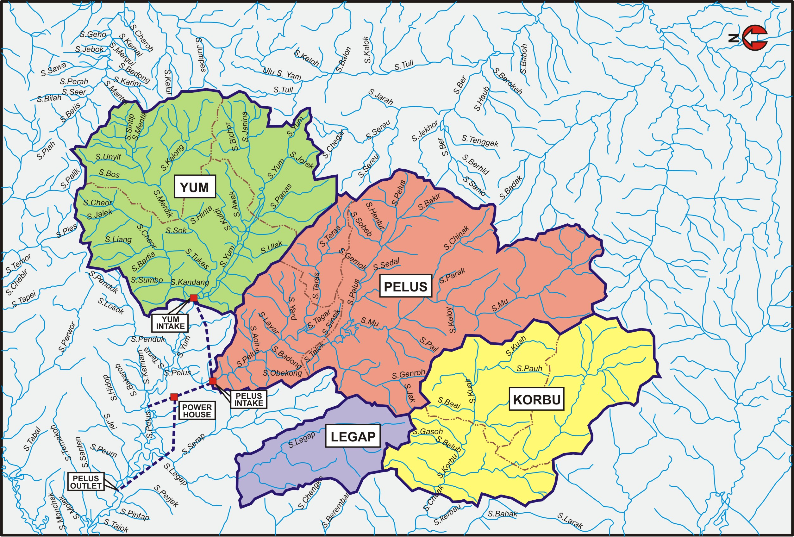

Figure 1: Pelus, Yum, Korbu and Legap Sub-Catchments

For this analysis, the stream flow was discussed at each single station. Stations 6044 (Sg. Yum at Kuala Yum) and 6035 (Sg Pelus below Kuala Yum) have a complete 13-year (Jan 1984-June 1997) and 14-year flow series, respectively (Jun 1985- October 1997). Meanwhile, the flow duration curve was developed by computing the percentage of time the various flow rates are equaled or exceeded and then plotting the discharge rates against the corresponding percentages of time.

Hydrological Procedure No. 12 (HPI2) 'Magnitude and Frequency of Low Flow in Peninsular Malaysia' describes a simple method to compute low flows. Like HP No.4, this procedure was developed based on regional frequency analysis. Four low flow regions (RC1; RC2; RC3 and RC4) were identified and using this procedure design low flows of return periods between 1, 10 and 25 years could be determined.

In the low flow frequency analysis, the total 7-day low flow for each year is identified. These total 7-days low flow value is then ranked starting with the lowest rank. Then, the percentage of ranking is computed for each rank. This is followed by plotting the log flow value against the respective percentage ranking on a probability paper. Information on Biological Oxygen Demand (BOD) and Total Suspended Sediment (TSS) were obtained using standard laboratory procedures.

- Results and Discussions

The proposed scheme of Sg. Pelus hydropower project intends to abstract waters from Sg. Yum and Sg. Pelus which is then diverted to an underground power station (34.8 MW) at Kuala Legap (04º 56” 47.8’E, 101º 15” 45.4’N). The impact on water flow at the time the stream waters diverted into the tunnel is predicted – where the diversion will disrupt the flows, particularly the volume, velocity and water level especially stream section below the diversion intakes.

The channel platforms may also unstable in the early diversion period. Reducing flow can develop sediment deposition particularly in the inner bends of the river. At the same time with decreased in water levels causing bank materials to be exposed and finally may lead to lateral erosion especially those in the step banks. These impacts however are temporary and localized and not considered causing any significant effects further downstream.

  - Sg. Yum - Daily Flow

Daily Q was constructed from the Station 6044. The station receives water from Sg Yum sub-catchment. Based on the figure, the maximum Q (m³/s) recorded was 26.3, while the mean and minimum Q is 5.080 and 2.0, respectively (Figure 2).
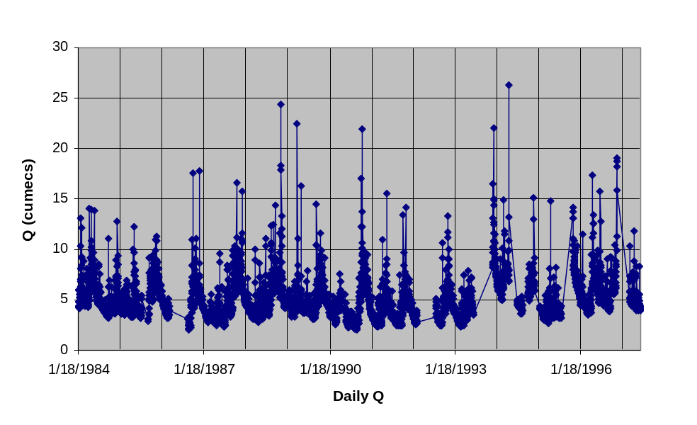
Figure 2: Daily Flow at Station 6044 (Sg. Yum at Kuala Yum)

b. Sg. Pelus- Daily flow

Daily flows recorded at Sg Pelus below Kuala Yum are expected to be higher compared to Sg Yum as this station received both discharges from Pelus and Yum catchments. Based on the flow data, the maximum daily flow was 66.7 m³/s. The average over 12 years record is 11.391 m³/s and the minimum flow is 0.6 m³/s (Figure 3).

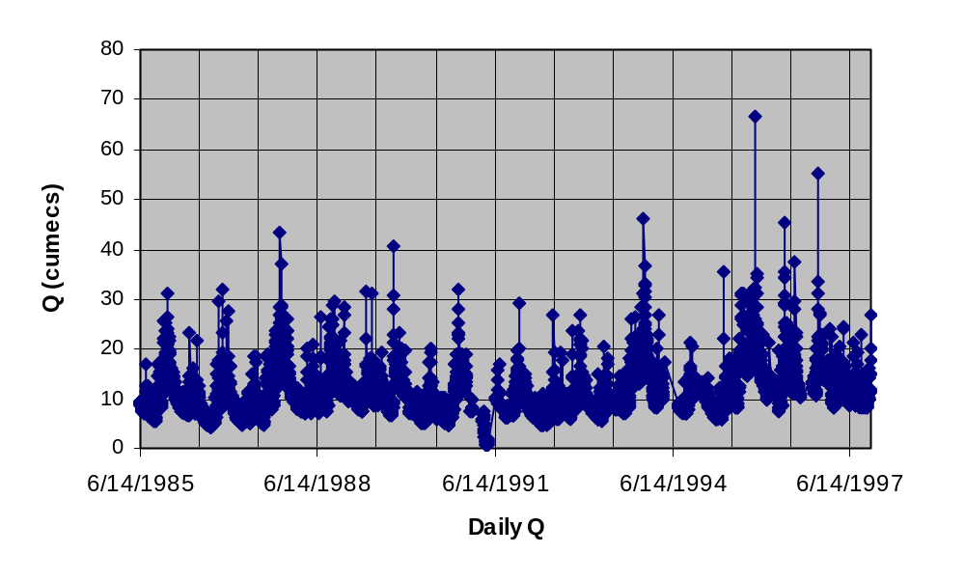
Figure 3: Daily flow at Station 6035 (Sg. Pelus below Kuala Yum)

c. Flow Duration Curve

The flow duration curve is a plot that shows the percentage of time that flow in a stream is likely to equal or exceed some specified value of interest. For example, it can be used to show that the percentage of time river flow can be expected to exceed a design flow of some specified value (e.g., 5 m³/s), to show the discharge of the stream, or to exceeded some percent of the time (e.g., 80% of the time).

The basic time unit used in preparing a flow-duration curve will greatly affect its appearance. For this study, mean daily discharges were used. The flow duration curve was developed by computing the percentage of time the various flow rates are equaled or exceeded and then plotting the discharge rates against the corresponding percentages of time.

Figures 4 and 5 show the daily flow duration curves calculated at Stations 6044 and 6035. It is estimated that for both stations, 50 percent of 4 m³/s and 8.2 m³/s of discharges will be exceeded or equaled. According to the figure to follow, minimum instream flow of approximate 2 m³/s is likely to be available 100 % of the time for an average year. However, the demand of 5 m³/s will only be available 25 % for Station 6044 and 80 % of the time. This implies that full supply will be available during a portion of the water year while a reduced supply will be available during other times of the year.

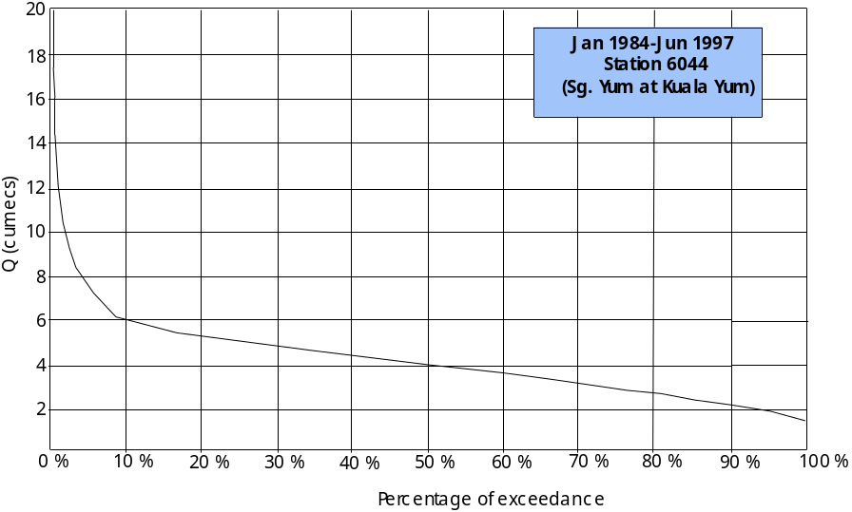
Figure 4: Flow Duration Curve for Sg Yum at Kuala Yum

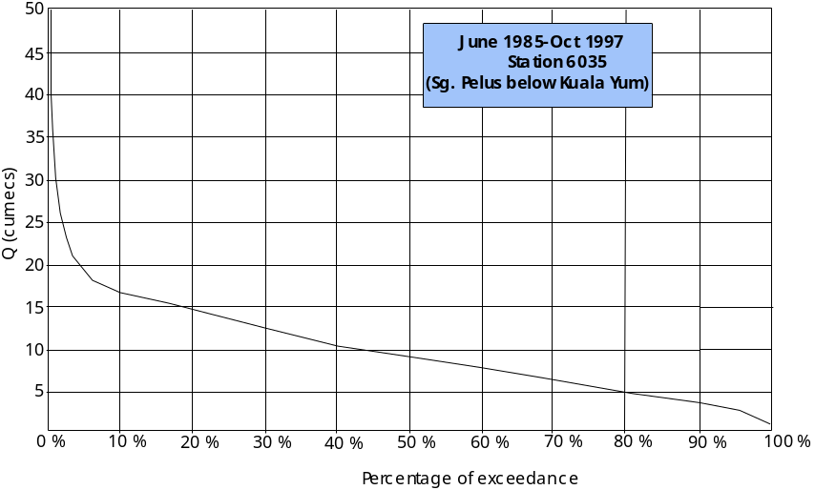
Figure 5: Flow Duration Curve at Sg Pelus below Kuala Yum

d) Low Flow

In the low flow frequency analysis, the total 7-day low flow for each year is identified. Line fitting is drawn to provide the representative 7-days low flow probability line as shown in Figure 6. The value was re-calculated from the mathematical model,

Ŷ = ý + S_{y ż} ……………………. [1]

Where ý is the population mean, S_{y} is standard deviation of the logarithms and _{ż} is standard normal deviate. The estimated 7-day low flow for selected exceedence frequency (T) is tabulated in Table 2.

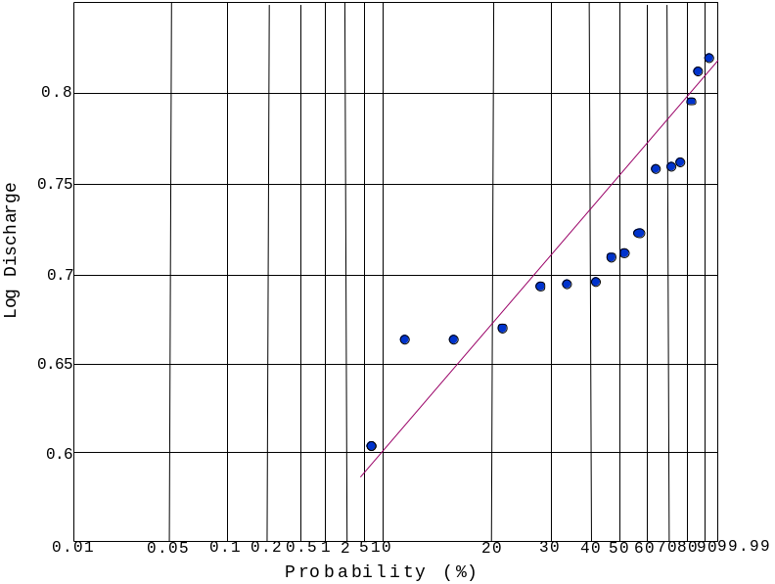

Figure 6: 7-Day Low Flow Frequency Curve

Table 2: 7-Day Low Flow Estimates for Sg. Pelus Catchment
T (Years) | 7-days low flow Q7, T(cumecs)
01.5  02.33  05.0  10.0  20.0  50.0 | 2.413  1.602  1.175  0.986  0.890  0.801

e) Environmental Flow Assessment (EFA) For Water Resources Management

For Sg. Pelus river diversion project, the environmental group has adopted a suite of methods to determine environmental flows. These range from desktop studies in unstressed catchments to comprehensive studies of minimum flow requirements. The outputs from these assessments have been used to recommend Environmental Flow Assessment (EFA). EFA is a description of the flow regime required to maintain the ecosystem values, targeted by the assessment, at a low level of risk.

In this study, EFA is generally focused to those parts of the ecosystem and the specific times of the year that they are potentially at risk, particularly at the section where the stream will be diverted to the tunnel. For example, during the drought, the water use in a catchment may affect species that have particular requirements in these months (e.g. spawning, riparian germination and habitat availability) (Maidment 1993). At other times outside the months, water use may not have a great impact on the ecological processes in a river diversion section. It is therefore critical to set the environmental flows during the planning stage of the project to ensure that this value is adhered to during operations of the diversions.

For environmental flow requirement, the measured water quality values for BOD (biochemical indicator) and TSS (physical indicator) for various locations at Sg Pelus and it tributaries taken during the field works showed BOD concentration is between 1.8 mg/l (Sg Menlik, a tributary of Sg Yum and upstream of the proposed Yum Intake) to 3.1 mg/I (Sg Pelus at 500 m downstream of the proposed Pelus Outlet) while TSS concentration is between 8.0 mg/l (Sg Menlik) to 48.8 mg/l (Sg Pelus). The average values for both BOD and TSS parameters are 2.45 mg/l and 28.4 mg/l, respectively. This means that, both parameters are under the Class II. The required environmental flow for Sg Pelus is estimated. It is based on the average as represented by BOD and TSS against the 7-day low flows. The result is tabulated in Table 3.

Table 3: Environmental Flow Assessment (EFA) Based on Mean Sampled Value of BOD and TSS under 7-Day Low Flow Conditions

 | BOD | TSS
Mean (mg/L) | 2.45 | 28.4
7-day Low Flow:  m³/s  L/s | 0.986  986 | 0.986  986
Estimated Loading (mg/s) | 2415.7 | 28002.4
Required Environmental Flow (m³/s) | 0.279 | 0.280

NOTE: The estimated loading was computed by multiplying mean BOD and TSS (mg/L) load with mean daily flow (L/s)/ 7-Day Low Flow.

To maintain at least Class II waters, the minimum environmental flows required for BOD and TSS are 0.279 m³/s and 0.280 m³/s, under 7-day low flow. Based on Table 2, the 7Q10 was calculated at 0.986 m³/s. Both values shown are below the 7Q10, meaning that even during the dry season, the values are still can maintain at Class II as water volume is plenty enough to cater both parameters.

- Conclusion

In conclusion, the work presented here should convey the need for reporting of low flow confidence limits, and the value of using these limits in the decision making process, particularly when it involves with river diversion works. In summary, the results obtained from this study can summarized as follows:

- Total catchments size for Yum and Pelus are 135 km² and 170 km².
- Stations 6044 (Sg. Yum at Kuala Yum) and 6035 (Sg Pelus below Kuala Yum) are the gauged system used for the analyses.
- Mean daily flow for Sg. Yum is 5.080 m³/s.
- Mean daily flow for Sg. Pelus is 11.391 m³/s.
- 50 % of 4 m³/s of discharge will be exceeded/ equaled in Station 6044
- 50 % of 8.2 m³/s of discharge will be exceeded/ equaled in Station 6035
- BOD requirement for Environmental Flow Assessment (m³/s) for Sg Pelus is 0.279 m³/s.
- TSS requirement for Environmental Flow Assessment (m³/s) for Sg Pelus is 0.280 m³/s.

In conclusion, the work presented here should convey the need for reporting of low flow confidence limits, and the value of using these limits in the decision making process. Finally, the case study in Sg Pelus provides good exercise to identify acceptable limit threshold for the construction of the tunnel and at a same time maintaining the river water level for biotic and abiotic lives along the river system.

Acknowledgements

The activities that are described in this paper are carried out with the permission from UKM Pakarunding Sdn Bhd and Tenaga National Berhad. Special thanks are also due to PPSPP, FSSK and Drainage and Irrigation Malaysia for providing maps and secondary data.

Correspondence to: Mohd Ekhwan Toriman, School of Social Development & Environmental Studies, FSSK Universiti Kebangsaan Malaysia, 43600 Bangi, Selangor.

Submission Date : 9 January 2010

Reference

Arthington, A.H., King, J.M., O'keefe, J.H., Bunn, S.E., Day, J.A., Pusey, B.J., Bludhorn, D.R. and Tharme, R., (1992). Development of an holistic approach for assessing environmental flow requirements of riverine ecosystems. In: Pigram, J.J. and Hooper, B.P. (Eds.), Proceedings of an International Seminar and Workshop on Water Allocation for the Environment. Centre for Water Policy Research, Armidale, 69-76.

Hafez Salleh, Azlan Shah Ali, Syahrul Nizam Kamaruzzaman, Loo Siaw Chuing. (2009). A case studies of intelligent buildings in Malaysia. Malaysian Construction Research Journal. Vol. 4,40-51.

Hafizan Juahir, Sharifuddin M. Zain, Mazlin B. Mokhtar, Mohd Ekhwan Toriman, Zaihan Jalaludin & Ijan Khushaida M. Jan. 2008. The Use of Chemometrics Analysis as a Cost-Effective Tool in Sustainable Utilisation of Water Resources in the Langat River Catchment, Malaysia. American-Eurasian J. Agric. & Environ. Sci. 4 (2): 258-265.

Hydrological Procedure No. 12 (HPI2) .Magnitude and Frequency of Low Flow in Peninsular Malaysia. Kuala Lumpur: Drainage Irrigation and Department Malaysia.

Loneragan, N.R. & Bunn, S.E., (1999). River flows and estuarine ecosystems: Implications for coastal fisheries from a review and a case study of the Logan River, southeast Queensland. Australian Journal of Ecology, 24, 431-440.

Maidment, D. (1993).Handbook of Hydrology. McGraw Hill Publisher, United Kingdom.

Mohd Ekhwan Toriman & Shukor Md. Nor. (2006). An analysis of rainfall interception on the selected experimental plot of Pangkor Hill Reserved Forest. Journal Wildlife and National Park. December 2006.169-178.

Mohd Ekhwan Toriman, Mazlin Mokhtar, Muhamad Barzani Gasim, Sharifah Mastura Syed Abdullah, Osman Jaafar & Nor Azlina Abd Aziz. (2009). Water Resources Study and Modeling at North Kedah: A Case of Kubang Pasu and Padang Terap Water Supply Schemes. Research Journal of Earth Sciences 1 (2): 35-42.

Mohd Ekhwan Toriman, Muhamad Barzani Gasim & Hafizan Juahir. (2009). Application of Artificial Neural network in water level-discharge relationship of Sg Gumum-Tasik Chini Pahang. In Mushrifah Idris, Mohammad Shuhaimi Othman, Sahibin Abd Rahim, Khatijah Hussin, Nur Amelia Abas (eds.). Sumber asli Tasik Chini. Faculty Science and Technology Publishers. UKM. 89-105.

Petts, G. E. (1984). Impounded Rivers: Perspective for Ecological Management. Wiley, Chichester.

Pyrce, R. (2004). Hydrological Low Flow Indices and Their Uses, Watershed Science Centre, Trent University, Canada.

Rosenfeld J. S., Post J., Robins G. and Hatfield T. (2007). Hydraulic geometry as a physical template for the river continuum: application to optimal flows and longitudinal trends in salmonid habitat. Canadian Journal of Fisheries and Aquatic Sciences. 64, 755–767.

