Estimate Biological nitrogen fixation in horse bean
Tayeb Saki Nejad
Islamic Azad University, Ahvaz Branch
Tayebsaki1350@yahoo.com
Saki1350@gmail.com

Abstract : Research projects as split plot experiments in a randomized complete block design with four replications in field research in Islamic Azad University of Ahvaz 3 consecutive years (2006,2007,2008) implementation was the main assembly, four digits bean plant: blessing, Venus, damascene the number of islands in the province have grown and sub-plots in the two years 2006 and 2007 three levels of nitrogen fertilizer (N2 and N3 treatments, respectively 20 and 40 and 80 kg fertilizer N ha simultaneously planting) and the third year, 2007 values were doubled care. After the Earth, using figures with Rhizobium bean plant (Rh.Legominosarum) inoculation and immediately killed each year in mid took. Survey figures, figure blessing highest percentage of mean total nitrogen plant 1.97 percent won. In sub-plots, with increasing amounts of nitrogen, accumulation of this element bean plants increased. Percent nitrogen treatments nodes N2 and N3 showed a significant difference, but the highest accumulation of nitrogen treatments N1 nodes with 1.67 percent won, thus whatever amount of fertilizer increased, the amount of biological nitrogen fixation nodes decreased. N3 treatment reduced accumulation of 40 to 50 percent nitrogen found in to other treatments. With increasing N rate, weight, number and size of the plant nodes decreased blessing average number of nodes 1250 nodes per plant among the highest number of cultivars grown offered. Number of nodes equal treatment and 1450 to increase the amount of fertilizer treatments 80 kg 998 nodes per plant decreased in all fertilizers in small amounts or how large gland enlargement process was observed. The mean largest tumor diameters in the treatment 1.98 cm were measured. Green and white non-effectiveness of enzyme Nitrogenase stated that usually the primary growth was achieved in pink and red and efficient biological nitrogen fixation, approximately 35 days after planting continued until after flowering and 10 days after flowering, gland Posts brown and black, showed the node representing aging and lack of nitrogen is established. The study of the properties such as root length, root weight and volume was observed with increasing nitrogen fertilizer
Key words: biological nitrogen fixation, horse bean
1. Introduction
During the recent years in the world, food production and consumption of fertilizers has increased gradually. Demand for nitrogen fixation as the chemical and irregular increase is nearly twice (Table 1) due to the current energy crisis situation will be difficult. In addition, chemical nitrogen fixation in the field, since the fundamental solution to reduce the energy required for the traditional method (Haber - Bush) in the production of ammonia is not recommended. Biological nitrogen fixation can produce the crisis and to modulate the nitrogen fertilizer application. Identifying factors influencing production efficiency of this process can be beneficial and highly stabilized nitrogen increased. Province with more than 7000 hectares under cultivation Bean (2007) one of the major producing provinces of the product is high and nitrogen fertilizer application, average 300-250 kilograms per hectare to increase performance is common among farmers These values increased cost of nitrogen fertilizer plant as well as severe pollution to the River that shed all of the search, so the necessity of expanding and increasing the efficiency of biological fixation system, it is felt the product, according to the necessity of this study was to implement appropriate amounts of fertilizers and nitrogen are introduced improved varieties can be used to stabilize natural systems use high nitrogen fertilizer nitrogen prevents said.

Table 1: the global need for nitrogen (million tons) during the coming years.
Region / Year | 1980 | 1985 | 1990 | 1995 | 2000 | 2010
Developed countries | 37.5 | 47.6 | 58 | 71 | 88 | 98
In developing countries | 18 | 25 | 33 | 43 | 54 | 70
World | 55 | 73 | 92 | 115 | 139 | 178

2. Materials and methods
This research farm research - Research, Islamic Azad University of Ahvaz
Southern city of Ahwaz in 3 years were, where experiment and semi-arid climate is dry and the 40-year Meteorological Data Ahvaz 94/213 mm average annual rainfall, mean annual temperature of 24/25, the average maximum 92/32 annual temperature, average minimum annual 4 / 18 ° C is. Planting date mid every 3 years was before this date, disk and plow the earth and fire trowel and calcium phosphate fertilizer menu and then the earth was based classification map plots in the field experiment was performed in every plot of 24 square meters the bed took up 10 lines and culture based on the amount of nitrogen fertilizer treatments the tape stack was added. 3 -2 on the test weed weeds was conducted for disposal. Test plan as split plot randomized complete block design with four replications that included four main treatment plant bean varieties that are: blessing
V1, Z. V2, Shami V3 and V4 figure Jazayeri and sub-plots in the first two years 1383 and 2006, Kvass levels (N0 = 20, (N3 = 80, N1 = 40 kg per ha and the third year was double 1385 values Kvdy were studied. reviews root cylinder method was performed by the full scoop enough of the node number and diameter of root parameters of (Bakvlys) were measured and cut Posts tumor diagnosis was inside color. some plant gland intact shoots, including leaves and stems for the estimated amount of nitrogen using Kjldal was sent to the laboratory. and also using the root Newman and graduated cylinder method of water transport, root volume was measured.. before the implementation experiment to evaluate soil field sampling of the depth of 15-0, 30-15 and 60-30 cm was 15 and a total analysis of soil samples were sent to the laboratory that the final results of this analysis is given in Table 3

N₂ + 8H⁺ + 8e⁻ + 16ATP 2NH₃ + H₂ + 16ADP + 16Pi

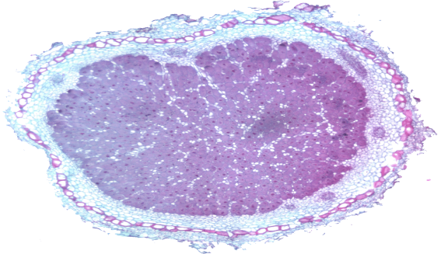
Figure 1. Full nodules

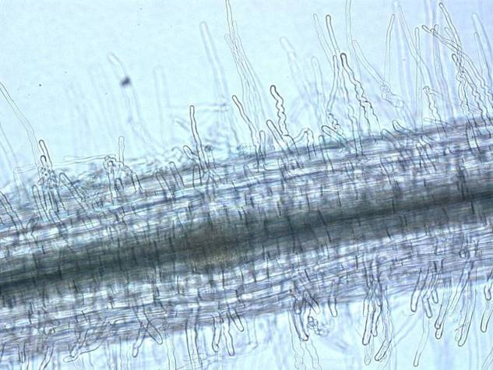
Figure 2. Inoculation on root

3. Results and discussion
3.1. percentage of total plant nitrogen
Analysis of variance showed that treatments of: bean cultivars and the amount of fertilizer nitrogen accumulation in plant-level% 1 in every 3 years were significant cultivar Barakat highest percentage of mean total nitrogen plant 1.97 percent won. And figures Jazayeri and Z. respectively 1.76 and 1.68 percent and Shami figure with 1.43 percent in the next categories were. For sub-plots that V3 with mean 2.73 percent of V1 with the highest and 1.83 percent of the lowest average accumulation of nitrogen element in bean plants showed other words, increasing the amount of nitrogen accumulation of this element increased the bean plant demonstrates the potential for plant uptake is the element that increased dry matter and number of branches is required. (Hardarsvn and Jetty 2004
3.2. Percent nitrogen root gland
Percentage of nitrogen nodes to significant amounts of fertilizer and bean cultivars Vasr their interaction showed a 1% level. N2 and N3 treatments statistically the same, but with the N10 treatment, significant differences were present, what amount of nitrogen increased, the amount of biological fixation of this element nodes decreased. N3 treatment reduced accumulation of 40 to 50 percent nitrogen found in to other treatments. Small amounts of soil nitrogen caused the gene is activated and stabilized biological Nitrogen's enzyme, glutathione synthesis of nitrogen into the air in the root of high quantities but do nitrogen, available nitrogen in soil Nitrogen's enzyme in glutathione synthesis is used (Aviv and Hardy 2003) . Percent nitrogen accumulation of blessing the figure was more than other varieties and Hay Yvtzy (2005) have stated that the figures that matter most called the root secretion and assembly, which is attracting more Rhizobium bacteria in root level and increase the amount established is. Aviv and Hardy (2003) announced that the small amounts of soil nitrogen in the biological fixation gene that is activated enzyme nitrogen's nitrogen into the air Glutathione synthesis in the root and thus stabilize do take place but when large amounts of soil nitrogen by this act nitrogen's enzyme using the available nitrogen in soil occurs in glutathione synthesis (22).

Figure3. Nodules on root
Hay and Yvtzy (2005) in numbers that indicate their more established, have said that the figures that matter most called the root secretion and assembly, which is attracting more Rhizobium bacteria in root level and increase the amount established gives (14). Cultivars grown in the review, figure blessing percent more nitrogen accumulation demonstrated that because of this, probably is a matter of theory Hay and Yvtzy.
Tumor characteristics Blessing figure that the highest percentage of nitrogen due to consolidation period from planting to
Flowering, flowering later than other cultivars (Nadir and Hay 2004), the highest weight (926 mg per plant) and number of nodes (1250
Nodes per plant per day) provided is. With increased fertilizer value, weight and number of nodes on the root node treatment decreased
The number equal to 1450 and increasing fertilizer treatment to 998 nodes per plant decreased.

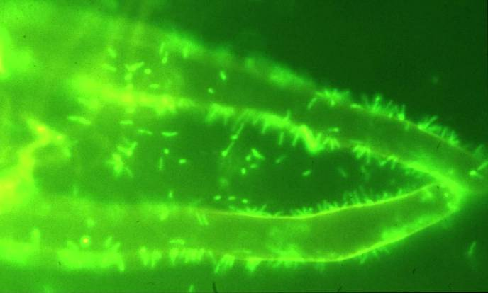 Figure4. Rizobium on root
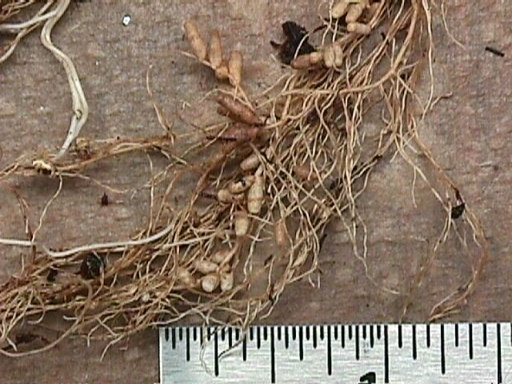

Reference:
- Hardarson,P.T and Jutes,S.D 2004, in biological Nitrogen Fixation, proceedings of the National Symposium held at Indian agriculture research Institute, new poi 544-51
- Hekio, N.A and Uotzii, L.P 2005, Alternating strips of grass and Legumes and Nitrogen fertilization strategy for long term herbage production from a brome – alfalfa stand. Plant science july/juillet, 2006, Velum 75, No3, pp649-654).

