Antimicrobial properties and Bioactive compounds from six wild edible mushrooms of Western Ghats of Karnataka, India.

Ch.Ramesh and Manohar G. Pattar*
Mycology Laboratory,
Department of Botany, Karnatak University
Dharwad – 580003 Karnataka India
e-mail: pgmanohar@gmail.com

Abstract:
Methanolic extract of six wild edible mushrooms isolated from Western Ghats of Karnataka were used in this study. Among the isolates (Lycoperdon perlatum, Cantharellus cibarius, Clavaria vermiculris, Ramaria formosa, Marasmius oreades, Pleurotus pulmonarius) only four have shown satisfactory results. Quantitative analysis of bioactive components ranged where phenol (3.20 ± 0.05 mg/ml to 6.25 ± 0.08 mg/ml), flavonoid (0.40 ± 0.052mg/ml to 2.54 ± 0.08 mg/ml) and ascorbic acid (0.06 ± 0.01 mg/ml to0.16 ± 0.01 mg/ml) content. All the isolates have shown high phenol and flavonoid but ascorbic acid content was vestigial. Evaluation of antioxidant capacity on DPPH was found significant when compared with standard antioxidant like BHA. The Concentration (IC₅₀) was ranged (0.94 ± 0.27mg/ml to 7.57 ± 0.21mg/ml). Determination of antimicrobial activity profile of all the isolate tested against a panel of standard pathogenic bacteria and fungi indicated that the concentration of bioactive components directly influence the antimicrobial capability of the isolates. Agar diffusion assay showed considerable activity against all bacteria. Minimum Inhibitory concentrations values of the extracts of four isolates are also active even in least concentration. These results are discussed in relation to therapeutic value of the studied mushrooms.
Key words: Western Ghats, In-vitro, antioxidant, agar diffusion assay, DPPH mushrooms, bioactive.
Abbreviations: DPPH: 1,1-Diphenly-2-picrylhydrazyl
BHA: Buthylated hydroxyanisol
Introduction
Mushrooms have been shown to produce several biological active compounds that are usually associated with cell wall and these have been suggested to contribute enhance immunity and tumor retarding effects. Among the local communities, mushrooms may represent potential sources of antibacterial drugs since earlier screening for antibiotics started with mushrooms and proved successful (Opige et al 2006)
People usually use fruit bodies and sclerotia of edible mushrooms as major food condiments which are served at their important family meals Edible macro fungi are usually collected from the wild because farms growing them are very few (Jonathan et al 2007) Multiple drug resistance in human pathogenic microorganisms has developed due to indiscriminate use of commercial antimicrobial drugs commonly used in the treatment of infectious diseases. This situation has forced scientists to search for new antimicrobial substances from various sources as novel antimicrobial chemotherapeutic agents (Turkoglu et al 2007)
The scientific community, in searching for new therapeutic alternatives, has studied many kinds of mushrooms and has found variable therapeutic activity such as anticarcinogenic, anti-inflammatory, immuno-suppressor and antibiotic, among others. In recent decades, various extracts of mushrooms and plants have been of great interest as sources of natural products. (Aziz et al 2007) In recent years, multiple drug resistance in human pathogenic microorganisms is rampant, due to indiscriminate use of antimicrobial drugs commonly used in the treatment of infectious diseases. In the continuous search for new antimicrobial structures, mushrooms are of interest to investigators Sixty antimicrobial compounds have been isolated from mushrooms. However, only the compounds from microscopic fungi have been present on the market as antibiotics until now (Wong et al 2009).
Phenolic compounds have attracted much interest recently because in vitro and in vivo studies suggest that they have a variety of beneficial biological properties, which may play an important role in the maintenance of human health. Their significance for the human diet and antimicrobial activity has been recently established Laetiporus sulphureus antioxidant and antimicrobial activities were reported and correlated to the phenols and flavonoids contents (Barros et al 2007)
The aim of present work is of in vitro experiments to screen bioactive compounds such as Total Phenols, Flavonoids, Ascorbic acid content, DPPH scavenging Assay and moreover their antimicrobial potential from methanolic extract of wild edible mushrooms No much literature is available in regard to their antioxidant and antimicrobial activities in. The present study reveals the biopharmaceutical potential of mushrooms.

Materials and Methods
Chemicals:

1,1-Diphenly-2-picrylhydrazyl (DPPH), Buthylated hydroxyanisol (BHA) Gallic acid, Folinciocalteu’s phenol reagent (FCR), sodium carbonate, Methanol, chloroform (Merck, Germany) Remaining chemicals and reagents were analytical grade.
Mushrooms:
Among the isolated mushrooms six edible species were selected from non-gilled fungal group of Aphyllophorales Viz: Lycoperdon perlatum (Pers.) Cantharellus cibarius (Fries), Clavaria vermiculris (Fries), Ramaria formosa(Fr.) Quel, Marasmius oreades (Bolt. ex Fr), Pleurotus pulmonarius (Fr.) Quel Fr. used in this study. Both young and old basidiocarps were collected from Dandeli, Sambrani and Karlakatta forests of Western Ghats of Karnataka. Identification was done, by comparing their morphological, anatomical and physiological characteristics and monographs with descriptions given in the manual (Purkyastha and Aindrila chandra 1978) and also through the electronic data on identification keys of mushrooms (Kuo 2004). All the specimens were deposited at the herbarium of Mycology laboratory, Department of Botany, Karnatak University Dharwad. Karnataka.

Preparation of methanolic extracts:

Methanolic extracts of mushrooms was done based on procedures described by (Barros et al 2007) with some modifications. A fine dried mushroom powder sample (100 g) was extracted by stirring with 100 ml of methanol at 25ºC at 150 rpm for 24 h and filtered through Whatman No 4 paper. The residue was then extracted with two additional 100 ml portions of methanol. The combined methanolic extracts were evaporated at 40ºC to dryness. The organic solvent in the extracts was removed by a rotary evaporator. For the entire analysis compounds of extract were dissolved in DMSO and filter-sterilization through a 0.22μm membrane filter. Extracts were kept in the dark at 4°C for not more than one week prior to use.
Determination bioactive components:
Phenolic compounds in the mushroom methanolic extracts were estimated by a colorimetric assay, 1 ml of sample was mixed with 1 ml of Folin and Ciocalteu’s phenol reagent. After 3 min 1 ml of saturated sodium carbonate solution was added to the mixture and adjusted to 10 ml with distilled water. (Barros et al 2007) The reaction was kept in the dark for 90 min, after which the absorbance was measured spectrophotometrically (Model - UV-1601 SHIMADZU) at 765 nm. Gallic acid was used to calculate the standard curve (0.01–0.4 mM). The mean values of results were expressed as milligrams of Gallic Acid Equivalents (GAE s) per gram of extract.
Flavonoid concentration were determined (Aziz et al 2007) where methanolic extract solution (1 ml) was diluted with 4.3 ml of 80% aqueous ethanol and 0.1 ml of 10% aluminum nitrate and 0.1 ml of 1 M aqueous potassium acetate were added. After 40 min at room temperature the solution was mixed well and intensity of the pink color was measured spectrophotometrically (Model - UV-1601 SHIMADZU) at 415 nm. Quercetin was used to calculate the standard curve of total flavonoid concentration (Absorbance = 0.002108 μg quercetin – 0.01089 (R2: 0.9999)
Ascorbic acid was determined (Barros et al 2007) with methanolic extract (100 mg) was extracted with 10 ml of 1% metaphosphoric acid for 45 min at room temperature and filtered through Whatman No 4 filter paper. The filtrate (1 ml) was mixed with 9 ml of 2, 6-dichloroindophenol and the absorbance was measured within 30 min at 515 nm against a blank. Content of ascorbic acid was calculated on the basis of the calibration curve of authentic L-Ascorbic acid (0.020–0.12 mg/ml). The results were expressed as milligrams of ascorbic acid per milliliter of extract. All the above estimation of bioactive compounds was carried out in triplicates and means were plotted.

Scavenging activity on DPPH for antioxidant assay

DPPH Scavenging assay was determined (Barros et al 2008) with slight modification Mushroom extracts (0.3 ml) were mixed with methanolic solution containing DPPH radicals (6 x 10⁻⁵ mM, 2.7 ml). The mixture was shaken vigorously and left to stand for 60 min in the dark (until stable absorption values were obtained). The reduction of the DPPH radical was determined by measuring the bleaching of the purple-colored methanol solution of DPPH at 517 nm. The Radical Scavenging Activity (RSA) was calculated as a percentage of DPPH discoloration using the equation:
% RSA = [(A_{DPPH} _ A_{S})/A_{DPPH}] x 100,

Where A_{S} is the absorbance of the solution when the sample extract has been added at a particular level and A_{DPPH} is the absorbance of the DPPH solution. The extract concentration providing 50% of radicals scavenging activity (IC₅₀) was calculated from the graph of RSA percentage against extract concentration. BHA used as standards. Extract concentration providing 50% inhibition (IC₅₀) was calculated from the graph plotted inhibition percentage against extract concentration. Tests were carried out in triplicate.
Determination of Antimicrobial efficacy

Microbial test organisms

Test organisms and culture media. The bacterial test organisms used were two Gram positive species Staphylococcus aureus (ATCC 25923), Bacillus subtilis (ATCC 6633), Gram negative species Escherichia coli (ATCC 25922), Pseudomonas aeruginosa (ATCC 27853) grown in Mueller Hinton Agar at 37⁰ C for 24 h (Merck). Fungal species was unicellular Candida albicans (ATCC 60192) grown in Potato Dextrose Agar (Hi Media) at ambient temperature for 72 h.
Antimicrobial activity
Antimicrobial activity of methanolic extract of mushrooms was determined by the Agar Well Diffusion method. (Oyetayo et al 2009) with slight modification according this experimental conditions Briefly, The methanol extracts were dissolved in Dimethylsulfoxide (DMSO) to final concentration of 10 mg/ml and filter sterilized through 0.45 μm membrane filter. Small wells (6 mm diameter) were made in the Agar plats by sterile cork borer. 100µl of extract each isolates of mushrooms were loaded into the different wells. Concentration of target microbial cells suspensions was adjusted to 10⁴ cfu/ml. In order to determine the antimicrobial efficacy of the fractions aliquot of test culture (100 µl) was evenly spread over the surface of the solidified agar. Bacteria were cultured in Mueller Hinton Agar and fungi on Potato Dextrose Agar. Ampicillin (10 µg/ml) for bacteria, Nystatin (100 U) for fungi were used as positive control, DMSO as negative control for test microorganisms and incubated at 37º C for 24 h for bacteria and at 27º C. 48 h for fungi. After incubation period zone of Inhibition was measured in mm. All the tests were carried out in triplicate and their means recorded.
Minimum Inhibitory Concentration (MIC) Assay
The MIC was defined as the lowest concentration of the compounds to inhibit the growth of microorganisms. The MIC values were studied for the microbial strains, being sensitive to the extracts in the Agar Well Diffusion method. From the stock solutions of the extracts initially prepared at the concentration of 10mg/ml was added into the first wells. Then, dilutions were made so as to decrease the concentration of extract by 1mg at each dilution. Positive, negative controls, and incubation condition were followed same as in zone of inhibition assay. Visible growth (turbidity) in the dilution tubes was criteria to determine MIC values for the tested microorganism at the given concentration of each extract. The extract tested in this study was in triplicate against each test organism.

Statistical analysis

All experiments were carried out in triplicate. Data obtained were analyzed by one way analysis of variance and means were compared by Duncan’s tests (SPSS 9 Student version). Differences were considered significant at (p<0.05)

Results and Discussion

In the present experiment six species of wild edible mushroom isolated from Western Ghats forest of Karnataka were evaluated for their content of total phenols, flavonoid, and ascorbic acid. Obtained methanolic extracts were screened for their DPPH scavenging assay and antimicrobial efficacy. These assays were carried out using the DMSO solvent. In this study only four species (L. perlatum C. vermiculris M. oreades and P. pulmonarius) have shown significant and satisfactory results when compared to other two isolates and research work of recent literatures.

Bioactive components

Fig.1 shows phenol, flavonoid, and ascorbic acid concentration of the isolates where total phenols are the major bioactive component found in extracts of isolates expressed as mg of GAE per gram of fruit body which was ranged (3.20 ± 0.05 mg/ml to 6.25 ± 0.08 mg/ml) average concentration of flavonoid ranged (0.40 ± 0.052mg/ml to 2.54 ± 0.08 mg/ml) and followed by very small concentration of ascorbic acid ranged (0.06 ± 0.01 mg/ml to0.16 ± 0.01 mg/ml) found in all the isolates. The total phenolic compound amount was calculated as quite high in M. conica ethanol extracts (41.93±0.29 μg mg-1 pyrocatechol equivalent). (Turkoglu et al 2006) The total phenolic compound amount was calculated as quite high for R. flava ethanol extracts (39.83±0.32 μg mg-1 pyrocatechol equivalent). In contrast to this, the total flavonoid compound concentration was measured as 8.27±0.28 μg mg-1 quercetin equivalent. (Gezer et al. 2006) FRS activity was compared with the standard phenolic, BHA, which gave an IC₅₀ of >1.5 µg of equivalent phenol. T. heimii, T. mummiformis, and B. edulis expressed very high activity and, Cantharellus cibarius with an IC₅₀ of 0.23 mg/mL showed 10- fold lower activity compared to the collected sample Termitomyces heimii. (Puttaraju et al 2006) The total phenolic com pound amount was calculated as quite high RD ethanol extract (47.01 ±0.29 μg mg⁻¹ pyrocatechol equivalent). According to (Aziz et al 2007) it is possible that the high inhibition value of RD extract is due to the high concentration of phenolic compounds. Total phenols were the major bioactive components found in the extracts, ascorbic acid was found in small amounts (0.08–0.16 mg/g) (Barros et al 2007). S. crispa, a medicinal mushroom contained the largest total concentration of phenolic compounds (764 μg/g), while Agaricus bisporus was the edible species with the most phenolics (543 μg/g) Inonotus obliquus contained the largest total concentration of flavonoids (143 μg/g) while Phellinus linteus had no flavonoids. (Kim et al 2008) The total phenolic compounds of mycelium were the highest (p<0.05) at 31.20 mg of GAE per g of mycelium, followed by oven-dried, freeze-dried and fresh fruit body. Total phenolic content of BHA was (417.84±28.97 mg) of GAE per g of BHA. (Wong et al 2009) Table 1 shows high phenolic content of L. perlatumc followed by least content in M oreades which variation indicate their mature and young stages of fruiting bodies. Where as the high flavonoid content found in C. vermiculris followed by least content in P. pulmonarius but ascorbic acid found in small quantity in which high content found in M. oreades followed by least amount in C. vermiculris. Higher contents of bioactive compounds were found in stage I (immature fruiting bodies) for L. deliciosus while for L. piperatus stage II (mature with immature spores) presented the highest content. (Barros et al 2007).

Antioxidant assay:

DPPH scavenging assay measured at 517 nm. Positive DPPH test suggests that methanolic extracts of all the samples were free radicals scavengers. The 50% of inhibition values were ranged (IC₅₀ = 0.94 ± 0.27 to 7.57 ± 0.21mg/ml). The RSA of BHA and isolates on DPPH radical are compared and shown in Fig 2. Among the studied concentration RSA was significant in L. perlatum (0.94 ±0.27 mg/ml) followed by P. pulmonarius (1.62 ±0.2 mg/ml) other isolates were showed the satisfactory RSA in C. vermiculris (2.63 ± 0.14mg/ml) and M. oreades (3.54 ± 0.18mg/ml) and remaining two isolates shown vestigial RSA when compared with commonly used synthetic antioxidant BHA (0.80±0.00mg/mL). According to (Barros et al 2008) A. silvaticus was the most efficient species shown higher (5.37 ± 0.06mg/ml) while A. arvensis presented lower antioxidant properties lower (15.85 ± 0.27 mg/ ml) concentration which are compatible to its lower phenols content. EC₅₀ values of the extracts in DPPH radical scavenging of the fresh fruitbody, oven dried fruitbody, freeze dried fruitbody and mycelium extracts were approx. 3.75, 5.81, 8.67 and 13.67 mg/mL respectively, whereas that of BHA was 0.0126 mg/mL (Wong et al 2009). When the reaction time was for 1 min, DPPH activity ranged between 15 (Pleurotus eryngii) and 70% (Ganoderma lucidum); while with a reaction time of 30 min, DPPH activity ranged between 5 (Pleurotus eryngii) and 78% (Agaricus bisporus). Overall, medicinal mushrooms had a higher DPPH activity than edible mushrooms (Kim et al 2008) Scavenging activities of D. indusiata were well pronounced at concentrations of 0.5 mg/ml to 2 mg/ml. The free radical scavenging effect of WE was slightly higher than BHT at concentrations of 0.5 to 2 mg/ml. (Oyetayo et al 2009)

Antimicrobial assay

All the mushrooms used in this study were found to exhibit various degrees of antimicrobial effects against the tested microorganisms. The best in-vitro antibacterial activity was considered halo > 15mm as highly active exhibited by L. perlatum (24.0mm) followed by P. pulmonarius M oreades and C. vermiculris against E. coli. Table 2 shows evidenced by the clear zone of inhibition and MIC concentration exhibited by the mushroom extracts against the tested bacteria and fungi. Candida albicans found very susceptible only to extract of P. pulmonarius and M oreades when compared to positive controls. The antibacterial activity (22.0mm) was exhibited by D. elegans against E. coli. This was followed in order by T. lobayensis, C. occidentalis and A. polytricha with values 20.0, 19.0 and 18.0mm respectively. (Gbolagade and Fasidi 2005) Pure extract of Polyporus giganteus produced the widest zone of inhibition (24.0 mm) against E. coli followed by P. atroumbonata (18 mm) against the same bacteria pure extract of both Fomes lignosus and T. microcarpus produced inhibitory zones of 16.0 mm each against E. coli. (Jonathan et al 2007) Figure 3 Shows the comparative study of antimicrobial efficacy of methanolic extract and significant (p>0.05) relationship among all the wild isolates. The MIC values indicate that among the selected microorganisms studied, extract inhibited the growth of Gram-negative bacteria better than Gram-positive bacteria and yeast. According to Thembekar et al (2006) the antibacterial activities of aqueous extract of both edible Pleurotus sajarcaju and Agaricus were significant up to10% dilution against all the tested pathogens B. cereus, B. subtilis, S. aureus, and S. epidermidis presented high sensitivity to metabolic compounds of L. edodes. B. cereus and S. aureus are widely recognized as important food borne pathogens and the potential of its inhibition presented by L. edodes may receive more attention. (Ishikawa et al 2001) A high percentage of activity was also shown by extracts obtained from isolates belonging to the genus Ganoderma (62.5%), followed by extracts from species of Rigidoporus (27.2%). A low percentage of antimicrobial activity was shown by extracts of Phellinus species (7.8%) (Getha et al 2009) Figure 4 Summarizes the similarity between the efficacies Minimum Inhibitory Concentrations of mushrooms extracts and Positive control in relation to their susceptibility to the pathogenic microorganisms. These results revels that M oreades, P pulmonarius L. perlatum and C. vermiculris were comparatively similar concentration of standard antimicrobials which confirm the bioactive components of edible mushrooms.

Conclusions:

Among isolated, methanolic extract of four species (Lycoperdon perlatum Clavaria vermiculris Marasmius oreades and Pleurotus pulmonarius) of wild edible mushrooms have shown biopharmaceutical potentiality on DPPH Scavenging activity and antimicrobial efficacy which directly influenced by the content of bioactive components. This work has shown the biopharmaceutical capabilities of wild edible mushrooms.

Acknowledgments:

We are thankful to The Chairman Department of Botany, Karnatak University for providing laboratory facilities and M.oE.F New Delhi for their financial assistance.

REFERENCES

Aziz T, Mehmet E D, Nazime A M. Antioxidant and Antimicrobial Activity of Russula delica Fr: An Edidle Wild Mushroom Eurasian Journal of Analytical Chemistry 2007 2 (1): 64-67.
Barros L, Baptista P, Leticia Estevinho M, Ferreira I C F R. Effect of fruiting body maturity stage on chemical composition and antimicrobial activity of Lactarius Sp. Mushrooms J Agric. Food Chem. 2007 55: 8766–8771.
Barros L, Calhelha R C, Vaz J A, Ferreira I C F R, Baptista P, Estevinho L M. Antimicrobial activity and bioactive compounds of Portuguese wild edible mushrooms methanolic extracts Euro Food Res Technol 2007,225:151–156.
Barros L, Falcao S, Baptista P, Freire C, Vilas-Boas M, Ferreira I C F R. Antioxidant activity of Agaricus sp. mushrooms by chemical, biochemical and electrochemical assays Food Chemistry 2008,111, 61–66.
Getha K, Hatsu M, Wong H J, Lee S S. Submerged cultivation of basidiomycete fungi associated with root diseases for production of valuable bioactive metabolites J of tropical forest science 2009, 21(1) 1–7.
Gezer K, Duru M E, Kivrak I, Turkoglu A, Mercan N, Turkoglu H, Gulcan S. Free-radical scavenging capacity and antimicrobial activity of wild edible mushroom from Turkey African Journal of Biotechnology 2006, Vol. 5 (20) 1924-1928.
Gbolagade S, Fasidi I O. Antimicrobial Activities of Some Selected Nigerian Mushrooms African Journal of Biomedical Research 2005, 8: 83- 87.
Jonathan G, Loveth K, Elijah O. Antagonistic Effect of Extracts of Some Nigerian Higher Fungi Against Selected Pathogenic Microorganisms American-Eurasian J. Agric. & Environ. 2007, Sci 4: 364-368.
Ishikawa N K, Kasuya M C M, Vanetti M C D. Antibacterial activity of Lentinula edodes grown in liquid medium Brazilian Journal of Microbiology 2001, 32:206-210.
Kim M Y, Seguin P, Ahn J K, Kim J J, Chun S C, Kim E H, Seo S H, Kang E Y, Kim S L, Park Y J, Ro H M, Chung I M. Phenolic Compound Concentration and Antioxidant Activities of Edible and Medicinal Mushrooms from Korea J. Agric. Food Chem. 2008,56, 7265–7270.
Kuo M, Contributors, Retreived from the MushroomExpert.Com, 2004. Available at: http://www.mushroomexpert.com/contributors. html.
Opige M, Kateyo E, Kabasa J D, Olila D. Antibacterial activity of extracts of selected indigenous edible and medical mushrooms of eastern Uganda. International J of tropical medicine. 20061(3): 111 - 116.
Oyetayo V O, Dong C H, Yao Y J. Antioxidant and Antimicrobial Properties of Aqueous Extract from Dictyophora indusiata The Open Mycology Journal 2009,3: 20-26.
Purkyastha R P, Aindrila C. Manual of Indian Edible Mushrooms. Today’s and Tomorrow’s Printers and Publication New Delhi. 1978 (1st edition) pp – 346.
Puttaraju G N, Venkateshaiah S U, Dharmesh S M, Nanjaraj S M, Somasundaram R. Antioxidant Activity of Indigenous Edible Mushrooms J. Agric. Food Chem. 2006,54 : 9764-9772.
Tambekar D H, Sonar T P, Khodje M V, Khante B S. The novel antibacterial from two edible mushrooms Agaricus bisporus and Pleurotus sajopr caju. International journal of Pharmacology 2006, 2(5): 584-587.
Turkoglu A, Kivrak I, Mercan N, Duru M E, Gezer K, Turkoglu H. Antioxidant and antimicrobial activities of Morchella conica Pers. African J of Biotechnology. 2006, 5 (11) 1146-1150.
Wong K H, Vikineswary S, Noorlidah A, Umah R K, Murali N. Effects of Cultivation Techniques and Processing on Antimicrobial and Antioxidant Activities of Hericium erinaceus (Bull.:Fr.) Pers. Extracts Food Technol. Biotechnol. 2009, 47 (1) 47–55.

Figure 1 - Bio active components of mushrooms methanolic extract.
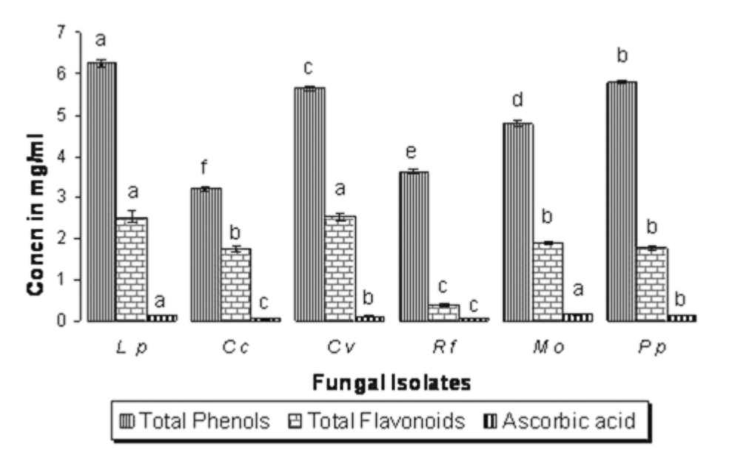

L p - Lycoperdon perlatum C c - Cantharellus cibarius C v - Clavaria vermiculris R f- Ramaria formosaM o - Marasmius oreades P p- Pleurotus pulmonarius Vertical bars indicate standard error followed by letters denotes significantly (p>0.05) different

Figure 2 - Activity (IC_{50 in} mg/ml) concentration of mushrooms extract
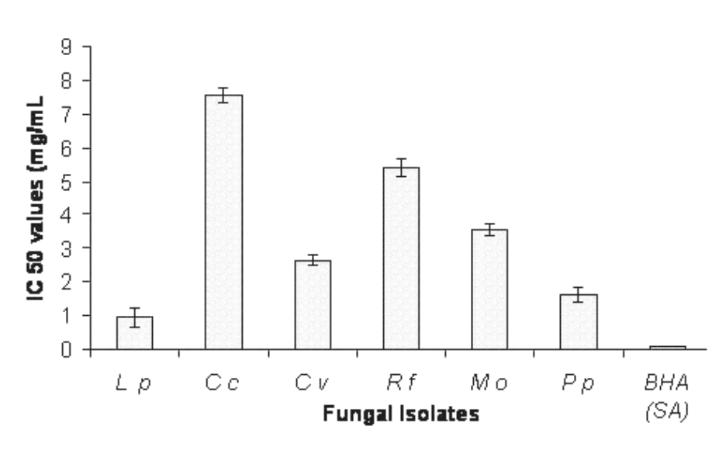
Lp - Lycoperdon perlatum Cc - Cantharellus cibarius Cv - Clavaria vermiculris Rf- Ramaria formosa Mo - Marasmius oreades Pp- Pleurotus pulmonarius BHA - Butylated hydroxytoluene (Synthetic Antioxidant) Error bars are standard error values of the mean denotes significantly (p>0.05) different

Figure 3 Antimicrobial efficacy of methanolic extract of wild edible mushrooms
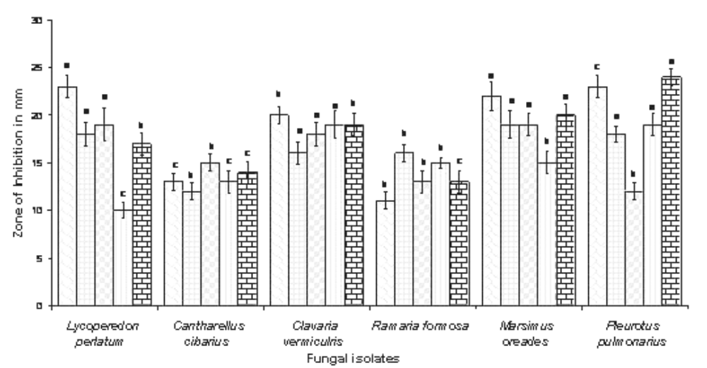
Error bars are standard error values followed by letter denotes significantly (p>0.05) different

Figure 4- Similarity of Minimum Inhibitory Concentration values of mushrooms when compared to control drugs in relation to their susceptibility to the test microorganisms
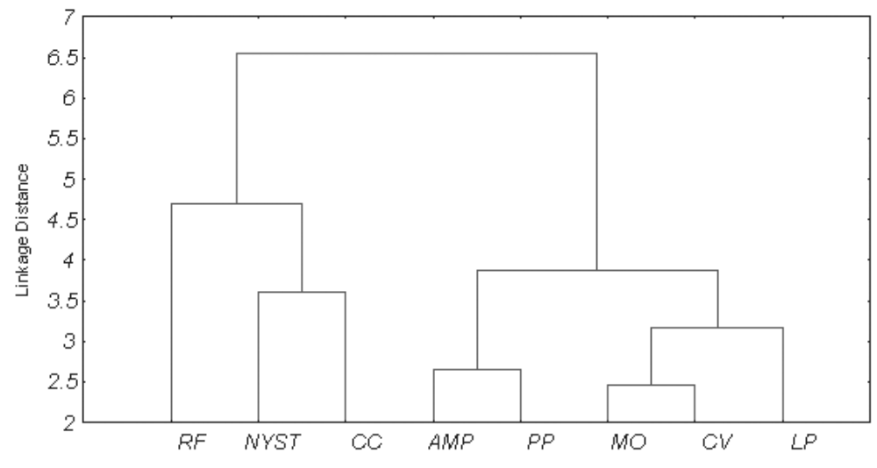

Table 1. Bioactive compound contents of the wild edible mushrooms (Mean ± Standard Deviation; n=3)

Sl No | FUNGAL ISOLATES | Total Phenols (mg/ml) | Total Flavonoids  (mg/ml) | Ascorbic acid  (mg/ml)
1 | Lycoperedon perlatum | 6.25 ± 0.08 | 2.52 ± 0.15 | 0.15 ± 0.00
2 | Cantharellus cibarius | 3.20 ± 0.05 | 1.75 ± 0.07 | 0.06 ± 0.01
3 | Clavaria vermiculris | 5.65 ± 0.05 | 2.54 ± 0.08 | 0.11 ± 0.01
4 | Ramaria formosa | 3.62 ± 0.05 | 0.40 ± 0.05 | 0.07 ± 0.00
5 | Marsimus oreades | 4.78 ± 0.07 | 1.89 ± 0.04 | 0.16 ± 0.01
6 | Pleurotus pulmonarius | 5.79 ± 0.03 | 1.76 ± 0.06 | 0.13 ± 0.00

Table 2 – Antimicrobial efficacy of methanolic extract of wild edible mushrooms

Zone of inhibition in mm (MIC values mg/ml)
Fungal isolates | Gram +ve Bacteria. |  | Gram –ve Bacteria. |  | Fungi
Fungal isolates | Bacillus subtilis | Staphylococcus aureus | Escherichia coli | Pseudomonas aeruginosa | Candida albicans.
Lycoperedon perlatum | 24(3) | 18 (2) | 19 (2) | 10 (ND) | 17 (3)
Cantharellus cibarius | 13 (ND) | 12 (ND) | 15 (3) | 13 (ND) | 14(ND)
Clavaria vermiculris | 20 (5) | 16 (3) | 18 (2) | 19 (2) | 19 (2)
Ramaria formosa | 11 (ND) | 16 (2) | 13 (ND) | 15 (3) | 13 (ND)
Marsimus oreades | 20 (3) | 19 (2) | 19 (2) | 15 (3) | 20 (2)
Pleurotus pulmonarius | 23 (3) | 18 (2) | 12 (ND) | 19 (2) | 24 (1)
Ampicillin 10 µg/ml | 18 (4 ) | 19 (1) | 16 (2) | 17 (2) | ND
Nystatin  100 Units | ND | ND | ND | ND | 19 (2)
DMSO | Control | Control | Control | Control | Control
ND – not determined

