Response to Sulfur and Organic Matter Status by the Application of Sulfidic Materials in S-Deficient Soils in Bangladesh: Possibilities and Opportunities

Abul Hasnat Md. Shamim^{1, 2} and Farook Ahmed¹

¹Graduate School of environmental Science, Okayama University, Okayama 700-8530, Japan
²School of Agriculture and Rural Development, Bangladesh Open University, Gazipur-1705, Bangladesh
abulhasnats@yahoo.com

Abstract: The sulfidic materials (SM)/layers of acid sulfate soils deserve attention to use these soil materials for the reclamation of sulfur deficient soil and other poor soils such as saline, alkaline, or calcareous (Khan et al. 2002). The availability of land for growing crops is limited; it may become inevitable to utilize marginal and problem soils. Sulfur deficiency has become widespread over the past several decades in most of the agricultural areas of the world including Bangladesh, which have need of sustainable measures for their reclamation. The content of available sulfur in the soils were increased by the application of SM, regardless of soil conditions and the effects were significantly positive (p≤0.05) with the ahead of time in compared to other treatments like gypsum, magnesium sulfate etc. At the same time, all the rates of SM showed the significantly (p≤0.05) positive effects on organic matter status in the soils and increments were more striking with the higher rates. This means the SM has potential and effective impacts than that of gypsum or magnesium sulfate not only as a source of fertilizer but also to enrich the fertility and productivity status of soil. Moreover, the SM treatment was found to be maintained the high nutrient status in the soil till the final harvest at maturity of different crops, reflecting a good indication for its long term use. It is mentioned that the use of SM did not show any harmful effect on the plant and soil in Bangladesh so far. [Report and Opinion. xxxx;x(x):xx-xx]. (ISSN: 1553-9873).
Key words: Sulfur, organic matter, sulfidic materials, s-deficient soils

1. INTRODUCTION

Bangladesh is the largest deltaic floodplain in the world lying in the Northeastern part of South Asia with a total area of 147570 km² and population of 150 million people. She lies between 20°34´ and 26°38´ North latitude and 88°01´ and 92°41´ longitude. Agriculture is the life force of her economy. The country has been a food deficit area for long time and has about 8.2 million hectares of cultivated land with average cropping intensity of about 185 percent (Kafiluddin and Islam, 2008). Soil is the most important natural resource. The majority of the country’s soils are alluvial. Hill and terrace soils represent only 20 percent of the country and 8-10 percent of the cultivable land.
Sulfur deficiency has become widespread over the past several decades in most of the agricultural areas of the world including Bangladesh (Figure 1), becoming a limiting factor to higher yields and fertilizer efficiency. It is noted that about 7 M ha (about 52 %) of agricultural lands are reported to consists of sulfur deficient soils in the northern region of Bangladesh (SRDI, 1999). Maintenance of field S fertility is often overlooked, and S deficiency symptoms in crops are sometimes confused with P or N deficiencies or Al toxicity. Since concentrated fertilizers with a low S content are now widely used, S deficiency problems appear more often (Hitsuda, et. al., 2005). According to estimates of The Sulphur Institute (TSI) based on crop demand, fertilizer efficiency and current inputs, the current S deficit is about 9.6 million tonnes annually. With increased food production raising S requirements and assuming slower expansion rates for S application, this S deficit is projected to grow to 11.9 million tonnes by 2015 (Ming Xian FAN and Donald L MESSICK, 2007) In Asia: In the late 1990s and early 2000s, intensified agricultural production, pressured by the backdrop of food self-sufficiency goals and limited land resources in the globe’s two most populous nations, China and India, has created the S nutrient imbalance. This imbalance is expected to grow due to the widespread gap between available production and supply, and crop requirements. Asia’s annual S fertilizer deficit is projected to increase from over 5 million tonnes currently to 6.4 million tonnes by 2013, with over 70 % represented by China and India (Morris, 2007). A regional breakdown of world S deficits is shown in Figure 2. Asia is the region manifesting the greatest S shortfalls.
In most of the world, since the 1950's or earlier, the crop productions have grown two or three fold, as well as have inputs of N, P and K fertilizers. However, S inputs have been steady and sometimes decreasing due to use of “high- analysis fertilizers” with low S content. Figure 3 shows the estimated plant nutrient sulfur balance in Asia.

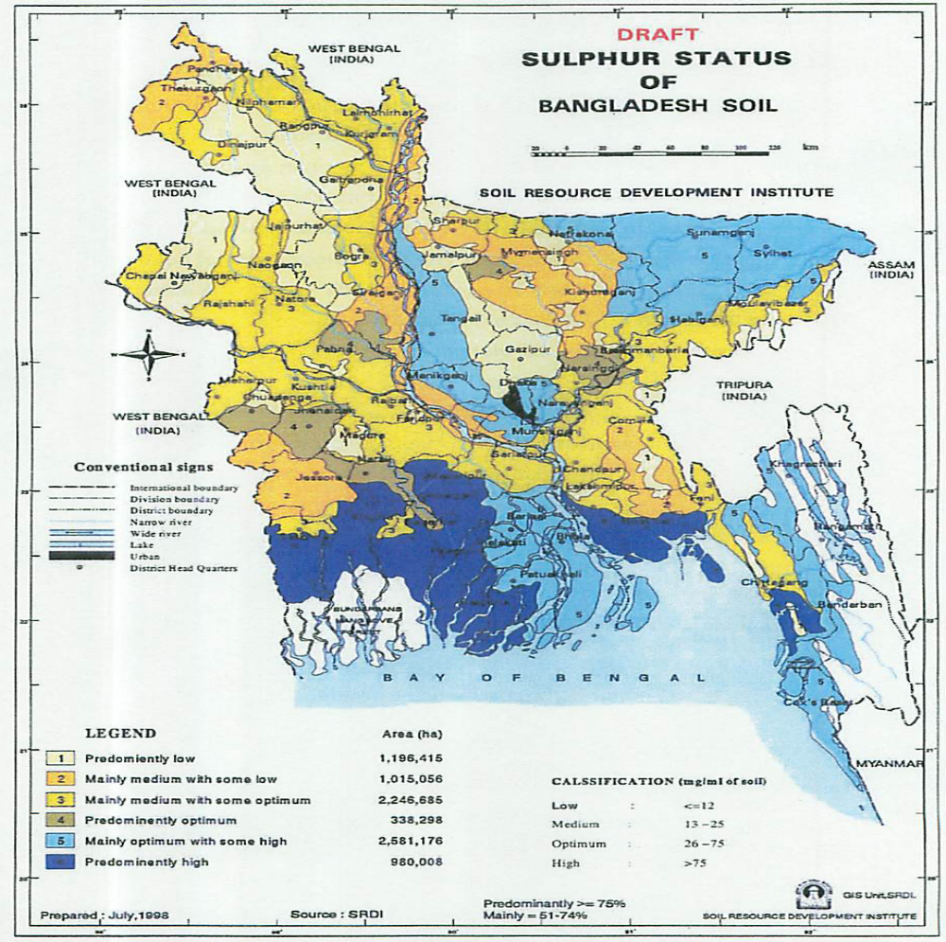
Figure 1: Map of the sulfur deficient areas in Bangladesh.
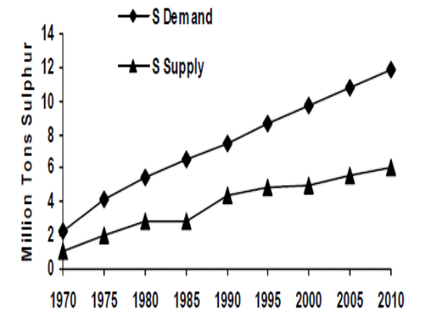
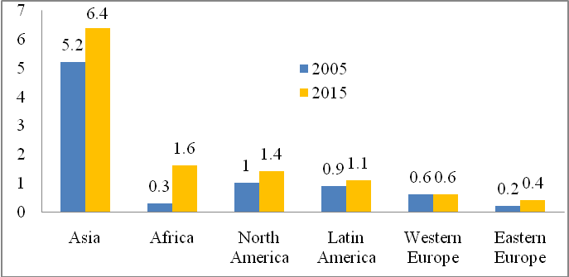
(Source: Ming Xian Fan and Donald L Messick, 2007) (Source: Donald L Messick and Ming Xian Fan, 2003)
Figure 2: Regional plant nutrient sulphur deficit in 2005 Figure 3: Plant nutrient sulfur balance in Asia
and 2015 (Million Tons).

A clear imbalance in the nitrogen, phosphorous, potassium: sulfur ratios of fertilizer applied have arisen in many areas of Bangladesh. Sulfur deficiency in Bangladesh was first identified in 1978. The current intensive use of agricultural land for crop production has extended the sulfur deficient areas to about 80 % in the Northern region of Bangladesh (Khan, et al., 2007). Poor crop production as a result of acute sulfur deficiency has frequently been reported by many scientists in different regions of India (Tiwari, et al., 1985) and Bangladesh (Khan, 2000). It is mentioned that the critical level of sulfur for Bangladesh soils has been determined as 10 µg g⁻¹ soil. The current use of gypsum, ammonium sulfate, zinc sulfate, etc. as sulfur fertilizers to the soils can instantly supply the sulfur to crops but the fertilization has to be done for each crop in every year, which was even unable to give satisfactory yield of crop and it is not a good practice for the soils as well as environments. Therefore, a suitable and sustainable source of sulfur is very important.
The availability of land for growing crops is limited; it may become inevitable to utilize marginal and problem soils. The sulfidic materials (SM)/layers of acid sulfate soils (ASSs) deserve attention to use these soil materials for the reclamation of saline, alkaline, calcareous or sulfur deficient soils (Khan et al. 2002). The SM was detected at depths of 10 to 40 cm in the different pockets of actual ASSs of Cox’ Bazar coastal plains in Bangladesh (Khan et al. 2005). The high Mg and Al contents of the soils may be valuable for tea plants and nursery crops.
These soils are also found in several lowland areas of the world. But since the sulfide layers in ASSs can exert severe effects on surrounding ecosystems, immediate steps should be taken to consider these soils further (Khan et al. 2002). Delayed effects of potential chemicals stored in the SM resulted in harmful effects, like a “chemical time bomb” on the associated environments (Khan and Adachi, 1999). Potential ASSs may have high pH like 6 to 7 does not mean that the soils are safe because at that situation it may create H₂S, Fe, some organic acids and CO₂ problems (Kabir, 2005).
On the other hand, salinity is a widely recognized problem throughout the world and the annual losses due to salinity have been estimated more than 7 billion dollars (Norbors and Dykes, 1984). Adverse effect of salinity has been increasing day by day (Butson and John, 2000). Salt affected coastal areas in Bangladesh mainly include saline (>20%) and acid sulfate (>3%) soils, which occupied >23% of the cultivable lands. These soils could display high agricultural potentials if they were to be reclaimed by appropriate methods (Khan et al., 2006). Reclamation of acid sulfate soils through liming, leaching, construction of raised bed is not sustainable. Moreover, the neutralization of them with lime, leaching let to the deterioration of soils, related ecosystems and to permanent soil acidification (Khan and Adachi, 1999). Accordingly, the SM and techniques to manage them have been put forward (Khan et al. 2002). Application of SM as compared to gypsum as a source of sulfur was shown to be potentially valuable for the improvement of fertility and productivity of sulfur deficient soils. He also claimed that it can be used for the amendment of alkaline, saline and calcareous soil.
Ribeiro, et. al., 2001 reported that maximum levels of S are found in wetlands, mainly in soils containing acid-sulfate materials, and in alkaline, gypsiferous soils in arid and semiarid regions. The utilize of sulfidic materials (SM) or layers obtaining from acid sulfate soils (ASSs) as sulfur fertilizer for crop production is very scanty. Khan, et al., (2002) reported that the high organic matter (2-9 %) total sulfur (3-7 %) and micronutrients in ASSs or SM deserve attention to use these soil materials for the reclamation of alkaline, calcareous or sulfur deficient soils and also for the amendment for ASSs themselves by the removal of SM from the soil. Khan, et al. (1994) also reported that the ASSs contained high Mg (1.3 to 2.6 c mol kg⁻¹) and Al (1 to 2 c mol kg⁻¹). But the use of high Al contained ASSs or SM did not notice any harmful effects when applied in the soils having pH > 4.5 (Khan, et al., 2002). It is mentioned that SM in an ASS layer, which occupies 0.7 M ha land area in Bangladesh, had low pH (< 3), high sulfate and organic matter (Khan, et al., 2006). This is well known that soil organic matter (SOM) plays an essential role in ecosystem functioning through the storage of carbon and nutrients, improvement of aeration and water-holding capacity, and thus primary production and biogeochemical cycling. Changes in SOM contents (by natural or anthropogenic causes) have a significant impact on the global C cycle as SOM is the largest terrestrial C pool. Incorporating organic matter into soil can have several impacts because it disturbs the physical, chemical and biological balances in the soil. It can: (1) change the amount of nitrogen that is available to plants; (2) change the amount of other nutrients available; (3) change the way the soil sticks together (soil aggregation); (4) change the number and type of organisms present in the soil.
The eradication of SM from the ASSs is not only reclaimed the ASSs for a long time but its use in sulfur deficient or non-fertile soils at the rate of about 300 to 1500 kg ha⁻¹ may improve the fertility and productivity of the soils. Khan, et al. (2007) reported that the application of SM at the rate of 75 kg S ha⁻¹ for sulfur deficient soils had no negative effect on soil pH, nutrient status in the soils and Sunflower production under pot experiment. They suggested that the application of SM was not only effective as sulfur fertilizer but also enriched the organic matter status and other nutrients in the soils. Moreover, many studies have been conducted on the mineralization of elements such as N, P, and K from animal manures in various climates and soil conditions (Ebeling, et al., 2003; Egrinya-Eneji, et al., 2003; Eghball, et al., 2002; Schmitt, et al., 2001). However, there are relatively few that focus on nutrients such as Ca and S (Egrinya-Eneji, et al., 2003).
In this respect, the present report is considered to evaluate the impacts of SM or ASSs in response to available sulfur and organic matter status in s-deficient soils in Bangladesh. The specific considerations are: (1) Since the SM contained high amounts of organic matter, total-sulfur and rich in nutrients then their potentiality and effectiveness as an amending material for sulfur deficient and others non-fertile soils and (2) More than 80% of the agricultural land in Bangladesh is s-deficient and about 23% land is affected by salinity. Therefore, the reclamation of saline soils instead of gypsum, sulfidic material rich in [Al₂(SO₄)₃] may play better role like improvement of soil structure. These sorts of approaches may lead to the long term or permanent solution of the problems of these soils. This approached works could be a new resource for the society/country.

2. OPINIONS AND DISCUSSION
Although considerable report has been written on improvement of s-deficient soils by different scientists in the world, there are no data on the remediation measures of these soils so far. Some scientists has been tried to reclaim such kind of problem soils by the application of sulfidic materials (SM). It has been attracted much attention because the used SM acted as a dual benefit in just case. The SM not only recovers s-deficient and/or non-fertile soils but also it reclaims itself also.

2.1Sulfur and organic matters in the soils
Table 1 shows the response of available sulfur and organic matter status influenced by the application of SM. The content of available sulfur in the soils were increased by the application of SM, regardless of soil conditions and the effects were significantly positive (p≤0.05) with the ahead of time in compared to other treatments like gypsum, magnesium sulfate etc. At the same time, all the rates of SM showed the significantly (p≤0.05) positive effects on organic matter status in the soils and increments were more striking with the higher rates (Khan et al., 2007; Shamim et al., 2008 and 2009).
Shamim, et al. (2009) reported that the available S contents of the soil was increased by the application of SM and G but the effects were more pronounced in case of SM and the increments were significantly (p≤0.05) stronger with the passes of time (Table 1). Apart from fertilizer rates, the applied SM and G increased the available S contents by 295 and 196 %, respectively at post harvesting of rice at maturity (Table 1) under field experiment. This might be due to the contents of other essential nutrients especially N in SM, which enhanced sulfur uptake by the rice compared with the G treated plots. On the other hand, S content was found to be increased by the treatments but decreased in few cases by the passes of time was attributed due to the uptake of growing rice plant.
The content of organic matter in the soil throughout the experimental period was found to be improved a little by the different rates of gypsum fertilization, whereas almost all the doses of SM significantly increased the organic matter status in the soils and the increments were more striking with the higher doses of SM. The application of SM increased the average organic matter in the soil by 72 % IOC (Increased over control) at post harvesting of rice at maturity, while these increments were 58 % for G treatments. These increments in organic matter status in the soil were attributed to the high content of organic matter in the applied SM and the little enrichment of organic matter by the G treatments were attributed to the contribution of cultivation processes.
Shamim, et al. (2008) also mentioned that by the use of SM and G, the available S contents of the soils were increased and the effects were more striking by SM instead of G and the increments were significantly (p≤0.05) improved with the passes of time. The applied SM and G increased the available S contents, apart from fertilizer rates by 228 and 187 % IOC for Sirajgonj soil (s-deficient soil); 140 and 88 % for Gazipur soil (s-deficient soil), respectively at post harvesting of rice at maturity under pot experiment. The SM exerted better response for the increment of sulfur (Table 1) in both the s-deficient soils. The application of SM increased the average organic matter in the soil by 20 to 43 % IOC at post harvesting of rice at maturity, while these increments were 6 to 22 % for G treatments. They also claimed that the application of SM at the rate of 160 kg S ha⁻¹ for sulfur deficient soils had no negative effect on nutrient status in the soils and rice production under pot experiment.

Table 1: Response of available sulfur and organic matter status of the soils at maturity stages of different plant species as influenced by the application of sulfidic materials in sulfur deficient soils

Plants | Treatments | Available sulfur | Organic matter | References
Sunflower  (Helianthus annus L.) | ªSM_{25,} SM₅₀ & SM₇₅ | 188 to 230% ^{b}IOC | 45 to 69% IOC | Khan et al., 2007
Rice (Oryza sativa L.;  Var. BR 16: Shahi balam) | SM_{40,} SM_{80,} SM₁₂₀ & SM₁₆₀ | 141 to 229% IOC | 20 to 43% IOC | Shamim et al., 2008
Rice (Oryza sativa L.;  Var. BR 11: Mukta) | SM_{20,} SM_{30,} SM_{40,} SM₅₀ & SM₆₀ | 295% IOC | 72% IOC | Shamim et al., 2009
ªSM = sulfidic material (SM: kg S ha⁻¹), ^{b}IOC = Increased over control

3. SUMMERY AND FUTURE DIRECTIONS
Deficiency of sulfur has become widespread over the past several decades in most of the agricultural areas of the world including Bangladesh. Strides have been made in gaining the recognition and the commercial sector is beginning to recognize that not only can plant sulphur requirements no longer be ignored. Accordingly, the following requisites will be needed:

- The authorities of Bangladesh should be taken necessary steps to ensure the use of SM as a source of sulfur for poor soils (s-deficient, alkaline soils etc.); Besides this:
- Sulphur fertilizer products must be produced and available locally;
- The fertilizer industry needs to take more active strategies, such as 1) more efficiently produce, distribute and use traditional S fertilizers based on their S content; 2) increase production of sulphate/elemental S enriched high analysis NP/NPK compound fertilizers through incorporation of low cost elemental sulfur;
- To meet up increasing demand for S in agriculture and balanced fertilization technology, increasing S fertilizer production and accelerating commercialization of S products will provide significant benefits to both fertilizer manufacturers and farmers;
- The authorities (National and local) will need to ensure that their fertilizer policies, at a minimum, do not impose obstacles on S fertilizer manufacturing and application, and more importantly are proactive to ensure that S is easily accepted in fertilizer regulations and crop S fertilizer recommendations are in place;
- Sulfur needs to be included in fertilizer supply and consumption statistics by all government and industry associations producing fertilizer statistics.
As a final point, S must take its rightful place as a major plant nutrient together with N, P, and K by all stakeholders in balanced fertilization for higher yield and fertilizer efficiency.
Prospects of acid sulfate soils:
The sulfidic materials (SM)/acid sulfate soils-
- can easily be used as a source of sulfur and bio-fertilizers;
- may be used for the reclamation and/or improvement tea soils/plants;
- can be used for the amendment of alkaline, saline and calcareous soils and
- can be used as pot soil and nursery development.
These require extensive researches under various conditions.
Future research needs:
- use as a reclaiming materials for poor soils or adaptation of crops;
- removal of SM can be acted as a dual benefits.

Acknowledgements: The authors desire to express their appreciation to the Ministry of Education, Science, Culture and Sports, Government of Japan and The Sulphur Institute, United States for their kind support.

References
[1] Abul Hasnat Md. Shamim, Md. Harunor Rashid Khan and Takeo Akae. Effectiveness of Sulfidic Materials on N, P, K, Mg and S Nutrient Uptake by Rice Plants Grown in Sulfur Deficient Soils under Field Experiment. New York Science Journal, 2009; 2 (4), pp. 33-41.
[2] Abul Hasnat Md. Shamim, Md. Harunor Rashid Khan and Takeo Akae. Impacts of Sulfidic Materials on the Selected Major Nutrient Uptake by Rice Plants Grown in Sulfur Deficient Soils under Pot Experiment. Journal of American Science, 2008; 4(3):68-74.
[3] Buston F. and Jhon J. The impacts of land salinity on wetlands: Diatoms as biomonitors in the wheat belt region of Western Australia, Remade Lands, International conference on the remediation and management of degraded lands. Fremantle, Western Australia, 30 November-2 December 2000. p. 144
[4] Donald L MESSICK and Ming Xian FAN. Sulphur deficiencies in Asia and Pacific Regions: Importance of sulphur fertilization. IFA Regional Conference for Asia and the Pacific, Republic of Korea, 6-8 October, 2003.
[5] Ebeling AM, Cooperband LR and Bundy LG. Phosphorus source effects on soil test phosphorus and forms of phosphorus in soil. Commun. Soil Sci. Plant Anal, 2003; 34:1897–1917.
[6] Eghball B and Power JF. Phosphorus and nitrogen based manure and compost applications: Corn production and soil phosphorus. Soil Sci. Soc. Am. J, 1999; 63:895–901.
[7] Eghball B, Wienhold BJ, Gilley JE and Eigenberg RA. Mineralization of manure nutrients. J. Soil Water Conserv, 2002; 57:470–473.
[8] Egrinya-Eneji A, Irshad M, Honna T, Yamamoto S, Endo T and Masuada T. Potassium, calcium and magnesium mineralization in manure treated soils. Commun. Soil Sci. Plant Anal, 2003; 34: 1669–1679.
[9] Hitsuda K, Yamada M and Klepker D. Sulfur requirement of eight crops at early stages of growth. Agronomy Journal, 2005; 97:155-159.
[10] Kabir SM. Acid sulfate soil ecosystems and their sustainable management. Unpublished Ph.D thesis, University of Dhaka, Bangladesh. 2005; pp. 1-2.
[11] Kafiluddin A and Islam MS. Fertilizer distribution, subsidy, marketing, promotion and agronomic use efficiency scenario in Bangladesh. IFA Crossroads Asia-Pacific, Melbourne, Australia, 16-18 December 2008.
[12] Khan HR, Blume H-P, Kabir SM, Bhuiyan MMA, Ahmed F, Syeed SMA. Quantification of the severity, reserve and extent of acidity in the twenty profiles of acid sulfate soils and their threats to environment. Soil & Environ, 2007; 26: 45-55.
[13] Khan HR, Kabir SM, Bhuiyan MMA, Blume H-P, Adachi T, Oki Y and Islam K R. Physico-chemical amendments of acid sulfate soils for rice production in Bangladesh. The 18th World Congress of Soil Science Abstract, Philadelphia, Pennsylvania, USA, July 9-15, 2006. p.682.
[14] Khan HR, Bhuiyan MMA, Kabir SM, Oki Y and Adachi T. Effects of selected treatments on the production of rice in acid sulfate soils in a simulation study. Jpn. J. Trop. Agr, 2006; 50:109-115.
[15] Khan HR, Blume H-P, Bhuiyan MMA and Kabir SM. Spatial and temporal patterns of acidifications in acid sulfate soils and their environmental threats: A case study in Bangladesh. Presented in International Conference on Environmental Processes Engineering and its Related Sciences, held on 25-28 February, 2005 in Penang, Malaysia.
[16] Khan HR, Bhuiyan MMA, Kabir SM, Ahmed F, Syeed SMA and Blume H-P. The assessment and management of acid sulfate soils in Bangladesh in relation to crop production. In: The restoration and management of derelict land, MH Wong and AD Bradshaw (ed.), World Scientific Publishing Co. Pte. Ltd. UK, 2002; 254-262.
[17] Khan HR. Problem, prospects and future directions of acid sulfate soils. Proc. Inter. Conference on Remade Lands 2000, A Brion and RW Bell (ed.). Perth, Australia, Nov. 30 to Dec. 2, 2000; 66-67.
[18] Khan HR, Adachi T: Effects of selected natural factors on soil pH and element dynamics studied in columns of pyretic sediments. Soil Science and Plant Nutrition, 1999; 45: 783-793
[19] Khan HR, Rahman S, Hussain MS, Adachi T. Growth and yield response of rice to selected amendments in an acid sulfate soil. Soil Sci. Plant Nutr., 1994; 40: 231–242.
[20] Ming Xian FAN and MESSICK Donald L. Correcting Sulphur Deficiency for Higher Productivity and Fertilizer Efficiency, IFA Crossroads, Asia-Pacific 2007, 17-19 December Bail, Indonesia, 2007.
[21] Morris RJ. Sulphur in Agriculture: Global Overview, Fertilizer focus, January/February 2007
[22] Norbors M. and Dykes T. 1984: Obtaining cereal cultivars with increased tolerance to salt, drought and acid stressed soils through tissue culture, LARCS on Biotech. 23-27 April, IRRI, Manila, p. 51-60
[23] Ribeiro ES, Dias LE, Alvarez VH, Mello VJWV and Daniels WL. Dynamics of sulfur fractions in Brazilian soils submitted to consecutive harvests of sorghum. Soil Sci. Soc. Am. J, 2001; 65: 787-794.
[24] Schmitt MA, Schmidt JP, Randall GW Lamb JA, Orf JH and Gollany HT. Effect of manure on accumulation of dry matter, nitrogen, and phosphorus by soybean. Communication Soil Sci. Plant Anal, 2001; 32:1931–1941.
[25] SRDI (Soil Resources Development Institute). Map of the nutrient status of sulphur and upazila land soil resource utilization guide, 1999.
[26] Tiwari KN, Dwivedi BS and Pathak AN. Iron pyrites as sulfur fertilizer for legumes. Plant soil, 1985; 86:295-298.
Correspondence to:
Abul Hasnat Md. Shamim
Ph. D Student
Graduate School of Environmental Science
Okayama University, Okayama 700-8530, Japan
E-mail: abulhasnats@yahoo.com

Received: xx/xx/xxxx

