Hydrogeochemical Investigation and Numerical Simulation of Solute Transport into Surface and Groundwater , Case Studied: Jiaxing Landfill Leachate
Souleymane KEITA Department of Hydrogeology and Water Resources School of environment Studies China University of Geosciences 430074 Wuhan China
soulkei_ml@yahoo.fr

Abstract: Problem statement: Hangjiahu regions belong to the Yangtze River Delta region in Zhejiang Province in China. The vast majority of this region is flat, so surface and groundwater both have a low flow rate. With the rapid economic development of the area, a large number of industrial and domestic garbage are generated. These landfill or garbage are exposed and stacked. Because of mismanagement of environment, the atmosphere under the leaching rainfall, results in harmful gases and leachate. A serious pollution of the atmosphere surrounding the dump, soil, surface water and groundwater occurred. By studying the area under different hydro geological conditions this groundwater pollution due to the landfill can be stopped and prevented. This research can also provide a scientific basis. Approach: some samples were taken to some specific sampling points in order to do chemical analysis. A hydro geological investigation was done on the study area. By using all these data, groundwater pollution was evaluated and predicted through numerical simulation software: GMS (Groundwater Modeling System), from 1996 to 2011. Results: it appeared that the level and the flow rate of the groundwater change according the dry or wet period. So, the pollution increases with there rising. In the Hexi Bang Village, the change in water level is about 0.5m:1.5m in wet period and 1m in dry period. Also water level is higher near the landfill (3.1m)than in other places. Groundwater flows very slowly and water level is law in some area because of poor permeability of the aquifer and groundwater exploitation, simulated water table was significantly lower than the region surrounding the central region. In July 2007 HexiBang demolition stopped the exploitation of groundwater in the area. The depression cones have disappeared in groundwater pumping areas on July 2009. The people of Hexi Bang village may have a negative impact on water quality. And surface and groundwater at the north and the south-east of landfill also can be harmful for people. Also from the simulation results, in January 2009 the chlorine ion (10mg / l) contour lines moved northward at about 220m. And in January 2011 they moved for about 235m. So from January 2009 to January 2011, during these two years, the 10mg / l contour moved to the north for about 15m. From the simulation results 0.01mg/l of BTEX contour line ,moved about 50m northward in 10 Years and about 84m northward in 20 Years.conclusion/recommandations: Experimental and simulation results were compared and showed
that close agreement between these two values were obtained. The application of ecological methods to remove harmful substances such as the cultivation of suitable plants is also necessary.
Keywords: Hydrogeochemical Investigation-Numerical simulation-Solute Transport-Jiaxing Landfill.
INTRODUCTION
Pollutants migration, transformation and accumulation in soil and groundwater are results of combined effects of a complex physical, chemical and biochemical actions. Research of pollutants migration and transformation in the groundwater has more than 50 years of history. Now we have a better theory and a wide variety of computing models, part of the models has been applied to solve practical engineering problems. Model solutions have also been in great progress, and we have some relatively sophisticated numerical simulation methods and softwares.
This work was done by combining both deterministic and stochastic models as defined by Addiscott (1985) [1].
The first to propose a similar model of advection-dispersion equation are Lapidus and Amundson (1952) [2], they opened a prelude to the study of solute transport, but they did not give the model parameters derivation ways and specific meaning.
In 1954, Scheidigg will use Lapidus to the three-dimensional expansion of the equation, bearing in mind at the time of the solute transport in the role of mechanical dispersion, so that the theoretical study of solute transport in a step forward.

Corresponding author: Souleymane KEITA Hydrogeology and Water Resources Department the School of Environmental Studies China University of Geosciences Wuhan 430074, Lumo Road 388, Tel: +8613545910535. e-mail: soulkei_ml@yahoo.fr

In 1956, Rifai used Scheidigg on basic research results, but also takes into account the molecular diffusion of solute transport role and the introduction of the concept of dispersion (hydrodynamic dispersion coefficient and pore water velocity ratio α = D / V), so that solute migration theory is used for more depth of groundwater.
Between 1961-1962 Nielson and Biggar [3,4] based on a series of experiments, made easy mixed replacement theory, consider the flux of solute by convection, diffusion and dispersion caused by the combined effects, and theoretically set up a convection dispersion equation. According to the experimental results, Lapidus, Shceidegg and Nielson's model is a comparative analysis of the results and shows that the convection dispersion equation better describes the conservative substances in porous media.
Nielosn set up a one-dimensional convection-dispersion equation as follows:

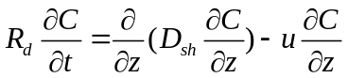
Rd for the retardation factor, Dsh for hydrodynamic dispersion coefficient, (L2 / T); ц for the average pore water velocity, (L / T); C is solute concentration, (M/L3); z for vertical to the coordinates, (L).
Lindstrone et al [6], Cleary and Adrain [7], obtained the same results with different boundary conditions of the analytical solution[5]. With the popularization of computers, numerical methods are used to solve many solute transport problems [8].
In 1980, Dasgupta .. D [9], set up a chemical reaction groundwater solute transport model, and simulated a leachate migration and transformation of iron ions from a garbage in Miami in the United States. Morrison and Stan J (1995) [10], set up the value of uranium and iron six interaction reaction - migration model to analyze the reaction of iron hydroxides walls of hexavalent uranium in groundwater. Toride et al (1996) [11] set up for stable linear filter down and primary sport of the CDE(convection-diffusion Equation) model Absorption; Flury (1998) [12] the solute degradation and adsorption process and the relationship between soil depth using a generalized function, and experimental data authentication; Pachepsky (1999) [13] set up a description of the different soil moisture and reflect the fractal characteristics of medium convection - diffusion equation. In 1999 Stewart, Iris T, etc. [14] set up a TTFs (type transfer functions) model Fresno, California United States east of the regional DBCP (dibromo-chloropropane) on the impact of groundwater quality assessment of a simulation. Karapanagioti et al (2001) [15] taking into account evaporation, dispersion, adsorption and degradation established aquifer contaminant transport model of multi-component mixtures. Vanderborght (2007) [16] for pesticides and salt transmission prediction study will describe the material in the solid and liquid two states under the reaction function with convection -- combining the dispersion equation and application.
The study area Overview
Hangzhou-Jiaxing-Huzhou Taihu Lake Basin is located in the southeastern region of China in Zhejiang province(see Figure1and 2). The geographical coordinates are: longitude between 120° 00' and 121 °16' latitude between 30°13' and 31°02' , for an area of about 6490km2. 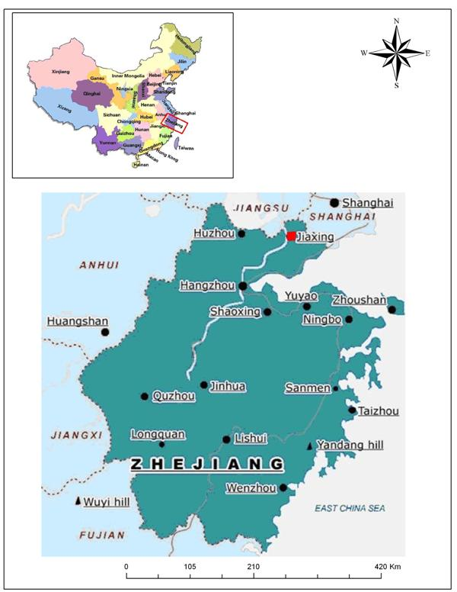
Figure 1 Location of the Study Area
Ground elevation is between 1 ~ 7m. In the Western Part, there is a sporadic distribution of residual hill with an average elevation of 100 meters.
The study area is located in subtropical monsoon climate zone with four seasons. The annual average temperature 15.7 ° C ~ 16.2 ° C. Average precipitation over the years is between 1140 ~ 1350mm.
The average surface evaporation is 910mm/year with an average of 80 percent of relative humidity.
The area occupied by surface water is of 679km2(10.5% of total area). The total river length is 24000km..
Jiaxing region is densely populated and economically developed.
The land known as the "land of fish and rice" is fertile and rich(9.31% of Zhejiang Province.
The study area's population is 19.35% of Zhejiang Province for a gross domestic product accounted of 30.64% (see the Table 1).
Table 1 Socio-economic profiles (by the end of 2004 statistical data)

Region Population Land (km2) Arable land Gross domestic product
(million) (1000 hectares) (billion RMB)

Hangzhou City 4.0159 3068 98.327 1949.41
Huzhou City 1.5032 2502 72.734 388.45
Jiaxing City 3.3394 3915 210.84 1107.15
Province 45.7722 101800 1594.92 11243

Jiaxing City Landfill basic information
Jiaxing landfill is surrounded by rivers(see Figure 3).
Landfill rubbish dumps average altitude is about 25m and the elevation throughout the region is between 4.2m to 2.0m. The main aquifer layer is fine powder of sand. And there is no large-scale exploitation of water resources in the region.
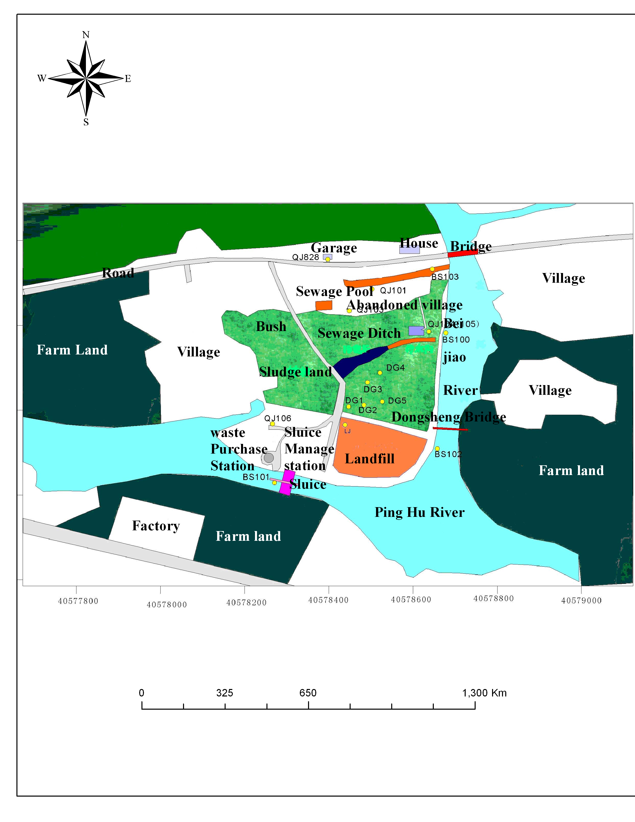
Figure 2 Jiaxing Landfills Overview map with the sampling points
MATERIALS AND METHODS
This work was done in two important phases: investigations and numerical simulation.
Investigations:
Landfill leachate is generated by water or other liquids passing through the trash [17]. Landfill leachate comes mainly from precipitation, surface water, groundwater intrusion into landfill and litter moisture [18-19].
Some soil and water samples were used for experimental analysis in November 2007 and September 2008. It was about: Absorption, adsoption, desorption,…,and to get the main organic and inorganic pollutants in the study area.
The experiments were done at China University of Geosciences (Wuhan), School of Environmental Studies Laboratory of the solute transport. At the trial period, the indoor temperature was 23-25 degrees Celsius.
The main experimental equipment are in Table 2.

Table 2 Main experiment Equipment

Name Model Remarks

Electronic Balance BS210S Max210g d=0.1mg Germany sartorious

Conductivity Meter HI8733(With ATC function Sihuan Italy HANNA
HI76302 conductivity electrode)

Graduated cylinder 500ml,100ml,50ml,1050ml

Ion chromatograph DX120 Diana

Peristaltic pump

Vacuum pump

Landfill Leachate production forecasting methods are: empirical formula, water balance, statistical method and model.
Empirical formula:
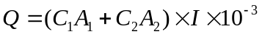
Where:
Q —— average Leachate produced a day （m³/d）；
I ——found by using the annual average rainfall to convert into daily average rainfall（mm/d）；
A1 ——Landfill area（m²）；
A2 ——Landfill resting seepage or influence zone area（m²）；
C1 and C2 are coefficients that are function of hydrogeological conditions(nature of soil, its porosity and slope, precipitation, evapotranspiration…) of respectively A1 and A2.they values vary from 0.2 to 0.8
For surface water we have [20]
(for high flow rate)
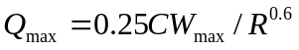(for low flow rate)
Where: 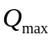is the largest volume of leachate generated（mm/d）；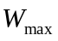 is the largest monthly precipitation（ mm/d）；C is the outflow coefficient(0.60-0.75); R is Filtrate leaching delay time（d ）.
Water balance method:
Where: L is Leachate production in a certain period （m³）；P: precipitation in landfill site in the same period（m³）； W: water generated by garbage degradation (m³）；Q_{1:}external infiltration of water（m³）;Q2: inflow of water from the external surface（m³）；Q_{3:} the loss of Landfill site from the water table（m³）； E_{1:} Evaporation of water table landfill site（m³）； E₂ Landfill plant leaf surface water evaporation(m³）；G: the moisture away from landfill gas（m³）；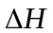 changes in the value of landfill pit water content(m³）.
(3) statistical method
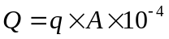
Where: Q Leachate production (m³/d)；
A Landfill catchment area( m²⁾；
q Leachate production per unit area m³/ha.d
The model: to predict the solute transport we need to solve simultaneously the groundwater flow in unconfined aquifer and the solute transport equations [21-22-23]:
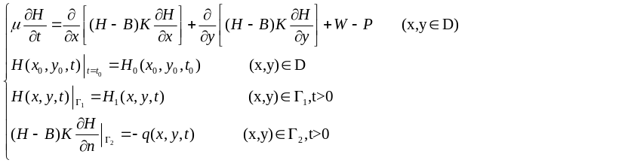 (Groundwater flow)

Where: K-permeability coefficient (m / d); - rock water aquifer degrees (dimensionless); H (x0, y0, t) - unconfined aquifer water level (m); B (x, y) - aquifer Bottom elevation (m); H0 (x0, y0, t0) - the initial flow field (m); H1 (x, y, t) - a class of the border on the water level (m); W-vertical aquifer system strength supply (m3 / (d.m2)); P-water supply and agricultural production intensity (m3 / (d.m2)); q (x0, y0, t) - II on the border of the flow (m3 / (dm )).
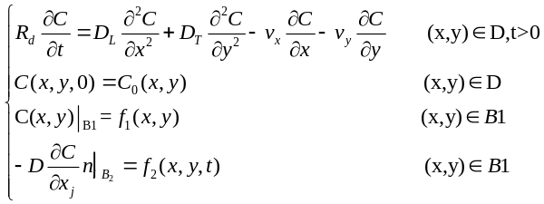 (Solute transport)
Where: C0 (x, y) - the initial concentration of pollutants (mg / l); f1 (x, y, t) to set the boundary concentration (mg / l); f2 (x, y, t) - gives the boundary diffusion flux (mg.m-2.t-1); D-hydrodynamic dispersion coefficient (m2 / d); Rd-pollutant retardation factor.
Numerical simulation
The results of these investigations have been used as input into a GMS(Groundwater Modeling System) to make simulation(by solving the model equations) in order to understand and to predict water pollution. Groundwater Modeling System (GMS) is a software made by Brigham Young University in the United States of America and US Army.
GIS (Geographic Information System) also has been used to output maps.
The study area covers 1.7km2, it is surrounded by three rivers and these rivers are cutting an unconfined aquifer. Landfill site is in south-east corner of the study area, it covers an area of 0.21853044 km2. The accumulation of ground above the average thickness is about 25m (Figure 4-5). According to the geological conditions and hydro-geological conditions, the thickness of the upper soil layer is about 0.2-3m; the lower fine powdered sandy layers thickness is 3-7m (Figure 6). They are two Anisotropic and homogeneous structures. The rivers can serve as a constant head boundary.
According to the characteristics of groundwater flow, the area can be summarized into a three-dimensional non-steady groundwater flow system.
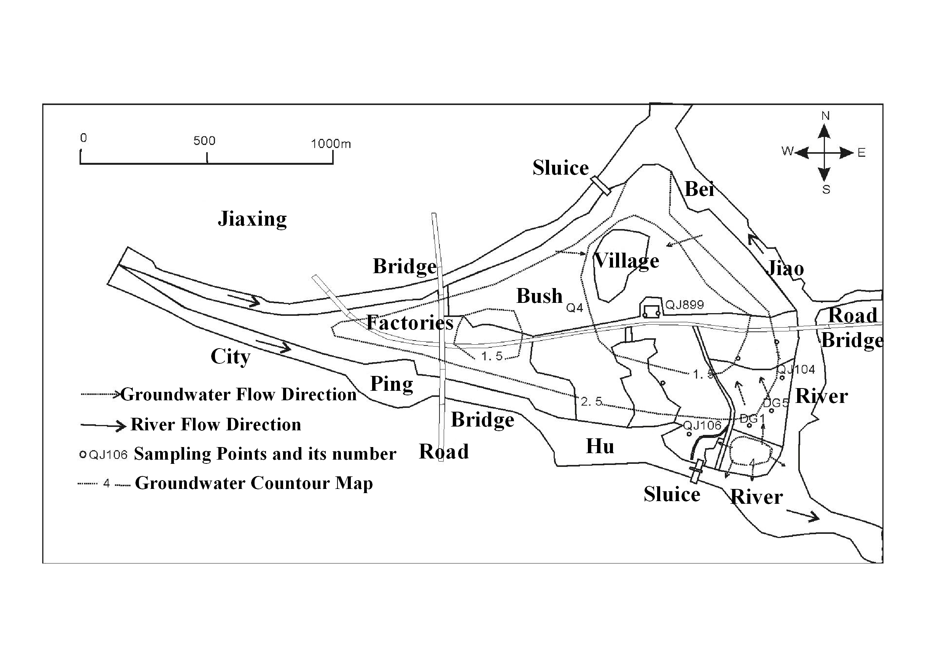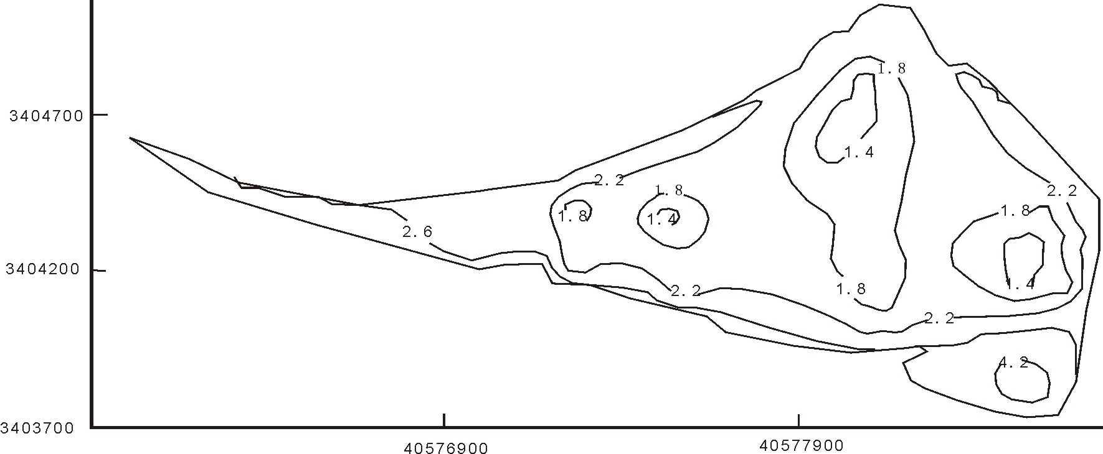
Figure 3 study area conceptual model Figure 4 the initial water level map
Some sampling points have been set up to get initial water level (Figure 7).
There are two main periods: wet period and dry period taken as boundary condition. And the source/sink are: infiltration, precipitation, evapotranspiration irrigation, exploitation(water supply) etc. The main parameters are in table 3 and the rainfall distribution in Figure 8.
.
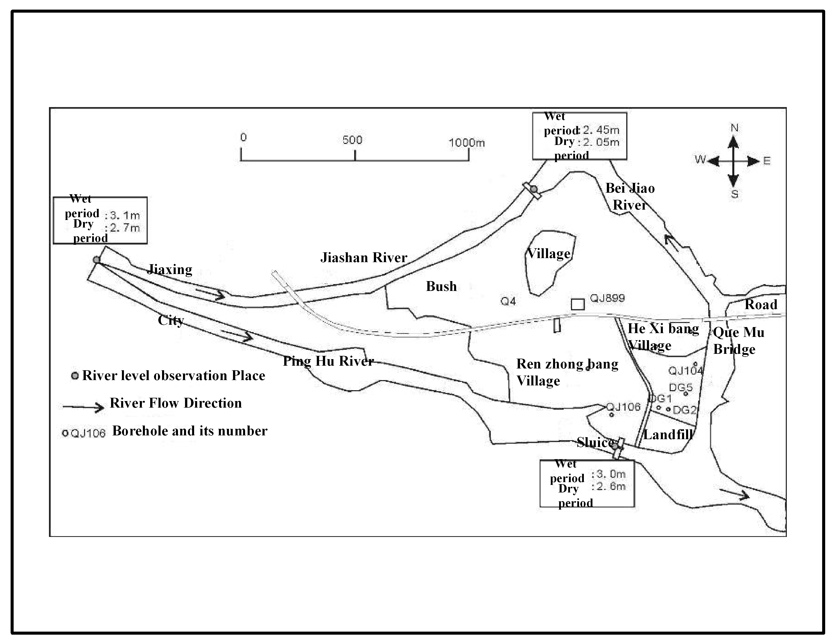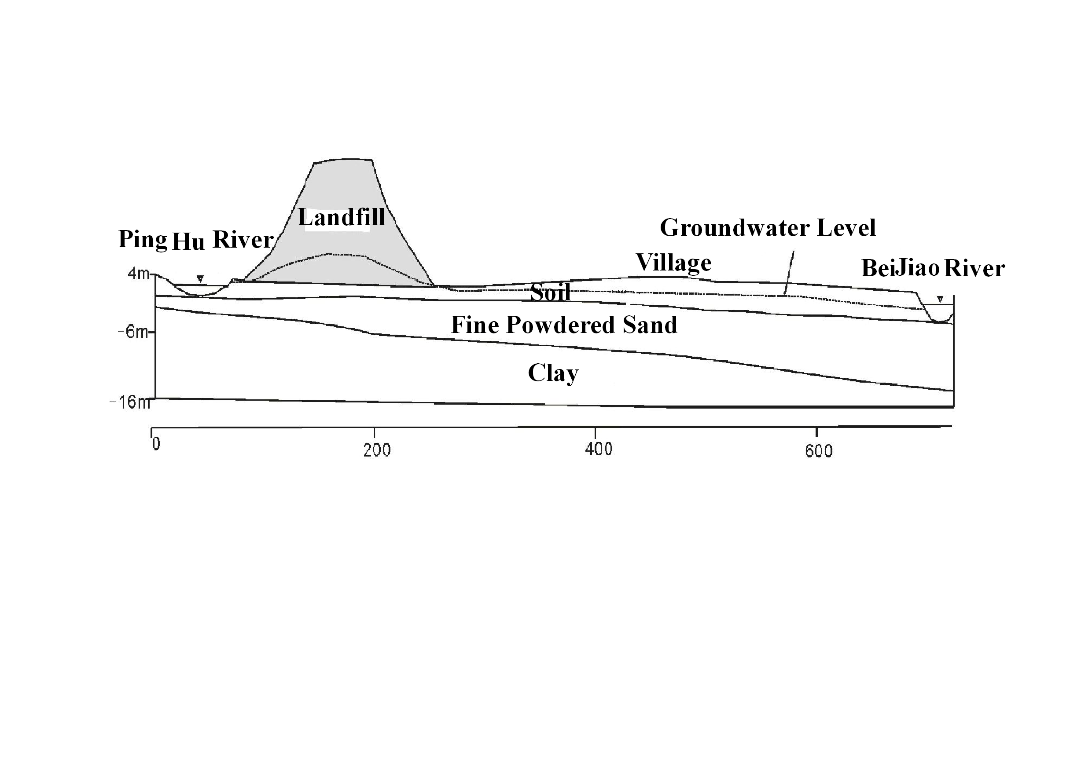
Figure 6 Change in the river water level Figure 5 hydrogeological study area profiles
Table 3 Hydrogeological simulation parameter table

Parameters The first Layer The second Layer

The level of permeability coefficient（m/d） 0.08 0.46

Degree of gravity water supply 0.1 0.3

Degree of flexibility in water supply（1/m） 0.0001 0.00003

*Note: These data were get from Jiaxing Water Conservancy and Hydropower Survey and Design Institute

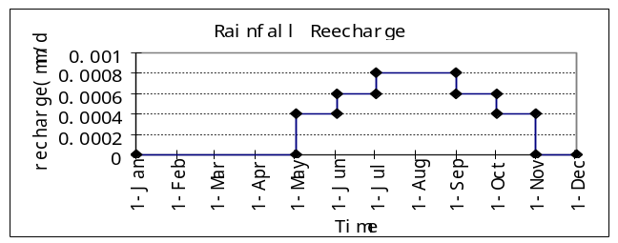

Figure 7 The average rainfall distribution on the study area
The simulation has used a discrete rectangular grid spacing. In the X direction the distance between two nodes is 43m while in the Y direction the grid spacing is 14m. In the Z direction, based on borehole data in this area, and the hydro-geological profiles, there are two layers(see Figure 9 and 10)
So there is at all 2892 cells (1446/layer)
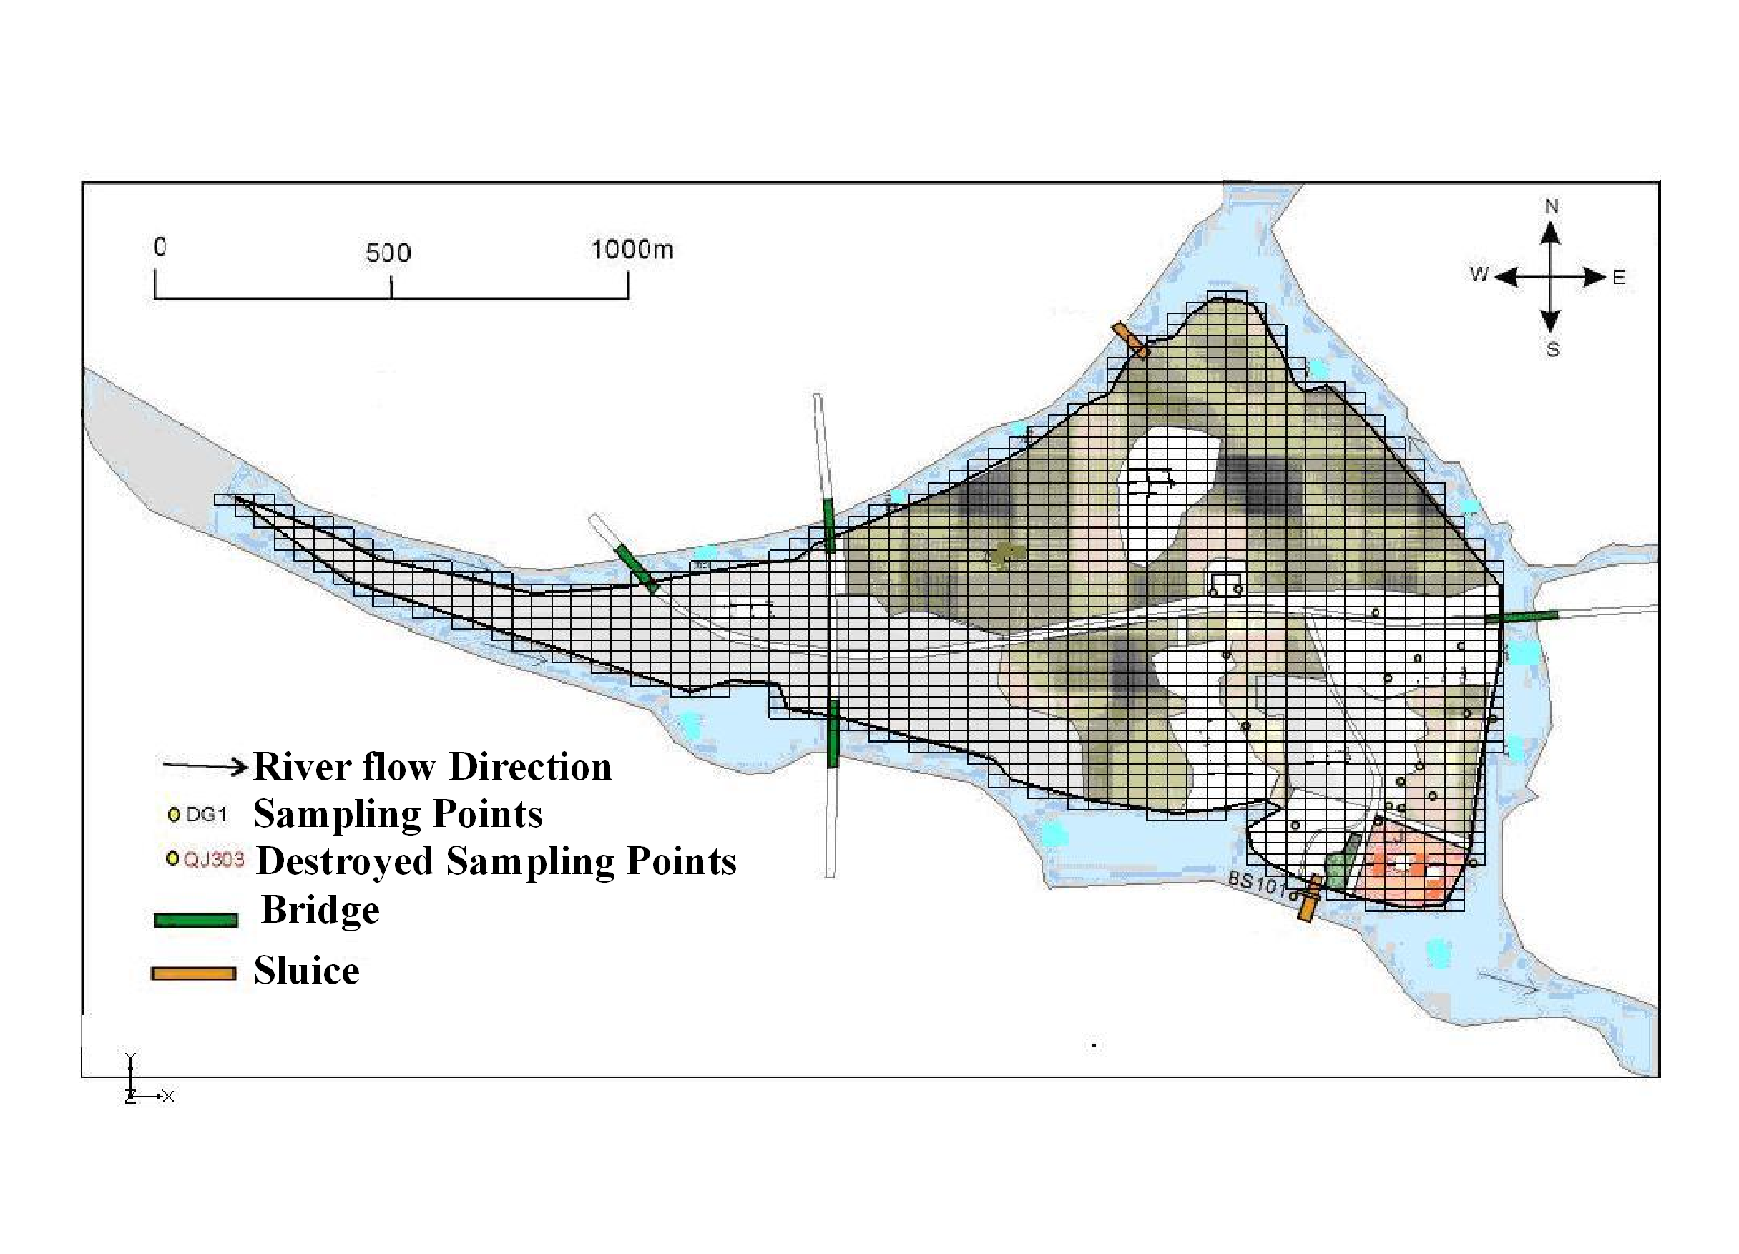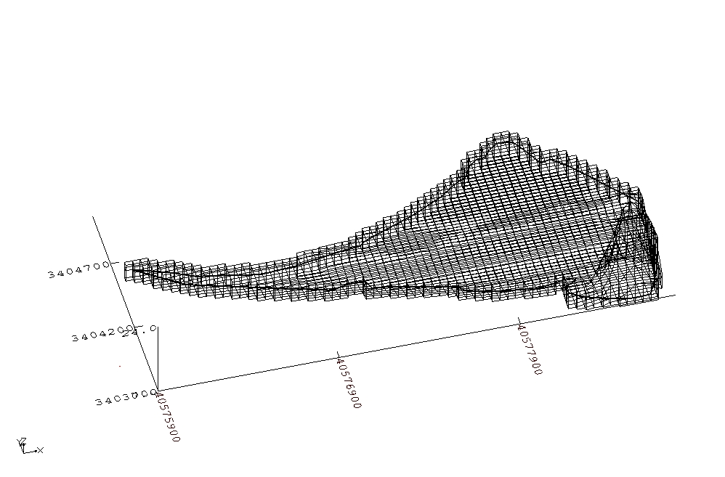
Figure 8 Mesh of study area map Figure 9 Mesh of three-dimensional map (20 times vertical zoom)
The landfill was opened in 1996 and closed in 2007,but the simulation time is from January 1996 to February 2011. And time unit is one day. Seven observation wells: QJ104, QJ106 ,QJ899, DG1, DG2, DG3 and DG5 are chosen according to hydrogeological conditions and there data are used for the simulation(see Table 4).
Table 4 Fitting test observation time
Observation wells Observation time Fitting stage The testing phase

DG1 2007.12-2008.9 2007.12-2008.9

DG2 2007.12-2008.9 2007.12-2008.9

DG3 2007.12-2008.9 2007.12-2008.9

DG5 2007.12-2008.9 2007.12-2008.9

QJ104 2006.7-2008.9 2006.7-2007.12 2007.12-2008.9

QJ106 2006.7-2008.9 2006.7-2007.12 2007.12-2008.9

QG899 2006.7-2008.9 2006.7-2007.12 2007.12-2008.9

This study used Calibration model based on previous hydro-geological conditions and the pumping test data to develop a set of initial parameter values. And the first time step values are got from these values, the second time step values from the first time step values etc. And simulation results reflected the observed data (Figure 11).

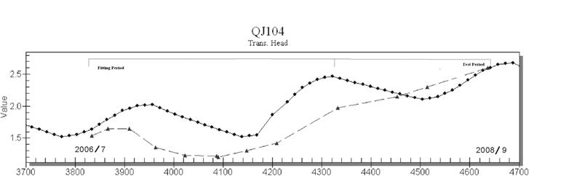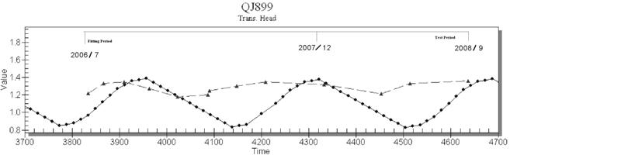

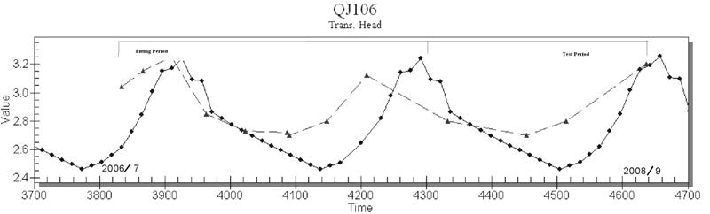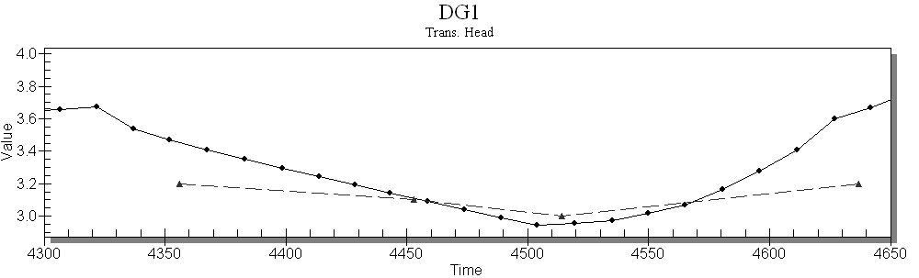

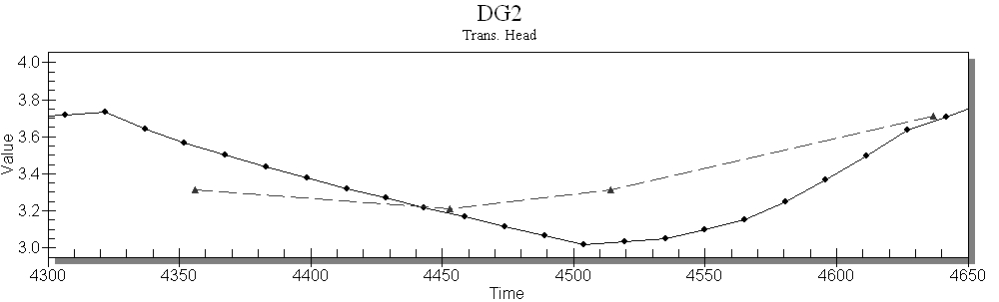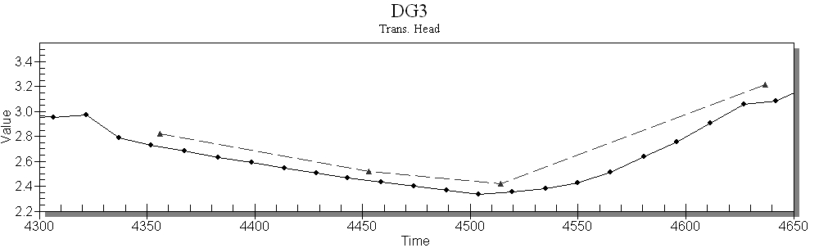

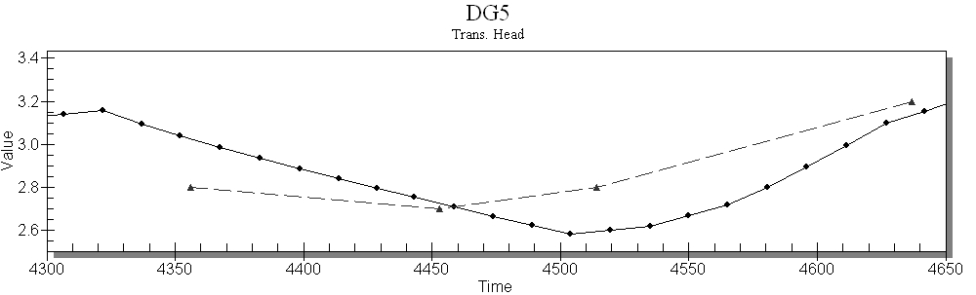

Figure 10 observation wells data set
*Triangle for the observed data
**Dot for interpolated data

