Au, Sn, W and Nb/Ta Mineralization in Northern and Northeastern Burundi.
¹Juvenal Mutima*, ²Jian Wei Li^{a,b}.
- Faculty of Earth Resources, China University of Geosciences, Hongshan District, 388 Lumo Road, Hubei,
Wuhan, 430074, China.
2a. Faculty of Earth Resources, China University of Geosciences, Hongshan District, 388 Lumo Road, Hubei,
Wuhan, 430074, China.
2b. State Key Laboratory of Geological Process and Mineral Resources, China University of Geosciences,
Wuhan , Hubei Province 430074, China.
mutima_juve@yahoo.fr, jwli@cug.edu.cn
Abstract: Burundi, located in the Northeastern part of the Kibaran Belt, hosts numerous important deposits of Ni (in Southeastern), Au, Sn, W and Nb/Ta (in Northern and Northeastern). Except Ni occuring within mafic and ultramafic intrusions; these mineral deposits mainly occur in pegmatites and hydrothermal quartz veins which are interpreted to be related to the G4 granites that intruded the Kibaran belt between about 1000 and 900 Ma. Gold deposits are spatially unrelated to G4 granites and occur preferentially within or near faulted, narrow synclinoria containing intramountaineous molasse deposits. Gold deposits are stockworks quartz veins types in quartzite wallrocks. Hydrothermal vein systems with tin-tungsten ore deposits are located within metasedimentary country rocks on top of granites highs. Rb-Sr isotope data on feldspars and micas from the pegmatites, as well as on whole rock samples from associated granites, were interpreted as indicative for a magmatic event at ca 980 Ma and hydrothermal overprint at ca 630 Ma, as maximum and minimum ages respectively. The origin of gold quartz veins is related to the processes taking place in the lower part of the crust underneath the Kibaran orogen, whereas the age and origin of the tungsten is still a matter of discussion. Up to now, the mining of these ores still small-scale explotation due to lack of an appropriate mining technology, the use of primitive equipment, the destruction of environment with no compensation. [Academia Arena, 2009; 1(x): xx-xx]. (ISSN 1553-992X)
Key words: Kibaran Belt; G4 granites; Gold deposits; Tin-Tungsten; Nb/Ta, Burundi.

1. Introduction
Burundi is situated in the southwestern part of the northeastern Kibaran belt, central Africa. The Kibaran belt extends from Zambia border, Angola and D.R Congo in the southwest, through eastern D.R Congo, Burundi, western Tanzania, and Rwanda to southwestern Uganda in the north-northeast. It is about 1,500 km long and up to 400 km wide (Romer and Lehmann, 1995).The belt is northernmost of a series of Mesoproterozoic roughly parallel domains in eastern or southern Africa. The northeastern Kibaran belt is exposed in SW Uganda, NW Tanzania, Rwanda and Burundi. It has been interpreted in Burundi as an intracontinental belt characterized by abundant peraluminous two- mica granites of crustal origin associated with an extensional process from ±1330 Ma to ±1260 Ma (Klerkx et al, 1987). Extension was followed by compression and a late shear event with alkaline granitic magmatism (Klerkx et al, 1987; Tack et al, 1990).
The Kibaran belt is well known for its endowment in Sn, Nb/Ta, , W and Au mineralization. The most important deposits of central African metal province are located in eastern D.R Congo and Rwanda, with economically less important deposits in southern Uganda, western Tanzania and Burundi situated around the periphery of this metal province (Romer et al, 1995). Mafic-ultramafic layered intrusion with Ni, Co, Cu, platinum-group metals (PGM) and Fe/Ti deposits form a belt parallel to the eastern margin of the Kibaran towards the Tanzania craton. Since 1930, gold, tin, tungsten and Colombo-tantalum prospecting and exploration have been operated by many companies (SOMUKI, BRGM, MRAC, UNDP, BUMINCO), under supervision of Ministry of Energy and Mines in BURUNDI. Various methods have been used during the explorations, such as magnetic and electromagnetic surveys, alluvia and eluvions sampling, drilling and trenching, leading to delineation of numerous anomalies.
A lot of projects and numerous geoscientific researches have been conducted in Kibaran belt, but no particular attention has been focused previously on the geology, tectonic and distribution of potential mineral resources in Burundi. Au, Sn, Nb/Ta and W mineralizations mainly occur within some areas in association with certain types of rocks. Nevertheless, their origin and their relationships still on debate. This paper is an overview of local geology, origin, distribution and tectonic setting of Au, Sn, Nb/Ta and W mineralizations within the North and northeastern of Burundi in order to gain a deeper understanding of their metallogenesis during the Kibaran Belt evolution. This paper is also a kind of sensibilization to all readers and all companies who can be interested in Burundi’s mineral resources and can establish a governmental mining-support service to improve methods of mining.
2. Geology of Burundi
The Kibaran belt is composed of Paleo- to Mesoproterozoic rocks. The Kibaran belt had a long tectonic history spanning from about 1400 to 950 Ma. In the western part of the Kibaran belt, shallow-water sedimentation started around 1420 Ma .The rocks comprise turbiditic and deltaic sediments, shallow marine and volcanogenic sediments. Around 1400 Ma, rocks were deformed during the Kibaran orogenenesis, with formation of thrust faults and folds (Tack et al, 2006). These deformed sediments were intruded by several granite intrusions. Based on petrographical observations and Rb-Sr ages, the granites which intruded the Kibaran belt were subdivided in four types (G1 to G4) (De Clercq et al, 2008). Recent U-Pb dating show that the G1, G2 and G3 granites were emplaced at 1380 ± 10 Ma, while the G4 granites ( called “Sn-granites”) formed at 986 ± 10 Ma (Tack et al, 2006). The G4 granites have an exposure covering the whole Kibaran belt and represent the most important magmatic event in terms of metallogenic evolution.
Burundi’s geology is mostly made up of rocks belonging to the mesoproterozoic Kibaran belt, which is here termed as Burundian Super group, and of the Neoproterozoic Malagarazian Supergroup, which is equivalent to the Bukoban System in northwestern Tanzania. The Malagarazian Supergroup is composed of the conglomerates, quarzites and dolomitic limestones as well as of volcanic rocks (basalts). The Burundian Supergroup consists of primarily arenaceous sediments of moderate to low grade metamorphism. In the Western part of the country, the sediments of Burundian are pelitic in composition and show a high grade metamorphism locally, of amphibolitic facies. Numerous two micas granites intrude the Western part of Burundian, called Western Internal Domain (WID) and are accompanied by mafic rocks; whereas its oriental party called Eastern external Domain (EED) is characterized by the absence of granitic rocks intrusions except in the granitic anticline of Karuzi and the granites of Muyinga. Between the two zones (WID and EED) is located a zone composed of mafic and ultramafic rocks extending from Kabanga in north, through Musongati to Mugina in south. This zone also host alkaline granites (A-types) occuring at Gitega-Makebuko-Bukirasazi. The mafic - ultramafic intrusions and the synorogenic S-type granites formed at ca.1370 Ma whereas the post orogenic A-types granites and minor mafic intrusive were emplaced in shear zones at ca. 1205 Ma (Tack et al, 2002). Archaean Complex composed of compound and granitic gneisses locally containing intercalations of amphibolites and metaquartzites occur in the South-West and the North-East of the country. Tertiary and Quaternary sediments fill parts of the Western Rift at the northern tip of Lake Tanganyika.

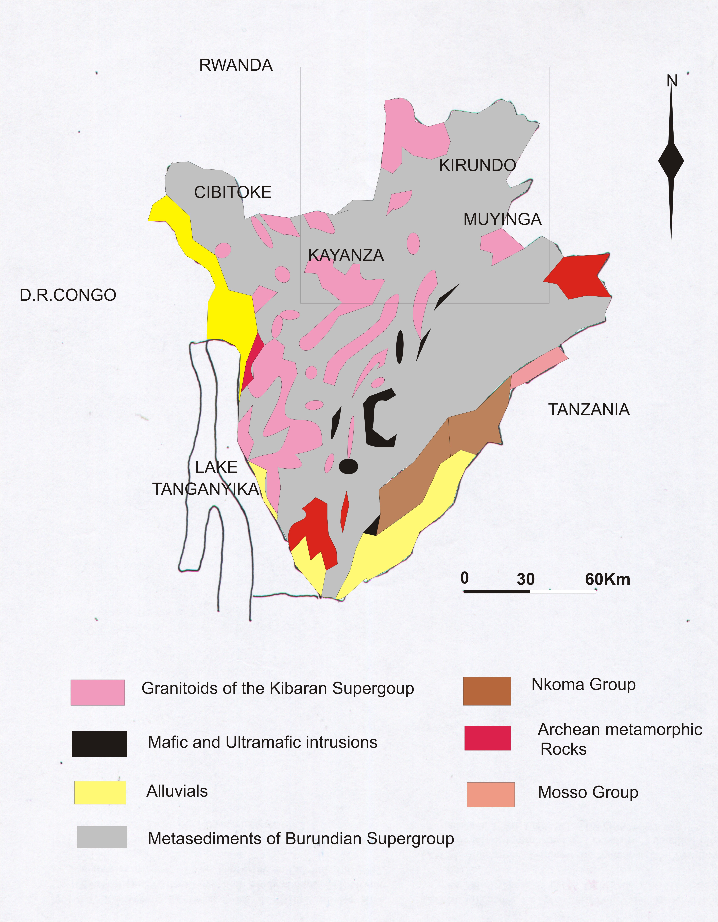
Figure 1.Geological overview of Burundi (Deblond, 1990; modified).

3. Stratigraphy and volcanic intrusions
The Archean rocks in Burundi subjected to retrogressive metamorphism of greenschist facies and subsequent deformation during the paleoproterozoic Ubendian orogeny. Rocks of the mesoproterozoic Kibaran belt are widespread in Burundi and are locally termed as Burundian Supergroup. The lower Burundian Supergroup consists of quartzitic sequence, which overlies directly the Archean basement. The upper part is overlain by schist of considerable thickness, with graphitic schists that interbedded with Quartzitic rocks. The middle Burundian Supergroup begins with a sequence of quartzites overlain by schists and green phyllites. The upper Burundian Supergroup is generally characterized by poorly sorted sediments containing arenites with lenticular congromeratic bands.
The rocks of Burundian Supergroup are intruded by synorogenic G1 and G2 foliated granites. (during the Kibaran orogeny (1300Ma). Post-collisional rifting in the eastern part of the belt ( central and eastern Burundi and westernmost Tanzania ) produced small layered mafic and ultramafic intrusions with Ni, Co,Cu, Pt, Cr,V, and Ti mineralizations,as well as alkaline and calcalkaline granites intrusions that are the main component of the G3 types(1250-1210Ma) (Brinckmann et al;1994). Neoproterozoic rocks in Burundi as represented by the Malagarazian Supergroup, which is equivalent to the Bukoban system of adjacent Tanzania. Mostly Neogen sediments fill parts of the western Rift at the northern tip of Lake Tanganyika and along various rivers. The Muyinga region is dominated by metasedimentary rocks that range from limestones to quartzites. This region has also been intruded by pegmaitic granites, muscovite granites and porphyry granites (two-mica granites). The geological formations of the Kirundo province is composed of quarzites, siltstones, limestones and phyllites. The complexes of Migendo, Murehe and Cohoha are composed of metasediments which have been intruded by a lot of granites.
4. Tectonic features.
The Kibaran belt, notably the western rift region has been affected by the Pan-African deformation spanning from ca. 660 Ma to 550 Ma .The upper Burundian fold belts are narrow and deep structures separated by large outcrops of basement. These fold belts are stacked with an eastward vergence (towards the Tanzania craton) to the east and with a westward vergence (towards the Congo craton) to the west (Villeneuve et al, 2004). In central of Burundi a fault system crosscuts the kibaran belt and gives rise to an N-S trending corridor, which is known as the N-S accident. It has been assumed that the N-S accident is either representing a late kibaran suture , or a late kibaran lateral strike slip deformation, which culminated in a major shear zone(Thomas and Martin ; 2008).The Kirundo-Muyinga region has been deformed. Faults and fractures are generally oriented NW-SE.

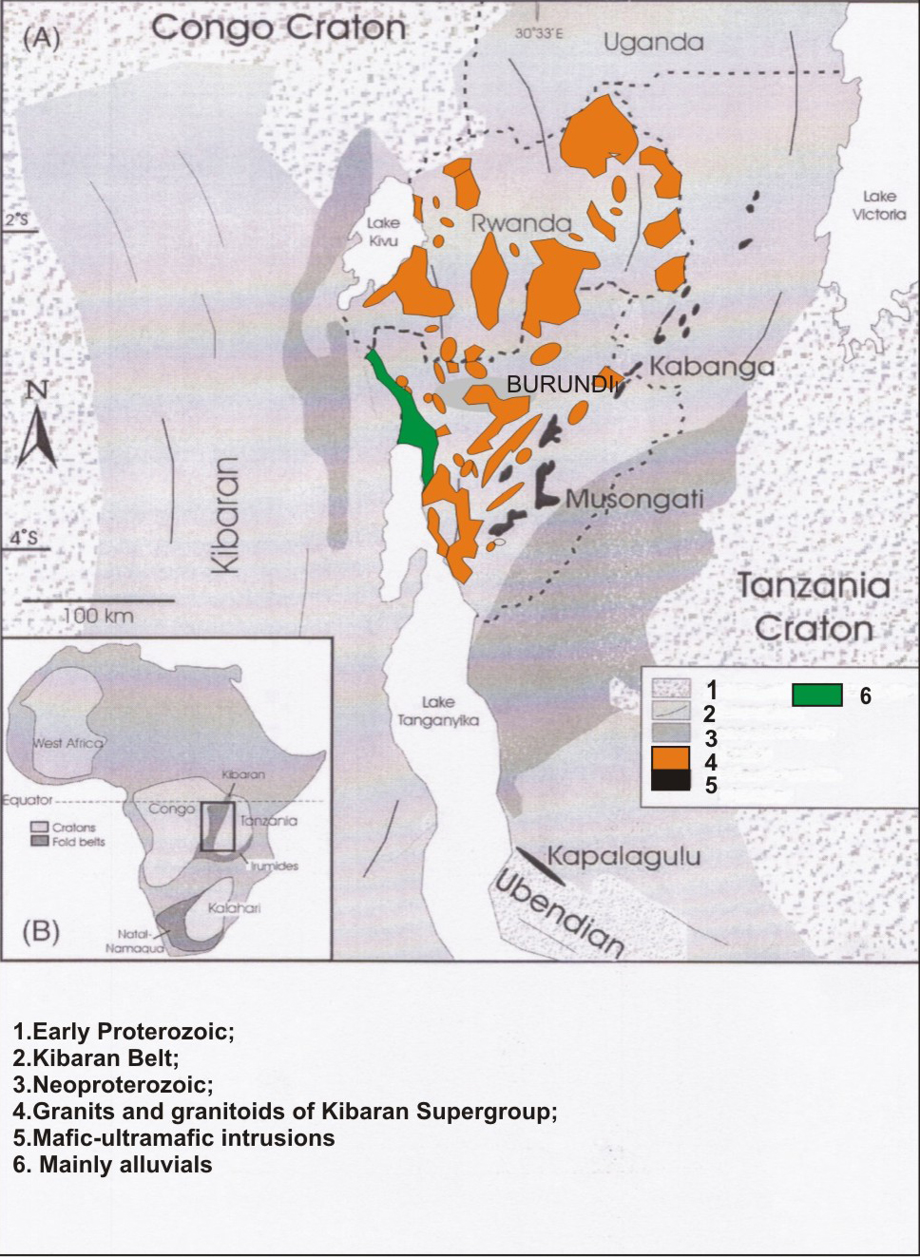
Figure 1. Geological outline of the Northeastern Kibaran Belt (Tack et al, 1994; Maier et al, 2008; modified and updated).

5. Mineralization in Burundi.
5.1 Laterite Ni deposits
Three nickel laterite deposits are known in Burundi: Musongati, Nyabikere and Waga. Although disseminated, nickel and copper sulphides have been described from rocks underlying the Musongati laterite. The Musongati Ni deposit, located in southeast Burundi, is the largest Ni deposit in the country and accounts for approximately 6% of the world’s nickeliferous laterite (Deblond and Tack 1999). The 60 km² Musongati nickel laterite deposit resulted from weathering of the Mesoproterozoic Mukanda-Buhoro-Musongati layered igneous complex (ultramafic complex), particularly, serpentinized dunite with a primary nickel content of about 0.3%. Two types of ore are present in approximately equal proportions: limonite and saprolite. Nickel in the limonite ore type is tied to goethite whereas in the saprolite ore type it is related to serpentine group minerals (chrysotile, antigorite) and clay minerals (pimelite and nontronite) (Mining review Africa, 2005). The intrusions of the Kabanga–Musongati belt were emplaced at ca 1.4 Ga into pelitic sediments of the Burundi and Karagwe–Ankolean Supergroups that accumulated during an early rifting phase of the Kibaran orogeny. The parental magmas to the intrusions were of picritic composition (ca 15% MgO) that assimilated variable amounts of sulfidic sedimentary rocks during emplacement. Modeling suggests that the Musongati magma assimilated ca. 5% of sedimentary material.
The Musongati mafic and ultramafic rocks intrusions were explored for their Ni-laterite potential in the 1970s and 1980s by the Burundi government , assisted by the United Nations Development Programs( UNDP,1977); the world Bank….The proven reserves are 75Mt (1.5%Ni) at Butihinda and 50Mt (1.23%Ni) at Rubara. A high -grade zone at Butihinda contains 30Mt ore at 1.62%Ni, with 472Kt Ni, 89Kt Cu, 34Kt Co, 8.5Kt Pt and 15.13t Pd. This makes Musongati one of the largest laterite deposits in the world. Ni laterites were also identified at Nyabikere and Waga and Mukanda-Buhoro (Maier et al; 2008).
5.2 Au mineralization
Since 1930, numerous gold deposits have been discovered in Burundi, mainly in the Mabayi (North-West), Cankuzo-Ruyigi (East), and Tora-ruzibazi areas. In North-East (Muyinga), the gold deposits occurred as placers and vein-type deposits. Gold mineralization in NW Burundi is located in a NNW-SSE aligned zone of 60 by 10km which extends from Ntendezi/Rwanda in the north to Ndora/Burundi in the south. Gold occurs in quartz and also in pyrite and arsenopyrite, as most of the visible gold is found in gossans developed from sulfides by supergene alteration (Pohl and Gunther, 1991). In General, Au quartz veins are commonly massive and rather homogenous, but brecciation of earlier quartz and cementing by later generations can frequently be observed. These breccias may contain country-rock fragments. Country rocks are variably competent bands in metasediments or greenstones of the volcanic arc. The larger deposits consist of breccias zones reaching a length of several hundred meters and widths of fifty meters comprise mainly fragmented country rocks in addition to quartz, chalcedony, sulfides (pyrite, arsenopyrite, chalcopyrite, galena and sphalerite), tourmaline and muscovite. Country rocks alteration affecting greenstones produced carbonization (ankerite, siderite), pyritisation, chloritization and argilic facies. Metasediments are silicified, sericitized, tourmalinized and rarely kaolinized.Gold quartz veins are mostly controlled by brittle shear zones (Chartry, 1989). They occur at considerable distances from G4 granites
There are two different types of gold mineralization: Mesothermal quartz-tourmaline-muscovite-(rutile) veins with sulfide oxides and a subsequent hematite stage and Epithermal hematite/limonite breccia zones with visible gold. In mesothermal quartz-veins, Gold occurs as refractory micro gold in pyrite and arsenopyrite, and as visible gold from supergene enrichment. In epithermal breccia zones, Au occurs in large aggregates dominantly associated with pseudomorphically replaced pyrite cubes. The breccia bodies contain hydrothermal quartz clasts which are of mesothermal origin and which have fluid inclusion characteristics of the type 1 gold mineralization (Brinckmann et al, 2001). The fluid inclusions in quartz from gold deposits are composed predominantly of liquid CO₂ and an aqueous phase with salinity of about 8wt% NaCl equiv. In addition, small daughter crystals of complex carbonates (Ca-Fe-Mn-Zn) are ubiquitous. All types of Au-inclusions are clearly primary, forming growth planes in quartz crystals (Pohl and Gunter, 1991). In Muyinga, especially at Butihinda, Gold deposits are stockworks quartz veins types in quartzite wallrocks. This area is underlain by Neoproterozoic low to medium-grade metamorphic sedimentary sequences with minor volcanic intercalations, and by granitic intrusions of Kibaran (1265--1210 Ma) and post-Kibaran age (970 Ma).
5.3. Sn, Nb/Ta and W mineralizations.
Tin (cassiterite), tantalum-niobium and tungsten in Burundi are part of the Kibaran metal province in central Africa. The Sn, Nb/Ta and W mineralizations occur in pegmatites and quartz veins which are interpreted to be related to the G4 granites which intruded the Kibaran belt between about 1000 and 900 Ma (Pohr & Gunther, 1991). Rb-Sr isotope data on feldspars and micas from the pegmatites, as well as on whole rock samples from associated granites, invariably are scattered in the ⁸⁷Sr/⁸⁶Sr-⁸⁷Rb/⁸⁶Sr isochron diagram. Maximum and minimum ages estimates obtained from envelopes around the scattered data were interpreted as indicative for a magmatic event at ca 980 Ma and hydrothermal overprint at ca 630 Ma, respectively (Cahen and Ledent, 1979). Primary tin mineralization is associated with leucocratic granites which represent late phases of late-orogenic to orogenic granites complexes. The Sn-mineralized quartz veins formed at 951 ± 18 Ma (Brinckmann et al, 2001).Tungsten mineralizations are, next to quartz veins, also found in skarns containing Scheelite, associated with mafic intrusions. The tungsten age has not yet been determined.
The Nb-Ta from kivuvu and Ruhembe pegmatites have variably discordant U-Pb data that define emplacement ages at 962 ± 2 Ma and 968 ± 33 Ma , respectively (Romer et al ; 1995). Tantalum-niobium production of Burundi is from sluicing of alluvial and colluvial sediments and deeply weathered pegmatites in the North-Northwest of the country. Tantalum-niobium is in most of cases associated with cassiterite and tungsten, with which they are mined together (Example of mines at Kabarore and Murehe in kayanza and kirundo provinces respectively). Their formation is related to G4 granites (tin granites) which can be described as equigranular, unfoliatedbiotite-muscovitegranites and muscovite leucogranites that generally have low content of Ca. They are often cataclastic and show strong hydrothermal alteration including muscovitization, albitization and blastes is of microcline, tourmaline, fluorite, and topaz (Lehmann and Lavreau, 1988).
Pegmatite fields with exploitable Sn, Ta/Nb, Be and Li occur in some areas where erosions has exposed higher-grade metamorphic terrains (Varlamoff, 1972). Hydrothermal vein systems with tin-tungsten ore deposits are located within metasedimentary country rocks on top of granites highs such as at Murehe (Kirundo-Busoni) in northern Burundi. Country rocks are black shales and dark sandstones which host numerous small quartz veins. Within the mineralized zone, pyrite is almost completely leached from the black shales, thus leaving a rock studded with nearly empty cavities. The tungsten concentration of metasedimentary rocks in the “tungsten belt” is relatively high; especially the carbonaceous metasedimentary rocks; due to absorption of tungsten by organic matter (De Clercq et al, 2008). In some areas as Ntega, Nyabisaka and Gitobe, Ta-Nb-Sn ore deposits are exclusively hosted in highly fractionated, leucocratic granite pegmatite lenses that usually are several 10 meters thick and several 100 meters long. Generally, hydrothermal alteration of the country rocks is normally not conspicuous although always present. Locally however, tourmalinization, sericitazation, silicification and kaolinization may be very pronounced. Nevertheless, kaolinization is less advanced here than nearby Rutongo in Rwanda.

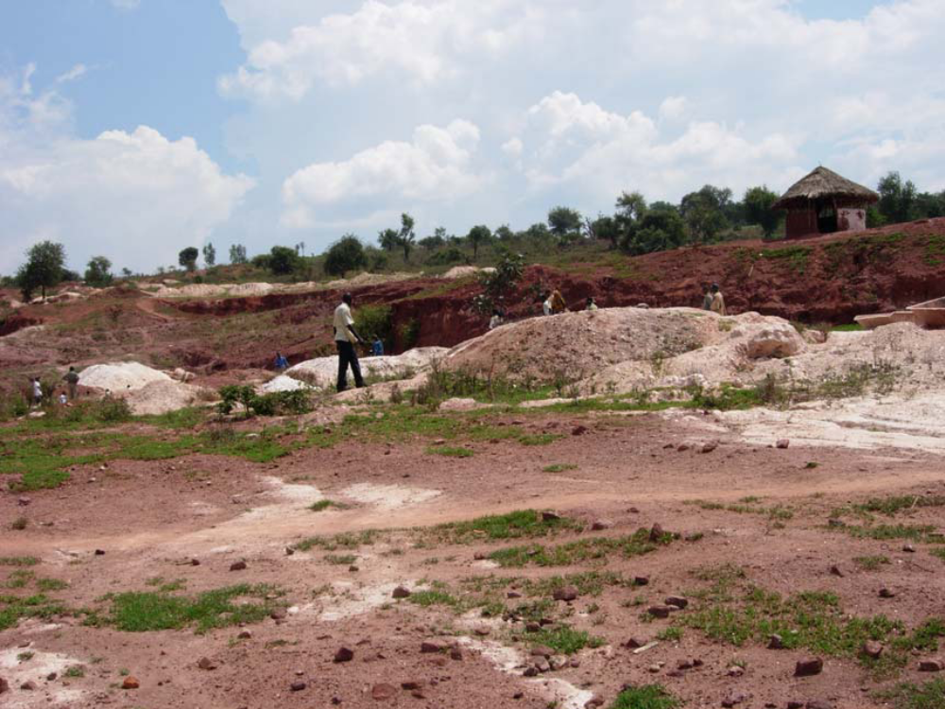
Figure. 18: Exploitation of Nb/Ta in Murehe forest, Kirundo (Nzigidahera B. et al, 2005; INCEN-Burundi

6. Discussion and conclusion
Au mineralization occurs within Muyinga and Mabayi areas whereas Sn, Nb/Ta and W mineralizations occur within Kayanza and Kirundo area. Even if there are many granites and granitoids intrusions in Burundi( central, West , South-West and Northern parts),tin, tungsten and Nb/Ta are closely associated with specialized granites (G4) intruding at the interface between older granite-basement domes (A-types) and the overlying sedimentary succession. The Kibaran tin granites are certainly not anorogenic A-types; as confirmed by geochemical data as well as by geological observations. Obviously, however, they can not be post-orogenic in relation to the main phase of Kibaran folding (Pohl, 1991). The G4 granites are marked by moderately elevated contents of Li, Cs, Rb, B, F and Sn, which can be used to distinguish them from barren granites. Granite intrusions and mineralization were syntectonic. Kibaran Gold deposits are spatially unrelated to G4 granites and occur preferentially within or near faulted, narrow synclinoria containing intramountaineous molasse deposits. Tectonic control of the quartz veins and breccias zones is often so similar to tin and tungsten deposits that contemporaneous formation can be doubted. The origin of gold quartz veins is related to the processes taking place in the lower part of the crust underneath the Kibaran orogen. The source of gold may be sought either in Archean greenstone belts or in Lower Proterozoic mafic rocks underneath the Kibaran metasedimentary pile, which contain numerous gold deposits in east and south of the Kibaran belt (Gabert, 1990).
Nevertheless, the origin of the tungsten is still a matter of discussion. Two models are proposed: Firstly, the mineralization fluid was originally a metamorphic fluid which was in equilibrium with metasedimentary and magmatic rocks at temperature below 500ºC.In this model, the emplacement of G4 granites triggered hydrothermal circulation around the contact zone between the intrusion and the country rocks. The circulating fluids could have remobilized tungsten from G4 granites and maybe to a minor extent from skarns and metasedimentary rocks (Dewaele et al, 2007). The second model supposes an original magmatic origin (G4 granites) for the mineralizing fluid.
Tin and Tungsten deposits are very similar concerning paragenesis, wallrocks alteration, fluid composition and fluid evolution. But the relationship between the Sn and W mineralized quartz veins is not clear since both vein types mostly occur at different locations. The U-Pb columbite age confirms earlier Rb-Sr muscovite data from the Sn mineralizations and G4 whole rock data sets that gave individual ages ranging from 977 to 869 Ma (Cahen and Ledent, 1979; Brinckmann et al, 1994). The lower intercept age closely corresponds to earlier Rb-Sr age determination on muscovite and whole-rock samples from hydrothermal vein systems that gave 630 ± 14 Ma and 640 ± 28 Ma (Brinckmann et al, 1994).
Muyinga region has been affected by pan-African deformation and most of faults found have generally three orientations: NS, NE-SW and NW-SE. In these faulted zones have many areas which are gold mineralized. As proposed by CHARTY, 1988; at Nyarubuye area is more located quartz veins which host gold ores as well as this region have been affected by two major faults. These Au bodies can be interpreted as the result of the initial post Kibaran mesothermal gold mineralization related to the peripheral parts of hydrothermal systems in association with the G4 granites magmatism, and later gold remobilization by epithermal fluid circulation during Panafrican uplift and rifting. This shows the relationship between tectonic and gold mineralization in Muyinga region and Mabayi, Cibitoke. Nowadays, the mining of these ores still small-scale explotation due to lack of an appropriate mining technology, the use of primitive equipment, the destruction of environment with no compensation. This requires the attention of researchers to conduct many researches on these deposits, an attention also to some small or big companies to be interested in Burundi ores deposits, and improve the exploration methods for discovering new ores deposits, and improve the conditions of mining for more production and safe environment.

Correspondence to: Juvenal Mutima, Jian Wei Li, Faculty of Earth Resources, China University of Geosciences, Wuhan, Hubei Province 430074, China. Telephone numbers: +862767885996, +862767883061, emails: mutima_juve@yahoo.fr, jwli@cug.edu.cn.

References
1. Brinckmann, J., 1988: The post Kibaran tin and tungsten mineralization in North Burundi (Mulehe and Nyabisaka): International Geological correlation program 255 Newsletter/bulletin, V.1, pp 41-56.
2. Brinckmann, J., Lehmann, B. & Timm, F., 1994: Proterozoic gold mineralization in NW- Burundi: Ore geology reviews; V.1, P 1-9
3. Brinckmann, J., Lehmann, B., Whrich, H., Hohndorf, A., Mussallam, K., Thorolf, W. & Timm, F., 2001: Geology and primary gold mineralization of the Kibaran mountains, NE Burundi, Eastern Africa; 195 P.
4. Cahen, L.and Letendt, D., 1979: Précisions sur l’âge, la pétrogenèse et la position stratigraphique des ”Granites à étain” de l’Est de l’Afrique Centrale. Bulletin de la société belge de Géologie, 88:33-49.
5. Cahen, L., Snelling, N.J., Delhal, J., and Vail, J.R.; 1984: The geochronology and evolution of Africa:
Oxford, Clarendon Press, 512 p.
6. Deblond, A. & Tack, L., 1999: Main characteristics and review of mineral resources of the
Kabanga- Musongati alignment in Burundi. Journal of African Earth Sciences 29, 313-328.
7. De Clercq, F., Muchez, P., Dewaele, S. & Boyce, A., 2008: The tungsten mineralization at Nyakabingo and Gifurwe (Rwanda): Preliminary results. 11/3-4: 251-258.
8. Dewaele, S., Tack, L., Fernandez, A.M., Boyce, A. &Muchez, P., 2007: Cassiterite mineralization in
vein-type deposits of the Kibara orogen (Central Africa): Nyamiumba (Rutongo area, Rwanda). In
Andrew, C.J. et al.
9. Duchesne, J.C., Liegeois, J.P., Deblond, A. & Tack, L.,2004: Petrogenesis of the Kabanga- Musongati layered mafic-ultramafic intrusions in Burundi (Kibaran Belt):geochemical, Sr- Nd isotopic constraints and Cr-Ni behavior. Journal of African Earth Sciences 39, p.133-145.
10. Frisch, W., 1975: Die Wolfram-Lagerstatte Gifurwe (Rwanda) und Die Genese der
zentralafrikanischen Reinit-Lagerstaatten.Jahrbuch der Geologische Bundersanstalt, 118:119-191
11. Gabert, G.; 1990: Lithostratigraphic and tectonic setting of Gold mineralization in the Archean cratons of Tanzania and Uganda, East Africa. Precambrian res.46:59-69.
12. Klerkx, J., Liegeois, J.P., Lavreau, J., Claessen, W.; 1987: Crustal evolution of Northern Kibaran Belt, eastern and central Africa. In: Kroner, A., (Ed), Proterozoic lithospheric evolution: Washington,
American Geophysical Union. Geodynamics series, Vol 17, pp.217-233.
13. Lehmann, B. & Lavreau, and J., 1988: Geochemistry of Tin granites from Kivu (D.R.Congo) Rwanda and Burundi: International Geological correlation program 255, p.43-46.
14. Maier, W.D, Barnes, S.J., Bandyayera, D., Livesey, T., LI, C & Ripley, E, 2008: Early Kibaran rift- related mafic-ultramafic magmatism in western Tanzania and Burundi: Petrogenesis and ore potential
of the Kapalagulu and Musongati layered intrusions. Lithos 101, 24-53.
15. Nzigidahera B., Fofo A. and Misigaro A., 2005: Paysage aquatique protégé du Nord du
Burundi: Etude d’identification. Institut National pour l'Environnement et la Conservation de la Nature INECN, 95p.
16. Pohl, W. & Gunther, M.A, 1991: The origin of Kibaran (late mid-proterozoic) tin, tungsten and gold quartz vein deposits in Central Africa: a fluid inclusions study. P 51-59.
17. Pohl, W., 2006: Metallogeny of Northeastern Kibaran belt, Central Africa. Institute of Geology, Technical University. Vol 22, 103-119.
18. Romer, Rolf.L. & Lehmann, B., 1995: U-Pb columbite age of Neoproterozoic Ta-Nb Mineralization in Burundi. Economic Geology, Vol 90, PP. 2303-2309.
19. Salpeteur, Cassard, D. & Bizimana, E., 1992: Structure of the gold bearing Kibarian district of
Nyungwe (Southwest Rwanda) - implication for Burundian Stratigraphy. Annales de la société
Géologique de Belgique, T115, p. 253-263.
20. Tack, L., Deblond, A.; 1990: Intrusive character of the Late Kibaran magmatism in Burundi.IGCP
No.255 Newsletter 3, 81-87.
21.. Tack L., Liegeois J. P., Deblond A., Duchesne J.C ;( 1994): Kibaran a-type granitoids and mafic
rocks generated by two mantle sources in a late orogenic setting (Burundi). Precambrian research 68;
p 323-356
22. Tack, L., Fernandez, A.M., Tahon, A., Wingate, M.; 2002: Meso and Neoproterozoic emplacement
ages of magmatic rocks in Burundi: new constraints for the geodynamic evolution of the
Northeastern Kibaran Belt (NKB). Vol IGCP, 418/440.
23. Tack, L., Fernandez, A.M., Dewaele, B., Tahon, A., Dewaele, S., Baudet, D., &Cutten, H., 2006: The
Northeastern Kibaran belt: a long-lived Proterozoic intraplate history. 149-151.
24. Thomas, S. & Martin, and H., 2008: Geological Atlas of Africa: 307 P.
25. Varlamoff, N., 1972. : Central and West African rare-metal granitic pegmatites, related aplites, quartz-veins and mineral deposits. Mineralium deposita, 7: 202-216.
26. Villeneuve, M. & Chorowicz, J., 2004: Les sillons plissés du Burundien Supérieur dans la chaine
Kibarienne d’Afrique Centrale.C.R. Géosciences 336, 807-814.

