Effect of Parthenium hysterophours ash on growth and biomass of Phaseolus moongo

Munesh Kumar* and Sanjay Kumar

Department of Forestry, HNB Garhwal University, Srinagar Garhwal, Uttarakhand, India
muneshmzu@yahoo.com *Corresponding author
Abstract: The aim of the study was to find the effect of Parthenium hysterophours ash on germination, plumule and radicle length and biomass production of Phaseolus moongo. The study revealed that among the concentrations used 1% has enhanced germination, plumule and radicle length and biomass production and reduced with increasing higher concentration of aqueous solution. However, higher concentration over 3% suppressed all growth activities. Although the growth parameters when compared with control showed best in control. The study concluded that increasing concentration of ash has adverse effect on germination, radicle and plumule length, biomass of P. moongo than the control. Therefore, burning of P. hysterophours should be avoided in the agricultural field to enhance over all productivity of P. moongo.
Keywords: Toxic effect, radicle, plumule, biomass

1. Introduction
Parthenium hysterophorus L. commonly known as carrot weed, white top, chatak chandani Congress grass, star weed. The plant belongs to the division Magnoliophyta, class: Magnoliopsida, Order: Asterales and family: Asteraceae. The species is distributed in Argentina, Australia, Bangladesh, China, Cuba, Dominican Republic, Ethiopia, Haiti, Honduras, India, Jamaica, Madagascar, Mauritius, Mexico, Mozambique, Nepal, New Caledonia, Pakistan, Papua New Guinea, Puerto Rico, South Africa, Sri Lanka, Swaziland, Trinidad, the United States of America, Venezuela, Vietnam and West Indies. Parthenium probably entered India before 1910 (through contaminated cereal grain), but went unrecorded until 1956. Since 1956, the weed has spread like wildfire throughout India. It occupies over 5 million hectare of land in the country. Parthenium grows well in wastelands, forestlands, agricultural areas, scrub/shrub lands, overgrazed pastures and along roadsides. It tolerates a wide variety of soil types and prefers alkaline, clay loam to heavy black clay soils. The well growth of plant occurs, where the annual rainfall is greater than 500 mm and falls dominantly in summer.
P. hysterophorus due to its invasive capacity destroyed its natural ecosystems. It has changed native habitat in Australian grasslands, open woodlands, river banks and floodplains (Mc Fadyen, 1992; Chippendale & Panetta, 1994). In national wildlife parks southern of India its invasiveness have been observed (Evans, 1997). From the emanation of allelochemicals, plants can regulate the soil microbial community in their immediate vicinity, affect herbivory, encourage beneficial symbiosis, change the chemical and physical properties of the surrounding environment, and directly inhibit the growth of competing plant species (Pedrol et al., 2006).
Allelopathic compounds play important roles in the determination of plant diversity, dominance, succession, and climax of natural vegetation and in the plant productivity of agro ecosystems. Allelopathy also may be one of several attributes which enable a plant to establish in a new ecosystem (Callaway and Aschehoug 2000; Callaway and Ridenour 2004).
The P. hysterophorus become a widespread weed in the Himalayan zone of Garhwal. Presently the weed is a major problem in the agriculture filed of Garhwal Himalaya. The species start their growth before rainy season and cover whole area of agriculture field, which suppressed the growth of other herbaceous vegetation also. Before Kharif crop P. hysterophours remain covered with their peak growth in agricultural land. People through ploughing in agriculture uproot P. hysterophorus collect and burned in the agriculture filed. In the kharif crop due to climatic variability the rains are very less and people prefer to grow Phaseolus moongo in the many areas of the Garhwal Himalaya. The large scale burned ash of P. hysterophours remained with the sown crop in the agriculture filed. Before carried out the experiment the hypothesis was developed that; 1) is P. hysterophorus ash has any effect on the germination, radicle and plumule and biomass production of P. moongo. Therefore the present study was aimed to find out effect of ash on seed germination, plumule and radicle and biomass production of P. moongo

2. Materials and Methods
The study was conducted in the Laboratory of Department of Forestry, HNB Garhwal University, Srinagar. The experiment was carried out in bioassay culture. In bioassay culture the collected naturally burned ash of P. hysterophorus form the agriculture filed was collected. A powder ash of 1g, 3g, 5g, 7g and 9g and was weighed and added each to 100 ml of double distilled water for 1%, 3%, 5%, 7% and 9% concentration and kept at room temperature (22-25 °C) for 24 hours. The solutions were filtered through Whatman No. 1 filter paper and stored in dark cool place for use. 10 seeds in each Petri Dishes of 15cm diameter (Fig.1) with four replicates were used for each concentration. The aqueous extracts were used regularly for moisten the seeds. A separate series of control was set up using distilled water. The germination of seeds, plumue and radicle length and biomass of seedling were counted every day for 7 days.
3. Results
The results of the study indicated that among the concentrations, the highest values of radicle and plumule growth of P. moongo were in the control. The concentration of 1% gave the second larger values of radicle and plumule length, which further reduced in 3% concentration. Onwards 3% concentration of ash aqueous solution no germination, plumule and radicle length was recorded (Table.1 Fig.1). Similar as radicle and plumule length, the biomass of seedling was also estimated for fresh weight and dry weight. Among the concentrations the highest moisture percentage was in 1% followed by 3 % however both the values were lower then the control. The biomass was also reduced with increasing concentration of aqueous Solution.

Table.1 Effect of P. hysterophorus ash on germination, plumule and radicle length and biomass of P. moongo

Control | Germination  (%) | Radicle Length (cm) | Plumule Length (cm) | Biomass |  | Moisture  (%)
 |  |  |  | Fresh weight  (g) | Dry weight  (g) | Moisture  (%)
Control | 100 | 9.28 | 16.40 | 3.33 | 0.32 | 90.99
1% | 100 | 3.87 | 8.63 | 1.97 | 0.30 | 83.76
3% | 100 | 1.64 | 3.13 | 0.47 | 0.17 | 62.79
5% | - | - | - | - | - | -
7% | - | - | - | - | - | -
9% | - | - | - | - | - | -

4. Discussion
The allelopathic nature of P. hysterophorus has been well documented and water soluble phenolics and sesquiterpene lactones have been reported from the roots, stems, leaves, inflorescences, pollen and seeds (Evans, 1997). Rajan (1973) and Kanchan (1975) were the first to report the presence of plant growth inhibitors in parthenium weed, and the latter identified parthenin, caffeic acid and p-coumaric acid as the primary inhibitors in stem tissues. Kanchan and Jayachandra (1979) also found that these inhibitors were present in root exudates and could be extracted from the leaves of P. hysterophorus (Kanchan & Jayachandra, 1980a). In addition, a range of phenolics, including caffeic acid, ferulic acid, vanicillic acid, anisic acid and fumaric acid were found in air-dried root and leaf material. Srivastava et al. (1985) reported that that aqueous extracts of leaves and inflorescences inhibited the germination and seedling growth of barley, wheat and peas. Kohli et al. (1985) suggested that two allelochemicals acting

synergistically were responsible for the significant decrease in seed germination and subsequent growth of cabbage, when placed in leaf and inflorescence leachates from parthenium weed. Patil and Hedge (1988) isolated and purified parthenin from leaves of P. hysterophorus and demonstrated that this compound significantly decreased the germination of wheat seeds and adversely affected seedling growth. The allelopathic effects have been shown with foliar leachates of P. hysterophorus on a diverse range of agricultural and tree crops: cowpea, sunflower, Casuarina, Acacia, Eucalyptus and Leucaena (Swaminathan et al., 1990); rice, wheat, black gram and chickpeas (Singh & Sangeeta, 1991); green gram and wheat (Agarwal & Anand, 1992); barley and Cassia tora (Singh et al., 1992); mung beans and guar (Kohli & Rani, 1992); various species of Indian forage crops, pulses and oil seeds (Aggarwal & Kohli, 1992); sorghum (Ayala et al., 1994); maize, ragi (Eleusine oracana; Eragrostidae) and soyabeans (Bhatt et al., 1994); sunflower, french beans and cotton Madhu et al., 1995); radish
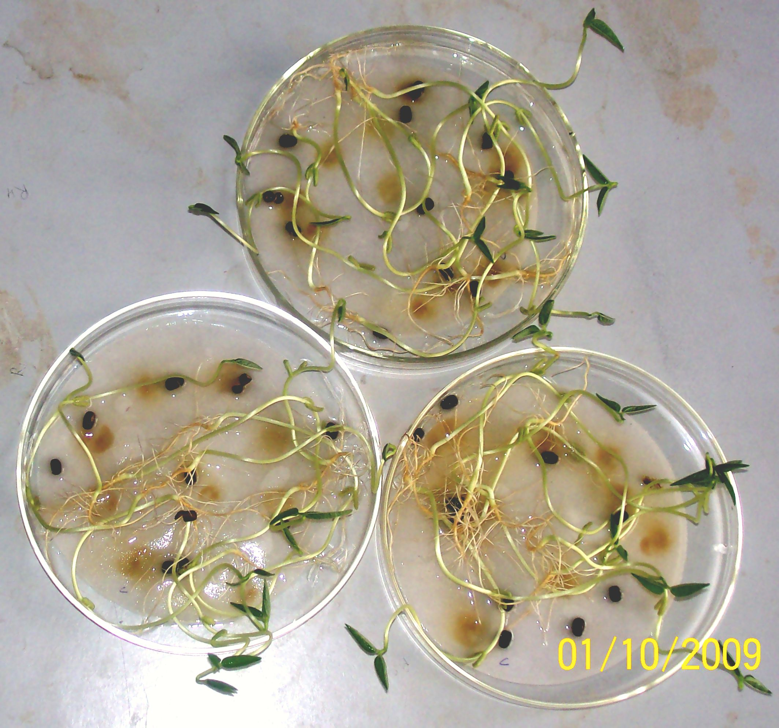
Control
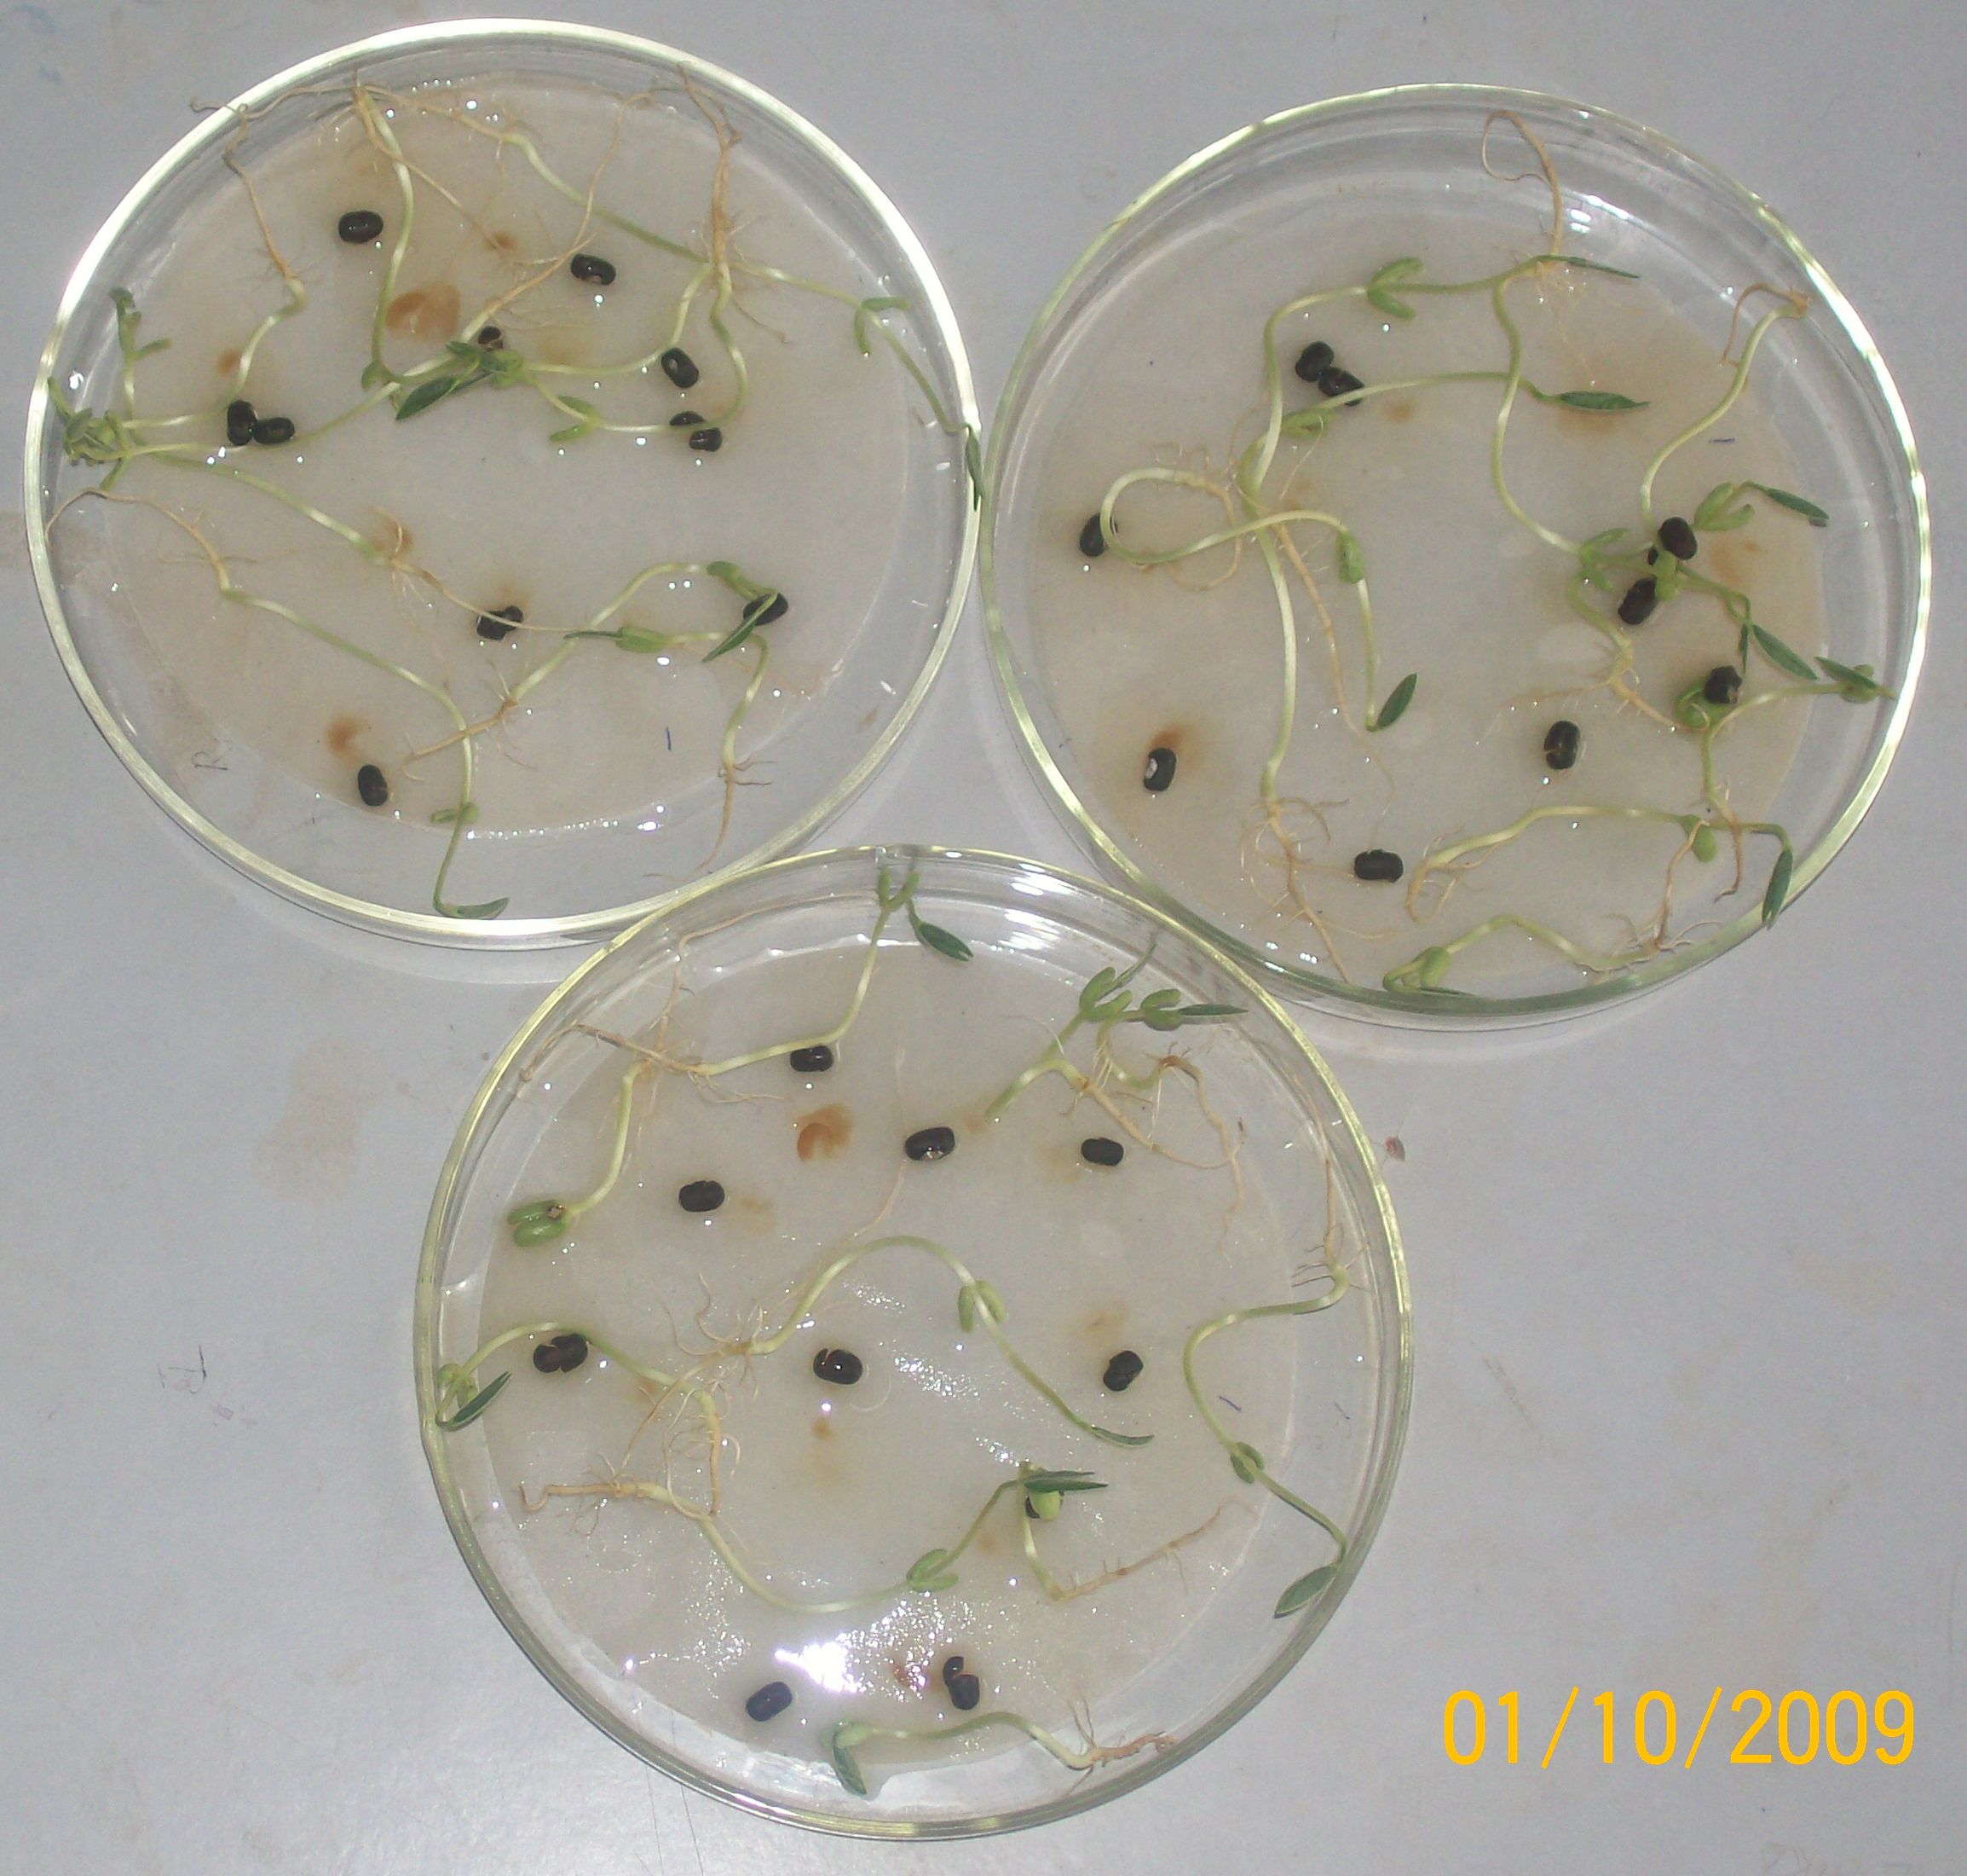
1%
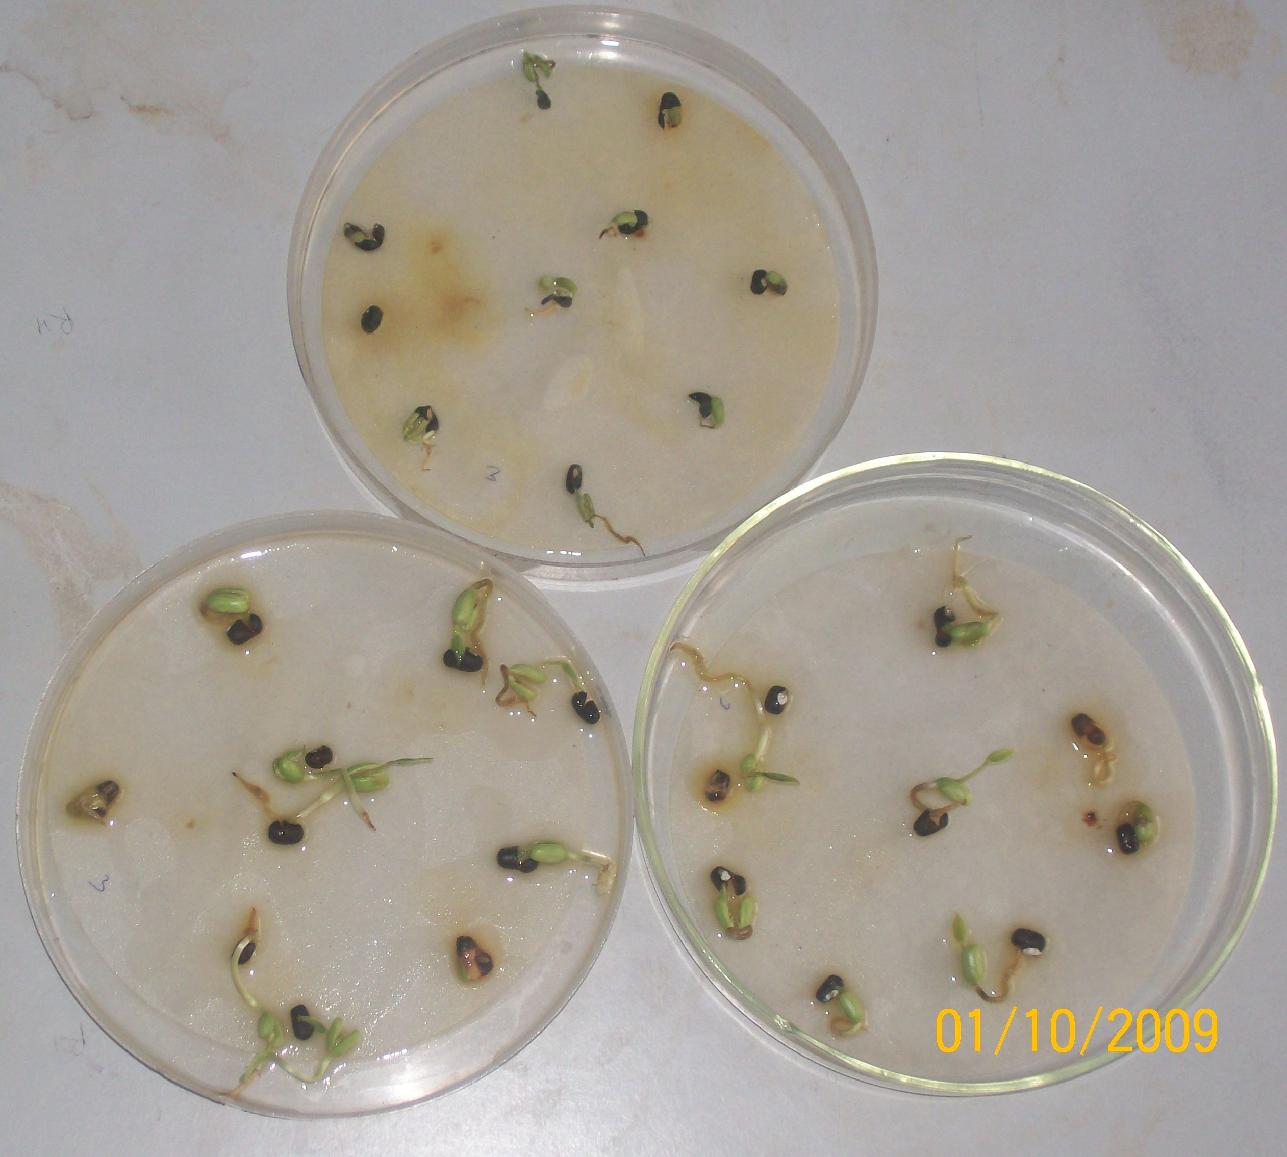
3%
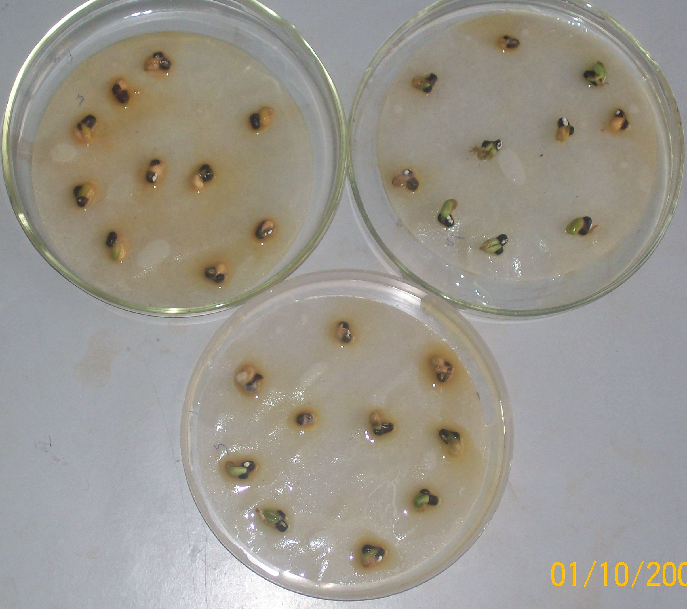
5%
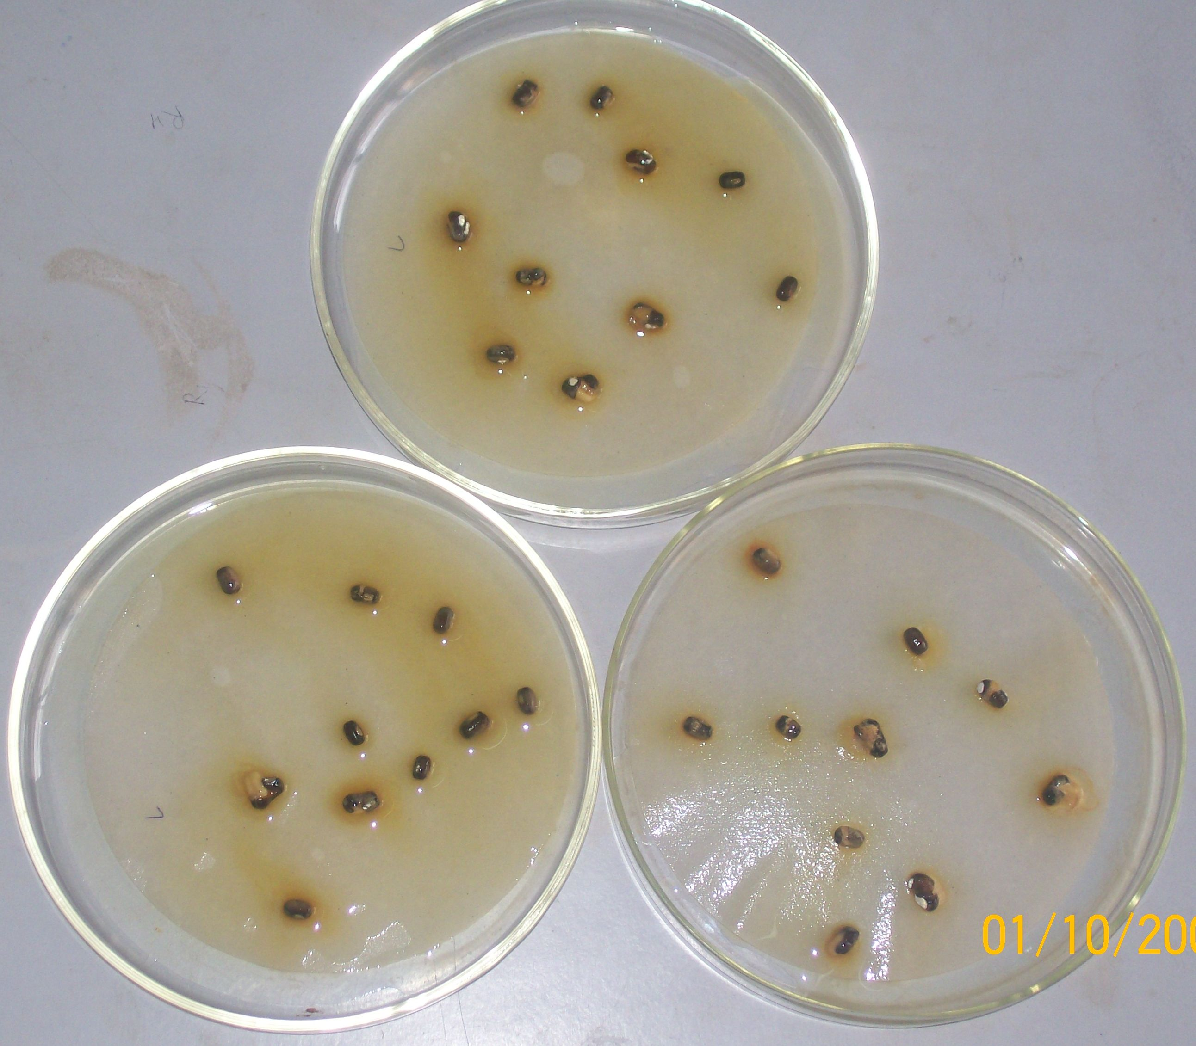
7%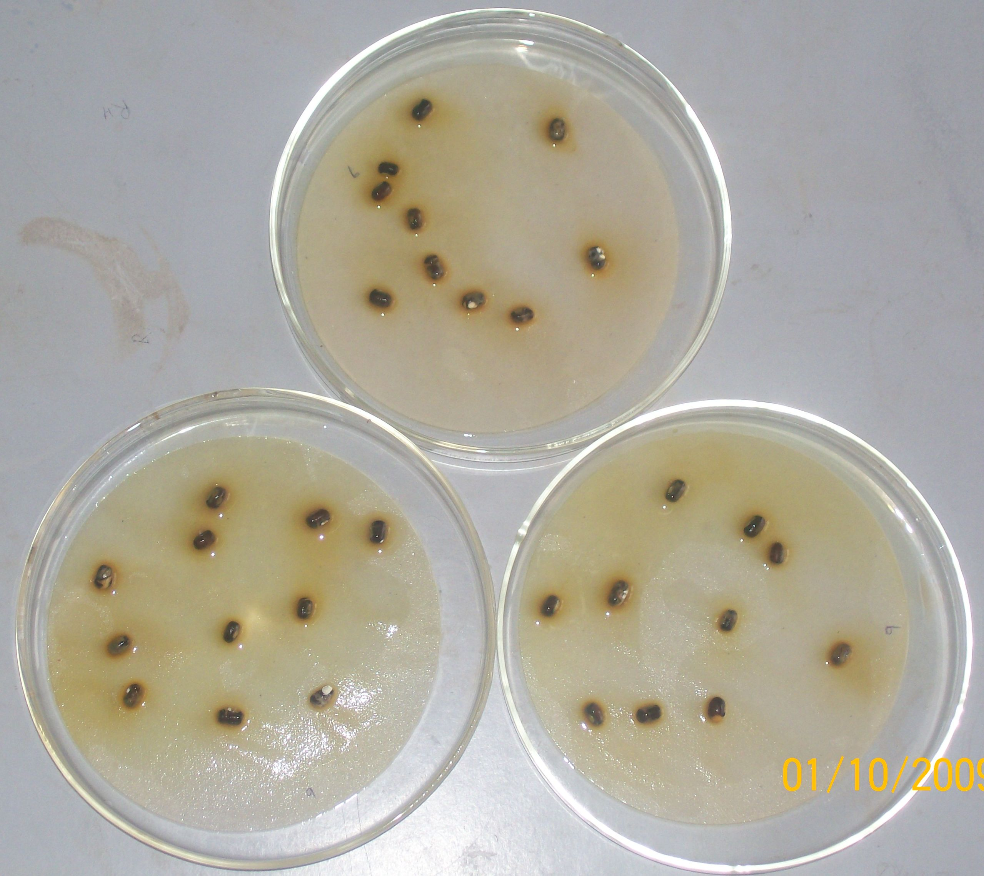
9%

Figure. 1. Growth performance of P. moongo in different concentration of P. hysterophours ash

(Mehta et al., 1995); okra, chilli peppers and clover (Dhawan & Dhawan, 1995a), have demonstrated that the germination and yields of traditional Indian pulse crops (guar, black and green gram) were reduced when these were grown in soils previously infested by parthenium weed.

5. Conclusion
The study could be concluded that increasing concentration of ash reduced the germination, radicle and plumule length, biomass and moisture content of P. moongo than the control. Therefore, it is suggested that after ploughing P. hysterophours should not be burned in the agricultural filed to reduce over all productivity of P. moongo.

References
- Agarwal, C. Anand, A. (1992) Ecological studies on allelopathic potential of Parthenium hysterophorus L. in relation to Phaseolus aureus L. and Triticum aestivum L. In: Tauro, P.; Narwal, S.S. (eds) Proceedings of the 1st National Symposium on Allelopathy in Agroecosystems, Hisar, India, February 1992. Hisar; Haryana Agricultural University, pp. 64–65.
- Aggarwal, A. Kohli, R.K. (1992) Screening of crops for seed germination against Parthenium hysterophorus L. leachates. In: Tauro, P.; Narwal, S.S. (eds) Proceedings of the 1st National Symposium on Allelopathy in Agroecosystems, Hisar, India, February 1992. Hisar; Haryana Agricultural University, pp. 66–68.
- Bhatt, B.P. Chauhan, D.S., Todaria, N.P. (1994) Effect of weed leachates on germination and radicle extension of some food crops. Indian Journal of Plant Physiology 37: 177–179.
- Callaway, R. A., and Ascjempig, E. T. 2000. Invasive plants verse their new and old neighbors: A mechanism for exotic invasion. Science 290:521–523.
- Callaway, R. A., and Ridenour, W. M. 2004. Novel weapons: Invasive success and the evolution of increased competitive ability. Front. Ecol. Environ. 2:436–443.
- Chippendale, J.F. Panetta, F.D. (1994) The cost of parthenium weed to the Queensland cattle industry. Plant Protection Quarterly 9: 73–76.
- Dhawan, P. Dhawan, S.R. (1995a) Allelochemic effect of Parthenium hysterophorus Linn. on the germination behaviour of some agricultural crops. Flora and Fauna 1: 59–60.
- Evans, N.C., 1997. Parthenium hysterophorus a review of its weed status and the possibilities for biological control. Biocontrol News and Information, 18: 89-98
- Kanchan, S.D. (1975) Growth inhibitors from Partheniumhysterophorus Linn. Current Science 44, 358–359.
- Kanchan, S.D. Jayachandra (1979) Allelopathic effects of Parthenium hysterophorus L. Exudation of inhibitors through roots. Plant and Soil 53: 27–35.
- Kanchan, S.D. Jayachandra (1980a) Allelopathic effects of Parthenium hysterophorus L. II. Leaching of inhibitors from aerial vegetative parts. Plant and Soil 55: 61–66.
- Kohli, R.K. Kumari, A. Saxena, D.B. (1985) Auto- and teletoxicity of Parthenium hysterophorus L. Acta Universitatis Agriculturae Brno [Czechoslovakia] 33: 253–263.
- Kohli, R.K. Rani, D. (1992) Identification and bioefficacy of soil chemics of Parthenium. In: Tauro, P.; Narwal, S.S. (eds) Proceedings of the 1st National Symposium on Allelopathy in Agroecosystems, Hisar, India, February 1992. Hisar; Haryana Agricultural University, pp. 196–198.
- Madhu, M. Nanjappa, H.V.; Ramachandrappa, B.K. (1995) Allelopathic effect of weeds on crops. Mysore Journal of Agricultural Sciences 29, 106–112.
- McFadyen, R.E. (1992) Biological control against parthenium weed in Australia. Crop Protection 11, 400–407.
- Mehta, U.C. Mahato, K.C. Singh, J.N. (1995) Effects of Parthenium extracts on pollen tetrad and pollen sterility in radish (Raphanus sativus L.). Cruciferae Newsletter 17, 48–49.
- Patil, T.M.; Hedge, B.A. (1988) Isolation and purification of a sesquiterpene lactone from the leaves of Parthenium hysterophorus L.-its allelopathic and cytotoxic effects. Current Science 57: 1178–1181.
- Pedrol, N., Gonzalez, L., and Reigosa, M. J. 2006. Allelopathy and abiotic stress, pp. 171–209, in M. J. Reigosa, N. Pedrol, and L. Gonzalez (eds.). Allelopathy: A Physiological Process with Ecological Implications. Springer, Netherlands.
- Rajan, L. (1973) Growth inhibitor(s) from Parthenium hysterophorus.Current Science 42, 729–730.
- Singh, S.P., Sangeeta (1991) Allelopathic potential of Parthenium hysterophorus L. Journal of Agronomy and Crop Science 167: 201–206.
- Singh, K.; Shaki, A.K.; Pal, S.; Bahyan, S.S. (1992) Phyto-allelopathic influence of Parthenium hysterophorus L. In: Tauro, P.; Narwal, S.S. (eds) Proceedings of the 1st National Symposium on Allelopathy in Agroecosystems, Hisar, India, February 1992. Hisar; Haryana Agricultural University, pp. 61–63
- Srivastava, J.N.; Shukla, J.P.; Srivastava, R.C. (1985) Effect of Parthenium hysterophorus Linn. extract on the seed germination and seedling growth of barley, pea and wheat. Acta Botanica Indica 13: 194–197.

28/11/2009



Sanjay Kumar Munesh Kumar

