In Vivo Protein Profiling and Catalase Activity of Plumbago zeylanica L.

Jyoti Ranjan Rout*, Satyajit Kanungo, Ritarani Das and Santi Lata Sahoo
Biochemistry and Molecular Biology Laboratory, P.G. Department of Botany,
Utkal University, Vani Vihar, Bhubaneswar, Orissa- 751004, India, *E-mail: routjr@gmail.com

*Corresponding author
Jyoti Ranjan Rout
Biochemistry and Molecular Biology Laboratory,
P.G.Department of Botany,
Utkal University, Vani Vihar,
Bhubaneswar, Orissa-751004, India.
Contact No: +919438047975
E-mail: routjr@gmail.com

Co-author 1:
Satyajit Kanungo
Biochemistry and Molecular Biology Laboratory,
P.G.Department of Botany,
Utkal University, Vani Vihar,
Bhubaneswar, Orissa-751004, India.
Contact No: +919438733453
E-mail: satya_9bt@yahoo.com

Co-author 2:
Ritarani Das
Biochemistry and Molecular Biology Laboratory,
P.G.Department of Botany,
Utkal University, Vani Vihar,
Bhubaneswar, Orissa-751004, India.
Contact No: +919853432817
E-mail: ritarani.das@gmail.com

Co-author 3:
Santi Lata Sahoo
Biochemistry and Molecular Biology Laboratory,
P.G.Department of Botany,
Utkal University, Vani Vihar,
Bhubaneswar, Orissa-751004, India.
Contact No: +919438363141
Fax No: 0674-2581598
E-mail: santi_bot_uu@yahoo.co.in

ABSTRACT: Medicinal plants play an important role in folk medicine, and different plant species have been used in the treatment of many diseases. The plant species Plumbago zeylanica (known vernacularly as chitarak) of the family Plumbaginaceae is distributed as a perennial herb in through out the tropical and subtropical countries of the world. Traditionally it is used as carminative, anthelmintic, to cure inflammation, piles etc. In the first part of our study, total protein content (11.1mg/ gm of fresh leaf) was estimated from leaf sample of P. zeylanica and then the sample was run in SDS-Polyacrylamide gel electrophoresis to find out the molecular weight of the protein. In second part, the catalase activity was studied from the leaf sample and all the experiments were carried out from in vivo grown plant. In this study it was found that P. zeylanica contained several protein bands of molecular weight 50.08, 41.25, 38.41, 36.21, 28.74 and 25.52kDa and the total catalase activity was 168.40±7.28 nKat/min/mg of protein.

Key words: Catalase activity; molecular weight; Plumbago zeylanica L.; SDS-Polyacrylamide gel electrophoresis

INTRODUCTION
Plumbago zeylanica L., commonly known as white chitarak (family: Plumbaginaceae) is a perennial herb that is grown in most parts of India and is used in the traditional system of Indian medicine against a number of ailments including skin diseases, diarrhea and leprosy ( Kritikar and Basu, 1993). The roots contain an alkaloid called as plumbagin, a natural napthaquinone, possessing various pharmacological activities such as antibacterial, antifungal, anticarcinogenic (Krishnaswamy and Purushothaman, 1980) and radiomodifying properties (Bopaiah and Pradhan ,2001). The root is pungent, diuretic, germicidal, astringent, vesicant.The roots of this plant has been reported to be a powerful poison when given internally or applied to ostium uteri, causes abortion (Choudhary et al., 1982).
Reactive oxygen species (ROS), such as superoxide anions, hydrogen peroxide, and hydroxyl, nitric oxide and peroxynitrite radicals are produced in the organism during the chemical reactions that contribute to the development and the maintenance of the cellular life(Coudert et al., 1994). It has been established that oxidative stress is among the major causative factors in induction of many chronic and degenerative diseases including atherosclerosis, diabetes mellitus, cancer, Parkinson's disease and immune dysfunction and is involved in aging. There is growing interest toward natural antioxidants from herbal sources (Larson, 1988; Gazzani et al., 1998; Velioglu et al., 1998). Antioxidants, both exogenous and endogenous, whether synthetic or natural, can be effective in prevention of the free radical formation by scavenging or promotion of their decomposition and suppression of such disorders (Halliwell, 2000; Metodiewa and Koska 2000; Young and Woodside, 2001; Maxwell, 1995). Catalase is a major primary antioxidant defense component that primarily catalyses the decomposition of H₂O₂ to H₂O. The enzyme is one of the earliest enzyme had been studied and purified. Catalase has been found in all aerobic cells containing cytochorom (Percy, 1984). Epidemiological and studies on medicinal plants and vegetables strongly have supported the idea that plant constituents with antioxidant activity are capable of exerting protective effects against oxidative stress in biological systems (Cao et al., 1996; Block and Patterson, 1992; Ness and Powles, 1997). Thus it is necessary to find out the medicinal plants which could provide the antioxidant substances that may help to modulate oxidative stress related disorders. In order to do this, the present study was designed to measure the catalase activity of P. zeylanica L. At the same time the molecular weight of the protein was determined on same plant material.

MATERIALS AND METHODS

Plant Material: The young healthy leaves of Plumbago zeylanica L. were collected from Botanical garden of Utkal University, Vani Vihar, Bhubaneswar, Orissa, India. Voucher specimen of this plant material was deposited at the Herbal Museum, Department of Botany, Utkal University for identification. The leaves were cleaned, washed, dried and then carefully stored at -20⁰C for further study.
Chemicals: Chemicals and reagents, including Folin-Ciocalteau reagent, acrylamide, N, N׀-methylene bisacrylamide, ammonium persulphate were obtained from Sisco Research Laboratories (Mumbai, India). Sodium dodecyl sulfate (SDS) and TEMED were purchased from Himedia Laboratories Pvt. Ltd (Mumbai, India). Both the protein molecular weight marker and catalase marker were purchased from Bangalore Genei (Bangalore, India). All other chemicals and solvents were analytical grades and obtained from Merck (Mumbai, India).
Extraction and Estimation of Total Leaf Protein: Total leaf protein was extracted by the Polyvinyl polypyrrolidone (PVPP) precipitation method. Fresh leaf tissues (0.5 g) were homogenized in 50mM sodium phosphate buffer containing 10% (w/v) insoluble PVPP using a prechilled mortar and pestle and incubated overnight at 4⁰C. The homogenates were centrifuged at 12,000 rpm for 20 min at 4⁰C (Remi Instruments, India). The supernatant was collected and kept under -20⁰C for protein estimation and enzyme assay. The protein estimation was done by the method of Lowry et al., (1951). Protein in the unknown sample was estimated at 750 nm using bovine serum albumin as standard and expressed per gm fresh weight basis. Total 11.1±2.6mg of protein was found per gm fresh leaf of P. zeylanica.
Analysis of Protein Profile of Leaf by SDS-PAGE: After estimation of protein the supernatant samples were diluted with 50mM sodium phosphate buffer to make the concentration 25, 50 and 100 µg of protein and then mixed with equal volumes of solubilizing buffer [62.5 mm Tris-HCl, pH 6.8, 20% (w/v) glycerol, 2% (w/v) SDS, 5% (v/v) 2-mercaptoethanol and 0.01% bromophenol blue] and heated for 4 min at 95⁰C, cooled on ice before loading on 10% polyacrylamide slab gels. Gels were made according to Laemmli (1970). A 10% separating gel containing 375 mm Tris- HCl, pH 8.8, 0.1% (w/v) SDS, 0.05% (w/v) ammonium persulfate and 0.4 µl ml⁻¹ TEMED was used for resolving the polypeptides whereas a 5% stacking gel containing 125 mm Tris-HCl, pH 6.8, 0.1% (w/v) SDS, 0.05% (w/v) ammonium persulfate and 0.5 µl ml⁻¹ TEMED was used to concentrate (stack) the polypeptides. The electrophoresis running buffer consisted of 25 mm Tris, 192 mm glycine and 0.1% SDS, pH 8.3. Electrophoresis was accomplished at 35 mA for 4 h using a Bangalore Genei electrophoresis system. The gels were stained by silver staining method until the background was clear (Switzer, 1979). The gel was then scanned and photographed by using a Gel documentation system (Bio-Rad, Japan) and analyzed with Quantity one software from Bio-Rad. The protein molecular weight marker from Bangalore Genei, India was used to know the molecular weight of the protein.
Enzyme Assay: Catalase activity was determined by measuring the decrease in absorbance at 240 nm (Aebi, 1983). The reaction mixture contained 0.5 ml of enzyme extract and 2.0 ml of 0.1 M sodium phosphate buffer (pH 6.8) and the reaction was stared by the addition of 0.5 ml of 10mM hydrogen peroxide. The decrease of absorbance was recorded. Decrease of absorbance was recorded in every 15 sec up to 3 min. Catalase activity was expressed as nKat/ min/ mg of protein.
Enzyme Activity on Native Gels: For the analysis of catalase activity, cell free protein extract in 50mM sodium phosphate buffer (pH 7.5) was centrifuged at 12000 rpm at 4⁰C for 20 min. Catalase band were separated on 8% non-denaturing polyacrylamide gels at 120 V for 12 h at 4⁰C, and then gel was stained by Vitoria et al. (2001) method. Gels were incubated in 0.003% H₂O₂ for 10 min and developed in a 1% (w/v) FeCl₃ and 1% K₃Fe (CN₆) (w/v) solution for 10 min. One unit of native PAGE protein molecular weight marker from Banglore Genei (catalase, 240 kDa) was applied to gel to serve as a positive control of catalase activity.

RESULTS AND DISCUSSION

Total protein was extracted from leaves of P. zeylanica L. and then analysed by SDS-PAGE. As visualized from SDS-PAGE intensity several protein bands of molecular weight 50.08, 41.25, 38.41, 36.21, 28.74 and 25.52kDa were screened against the standard protein markers [ phosphorylase b (97.4 kDa); bovine serum albumin (66.0 kDa); ovalbumin (43.0 kDa); carbonic anhydrase (29.0 kDa); lactoglobulin (18.4 kDa) ]. From the staining it was cleared that the leaf part of P. zeylanica contained several molecular weight proteins but the 50.08 kDa gave the thickest band comparing to other bands (Fig. 1).
Natural antioxidants that are present in herbs are responsible for inhibiting or preventing the deleterious consequences of oxidative stress. Herbs contain free radical scavengers like polyphenols, flavonoids and phenolic compounds. In the present paper, we have evaluated the in vivo catalase activity of P. zeylanica. Catalase is widespread in nature, having been found in all aerobic organisms studied to date. Most of the work has been performed on the enzyme obtained from mammalian and bacterial sources where it is present in highest concentration (Jin et al., 2003; Yumoto et al., 2000). However the antioxidant properties have been done on same plant from the root extract by Tilak et al., (2004) but no work has been done regarding catalase activity from leaf sample.
Catalase assay was studied for 3 min by taking absorbance at 240nm against blank. In every 15 sec the absorbance was recorded and it was found that the activity was gradually becomes constant by increasing the time duration (Fig. 3). The final catalase activity was calculated by nKat/ min/ mg of protein. It was found that the leaves of P. zeylanica contained 168.40 ± 7.28 nKat/min/mg of protein. From the activity staining of catalase it was clear that the more in concentration of protein gave the thicker band and the staining cleared that the both the catalase marker and the leaf extract of P. zeylanica were in a straight line (Fig. 2). From the above line it was cleared that the leaves of P. zeylanica contained the catalase activity.
However, the chemical constituents present in the extract, which are responsible for this activity, need to be investigated, and it is obvious that the constituents like tannins, reducing sugars and proteins present in the extract may be responsible for such activity. The phytochemical tests indicated the presence of alkaloids, glycosides, tannins, and flavonoids in the crude methanolic extract. Several of such compounds are known to possess potent antioxidant activity (Lee et al., 2004). Some of these constituents have already been isolated from this plant. Hence, the observed antioxidant activity may be due to the presence of any of these constituents. The plant exhibited strong anticancer, hepato-protective, antiviral and several other activities. These properties may be due to its antioxidant activity. The crude methanolic extract merits further experiments in vivo.

ACKNOWLEDGEMENTS

This study was supported by a grant from SAP-DRS Programme of UGC, New Delhi. J.R.R. wish to thank Prof. Manoranjan Kar, Head, Department of Botany, Utkal University for his encouragement and providing laboratory facilities for this study.

REFERENCES
Aebi, H.E. 1983. Catalase. In “Method of Enzymatic analysis”, VCH, Weinheim, Germany-Deerfield, FL. 3: 273-286.

Block, G., Patterson, B. 1992. Fruits, vegetables and cancer prevention: a review of the epidemiological evidence. Nutr Cancer, 18: 1-29.

Bopaiah, C.P., Pradhan, N. 2001. Central nervous system stimulatory action from the root extract of Plumbago zeylanica in rats. Phytother. Res.15: 153-156.

Cao, G., Sofic, E.R., Prior, R.L. 1996. Antioxidant capacity of tea and common vegetables. J Agric Food Chem, 44: 3426-3431.

Choudhary, A.K.A., Sushanta, K.C., Azadkhan, A.K. 1982. Antifertility activity of Plumbago zeylanica Linn. root. Indian J. Med. Res. 76: 99-101.

Coudert, P.C., Rubat, C., Sautou, V., Bestide, M., Chopineau, J. 1994. The free radicals. Actualites Pharmaceutiques, 321: 37-46.

Gazzani, G., Papetti, A., Massolini, G., Daglia, M. 1998. Anti and prooxidant activity of water soluble components of some common diet vegetables and the effect of thermal treatment. J Agric Food Chem, 46: 4118-4122.

Halliwell, B. 2000. The antioxidant paradox. Lancet, 355: 1179-1180.

Jin, L.H., Kim, D.W., Eum, M W.S., Yoon, C.S. 2003. Human liver catalase: cloning, expression and characterization of monoclonal antibodies. Mol. Cells, 15: 381-386.

Krishnaswamy, M., Purushothaman, K.K. 1980. Plumbagin, A study of its anticancer, antibacterial and antifungal properties. Indian J. Exp. Biol. 18(8): 876-877.

Kritikar, K.R., Basu, B.D. 1993. Indian Medicinal Plants, Shiva Publishers, Dehradun, India 2: 1466.

Laemmli, U.K. 1970. Cleavage of structural proteins during the assembly of the head of bacteriophage T4. Nature, 227: 680-685.

Larson, R.A. 1988. The antioxidants of higher plants. Phytochemistry; 27(4): 969-978.

Lee, J., KOO N., Min, D.B. 2004. Reactive oxygen species, aging and antioxidative neutraceuticals. Comp Rev Food Sci Food Safety, 3: 21-33.

Lowry, O.H., Rosebrough, N.J., Farr, A.L., Randall, R.J. 1951. Protein measurement with the Folin Phenol reagent. J. Biol. Chem,193: 265-275.

Maxwell, S.R.J. 1995. Prospects for the use of antioxidant therapies. Drugs, 49(3): 345-361.

Metodiewa, D., Koska, C. 2000. Reactive oxygen species and reactive nitrogen species: relevance to cyto(neuro)toxic events and neurologic disorders. An overview. Neurotox Res, 1(3): 197-233.

Ness, A.R., Powles, J.W. 1997. Fruit and vegetables and cardiovascular disease: a review. Int J Epidemiol, 26: 1-13.

Percy M.E. 1984. Catalase an old enzyme with a new role? Can. J. Biochem. Cell. Biol., 62: 1006-1014.

Switzer R.C. 1979. A highly sensitive silver stain for detecting proteins and peptides in polyacrylamide gels. Anal. Biochem., 98: 231-237.

Tilak, J.C., Adhikari, S., Devasagayam, T.P.A. 2004. Antioxidant properties of Plumbago zeylanica, an Indian medicinal plant and its active ingredient, plumbagin. Redox report, 9: 219-227.

Velioglu, Y.S., Mazza, G., Gao, L., Oomah, B.D. 1998. Antioxidant activity and total phenolics in selected fruits, vegetables and grain products. J Agric Food Chem, 46: 4113-4117.

Vitoria, A.P., Lea, P.J., Azevedo, R.A. 2001. Antioxidant Enzymes Responses to Cadmium in Radish Tissues. Phytochemistry, 57: 701–710.

Young, I.S., Woodside, J.V. 2001. Antioxidants in health and disease. J Clin Pathol, 54: 176-186.

Yumoto, I., Ichihashi, D., Iwata, H., Istokovics, A. 2000. Purification and characterization of a catalase from the facultatively psychrophilic bacterium Vibrio rumoiensis S-1^{T} exhibiting high catalase activity. J. Bacteriol., 182: 1903-1909.

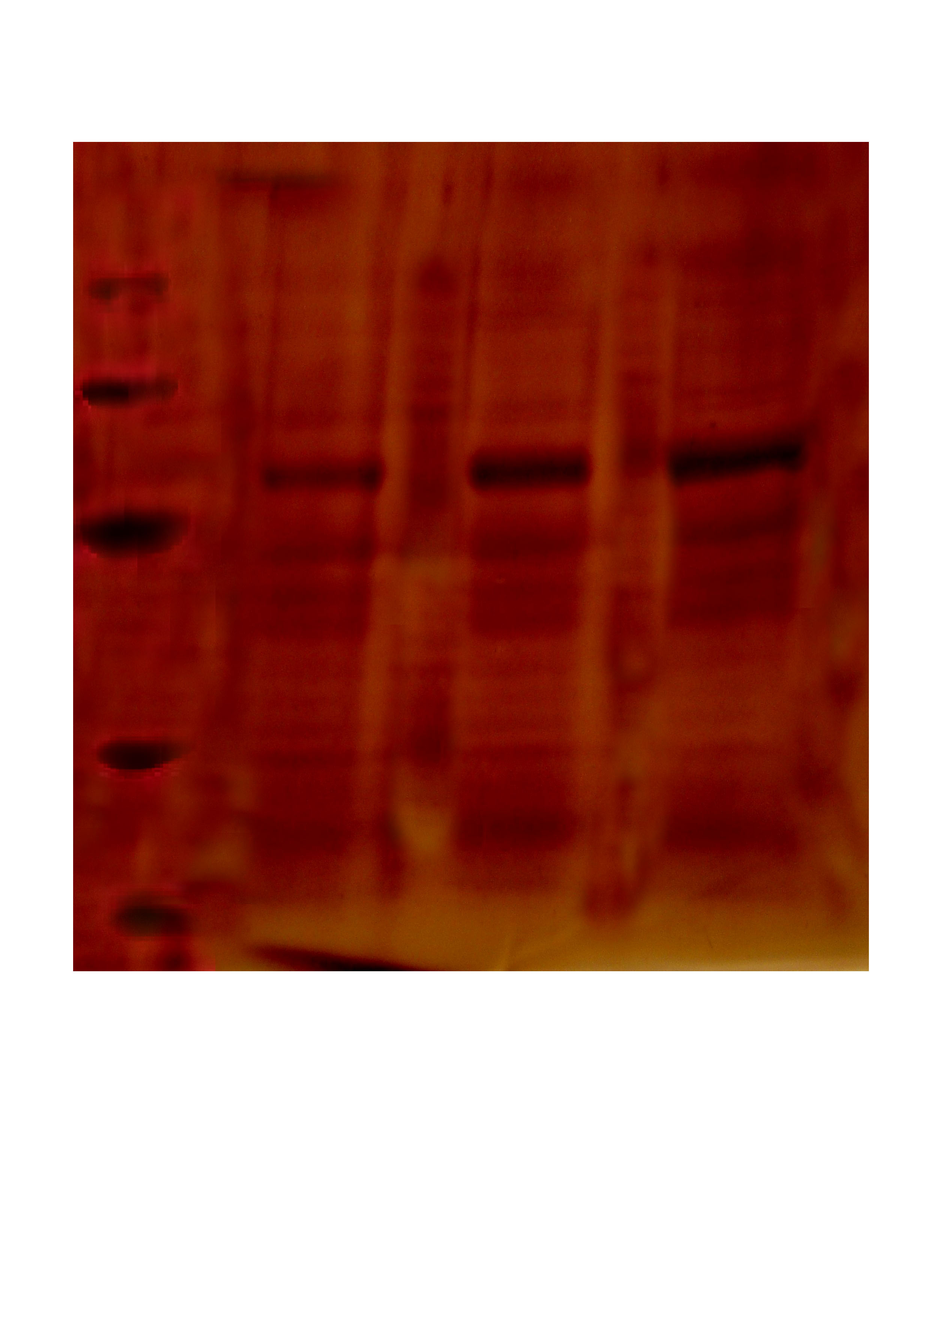
M 2 3 4

M.W. (kDa)

97.4

66.0

43.0

29.0

18.4
50.08 kDa

Fig. 1: SDS-PAGE profile of leaf proteins extracted from P. zeylanica L. In the left lane M: molecular weight (MW) of protein standards are indicated. Different concentration of total protein (25, 50 and 100µg/ well- in lane 2, 3 and 4 respectively) were used.

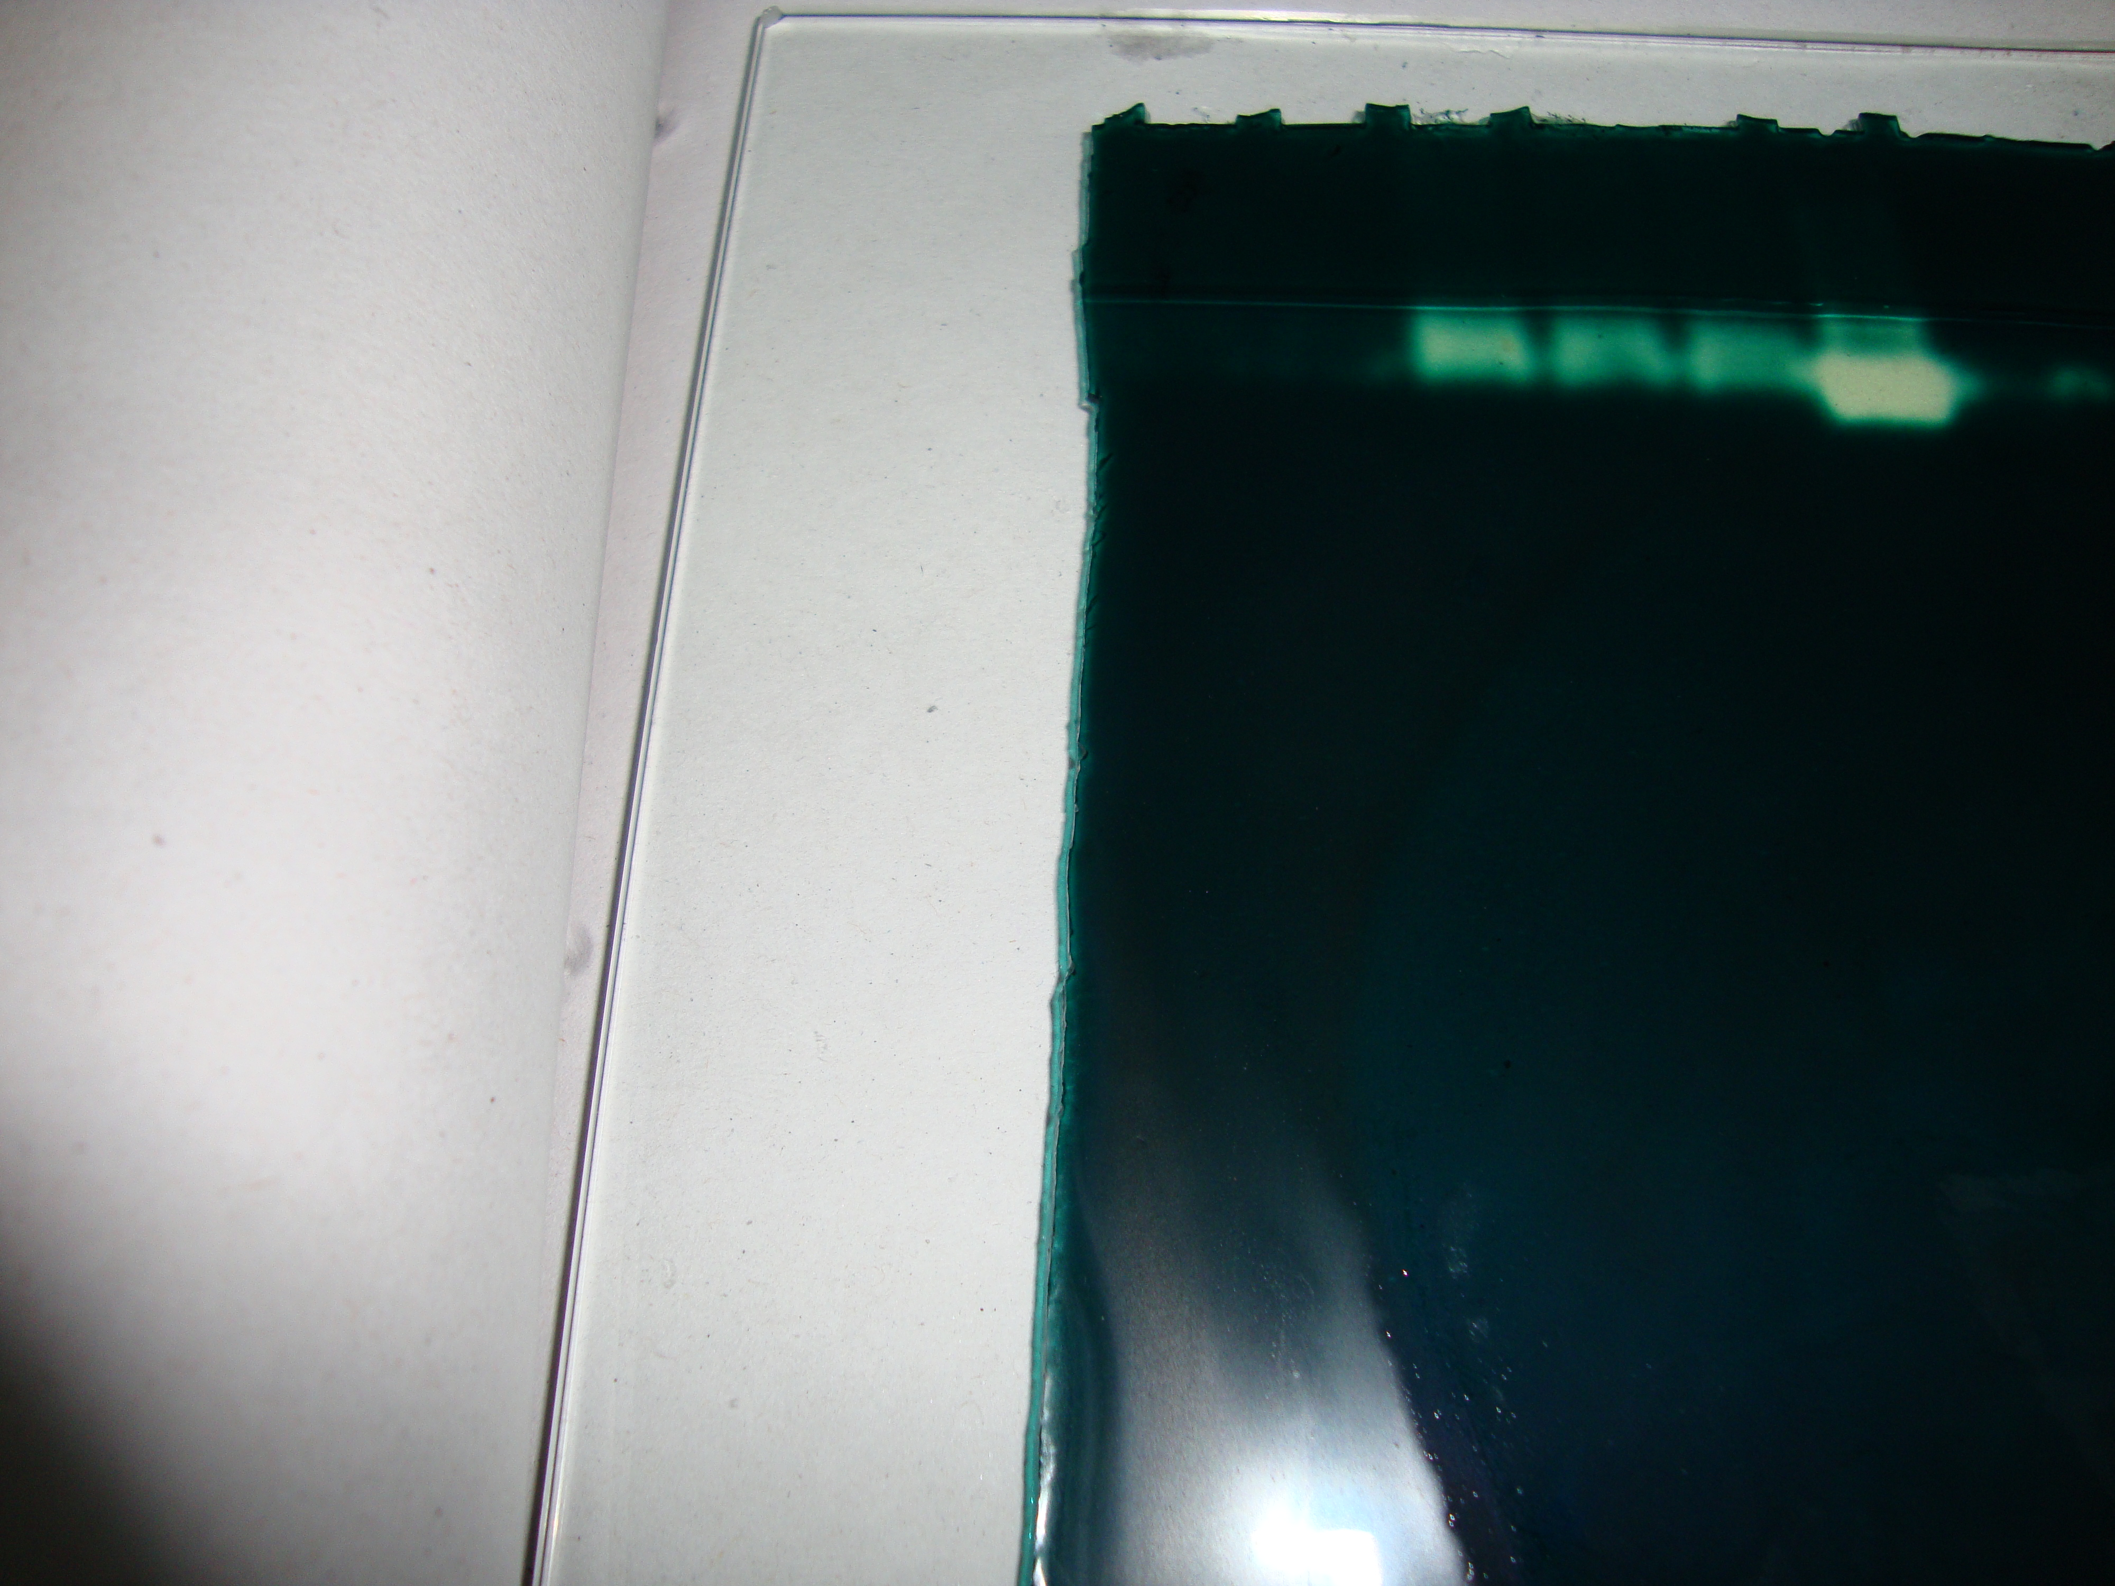
1 2 3 M

Fig. 2: Activity staining for Catalase in P. zeylanica L. leaves after running in 8% non-denaturing polyacrylamide gels at 120 V for 12 h at 4⁰C. 25, 50 and 100 µg of protein (in lane 3, 2 and1 respectively) from leaves were loaded onto each gel lane. Lane 4 (M) was used as catalase marker

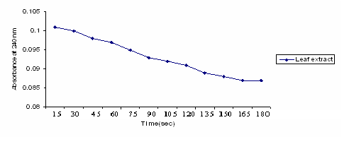

Fig. 3: Catalase activities of leaf extract from P. zeylanica L.

