SOME PECULIAR STRUCTURES IN BERGENIA SPECIES GROWING IN WESTERN HIMALAYA

SANYUKTA CHOWDHARY AND K. R. VERMA
Department of Botany
Kumaun University,
S. S. J. Campus Almora.
Uttaranchal. India

hellosanyukta28@gmail.com

ABSTRACT

Some peculiar structures at the petiolar region of Bergenia species are described. Presence of hood like structure at petiole region is one of the chief diagnostic characters in all the three species of Bergenia i.e., Bergenia ciliata (Haw.) Sternb., B. ligulata (Wall.) Engl.L., B. stracheyi (Hook.f.&Thoms.) Engl. found in Western Himalaya.

INTRODUCTION

Bergenia species are evergreen herb belonging to the family Saxifragaceae. The rhizomes of these plants are used in the indigenous system of medicines (Kirtikar and Basu, 1935). The rhizome of Bergenia ciliata and Bergenia stracheyi contains Gallic acid, tannic acid, mucilage, wax, glycosides, albumens, starch etc. The rhizome dissolves kidney stones, heals old wounds, cure septic, act as astringent etc. (Chopra et al., 1956).
While collecting Bergenia species of Kumaun Himalaya, authors have collected number of Bergenia species such as – B.ciliata (Haw.)Sternb., B.ligulata (Wall.)Engl.L. and B.stratcheyi (Hook.f.&Thoms.). After critical examination some peculiar structures were observed.

DISTRIBUTION OF PLANT : B. ligulata and B. ciliata grow in Western Himalaya upto 4,000 to 11,000 feet, while B.stratcheyi is found from 9,000 to 13,000 feet.

PLANT : Bergenia is a perennial herb with rough and thick rhizome. Leaves in rosettes, simple, large, fleshy, peltate; petiole sheathing at base. Scape stout, arising from the rhizome, with 5 – merous corymbose - clusters of flowers. Stamens 10 unequal in size (5 larger and 5 smaller), pollen 3 colporoidate, smooth. Ripe carpels dry and splitting vertically. Seed smooth and fruit is a capsule (Gaur, 1999). Commonly found growing in moist and shady slopes particularly on rock crevices.

PECULIAR STRUCTURES : During the course of identification, some interesting structures were observed at the petiolar region of all three species of Bergenia. These are as follows :
- Broad petiolar sheath (Fig. no. – 1) which is already reported by different workers such as – Hooker (1888), Rendle (1963), Lawrence (1969) and others in their works.

- A hood like outgrowth (Fig. no. – 2) is found which occurs either at lower half or upper half of the petiole which vary season to season. This is an entirely new finding for all three above mentioned species.

- Bulb like structure (Fig.no. – 3) is also observed at the tip of the rhizomatous stem, which is the third interesting point seen in the said genus. This bulb like structure is floral primodia (Fig.no. – 4) which is covered by two petiolar sheaths. Bulb like structure developed in autumn (Oct. – Nov.) and remains upto early spring (Feb. – March). The petiolar sheath seems to be act as protective cover of floral primodia during adverse winter months.

ACKNOLEDGEMENT

We thank Prof. P. C. Pande, Department of Botany, Kumaun University, S. S. J. Campus, Almora, Uttarakhand, India for valuable suggestions and critically going through the manuscript. Thanks are also due to Prof. K. N. Pandey, H. O. D., Dept. of Bot., S. S. J. Campus, Almora for providing facilities.

REFERANCES

Chopra, R. N., S. L. Nayar and I. C. Chopra. 1956. Glossary of Indian Medicinal Plants. C.S.I.R., New Delhi.

Gaur, R. D. 1999. Flora of the District Garhwal North-West Himalaya. Trans Media. Srinagar (Garhwal), U.P., India.

Hooker, J. D. 1888. The Flora of British India. Vol. II. Bishen Singh Mahendra Pal Singh, Dehra Dun and Periodical Experts. 42 D Vivek Vihar, Delhi – 32.

Kirtikar, K. R. and B. D. Basu. 1935. Indian Medicinal Plants. Lalit Mohan Basu Publication. Allahabad.

Lawrence, G. H. M. 1969. Taxonomy of Vascular Plants. Oxford and IBN Publishing Corporation. New Delhi.

Rendle, A. V. 1963. The Classification of Flowering Plants. The Syndics of the Cambridge University Press. London, N.W.1.

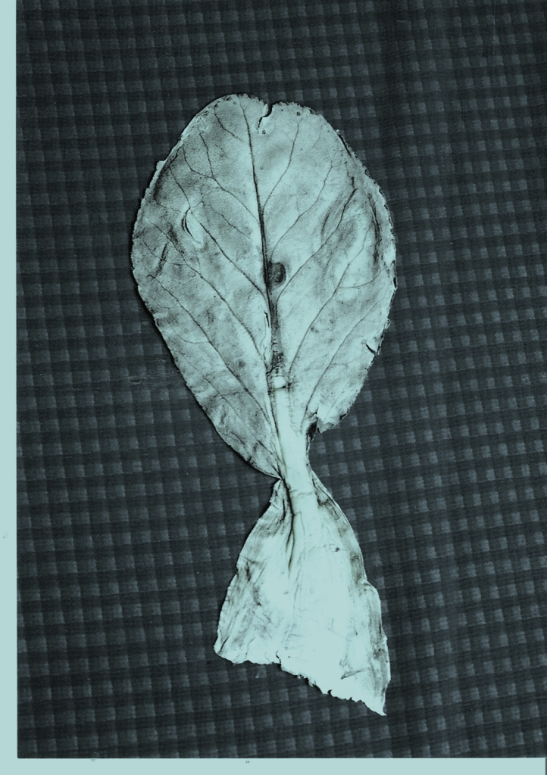
Fig. no. 1. Bergenia stratcheyi showing broad petiolar sheath.

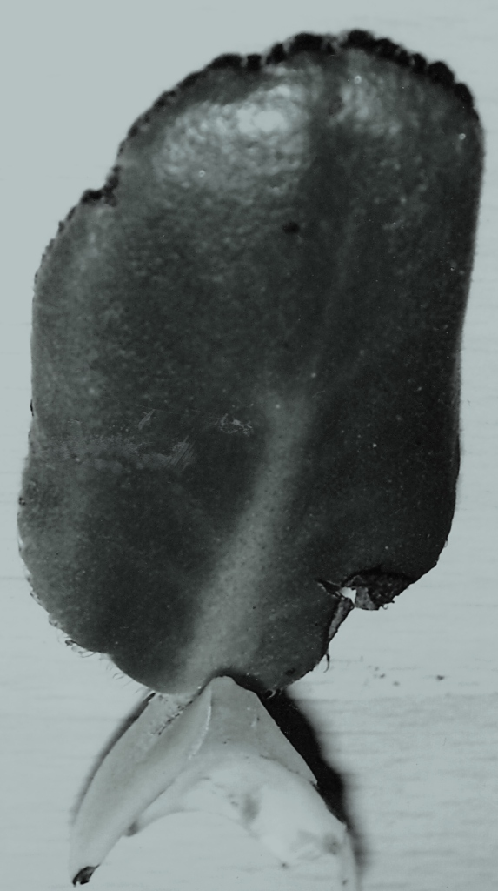

Fig. no. 2. Bergenia stratcheyi showing hood like structure.
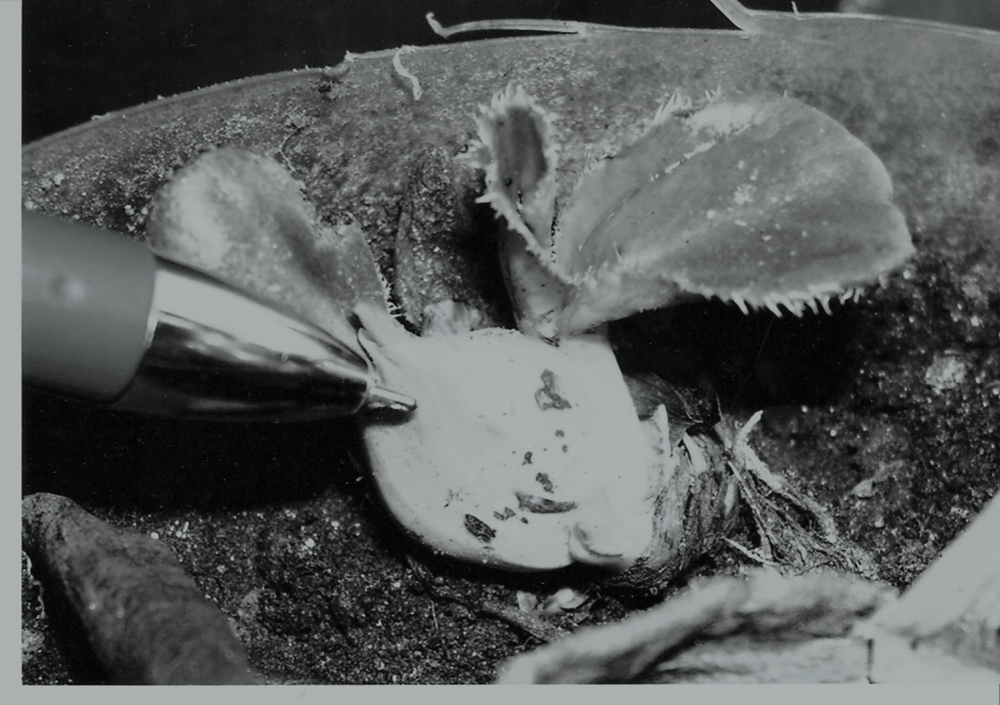

Fig. no. 3. Bergenia stratcheyi showing bulb like structure.

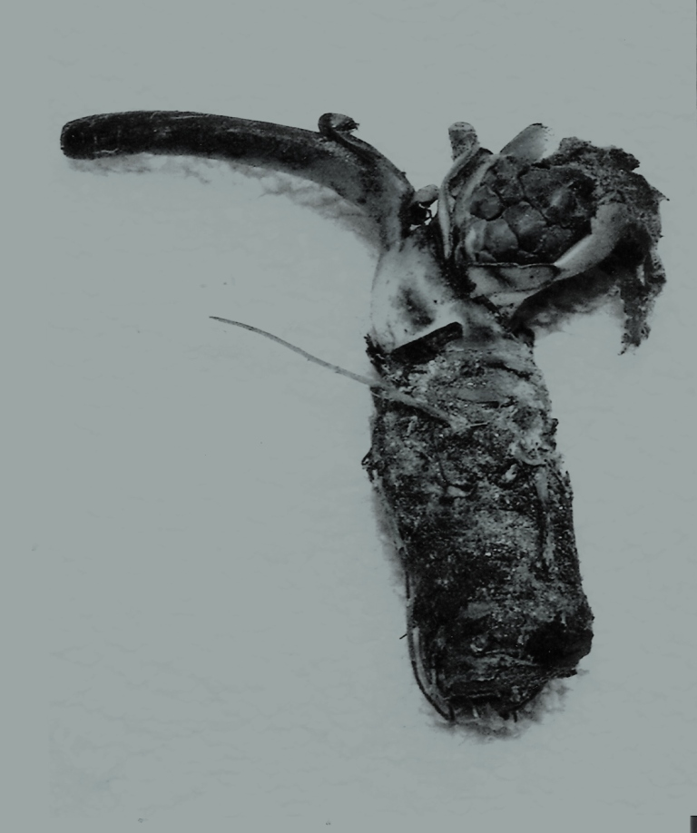
Fig. no. 4. Bergenia ciliata showing floral primodia.

