A Comparative Study Between Endoscopic Clip Application versus Argon Plasma Coagulation (APC) In Management Of Bleeding Peptic Ulcer
Hanan. M.M. Badawy ,ass. prof. internal medicine ,Ain shams faculty of medicine
k.gawish@yahoo.com
Abstact:Acute upper gastrointestinal bleeding (ugiB) remains an important emergency situation. In the last two decades, major developments took place influencing incidence, etiology and outcome of patients with acute UGIB.Peptic ulcer bleeding is the most significant complication of ulcer disease,being responsible for 50% of all cases mortality.Patients and methods:Thirty group i included 15 patients suffering from acute ugib were randomely divided into two groups : patients who were treated with endoscopic clip application.groupii included 15 patients who were subjected to endoscopic apc.all patients were classified according to forrest clssification and the clinical rockall score.results:there were insignificant diffirance between the two groups as regard rockall score ,site of the ulcer,and rebleeding between the two groups.also there were significant diffrence between the twogroups regarding forrest classification.rebleeding was significant with higher rockall score in group i but it was insignificant in groupii.conclusion: Endoscopic application of hemoclips have a less rebleeding rate than Argon plasma coagulation for treatment of bleeding peptic ulcer ,although this was statistically insignificant .Meanwhile APC is still less costy ,and easy for jonyor endoscopists in emergency units. Clinical and endoscopic assessment (through Rokcall score and Forrest classification)could help in making best choice for endoscopic management.
,introduction:Since the late 1980s, endoscopic hemostatic therapy has been widely accepted as the first-line therapy for upper-gastrointestinal bleeding.. Most clinical trials demonstrated a reduction in both recurrent bleeding and the need for surgical intervention when endoscopic hemostasis was used (Alan Barkun et al., 2003). Endoscopic therapy can be broadly categorized into injection therapy, thermal coagulation, and mechanical hemostasis. When analyzed separately, injection therapy, thermal-contact devices, and mechanical treatment all decrease the frequency of recurrent bleeding and rate of surgical intervention. (Park et al., 2004).Argon plasma coagulation (APC) is a noncontact type of coagulation that is easier to target to bleeding sites. A high-frequency current is transmitted by the ionized, electrically conductive argon gas. The argon gas flows onto the target surface, even if approached tangentially. APC has been used successfully to obtain hemostasis during open surgery. The use of APC in digestive tract endoscopy was first described in 1994. It is being applied more and more widely in the treatment of different GI pathologic disorders, hemorrhagic lesions in particular. (Canard et al., 2001). The only mechanical therapies widely available are endoscopically placed clips and band ligation devices. Endoscopic clips usually are placed over a bleeding site (e.g. visible vessel) and left in place(Church et al., 2003).. This consisted of a stainless steel clip (of size approximately 6 mm long and 1. 2 mm wide at the prongs) with a metal deployment device (that could be used to insert the clip into the endoscopic camera, and deployed outside the camera) enclosed in a plastic sheath. These clips were initially reloadable (Devereaux, 1999).
Risk Assessment, Prognstic Indices:Numerous prognostic scores have been devised to aid the gastroenterologist in the management of upper gastro- intestinal bleeding, stratifying individual patients by risk of re-bleeding and death. These scores range from the simple, endoscopy-based analysis of ulcer appearance described by Forrest et al (Table 1), through pre-endoscopic clinical scores such as the ‘clinical’ Rockall scores, to combined clinical and endoscopic evaluation, best exemplified by the classical Rockall (Van Leerdam, 2008).Such a scheme should aid in making clinical decisions, as to both the need for urgent intervention and the prediction of continued or recurrent bleeding in the context of endoscopic therapy. (Sung, 2005).

Table 1: Rockall Risk Scoring System for Patients with Peptic Ulcer Disease
Features |  |  | Points
Age (years):
< 60 |  |  | 0
60 to 79 |  |  | 1
> 79 |  |  | 2
Shock :
No shock (SBP ≥ 100, pulse < 100 bpm) |  |  | 0
Tachycardia (SBP ≥ 100, pulse ≥ 100 bpm) |  |  | 1
Hypotension (SBP < 100) |  |  | 2
Comorbid illness:
No major comorbid illness  CHF, ischemic heart disease, other major comorbidity. |  |  | 0  2
Liver or renal failure, disseminated cancer |  |  | 3
Diagnosis :
Mallory-Weiss tear, no other lesion identified and no stigmata of recent hemorrhage |  |  | 0
All other pathology causing bleeding (except cancer) |  |  | 1
Upper gastrointestinal tract cancer |  |  | 2
Major stigmata of recent hemorrhage:
None or dark spot only |  |  | 0
Blood in upper gastrointestinal tract, adherent clot, visible or spurting vessel |  |  | 2
Score | Rebleeding | Mortality
< 3 points | 6. 2 % | 0. 2 %
3 or 4 points | 13 % | 6. 8 %
> 4 points | 25 % | 20 %
SBP = systolic blood pressure (mm Hg); bpm = beats per minute;
CHF = congestive heart failure
Quoted from( Best Practice & Research Clinical Gastroenterology, 2008). (Rockall,1995, debate abounds as to the benefits of using such scores, with fears that th).

Table 2: Forrest classification of stigmata of recent haemorrhage and associated re-bleeding rates.

Forrest class | Type of lesion | Risk of rebleeding if untreated
IA | Arterial spurting bleeding | 100%
IB | Arterial oozing bleeding | 55%
IIA | Visible vessel | 43%
IIB | Non bleeding ulcer with an adherent clot | 22%
IIC | Hematin covered flat spot | 10%
III | No stigmata of hemorrhage | 5%
Quoted from (Best Practice & Research Clinical Gastroenterology, 2008). (Forrest ,1974).

PATIENTS AND METHODS
This study was conducted on 30 patients presenting with hematemesis and upper GIT endoscopy was done after resuscitation of the patients and showed a bleeding peptic ulcer.
The patients were selected according to Forrest classification between group IA (spurting bleeding) to IIB (non bleeding ulcer with an adherent clot).A score was calculated to them according to Rockall’s score.
All participants were subjected to:
Resuscitation including IV fluids, packed RBC transfusion until become hemodynamically stable. Routine laboratory investigations: complete blood count, liver and kidney function tests, prothrombin time, partial thromboplastine time. Upper GIT endoscopy and the patients with selection criteria of bleeding ulcer randomely subjected to one of the two options of treatment : Group I: Consisting of 15 patients subjected to clip application using a metallic clips (Hemoclip), Group II:Consisting of 15 patients in which Argon Plasma Coagulation (APC) was done using an argon plasma coagulator unit.
Clip application device: clip application was done using a metallic clips (Hemoclip; Olympus America , rotational clip fixing device HX`6UR`1 through flexible ndoscopes). The clip fixing device length is 23mm and maximum insertion portion diameter is 2. 8 mm with processing port. Clips are loaded onto the fixing device and drawn into a sheath. At the target lesion, the clip is advanced out of the sheath, oriented with the rotational handle, and then deployed. The mechanism of hemostasis is mechanical compression.
Technical Detailes:
Hemoclips have 2 components: metallic double pronged clips and a delivery/deployment catheter-handle assembly The prongs of the clip are applied with pressure onto the target tissue and pinched closed by manually squeezing the catheter handle assembly (Chuttani et al., 2006). The endoscopic clipping device was introduced by Olympus Corporation (Tokyo, Japan). The terms ‘‘endoclip’’ and ‘‘hemoclip’’ have been used for this device. The delivery/deployment catheter consists of a metal cable within a metal coil sheath, enclosed within a 2. 2 mm Teflon catheter. The tip of the metal cable has a hook onto which the clip is attached. A handle consisting of 2 sliding components controls loading and deployment. A rotation mechanism on the handle allows directed orientation of the clip. The clips are 1. 2 mm wide multiangled stainless steel ribbons with an opening angle of 90 degrees or 135 degrees. Clips open from 6 mm to 12 mm, depending on the specific clip.The clips are configured to be withdrawn into the outer Teflon sheath for delivery through the endoscope accessory channel (minimum 2.8 mm). The device may then be removed and additional clips loaded and the process repeated. Precision in clip loading and deployment are required for effective use
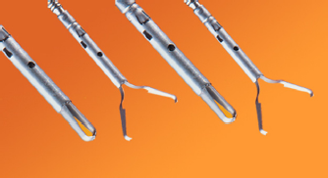

Difficulties and Complications:
Clipping is easiest when the endoscope can be kept in a straight position, with the possibility of axial push into the tissue. Tangential access to the lesions sometimes results in poor anchoring of the clip in the gastric wall. The fundic region can also be a challenge, because the firing mechanism is often weakened when the scope tip is retroflexed. Clips also work poorly through the working channel of a duodenoscope, and the elevator must be minimally engaged to allow release of the clip .
APC in Group II:Argon Plasma Coagulation (APC) was done using an argon plasma coagulator unit(TERNO ABC TOM 201, Germany). Spray mode was used with 2 power/gas settings (respectively, 40 and 70 W and 1.5 to 3 L/min). Probe of 2.3 mm was used with endoscopes with corresponding channel diameters (2.8- mm diameter accessory channels). The maximum coagulation depth achieved by APC is 3 to 4 mm, which minimizes the risk of perforation. Continuous suction was applied to remove smoke and prevent overinflation of the GI tract.The APC apparatus includes a high-frequency monopolar electrosurgical generator, source of argon gas, gas flow meter, flexible delivery catheters, grounding pad, and foot switch to activate both gas and energy. Probes are available that direct the plasma parallel or perpendicular to the axis of the catheter. APC systems (ERBE Elektromedizin, Tübingen, Germany; and Conmed, Utica, N.Y.) include an electrosurgical unit that generates a high frequency electrical current, an argon gas cylinder, and a gas flow meter. Disposable probes for endoscopic application consists of a flexible teflon tube with a tungsten monopolar electrode contained in a ceramic nozzle located close to its distal end. APC probes are available in a variety of diameters and lengths (2.3 mm OD [220 cm, and 440 cm length], and 3.2 mm OD [220 cm length]). A foot switch synchronizes argon gas release with the delivery of electrical current. Generators deliver an output voltage of 5000-6500 V.
Follow up:After endoscopy, all patients were closely monitored clinically for one weak looking for symptoms and signs of bleeding . All patients received the same proton pump inhibitor, and Blood transfusion was given to maintain the hemoglobin level above 8g/dL. Clinical recurrent bleeding was defined as signs of bleeding: vomiting of fresh blood, passage of melena with pulse rate higher than 100beat/min,decrease in systolic blood pressure exceeding 30mmHg, after the early stabilization of pulse, blood pressure, and or decrease in hemoglobin concentration by at least 2 g/dL over a 24-hour period. In case of rebleeding endoscopy was repeated as an emergency procedure and the same primary endoscopic management was used. Indications for surgery ; where failed endoscopic treatment on second endoscopy, recurrence of bleeding after a second therapeutic endoscopy, or a total blood transfusion requirement of greater than 8 units to maintain a hemoglobin level of 10 g/dL.

Results
Data Management: Data were collected, revised, verified then edited on P. C. Data were then analyzed statistically using SPSS statistical package version 15. The following tests were done:
- Student t-test = Unpaired Student T-test was used to compare between to two groups in quantitative data.- Chi–square test = the hypothesis that the row and column variables are independent, without indicating strength or direction of the relationship.-Mann whitney = A nonparametric equivalent to the t test

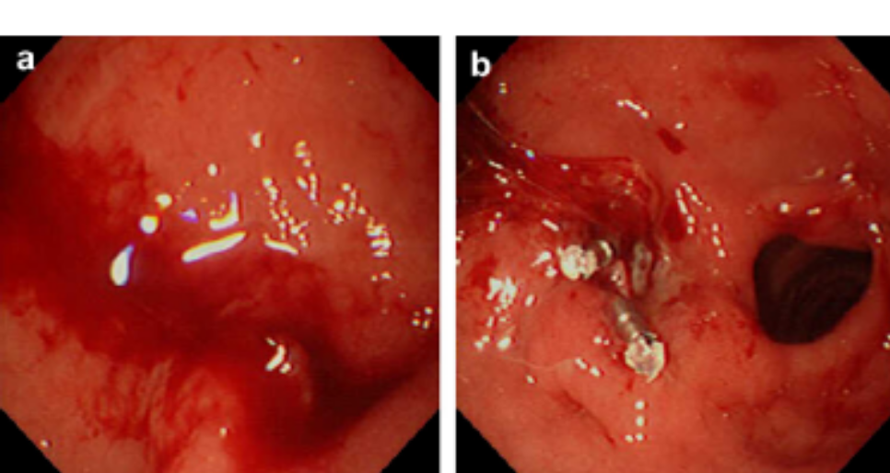

Figure 1: Showing control of bleeding of bleeding gastric ulcer after 2 hemoclip application in patient of clip application group .

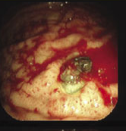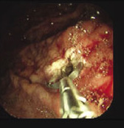

Figure 2: Showing control of bleeding of bleeding gastric ulcer (blood clot) after hemoclip application in patient of clip application group .

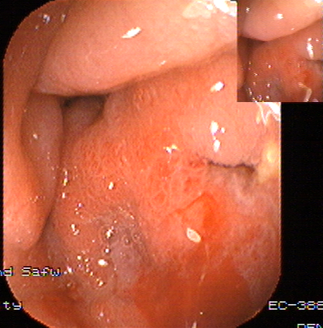
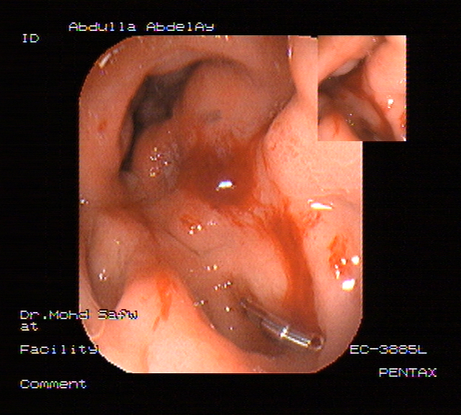

Figure 3: Showing control of bleeding gastric ulcer (oozing) after 2 hemoclip application in patient in clip application group

 |  | Ulcer With Visible Vessel
 |  | Negative | Positive | Total
Group I | N | 13 | 2 | 15
Group I | % | 86.67 | 13.33 | 100.00
Group II | N | 12 | 3 | 15
Group II | % | 80.00 | 20.00 | 100.00
Chi-square | X² | 0.240
Chi-square | P-value | > 0.05 (N.S)
Table (3) shows insignificant difference between the 2 groups regarding the presence of ulcer with visible vessel.(P-value was >0.05 which is non significant).
 |  | Ulcer With Oozing Vessel
 |  | Negative | Positive | Total
Group I | N | 8 | 7 | 15
Group I | % | 53.33 | 46.67 | 100.00
Group II | N | 11 | 4 | 15
Group II | % | 73.33 | 26.67 | 100.00
Chi-square | X² | 1.292
Chi-square | P-value | > 0.05 (N.S)
Table (4) shows insignificant difference between the 2 groups regarding the presence of ulcer with oozing vessel. (P-value was >0.05 which is non significant).

 |  | Forrest's Classification
 |  | IA | IIA | IB | IIB | Total
Group I | N | 0 | 2 | 7 | 6 | 15
Group I | % | 0.00 | 13.33 | 46.67 | 40.00 | 100.00
Group II | N | 5 | 3 | 4 | 3 | 15
Group II | % | 33.33 | 20.00 | 26.67 | 20.00 | 100.00
Chi-square | X² | 8.981
Chi-square | P-value | <0.05 (S)
Table (5) shows significant difference between the 2 groups regarding Forrest’s classification.( P-value was <0.05 which is significant).
Group | Rockall's Score |  |  |  | T-test
Group | Range |  | Mean | SD | t | P-value
Group I | 3.000 | 8.000 | 4.933 | 1.668 | -0.585 | > 0.05  (N.S)
Group II | 3.000 | 9.000 | 5.333 | 2.059 | -0.585 | > 0.05  (N.S)
Table (6) shows insignificant difference between the 2 groups regarding the Rockall'S Score. (P-value was > 0.05 which is non significant).
 |  | GASTRIC OR DUODENAL
 |  | DU | GU | Total
Group I | N | 7 | 8 | 15
Group I | % | 46.67 | 53.33 | 100.00
Group II | N | 10 | 5 | 15
Group II | % | 66.67 | 33.33 | 100.00
Chi-square | X² | 1.222
Chi-square | P-value | > 0.05 (N.S)
Table (7) shows nonsignificant difference between the 2 groups regarding presence of gastric or duodenal ulcer. (P-value was >0.05
 |  | Rebleeding
 |  | Negative | Positive | Total
Group I | N | 12 | 3 | 15
Group I | % | 80.00 | 20.00 | 100.00
Group II | N | 10 | 5 | 15
Group II | % | 66.67 | 33.33 | 100.00
Chi-square | X² | 0.682
Chi-square | P-value | > 0.05 (N.S)
Table (8) shows insignificant difference between the 2 groups regarding occurrence of rebleeding. (P-value was >0.05 ).
Group | Rebleeding | Forrest's Classification |  |  |  |  |  | Chi-square
Group | Rebleeding |  | IA | IIA | IB | IIB | Total | X² | P-value
Group I | Negative | N | 0 | 0 | 6 | 6 | 12 | 9.643 | < 0.01(H.S)
Group I | Negative | % | 0.00 | 0.00 | 40.00 | 40.00 | 80.00 | 9.643 | < 0.01(H.S)
Group I | Positive | N | 0 | 2 | 1 | 0 | 3 | 9.643 | < 0.01(H.S)
Group I | Positive | % | 0.00 | 13.33 | 6.67 | 0.00 | 20. 0 | 9.643 | < 0.01(H.S)
Group II | Negative | N | 3 | 3 | 2 | 2 | 10 | 9.643 | < 0.01(H.S)
Group II | Negative | % | 20.00 | 20.00 | 13.33 | 13.33 | 66.67 | 2.100 | > 0.05 (N.S)
Group II | Positive | N | 2 | 0 | 2 | 1 | 5 | 2.100 | > 0.05 (N.S)
Group II | Positive | % | 13.33 | 0.00 | 13.33 | 6.67 | 33.33 | 2.100 | > 0.05 (N.S)
Table (9) shows highly significant difference in rebleeding incidence in different Forrest’s classes in group I.( P-value was <0.01).while there was insignificant difference in rebleeding incidence in different Forrest’s classes in group II ( P-value was >0.05).
Rockall's Score | Rebleeding
Rockall's Score | Negative |  | Positive |  | T-test
Rockall's Score | Mean | SD | Mean | SD | t | P-value
Group I | 4.417 | 1.240 | 7.000 | 1.732 | -3.014 | < 0.05 (S)
Group II | 5.900 | 2.234 | 4.200 | 1.095 | 1.587 | > 0.05 (N.S)
Table (10) shows significant occurrence of rebleeding with higher Rockall's Score in group I . (P-value was <0.05). While there is insignificant occurrence of rebleeding with higher Rockall's Score in group II (P-value was >0.05).
Rockall's Score |  | Rebleeding
 |  | Negative | Positive | Total
<5 | N | 10 | 2 | 12
<5 | % | 33.33 | 6.67 | 40.00
≥5 | N | 12 | 6 | 18
≥5 | % | 40.00 | 20. 00 | 60.00
Chi-square | X² | 1.02
Chi-square | P-value | > 0.05 (N.S)
Table (11) shows insignificant relation between <5 or ≥5 Rockall's score and the occurrence of rebleeding in the whole patient population. (the P-value was >0.05 ). There was also insignificant difference in the 2 groups regarding occurrence of rebleeding in relation to the site of ulcer GU or DU. ( P-value was >0.05).

Forrest's Classification | No of Clips
Forrest's Classification | Clips 2 |  | Clips 3 |  | Total |  | Chi-square
Forrest's Classification | N | % | N | % | N | % | X² | P-value
IIA | 1 | 6.67 | 1 | 6.67 | 2 | 13.33 | 0. 877 | > 0.05 (N.S)
IB | 5 | 33.33 | 2 | 13.33 | 7 | 46.67 | 0. 877 | > 0.05 (N.S)
IIB | 5 | 33.33 | 1 | 6.67 | 6 | 40.00 | 0. 877 | > 0.05 (N.S)
Table (12) shows insignificant relation between the number of needed clips and forrest classification in group I. (P-value was > 0. 05).
 | No of CLIPS
 | 2 |  | 3 |  | T-test
 | Mean | SD | Mean | SD |  | t | P-value
Rockall's score | 4.727 | 1.679 | 5.500 | 1.732 |  | -0.783 | > 0.05 (N.S)
Table (13) shows insignificant relation between the number of clips in relation to Rockall'S Score group I. (P-value was >0.05).
There was also insignificant relation between the number of needed reclipsing in relation to Rockall's Score and the size of ulcer in group I .(P-value was >0.05).
DISCUSSION

Peptic ulcer bleeding is the most common cause of upper gastrointestinal bleeding, responsible for about 50% of all cases Mortality is increasing with increasing age and is significantly higher in patients who are already admitted in hospital for co-morbidity. Risk factors for peptic ulcer bleeding are NSAIDs use and H. pylori infection (van Leerdam, 2008).
In patients with ulcers presenting with ongoing bleeding or high risk features (Forrest I, IIa, IIb), surgery was frequently required in the past to solve the situation. However, endoscopic therapy has been well documented to treat these ulcers. (Aabakken, 2008).
The timing of the initial endoscopy has been debated. In general, red hematemesis indicates emergency upper endoscopy, while black hematemesis and/or melena without haemodynamic instability can wait until normal working hours. However, from a logistic point of view, early endoscopy has been advocated to ensure optimal utilisation of resources .In this study there is no significant difference in both groups regarding age, shock, presence of comorbid illness or liver cell failure, ulcer size, rockall score and site of ulcer; factors known to affect prognosis in many previous studies.
the study showed that the rate of rebleeding was slightly higher in APC group despite of being statistically insignificant.Also there was no significant relation between the rate of rebleeding and the size of the ulcer.Few reports have concerned the indication for and efficacy of each hemostatic therapy according to location,depth,and size of ulcer and bleeding activity of the exposed vessel. if the ulcer is large or deep,the possibility of complications including further ulceration,recurrence of bleeding,and perforation is high and great care is required in performing the procedure if the bleeding ulcer is located on the posterior wall or lesser curvature of the gastric body or on the posterior wall of the duodenal bulb, the hemostatic rate is lower than for other therapies because of the technical difficulty of approaching the lesion. Chung et al. (1999)
In the present study although there was no statistical significance difference in rebleeding incidence in both groups there was highly significant difference in rebleeding incidence in relation to different Forrest’s classes in group I.( P-value was <0.01 which is highly significant ).while there was insignificant difference in rebleeding incidence in different Forrest’s classes in group II.
Also, the rate of surgical interference of both groups was 0%
In recent years, the Rockall score has been used to select patients with a low risk of re-bleeding for early discharge. Almost all patients in this low risk group belong to patients without any stigmata of recent hemorrhage (SRH). However, patients with a SRH are a high-risk group for further re-bleeding and also mortality. It is therefore important to determine whether the Rockall score could be useful in patients who have undergone endoscopic therapy for UGIB, to identify high-risk patients and thus improve their management and outcome (Bessa et al., 2006).
In the present study we assessed correlation between high risk Rockall’s score (>5) and occurrence of rebleeding, which rebleeding is 6.67% in low risk Rockall’s score(<5). While rebleeding is 20.00% in high risk Rockall’s score (>5). However, this is statistically non significant. but incidence of rebleeding in relation to high risk Rockall's score is significant in group I. This did not go in agreement with Saperas et al. (2008), who concluded that the Rockall scoring system accurately identifies patients at high risk of death, but not of rebleeding.
Inspite that our study partially goes with Church and Palmer(2001) who observe good correlation between the Rockall score and both the probability of re bleeding and mortality in patients undergoing endoscopic therapy for peptic ulcer hemorrhage.
In the present study the mortality rates between the two groups were the same which is 0% in the two groups despite of significantly higher need for surgery in group II .
This goes with Sung et al. (2007) and Chung et al. (1999) who concluded that there was no difference in all-cause mortality irrespective of the modalities of endoscopic treatment.
Sung et al. (2007)in a meta-analysis of 15 studies reported that regardless of improvements in sustaining hemostasis by clipping leading to less rebleeding and fewer interventions with surgery, mortality has not been reduced. and there is no indication of a reduction in the death rate. Nevertheless, it is a mystery that despite successful control of hemorrhage in many studies using various combinations of endoscopic and pharmacological therapies, the mortality rate remains unchanged..
Conclusion: Endoscopic application of hemoclips have a less rebleeding rate than Argon plasma coagulation for treatment of bleeding peptic ulcer ,although this was statistically insignificant .Meanwhile APC is still less costy ,and easy for jonyor endoscopists in emergency units. Clinical and endoscopic assessment (through Rokal score and Forrest classification)could help in making best choice for endoscopic manageme REFERENCES
*Aabakken L (2008): Current endoscopic and pharmacological therapy of peptic ulcer bleeding. Best Practice & Research Clinical Gastroenterology; 22, (2): 243-259.
*Alan Barkun, et al. (2003): Consensus for managing patients with non variceal upper gastrointestinal bleeding. Annals of Internal Medicine; 139 (10): 843-857..
*Bessa X, O’Callaghan E, Ballest´e B, Nieto M, Seoane A, Panad`es A, Vazquez DJ, Andreu M and Bory F (2006): Applicability of the Rockall score in patients undergoing endoscopic therapy for upper gastrointestinal bleeding. Digestive and Liver Disease; 38: 12-17. Canard JM, Vedrenne B. Clinical application of argon plasma coagulation in gastrointestinal endoscopy: has the time come to replace the laser? Endoscopy 2001;33:353-7.
*Chuan C, Ming-Szu H, Te-Fa C, Jih-Chang C and Cheng-Ting H (2007): Risk scoring systems to predict need for clinical intervention for patients with nonvariceal upper gastrointestinal tract bleeding. American Journal of Emergency Medicine; 25: 774–779.
*Chung IK, Ham JS, kim HS, et al. (1999): Comparison of the hemostatic efficacy of the endoscopic hemoclip method with hypertonic saline-epinephrine injection and a combination of the two for the management of bleeding pepic ulcers. Gastrointest Endosc; 49: 13-18.
*Church NI and Palmer KR (2001): Relevance of the Rockall score in patients undergoing endoscopic therapy for peptic ulcer hemorrhage. Eur J Gastroenterol Hepatol; 13: 1149-52.
*Church NI, Dallal HJ, Masson J, Mowat NA, Johnston DA, Radin E, et al. (2003): A randomized trial comparing heater probe plus thrombin with heater probe plus placebo for bleeding peptic ulcer. Gastroenterology; 125 (2): 396-403.
*Chuttani R, Alan Barkun, Steven Carpenter, et al. (2006): Endoscopic clip application devices. the American Society for Gastrointestinal Endoscopy; 63 (6): 16-51.
*Devereaux CE and Binmoeller KF (1999): "Endoclip: closing the surgical gap". Gastrointest Endosc; 50 (3): 440-442.

*Forrest JAH, Finlayson NDC & Shearman DJC. Endoscopy in gastrointestinal bleeding. Lancet 1974; 2: 394–397.
*Hachisu T (1998): Evaluation of endoscopic hemostasis using an improved clipping apparatus. Surg Endosc; 2: 13-7.
*Hachisu T, Yamada H, Satoh S, et al. (1996): Endoscopic clipping with a new rotatable clip-device and a long clip. Dig Endosc; 8: 127-33.
*Park CH et al. (2004): Optimal volume for epinephrene for endoscpic prevention of recurrent peptic bleeding . Gastrointes Endosc; 60: 875-880.
*Park CH, Joo YE, Ki HS, et al. (2004): Aprospecive, randomized trial comparing mechanical methods of hemostasis plus epinephrine injection alone for bleeding peptic ulcer. Gastrointest Endosc; 60: 173-179.
*Raju GS and Gajula L (2004): Endoclips for GI endoscopy. Gastrointest Endosc; 59: 267-279.
*Rockall TA, Logan RF, Devlin HB and Northfield TC (1995): Incidence of and mortality from acute upper gastrointestinal haemorrage in the United Kingdom. Steering Committee Gastrointestinal Haemorrhage. BMJ; 311(6999): 222-226.
*Saperas E, Sebastian V, Carolina B, Joan D, Jose R and Juan RM (2008): Applicability of the Rockall Scoring System and Prediction of Rebleeding and Mortality After Combined Pharmacologic and Endoscopic Treatment of High-Risk Bleeding Peptic Ulcers. Gastrointestinal Endoscopy; 67: 255.
*Sung J (2006): Current manegement of peptic ulcer bleeding. Natural Clinical Practice; 3: 24-32.
*Sung JJ, Tosi KK, Lai LH, et al. (2007): Endoscopic clipping versus injecion and thermocagulation in treatment of non variceal upper gastrointestinal bleeding: ameta-analysis. Gut; 56: 1364-1373.
van Leerdam (2008): Epidemiology of acute upper gastrointestinal bleeding. Best Practice & Research Clinical Gastroenterology; 22 (2: 209-224.

,

