Assessment Of Top Soil Quality In The Vicinity Of Subsided Area In Jharia Coalfield, Dhanbad, Jharkhand
Arvind Kumar Rai¹ Biswajit Paul ² Gurdeep Singh³
Research Scholar¹, Assistant Professor², Professor& Head³
Department of Environmental Science &Engineering,
Indian School of Mines, Dhanbad, Jharkhand, India
Email: arvind_dese@rediffmail.com.

ABSTRACT
Coal mining is the major mining activity performed in the India. There are two types of methods applied for mining such as opencast mining and underground mining. Both produce huge amount of wastes, especially while performing the opencast mining activities. Opencast project involved displacement of large amount of overburden to excavate the valuable mineral. In mining areas the soils are affected by various activities such as blasting, drilling and quantity of explosives used. This paper presents the results of the studied carried out on top soil (0-15cm) quality parameters of Jharia coalfields. It has been observed that the soil quality in subsided areas have relatively low pH, low moisture content and high conductivity. The present study, helped to reveal the extent top soil quality in subsided areas and its results are very vital for planning the rehabilitation programmed of Jharia coalfield.
KEY WORDS Opencast project, Overburden materials, Subsided areas.
INTRODUCTION Topsoil is the upper surface of the earth's crust, and usually is no deeper than approximately eight inches (20 centimeters). The earth's topsoil mixes rich humus with minerals and composted material, resulting in a nutritious substrate for plants and trees. It may one of the earth's most vital resources, because it represents a delicate nutritional balance that provides food for many of the animals on earth, either directly in the form of plant material or indirectly in the form of products from animals that eat plants. Topsoil is formed over a long period of time. Soil formation takes place when many things interact, such as air, water, plant life, animal life, rocks, and chemicals. The topsoil will be dark brown or black in color (though not in very arid or dry areas), and is made up of rock material that has been chemically and physically broken down and changed, and mixed with organic materials such as dead plants, particularly roots of them. Furthermore, top soil will generally be full of plant and animal life.
In coal mining areas, the top soils are not selectively handled as a result the top soil material gets mixed with overburden materials and thus the soil, an important resource for land management is lost and it degrades the quality of agricultural soil. Mining activity in JCF started in 1895 and large scale mining started in 1920. Mining activity includes mainly opencast mines grew rapidly due to better quality of coal and multi seam occurrence in this field. Opencast mines were owned by local or private owners operating in very small patches or small units (Sharma, B.K, 2007). During this period (Nationalization of coal industry, 1971 -73), coal was exploited by the local or private owners in an unscientific way. This led to many problems such as subsidence and fire problems which create havoc in many localities. Most of the problems of subsidence and fire are scattered throughout the Jharia coalfield (JCF). These problems are mainly concentrated along the eastern side of the JCF viz. Lodna area, Kustore area and Bastacolla area. In Fig 2 fire affected area has been shown. The fires have affected surface structures, houses, buildings, and top soil in its vicinity. Top soil varied in their composition and properties depending upon the fire and subsidence involved. The subsidence movements cause the changes in the surface topography and surface drainage system (Saxena et al., 2000). These subsidence movements can damage all the categories of the surface properties around the subsided areas.
MATERIALS AND METHODS
Study area
The Jharia Coalfield (JCF) is one of the Lower Gondwana Coalfields of India, covering an area of about 72 km². It is one of the most important coalfields in India, located in Dhanbad district, between latitude 23° 39' to 23° 48' N and longitude 86° 11' to 86° 27' E. This is the most exploited coalfield because of available metallurgical grade coal reserves. In Fig 1 depicts the study area of JCF. This sickle shaped coalfield is about 40 km in length and approximately 12 km in width stretches from west to east and finally turns southward covering an area of about450 sq.km.
JCF is located about 260 kms North West of Kolkata in East India. JCF contains 40 identified coal horizons and the leasehold area of Bharat Coking Coal Limited (BCCL) is 270 sq.kms (Sharma, B.K. 2007).This coalfield has one of the highest coal densities in the world.
For the purpose of conducting various tests on the top soil in the laboratory, soil samples have been collected from selected subsided zone viz. Lodna area, in Jharia coalfield. Lodna area is fire affected area. Removal of top soil due to mining affects soil properties mainly through the loss of soil organic matter, plant nutrients and exposure of sub soil material with low fertility and high acidity.
Soil samples
The air dried top soil samples were ground and pass through 2mm sieve. The care must be taken to collect representative samples and record the samples so that lab results can be used. Soil should be collected with a clean soil sampling tube. Debris should be cleared from the surface and a hole dug to six inches. Once the hole is dug, scoop a part of soil off one side of the sampling tube and place the part of soil into a clean polythene bag. Top soils samples can be drawn with any of these equipments namely, soil auger (tube), screw type auger, spade, gardening hand tool (Khurpi). The collected top soil samples after coning and quartering then sieving (2mm) were used for analysis of different soil quality parameters.

Sampling sites and analysis
Lodna area is the one of the most important colliery and subsided zone in Jharia coalfield, Dhanbad, Jharkhand. Some of the colliery of Lodna Area is facing serious subsidence problems due to presence of small patches of underground fires scattered throughout the area. In Table 1 sampling sites, longitude, and latitude are mentioned. Opencast cast mining has also been done in this area such as North Tisra. Representative composite top soil samples were taken from the Lodna area of JCF up to 15 cm depth as per standard procedure of Indian agricultural research institute, New Delhi. The location of sampling sites was randomized to avoid biasing in results.
Laboratory methods: The following methods are briefly mentioned underlined.
pH The pH value which is a measure of the hydrogen or hydroxyl ion activity of the soil water system indicates whether the soil is acidic, neutral or alkaline in reaction. Crop growth suffers much both under very low as well as high pH.
The instrument for pH measurement commonly used is a digital pH meters have single electrode assembly. The instrument being a potentiometer, the pH scale has to be calibrated before use with buffer solutions of known pH values. 20 gm of soil is taken in a 100ml beaker to which 40 ml of distilled water is added (Ghosh., et al 1983). The suspension is stirred at regular intervals for 30 minutes and the pH is recorded. The suspension must be stirred well just before the electrode are immersed and readings taken.
Electrical conductivity The conductivity of the supernatant liquid (after pH determination) is determined with the help of salt bridge.
Moisture content The standard method for determining moisture content of soil is the oven- drying method. This is the procedure recommended for soil. Moisture content measured by gravimetric method and expressed as percentage. Loss of weight of the samples was calculated to determine the moisture content.
Organic carbon The soil is grounded and completely passed through 0.2mm sieve (80mesh) and 1gm is placed at the bottom of a dry 500ml conical flask. Add 10 ml of potassium dichromate (1N) in the 500 ml conical flask, swirled and conical flask gently to disperse the soil in the dichromate solution. Then 20 ml of sulphuric acid is run in run in and swirled again two or three times. The flask is allowed to stand for 30 minutes and thereafter 200ml of distilled water along with 10 ml of ortho – phosphoric acid is added and 1ml of diphenylamine indicator. The whole contents are titrated with ferrous ammonium sulphate solution till the color flashes from blue – violet to green. For a final calculation, a blank is run without soil.
Available nitrogen In a 800 ml dry Kjeldhal flask, 20 gm of soil is taken. 20ml of water, 100ml potassium permanganate and 100 ml sodium hydroxide. The frothing during boiling is prevented by adding 1ml paraffin or a few glass beads. The whole contents are distilled in a Kjeldhal assembly at a steady rate and the liberated ammonia collected in a conical flask (250ml) containing boric acid solution (with mixed indicator). With the absorption of ammonia the pinkish color turns to green. Nearly 100ml of distillate is to be collected in about 30 minutes which is titrated with (0.02N) sulphuric acid to the original pinkish color. For the final correction blank is run without soil (Subbiah and Asija.1956).
Available phosphorus In a 25 ml volumetric flask, 5ml of the soil is taken and adding 5ml of dickman and bray reagent. The neck of the volumetric is washed down and the contents are diluted to about 22ml, then 1ml of dilute stannous chloride solution is added and volume is made up to the mark. The intensity of the blue color is measured (using 660nm) just after 10 minutes and the concentrations phosphorus is determined from the standard curve (Olsen, S. R, 1954).
RESULTS & DISCUSSIONS
The results of the various soil quality parameters of JCF area are presented in Table 2.
From the above results it could be observed that the pH of soil in the subsided areas varied between 4.2 -5.8.Top soil in subsided zone has slightly low pH. This may be due to oxidation of pyrite which is generally present in coal controls the lowering of pH. Low pH were responsible for most of the nutrients can be readily not available to plants. The total range of the normal soil pH scale is from 0-14. Values below the mid-point (pH 7.0) are acidic and those above pH 7.0 are alkaline. pH of the soil is the measure of hydrogen ion activity and depends largely on relative amounts of adsorbed hydrogen and metallic ions. The desired pH for good vegetation ranges from 5.5 to 6.8.pH is a good measure of acidity and alkalinity of soil water suspension and it provides a good identification of soil chemical nature (Sharma, H.P. 2008). `
Electrical conductivity (EC) of top soil varied between 0.61 mmhos/cm - 0.89 mmhos/cm. These values showed that conductivity of top soil increasing in subsided areas. The higher conductivity values in subsided zone are due to upward migration of salts along with them through cracks or fissures (Tripathy, et al., 1998). The EC value depends on the dilution of the soil suspension, total salts and sodium content. High value of EC can toxic to plants and may prevent them from obtaining water from the soil.
The observed moisture content was ranging from 4.9 % to 7.5% .The minimum and maximum values were recorded at South tisra and Bararee. The moisture content of subsided area is low as compared to normal area. The organic carbon content in top soil in degraded areas varied from between 0.21% -0.41%.The minimum and maximum values were recorded at Goluckdih and Bagdigi. It showed a decreasing of organic carbon from non degraded areas to degraded areas. Low organic content in subsided zones is because of burning out of organic matter present in top soil, low rate of humiliation and lack of microbes in top soil. The available nitrogen content fluctuated between 90.64 kg/ha to 110.65 kg/ha. The minimum and maximum value recorded at Goluckdih and Jeenagora respectively. Lower value of nitrogen in subsided zone is due to loss of organic carbon which contains nitrogen and nitrogen fixing microorganisms in soil.
The available phosphorus content fluctuated between 3.42 kg/ha to 5.51kg/ha. The minimum and maximum value recorded at Kujama and Bagdigi respectively. The value of phosphorus content is low to medium range in subsided zone. Low phosphorus in soil is because of its presence in insoluble state or due to lack of organic matter in soil.
CONCLUSIONS
From the present study it can be concluded that the top soil in subsided zone (Lodna area) has degraded slowly day by day. During mining operations, steps must be taken, by good planning and environment management to minimize effects of soil erosion, degradation, dust pollution and impacts on local biodiversity. Keeping above view in consideration for safe (less degraded), environmentally friendly and sustainable mine planning the most important part is the effective management of degraded land. Opencast mining should be planned in such a way that after the closure of the mine area it can be afforested to merge with the surrounding forest areas.

REFERENCES
- Ghosh, A.B; Bajaj, J.C; Hassan, R; & Singh, D. Laboratory Manual for Soil and Water Testing 1ST Edition, Soil Testing Laboratory Division of Soil Science and Agricultural Chemistry, IARI, New Delhi. 1983. pp11- 17
- Sharma, H.P. Study of the Impact of Municipal Solid Waste Dumping on Soil Quality in Guwahati City, Poll. Res. 2008. 27(2):327 -330.
- Jackson, M. L. Soil Chemical Analysis. Prentice Hall, Englewood Cliffs, NJ, 1967. USA.
- Olsen, S.R Estimation of Available Phosphorus by Extraction with Sodium Bicarbonate. U.S. Dep. Agriculture, NY, USA. 1954, 939
- Saxena, M.M. Environmental Analysis. Water, Soil and air Second Edition, Agro Botanical Publishers, Bikaner 1989. 121-140
- Saxena, N.C. Environmental Aspects of Mine Fire Proceedings of National Seminar on Mine Fires, BHU, Varanasi, 1995. 101- 106.
- Sharma, B.K. Harnessing of the Thermal Energy from Mine Fires in JCF- An Alternative Source from Waste Heat,1st International Conference on MSECCMI, New Delhi, India. 2007 325.
- Subbiah, B. V. & Asija G.L. A Rapid Procedure for Estimation of Available Nitrogen in Soils, Current Science, 1956 (25) 259 -260.
- Tripathy, D.P. Singh, G, Panigrahi, D.C. Proceedings of the Seventh National Symposium on Environment, 1998.Feb-5-7, 205

LIST OF TABLE

Table1.Top Soil Quality Sampling Stations within the Jharia coalfield.
S.No | Sampling sites | Latitude | Longitude
1 | Kujama | 23⁰ 44’ 15” | 86⁰ 25’ 28”
2 | Goluckdih | 23⁰ 42’ 30” | 86⁰27’ 46”
3 | North Tisra | 23⁰ 42’ 35” | 86⁰ 26’ 50”
4 | South Tisra | 23⁰ 43’ 06” | 86⁰ 26’ 30”
5 | Lodna | 23⁰ 43’ 30” | 86⁰ 25’ 55”
6 | Jealagora | 23⁰ 42’ 40” | 86⁰ 25 ‘20”
7 | Jeenagora | 23⁰ 42’ 40” | 86⁰ 26’ 48”
8 | Joyrampur | 23⁰ 42’ 45” | 86⁰ 26’28”
9 | Bagdigi | 23⁰ 42’ 30” | 86⁰ 25’ 39”
10 | Bararee | 23⁰ 42’ 12” | 86⁰ 25’ 41”

Table 2.Top soil quality of various parameters of JCF.
S.No | Sampling Locations
 |  | pH | Electrical Conductivity  (mmhos/cm) | Moisture Content  (%) | Organic Matter  (%) | Available Nitrogen  (kg/ha) |  | Available Phosphorus  (kg/ha)
1. | Kujama | 4.8 | 0.61 | 5.8 | 0.28 | 93.45 |  | 3.42
2. | Goluckdih | 4.2 | 0.68 | 6.9 | 0.21 | 90.64 |  | 3.67
3. | North tisra | 4.5 | 0.74 | 6.1 | 0.38 | 95.72 |  | 4.87
4. | South tisra | 4.3 | 0.83 | 4.9 | 0.32 | 95.68 |  | 4.21
5. | Lodna | 4.8 | 0.89 | 6.4 | 0.24 | 94.78 |  | 3.98
6. | Jealagora | 5.7 | 0.82 | 7.1 | 0.28 | 97.21 |  | 4.86
7. | Jeenagora | 5.2 | 0.72 | 6.9 | 0.31 | 110.65 |  | 4.62
8. | Joyrampur | 5.6 | 0.69 | 5.9 | 0.33 | 107.82 |  | 5.38
9. | Bagdigi | 5.3 | 0.76 | 7.2 | 0.41 | 98.64 |  | 5.51
10. | Bararee | 5.8 | 0.73 | 7.5 | 0.39 | 98.94 |  | 4.97

List of Figure:
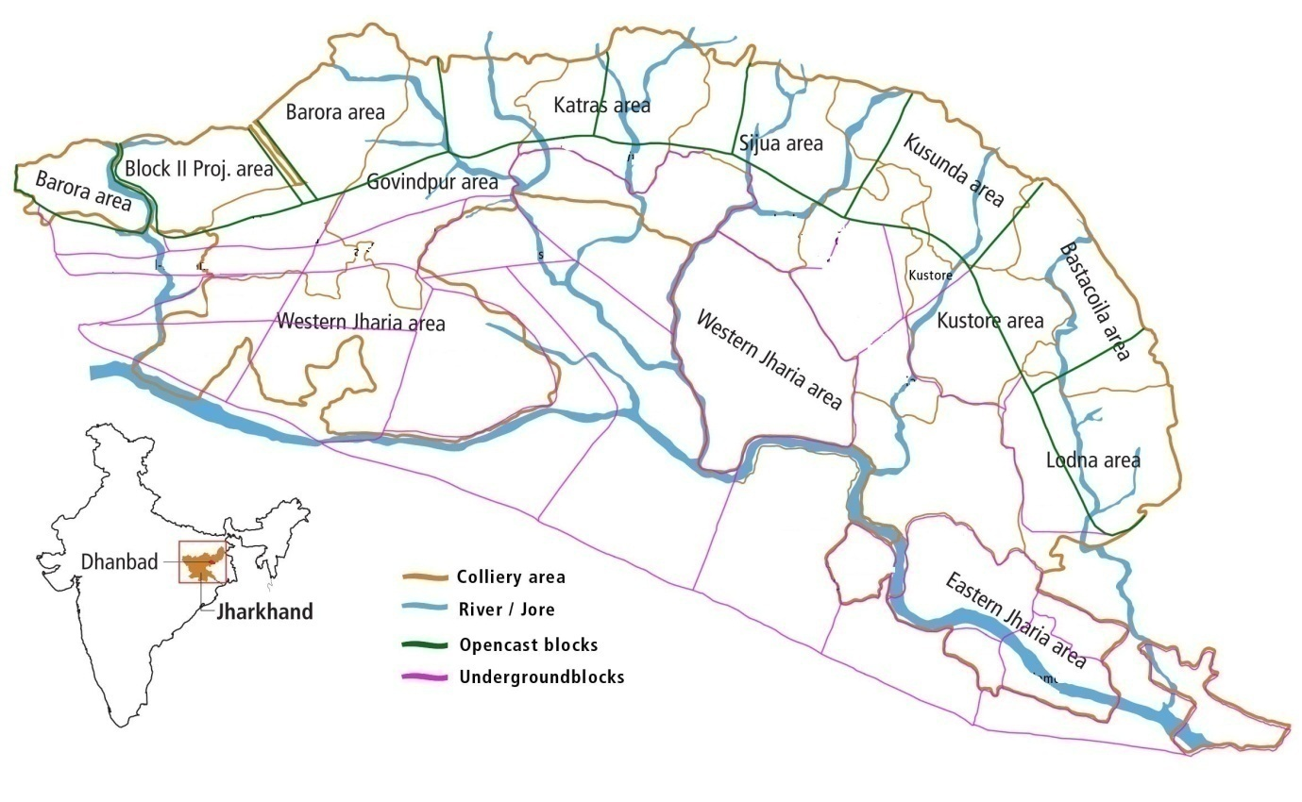
Sampling sites
Fig 1 Study area of JCF. (Ten sampling sites only in Lodna area)

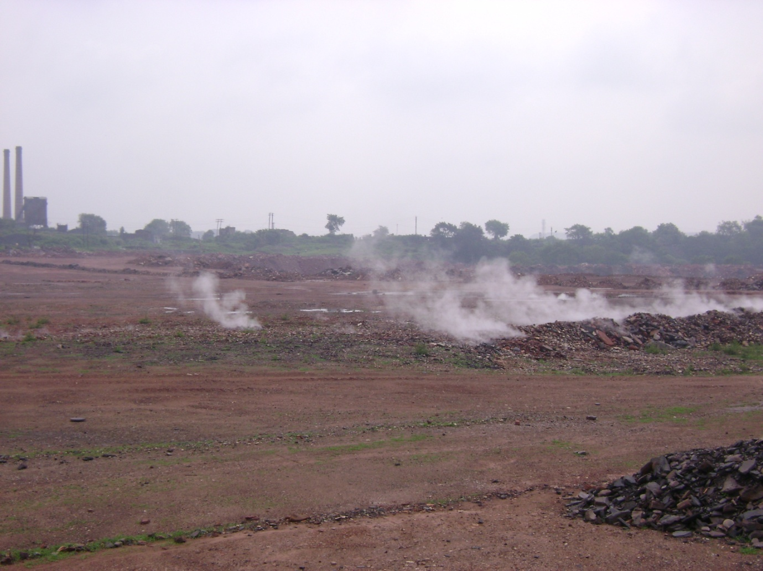
Fig 2 Fire affected area in Jharia coalfield

Correspondence author name:
Arvind Kumar Rai
Department of environmental science & engineering
Indian School of Mines University, Dhanbad - 826004
Jharkhand, India.
Phone: +91- 9709208425
Email: arvind_dese@rediffmail.com,
geotech_arvind@yahoo.com.sg,
**********************************************************************************

REFERENCES
- Ghosh, A.B; Bajaj, J.C; Hassan, R; & Singh, D. Laboratory Manual for Soil and Water Testing 1ST Edition, Soil Testing Laboratory Division of Soil Science and Agricultural Chemistry, IARI, New Delhi. 1983. pp11- 17
- Sharma, H.P. Study of the Impact of Municipal Solid Waste Dumping on Soil Quality in Guwahati City, Poll. Res. 2008. 27(2):327 -330.
- Jackson, M. L. Soil Chemical Analysis. Prentice Hall, Englewood Cliffs, NJ, 1967. USA.
- Olsen, S.R Estimation of Available Phosphorus by Extraction with Sodium Bicarbonate. U.S. Dep. Agriculture, NY, USA. 1954, 939
- Saxena, M.M. Environmental Analysis. Water, Soil and air Second Edition, Agro Botanical Publishers, Bikaner 1989. 121-140
- Saxena, N.C. Environmental Aspects of Mine Fire Proceedings of National Seminar on Mine Fires, BHU, Varanasi, 1995. 101- 106.
- Sharma, B.K. Harnessing of the Thermal Energy from Mine Fires in JCF- An Alternative Source from Waste Heat,1st International Conference on MSECCMI, New Delhi, India. 2007 325.
- Subbiah, B. V.& Asija G.L. A Rapid Procedure for Estimation of Available Nitrogen in Soils, Current Science, 1956 (25) 259 -260.
- Tripathy, D.P. Singh, G, Panigrahi, D.C. Proceedings of the Seventh National Symposium on Environment, 1998.Feb-5-7, 205

10/14/2009

