Rapid Prototyping and Multi-axis NC Machining for The Femoral Component of Knee Prosthesis

Jeng-Nan Lee^{1*}, Hung-Shyong Chen¹, Chih-Wen Luo¹ and Kuan-Yu Chang²
1 Department of Mechanical Engineering, Cheng Shiu University, Kaohsiung County, Taiwan 833, RO China.
2 Mackay Memorial Hospital Taitung Branch, Taitung, Taiwan 833, RO China.
jengnan@csu.edu.tw

__________________________________________________________________________________________________________________________________________________
Abstract: In this paper, a design system combining clinical experience and engineering knowledge was developed for the manufacture for femoral component of knee prosthesis. The femoral component is developed on a prescription basis and is unique for each patient. The medical image of the femoral component obtained according to the patient CT. The necessary constrains based on surgical experience were integrate into the CAD system. The rapid prototyped model was built as the reference for review. In the process planning, the fixture is designed and the cutting sequence for rough and finish machining is arranged. Through the application of CAM software, the interference-free toolpath and the cutter location file for multi-axis NC machining are generated. The cutting simulations with solid model are performed to verify the generated toolpath and NC program. The result of this work can be of crucial benefit in research and development. [Life Science Journal. 2010; 7(1): 79 – 83] (ISSN: 1097 – 8135).

Keywords knee prosthesis, femoral component, CAD/CAM, rapid prototyping, multi-axis machining
________________________________________________________________________________________________

1. Introduction
The biomedical engineering has great advancements in the health care of patient. Many of these are related to various technologies such as imaging systems, reverse engineering, rapid prototyping, and multi-axis NC machining. These technologies allow users to increase productivity and decrease the cycle time for product development. The medical industry has certain applications which are well suited to these technologies.
Artificial knee replacement surgery is becoming more common as the population of the world. Each year, over two million osteoarthritis joints are replaced with artificial joints worldwide. The main reason for replacing any arthritic joint with an artificial joint is to stop the bones from rubbing against each other ^{[1]}. A primary concern of these devices for the hip and knee is to eliminate pain and improved mobility ^{[2]}.
Artificial knee replacements may be classified in two basic types: cemented prosthesis and cementless prosthesis. Cemented prosthesis is held in place by a type of epoxy cement for fixation, whereas cementless prosthesis has a rough, porous surface intended for bone to grow into and attach the prosthesis to the bone ^{[3, 4]}.
In the knee prosthesis design, Sathasivam and Walker ^{[5]} determines the femoral and tibial bearing surface geometries which will induce the least destructive fatigue mechanisms in the polyethylene whilst conserving the laxity of the natural knee. Sixteen knee designs were generated by varying four parameters systematically to cover the range of contemporary knee designs. Liau et al. ^{[6]} investigates the effects of malalignment on stresses in tibial polyethylene component of total knee protheses. The greatest increase of contact stress and von Mises stress was occurred in the high conformity flat-on-flat design of knee prosthesis under the severest malalignment condition. The high conformity curve-on-curve design of knee prosthesis has the minimal risk of polyethylene wear under the malalignment conditions. The orthopedic industry consults with surgeons in the development of new implant systems and related instrumentation. Their expertise and medical training coupled with bioengineering and manufacturing capability provides the collaboration to advance the state of the art of these implants. The soft tissue integrity and bone remodeling all relate to the success of the implant. Thus, solid modeling and rapid prototyping can bridge the gap between the designers and the manufacturing engineers which is essential for concurrent engineering ^{[4]}.
Gouging is a very important problem in finishing complicate surface. Gouging occurs when portions of the profile of cutting tool penetrate the designed surface. Two types of gouging problems, local gouging and rear gouging, need to be considered in the process of toolpath generation. The mismatch in curvatures between the cutting tool and the designed surface can cause local gouging. Rear gouging occurs as a result of the interference between the tool geometry and the local surface shapes. Rao and Sarma ^{[7]} described an exact method for the detection and elimination of local gouging in five-axis machining using a flat-end tool. Lee ^{[8]} presented a new methodology for determining feasible tool orientation of toroidal milling cutter with collision and gouging avoidance in five-axis machining of free-form surface.
In this paper, the femoral component of knee prosthesis is developed based on the CAD/CAM system and rapid prototyping. Rapid prototyped model is fabricated from three-dimensional CAD model for concurrent development. The generated multi-axis toolpath from CAM is converted to the NC code. Figure 1 shows the flowchart of the integrated research for solid modeling, rapid prototyping, and NC machining of femoral component.

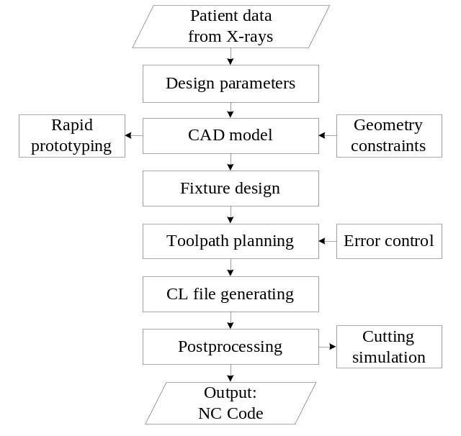

Figure 1. Flowchart of the solid modeling and manufacture for femoral component of knee prosthesis.

2. Geometry of femoral component
Artificial knee replacement is made up of three main parts. The femoral component (top portion) replaces the bottom surface of the femur and the groove where the patella fits. The tibial component (bottom portion) replaces the top surface of the tibia. The patella component (kneecap potion) replaces the surface of the patella where it glides in the groove on the femur, as shown in Figure 2. The components are often anatomically shaped or contoured designs versus basic geometric shapes. They are produced as a family in a range of sizes that can be selected at surgery to match the patient requirements.
A painful knee as a result of osteoarthritis (OA) can severely affect your mobility. Custom-made femoral component is necessary for those situations when an off-the-shelf standard size implant is not suitable. To develop the implant, the surgeon and the engineer determine the basic requirements and design criteria use either patient X-rays, the computer tomography (CT) scans or magnetic resonance image (MRI). To provide the best fill and fit femoral component to each individual patient, the shape is of major concern. The goal for the femoral component design was to define a product that met manufacturing requirements and surgical expectations. The first step is computer-aided design. The design features of a femoral component are specified as shown in Figure 3. The geometry of femoral component may also be modeled to serve as a reference.

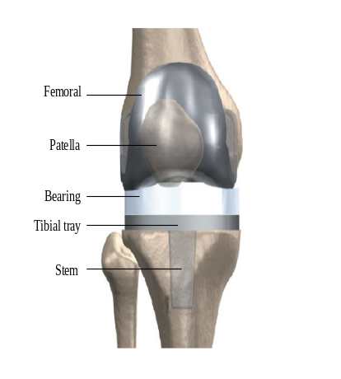

Figure 2. Schematic illustration of the anatomy of total knee prosthesis ^{[1]}.
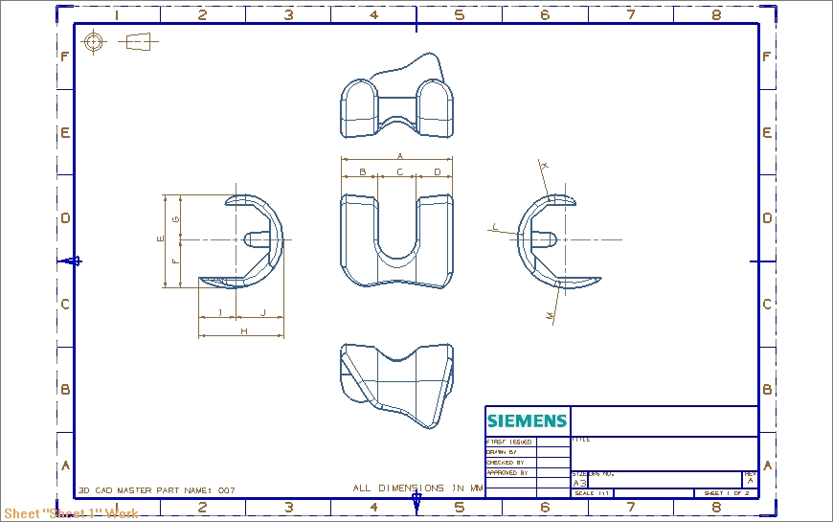

(a) Front view. (b) Left side sagittal view.

(c) Right side sagittal view.

Figure 3. The design parameters of femoral component model.

3. Rapid prototyping of femoral component
Rapid prototyping and manufacturing technology was developed in the late 1970s and early 1980s. The benefits of rapid prototyping (RP) are the enhanced visualization capability and the decrease of cycle time required to produce prototype parts. The physical model of a part is made directly from a three-dimensional CAD model by rapid prototyping. The materials used include liquid resin, fusing powdered thermoplastic materials, ceramics, ABS, investment wax, etc. The layer creation techniques comprise liquid-layer curing, extrusion of melted plastic, binder-droplet deposition onto powder layer, laser-driven, electron-beam, etc. The RP primitives provided actual full-scale models that can be handled, analyzed, and used for future development.
The RP process begins with a CAD model. A preferably solid modeling CAD system is a key component of success. Most popular solid model CAD systems require translated processors to create the stereolithography (STL) file for a RP system. The degree of resolution for the model surfaces must be specified by entering a quality value in the interface of CAD system. This step assures that the CAD data is input to the RP machine in the tessellated STL surfaces of the object are represented as numerous tiny triangles. After creating STL model files, the next step is to simulate the process of build prototype via Catalyst® software (pre-process). The simulation software automatically slices, calculates support structures, and creates toolpaths. Figure 4 shows the computational steps in producing a stereolithography file of the femoral component.
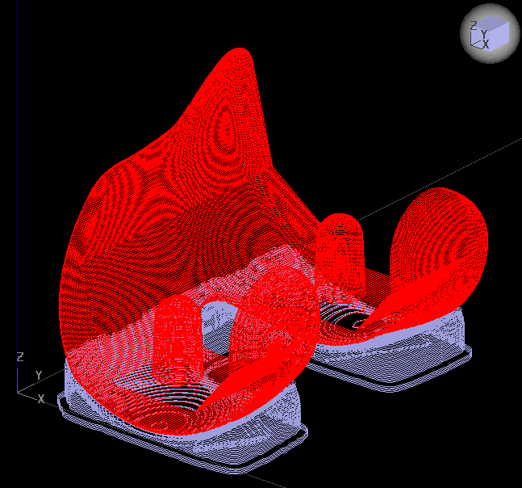
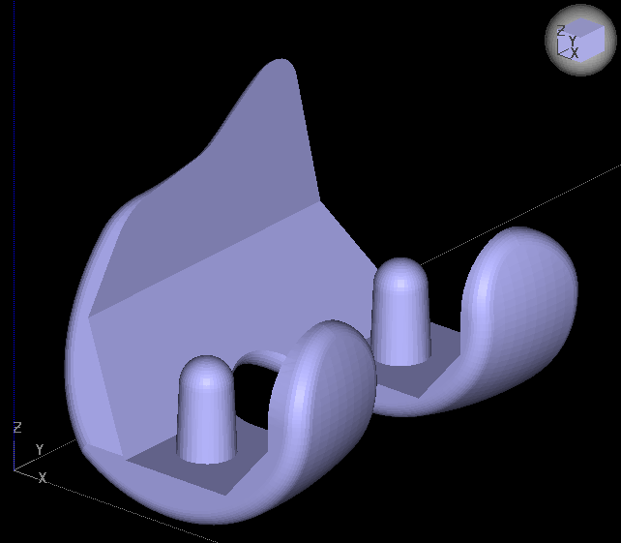

(a) Three dimensional (b) Support structure is
description of the femoral planed.
component.
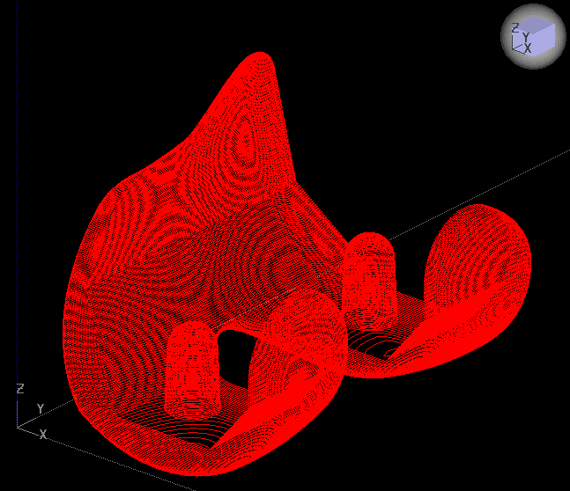
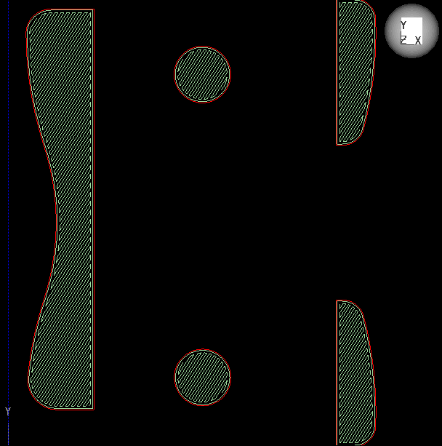

(c) The femoral component (d) A set of tool path is
is divided into slices. determined for
manufacturing each slice.
Figure 4. The computational steps in producing a stereolithography file.

3.1 Fused-deposition modeling
After the simulation of slicing and the extruder path, a stereolithography file is imported into rapid prototype machine. The process of additive manufacturing is used to build part in layers. The technique of fused-deposition modeling (FDM) is applied in this paper. In the FDM process, as shown in Figure 5, parts are built layer by layer. The extrusion heads move in two principal directions over a table. The table can be raised and lowered as needed. A thermoplastic filament is extruded through the small orifice of a heated die. The initial layer is placed on a foam foundation by extruding the filament at a constant rate while the extrusion heads follow a predetermined tool path. When the first layer is completed, the table is lowered so that subsequent layers can be superposed. Whilst the part is completely created, support structures are dissolved in a water-based solution or snapped off by hand. The RP prototype can be sent to the surgeon for review and approval prior to fabricating the femoral component.
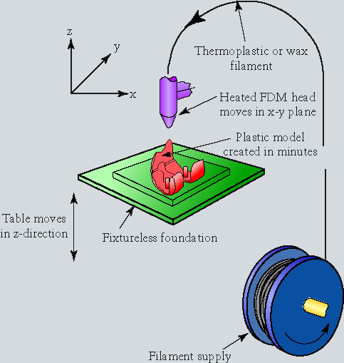

Figure 5. Schematic illustration of the fused-deposition modeling process ^{[3]}.

4. CAM for the femoral component
The femoral component has to be machined on multi-axis CNC machine tools because of their complex shapes. Machining sequences and cutter location (CL) files can be created in the manufacturing module of UniGraphics NX software, which is the same CAD/CAM environment that the solid model was created in. In order to clamp and manufacture the femoral component, the design model was modified to become the workpiece model for cutting simulation.
In the set up environment of manufacturing module for the femoral component, an alike femoral component workpiece (red portion) is built first and than assembled with the manufacturing model, as shown in Figure 6. The operation of multi-axis milling is used to machine the complex surface. In specifying tool orientation for multi-axis machining within CAD/CAM software, two constraints, i.e. collision and gouging, are the major consideration. The generated CL file can be verified through the function of solid cutting simulation built in this module. Figure 7 shows the cutting simulation of finish machining by multi-axis machining operation.
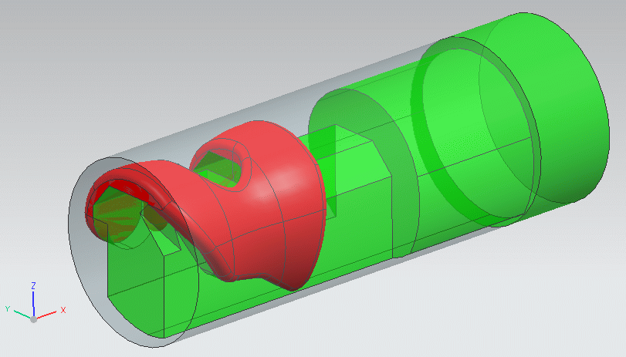

Figure 6. Manufacturing model is assembled with the workpiece model.
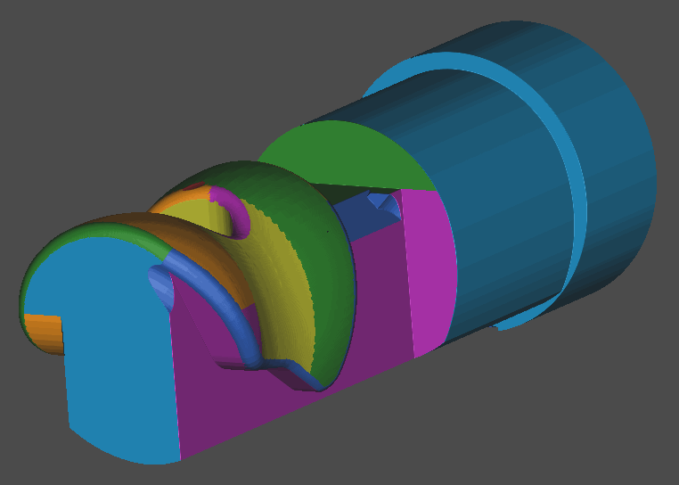
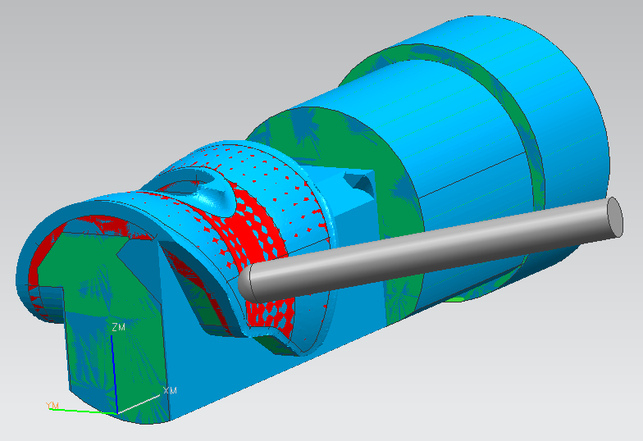

(a) (b)
Figure 7. Cutting simulation of finish machining for the femoral component.

4.1 Linear tolerance
Once five-axis machine tools where rotary and linear motion takes place simultaneously, the trajectory of the cutting tool point will deviate from a straight line between adjacent points derived from CL file. This will result in gouging of the part. The amount and direction of deviation depends upon the configuration of the machine tool and the part geometry. To avoid gouging, the function of linear tolerance set in CL file is to interpolate the additional machine coordinate (MCD) points between those derived from the CL file to ensure that this deviation does not exceed the tolerance (Figure 8). The format revealed in the CL file is LINTOL / {ON | OFF | tol}.
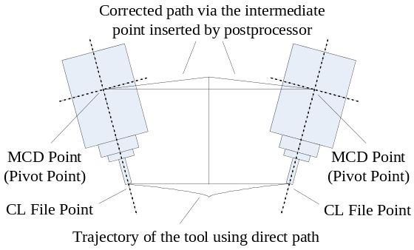

Figure 8. Schematic illustration of the linear tolerance.

5. Results and discussions
5.1 Geometric modeling and rapid prototyping
Using the commercial CAD/CAM system, the complicated surface geometry of the femoral component of knee prosthesis is developed. The solid model of custom-made femoral component built by Unigraphics NX software is shown in Figure 9. After the computational steps in producing a stereolithography file, the FDM process is adopted to obtain the rapid prototyped model (Figure 10).
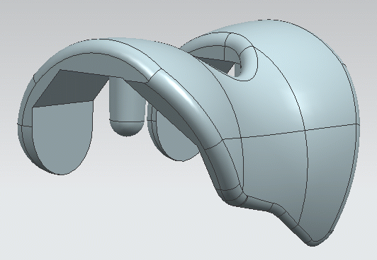

Figure 9. Solid model of a femoral component built by Unigraphics NX.

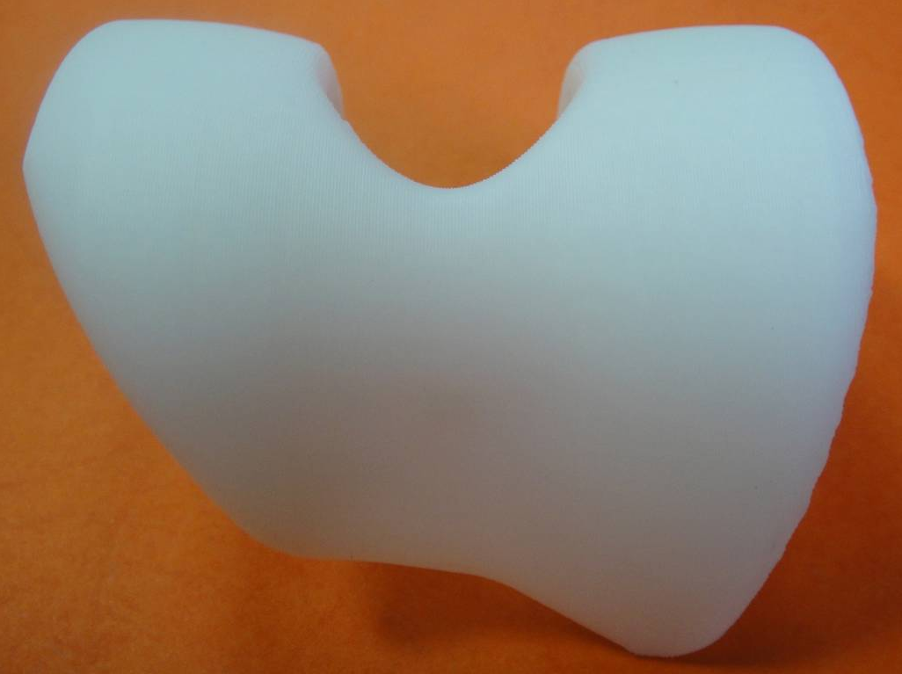
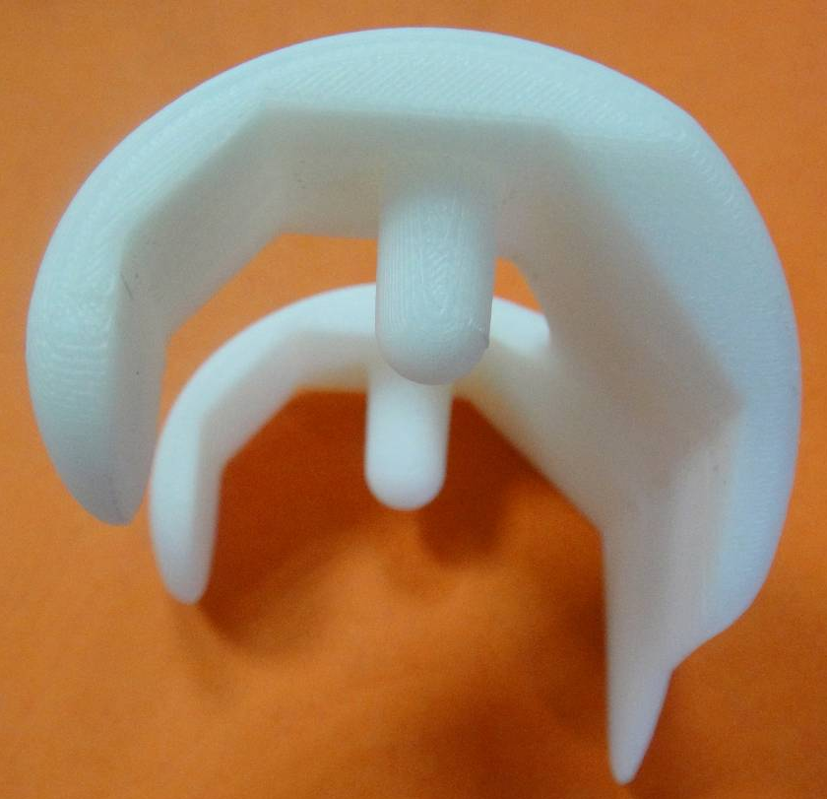

(a) Front view (b) Side view
Figure 10. Rapid prototyped model of a femoral component produced through FDM process.

5.2 Toolpath simulation and virtual-cut
To avoid the risk of human error, the generated toolpath is verified before actual machining through solid cutting simulation. Table 1 shows the used machining parameters corresponding to various machining process. Figure 11 reveals the toolpath generation and the cutting simulation of finish machining with ball-end mill simulated by UniGraphics NX.
The toolpath generated from UniGraphics NX is converted into NC program by the postprocessor of table-tilting type five-axis machine tool. The NC program is verified via VERICUT® software. The CNC machine tool and controller are modelled to perform realistic 3D simulation. Figure 12(a) presents the cutting simulation of rough machining. Figure 12(b) shows the result of finish machining. The simulation results demonstrate that the collision between the shank and workpiece surface does not occur.

Table 1. Machining parameters for femoral component.

Machining Process | Cutting Tool | Chordal Deviation | Scallop height | Cutting Method | Out-  Toleance
Rough Machining | 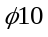 | 0.1 mm | 0.1 mm | Zig-zag | 0.5 mm
Finish Machining | 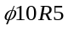 | 0.01 mm | 0.01 mm | Zig-zag | 0.0 mm

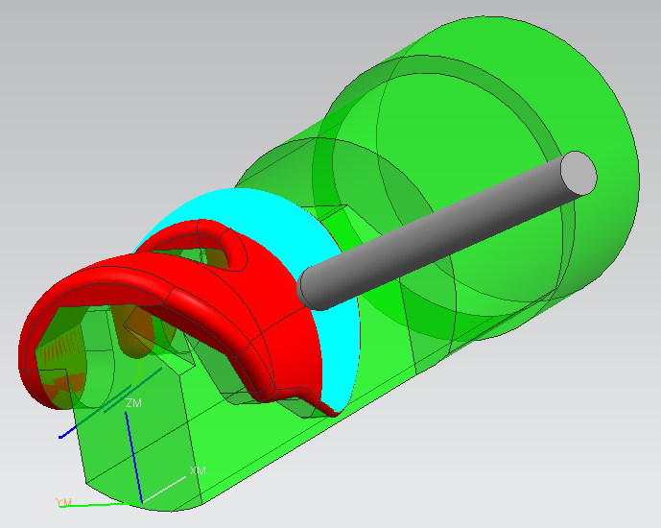
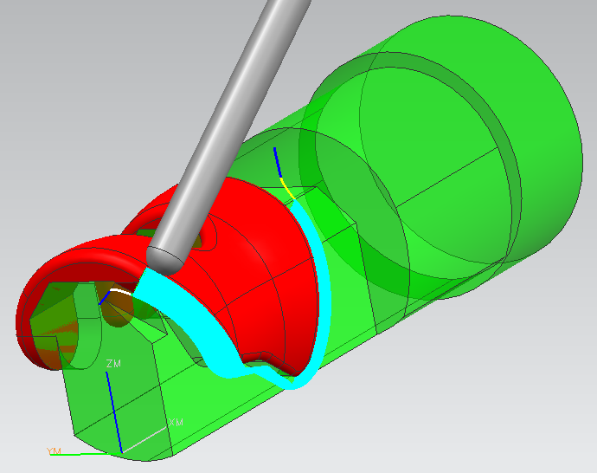

(a) Finish machining of tibiofemoral surface.
(b) Finish machining of fillet surface.

Figure 11. Multi-axis toolpath generation for the femoral component. (UniGraphics NX)

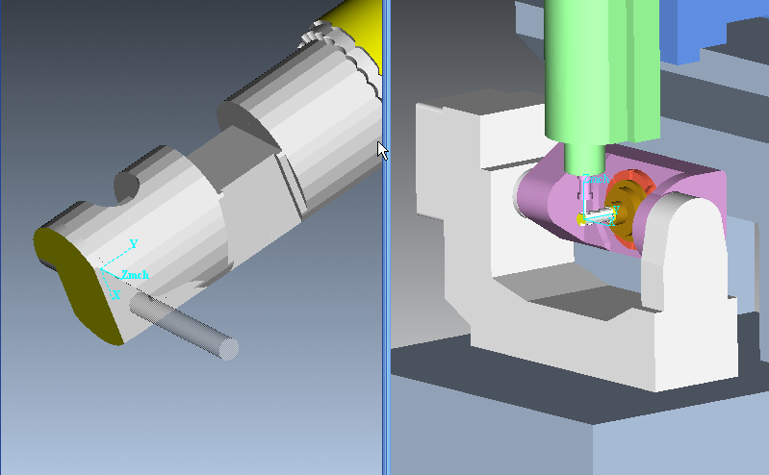

(a) Rough machining. (Flat-end mill)
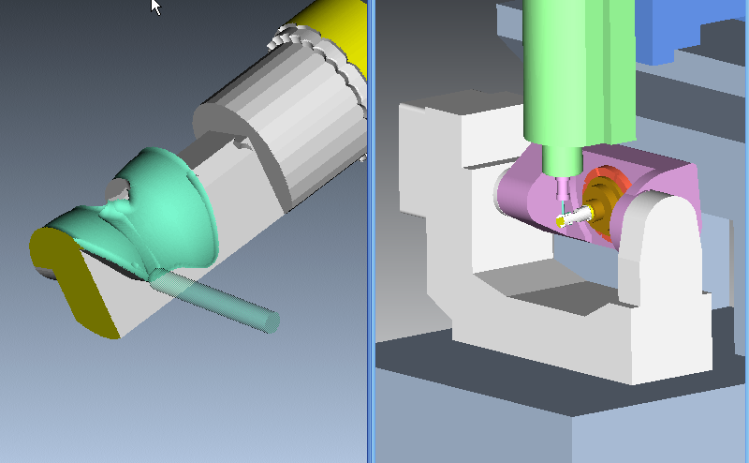

(b) Finish machining. (ball-end mill)

Figure 12. Simulation of femoral component cutting by the end mill. (VERICUT®)

6. Conclusion
This paper presents the integrated approach of computer-aided design and computer-aided manufacturing for the design and manufacture for femoral component of knee prosthesis. The system implemented is from surgeon requirements to the completion of manufacturing. The solid modeling, rapid prototype and virtual machining are used in the system to establish the interface among conception, design and manufacture. The CAD/CAM techniques are applied to fulfill the design of complicated surface and multi-axis NC machining. The NC programs are verified through solid cutting simulation and virtual-cut. The results are useful for the development of the femoral component.

Acknowledgement
The authors would like to thank the financial support of the Ministry of Education and the Ministry of Economic Affairs, Taiwan, R. O. China

______________________________________________Corresponding Author
Jeng-Nan Lee, PhD
E-mail: jengnan@csu.edu.tw

References
- http://www.eorthopod.com
- Huang BW. Medical Devices Industry Yearbook, Industrial Economics & Knowledge Center, Taiwan, 2007.
- Kalpakjian S and Schmid SR. Manufacturing Processes for Engineering Materials, Pearson Education, New Jersey, 2003.
- Jacobs Paul F. Rapid Prototyping & Manufacturing Fundamentals of StereoLithography, Socity of Manufacturing Engineers, 1992.
- Sathasivam S and Walker PS. The conflicting requirements of laxity and conformity in total knee replacement. Journal of Biomechanics, 1999, 32: 239-247
- Liau JJ, Cheng CK, Huang CH and Lo WH. The effect of malalignment on stresses in polyethylene component of total knee prostheses – a finite element analysis. Clinical Biomechanics, 2002, 17:140-146
- Rao A and Sarma R. On local gouging in five-axis sculptured surface machining using flat-end tools. Computer-Aided Design, 2000, 32: 409-420
- Lee RS. And Lee JN. Interference-free tool orientation determination by virtual enveloping element for 5-axis machining of free-form surface. Journal of Engineering Manufacture, Proceedings of the Institution Mechanical Engineers, 2001, 215(B): 1683-1693

