An Integrated Investigation of CAD/CAM for the Development of Custom-made Femoral Stem

Jeng-Nan Lee¹ and Kuan-Yu Chang^{2*}
1. Department of Mechanical Engineering, Cheng Shiu University, Kaohsiung County, Taiwan 833, RO China.
2. Mackay Memorial Hospital Taitung Branch, Taitung, Taiwan 833, RO China.
mmhadm@ttms.mmh.org.tw
__________________________________________________________________________________________________________________________________________________
Abstract: In this paper, an integrated approach of CAD/CAM was presented for the concurrent development of custom-made femoral stem. The femoral stem is developed on a prescription basis and is unique for each patient. The geometric parameters and the necessary constrains based on surgical experience were integrate into the CAD system. The rapid prototyped model was built as the reference for review. Through the application of CAM software, the interference-free toolpath and the cutter location for multi-axis NC machining are generated. The cutting simulations with solid model are performed to verify the generated toolpath. It is also verified through the trial-cut with model material on a five-axis machine tool. [Life Science Journal. 2010; 7(1): 73 – 78] (ISSN: 1097 – 8135).

Keywords custom-made, femoral stem, CAD/CAM, rapid prototyping
_______________________________________________________________________________________________

1. Introduction
Over the last 25 years, major advancements in hip replacement have improved the outcome of the surgery greatly. Hip replacement surgery is becoming more common as the population of the world. The main reason for replacing any arthritic joint with an artificial joint is to stop the bones from rubbing against each other. Degenerative and arthritic problems result in very painful or nonfunctional joint movement. Replacing the painful and arthritic joint with an artificial joint gives the joint a new surface, which moves smoothly without causing pain ^{[1]}.
Each year, over two million osteoarthritis joints are replaced with artificial joints worldwide. A primary concern of these devices for the hip and knee is to eliminate pain and improved mobility. However, products for other areas such as the shoulder, ankle, elbow, wrist, etc. are also available as well as trauma and sports medicine devices ^{[2]}.
A total hip prosthesis replaces both the ball and the socket of the natural joint, in most cases, with a femoral component inserted in the upper end of the femur and an acetabulum component placed in the pelvis. Most modern implants are fabricated from (a) Ti-6Al-4V alloy, (b) ASTM F-75 cobalt-chrome alloy, or (c) 315 stainless steel alloy that are attached to prepared bony structures and surfaces. Ultra high molecular weight polyethylene bearings are used between the mating joint surfaces. The components are often anatomically shaped or contoured designs versus basic geometric shapes. They are produced as a family in a range of sizes that can be selected at surgery to match the patient requirements.
Total hips may be classified in two basic types: cemented and press fit. Cemented implants use a polymethyl methacrylate-based grout for fixation, whereas press-fit implants have a rough, porous surface intended for bone to grow into. They are fixed directly to bone. This rough surface can be manufactured by plasma spray operations, by sintering metal beads to the implant surface. These kinds of implants are often used in patients that are younger and more active, since their bone is better able to grow than those of older, more sedentary patients ^{[3, 4]}.
The orthopedic industry consults with surgeons in the development of new implant systems and related instrumentation. Their expertise and medical training coupled with bioengineering and manufacturing capability provides the collaboration to advance the state of the art of these implants. It is a very complex design environment. The soft tissue integrity and bone remodeling all relate to the success of the implant. Thus, solid modeling and rapid prototyping can bridge the gap between the designers and the manufacturing engineers which is essential for concurrent engineering ^{[4]}.
In the study of tool orientation for multi-axis machining, Choi et al. ^{[5]} proposed a method to generate optimal cutter location data for free-form surface. The optimization problem is formulated as a 2D constrained minimization problem. There are three constraints, viz., joint limits, gouging, and collisions on cutter location. Rao and Sarma ^{[6]} described an exact method for the detection and elimination of local gouging in five-axis machining using a flat-end tool. Lee ^{[7]} presented a method to find the admissible tool orientation by considering gouging. The drawback of these methods mentioned above is that they cannot guarantee a collision-free and gouge-free 5-axis toolpath.
This paper describes a design system combining clinical experience and engineering knowledge for the manufacture of custom-made femoral stem. The femoral stem is developed on a prescription basis and is unique for each patient. Rapid prototyped models are fabricated from three-dimensional CAD models for concurrent development. The generated toolpath from CAM is converted to the NC code. The trial cut is also performed with model material and demonstrates the practical application. Figure 1 shows the flowchart of the integrated research for design and manufacture of femoral stem.

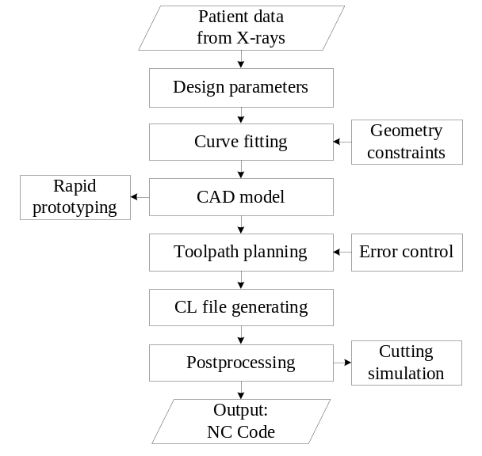

Figure 1. Flowchart of the integrated research for design and manufacture of femoral stem.

2. Geometry of femoral stem
The hip joint is one of the true ball-and–socket joints of the body. The hip socket is called the acetabulum and forms a cup that surrounds the ball of the upper thigh bone, known as the femoral head. The thick muscles of the buttock at the back and the thick muscles of the thigh in the front surround the hip. A hip that is painful as a result of osteoarthritis (OA) can severely affect your mobility. Custom-made femoral stem is necessary for those situations when an off-the-shelf standard size stem is not suitable. To develop the stem, the surgeon and the engineer determine the basic requirements and design criteria use either patient X-rays, the computer tomography (CT) scans or magnetic resonance image (MRI) as shown in Figure 2. To provide the best fill and fit femoral stem to each individual patient, the shape is of major concern.
The relationship of femoral size between proximal and distal diameters in most people is not proportional but wide distributed. According to the canal flare index, the femur shape can be divided into three types, stovepipe, normal, and champagne flute. The goal for the hip stems design was to define a product that met manufacturing requirements and surgical expectations.
The design features of a femoral stem are specified as shown in Figure 3,  is the head offset;  is the neck-shaft angle;  is the proximal diameter;  and  are the diameters of intramedullary; 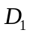 and 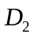 are the curve fitting points of intramedullary; E is the distal diameter; Stem length is the amount of X and J. Figure 4 is the design parameters of femoral stem model related to the features of intramedullary. By inputting a group of geometric data measured from X-ray, a CAD model of femoral stem which satisfies the design rules can be created.

3. Rapid prototyping of femoral stem
The conception invented by the engineer or surgeon may start off as hand drawn sketches. The engineers understand how to interpret the engineering drawing with its geometric dimensions and tolerances. They can envision the actual shape by observing the orthogonal views. The surgeons try to communicate a complex three-dimensional concept in this two-dimensional views is very difficulty. Features that seem insignificant on a sketch can become very expensive manufacturing challenges. The goal of rapid prototyping is to bridge this gap by providing actual full-scale models. The physical model of a part is made directly from a three-dimensional CAD model by rapid prototyping. The rapid prototyped model can be the important bases of revision, process planning and cost analysis. Figure 5 shows the computational steps in producing a stereolithography file of the femoral stem.
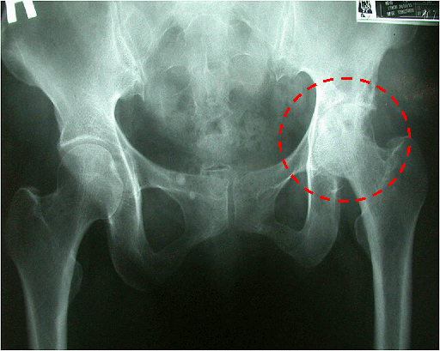

Figure 2. Degenerative osteoarthritis ^{[8]}
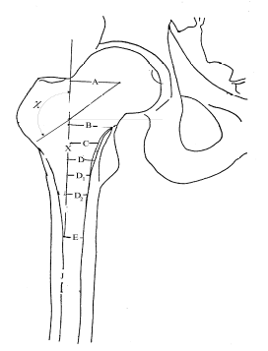

Figure 3. The features of femoral stem on X-ray.

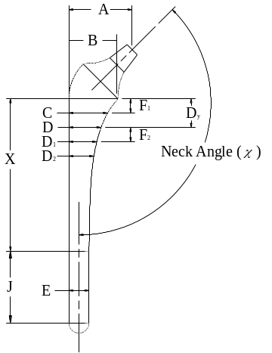

Figure 4. The design parameters of femoral stem model.

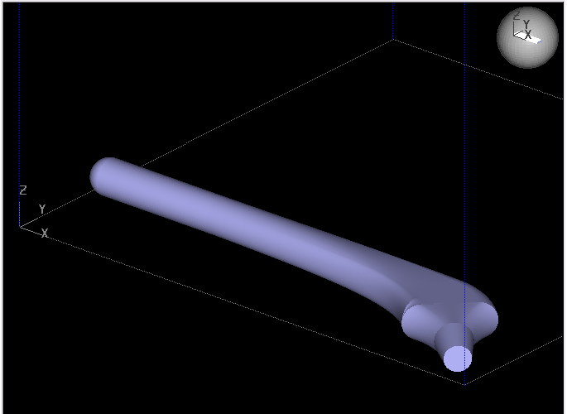

(a) Three dimensional description of the femoral stem.
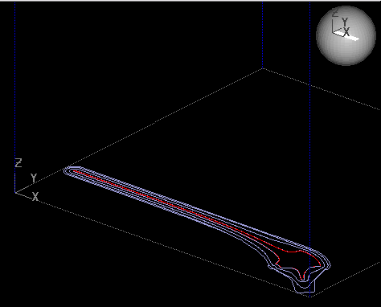

(b) Support structure is planed.
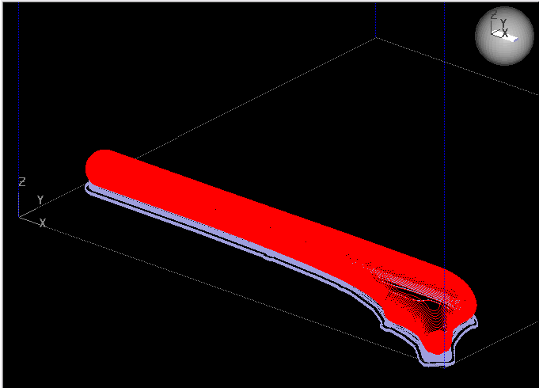

(c) The stem is divided into slices.
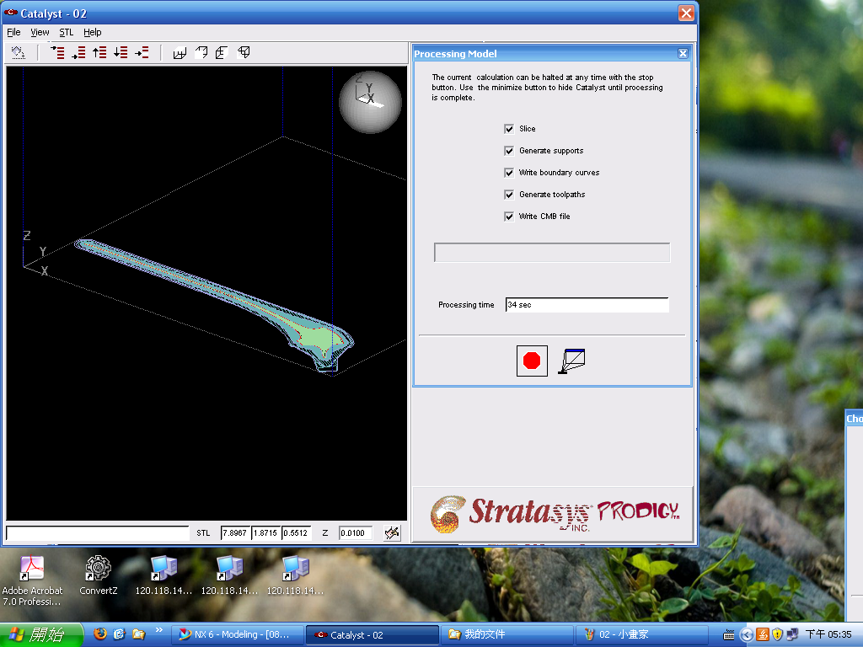

(d) A set of tool path is determined for manufacturing each slice.
Figure 5. The computational steps in producing a stereolithography file.

3.1 Fused-deposition modeling
After the simulation of slicing and the extruder path, a stereolithography file is imported into rapid prototype machine. The process of additive manufacturing is used to build part in layers. The technique of fused-deposition modeling (FDM) is applied in this paper. In the FDM process, as shown in Figure 6, parts are built layer by layer. The extrusion heads move in two principal directions over a table. The table can be raised and lowered as needed. A thermoplastic filament is extruded through the small orifice of a heated die. The initial layer is placed on a foam foundation by extruding the filament at a constant rate while the extrusion heads follow a predetermined tool path. When the first layer is completed, the table is lowered so that subsequent layers can be superposed. Whilst the part is completely created, support structures are dissolved in a water-based solution or snapped off by hand.
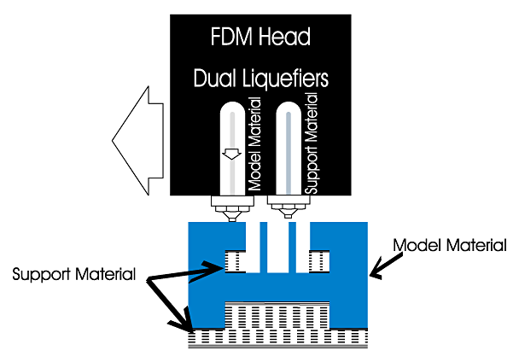

Figure 6. Schematic illustration of the fused-deposition modeling process ^{[9]}.

4. CAM for the femoral stem
The femoral stems have to be machined on multi-axis CNC machine tools because of their complex shapes. The interference-free toolpath is the major consideration for multi-axis machining of the stem. Machining sequences and cutter location (CL) files can be created in the manufacturing module of UniGraphics NX software, which is the same CAD/CAM environment that the solid model was created in. In order to clamp and manufacture the stem, the design model was modified to become the manufacturing model and a workpiece model can be created for cutting simulation.
In the set up environment of manufacturing module for the stem, a cylindrical workpiece is built first and than assembled with the manufacturing model, as shown in Figure 7. The operation of multi-axis milling is used to machine the complex surface. The machining features are selected based on the Surface Area drive method. The position and the orientation of the milling tool, also known as the cutter location, can be specified by the functions of Tool Axis and Projection Vector. The cutting and non-cutting parameters are chosen for the actual cutting conditions. The toolpath sequences created can be displayed on the system separately or serially. The generated CL file can be verified through the function of solid cutting simulation built in this module. Figure 8 shows the cutting simulation of finish machining by multi-axis machining operation.

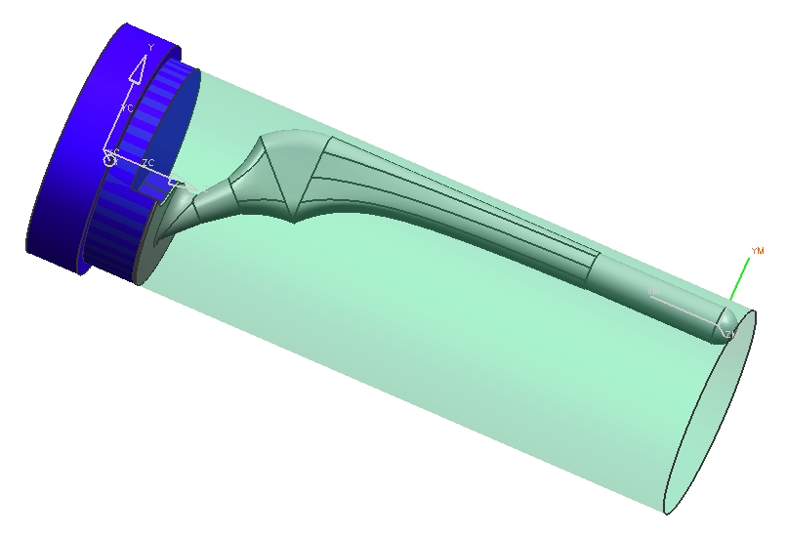

Figure 7. Manufacturing model is assembled with the workpiece model.
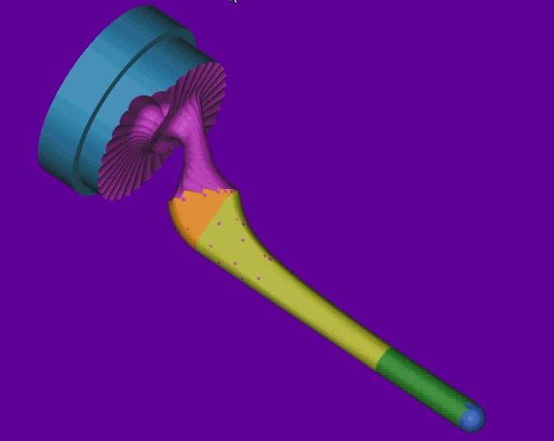

Figure 8. Cutting simulation of finish machining for the femoral stem.

5. Results and discussions
5.1 Geometric modeling and rapid prototyping
The design parameters of a femoral stem as shown in Table 1, is used to verify the validity and effectiveness of the proposed approaches. Using these parameters in CAD system, the surface geometry of the femoral stem is created. Two solid models of custom-made femoral stem built by Unigraphics NX software are shown in Figures 9,10,11,and 12. After the computational steps in producing two stereolithography files respectively, the FDM process is adopted to obtain the rapid prototyped models (Figures 13 and 14). The rapid prototyped models can be sent to the surgeon for review and approval prior to fabricating the actual stem.

Table 1. Design parameters of the femoral stem.
A,mm |  | B, mm | C, mm | D, mm
35 | 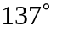 | 29.5 | 26 | 24
D₁, mm | D₂, mm | X, mm | J, mm | E, mm
22 | 20.3 | 85 | 50 | 15
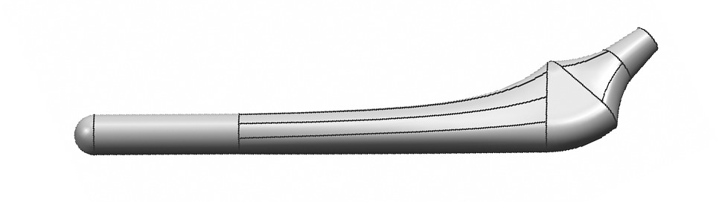

Figure 9. Solid model of a femoral stem built by Unigraphics NX. (Type I)

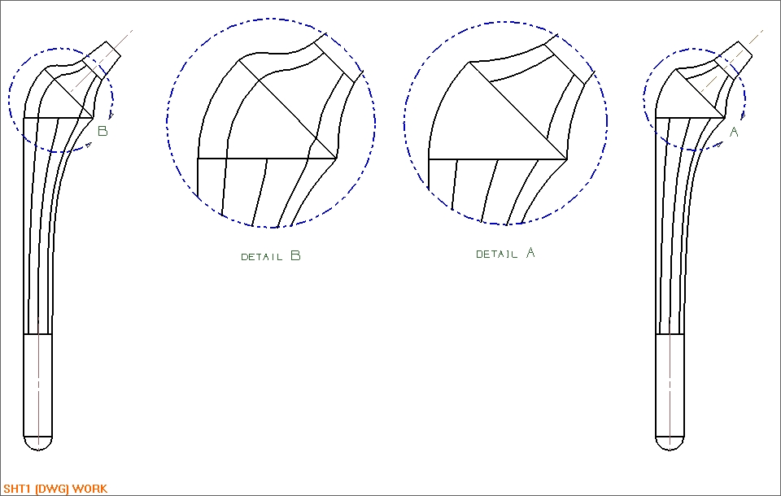

Figure 10. Detail view of a femoral stem. (Type I)

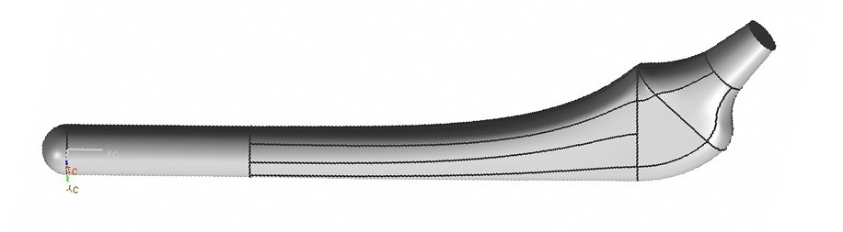

Figure 11. Solid model of a femoral stem built by Unigraphics NX. (Type II)

Figure 12. Detail view of a femoral stem. (Type II)
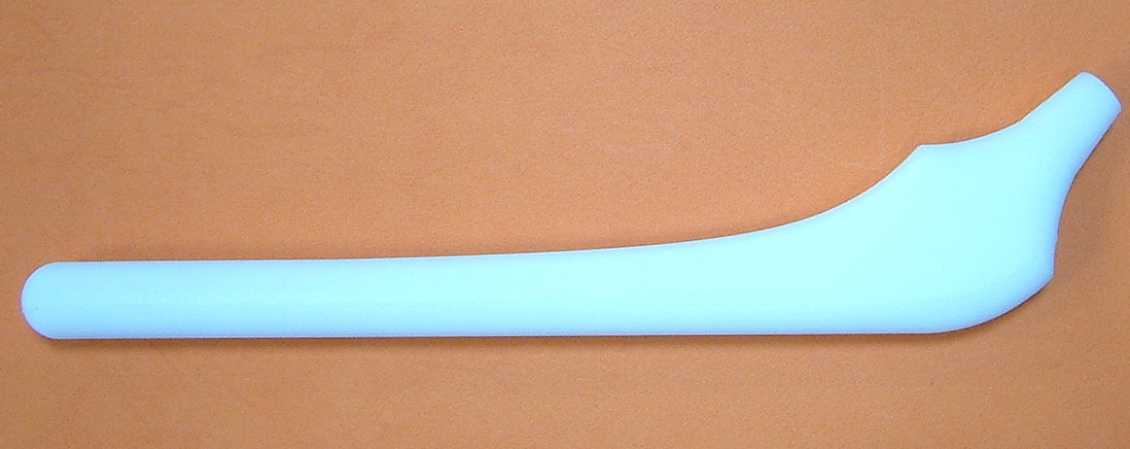

Figure 13. Rapid prototyped model of a femoral stem produced through FDM process. (Type I)



Figure 14. Rapid prototyped model of a femoral stem produced through FDM process. (Type II)

5.2 Toolpath simulation and trial-cut
To avoid collision between all machine tool components and the risk of human error, the generated toolpath is verified before actual machining through solid cutting simulation. Table 2 shows the used machining parameters corresponding to various machining process. Figure 15(a) reveals the toolpath generation of rough machining with ball end mill simulated by UniGraphics NX. Figure 15(b) shows the result of solid cutting simulation for rough machining using CL file. The toolpath generated from UniGraphics NX is converted into NC program by the postprocessor. The NC program is verified via VERICUT® software. Figure 16(a) presents the cutting simulation of rough machining. Figure 16(b) shows the result of finish machining. The simulation results demonstrate that the machining process works well and the collision between the shank and workpiece surface does not occur. After the simulation and the verification, the NC program is transferred to controller through Internet. The five-axis machine tool is used to perform the actual machining. Figure 17 shows the multi-axis machining of model material.

Table 2. Machining parameters for femoral stem.
Machining Process | Cutting Tool | Chordal Deviation | Scallop height | Cutting Method | Out-  Toleance
Rough Machining | 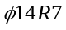 | 0.1 mm | 0.1 mm | Zig-zag | 0.5 mm
Finish Machining |  | 0.01 mm | 0.01 mm | Zig-zag | 0.0 mm
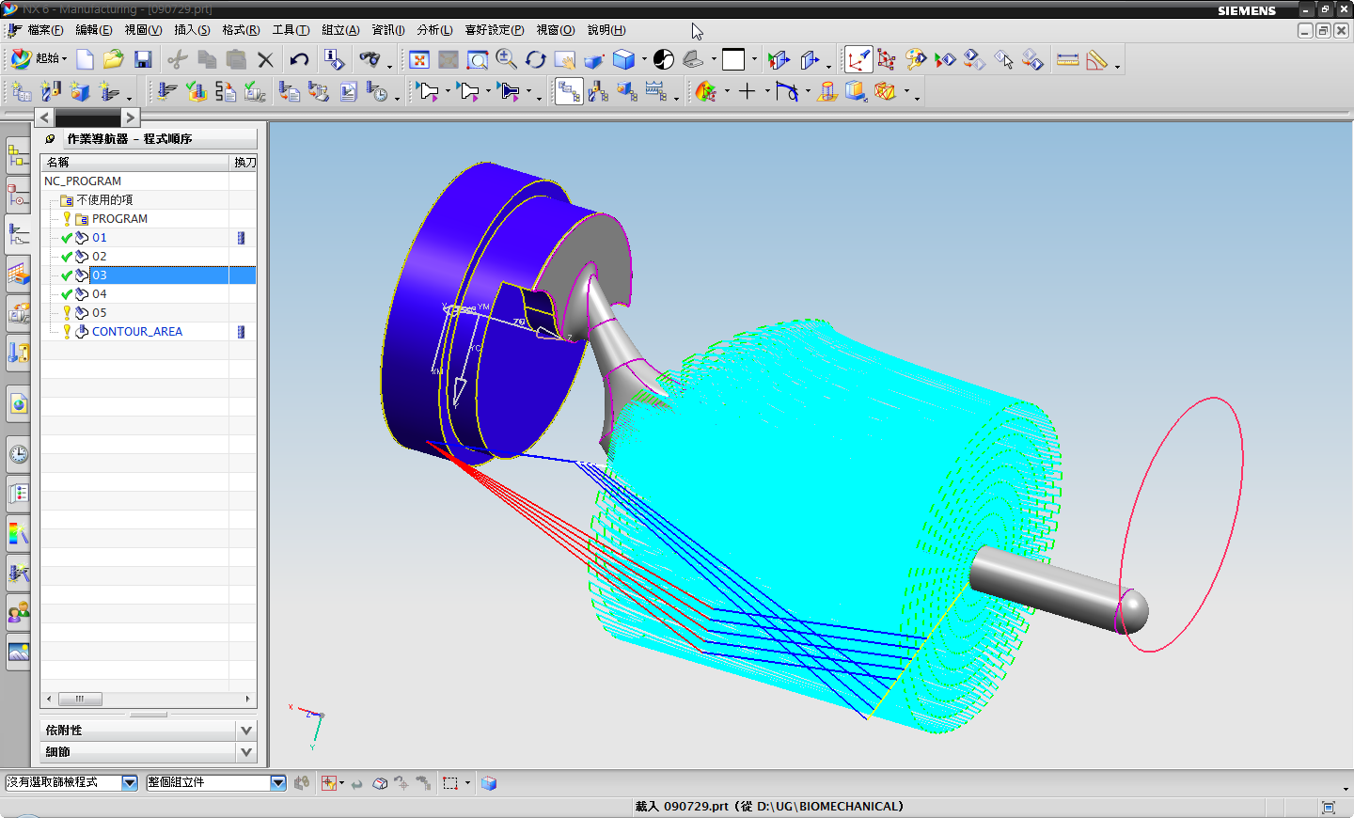
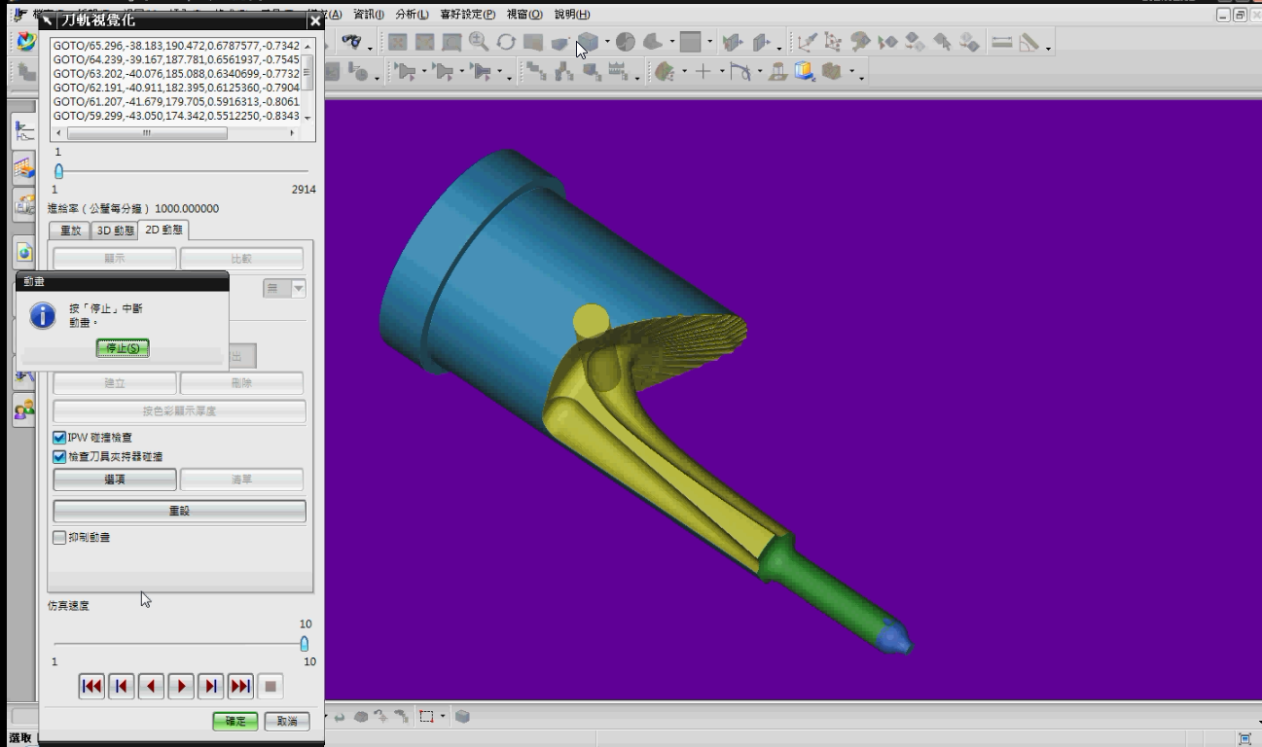

(a) Toolpath generation; (b) Cutting simulation.

Figure 15. Multi-axis toolpath for rough machining of the femoral stem. (UniGraphics NX)

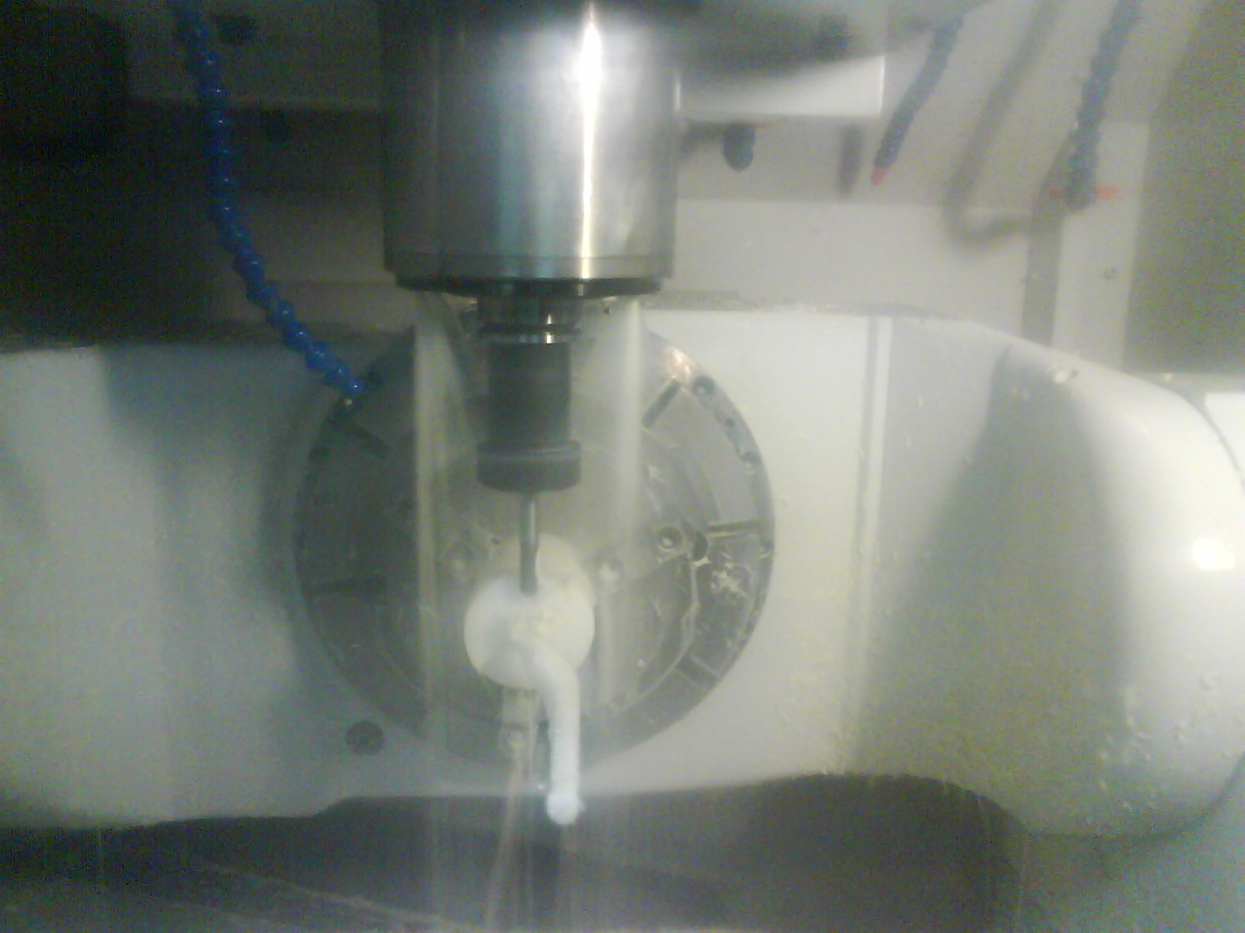

(a) Rough machining.

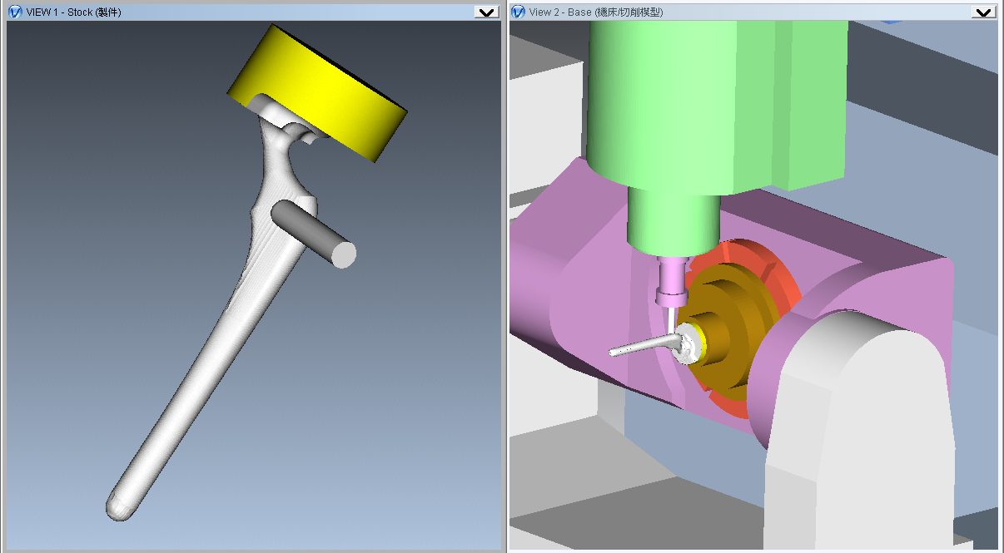

(b) Finish machining.
Figure 16. Simulation of femoral stem cutting by the ball end mill. (VERICUT®)

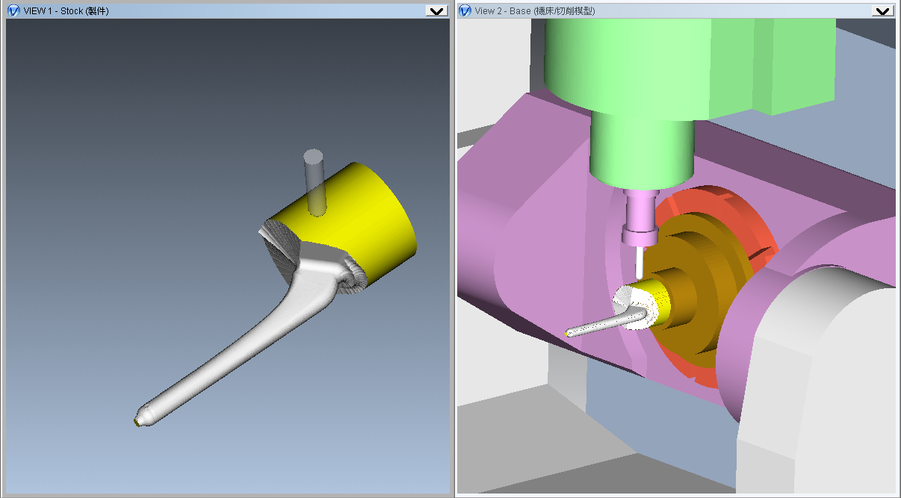

Figure. 17. The multi-axis machining of model material on five-axis machine tool.

6. Conclusion
A design system combining clinical experience and engineering knowledge was developed for the manufacture of custom-made femoral stem. The system implemented is from surgeon requirements to the completion of manufacturing. The solid modeling and rapid prototype are used in the system to establish the interface among conception, design and manufacture. The CAD/CAM techniques are applied to develop the complicated surface and multi-axis machining by inputting a group of geometric data provided from surgeon. The designed hip stems will meet the manufacturing requirements and surgical expectations.

Acknowledgement
The authors would like to thank the financial support of the Ministry of Education and the Ministry of Economic Affairs, Taiwan, R.O.C.

______________________________________________ Corresponding Author
Kuan-Yu Chang, MD
E-mail : mmhadm@ttms.mmh.org.tw

References
- http://www.eorthopod.com
- Huang BW. Medical Devices Industry Yearbook, Industrial Economics & Knowledge Center, Taiwan, 2007.
- Kalpakjian S and Schmid SR. Manufacturing Processes for Engineering Materials, Pearson Education, New Jersey, 2003.
- Jacobs Paul F. Rapid Prototyping & Manufacturing Fundamentals of StereoLithography, Socity of Manufacturing Engineers, 1992.
- Choi BK, Park JW and Jun CS. Cutter-location data optimization in 5-axis surface machining. Computer-Aided Design, 1993, 25(6): 377-386
- Rao A and Sarma R. On local gouging in five-axis sculptured surface machining using flat-end tools. Computer-Aided Design, 2000, 32: 409-420
- Lee YS. Admissible tool orientation control of gouging avoidance for 5-axis complex surface machining. Computer-Aided Design, 1997, 29(7): 507-521
- http://www.postal.com.tw
- http://www.stratasys.com

