Mechanical Stimulation Effect on Proliferation of Murine Osteoblast Cell

Bo Wun Huang¹, Feng-Sheng Wang², Jih-Yang Ko², Wun-Han Jhong¹, Ke-Tien Yen¹, Jung-Ge Tseng^{*1}
¹Graduate Institute of Mechatronics Engineering, Cheng Shiu University, Kaohsiung, Taiwan 833, RO China
²Chang Gung Medical Foundation, Kaohsiung Branch, Kaohsiung, Taiwan 833, RO China
james.tseng@csu.edu.tw
Received March 1, 2010
__________________________________________________________________________________________________________________________________________________
Abstract: Age-related diseases, such as osteoporosis, arthritis, accidental fracture, etc., are increased dramatically due to rapid progressing modern medical science and technology push the early arrival of aging society of mankind. How to increase osteoid of the healthy cell, restrain the malignant cell, and fast recovery from bone fracture are becoming major research subjects in the medical community. The growth of bones is proved in medical research to have some relationship with external strength, such as direct current, electromagnetic field, coupled electrical field, ultrasound, etc., and all such researches have their effectiveness in different level. However, few people study the mechanical excitation (vibrating shaker) onto the cell directly in subsonic frequency range. This research studies the culture of mice MC3T3 osteoblast cell in vitro, stimulate the growing cell with mechanical broad range subsonic frequency with or without temperature factor and investigate the effect of different amplitude, repeated number of times, and excitation durations of the stimulation. The cell concentration are then measured by MTT assay by fluorescence spectrometer and RNA assay by electrophoresis diagram and compared with the control (nature growing cell) set. Comparison of different parameters are obtained together with mechanical setup are ready to provide the information about the proliferation of osteoblast for medical community reference. [Life Science Journal. 2010; 7(1): 62 – 67] (ISSN: 1097 – 8135).
Keywords: Osteoblast cell; Mechanical Stimulation; Broadband Frequency; MTT assay; RNA assay.
________________________________________________________________________________________________

1. Introduction
The rapidly progressing modern medical science and technology push the early arrival of aging society of mankind. However, Age-related diseases are increased dramatic accordingly. Osteoporosis, so called “Silent Disease” in medical community, is one of the major problems for elderly people. The occurrence probability of osteoporosis induced fracture is more than three times of heart attack, stroke, and breast cancer within women. There are over 1.6 million hipbone fracture patients per year all over the world due to osteoporosis.
Lots of studies aim on how to improve or restrain the proliferation of osteoblast cell (human and/or animal model, in vitro or in vivo) by employing the external energy and/or combined with different physical/chemical treatment, co-culture with different materials, etc.
Chang [1] investigates the effect of physical stimulation on osteoporosis in osteoporotic animal models including the effect of: 1) whole body vibration (WBV) on osteoporotic SD rats model, and 2) pulsed electro- magnetic field (PEMF) and high magnetic single pulsed electromagnetic field (HMSP-EMF) on osteoporotic BALB/C mice model.
Tsai [2] studies the effects of low frequency pulsed electromagnetic fields on treatment or prevention of osteoporosis by inducing osteoclast (cocultured with osteoblast cell) apoptosis.
Rutten et al. [3, 4] employ low-intensity pulsed ultrasound (LIPUS), histology and histomorphometric analysis to determine bone formation and bone resorption parameters for bone healing at the tissue level in patients with a delayed union of the osteotomized fibula and find out that in both areas of new bone formation and cancellous bone, LIPUS significantly increased osteoid thickness, mineral apposition rate, and bone volume.
Tsui [5] discovered that the correlation coefficient, amplitude, and conduction velocity of the compound action potential (CAP) of the nerve tissue of a bullfrog are affected by ultrasonic stimulation which were postulated due to the mechanism of opening and closing ion channel gate causing modification of ion permeability of cell membrane in experiments.
Reher et al. [6] discover that Long wave ultrasound (LWU, 45 kHz) is capable of inducing a comparable or even higher enhancement of bone formation compared with traditional ultrasound (1 MHz), which, with LWU’s greater penetration, may accelerate the healing effect of ultrasound on osteoradionecrosis. Li et al. [7] compare the mechanisms of ultrasound on osteoblast proliferation with those of pulsed electromagnetic field (PEMF), by different signal transduction pathway inhibitors. Myrdycz et al. [8] evaluate the adhesion between cells and various substrates by ultrasounds [9]. Tanimoto et al [10] indicate that osteoblast-like cell proliferation increased with increasing sintering temperature and the biological stability of the sintered tricalcium phosphate (TCP) sheet surface was considered to have affected cell proliferation. Some researchers study how to culture the osteoblast cell on metallic support, phosphate ceramics, other surface or material, etc. [11~17].
Dumas et al. [18] identify that low-amplitude, high-frequency strain regimen is able to increase major matrix proteins of bone tissue and to regulate the expression of vascular endothelial growth factor (VEGF) variants, which shows that an appropriate combined loading has the potential to function cellularized bone-like constructs.
Bochu et al. [19] find that the mechanical vibration can distinctly enhance the growth of Gerbera jamesonii acrocarpous callus at 3 Hz in frequency, and its quality is higher than the controls. Meanwhile, after stimulation by mechanical vibration, the fibers direction in the cell wall was unclear, the degree of accumulation of fibers in the cell wall was high and the cytoskeleton rearranged.
Tanaka et al. [20] indicate that MC3T3-E1 osteoblasts cells are more sensitive to low amplitude, broad frequency (0 to 50Hz) strain, and this kind of strain could sensitize osteoblasts to high amplitude, low frequency strain, which also implies a potential contribution of stochastic resonance to the mechanical sensitivity of osteoblasts. Mechanical static stretching or strain are also employed for osteoblast cell proliferation [21~25].
Frias et al. [26] conduct the experiments to grow osteoblasts on the surface of a piezoelectric material, both in static and dynamic conditions at low frequencies (1 and 3Hz, respectively), and total protein, cell viability and nitric oxide measurements shows that both static and dynamic affect cell viability and proliferation negatively.
Henriksen et al. [27] investigate mechanical stimulation of human osteoblast like cell through intercellular calcium wave propagation.
When the vibrating wave propagate though a biological tissue, bioeffects including those induced by heat and vibration could result constructive and destructive effect for physiotherapy according to previous study. Also, the study of microscopic cell can assist to more understanding the macroscopic dynamic characteristic of bone structure [28].
This purpose of research is find the influence of mechanical stimulation over broad range of frequency onto mice MC3T3 osteoblast cell in vitro with different amplitude, time, excitation durations, and with or without temperature factor.

2. Cell Cultivation
The growth of bones is proved in medial research to have some relationship with external strength, such as direct current, electromagnetic field, coupled electrical field, ultrasound, etc., and all such researches have their effectiveness in different degree.
This research studies the culture of mice MC3T3 osteoblast cell in vitro, stimulate the growing cell with mechanical broadband frequency with or without temperature factor and investigate the effect of different amplitude, time, and excitation durations of the stimulation. The cells are then counted by MTT test and RNA extraction method and compared with the control (nature growing cell) set.
The flow chart of culture and stimulation of murine osteoblast cell is shown in Fig. 1.
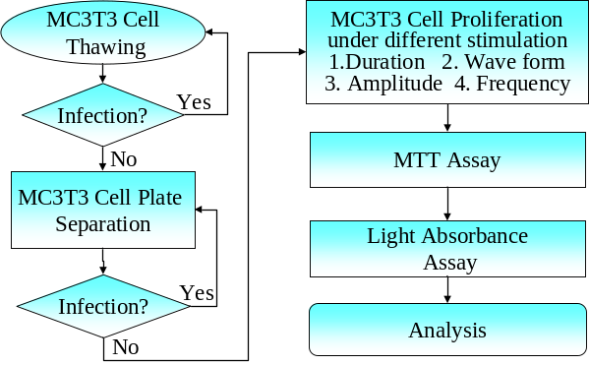
Fig. 1. The flow chart of culture and stimulation of murine osteoblast cell

3. MTT Assay
The MTT assay is a laboratory test and standard colorimetric assay (an assay which measures changes in color) to estimate the survival rate of the cell by measuring the reduction of yellow 3-(4,5-dimethythia- zol-2-yl)-2,5-diphenyl tetrazolium bromide (MTT) by mitochondrial succinate dehydrogenase. The procedures are as follows:
1. Preparation
(1) PBS
(2) MTT (5 mg/ml in PBS) – filter and prepare freshly
(3) Acidic isopropanol (0.1N HCl in absolute isopro- panol)
(4) 96-well plate (flat bottom)
2. Procedure
(1) Plate cells (104-106 cells) in 200 ml PBS in 96-well (flat bottom).
(2) Add 20 ml of MTT solution, mix well.
(3) Incubate for 4 hour in 37ºC
(4) Remove aliquot for analysis; add 200 ml acidic isopropanol and mix well.
(5) Incubate additional 1 hour in 37ºC
(6) Read absorbance intensity of the cell from Fluorescence spectrometer.

4. RNA Assay
The flow chart of RNA assay is shown in Fig. 2.
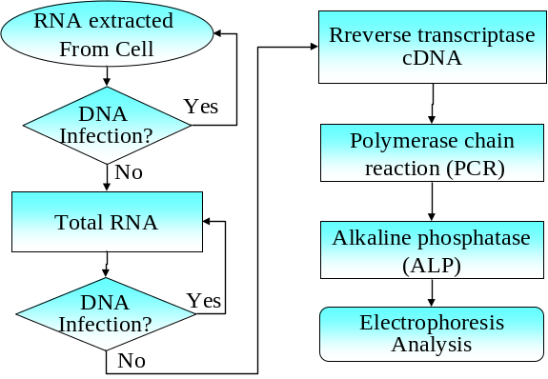
Fig. 2. The flow chart of RNA assay

4.1. RNA Extraction
1. Pipetting up the upper layer solution of the osteoblast cell, add 1 ml TRIZOL to suspend the cell.
2. Pipetting TRIZOL suspension solution to centrifuge tube, add 220 ul (BCP) excited for 15 seconds, wait for 2 minutes.
3. Place into 12,000 rpm, 4ºC centrifuge for 15 minutes.
4. Pipetting upper layer solution 400 ul to new centrifuge tube and mixed with 550 ul isopropanol.
5. Place into -80ºC container for 30 minutes.
6. Direct place into 12,000 rpm, 4ºC centrifuge from cryo-status and spin for 20 minutes.
7. Empty the solution, mixed with 1cc, 75% alcohol (0.1%DEPC water treated)
8. Place into 8,000 rpm, 4ºC centrifuge spinning for 5 minutes.
9. Pipetting the solution from the tube, dry up in the air (the cells are stuck tightly on the tube and will not come off from the tube, can use paper to such the remaining solution).
10. Add 0.1%, 15 ul (0.015 cc) DEPC water, mixed for 15 minutes. The RNA (appeared in sticky state since it contains nucleic acid) is ready for the assay.

4.2. Reverse Transcriptase cDNA
1. Quantitative total RNA, dilute to 500 ng/ul, pipetting 2 ul around 1 ng/ul. Calculate when the ph value is greater than 1.6 then can be used for experiment.
2. Reverse Transcriptase (RT) response: RT Polymerase Chain Reaction (PCR) is a widely used transformation. In RT-PCR, one RNA chain can be RT to complimentary DNA (cDNA), then use this template and PCR to proceed DNA duplication.

5. Experimental setup
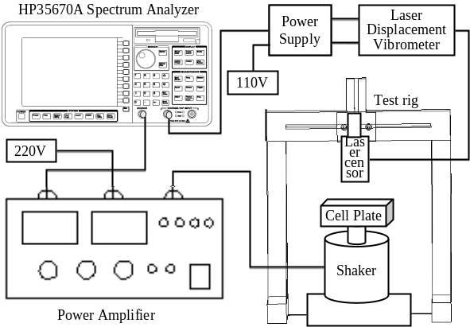
Fig. 3. Mechanical stimulation setup for MC3T3 cell

The experimental set up is shown in Fig. 3 to investigate the proliferation effects of osteoblast cell (MC3T3) under mechanical stimulation with different parameters: broad range of frequencies, amplitude, duration, repeated times, and temperature effects, etc. The MC3T3 cell culture plate is fixed at the center tip of a vibration shaker which is excited by one channel of HP 35670A spectrum analyzer through a 220V power amplifier. The sensor of a Laser Displacement Vibrometer is hanged on the test rig and placed around 3 cm apart from the top of the cell culture plate to measure actual cell vibration signal. This Laser Displacement Vibrometer is connected to the other channel of HP 35670A spectrum analyzer through 110V power supply.

6. Results and Discussion
The SEM (Scanning Electron Microscope) photos of just seeded and 80% growing of MC3T3 cell are shown in Fig. 4, 5.
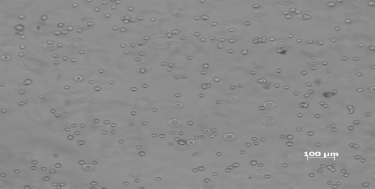
Fig. 4. The new seeded MC3T3 cell
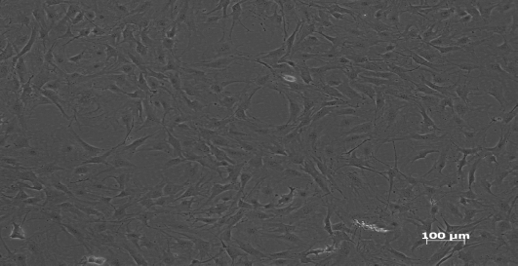
Fig. 5. 80% growing of the new seeded MC3T3 cell

Two major categories, under and avoid temperature, are described as follows:

6.1. Under temperature influence
6.1.1. Varying frequency
There are seven sets of cell culture plates, control_1, control_2 and five different excitation frequencies: 100 to 2000 Hz with wave form, amplitude (1 VPK, peak to peak), duration (20 min) keep the same. When one set of the culture plate is taking the stimulation in room temperature, all other six plates are kept inside the 37ºC incubator. Therefore, each set has different exposure period to the temperature. Since MTT and RNA assays will cause the death of the cell, hence, it needs two control sets (used in all experiments of this study) to evaluate the initial and final cell concentration under nature growth without any external stimulation. The cell proliferation varied through different frequencies is shown in Fig. 6. 500 and 1000 Hz excitation are restraining the growth of cell, while 2000 Hz excitation plate has the same proliferation rate with the nature growth.
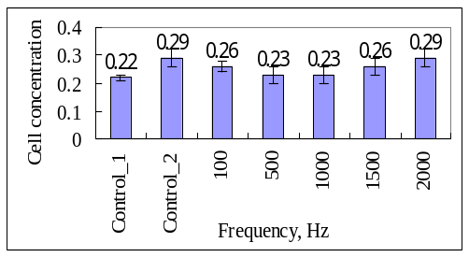
Fig. 6. Cell affected by excitation frequencies

6.1.2. Varying duration
The effect of cell growth on different excitation duration, with fixed frequency (2KHz), amplitude (1 VPK), and sine wave form, from 5 to 60 minutes is shown in Fig. 7. 40 minutes of excitation has increased the cell concentration almost 50% of the nature growth and over 50 minutes seams not affect much.
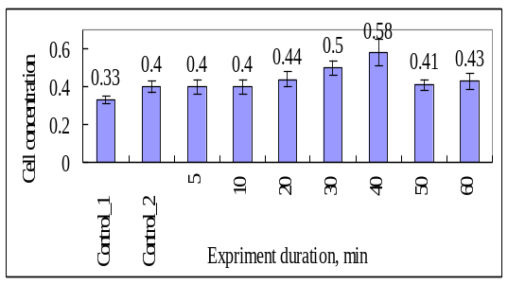
Fig. 7. Cell growth affected by excitation duration

6.1.3. Varying amplitude
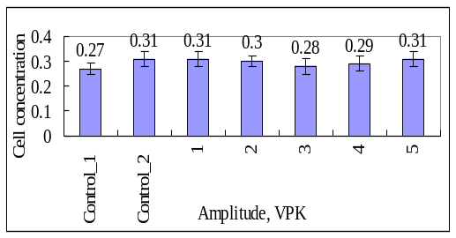
Fig. 8. Cell growth affected by excitation amplitude

The effect of cell growth on different excitation amplitude, with fixed frequency (2KHz), duration (40 min), and sine wave form, from 1 to 5 VPK (peak to peak voltage) is shown in Fig. 8. In the case, excitation amplitude seams not affect cell growth very much.

6.1.4. Varying number of repeated experiments
The effect of cell growth on different number of repeated experiments, with fixed frequency (2KHz), amplitude (1VPK), duration (40 min), and sine wave form, from once to five times is shown in Fig. 9. This experiment takes total 3 days to accomplish. Control_2 specimen is kept in the incubator without any disturbance while other sets are taken in and out of the incubator up to five times. Hence, no repeated experiment is growing faster than the nature growing cell in 37ºC 5% CO₂ incubator.

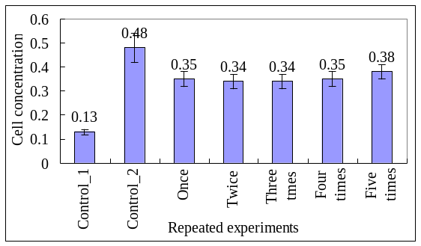
Fig. 9. Cell growth affected by repeated experiments

6.2. Avoid temperature influence
In this category, all cultured plates are taken out of the incubator when each of them has been proceeded the experiment in room temperature.

6.2.1. Varying frequency
The cell proliferation varied through different frequencies with fixed amplitude (1 VPK), duration (20 min), and sine wave form, is shown in Fig. 10. Similar to Fig. 6, 500 and 1000 Hz excitation are restraining the growth of cell, while 2000 Hz excitation plate has the same proliferation rate with the nature growth.

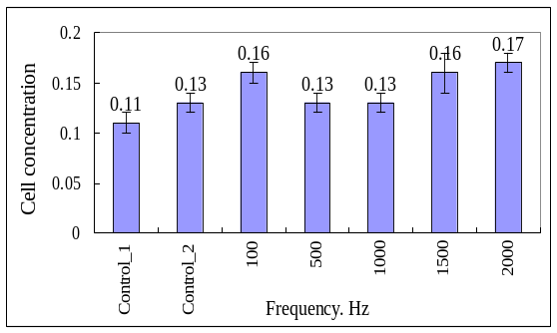
Fig. 10. Cell affected by excitation frequencies without temperature effects.

The electrophoresis diagram, shown in Fig.11, presents similar results as Fig.10, which is the more cell concentration (1.5K, 2KHz in Fig.10) measured by Fluorescence spectrometer, the lighter on electrophoresis bar (4, 5 in Fig.11).

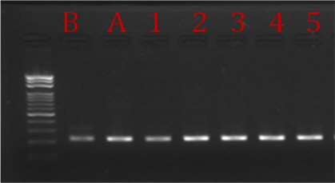
Fig. 11. Electrophoresis diagram with different excitation frequencies without temperature effects

6.2.2. Varying duration

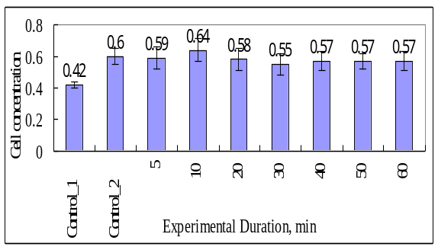
Fig. 12. Cell growth affected by excitation duration without temperature effects

The effect of cell growth on different excitation duration, with fixed frequency (2KHz), amplitude (1 VPK), and sine wave form, from 5 to 60 minutes is shown in Fig. 12. It is different from Fig. 7, 10 minutes of excitation has increased the cell concentration the most, but only about 7% of the nature growth and over 20 minutes seams not affect much.

6.2.3. Varying amplitude
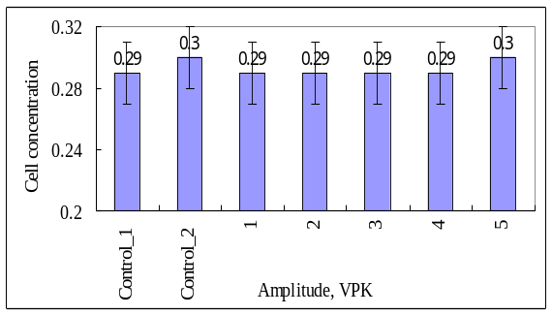
Fig. 13. Cell growth affected by excitation amplitude

The effect of cell growth on different excitation amplitude, with fixed frequency (2KHz), duration (40 min), and sine wave form, from 1 to 5 VPK (peak to peak voltage), and without temperature effect is shown in Fig. 13. It is similar to Fig. 6, excitation amplitude seams not affect cell growth very much.

6.2.4. Varying number of repeated experiments
The effect of cell growth on different number of repeated experiments, with fixed frequency (2KHz), amplitude (1VPK), duration (40 min), and sine wave form, from once to five times is shown in Fig. 14. This shows significant difference from Fig. 9. All the cell specimens including nature growing one, are not cultivated well enough compared to the plate always stays in the incubator (control_2) in Fig. 9. This result suggests that the culture environment, temperature, humidity, atmosphere with 5% CO₂, etc. are crucial to cultivate the osteoblast cell.
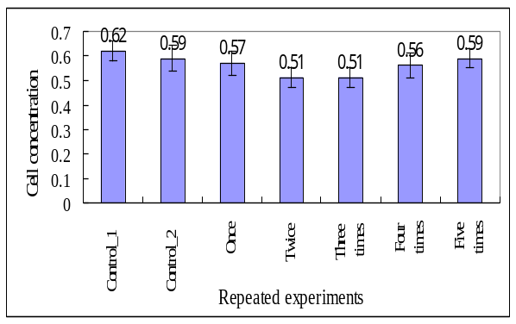
Fig. 14. Cell growth affected by repeated experiments without temperature effects

7. Summary
This research investigates the mechanical stimulation affects the proliferation of osteoblast cell. Different excitation parameters, temperature, broad range of frequencies, amplitude, duration, repeated number of experiments, etc., are compared for the cultivation of cells. The aim for this research is to understand the vibration stimulation of the murine osteoblast cell first and then use this model to analyze the related parameters of real human osteoblast or other cells in the future. Therefore, the result of this research is quite useful for physician’s reference.
Several aspects are discovered during this research and listed as follows:
1. Different frequencies of the stimulation have different effects onto the proliferation of the cell. Some frequencies (500, 1KHz) will suppress the proliferate of the cell, while others (1.5K, 2KHz) will increase the number of cell.
2. In subsonic range of frequencies excitation, the amplitude plays no significant role in the cultivation of cell.
3. The culture environment, including temperature, humidity, atmosphere with 5% CO₂, etc. are crucial and will help to cultivate the osteoblast cell.

Acknowledgements
This work was coworked with Dr. Wang in Chang Gang Medical Research Center and finished in Vibration and Noise Laboratory Cheng Shiu University. The author would like to thank the National Science Council, Taiwan, Republic of China, for financially supporting this research through Grant NSC95-2212-E-230-006.

References
- Yu-Ting Chang, Investigate the Effect of Physical Stimulation on Osteoporosis Using Animal Models, 2009. Master Thesis, National Cheng Kung University, Tainan, Taiwan, R.O.C.
- Ming-Ci Tsai, Effects of Different Stimulation Time of sPEMF on Apoptosis of Osteoclast-Like Cells Developed from Coculture of Osteoblast Cells and Bone Marrow Cells, 2002, Master Thesis, Chung Yuan Christian University, Tao Yuan, Taiwan, R.O.C.
- Sjoerd Rutten, Peter A. Nolte, Clara M. Korstjens, Marion A. van Duin, Jenneke Klein-Nulend, Low-intensity pulsed ultrasound increases bone volume, osteoid thickness and mineral apposition rate in the area of fracture healing in patients with a delayed union of the osteotomized fibula, Bone, 2008, 43: 348–354.
- Sjoerd Rutten, Peter A. Nolte, Clara M. Korstjens, Jenneke Klein-Nulend, Low-intensity pulsed ultrasound affects RUNX2 immunopositive osteogenic cells in delayed clinical fracture healing, Bone, 2009, 45: 862–869.
- Bo-Shiang Tsui, Studies on the response of neural tissues following ultrasonic stimulation, 2001. Master Thesis, Chung Yuan Christian University, Tao Yuan, Taiwan, R.O.C.
- P. Reher, N. Doan, B. Bradnock, S. Meghji, M. Harris, Therapeutic Ultrasound for Osteoradio- necrosis: an In Vitro Comparison Between 1MHz and 45 kHz Machines, European Journal of Cancer, 1998, 34 (12): 1962-1968.
- Jimmy Kuan-Jung Li, James Cheng-An Lin, Hwa-Chang Liu, Jui-Sheng Sun, Rouh-Chyu Ruaan, Chung Shih, Walter Hong-Shong Chang, Comparison of ultrasound and electromagnetic field effects on osteoblast growth, Ultrasound in Medicine & Biology, 2006, 32 (5): 769-775.
- A. Myrdycz, Dorothee Callens, K. Kot, F. Monchau, E. Radziszewski, A. Lefebvre, H.F. Hildebrand, Cells under stress: a non-destructive evaluation of adhesion by ultrasounds, Biomolecular Engineering, 2002, 19: 219-225.
- Yong Pan, Yong Hao, Tongwei Chu, Changqing Li, Zhengfeng Zhang, Yue Zhou, Ultrasonic-assisted extraction, chemical characterization of polysaccharides from Yunzhi mushroom and its effect on osteoblast cells, Carbohydrate Polymers, In Press, Corrected Proof, Available online 4 February 2010.
- Yasuhiro Tanimoto, Yo Shibata, Yu Kataoka, Takashi Miyazaki, Norihiro Nishiyama, Osteoblast-like cell proliferation on tape-cast and sintered tricalcium phosphate sheets, Acta Biomaterialia, 2008, 4: 397–402.
- M. Lewandowska-Szumiel, K. Sikorski, A. Szummer, Z. Lewandowski, W. Marczynski, Osteoblast response to the elastic strain of metallic support, Journal of Biomechanics, 2007, 40: 554–560.
- Takahiro Suzuki, Mika Hukkanen, Ryo Ohashi, Yoshiyuki Yokogawa, Kaori Nishizawa, Fukue Nagata, Lee Buttery, Julia Polak, Growth and Adhesion of Osteoblast-Like Cells Derived from Neonatal Rat Calvaria on Calcium Phosphate Ceramics, Journal of Bioscience and Bioengineering, 2000, 89 (1): 18-26.
- Tetsuya Yuasaa, Youji Miyamoto, Kunio Ishikawa, Masaaki Takechi, Yukihiro Momota, Seiko Tatehara, Masaru Nagayama, Effects of apatite cements on proliferation and differentiation of human osteoblasts in vitro, Biomaterials, 2004, 25: 1159–1166.
- Xue Qu, Yuqing Wan, Hanwei Zhang, Wenjin Cui, Jianzhong Bei, Shenguo Wang, Porcine-derived xenogeneic bone/poly (glycolide-co-lactideco- caprolactone) composite and its affinity with rat OCT-1 osteoblast-like cells, Biomaterials, 2006, 27: 216–225.
- Zhongli Shi, Xin Huang, Yurong Cai, Ruikang Tang, Disheng Yang, Size effect of hydroxyapatite nanoparticles on proliferation and apoptosis of osteoblast-like cells, Acta Biomaterialia, 2009, 5: 338–345.
- Heidi A. Declercq, Ronald M.H. Verbeeck, Leo I.F.J.M. De Ridder, Etienne H. Schacht, Maria J. Cornelissen, Calcification as an indicator of osteoinductive capacity of biomaterials in osteoblastic cell cultures, Biomaterials, 2005, 26: 4964–4974.
- Ilse Y. Pieters, Natasja M.F. Van den Vreken, Heidi A. Declercq, Maria J. Cornelissen, Ronald M.H. Verbeeck, Carbonated apatites obtained by the hydrolysis of monetite: Influence of carbonate content on adhesion and proliferation of MC3T3-E1 osteoblastic cells, Acta Biomaterialia, 2010, 6 (4): 1561-1568.
- Virginie Dumas, Anthony Perrier, Luc Malaval, Norbert Laroche, Alain Guignandon, Laurence Vico, Aline Rattner, The effect of dual frequency cyclic compression on matrix deposition by osteoblast-like cells grown in 3D scaffolds and on modulation of VEGF variant expression, Biomaterials 2009, 30: 3279–3288.
- Wang Bochu, Long Xuefeng, Liu Yiyao, Duan Chuanren, A. Sakanishi, The effects of mechanical vibration on the microstructure of Gerbera jamesonii acrocarpous callus, Colloids and Surfaces B: Biointerfaces, 2002, 23: 1–5.
- Shigeo M. Tanaka, Jiliang Li, Randall L. Duncan, Hiroki Yokota, David B. Burr, Charles H. Turner, Effects of broad frequency vibration on cultured osteoblasts, Journal of Biomechanics, 2003, 36: 73–80.
- In Sook Kim, Yun Mi Song, Tae Hyung Cho, Je Yeon Kim, Franz E. Weber, Soon Jung Hwang, Synergistic action of static stretching and BMP-2 stimulation in the osteoblast differentiation of C2C12 myoblasts, Journal of Biomechanics, 2009, 42: 2721–2727.
- Lin Tang, Zhu Lin, Yong-ming Li, Effects of different magnitudes of mechanical strain on Osteoblasts in vitro, Biochemical and Biophysical Research Communications, 2006, 344: 122–128.
- L.A. Viscontia, E.H.K. Yenb, R.B. Johnson, Effect of strain on bone nodule formation by rat osteogenic cells in vitro, Archives of Oral Biology, 2004, 49: 485-492.
- Ludwika Kreja, Astrid Liedert, Sofia Hasni, Lutz Claes, Anita Ignatius, Mechanical regulation of osteoclastic genes in human osteoblasts, Biochemical and Biophysical Research Communications, 2008, 368: 582–587.
- Katerina K. Papachroni, Demetrios N. Karatzas, Kostas A. Papavassiliou, Efthimia K. Basdra and Athanasios G. Papavassiliou, Mechanotransduction in osteoblast regulation and bone disease, Trends in Molecular Medicine, 2009, 15 (5): 208-216.
- C. Frias, J. Reis, F. Capela e Silva, J. Potes, J. Simoes, A.T. Marques, Polymeric piezoelectric actuator substrate for osteoblast mechanical stimulation, Journal of Biomechanics, In Press, Corrected Proof, Available online 8 February 2010.
- Zanne Henriksen, Jeffrey F. Hiken, Thomas H. Steinberg, Niklas R. Jorgensen, The predominant mechanism of intercellular calcium wave propagation changes during long-term culture of human osteoblast-like cells, Cell Calcium, 2006, 39: 435–444.
- Bo Wun Huang, Huang Kuang Kung, Kuan-Yu Chang, Bo Kai Hsu, Jung-Ge Tseng, Human Cranium Dynamic Analysis, Life Science Journal, Vol. 6, No.4, pp.15-22.

