Expression changes of DSCAM in induction of MSCs to differentiate into neurons

Tao Peng, Yanjie Jia , Junfang Teng, Boai Zhang, Guiyuan Fang
Department of Neurology, First Affiliated Hospital of Zhengzhou University, Zhengzhou, Henan 450052, China
jiayanjie1971@yahoo.com.cn
Received February 2, 2008

Abstract
Objective To explore the role of Down syndrome cellular adhesion molecule (DSCAM) in the course of the rat marrow mesenchymal stem cells (MSCs) differentiated to neurons in vitro. Methods MSCs from Sprague-Dawley rats were induced into neurons by baicalin. Immunocytochemistry, Western blot and other methods were performed to detect DSCAM in neurons. At the same time, RNA interfere technique was performed to observe the induction and differentiation after DSCAM-siRNA was transfected into MSCs. Results Before induction, the expression of DSCAM was not detectable in MSCs. After 24h pre-induction, DSCAM was slightly expressed in MSCs(1.71﹪±0.67﹪).After 6h induction by baicalin ,the expression of DSCAM increased (15.79﹪±4.24﹪) and reached the peak (53.16﹪±5.94﹪) after 3d induction. After 6d induction, DSCAM expression obviously decreased (28.99﹪±6.72﹪). After DSCAM-siRNA was transfected into MSCs, DSCAM expression obviously decreased. However, MSCs did not express neuron-specific β-III-tubulin, expression of β-III-tubulin was (1.40﹪±0.79﹪)after 6h induction, （41.59%±3.17%）after 3d induction and (59.11﹪±4.76﹪)after 6d induction. But after DSCAM-siRNA was transfected into MSCs, expression of β-III-tubulin obviously decreased （28.57%±2.91%、43.90%±12.31%）after 3d and 6d induction.

Conclusions DSCAM might play an important role in MSCs differentiation into neurons. [Life Science Journal. 2010; 7(1): 5 – 8] (ISSN: 1097 – 8135).

Key Words: Down syndrome cellular adhesion molecule; marrow mesenchymal stem cells; neuron; RNA interfere
________________________________________________________________________________________________

1. Introduction
Down syndrome cell adhesion molecule（DSCAM）, which Gene is located at 21q22, if over-expressed (such as the chromosome 21 trisomy) , that is Down syndrome. It results in abnormality of nerve cell migration, proliferation, differentiation, leads to congenital intellectual maldevelopment ^{[1]}. Moreover, DSCAM is between nerve cells, and plays an important role in the the imperative cell adhesion molecule in connections formation and maintenance of the neural network ^{[2]}. In the process of inducing marrow mesenchymal stem cells (MSCs) to nerve cells in vitro, we firstly observed the changes of DSCAM expression and explored the function.

2 Materials and methods
2.1 The main reagents and animals
DMEM liquid medium, B₂₇, fetal calf serum, Trizol purchased from Gibco Company; basic fibroblast growth factor (basic fibroblast growth factor, bFGF) purchased from Pepro Tech EC Inc.; mouse anti-polyclonal DSCAM, nerve cell marker protein β -III-tubulin antibody purchased from Abnova Corporation; goat anti-mouse-Cy3, goat anti-mouse-AP antibody purchased from Sigma company; Rat Rn-DSCAM-siRNA (FITC tags), transfection reagent HiPerFect, positive control Rn-MAPK1 Control siRNA, negative control AllStars Negative Control siRNA (FITC tags) purchased from Qiagen Inc.; RT-PCR kit purchased from Promega Corporation; The remaining biological and chemical reagents are imported or domestically analytical reagent.
MSCs was extracted form femur of SPF-class Sprague-Dawley rats by the University Center, and passaged more than 10 generations, regular cryopreservation in liquid nitrogen.

2.2 Induction of MSCs to nerve cells in vitro
In the light of our approach ^{[3]}, the culture and induction of MSCs differentiation was carried out. In accordance with the 2 × 10⁴ cells / hole ratio, the 10th generation of MSCs was vaccinated in the 6-hole culture plate with plastic coverslip, cultured 3d, the induction experiment began when 80-90% was fused. After 3 washes with D-Hank's fluid, a pre-induction medium (DMEM medium, 10% fetal calf serum, 10ng/ml bFGF) added, cultured 24h. After pre-induced, induced 6h by adding liquid (DMEM medium, 200-400μM baicalin), then adding liquid (DMEM medium, 200-400μM baicalin, 10ng/ml bFGF, B27) to maintain 6d.

2.3 DSCAM-siRNA transfected MSCs
According to the Qiagen company's operating instructions for MSCs transfection as follows: 1250ng siRNA was dissolved in 100 μl DMEM medium (no serum) and then adding 12μl HiPerFect transfection reagents, and incubated 10m at room temperature after mixing; the complex was dropped on the surface of MSCs, and then added to the DMEM medium (containing 10% FBS), so that the final concentration of siRNA to achieve 24nM, incubated 12-24h. Positive control ( Rn-MAPK-1 Control siRNA)and negative control (AllStars Negative Control siRNA) apply the same approach.

2.4 Immunocytochemistry method，image collection and analysis
After washed with PBS, the cells were fixed 20 min at 4ºC in stationary liquid (4% paraformaldehyde), reacted 10 min in 0.2% Triton, blocked 1h with 10% Bovine Serum Albumin (BSA), then incubated 24h at 4ºC with Anti-DSCAM (1:200), Anti-CD90 (1:200) or Anti-β -III-tubulin (1:800). The cells were stained and observed at room temperature with second antibody after 3 washs. The cells image were photoed 10x or 20× by microscope using 300dpi resolution. Every independent experiment collected more than 30 region of cells. Furthermore, the image collected in bright field contains the same counts of cells. Double person and double mind random method were counted positive cells and computed positive cells percentage.

2.5 Western Blot method
Collected cells of each group were cracked, degenerated, centrifuged in the cell lysate (50mM Tris-Cl, pH 6.8, 10mM EDTA, 2% SDS, 5mM DTT, 0.5mM PMSF) 100μl, collecting the supernatant protein samples and quantificating protein by Bradford method. Protein lysate was added in 4× gel upper sample buffer, and transferred to PVDF membrane after SDS-acrylamide gel electrophoresis ,blocked with 5% defatted milk (1 h at room temperature) and incubated overnight at 4 ºC with TBST. The membrane was washed 3 times, and reacted 1h at room temperature with IgG tagged by horseradish peroxidase, then washed 3 times. ECL reaction was conducted, followed by exposure and development. The same experiment needs 3 repeats.

2.6 RT-PCR
Total cellular RNA was extracted with Trizol reagent and quantitated conventionally. RT-PCR amplification reaction was performed on the light of Promega kit manual, the reaction system was 50μl, reverse transcription and PCR were accomplished in one step (35-40 cycles), 10μl of amplification product were added to 1.5% agarose gel, ultraviolet transilluminator was used to observe and photograph after electrophoresis. Primer was from Shanghai Public Health Synthesis Ltd.(Table 1)

2.7 statistical treatments
ImagePro Express software was used to collect and process all images. The data was expressed by ±s. GraphPad Prism 5.01 was used to make picture. Analysis of variance was used to evaluate the data, the P value less than 0.05 was considered to be significantly different.

3 The results
3.1 Induction of bone marrow mesenchymal stem cells to differentiate into nerve cells in vitro
of rats cultured 10 generations are mainly spindle, squamous cells and expressed MSCs marker(Figure 1A). After 6h induction with Baicalin, some cells changed to a triangle, cell microfilament contracted, pseudopodium formed slender processes and interlaced locally , similar to nerve cells; After 6d the majority of cells changed to be cone-shaped, interlaced into a network, and formated typical nerve cell structure (Figure 1B). This study chose β-III-tubulin as a marker of mature nerve cells, MSCs were not found to express β-III-tubulin before the induction and after 6h induction (1.40% ± 0.79%). With the cells differentiation, β-III-tubulin expression increased rapidly to (41.59% ± 3.17%) with 3d induction and (59.11% ± 4.76%, Figure 1C) with 6d induction. Western Blot also had similar results (Figure 2).

Table 1. Primer sequence
Gene name Primer sequence product
SCAM | Forward: 5’-AGAAGTGCCCACCAATTGAG-3’ | 135 bp
SCAM | Reverse: 5’-CACCCAGGTTCCTTCTGATC-3’ | 135 bp
β-III-tubulin | Forward: 5’-TGCGTGTGTACAGGTGAATGC-3’ | 240bp
β-III-tubulin | Reverse: 5’-GGCTGCATAGTCATTTCCAAG-3’ | 240bp
GADPH | Forward:5’-CCCACGGCAAGTTCAACGGCA-3’ | 430bp
GADPH | Reverse: 5’-TGGCAGGTTTCTCCAGGCGGC-3’ | 430bp

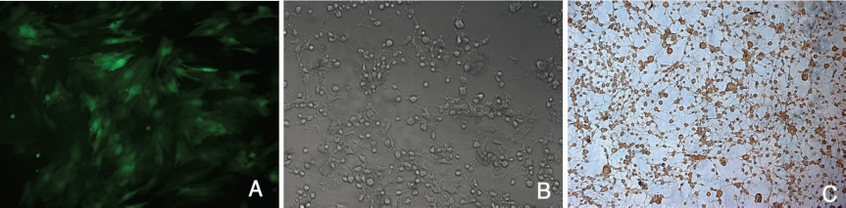
Figure 1. Induction of MSCs to neuron A: pre-induction, the 10th generation of MSCs(CD90 staining, FITC,×200); B :6d after induction, change of cell morphology(×200),the cells were cone shaped, similar to neuron; C: 6d after induction, expression of β-III-tubulin in differentiated cells(DAB coloration, ×100), most cells were cone shaped, interlaced to net, β-III-tubulin was hyperexpressed.
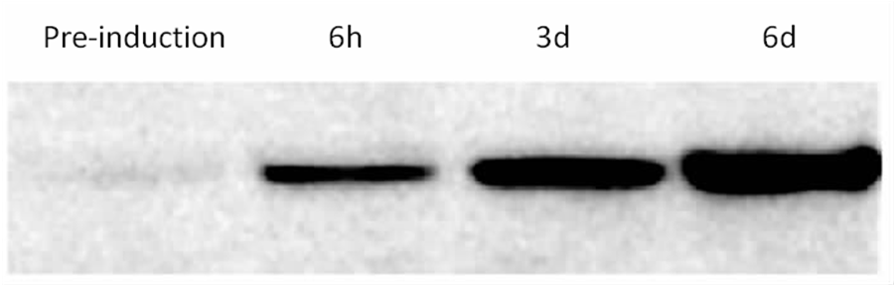
Figure 2. Changes of β-III-tubulin expression before and after induction (Western blot)
β-III-tubulin expression increased rapidly with the time.

3.2 Changes of DSCAM expression
The rats MSCs did not express DSCAM before induction., MSCs began to express a small amount of DSCAM (1.71% ± 0.67%) after 24h pre-induction and express partially on cell membrane and processes after 6h induction (15.79% ± 4.24%); With the extension of time the expression continued increasing, and to the peak after 3d induction ( 53.16% ± 5.94%). But DSCAM expression decreased significantly (28.99% ± 6.72%) after 6d induction, and it was significantly different from 3d induction (t = 8.516, P <0.01). Western Blot method had similar results (Figure 3).

3.3 DSCAM-siRNA transfected MSCs
MSCs had no obvious morphological changes after DSCAM-siRNA transfection, Green fluorescent granules can be observed in cells by fluorescence microscope after 24h transfection and can express more than 1 week (Figure 4A, 4B). The efficiency is (78±12.9) %. However, after baicalin induction, cell differentiation was poor, processes was short, straight .Branches and neural network formation were sparse (Figure 4C, 4D). Immunocytochemical stain (Figure 4E) and RT-PCR (Figure 5) prompted that DSCAM expression decreased significantly after DSCAM-siRNA transfection. But after DSCAM-siRNA transfection, with 3d or 6d induction, β-III-tubulin expression decreased significantly (28.57% ± 2.91%, 43.90% ± 12.31%), the difference was significant compared to untransfected cells ( P <0.01, P<0.05).

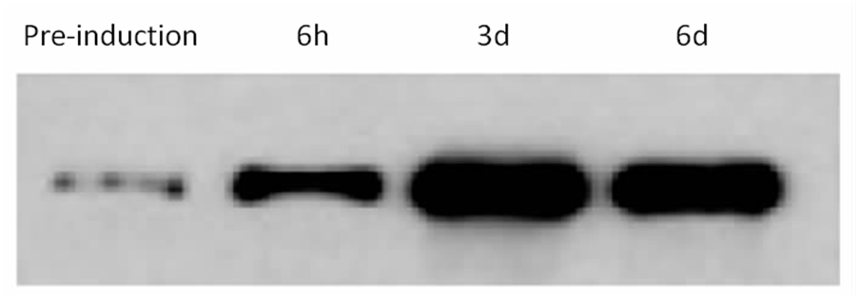
Figure 3 changes of DSCAM expression before and after induction(Western blot)
DSCAM expressed partially at 6h after induction. The expression increased gradually to the peak at 3d and decreased at 6d.

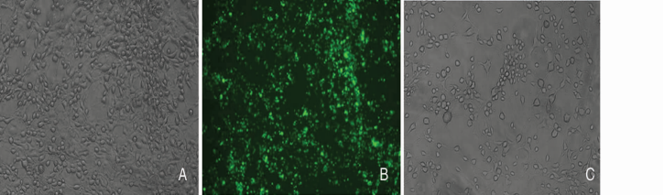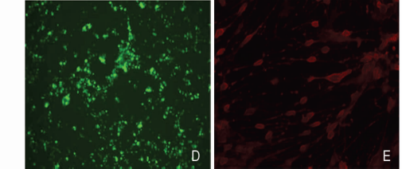

Picture 4 DSCAM-siRNA transfected MSCs A: Cell morphology of MSCS did not chang obviously after DSCAM-siRNA transfected MSCs(×100); B: Green fluorescent granules in cells can be observed in same visual field (×100); C: 6d after DSCAM-siRNA transfection and induction ,the differentiation of transfected cells were poor, the neural networks were sparse(×100); D: Green fluorescent granules can be observed in differentiated cells in same visual field (×100); E: 6d after siRNA transfection and induction, the change of DSCAM expression (immunofluorescence，Cy3 staining,×200) .

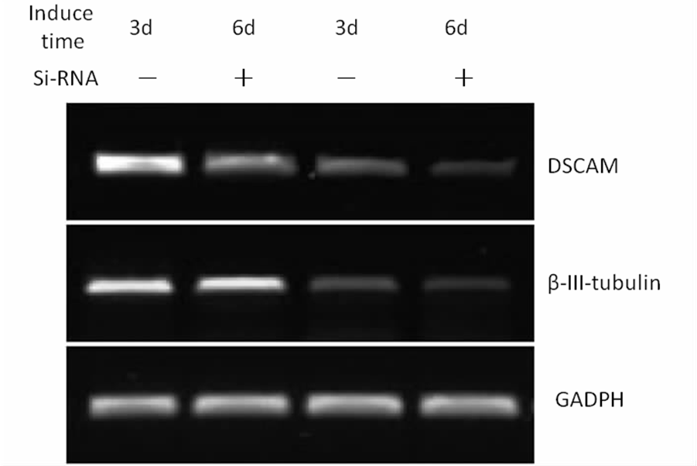
Picture 5 Changes of DSCAM mRNA expression before and after induction(RT-PCR)
DSCAM β-III-tubulin expression decreased significantly than untransfected group after siRNA transfection(p<0.01, p<0.05).

Discussion
DSCAM belongs to immunoglobulin super family. In 1998, Yamakawa isolated DSCAM gene and found that most of these genes expressed in the development phase of the nervous system ^{[4]}. Sequence analysis shows that, DSCAM consists of the N-end signal peptide, 10 immunoglobulin domain, 6 3-type fibronectin domains, a transmembrane domain and an intracellular domain. DSCAM can be cuted to 38,000 kinds of isomers through RNA, the protein may help nerve cells link exactly in the process of nerve network formation. Over-expression of DSCAM have the direct result of nerve cell migration, proliferation and abnormality of differentiation, this is the molecular genetics basis of Down's syndrome ^{[1]}.
Nearly 10 years, the study found that MSCs can be directed to differentiate into nerve cells and glial cells. As a class of ideal "seed cells", MSCs have the advantages of proliferation, security, autologous transplantation without immunological rejection. It can be applied to the clinical therapy of cell transplantation in the nervous system injury and degenerative diseases ^{[5]}.But the mechanism of MSCs differentiating to neural cells is not clear, it involves a number of signal transduction accesses. This study found that for the first time, the development of the nervous system as an important functional proteins, before the induction rat MSCs did not express DSCAM, with the induction time extending, expression of DSCAM gradually increased to the peak after 3d induction, and then began to decline. At the same time, the expression of nerve cell marker protein β-III-tubulin increased in the differentiated cells. The results suggested that, the cells induced and differentiated from MSCs had a certain degree of nerve cell function, but the process may also be the recurrence of nerve cell development, and furthermore, DSCAM express mainly in the nervous system development phase, including the spinal cord, cerebral cortex, cerebellum and so on, it plays a vital role to ensure the accurate and close connections of nerve cells in growth and directed extension of its axon branches ^{[6,7]}. The expression of DSCAM increase gradually in the course of MSCs differentiation, it may be associated with growth of induced cell axon branches and establishment of cell junctions. Nduced cells have the network structure and function of nerve cell. Interference of DSCAM siRNA affected DSCAM expression and led to the decline of effect of induction and differentiation and reduce of nerve cell junction.
A recent study found that, DSCAM play a role in the formation of particular retinal layer. The other two adhesion molecules, that is, the Sidekick-1 and Sidekick-2, play a role in a similar manner. These elements are widely distributed in the nervous system, may be the components of adherence code in formation of brain nerve connection ^{[8]}. Therefore, whether the mechanism of MSCs induced to differentiate into neural cells is similar will be involved in an in-depth study.

Corresponding author.
Email: jiayanjie1971@yahoo.com.cn
Projects supported by National Natural Science Foundation (30770758)

References
- Zinn K. Dscam and neuronal uniqueness [J]. Cell 2007, 129(3): 455-456.
- Schmucker D. Molecular diversity of Dscam: recognition of molecular identity in neuronal wiring [J]. Nat Rev Neurosci 2007, 8(12): 915-920.
- 贾延劼, 杨于嘉, 周燕, 等.黄芩甙诱导骨髓基质细胞向神经细胞分化的研究[J]. 中华医学杂志 2002, 82(19): 1335-1339.
- Yamakawa K, Huot YK, Haendelt MA, et al. DSCAM: a novel member of the immunoglobulin superfamily maps in a Down syndrome region and is involved in the development of the nervous system [J]. Hum Molecular Genetics 1998, 7(2): 227–237.
- Dezawa M, Hoshino M, Ide C. Treatment of neurodegenerative diseases using adult bone marrow stromal cell-derived neurons[J]. Expert Opin Biol Ther. 2005, 5(3): 427-435.
- Hughes ME, Bortnick R, Tsubouchi A, et al. Homophilic Dscam interactions control complex dendrite morphogenesis[J]. Neuron. 2007, 54(3): 417-427.
- Ly A, Nikolaev A, Suresh G, et al. DSCAM is a netrin receptor that collaborates with DCC in mediating turning responses to netrin-1[J]. Cell 2008, 133(7): 1241-1254.
- Yamagata M, Sanes JR. Dscam and Sidekick proteins direct lamina-specific synaptic connections in vertebrate retina [J]. Nature 2008, 451(7177): 465-469.

