亲爱马博士您好，此文一出刊，就一锤定音。因此我十分认真又补充了重要几句，由于时间急，我无法请到翻译员，只好用翻译机译出，请您在百忙中挤出时间，按后面中文大字校对出刊或供您定夺用与不用。校对出刊时删除中文
其它文章我也认真校对修改，椭圆图也改了下，我小学文化，一切来之十分艰难，实没有人能帮我，唯一灵感经常接收到似上帝信息而进行修改，和钱辅路。这是真的。
滴水之恩，定将涌泉相报。

Establishment of the Unified Field Theory
Author: Sun Chunwu
Translator: Yang Lin
Address: No. 59, Xihu Town, Yangzhou City, Jiangsu Province, PRC. Post code: 225008
Tel: 0514-82822538; E-mail: yzscw@163.com; Blog: http://yzscw.blog.163.com

Abstract: There are many problems on natural science disturbing scientists. Einstein focused on finding fields of unified gravity, electromagnetic force, strong force and weak force, so he could not take the lead to create the Unified Field Theory to analyze which one is of bigger mass, and what had integrated all these forces to evolve new substances. As a result, the author tries to create the Unified Field Theory, its graphics and formulas in the purpose of correctly getting to know the causes in Nature and the ability of after-movement energy-change so as to benefit the mankind. [New York Science Journal 2010;3(3):19-24]. (ISSN: 1554-0200).

Key words: Unified Field Theory; Oval charts and formulas; Application of the Unified Field Theory
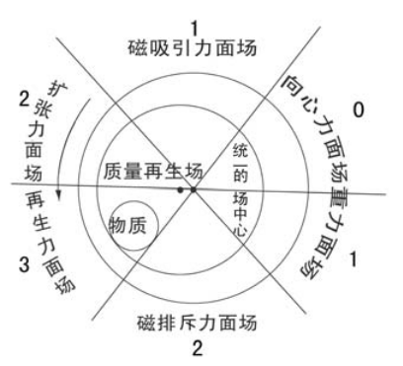
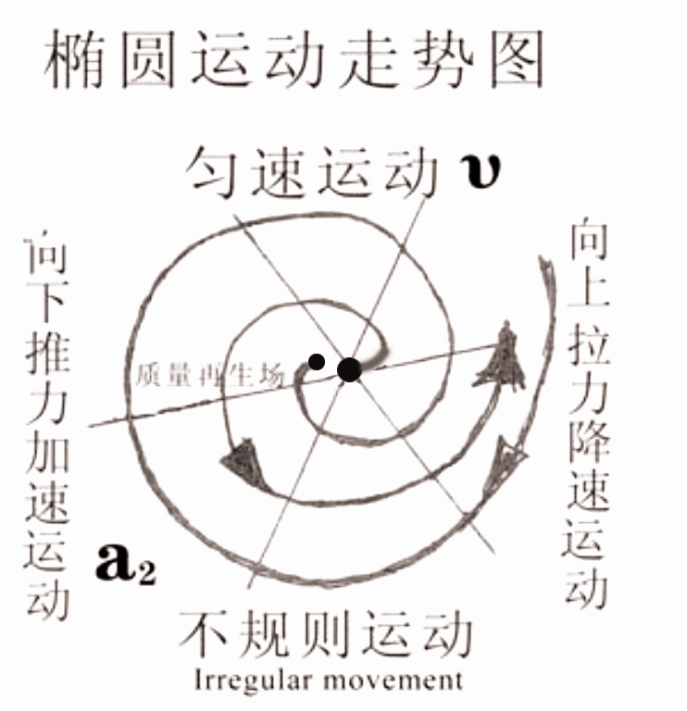

The Unified Field Theory integrates the formation and state of movement and development of things into an oval chart, sets data according to each position shown in the oval model, and then demonstrates by theory, teaching you how propose, solve, and discuss different kinds of problems. First of all, it informs you of what a unified field is. For example, masses of forces surfaces of different fields marked in this oval model generate different energies on the same field. The one of bigger mass is the unified filed. Therefore, when proposing, solving and discussing things like galaxies, planets, atoms, plant seeds, animal cells, a country or a person, etc., we can deem the living-body structure as the unity of the unified field, and then discuss how a mass moves on this living-body field to generate ethers such as gravity, magnetic force, strong force, and weak force, etc Chi child physical to.
What is the function of the unified field? We regard core objects that take up and consume much energy such as the pole of rotation of the earth, the core of atoms, the central government of a country or a living person as the unified fields. Then we can make accurate mathematical explanation to elements at each position on the oval model, e.g. the mass, speed, of the planets, and its distance from the core of the galaxy, etc.
This filed is formed by concentric movement, with its mass depending on the energy of the centripetal force on the force surfaces of the fields around. Its function is to locate objects around and unify them when the limit of their movements is reached, and provide or inherit wisdom and energy for the objects around.
Therefore, time and space begin at this time. Gravity, magnetism, electricity, light, etc. are formed one after another after self-autorotation and being pushed. They disappear also with the disappearance of self-autorotation, and time and space ends as well.
What is the Unified Field Theory? For example, when discussing problems like why the planet moves faster on one side of the galaxy core, but slower on the other side, the methods used in the process of demonstrating the unified field are called the Unified Field Theory, which is composed of the Unified Field Theory, an oval chart and the formulas of problem-proposing and problem-solving. With it, problems involved in the unified field can be discussed.
The large circle in the oval chart stands for the size of an object in the unified field.
The hole in the small circle of the oval chart is called “Black Hole” at the core of the galaxy. It resembles the length of arms of a lever, or a woman’s womb, or copy tools of computers, weapons, etc., generating more energy after systematic accelerated movement. The mass of petrol is lost after being transformed, but the energy is conserved. As a result, the hole in the small circle and tools, etc. are called the mass-regeneration filed, which is used to generate more energy.
It has a uniform criterion of mass. The bigger the mass of the field, e.g. the fiercer the centrifugal force, or the Bias was larger the holes, r the heavier the tools and weapons people use, the more energy they generate.
On the contrary, every time when the mass of the field gets smaller, or when moving on the field of gravity or the field of centripetal force, the higher the object whirls, the slower it moves, and the less energy it generates.
The substances in the hole of the oval chart can also be regarded as the names of objects that generate energy. Every time it moves systematically, the bigger the mass, the more energy it generates; the smaller the mass, or the weaker the centrifugal force, the less energy it generates, or the less evolution of synthesis. Therefore, the movement is not only dependent on the surroundings, tools, and weapons, etc., but also restricted by its own mass. In addition, it cannot generate energy alone.
The six (relative) different fields of force surface in the oval chart represent the time of laws of motion of everything on the earth, including people, and they do ordered movement of a new round. The numbers stand for that during the process of development at each stage, the movement they do to generate energy is random. These six fields, just like the cores of the mass-regeneration field and the unified field, are divided into three kinds of masses--- big, medium, and small. The other chart is to illustrate the push and friction of centripetal and centrifugal forces in different spaces, i.e. the so-called yin yao and yang yao in the Eight Diagrams.
Supposes the solution discusses when the thing must look like the Book of Change to forecast or Chinese medicine such, When discussing about things, we have to be as accurate as what Zhouyi has predicted, combining all the data to work out the correct answer.
The top of the large circle in the oval chart stands for the starting point of the time of one object, or objects converged under this condition. It won’t change in energy. By a terminology in physics, we call it “the surface field of magnetic attraction”. We label the energy it generates from constant velocity motion as 1.
The protruding part of the top of the oval chart stands for the motion from the top to the bottom. We call it “the surface field of expansionary force”, and the energy it generates and converges is labeled as 2.
Under it, the acceleration inertia can generate more energy, e.g. to increase the ovality of the earth. We call it “the surface field of strong force”, or “the surface field of regenerative force”. The energy it generates is labeled as 3.
In short, movement in these two surface fields is in acclerrated motion because there is an inertia of push.
The very bottom of oval chart is the surface field of magnetic repulsive-force, standing for that the c entripetal force of a mass is stronger when it spins slowly and the centrifugal force is stronger when it spins quickly if a mass moves on this field and at this time. The energy generated has been decreased to 2. (when actual operation should locate it along with speed speeds up, it increases progressively energy above 2)We call it “irregular motion”, which will result in fortuitous accidents.
The other side of the oval chart is a motion from the bottom to the top. The energy generated has decreased to 1. It does decelerated motion by inertia. We call it “the surface field of gravity”.
But on the top of such kind of field, since the objects have completely lost the ability to do work, and consumed energy by friction force and gravitation, so it does centripetal motion. Therefore, we call it “the surface field of centripetal force” or “the surface field of weak force”. The energy generated is 0.
done continuous accelerated centripetal movement, making the mass of the object in the center of the hole of the organizational structure of the joint force, generating more energy to do work after thrown by the centrifugal force after autorotation. If they move for a second time, the total mass of the system should be multiplied with the mass of the work done by throwing through acceleration inertia and the energy obtained from the distance away from the center, and then this new number should be multiplied with the energy of inertia one after another. After that, we can know energy evolved from different surface fields, giving rise to gradual acceleration of the speed of autorotation, such as expansion,
Opened the thing microcosm by the figure above to make the elliptic motion, said that the centripetal movement obtained the centripetal force, caused to enter the central material to obtain the system spinning centrifugal force to throw the acting, the nature myriad things is simple pushes by these two kinds the friction force table to narrate differently, only then caused on the unification field on each kind of field strength surface object, regardless in time, had the evolution development spinning energy in the space, then only then gradually had like the attraction, questions and so on electromagnetic force, strong action, weak action. This unifies again with the primal chaos sub-physics and so on narrates to their each kind of table, above and unifies each kind of data to utilize it nimbly, could go to suppose, the solution, to discuss the different stochastic problem which the myriad things or occurred and to justify oneself the unified field theory except to use the ellipse chart to untie the myriad things their past, the present, and the future, will be energy how many which the superposition generated in the movement, produced under the unification ellipsoid structural model, only then has carried on outside beginning has come again evolution movement, supposed the topic problem solving rule. Also sets up以上图是揭开了事物微观世界作椭圆运动，称向心运动而得到了向心力，使进入中心物质得到了系统自旋的离心力被抛出去做功，自然界万物就是以这两种简单不同推挤摩擦力表叙，才使统一场上各种场力面上的物体，无论在时间，还是在空间就有进化发展的自旋能量了，进而才逐步产生出如引力,电磁力、强作用力、弱作用力等问题。这样再来结合用太极子物理学等对它们的各种表叙，及结合以上各种数据灵活运用它, 就能去设、解、论万物或发生的不同随机问题和自圆其说了
统一场论除了用椭圆图来解开万物它们的过去，还是现在, 及将来，都是在运动中被复制出的能量多少，产生出统一椭圆球结构模型下，才进行了一元复始的进化运动外，去设题解题规律。还设立以上图是揭开了事物微观世界作椭圆运动，称向心运动而得到了向心力，使进入中心物质得到了系统自旋的离心力被抛出去做功，自然界万物就是以这两种简单不同推挤摩擦力表叙，才使统一场上各种场力面上的物体，无论在时间，还是在空间就有进化发展的自旋能量了，进而才逐步产生出如引力,电磁力、强作用力、弱作用力等问题。这样再来结合用太极子物理学等对它们的各种表叙，及结合以上各种数据灵活运用它, 就能去设、解、论万物或发生的不同随机问题和自圆其说了
统一场论除了用椭圆图来解开万物它们的过去，还是现在, 及将来，都是在运动中被复制出的能量多少，产生出统一椭圆球结构模型下，才进行了一元复始的进化运动外，去设题解题规律。还设立

max

Kg≠m•a2•t

Min
This formula gives you an inspiration to propose and solve problems. This formula appears like a lever, enabling us to associate the mass of movement of all things which doesn’t equal the energy they can generate.
“≠”tells the person who proposes and settles problems about the problem of limit of energy generated in motion in the system of the mass. With this limit, we can get to know the death of things and the speed of irregular periodical movement. Three things are proposed: ①“m”stands for the mass at the early stage of convergence, or the history of past. “t”stands for the energy generated after the convergence, or the present mass. “kg” stands for different occasions, different conditions, different results, or its future mass. ② Regardless of past, present or future, galaxies or atoms, animals or plants, macro or micro, “≠” means the contradiction between fast and slow. The speed contributes to the development of this contradiction, and time is the one to reconcile the contradiction.
Therefore, they are in compliance with the mass, acceleration, time, and the environment in one structure so as to propose and solve the problems. ③ “≠”also stands for the existence of the speed on the two sides of the autorotation pole, and the photon, electron radiated after the movement. So we should use different forms to discuss and different formulas to calculate. “t” (time) stands for the energy that can be generated after movement due to the existence of the regenerative field, and with what kind of mass to converge around the autorotation pole, in the regenerative field and other fields.
You can get to know the mass after their movement based on these conditions. The energy generated will be either the strongest or the weakest decided by the following three elements: first, the acceleration speed of autorotation; second, the speed in different situations on the two sides of the autorotation pole; third, the speed before or after the mass limit being unified. The relationship among them is unified randomly. If anyone of them converges or evolves and generates different amounts of energy, there will be numerous changes in the fields, just like new things keep on emerging in the Nature. Then discussions have to be held again one by one, or different formulas are used to calculate.
Therefore, this formula, like Chinese ideographic writing, contains both philosophy and inspiration for readers to associate, correctly calculating them and making out the causes of what does more work one by one. These objects, exceeding the bearing capacity of the mass of the system, result in “strong force” such as “electromagnetic force”, nucleus (proton as well as neutron) and “weak force” when the atoms decay. Or, readers can propose a mathematical equation of this object to calculate physical quantities such as different forces, and intensity to solve the problems.
It is safe to say that with the Unified Field Theory and data from the oval chart showing you how to propose and solve problems, the researchers will get the insight to imitate out their own charts or fill the problems into the corresponding positions of the chart, then get to know what their nature is, or what kind of movement structure they belong to, e.g. whether they do rectilinear motion, or do elliptic motion on a tilt. In this way, researchers will get to know their movement from a comprehensive, systematic, related, and developmental perspective so as to discuss random problems emerged such as how planets move in the galaxy as a unified field. Also, they can use simple methods to quickly solve the problem on fastness and slowness. At the same time, the view of transforming mass into energy and the quantum theory proposed by Newton and Einstein, as well as the superstring theory, etc. are summed up and arranged scientifically, making it clear that the one with a bigger mass or a proper method is the unified theory.
In the future, once the Unified Field Theory and the oval chart are accepted, a more magnificent scientific mansion of physics as strong as the framework of reinforced concrete will be built to propose and solve problems, leading people to put mass into a system to generate more regenerative energy, and to create a new moralized era featured by “great scientific development” so as to benefit the mankind.
Next, let’s have a look at how the Unified Field Theory is used to propose and solve problems. I will just make a simple statement here, but you can infer the whole from a single instance. For more detailed information, please refer to passages of the series of the Unified Field Theory (45 all together), such as The Great Parturition of Mother Universe, and you can refer to the 162 problems solved by Wang Xiyu so as to further understand the scientific value of the Unified Field Theory.
Example 1： in the physical formula of the Unified Field Theory, we propose a limit of the energy that can be regenerated of the quality when in motion, and converge the biggest or smallest quality within the limit of “t” (time). The core of the unified field is like the central government, the quality-regenerative field is like the economic policy, and all the force fields are like different groups of people. When start moving at the same time, in what kind of state do they converge and move? Suppose each of them appears with the greatest quality in every field, and suppose the energy generated by the primitive quality is 1, that by the progressive quality is 2, by the advanced quality is 3, by the speculative quality is 2, by the backward quality is 1, and by the hard quality is 1, which constitute a system. When an advanced person who has operational management capability and enough money runs a factory or company, the business will develop very quickly at once, just like the objects that have accelerated and moved for a while in the quality-regenerative expansionary-force field and the regenerative field. If we use the figures, the energy they have generated is six (three times two) and nine (three times three), respectively. While those people who have no management capability or fund can only work for others. They are like the objects moving in the gravity field or the centripetal-force field, which get no help from any dark energy or dark matter. A year later, if we use the figures to express, apart from the daily-use articles, other profits they have gotten is three (three times one) and zero (three times zero).
From the Unified Field Theory, we can get to know that after years of energy accumulation, the quality of these people has evolved in this net-force structure by inertia, and the energy doesn’t conserve. And they will invest their money in the things they are interested in. Suppose the primitive group does the business of land disposal and land leasing, the progressive group invest their money on real estate development, and the speculative group does any business that can get profit, such as buying or selling the real estate, and the backward and hard group accumulate money to purchase the living houses for future development.
Due to the development of the market and the different development of various groups of people, the backward and hard group who accumulate money to buy their houses cannot catch up with the increase of commodity prices, and then there will be situation of oversupply and dissatisfaction to the society. Therefore, the central government should firstly decide whether it is a planned-economy society or a market-economy society, whether their motion speed, structure, policy or strategy are injurious to the common benefit, and whether they have exceeded the greatest or the least limit, and then the government can flexibly use different methods, such as policies and laws to regulate and unify the unreasonable forces inside its movement structure. For example, we need to take comprehensive measure in the complex market economy, for its perniciousness is the same as the stocks. On the one hand, it damages the enterprise’s profits; on the other hand, it does harm to the society. So the government should implement comprehensive treatment to those who illegally rent or sell land, who use the profit to run the real estate business, who irresponsibly apply loans from the bank, and also raise the salary of the low-income earners, provide subsidies for purchasing an apartment to the poor households, and take effective measures to the problems such as low-price public-land sales, and high-priced removal compensate, etc., so as to enable each component inside the matter to unify in the fierce movement or psychological world or legal system. It will be as regular as the six fields in the oval chart, being well-organized and harmonious. Things are run in this kind of condition, rather than the chaotic state of no certain proportion, no certain conflict, and no certain difference.
If the Central authorities cannot and the tense decide on any new policy, either the compulsion could not unify these qualities small or the method appropriate person and the matter, has lacked the popular sentiment centripetal force, the society to the astatic development.
Example: Why are there two different spiral arms of different speeds around the galaxy? We should solve this problem--- fast and slow, in the oval chart. Firstly, you should find out the causes of the problem to be solved from intuition and sudden enlightenment. The mass of all the planets have given rise to the difference of the degree of inclination of the galaxy, changing the normal amount of energy generated after movement of the planets around the core of the galaxy. For example, some planets of small mass, or planets of big mass that have moved from the surface field of expansionary force or the surface field of regenerative force field to the surface field of gravity or the surface field of centripetal force, all do upwardly elliptical movement on the slant of the galaxy. Since there is centripetal force in both the two surface fields, the energy of autorotation regenerated by the star core inside the planet will decrease. Consequently, the autorotation of the planets doing upward movement around the core of the galaxy is unified by the gravity and friction force, and each of them decelerates in inertia and gradually bends to the core of the galaxy and forms the density wave, making use of the repulsive force to pull and move forward. On the other side, the planets are doing downward movement on the galaxy slant, being pushed by the acceleration inertia, enabling the working star core to regenerate much more energy in the acceleration inertia through the cavity whenever it is pushed one step forward by the centrifugal force. It will apply more force to the internal rock of the regenerative-force field of the earth mantle, and consequently increases the energy of the movement of the plate on the sphere surface. Meanwhile, some of the small granular matters inside the earth’s core will also be whirled and converged into numerous volcanic egg-shaped spheres of different sizes. Their masses of iron are constantly processed by the push and friction of centrifugal force and centripetal force, causing them to emit magnetism the same as the earth’s core. After pushing the mantle wall, it is pushed by the centrifugal force continuously. The earth’s core then keeps drifting and rising, no longer doing an elliptical movement consuming less energy as shown in the oval chart, while developing in to circular motion consuming more energy. Therefore, the intensity of autorotation is unified by the friction, gravitation and gravity with big mass in the core of the unified field, causing it to do upwardly accelerated movement of a shrinking ball, whirling from top down towards the south and north poles in the shape of the number “8” in cyclic motion, and converging with the plates in the mantle by the centripetal force from the earth’s
crust and the centrifugal force from the earth’s core, and then, some of the mantle plates also emit magnetism. Since these movements are continuous, placing the top and bottom parts of the south and north poles spheres in a state of constant magnetism accumulation, so the magnetic fields of the South Pole and North Pole are formed. Is also by like the primal chaos sub-speed speed and distribution quantity how many, has laid down a so-called magnetic field highway channel, produces the quality size electric current and so on.
When it is during the day, there will be some space due to the conjunction of the mantle plates, but they cause many large holes in the magnetism layers (to know more, please refer to the internal structure of the perpetual motion machine). While the sun-facing plates around the earth’s core do downward acceleration motion in the day, they do inward bending deceleration motion in the night. The small plates on the two sides of the sphere move regularly and orderly in the south-pole field and the north-pole field from left to right, interrupting the line of magnetic induction from the whirling motion of the earth’s core to the elliptic motion of the mantel plates. Therefore, the mechanical energy changes
into electric current, increasing the autorotation capability. Of course, the electrons inside the atom generate centripetal force, and the photons Proton
generate centrifugal force. When there is friction between two objects inside an atom, the one with weaker capability to bind the electron by the atom core will lose some electrons which will be transferred onto another object. Since it lacks electrons, it is positively charged. Conversely, the one which has gained extra electrons will be negatively charged. As a result, when the autorotation accelerates or regenerates different amounts of energy, there will be an uneven phenomenon that on one side of the galaxy, the objects move more quickly, and on the other side, the objects move more slowly.
In other words, spiral arms with different speeds on the two sides of the galaxy generate different amounts of energy because there is pulling force on the one side while pushing force on the other side. Besides, different masses of the planets on the two sides of the planet contribute to different amounts of energy. For example, on one side are the dark stars with a slower speed, which are at the early stage of evolvement, and on the other side are white dwarf stars with a quicker speed, which are at the late stage of evolvement. They converge, evolve, and generate; doing this again and again results in more energy generated, so the autorotation speed will certainly be quicker. In addition, different masses of the surface fields around the core of the galaxy have also exerted some impact, forcing the planets to move in their own surroundings and regenerate different amounts of energy, thus resulting in different speeds of movement. Apart from these, the inclination degrees of the planets also decide the limit of the amount of energy regenerated by the planets. There will also be problems like uneven periodical movement on the two sides of the galaxy core, and difference of the oval motion orbit and inclination. To solve problems in this system, we cannot explain them clearly with current physical theories or rules.

References:
- Assimov. Cosmos, Earth and Atomosphere (first livraison of Basic Knowledge of Natural Science). Tran. Wang Tao, Qian Dong, etc. The Press of Science, 1976.
- Chen Juquan, Chen Jianglan. Guidance and Training of Self-taught Examination on Philosophy. Press of the Huazhong University of Science and Technology.
3 Xiong Cheng堃 Liu Liang is handsome "Primal chaos Sub-Physics Initially To discuss". Chongqing Publishing house and 30 years latter in 2007 after Spring Festival, only then read the art of making oneself invisible art of making oneself invisible book which the Hong Kong person wrote to cause me to increase the wisdom and the strength. acknowledges:Miss Nanjing University Foreign language Institute Yang Lin and Yangzhou University political education specialized in 2007 lifetime Xu Jing Translator English Ps. Books on Magic Skills written by Hong Kong people after the Spring Festival of 2007 has enlightened and encouraged me a lot

Acknowledgement:
I’d like to express my sincere thanks to Yang Lin, a postgraduate majoring in English at the School of Foreign Languages in Nanjing University. Without her help, I cannot submit the English version of my research paper. And I’d also like to show my gratitude to Mr. Chen Tianhua, who is a teacher in physics in Guangdong Province. He has provided me a lot with my essay.

A brief introduction to the author:
Sun Chunwu, male, born in July, 1948, with the research field being natural science, was a worker in Sanli Electrical Appliance Group.
Address: No. 59, Xihu Town, Yangzhou City,
Jiangsu Province, PRC. Post code: 225008
Tel: 0514-82822538
E-mail: yzscw@163.com
Blog: http://yzscw.blog.163.com
References
- Assimov. Cosmos, Earth and Atomosphere (first livraison of Basic Knowledge of Natural Science). Tran. Wang Tao, Qian Dong, etc. The Press of Science, 1976.
- Chen Juquan, Chen Jianglan. Guidance and Training of Self-taught Examination on Philosophy. Press of the Huazhong University of Science and Technology.
- Ps. Books on Magic Skills written by Hong Kong people after the Spring Festival of 2007 has enlightened and encouraged me a lot
11/2/2009

创 立 统 一 场 论
孙纯武
江苏省扬州三力电器集团
中国江苏省扬州市西湖镇59 号
电话: 0514 一 82822538 邮编225008
电子信箱: yzscw@163.com
博客: http://yzscw.blog.163.com
自然科学里有许多难题困扰着科学家,爱因斯坦却把思维定制在寻找统一引力、电磁力、强作用力、弱作用力的场, 所以他也无法先创立出统一场论。再来分析论叙是谁质量大，统一了这些力而进化出新物质。因此,创立统一场论和图型及公式，得到正确认识自然界起因和运动后能量多少的能力, ,去造福人类。

[关键词]:统一场论，椭圆图图解及公式、统一场论的应用

Abstract: There are many problems disturbing the scientists in the field of natural science. But Einstein focused his thinking on searching for fields of unified gravity, electromagnetic force, strong force, and weak force, so he could not take the lead in creating the Unified Field Theory to analyze which one is of greater quality, and what has integrated all these forces to create new substances. As a result, creating the Unified Field Theory, its graphics and formulas to clearly get to know the causes of nature and the ability of energy-change after movement is of vital importance to the depiction and redesign of both evolution models of celestial bodies and all other things, so as to benefit the humankind.
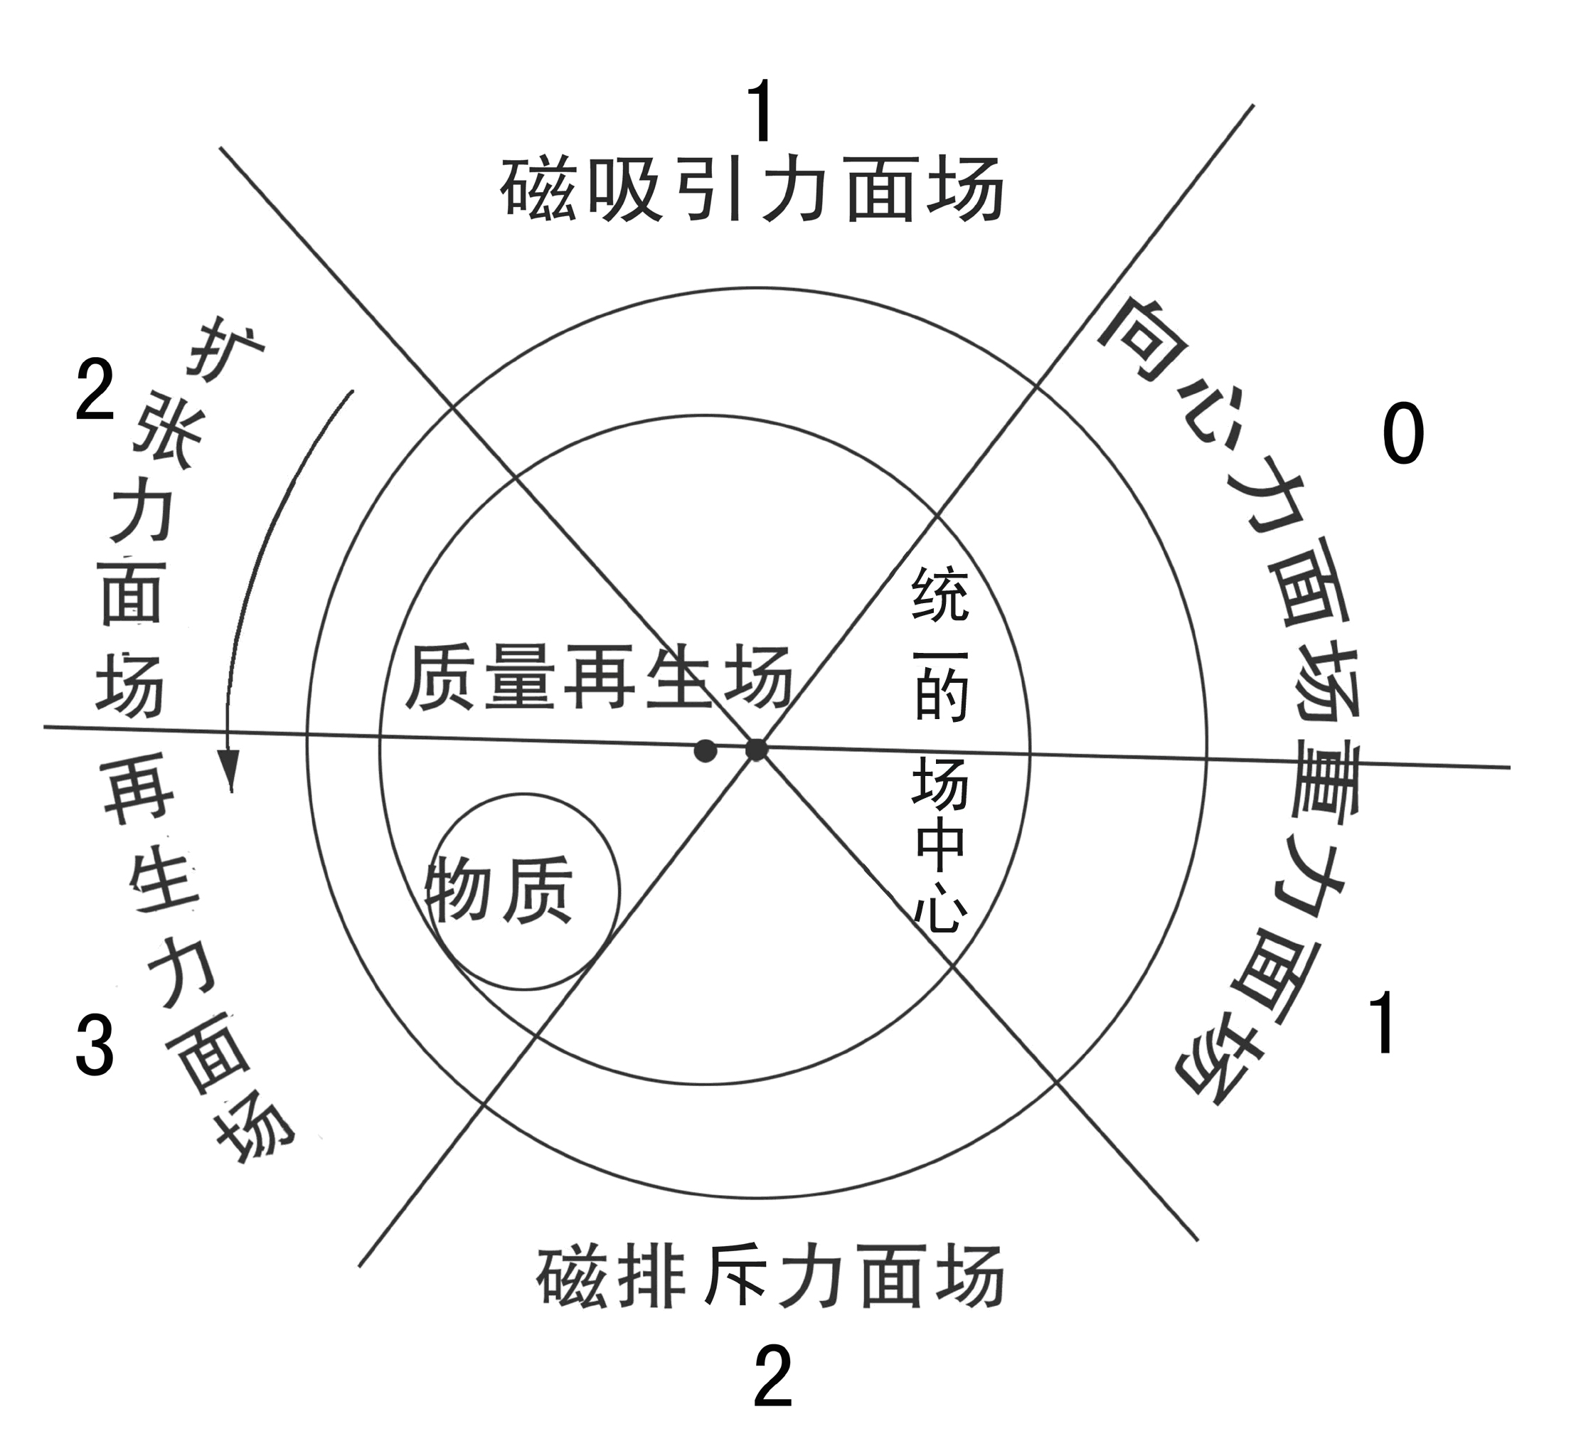
统一场论就是将事物形成和运动发展时的形态，浓缩到椭圆图形中去。并在图中各个位置设置各种数据，加以理论说明. 教会您去设、解、论各种问题。首先让你理解什么是统一场，如像图中各种力面场上的质量,在同一个场所上运动却复制出不同能量。 并发生了谁的活体质量大，谁就是统一的场。所以，将质量交换出能量的场所，在设、解、论如星系、星球、原子、植物种子、动物细胞,一个国家及一个人等事物时。 也可先把这个活体结构，定位看成是统一场的统一体。以后再来论叙一个质量是怎样在这个活体场上运动，才产生出如引力、电磁力、强作用力、弱作用力等太极子物理来。
什么是统一的场功能。将占有和消耗能量多的中心物体,如地球的自转极、原子的中心、一个国家的中央政府或一个人等事物,看成是统一的场。这样，就能对周围各个位置上如星球质量大小、运动速度快慢、距离星系中心远近等,做出准确的数学解释。
这个场是以向心运动形成，场的质量由周围场力面上向心力能量多少决定。它的功能，用来把周围的物体定位和在运动极限中统一作用，并为周围物体提供或遗传智慧能量。
因此，时间和空间就从这时开始，如万有引力等，相继在一定自旋推挤摩擦中产生。也随着自旋的消失，时间和空间就从这时结束。
什么是统一场论？例如星球在星系中心一边运动快, 另一边却运动的慢等问题论证时，就取其是发生在统一场上问题和论证过程所采用的方

法叫统一场论。它是由统一场论、椭圆图及设题解题公式所组成，论述万物运动发生在统一场上的难题。
椭圆图大圆圈的大小,是表示一个统一场物体的大小,。
图中小圆圈的空穴，在星系中心称黑洞空穴，它是离心力。似杠杆的力臂长短，或女性的子宫，或电脑复印机及工具、武器等，经过系统加速运动, 通过它将质量复制出更多能量。如汽油经过转化质量就不存在。所以，将小圆圈空穴及工具等，称质量再生场。是被用来复制出更多能量。
它有统一质量标准，场的质量越大,如离心力越大,或空穴偏得越大，或人们手中使用大质量的工具、兵器等，为它们复制出的能量就越多。
反之, 每当场或向重力面场向心力面场上运动时，越向上旋转运动就越慢，复制出的能量就越少等问题。
图中空穴中的物质等,也可认为做功物。它每被系统运动，质量越大，复制出的能量就越多；质量小或离心力小时，被复制出的能量就越少，或产生出合成进化就少。因此，它的运动, 既受周围环境、工具、兵器等的影响，也受本身质量的制约。并且它不能独立对自己复制能量。
椭圆图那六种（相对数）不同质量力面场，它表示万物及一个人等运动规律的时间，是作一元复始有序运动。而数字是表示它们在每一个发展过程中，做出了多少能量的的空间是无序运动。并且这六种场同质量再生场和统一的场中心一样，也有大中小三种质量。另一张图是表示它们在各种空间中，拥有的向心力和离心力推挤摩擦，就是周易八卦的所渭阴爻和阳爻。设解论事物时就要像周易预测或中医那样，将自旋的各种数椐多少，结合起来用才能得到正确结果。
.图大圆圈最上部, 表示一个事物质量运动时间的开始，或是在这样条件下运动合成的物体, 它没有什么能量变化，就统一用物理名词，称它为磁吸引力面场。它复制的能量1，匀速运动。
图突出上部一面，表示从上向下运动，它复制做出的能量2。称扩张力面场。
在它下部 ，加速惯性将质量复制出更多能量, 如使地球椭圆度大。称它为强作用力面场，或称再生力面场，它复制出的能量3。
总之,在这边都是加速运动，有一股惯性推力。
图最下部为磁排斥力面场，表示一个质量运动到这种场、或时间，它自旋最慢时向心力占上风，自旋最快时离心力占上风，复制出能量已减少为2。（在实际操作时应把它定位随着速度加快，它在2以上递增能量）称为不规则运动，会发生意外事故。
图的另一面是从下向上运动，复制出的能量已减少到1。在惯性中做降速运动，称它重力面场。
而在这种场上部，质量完全失去做功能力, 被摩擦力、引力等消耗能量，更使它作向心运动。因此，称向心力面场,也可称弱作用力面场，复制做出的能量0。
总之,在这边都是做降速运动，有一股向心拉力。就发生如收缩或退化等事出现。
当然,它们做出的能量已作连续向心加速运动，使这个合力组织结构空穴中心的物体质量，被自旋的离心力抛出去复制出更多能量做功。如果进行第二次运动计算或论述，应将系统总质量来乘加速惯性抛出去做功的质量大小、距离中心远近所得到的能量后，再按这个新数字去依次一一进行相乘惯性能，就可知这种各种场上一次次进化的能量，便使转速逐步加快，如发生了膨胀、光电磁或元素质量，似在椭圆图所在各种场位置上，被不断加速推挤摩擦发热的温度高低，也做出周期性的能量进化，或发生不匀速运动等。
因被复制出能量多的物体,不在沿消耗能量少的如椭圆运动，发展向消耗能量多的圆圈运动时，如夸克就复制不出更多能量，便又向椭圆运动，又在向心力作用下使它能量被加速复制提升，当它进入中心时,立刻使空穴中气体或物质，被它质量大的高温度蓝光等，产生出新的如团体或新的元素。或进入空穴中心，失去了被系统加速复制出更多自旋能量。就被质量大的摩擦力、引力等，统一了由自旋强度发散出的如电磁力、强作用力、弱作用力、引力。或事物进化的周期结束。
以上图是揭开了事物微观世界作椭圆运动，称向心运动而得到了向心力，使进入中心物质得到了系统自旋的离心力被抛出去做功，自然界万物就是以这两种简单不同推挤摩擦力表叙，才使统一场上各种场力面上的物体，无论在时间，还是在空间就有进化发展的自旋能量了，进而才逐步产生出如引力,电磁力、强作用力、弱作用力等问题。这样再来结合用太极子物理学等对它们的各种表叙，及结合以上各种数据灵活运用它, 就能去设、解、论万物或发生的不同随机问题和自圆其说了
统一场论除了用椭圆图来解开万物它们的过去，还是现在, 及将来，都是在运动中被复制出的能量多少，产生出统一椭圆球结构模型下，才进行了一元复始的进化运动外，去设题解题规律。还设立
max

Kg≠m·a2·t

Min
定见式公式启发您运用它去配合设题解题。公式从直观上杠杆形，还让您联想万物运动的质量，运动后不代表就做出是多少的能量。
“≠”告知设题解题人,质量在系统内运动速度中，复制能量的极限问题。有了这个极限，就可以知道事物生老病死和不匀速周期快慢的时间，并设计出了三种约定：①“m”表示合成初（期）的质量，或指历史的过去，“t”表示合成后所做出的能量的多少,或指现在的质量。 “kg”表示不同场合、不同条件，不同结果，或指它将来的质量。②无论过去、现在及将来，无论是星系还是原子, 是动物还是植物,是宏观还是微观。“≠”给出了它们都存有两种如快和慢的不同矛盾，构成矛盾进化发展的是速度的快慢，调和矛盾的是时间。
因此, 在一个结构中，它们都共同遵守如质量、加速度和时间以及在什么样环境等几个要素去设题解题；③“≠”也表示出在自转极两边运动有快慢的存在，及运动复制后发散出如光子、电子等等不同问题，因此，就要用不同的形式去论叙, 或用不同的公式去计算。t（时间）表示因为质量再生场的存在，才使事物运动后复制做出能量的多少。和自转极、再生场及各种力面场，各自以什么样的质量大小进行合成复制能量。
有了这些条件的存在,就让你联想到它们运动起来后的质量，所被复制做出的能量有三种情况岀现最多或最少：一是自转加速的快慢，复制发出能量有最多或最少的变化；二是在自转极两边不同环境运动的快慢，会导致复制做出的能量有最多或最少的变化；三是质量在速度极限时被统一前后的快慢，复制发出的能量也有最多或最少的变化等。并且，它们之间关系是互动随机中形成统一。其中如果有一个场力面运动的质量，合成进化复制出不同能量，都会带动其它各种场上千变万化的无统一定局走势，就使自然界新物种、新事物不断出现一样。就要一一去重新论叙, 或用不同的公式去计算。
因此，公式就像中国象形文字那样，既包含哲理，又包含用公式来启示引导读者发出联想，准确无误地去跟踪测量计算它们,一个个在不同场力面环境结构中，如是谁做出的功多少，超出系统质量承受力，发生了如“电磁力”、核子（质子、中子）之间的“强作用力”和原子衰变时的“弱作用力”等的统一原因。或根据定见式精神，去设这个事物理的数学方程去一一计算各种力的大小、强度等物理量来解开难题。
所以说，有了统一场论和椭圆图中那么多克星数据，教您设题解题，研究者心境自明，就可将各种难题模仿设计出自己的图形数据，或将难题填入图内相应位置，再来理清它们属什么性质,或存在于什么样运动结构中发生的问题。如是直线运动，还是在斜面上作椭圆运动；这样就能对它们运动，作全面、系统、有联系、有发展的眼光，来论证如星球在星系这个统一场上运动,所发散出的各种不同随机问题。也能简单快捷地方法去论快或慢的问题。同时，对牛顿、爱因斯坦质量转换能量观及量子论,超弦论等各种理论，也作了归纳和科学按排灵活运用。明确了谁的质量大或是方法得当,谁就是在这个自旋的统一场上是统一的场。
今后，统一场论这个万能理论和椭圆图，一旦得到人们的认同，将会去建立起更雄伟的，如钢筋混凝土的框架结构新的哲学和物理学等科学大厦，去设题解题。并会引领人们将质量存放进一个系统内去复制出更多再生能量，一个科学大发展的道德化新时代，去造福人类。
统一场论的应用
下面来看统一场论是怎样去设题解题的，在此仅作简单表述，举一反三，具体请看统一场论45篇系列中的文章，如《伟大宇宙母亲大分娩》，及利用这个理论配合王锡玉解162道难题等自圆其说。来帮助您进一步理解统一场论的科学价值。
掌握要领例题一：在统一场论的物理公式中，设出质量在速度中复制能量的极限,并在t时间时各自存在最大或是最小的那一种质量进行合成。统一的场就用中央政府,质量再生场就用经济政策，各个场力面就用各种质量思想人群。在同一时间开始运动时, 它们是以什么样质量出现合成和运动呢? 是一、二、三种质量中的哪一种？如果每一种场它们都以最大质量三出现，设原始类复制出能量为一、进步类为二、先进类为三，摇摆不定投机类为二、落后类为一、困难类为零来构成了一个椭圆运动体系。当先进有经营管理能力有资金的人场办工厂、办公司，好比是在质量再生扩张力面场、再生力面场上,经过加速和一段时间的运动,如用数字表示三乘三乘二、三乘三乘三, 他们分别做出能量是十八和二十七；而经济政策再生能量三和没有经营管理能力、缺少资金的人场靠打工去挣钱，这时就好比是在重力面场、向心力面场上运动，他们没有暗能量、暗物质的帮助，经过一年时间的运动后，如用数字表示,他们经济上的积累是三乘三乘一、三乘三乘零, 他们分别得到的能量是九和零。从统一场论中知道，这些人群各经一年年的能量积累，它的质量已被这个运动的合力组织结构,在惯性中进化不守恒加大了。因此，今后各自将能量钱去发散出感兴趣的事。假定原始类去搞土地出售、出租，进步类将钱投房地产开发，先进类将更多钱除了作房地产开发，还发展其它项目，摇摆不定投机类市场什么赚钱就做什么生意。如收、卖房地产赚钱，落后类和困难类将积累钱去购房屋自己居住，一个循环发展的消费链。
由于市场运动发展和各种人群发展速度不同，原始类、落后类和困难类将积累钱去购房屋,是跟不上物价的上涨，就出现供大于求或对社会的不满情绪。因此，质量大的中央政府,首先要根据事件是在计划经济还是在市场经济结构中运行，它们发展时的运动速度和组织结构,及政策或策略是否损害共同利益，超出自身一定承受能力的比例关系,也就是超出最大或最小极限时，才要随机地利用不同智慧，如政策、法令，或在自身运动能量结构中调整,去统一它的不合理的力。如在市场经济结构中运动，比较复杂，就要综合治理，因为它的危害性同高额运行的股票是双胞胎。一个掏空企业利润空间，一个是掏空社会各空间。所以要将违法出租和出售土地、违法搞房地产的单位或个人、用余利买卖房地产、银行内不负责任贷款、调高低收入人群工资、对困难户购房补贴、及对潜在如低价拍卖公有制房产,支付高价拆迁费等等问题进行综合治理。让事物内部各组织结构，在强大的运动或精神运动造势中及法治制度化中，产生凝聚力的统一。这样就能像椭圆图六种力面场那样有一定规律，既相适应、又相矛盾的相对有序,和谐不规则合力运动速度中搞房地产。但绝不是将事物或事件在运动发展中，被视作和圈定或调节为没有一定比例、没有一定矛盾、没有一定差别的同一和单调运动或无政府政策管理发展形态中搞房地产。
如果中央政府不能及时制定出什么新的政策，或强制统一不了那些质量小或方法得当的人和事，就缺少了民心的向心力，社会将向不安定发展。
掌握要领例题二：为什么星系两边出现不同一运动速度的旋臂？这要将研究的难题即实证,快和慢放在椭圆图结构快和慢的位置上，首先从直觉、顿悟出发就能找到你所需要解决快慢问题的原因来。一颗颗星球质量大小已造成星系倾斜度大小不同，它改变了一颗颗星球在围绕星系中心周围运动时所作出的能量多少的常态。如一些质量小的星球，或己从扩张力面场、再生力面场运动到重力面场、向心力面场上的一些质量大的星球，它们是从星系斜面下作向上运动。由于这两种场内均有一股向心拉力，这时星球内星核被复制做出的自转能量就减少。因此，星系中心这边向上运动的一颗颗星球，自转被重力、摩擦力引力等统一，使它在惯性中降速逐步向星系中心质量大收缩弯曲形成了密度波，来获得向心力和相互利用斥力推拉前进。而另一边星球是在星系斜面上作向下运动,有一股加速惯性推力帮助, 使星球内做功的星核，如地球的地核在系统中运动，每被离心力发生膨胀向外位移运动一步自旋, 就可通过空穴一边似杠杆力臂，在加速惯性中复制出更多能量。就对地幔再生力面场内壁岩石施力越多，也就加大了球体域面上地壳小活动板块活动和运动的能量。同时地核里面有些小颗粒物质，就像被滚雪球似地，被旋转复制成大大小小的火山蛋球体，它们铁的质量被离心力和向心力推挤摩擦不断加工，使它们同地核一样也产生了磁性铁球。不断受离心力推动，随着地核运动发生漂升不在沿椭圆图上消耗能量少的椭圆运动，发展向消耗能量多的圆圈运动。因此,这时自旋就被统一的场中心质量大的摩擦力、引力、重力等统一了强度，使它发生了收缩向上中心球形加速运动,呈空8字形向南北极作螺旋式上下旋转循环运动，并同地幔一块块的板块被地壳运动的向心力，以及地核的离心力推挤摩擦发热不断加工，一些地幔板块也产生了磁体。由于它们是连续运动，使南北极球体上下处,不断受到磁体的光临积累，就产生了南北极的磁场；也就是由如太极子电子等速度快慢和分布的数量多少，铺设了一条所谓磁场高速公路通道，产生出质量大小的电流等。地幔那白天一块块板块结合处突出下垂时空出的空间，却造成了天空磁层多个大空洞（可参观永动机内部结构）；而地壳周围一块块活动板块一端，朝太阳一面白天也在向外突出下垂加速运动时产生出光子，夜间在向内收缩弯曲做降速运动时产生出电子，这种球体两边一块块小活动板块，有规律地左右依次运动于南北极磁场上，就拉断了由地核旋转运动和地幔板块所作椭圆运动的磁感应线。因此，就能从机械能转换成电流加大加快自转能力了。当然，原子内电子是作向心力, 光子质子作离心力,使两个物体互相摩擦时，那个物体的原子核束缚电子本领弱,它的一些电子就会转移到另一个物体上，失去电子的物体因缺少电子而带正电, 得到了电子的物体因为有了多余电子而带等量的负电。所以，当发生电子自转加速和复制出能量多少不同时，就出现星系两边有一边运动快和一边运动慢的不匀速现象。
就是说，星系两边不同一的运动速度的旋臂, 一方面因星系一边有拉力，另一边有推力, 复制出的能量就不同。其次一方面星系两边星球质量不同造成的，如一边是暗星它们处于质量进化的早期，自转速度较慢。另一边白矮星是质量进化的后期, 它们合成进化复制，和再合成进化复制出的能量就多，自转速度必然要快；另一方面是由于星系中心周围各种场力面质量不同，迫使各种星球在各自环境中运动，被复制出不同能量，就发生运动速度的快慢。另外，星球倾斜极的度数大小,也决定星球质量在速度中复制能量极限的多少，同时还会出现星系中心两边有不同的不匀速周期的快和慢现象，以及做出的椭圆运动轨道,和倾斜极的度数大小不同等问题。而这种系统中的难题，如果用现有物理理论和定律，就不能解释清楚了。
参考文献：
1.美国阿西摩夫著，王涛、黔冬等译，.《宇宙、地球和大气》《自然科学基础知识》第一分册，科学出版社1976年。
2.陈聚全、陈江兰编，《哲学自学考试辅导与训练》，华中理工大学出版社。
3熊承堃 刘良俊 著《太极子物理学初论》。重庆出版社
及30年后2007年春节后才看了香港人写的奇门遁甲书使我增添了智慧和力量。
鸣谢：
南京大学外国语学院杨琳小姐及扬州大学政治教育专业2007年毕生徐敬翻译英文
广东省雷卅市北和中学物理组陈天华教师为我论文修改指导
作者简介：孙纯武(1948年-)，男(汉族) ，扬州市，主要从事研究自然科学等；
作者声明：我保证是此作品的著作权人，
单位名称、江苏省扬州三力电器集团 通信地址、中国江苏省扬州市西湖镇59号

