Desalination Water With Surfactant a New Method With Clear Vision
Moharam Barzegar Zenouz¹
- International Research and Training Institute of Barzegar Zenouz
Unit 1, First floor Neyayesh complex,Neyayesh high way, 2nd Shahran Square, Tehran, Iran
info@bzrt.ir

Abstract: Reverse osmosis (RO), multistage flash distillation (MSF), mediated electrochemical oxidation(MEO), electrolysis and ion exchange are in different condition indubitable RO is consider to be the best method (less than 0.8 $ /m³). In this regard for production of desalination water degree of salinity, environmental and economical cost are the determining factors. International Research and Training Institute of Barzegar Zenous has invented a new method of desalination. Desalination of water using surfactant in comparison with other methods in a wide range (700-60,000 ppm) makes it an acceptable method laboratory-scale and pilot plant. It makes sunny horizon for up grading technology and reaching to economical cost for each cubic meter of water. Importance of this technology will be more clear with demand of increase and drinking water.
Key Words- Surfactant-RO-MED-MSF-Electrodialysis-Desalination-Ion exchange
1. Introduction
Energy is one of the most basic and mooted subject in development countries and access to useful water (drinking- industrial- agricultural) from view of economic is one of important developing instrument. In future the method of surfactant desalination of water makes concentrations lower than 700ppm which most rational and economical for ion deleting rather than present conventional methods. But it doesn’t work for other impurities. Cost increases with increasing concentration. The electro dialysis and reverse osmosis from view of economical has preferable in concentration more than 5000ppm and distillation is an economical method for elimination of imparities in concentration in range of 100.000 ppm Of course, mentioned method has own usage range according to necessity and economical warranty. With growing and developing technologies new methods can reduce cost and increase efficiency. RO has allocated the most efficiency, in high concentration and the cheapest among mentioned methods.
The following conventional methods for desalinate brackish water is investigable:
1)From view of ability and usefulness every method has its portion in desalinate.
2) Economical investigation for every method
3) Environmental investigation for above methods
4) Technological, mechanical and operational technique
Brief description of conventional methods
1-Heating methods
Include multi stages suddenly chummy system methods, distillation with double effect and multi stage distillation,…. basic operation is steam production, exchange steam energy with salinity water and its variation by making vapor causes reducing boiling point. The distillation method produces desalinate water. We can repeat these stages with more efficiency to reduce waste of energy, and reduce cost of exploitation.
In this method if stages increase, cost reduced and according to use of this methods in salinity and sea water below 50 ppm can be prepared achieving drinking water. Usually capacity of motion units diverse and units to capacity under 100000 m³/ day is useful.
Efficiency of heating unit is increased by:
- Increasing number of stage
- Increasing temperature of feed in preheating section
- Increasing heat transfer
- Corrosion prevention
Pretreatments for this method include screening (physical) and anti sediment, anti microbe material and remove of gases.
2- Reverse osmosis
In recent years, RO system has been developed with technology expanding and building of membranes with high efficiency to reduced the heating system stages.
RO method removes ions to 95% and microorganisms to 99% and dissolved solid, can replace for heating methods or is competitive technology.
RO operation is to transfer water from diluted media to concentrated media.
With membrane and concentrated media the liquid is raised in concentrated media, if pressure is inforced on concentrated media. By using mechanical instruments , reverse direction of motivation water is possible to pass salt ions by tape of membrane water with rather purity conduct. From salinity water to opposite side and therefore we can get desalinate water from sea water. It's clear that geometrical figure seam and type of membrane and remove pollution and solid ingredient type of membrane can influence on RO method. RO operation in used for desalinate of sea water for drinking, hospital requirement and industrial proportional to achieve quality water.
3- Electrodialysis.
Electrodialysis method is base on using direct electricity that can shift cation and anion opposite direction. According to splice of salt solution and line of demarcation in a process, electrodialysis parts were prepared:
A) Pre treatment part
B) Membranes
C) Circulation pump
D) The source of electricity
E) Perfect treatment part after electrodialysis
4) Ion exchange (DI)
In this unite resin is used to interchange hydrogen with cations such as calcium, magnesium, sodium, salt solutions ,OH with anion can exist in water. Certainly the material used this stage can be anions or cations acting although efficiency of weak resins comparing to strong resin but it is more effective in industries and more expensive resins, because the efficiency of weak resins are better than others. Recycling efficiency is usually less than 40% for strong resins, while it is 100% for weak resins. Weak resins can be recycled by using weak or strong acids or bases. Ion exchange unites can be produced water with high purity, and less salt concentration which is preferable to other methods.
Using ion exchange method combined with the following techniques can eliminate pollution from water with higher pollution in water.
1-Floccalation of coagulation
2-Sedimentation
3- Aeration
4-Elimination algae
5-Hardness
6- Filtration
7-Absorbtation
8-Disinfection
9-Micro filter
10-Ultrafiltratin
11-Nano filtration
- | bacteria | suspended solid | range of desalinate | non ion dissolve solid | dissolve solid
distillation | unsuitable | unsuitable | concentrate & salinity30000 | suitable | suitable
ion exchange | unsuitable | unsuitable | very diluted<700ppm | unsuitable | very Suitable
reveres osmosis | very suitable | very suitable | 30000<Salinity and brackish water | suitable | suitable
electro dials | unsuitable | unsuitable | -~ 7000 | unsuitable | very suitable

Different methods for water purification
Desalinated water and increasing pollution of under group water are main sources of desalinated water for creating the desalination unit which has the following costs:
1-Maximum cost of feed (30% the whole cost)
2-Pretreatment cost
3-Desalivation cost
4-Storing cost
5-Operation cost (energy, chemicals, consuming cost,)
6-Human cost
According to pattern of sampling (using of sea water) the cost of investiture was estimated to be 1000 euro per m³/day. This cost can be reduced by changing the geography surrounding & capacity and other parameters. Under the best conditions the cost of produced water can be estimated to be about 50cent/m^{3.} With RO method and kind of sensitivity, apply consumption ratio to purity and elimination of contamination in water the kind of treatment can be chosen. It's clear that the role of dependent cost plays important role in the choice of other method.
Following are principles of environment in desalination of water
In planning & creation of an industrial desalination unite of place plays important role because environment and stable extension source of water consume energy, landfill and nearing to habitable can also play important role in economical & spoiling. One of the main factor that is related to desalination is minimum 20% liquid that should discharge waste in the open place and without planning in a discharging of waste. The pollution can increase in underground and surface water which show in below table.

Surface disposal | Disposal in surface water
 | Floating disposal in water
Wastewater treatment plant disposal | -
Waste disposal to end of flow waste water treatment plan | -
Use of water | This method include spray, treatment and leakage lake…
Injection to deep water | -
Waste disposal at evaporation lake | -
Disposal by removing total water | Use of evaporation mechanisms in order to change liquid disposal to solid and dry waste

Applying surfactant for desalination of water
According to worldwide requirement to desalination water and it’s importance, International Research and Training Institute has defined a project “Desalination of water with surfactant “ since 2000 and developed a new method successfully and obtained noticeable results. This method is registered as an innovation on 2008.06.13 in Registration Office for Company and Non Commercial Institute .

Figure1: Desalination method using surfactants
Anions & cations Surfactants
&M

In this method there are two pipes with different diameters, the first pipe with fewer diameters is inside the second pipe, internal pipe with membranes is related to external. Internal surface of external pipe is coated by surfactant. Passing water from two pipes attracting anions and cations by surfactant, exhausting water from internal pipe has less salinity and exhausting water from external pipe with more salinity which is the base of desalination in this method. Effective parameters are:
- Fluid velocity
- Pipes diameters
- Rate of salt concentration
- Temperature and ….
This Institute has prepared NaCl solutions with different concentrations from 700-60000 ppm and tested them. Electro conductivity is the base of measurement and concentration reduction has been measured in different section of pipe length and figure 2 has been found. As seen in the diagram salt reduction process has reduced with salt concentration reduction during the pipe length.
1)This new method works without using electricity and energy which is the most problem in water desalination. Of course, it is clear that this method needs minimum electricity for water pumping at inside and outside systems.
2)This method doesn’t need so much raw materials in contrast to the other methods especially ion exchange.
3) This method does not have any complex technology, doesn’t need experts and adversity personal for maintenance and service.
4) According to primaries forecast this method is cheaper than building cost of water desalination unite. According to some calculations, International Research and Training Institute of Barzegar Zenouz has used inexpensive materials for building of a pilot for every cubic m³ meter which is about 50 percent cheaper than RO equipment cost equivalent to 500 Euro.
5)Achieving cost of a cubic meter of desalinated water with this new method is about 50 cent.
6)This method can be used in small volume and supply water for example for small villages. This method doesn't need energy and heavy and expensive equipments compare to the other methods.
7)This method has remarkably advantages from environmental point of view such as using low of electricity, heating and fixity surrounding temperature since this system doesn’t need heating. This system approximately has natural sources, so doesn’t have any especial effect on environment. And doesn't have any risk on environment. In case of leakage and disposal, the waste water emission has about 40% desalination water.

Figure2: Approximately performance diagram of desalination unite according to testing condition

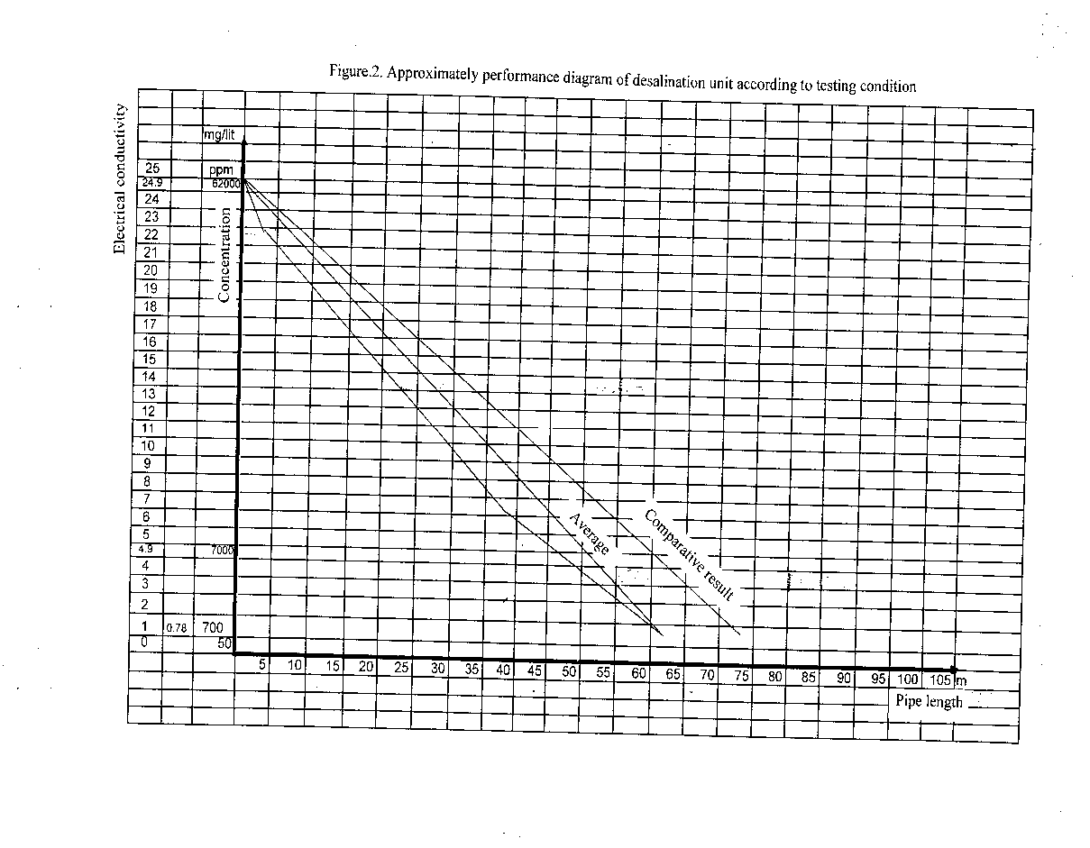
Conclusion
Using surfactant is a new method for desalination of water after passing necessary stages for industry. It has ability to enter the competition with ordinary methods. The cost of a cubic meter of desalinated water by RO method is the most desirable and available method in market, arriving to 40-50 cent since its invention in 40 years ago. It is clear that achieving cost of water by this invented method in center after optimization and achieving to product large amount of water will decrease the cost remarkably. Invested cost of this new method in pilot plant and first sample test is about 50 per percent of RO method that is 500 euro. Also achieving cost of a water per cubic meter in this stage is about 40 cent, that naturally every one of these figures gradually will decrease in mass production with engineering and optimization conditions in system.
It should be mentioned that achieving cost of a desalinated water per cubic meter by RO in system was more than 2$ using method has decreased the cost to 40-50 cent now.

References
1)Məllavialle J. Water treatment membrane, 1996.
2)Candew P.T, Membrane processes: A technology Guide; Lem.s., Royal society of chemistry, 1998.
3)Cheryan M, Ultra filtration and Micro filtration Handbook, Technomoc Publishing Co,1998.
4) Wangnic K, A Global overview of water desalination technology the respective, 2000 .
5) Semiat R, Desalination: present and future, International water resources association water international, 25(1): 54-65.
6) Seawater desalination in California, California coastal commission, available in http:// www.coastal.ac.gov/index.html,2007.
7) Gholfr B, Nosraty, M, Desalination sea water for industrial application, Ministry of Jihad- E- Agriculture, Iran.
8) Martini S. Nonionic surfactants:volume2.
9) Cross J. Nonionic surfactants, Chemical analysis:volume12.
10) Schick M. Nonionic surfactants: Physical Chemistry:volume23.
11) Eric J. Cationic surfactants: volume4.
12) Richmond JM. Cationic surfactants: Organic Chemistry.
13) Donn N. Rubinyh &Paulm. Cationic surfactants, Physical chemistry Holland:Volume 37.
14) Warner M . Anionic surfactants :Volume 7.
15) Schmitt TM. Analysis of surfactants, Principles of water treatment M. C. Amiri ph. D: Volume 40.
16) Gleick H. The world’s water 2006- 2007.
17) Murakami M. Managing water for peace in the middle east .

