The Study of Persian Gulf Cuttlefish ( Sepia pharaonis) Chromosome Via Incubation of Blood Cells

Drs.Foroogh Papan¹, Dr. Ashraf Jazayeri¹ and Marjan Ebrahimipour²

¹ Department of Biology, Collage of Science, Shahid Chamran University, Ahwaz, Iran. . Postal code: 65355141. Contact phone: 00989161414883.

² Graduated from Faculty of Sciences, Shahid Chamran University, Ahwaz, Iran. Postal code:3148844744.
Contact phone: 00989125664946.

Jazayeriashraf@yahoo.com

Abstract: Nowadays it is recognized that cuttlefish have extensive function in different basis. Despite this, there is some information about biology of cuttlefish. Due to this fact that no chromosomal study on Sepia pharaonis in Iran and even all over the world, has been dene, they just consider the chromosomes numbers in Sepia pharaonis in Persian Gulf (Bahracan region). Bahracan is one of the important fishing ground in eastern part of Khuzestan province. In this area fishermen hunt aquatic animals with trawl and gargoor.
In this project blood cell Incubation was used. Chromosomes preparations of the Cuttlefish Sepia pharaonis were studied using conventional Gimsa staining.
The numbers of diploid chromosomes (2N) of Sepia pharaonis were 48 and most of the metaphase plackes were in a range of 42 to 56. [Journal of American Science 2009;5(7)]. (ISSN: 1545-1003)].

Key words: Cuttlefishes, Sepia pharaonis, Cytogenetics, Persian Gulf

1. Introduction
A subclass of Coleoidea includes two subdivisions which Neocoleoidea is one of them (Nishinguchi, 2007). It contains Octopuses, Squids and Cuttlefishes. Neocoleoid is characterized by either, reduction and internalization of the shell or complete loss of it (Nishinguchi, 2007) so, as a result of it, a little information about origin and its relatives is available (Nishinguchi, 2007).
The shelled Cephalopods which originally belong to period of cenozoid (Khromov, 1998), such as all present forms of Squids and Cuttlefishes, have a vast distribution such as, regions of Indo-Pacific, along the coast line of the African coast to the Red Sea, Arabian Sea and China Sea (Meriem, 2001). In the above mentioned waters, the main distribution appears in the less than 50 m. depth.
Sepiidae family which belongs to order of Sepioidea (Roper, 2005), has significant value to commercial and industrial fisheries. Generally, due to the food crises which may end to a big disaster (Verbeke, 2005), sooner or lather is beter to be studied. More so that we would able to get benefit of it, in a large amount, in human consumption, all over the world.
To the fact that the recent molecular studies, have shown a high level of differences between phylogenetics of Coleoid Cephalopods ( Strugnell, 2007), the produced results are conflicting and to extend more confusing.
By taking in to account, the different geographical areas and observation of the fact of adaptation, encourage us to focus on the study of phylogenetics of Sepia pharaonis in Bahracan, which is a part of Persian Gulf. In this respect, the numbsr of chromosomes of Sepia pharaonis was determined and then it was compared with other species.
Chromosomal changes, particularly polyploidy, have played a significant role in the evolution of plants, and most higher plants are recent polyploids (DeWit, 1980). Although polyploidy is relatively rare in animals, chromosomal changes are increasingly recognized as an important force in animal evolution.
The extent of chromosomal changes and their roles in speciation are poorly understood in many animal taxa, including marine cephalopods. Chromosomal studies may provide a unique perspective on the evolution of marine cephalopods.

2. Material and Methods
The species of Sepia pharaonis, were collected from Bahracan regions which is part of Persian Gulf and is located in 49ْ 30´ E to 49ْ 55´ E; 30ْ 15´ N to 29ْ 50´ N. In this area fishermen hunt aquatic animals with trawl and gargoor.
The collected specimens were identified accordingly Silas, 1985; Aoyama and Nguyan, 1989 and Graham, 1994.
At the sea, blood samples were taken from 10 specimens that were chosen randomly from different catches of the area. Blood, spesificly, obtained from the central heart and branchial heart (figure1), and it resuspend in RPMI 1640. Cell division was arrested at the metaphases, using colchicin solution at the concentration of 0.1 cc. cells were incubated with cold 0.075 M Kcl solution for 20 minutes, prior to fixing in a fresh solution of acetic acid / methanol (1:3) for 10 minutes. Cell suspention which was dropped on the slides, was air dried and stained with 5% of Gimsa solution for about 15-20 minutes. The slides were observed by light microscope (Olympus, Japan), equipped with camera. Metaphase chromosomes were examined at 1000X magnification.
Then they were photographed and counted. Representative metaphases were printed on high contrast papers.

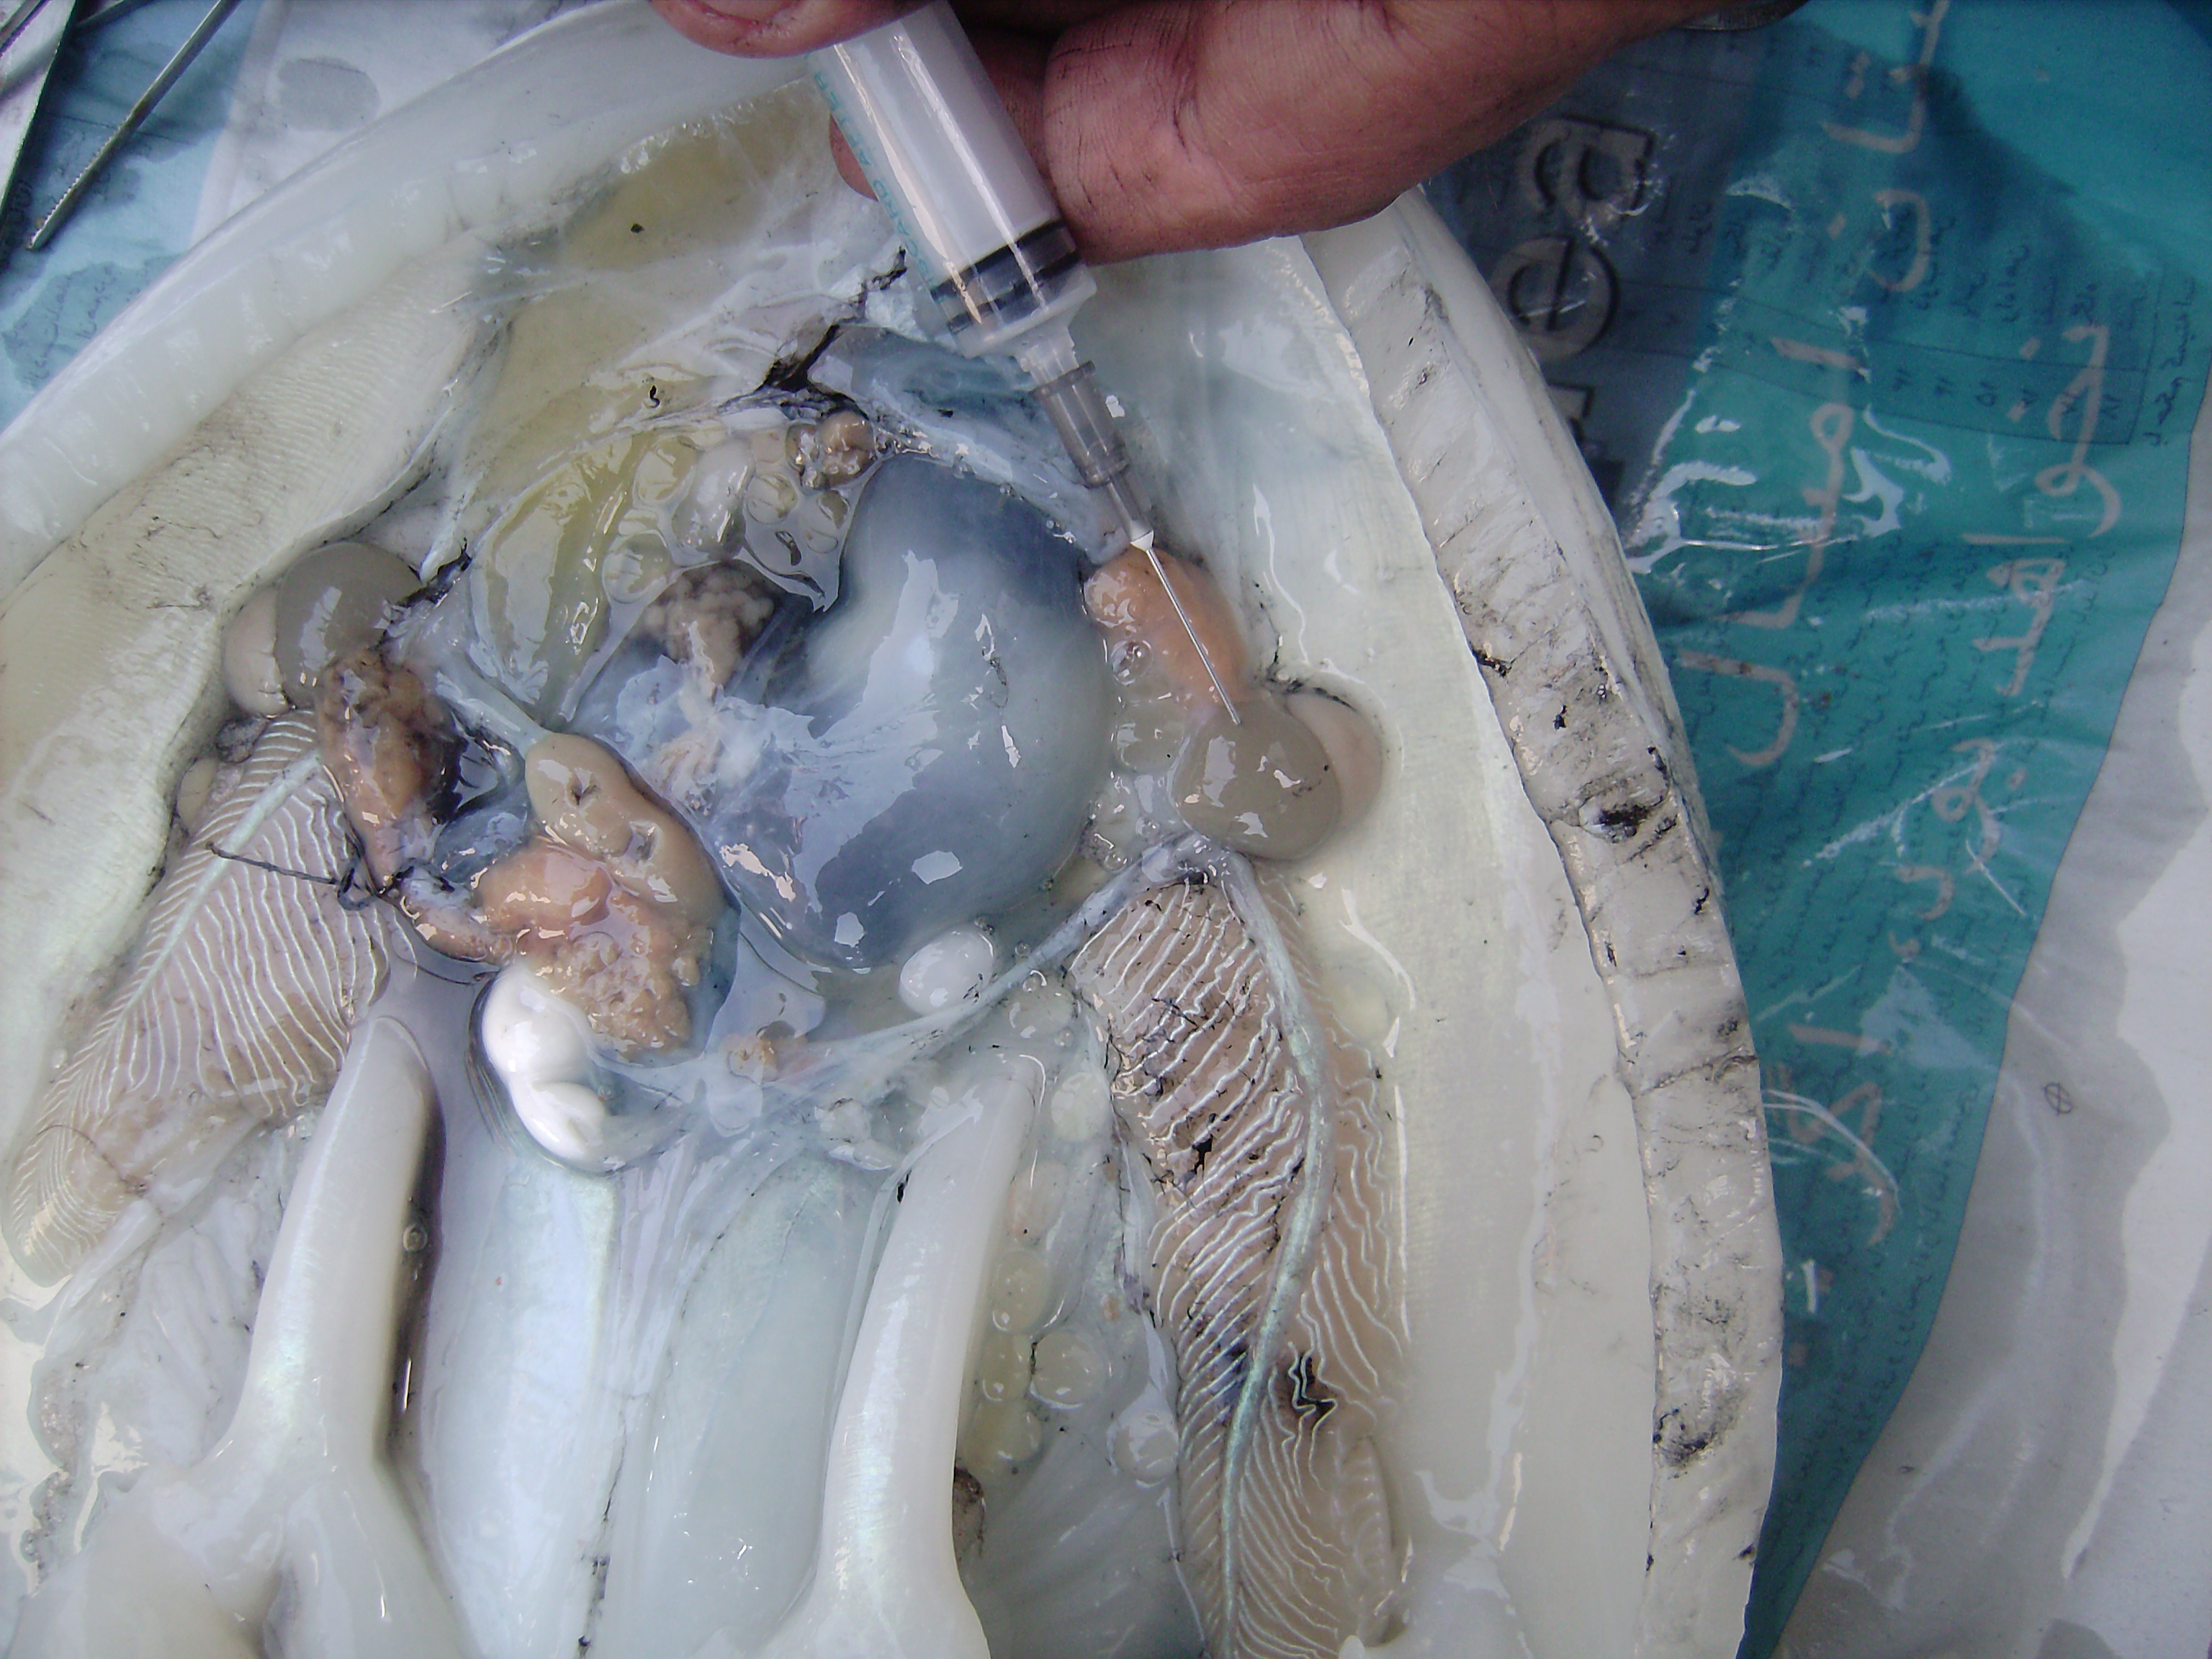

Figure 1. blood taken from branchial heart of Sepia pharaonis

3. Results
The obtained results showed that the numbers of diploid chromosomes (2N) of Sepia pharaonis were clearly 48 (figure2) and most of the metaphases plackes were in a range of 42 to 56. From the point of view of morphology, the chromosomes were different kinds such as submetacentric, telocentric and acrocentric. In adition, micro chromosomes were observed in all the pelackes.
In 2005, Karyological studies were made by Yue Mian and Yutaka on the embryos of seven cephalopods using chopping method. Two sepiids (Sepia esculenta and Sepia lycidas) and three loliginids (Sepioteuthis lessoniana, Heterololigo bleekeri and Photololigo edulis) were all 2n=92. Their karyotypes and total length of chromosomes were slightly different from each other. Two octopuses (Octopus ocel-latus and O. vulgaris) were both 2n=60. Their karyotypes and total length of chromosomes were, however, remarkably different from each other.
Nakamura, 1985, showed that chromosomes of cephalopoda species have high diploid numbers, 2N= 52 and 56.

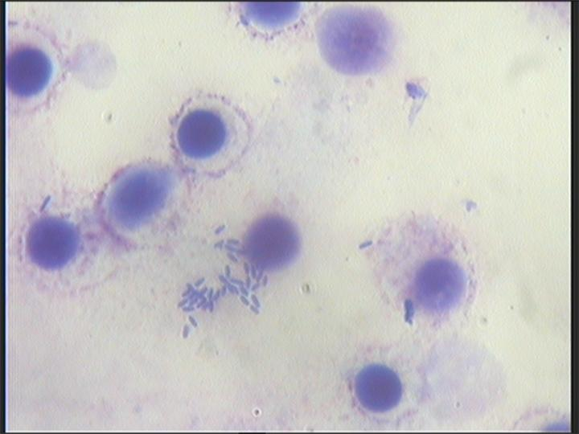

Figure 2. metaphases pelackes in Sepia pharaonis

4. Discussions
Phylogenetic studies based on nuclear and mitochondrial gene sequences have helped clarify cephalopod taxonomy. 18S rDNA sequences are available in a large range of taxa including cephalopods. The chromosomes number of cephalopods (52-112) are the highest among Mollusca (28-32) and their progression appears non-random. The number of chromosomes and the proportion of large chromosomes are higher in Decabrachia than in Octopoda. Thus, both number and morphology appear to change radically during evolution.
According to Nakamura, 1985, the range of the numbers of diploid (2N) chromosomes in Bivalves is 14 to 48, in Polyplacophora is 12 to 26 and in Cephalopoda is 52 to 56. in thus respect, it is clear that among the rest of the above mentioned invertebrates, Cephalopods has the highest number of chromosomes, although, Nutilus has the lowest number of chromosomes than other Cephalopods which is said, it is probably a matter of its ancestral (Bonnaud, 2003).
There is not published information on the chromosomal morphology of Cephalopoda. Inaba (2007) showed that Octopus vulgaris and Octopus variabilis have 2N = 56 chromosomes.
Cytogenetic data are used in taxonomoi analyses. Gene sequences, chromosome number and morphology can all be used as phylogenetic indicators, conservatism of chromosomes number being reported for many mollusc groups.
In the present study, species of Sepia pharaonis has number 2N = 48 chromosomes. Also they are, submetacentric, telocentric and acrocentric. Moreover, in all the plackes microchromosomes were observed.

Corresponding Author:
Dr. Ashraf Jazayeri
Department of Biology
Shahid Chamran University
Ahwaz, Iran.
E-mail: E-mail: Jazayeriashraf@yahoo.com

References

1. Aoyama,T. and Nguyan, T. Stock assessment of cuttlefish off the coast of the people’s Democratic Republic of Yemen. Shimonosaki University of Fisheries, 1989; 37(203) :61-112.
2. Bonnmaud, L., Saiahi, A. and Boucher-Rodoni, R. Are 28s r DNA and 18s r DNA information for cephalopod phylogeny?, Bulletin of Marine Science, 2003; 71:197-208.
3. Dewit, j.m.j. Origins of polyploids. Biological Relevance, W.H. Lewise, ed. Plenum press, NewYork. 1980; 3-15.
4. Graham, J.P., Mastic, L.C. and Boyle, P.R. Morphometric variation in Loligo forebsi and L. vulgaris: regional, seasonal, sex, maturity and worker differences. Fisheries Research, , 1994; 21: 127-148.
5. Inaba, A. Notes on the chromosomes of two species of octopods (Cephalopoda, Mollusca), Japanes Journal of Genetic. 2007; 34: 137-139.
6. Khromov, D.N. Distribution patterns of sepiidae. Smithsonian Institution Contribution to Zoology, 1998; 586: 191-206.
7. Meriem, S.B., Mathews, C.P., Al- Mamry, J. and Al- Rosadi, I. Stock assessment of the cuttlefish stock Sepia pharaonis in the Gulf of Oman. International Conference On Fisheries, Aquqculture and Environment in the NW I ndian Ocean, Sultan Qaboos Univercity, Mascat, Sultanat of Oman, 2001; 7: 91-97.
Nakamura, H.K. A review of molluscan cytogenetic for molluscan chromosome. Bivalvia, Polyplacophora and Cephalopoda, venus Japens Journal Malacology. 1985; 44: 193-226.
8. Nishinguchi, M.K., Mapes, R. Cephalopoda. In: Molluscan evolution. Journal of Molluscan Studies, 2007; 1464-3766.
9. Roper, C.F., Sweeney, M.J. and Nauen, C.E. Cephalopods of the world. An Annotated and Illustrated Catalogue of Species Know to date. Volume I. Chamberd Nautilus and Sepioids. 2005: 106-108.
10. Silas, E.G., Sarvesan, R., Nair, K.P., Sastri, Y.A., Sreenivasan, P.V., Meiyappan, M.M., Vidyasagar, K., Rao, K.S. and Rao, B.N. Some aspects of the biology of cuttlefishes. Cephalopod bionomics fisheries and resources of the exclusive economic zone on India. Central marine Fisheries Research Inst. Cochin, India. 1985; 37:49-70.
11. Strugnell, J. and Nishinguchi, M.K. Molecular phylogeny of coleoid cephalopods (Mollusca: Cephalopoda) inferred from three Mitichondrial and Nuclearloci: A comparison of alignment, implied alignment and analysis methods. 2007: 205- 220.
12. Verbeke, W. Agriculture and the food industry in the information age. Journal of Agricultural and Economics. Oxford University Press, 2005; 32: 347-368.
13.Yue mian. G. and Yutaka, N.; Karyological studies on seven cephalopods. The Japanese Journal of Malacology. 2005 ; 49(2) : 126-145.

19/9/2009

