Groundwater Chemistry Of Nagapattinam Coastal Town, Tamilnadu, India.

T. Ramkumar, S. Venkatramanan, I. Anitha Mary*, M. Anuradha, S. Varunkumar.
Dept. of Earth Sciences, Annamalai Unviersity. Annamalainagar - 608 002.
*Corresponding author: geoanitha@gmail.com

Abstract
Seasonal study on the ground water quality was carried in the coastal town of Nagapattinam, Tamil Nadu. Totally seventy two groundwater samples were collected from nine wells covering three season (postmonsoon, summer, premonsoon) during 2007.
The groundwater quality was determined on the basis of (APHA-1998), were physical and chemical parameter like (Ec,pH,TDS,Ca,Mg,Na,K,No3,So4,Cl). The analytical result indicates two or three well water suitable for drinking purpose, remaining suitable for domestic, irrigation and industrial usage. The piper trilinear diagram indicates that the majority of the sample falls in Na, Mg, Ca facies is dominating in groundwater, which is followed by Cl, SO₄. The USSL classification indicates most of the samples fall in salinity and sodium hazard. Finally correlation coefficient calculation method also adapted.
Keywords: Nagapattinam, hydrogeochemical facies, correlation coefficient, Irrigation water, Seawater intrusion.
Introduction
Water is a precious and most commonly used resource. Surface water resource, being exploited from time, may become short of supply or may not be easily available at site. Groundwater commonly occurs and it is widely distributed. There has been an increase in ground water development and utilization, particularly in developing countries for agriculture, industries and rural water supply schemes.
Groundwater is a precious and the most widely distributed resource of the earth and unlike any other mineral resource, it gets is annual replacement from the metric precipitation. The world’s total water resources are estimated at 1.36×10⁸ million. Of these global water resources about 97.2% is sea water, mainly in oceans, and only 2.8% is available as fresh water at only time on the planet earth. Out of this 2.8% about 2.2% is available as surface water and 0.6% as ground water. Even out of this 2.2% of surface water, 2.15% is fresh water in glaciers and ice caps and only of the order of 0.01% is available in lakes and streams; the remaining 0.04% being in other forms. Out of 0.6% of stored groundwater only about 0.25% can be economically extracted with the present drilling technology. Especially in the coastal regions the availability of fresh water is always threatened by over drafting or by seawater intrusion and in some cases the risk is from the agricultural and industrial activities. The paper makes an attempt to carry out qualitative analysis of some physico-chemical parameters of ground water in study area.
Location
The study area is a part of Nagapattinam district, located in the central part of Tamilnadu, between latitudes 10⁰15’ - 11⁰30’ and longitudes 70⁰30’ – 79⁰.55’ (Fig.1). The area demarcated for study falls in survey of India toposheets 58M and 58N, bounded by Cuddalore district on the northern side, Tanjavur and Tiruvarur districts on the western side and in the south and east by Bay of Bengal.
Geology of the study area
The district is predominantly underlined by quaternary fluvio-marine formation. The formations include mixture of sand, silt, clay, and natural levee complexes. The entire block comes under sedimentary terrain. Sedimentary formations include Alluvium, sandy clay, and are Muthupet in the Southeast and Vedaranyam in the southeast. The area forms part of cauvery delta with gentle slope towards Bay of Bengal. No surficial older formations are exposed except for small area around Mannarkudi (1040; 7929) covered by laterided and lateritic soil over the cuddalore formations of Mio-Pliocene age. The quarternary deposit represents the rest of the areas. The thickness of the quarternary sediments increases south of the Kollidam rivers. These sediments have been delineated as alluvial plain deposit. Cauvery formation of the Cauvery river and is distributaries, narrow fluvio-marine deltaic plain deposits (East coast formation). The fluvial deposits comprise flood plain, flood basin, point bar, channel bar and palace channels with admixtures of sand, silt, clay and gravel. The sedimentary formation in the district are represented by Miocene, Pliocene and quaternary formation. Groundwater occurs in these formations under water table and confined condition. The ground water is extracted by filter point wells, tube wells, shallow bore wells and infiltration wells especially in the sandy aquifers. The maximum and minimum water levels are observed to be 1m and 7m respectively. The premonsoon declining trends are compensated by subsequent monsoon recharge. During summer water level goes down to 6 to 7m below ground level.
Physiography and Drainage
The Nagapattinam district is a plain terrain with the slope less than 1%. The topographical slope is towards east and southeast. The total length of the coast in the east and south is 225 km. (CGWB). The district is drained by river like Kollidam and Cauvery in the North, Virasalar, Uppanar in the central part and Arasalar, T.R Ar, Vettar Ar, Keduvai Ar, Pandavai Ar, Vedaranyam Canal, Harichanranadi in the southern part of the district. The district forms the delta part of river Kollidam and Cauvery. The depth of the water table varies from 4.6m to 5.38m in winter and 2.40m to 3.85m in summer below ground level.
Methodology
Groundwater samples were collected from nine different wells during summer, premonsoon and postmonsoon. 72 samples. The depth of the water table varies from 4.6m to 5.38m in winter and 2.40m to 3.85m in summer below ground level. The physic-chemical characteristics of groundwater samples were determined using the standard analytical methods¹ and the results of major ions are given in Table.2. The pH and EC were measured with field kit. Ca and Mg by titrimetry, Na and K by flame photometer. Cl and HCO₃ were estimated by titrimetric method. SO₄ was estimated by turbidity method.
Result and Discussion
Major ion chemistry
Chemical constituents present in water in different seasons are presented in Table.1. The pH value indicates that most of the water samples are alkaline in nature. It is observed that the sodium ion influences the pH value as is related to sodium ion concentration in solution that is accompanied by an increase in pH due to the hydraulic process³. Electrical conductivity closely related to TDS indicates the amount of total dissolved solids present in the water. All the three season recorded higher concentration of TDS. This indicates cations and anions dissolved in water sample. Throughout the study period sodium is the dominant cation and chloride is dominant anion. The increasing of sodium in the groundwater is partly attributed to the weathering of plagioclase feldspar. Further, the study area is characterized with evaporate deposits and the solution of halite which forms anther important source of sodium in the groundwater. Added to this the influx of nearby seawater which might have increased the salinity of groundwater along with minor contributions from domestic and agricultural inputs. With respect to calcium concentration most of the samples exceed the permissible limit, increasing of calcium into groundwater is likely to gypsum, apatite, amphibole, magnetite and mica mineral release considerable amount of calcium. Magnesium and potassium increasing reason agricultural activities. The anions, chloride, bicarbonate increasing main reason sewage industrial waste, sulphate were dominated during summer, premonsoon and nitrate was dominant during Postmonsoon. Sulphate showed less variation between within the wells and between the seasons. On the other hand chlorides exhibit much variation in their concentration in the wells between the seasons. The conspicuous variation observed for this parameter is mainly by the influence of agricultural activity and by the influence of seawater into the shallow aquifer system. The correlation between sodium and chloride was observed high confirming the influence of seawater into the groundwater.

Hydrogeochemical facies
The concentrations of major ionic constituents of groundwater samples were plotted in the Piper trilinear diagram⁴ to determine the water type. The classification for cation and anion facies, in terms of major ion percentages and water types, is according to the domain in which they occur on the diagram segments (Back, 1996). The diamond shaped field between the two triangles is used to represent the composition of water with respect to both cations and anions. The points for both the cations and anions are plotted on the appropriate triangle diagrams. The plot of chemical data on diamond shaped trilinear diagram (Fig.2) reveals that majority of groundwater samples fall in the Na, Mg, Ca facies and Cl, SO4 facies. The diagram illustrates that majority of the samples have undergone the evolution towards more mineralization along with the process of contamination.
USSL Classification
The relative activity of sodium ion in the exchange reaction with soil is expressed in terms of a ratio known as sodium adsorption ratio (SAR). It is an important parameter for determining the suitability of irrigation water, because it is a measure of alkali/sodium hazard for crops. SAR can be estimated by the formula (all ions are expressed in epm).
SAR = 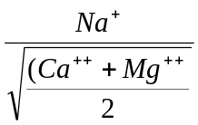

The analytical data plotted on the U.S Salinity Laboratory Diagram⁵ illustrates that most of the groundwater samples fall in the field of C₄S₄ and C₃S₁ indicating high to median salinity and high to low sodium water type which can be moderately suitable for irrigation purposes (Fig. 3a, b & c). The same trend was observed during summer and premonsoon seasons. Thus, based above said parameters the groundwater of Nagapattinam area is moderately suitable for the irrigation purpose.

Correlation coefficients
Statistical analysis carried out to get an overall idea of water chemistry of the region. Correlation coefficients calculated are shown in Table.2a, b & c. In summer season good correlation exists between Ca - SO₄ - Cl, Na and pH. Negative correlation is observed between Ca - Mg - K. During premonsoon period correlation exists between HCO₃ - K - Na. Good correlation exists between Na – Cl in premonsoon. Postmonsoon season correlation is observed between Na - Cl – K, SO₄ – HCO₃ and Cl – HCO₃, negative correlation is exists between Ca - K.
Conclusion
Groundwater in the study area is generally alkaline in nature. Total dissolved solid and Electrical conductivity exceeding^{2,6} standards except two or three well water. With respect to cation and anion, dominating cation is sodium, dominating anion is chloride. The groundwater increases its major ions concentration in the summer season in comparison to the post and premonsoon period. This is because of evaporation, precipitation and environment weathering in the study area.
The groundwater nature is explained by the Piper trilinear diagram which indicates that most of the groundwater samples fall in Na, Ca, Mg facies followed by Cl, SO₄ facies. The groundwater quality of irrigation water is compared based on electrical conductance, sodium absorption ratio show that groundwater moderately suitable for irrigation.
The values of correlation coefficients and their significance levels will help in selecting the proper treatments to minimize the contaminations of groundwater of study area. There is an increasing awareness among the people to maintain the groundwater at their highest quality and purity levels and the present study may prove to be useful in achieving the same.
References
APHA. Standard methods for the examination of water and waste water. American public health association, Washington. 1998.
BIS. Standards for water for drinking and other purposes. Bureau of Indian standards publication. New Delhi. 1983.
Papaioannou. A, Plageras. P, Dovriki. E, Minas. A, Krikelis. V, Nastos. P, Kakavas. K, and Paliatsos. A.G. Groundwater quality and location of productive activities in the region of thersaly. (Greece) 2007; 213:209-217.
Piper, A.M. A Graphic Procedure in the Geochemical Interpretation of Water Analysis. Trans. US Geol, Surv, Groundwater Notes. 1953. 12.
Richards, L.A. Diagnosis and improvement of saline and alkali soil, U.S. Department of Agriculture, Agriculture Handbook. 1954. 60.
W.H.O. Guidelines for the drinking water quality. Recommendation WHO, Geneva. 1984.
S.No. | Water quality parameter in mg/l | Concentration in study area mg/l
S.No. | Water quality parameter in mg/l | Postmonsoon |  |  | Summer |  |  | Premonsoon
S.No. | Water quality parameter in mg/l | Min. | Max. | Average | Min. | Max. | Average | Min. | Max. | Average
1 | pH | 7.1 | 8.1 | 7.6 | 7.2 | 7.7 | 7.5 | 7.4 | 7.9 | 7.6
2 | Electrical conductivity (µS/cm) | 2391 | 3892 | 3142 | 2987 | 3597 | 5668 | 1987 | 2369 | 4699
3 | Total dissolved solids (TDS) | 1530.0 | 2697 | 3272 | 1289 | 2019.0 | 3628 | 1537.0 | 2119.0 | 3007.4
4 | Calcium (Ca) | 30.0 | 192.0 | 87 | 160.0 | 443.0 | 242.07 | 86.7 | 290.3 | 150.1
5 | Magnesium (Mg) | 9.0 | 369.6 | 93.1 | 19.3 | 657.3 | 135.6 | 12.7 | 384.7 | 80.6
6 | Sodium (Na) | 132.2 | 1231.5 | 729.8 | 120.4 | 1238.3 | 744.5 | 101.7 | 1485.7 | 695.2
7 | Potassium (K) | 12.4 | 823.1 | 268.6 | 19.9 | 571.8 | 286.8 | 9.6 | 286.3 | 170.9
8 | Bicarbonate (HCO₃) | 156.6 | 1881.1 | 344.7 | 131.0 | 1666.4 | 431.7 | 102.2 | 813.5 | 330.2
9 | Sulphate (SO₄) | 566.5 | 1625.9 | 990.0 | 573.7 | 1143.2 | 849.3 | 486.9 | 951.6 | 698.6
10 | Chloride (Cl) | 170.8 | 619.2 | 855.1 | 147.3 | 1666.4 | 1072.5 | 98.4 | 1638.0 | 985.1
Table.1. Physico – chemical parameters of the groundwater samples

Column1 | pH | EC | TDS | Ca | Mg | Na | K | HCO₃ | Cl | SO₄
pH | 1.00
EC | 0.97 | 1.00
TDS | 0.62 | 0.62 | 1.00
Ca | 0.51 | 0.51 | 0.41 | 1.00
Mg | 0.16 | 0.16 | 0.17 | 0.03 | 1.00
Na | 0.53 | 0.53 | 0.98 | 0.28 | 0.08 | 1.00
K | 0.40 | 0.40 | 0.65 | -0.16 | 0.03 | 0.67 | 1.00
HCO₃ | 0.62 | 0.62 | 0.65 | 0.12 | 0.13 | 0.65 | 0.32 | 1.00
Cl | 0.47 | 0.47 | 0.96 | 0.48 | 0.10 | 0.96 | 0.48 | 0.55 | 1.00
SO₄ | 0.69 | 0.69 | 0.98 | 0.53 | 0.11 | 0.94 | 0.60 | 0.66 | 0.93 | 1.00
Table.2a. Correlation Coefficients of hydrochemical data of groundwater (Postmonsoon)
Table.2b. Correlation Coefficients of hydrochemical data of groundwater (summer)
Column1 | pH | EC | TDS | Ca | Mg | Na | K | HCO₃ | Cl | SO₄
pH | 1.00
EC | 0.71 | 1.00
TDS | 0.71 | 0.96 | 1.00
Ca | 0.64 | 0.35 | 0.35 | 1.00
Mg | 0.21 | 0.29 | 0.29 | -0.05 | 1.00
Na | 0.51 | 0.94 | 0.94 | 0.14 | 0.24 | 1.00
K | 0.45 | 0.67 | 0.67 | -0.05 | 0.01 | 0.63 | 1.00
HCO₃ | 0.51 | 0.69 | 0.69 | 0.02 | -0.15 | 0.69 | 0.66 | 1.00
Cl | 0.54 | 0.97 | 0.97 | 0.21 | 0.30 | 0.94 | 0.67 | 0.64 | 1.00
SO₄ | 0.86 | 0.70 | 0.70 | 0.75 | -0.07 | 0.54 | 0.26 | 0.42 | 0.56 | 1.00
Table.2c. Correlation Coefficients of hydrochemical data of groundwater (premonsoon)
Column1 | pH | EC | TDS | Ca | Mg | Na | K | HCO₃ | Cl | SO₄
pH | 1.00
EC | 0.66 | 1.00
TDS | 0.66 | 0.98 | 1.00
Ca | 0.59 | 0.19 | 0.19 | 1.00
Mg | 0.19 | 0.32 | 0.32 | -0.06 | 1.00
Na | 0.46 | 0.94 | 0.94 | -0.05 | 0.29 | 1.00
K | 0.53 | 0.57 | 0.57 | 0.06 | 0.30 | 0.37 | 1.00
HCO₃ | 0.47 | 0.59 | 0.59 | -0.18 | -0.16 | 0.59 | 0.58 | 1.00
Cl | 0.51 | 0.96 | 0.96 | 0.06 | 0.29 | 0.94 | 0.50 | 0.51 | 1.00
SO₄ | 0.79 | 0.69 | 0.69 | 0.71 | -0.03 | 0.51 | 0.37 | 0.38 | 0.52 | 1.00

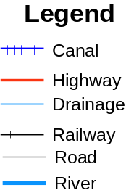
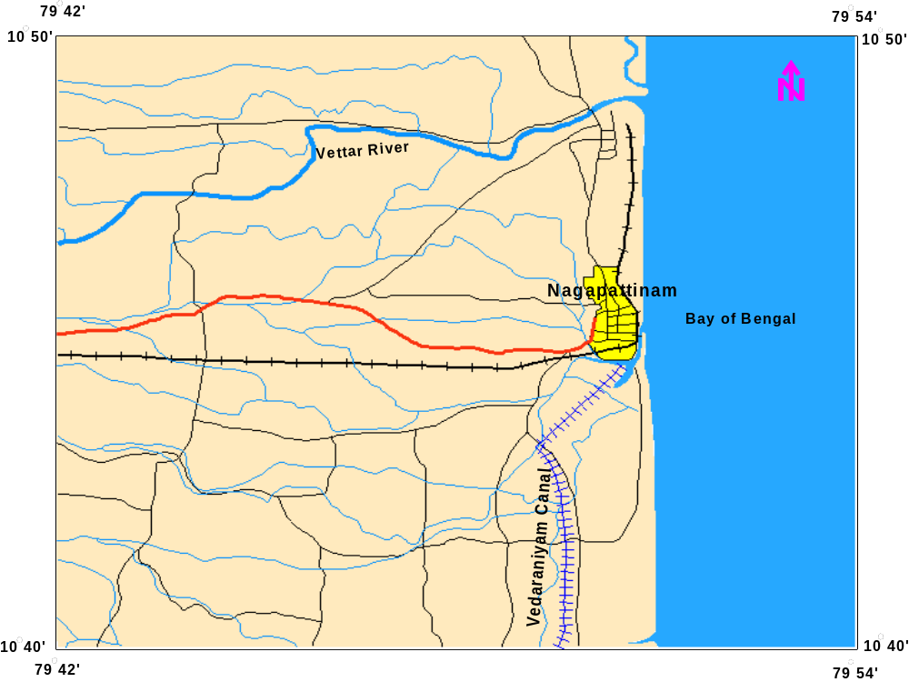
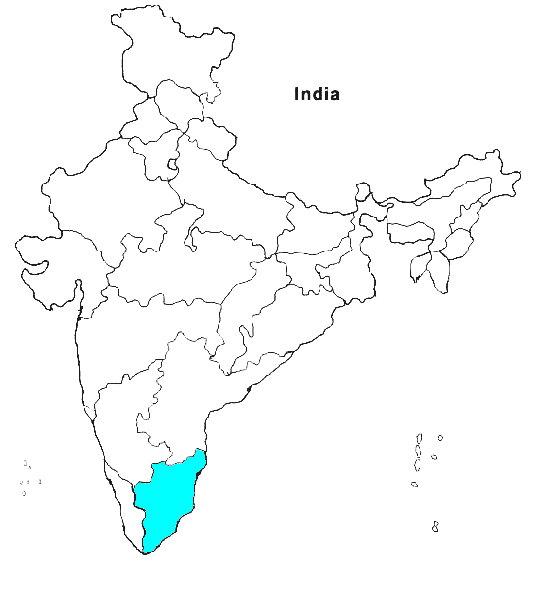
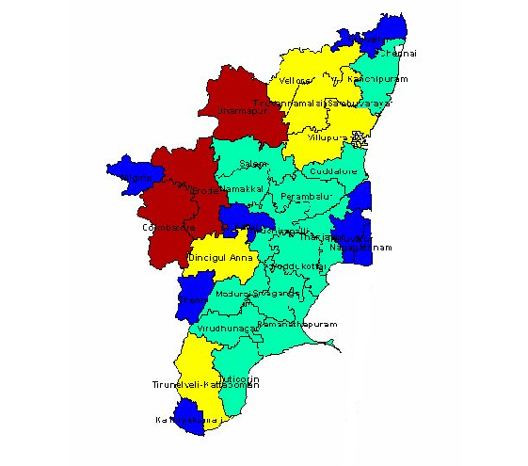
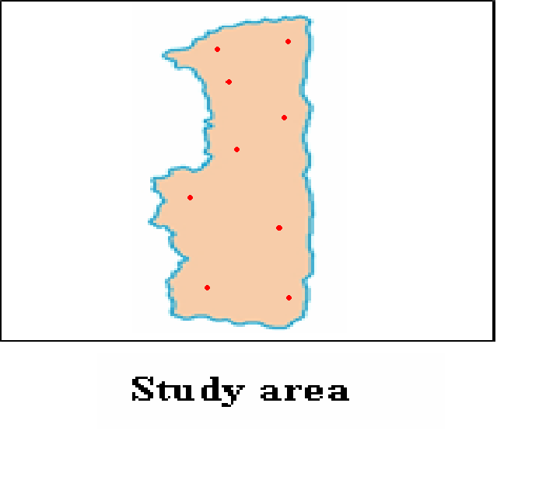
Fig: 1. Study area map of Nagapattinam

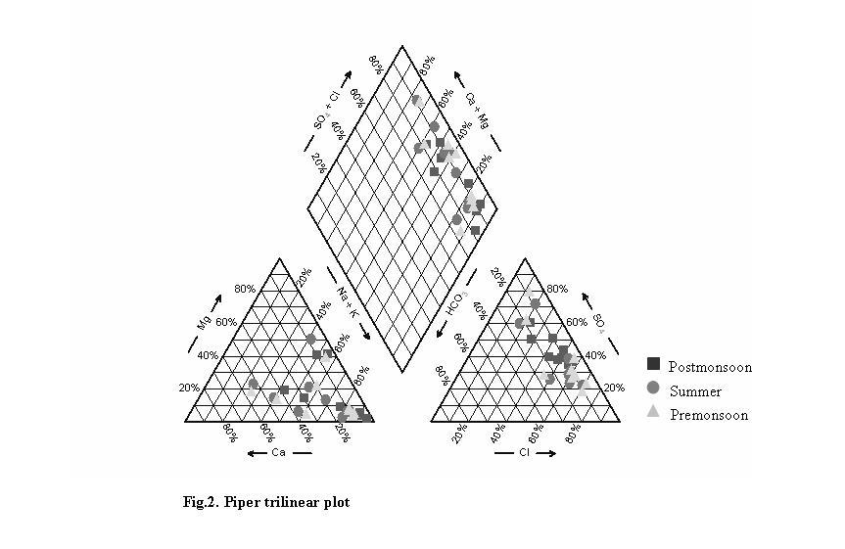

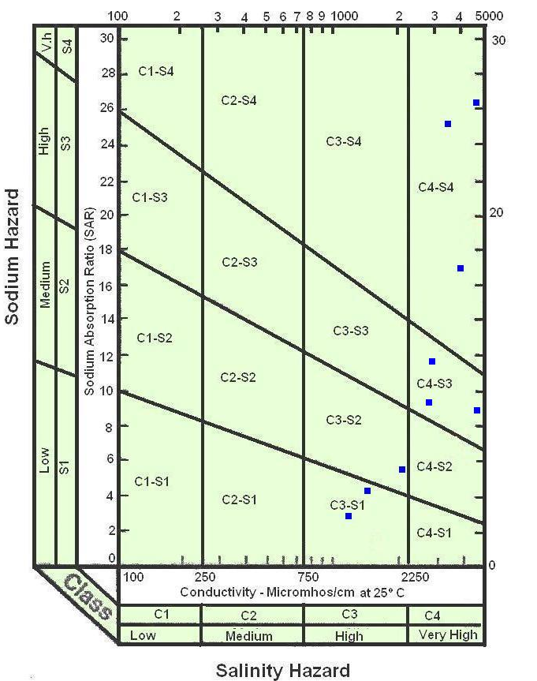
Fig.3a. USSL diagram (Postmonsoon)

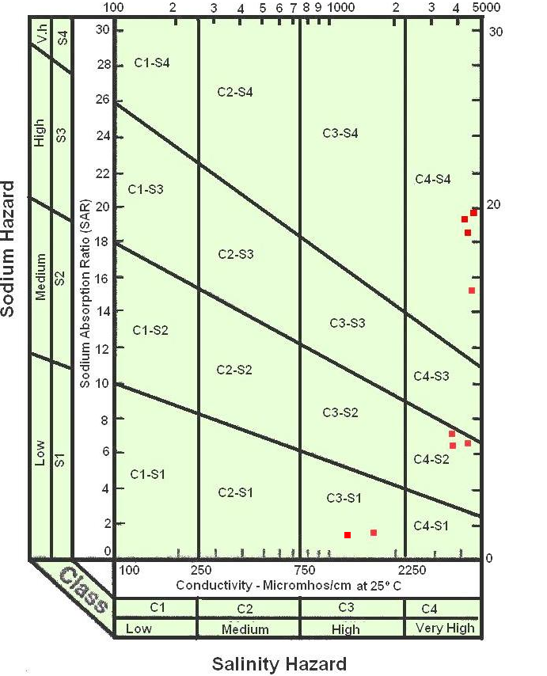
Fig.3b. USSL diagram (Summer)

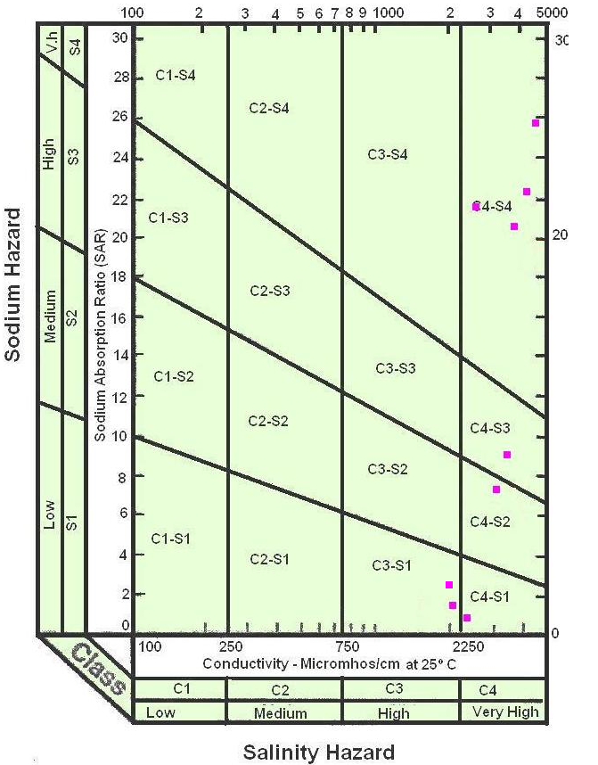
Fig.3c. USSL diagram (Premonsoon)

