Euglenoids of Lekki Lagoon: LM and SEM Images of some Taxa
T.A. ADESALU* and D.I. NWANKWO**
*Department of Botany and Microbiology, University of Lagos, Nigeria.
**Department of Marine sciences, University of Lagos, Nigeria.
E-mail corresponding author: boseadesalu@yahoo.com.
Telephone: 23418975122

With 15 Figures

Abstract: This paper presents a pioneer investigation of the euglenoids of Lekki lagoon, located in Epe Local Government area of Lagos. Samples were collected monthly for two years (June 2003-May 2005) at twelve different locations within the same body of water. An examination of the euglenophytes showed 50 taxa belonging to four genera; Euglena, Phacus, Strombomonas and Trachelomonas. The most recorded taxa was Trachelomonas (22) followed by Euglena (17), Phacus and Strombomonas accounted for nine and two taxa respectively. Community structure analysis revealed a diverse environment. Fifteen taxa are new records for Lagos lagoon complex.

Keywords: Euglenoids, diversity, flagellates, physico-chemical parameters.

Introduction.
Lekki lagoon; (longitudes 4⁰00' E and 4⁰12' E and latitude 6⁰25' N and 6⁰37' N) is one of the major lagoons that provide people of Lagos, Ogun and Ondo states South-West Nigeria with aquatic foods such as fishes, periwinkles shrimps and crabs because it links all these states. It also serves as means of water transportation as engine boats are used to transport people from and away its environs. Two peaks of rainfall are associated with this lagoon, a major peak in July and a lesser peak in September. This paper is a part of some of the publications from the work done between June 2003 and May 2005. Earlier published papers are on Chrysophytes (Wujek et al., 2004, 2007) and diatoms checklist (Adesalu and Nwankwo, 2009).
Other related work on euglenoids in Nigeria included Egborge (1973) who reported three euglenoids in Oshun River; Opute (1991) work accounted for 33 species from Warri/Forcados estuary; Nwankwo and Akinsoji (1988, 1992); observed eleven and six species from Ogbe and Orile channel respectively while Nwankwo (1995) gave report of 48 species from storm-water channels in Lagos, Kadiri (2000) reported 22 euglenoids of Ikpoba reservoir and more recently Adesalu et al., (2008) recorded six euglenoids from Ogbe creek; twenty years after Nwankwo and Akinsoji (1988) report. This paper provided the checklist of euglenoids in the Lekki lagoon and influence of physico-chemical parameters on their composition.

Materials and Methods.

Description of study site and collection of phytoplankton samples were as described elsewhere (Adesalu and Nwankwo, 2009). For physico-chemical analysis, water samples were stored in 1L properly labeled plastic containers with screw caps and transported to the laboratory in ice-chests. In the laboratory, all water samples were stored in refrigerator (t ≤ 4⁰C) for further analysis within 24h. All samples were collected during the hours of daylight to minimize variations due to diurnal migration.
Analysis of biological samples:
Biological samples were investigated using Olympus BX51 photomicroscope at the Bowling Green State University, Ohio, U. S. A. For the scanning electron microscopy studies, a drop of the acid cleaned samples was placed on SEM stub using a pipette (a drop per sample) and air dried overnight. Prepared scanning electron microscope stubs were taken into the microscopy laboratory where the stubs were transferred into a high vacuum evaporation (sputter coater) for 10minutes and the specimens were coated with gold over a thin layer of carbon spraying, this reduces charging effect in the electron beam (Shin, 1974). The microphotographs were taken using a JEOL 840A SEM operating at accelerating ranges of 10-20v with working distance between 8-10 at Central Michigan University, Mt Pleasant, Michigan and Bowling Green State University, Ohio, U. S. A. Identification of species was based on some relevant text (John and Robert, 2003; Prescott 1962; Konrad and Hindak 2005; Whitford and Schumacher, 1973). Community structure analyses used were as described elsewhere (Adesalu et al., 2008).
Physico-chemical analysis
The methods described by American Public Health Association (APHA, 1998) were used for physical and chemical analysis. The air and surface water temperature were recorded in situ with simple thermometer while the transparency was measured using a Secchi disc, the water pH values were determined using the Phillips pH meter (Model PW950). The Federal Meteorological Department, Oshodi, Lagos kindly provided rainfall and sunshine hours data for the period of investigation. Salinity was determined using the silver nitrate chromate titration method as described by Barnes (1980).
Chloride content of the water was determined using Mercury tri-oxonitrate V (HgNO₃)₂ method while Soxhlet extraction method was used for determination of Oil and grease, Griffin oxygen meter determined the Dissolve oxygen content while biological oxygen demand was done after the dissolved oxygen has been measured using the standard method of biochemical consumption of oxygen in 5 days at 20⁰C (BOD₅). Calcium content of the water samples were determined using EDTA Titrimetric (APHA, 1998) while Zinc, Copper and Iron contents were determined by Atomic absorption spectrophotometer (AAS). Phosphate-phosphorus and sulphate content were analysed using ascorbic acid and gravimetric methods respectively. Nitrate-nitrogen was determined by calorimeter.

Results
Physico-chemical parameters
The mean range of environmental characteristics of Lekki lagoon was presented in Table 1 while Figure I shows the relationship between sunshine hour and rainfall pattern at Lekki lagoon. Although surface water temperatures differences exist between different sampling stations in the lagoon, their variation followed a similar pattern. Transparency was generally low (≤14.41cm) and corresponds to low amount of rainfall while average total suspended solids recorded its higher value (11.76mgL⁻¹) in station G and this correspond to wet season. The water samples were essentially neutral (≤ 7.46) and surface water salinity values were low (≤ 0.55‰) throughout the study period.
Generally high Phosphate –phosphorus values were recorded at the cessation of rains and low salinity; high and low nitrate –nitrogen content were recorded during the wet and dry months respectively. Chloride values recorded throughout were generally low (≤10.00mgL⁻¹). In general, higher oxygen content values were recorded during the wet season while lower dissolved oxygen values were recorded in dry season Biological and Chemical Oxygen Demand values recorded throughout the study period were generally low (≤0.31mgL⁻¹ and ≤0.36mgL) respectively. Oil and grease values were also generally low while higher turbidity value was recorded in wet season The sulphate content in mg/l was generally low throughout the sampling period.

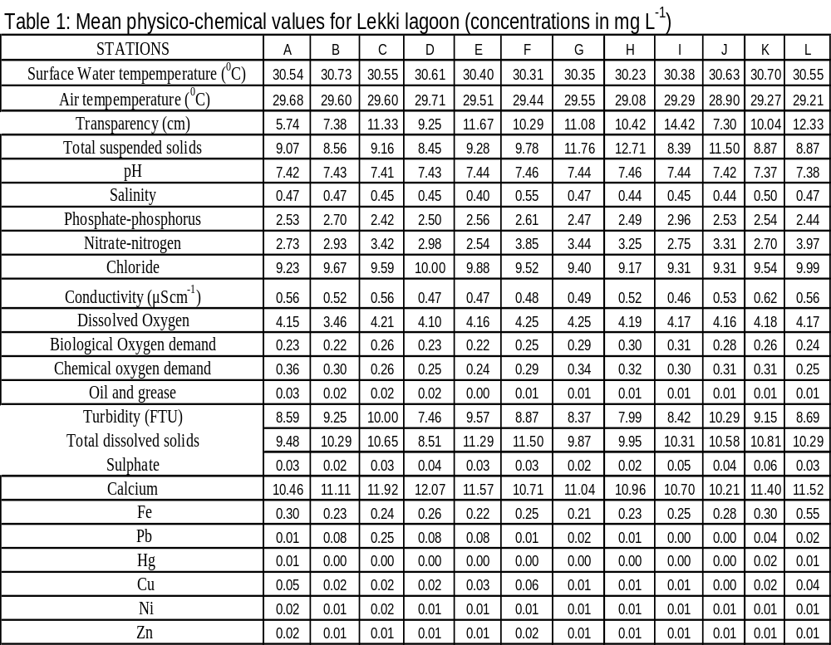

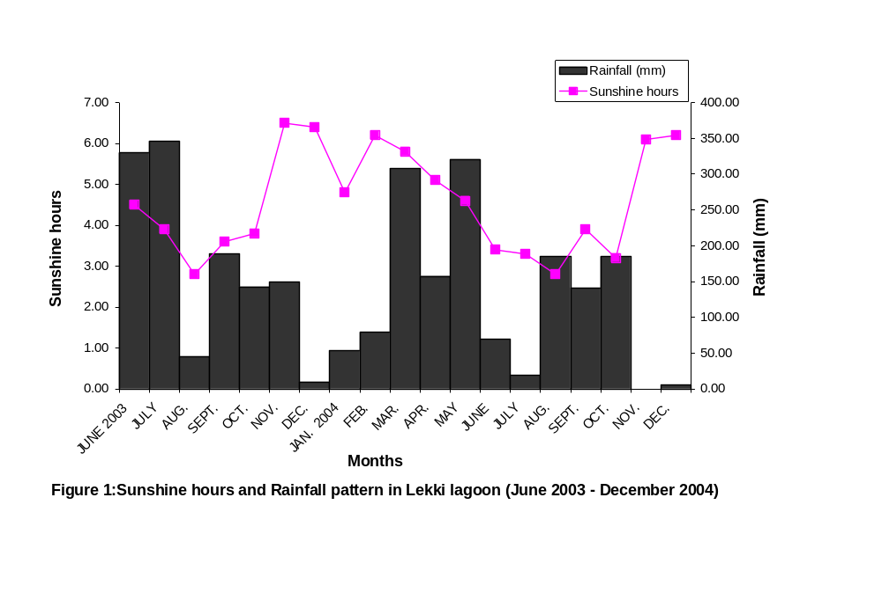
The Euglenoids
A total of 50 euglenoids taxa belonging to four genera Euglena, Phacus, Trachelomonas and Strombomonas were observed in this study (Table 2). Figures 1 and 2 show some micrographs of euglenoids species identified. Out of the fifty euglenoids species identified the genus Euglena accounted for seventeen in which E. acus was observed in all stations followed by Euglena sp. 1 which was not observed only in station J and E. deses and E.polymorpha which appeared in some of the stations. The genus Phacus which only recorded 11 species has P. longicauda and P. orbicularis as the prevalent representatives in the water body. More euglenoids were recorded during dry season than wet season and consequently more euglenoids densities at this period. Trachelomonas recorded T. gibberosa and T. hispida as the prevalent species of the genus while Strombomonas maxima and Strombomonas sp. ably represented the genus Strombomonas in the study site.
Dominance of euglenoids by a few species was reflected by low equitability ‘j’ value recorded and since Margalef’s ‘d’ value is influenced by the number of species and individuals and the highest ‘d’ value (1.98) was recorded in station D. The Shannon-Weaver diversity index (H¹) is influenced by both number of species and equitability. In Lekki lagoon, highest H¹ values was observed also in station D, while lowest ‘j’ value (0.02) was recorded in station E (Table 1).
The period of high species richness corresponded with the period of lower evenness. The high diversity value in station D was due to dominance of several species such as Euglena acus, Phacus orbicularis, P. longicauda Trachelomonas gibberosa and T. hispida var coronata. Seasonal variation in Shannon-Weaver information (H^{I}) and Equitability ‘j’ in this study follow each other closely with the highest values of these two found in station D. Lowest (H^{I}) value (0.06) corresponded with low equitability ‘j’ value (0.02) and since ‘j’ is sensitive to species richness and dominance diversities, the low ‘j’ was a reflection of this. (Figure 2)

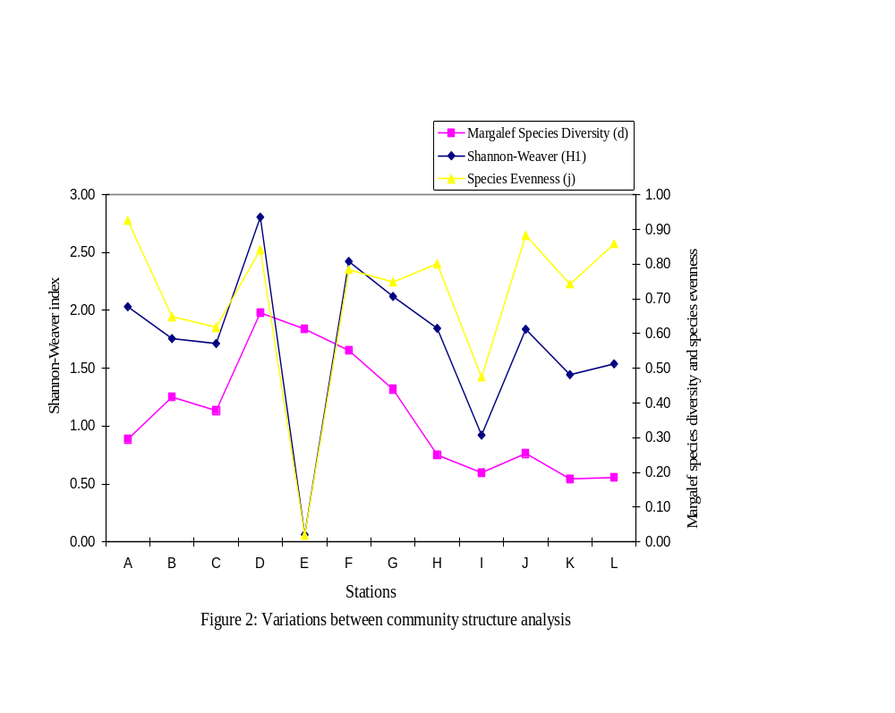
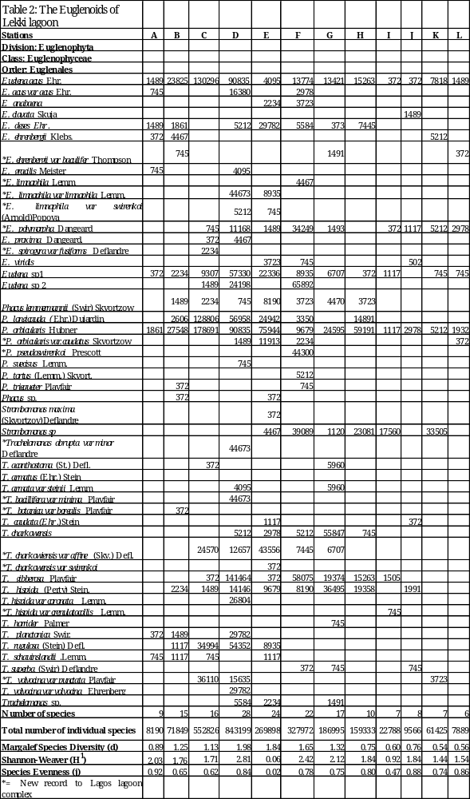

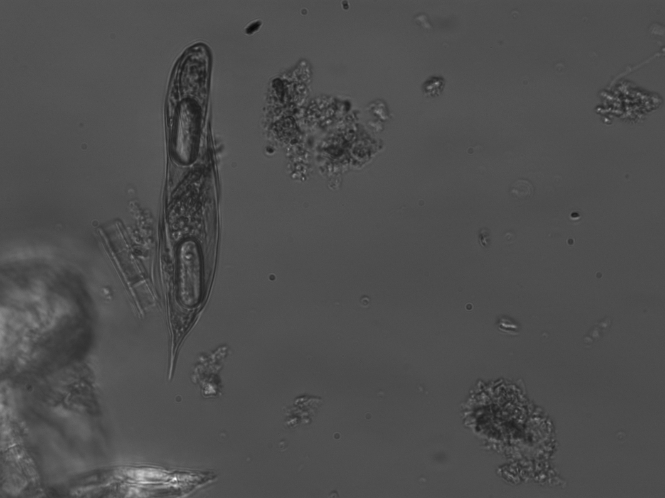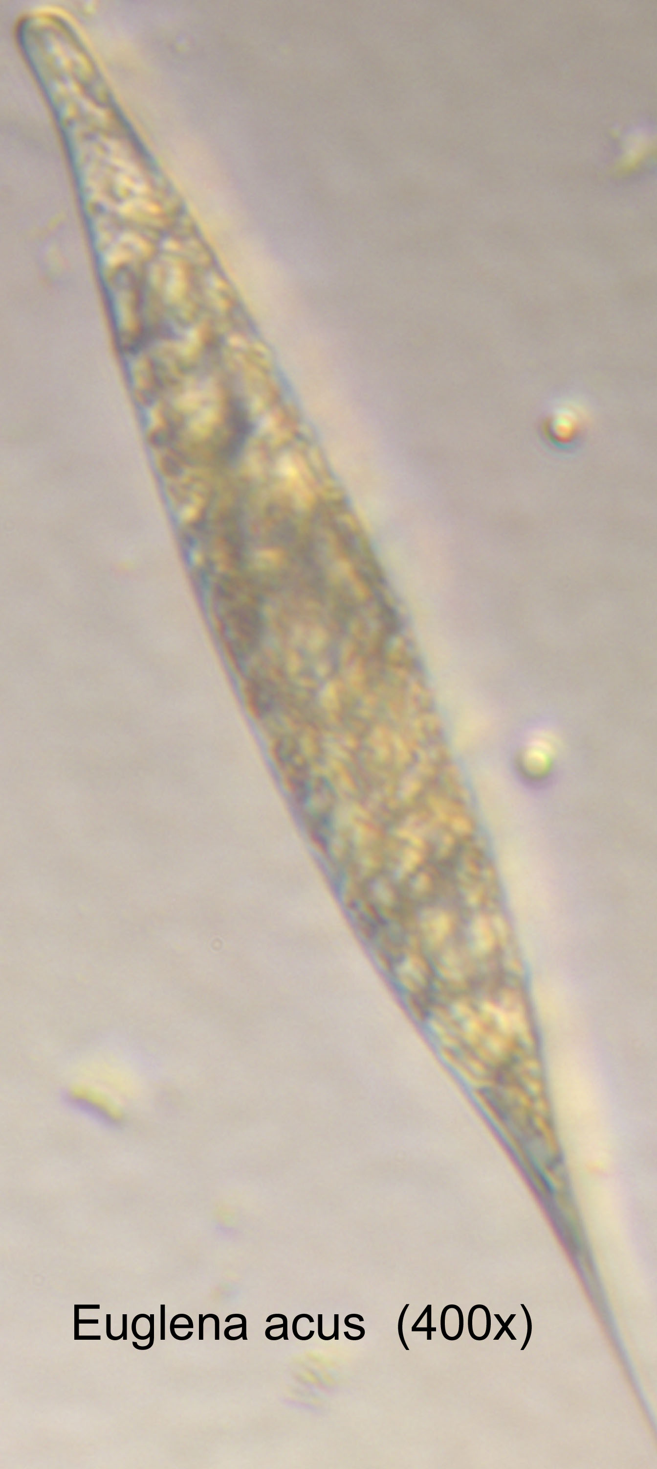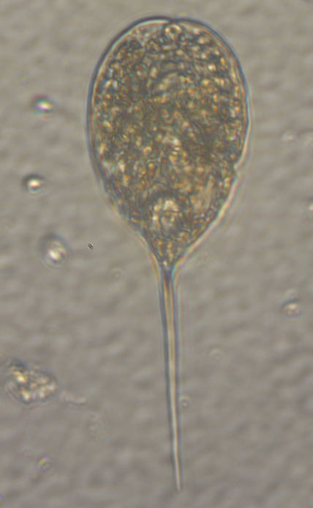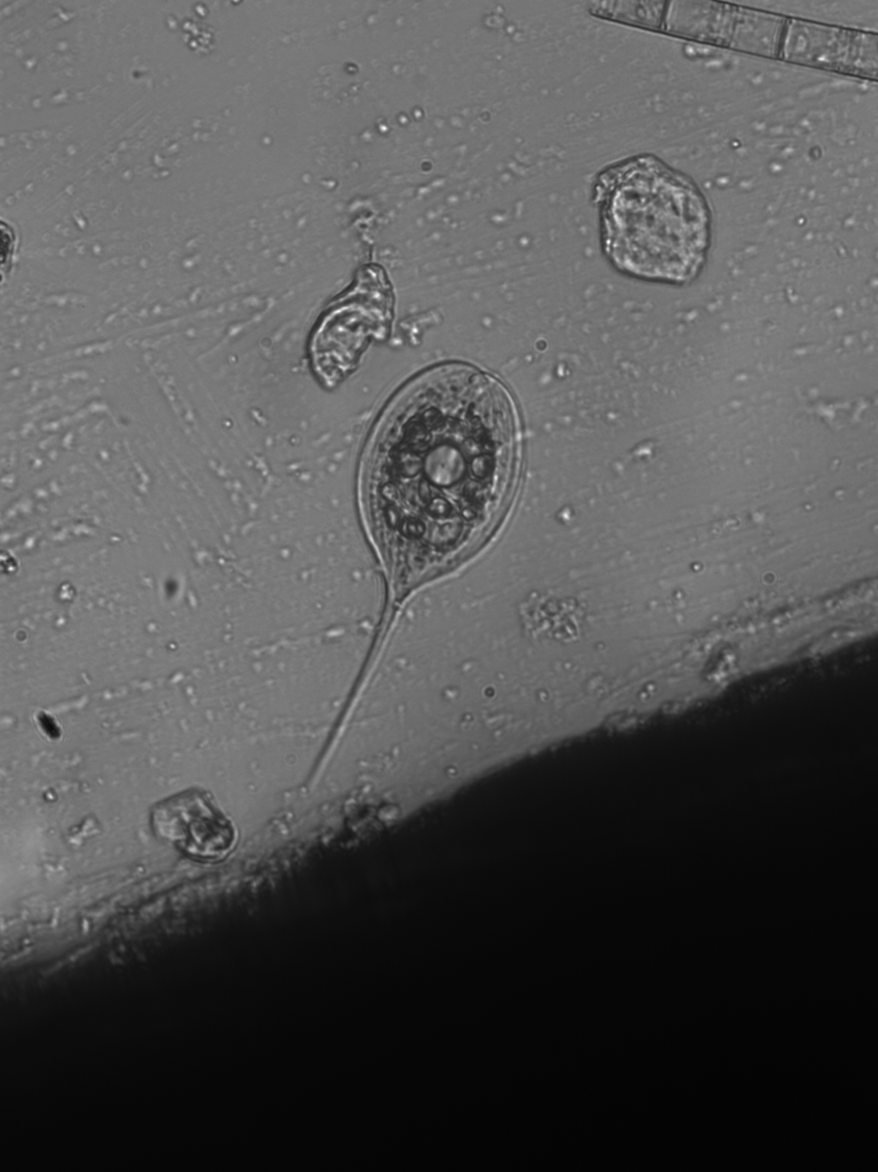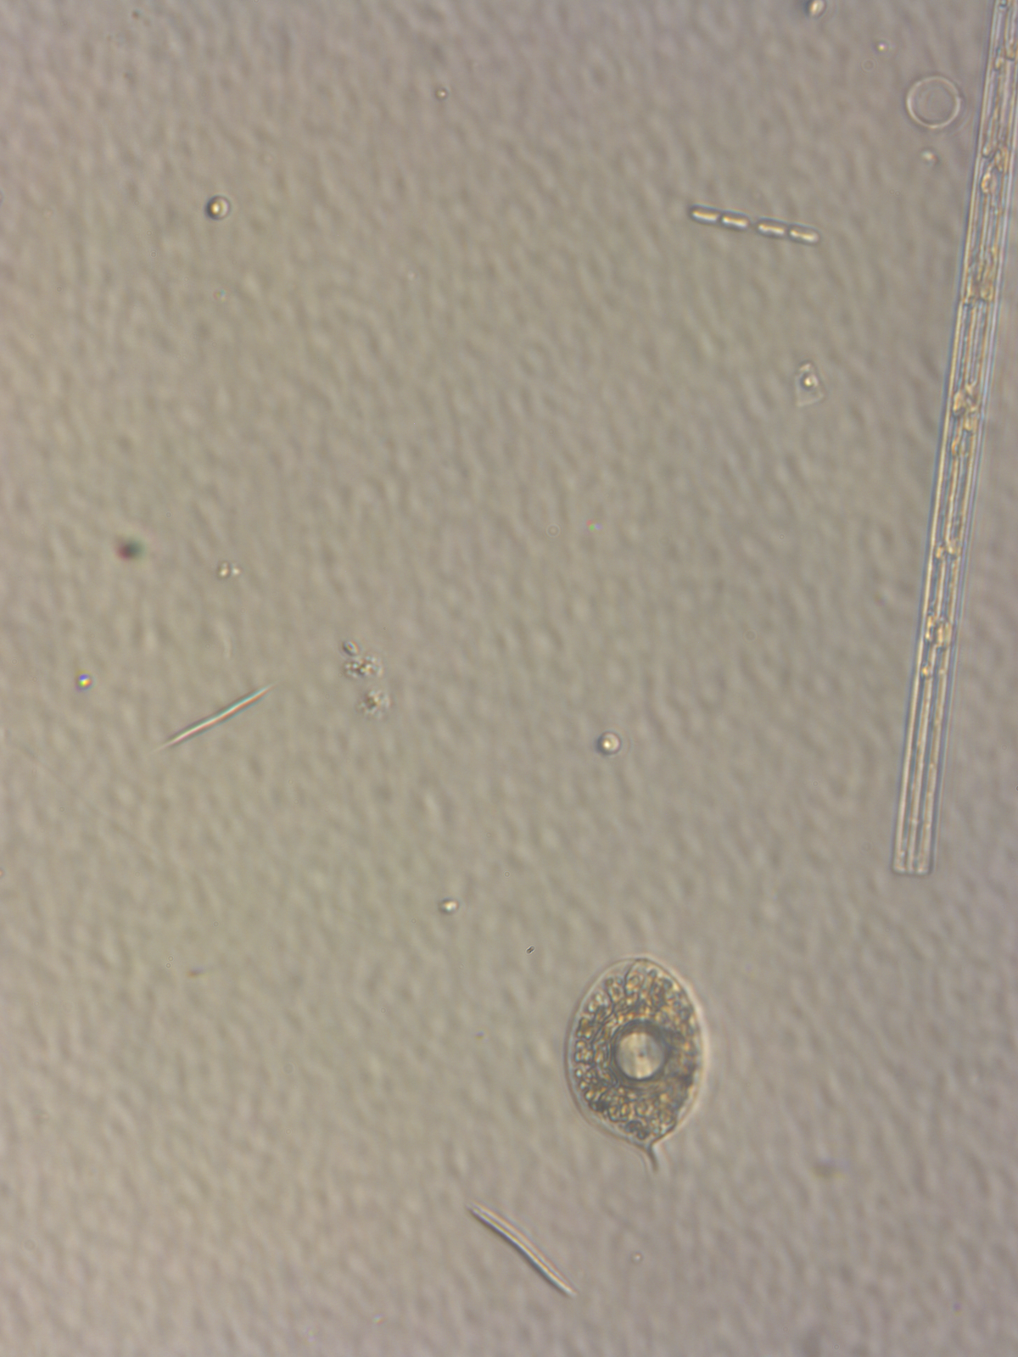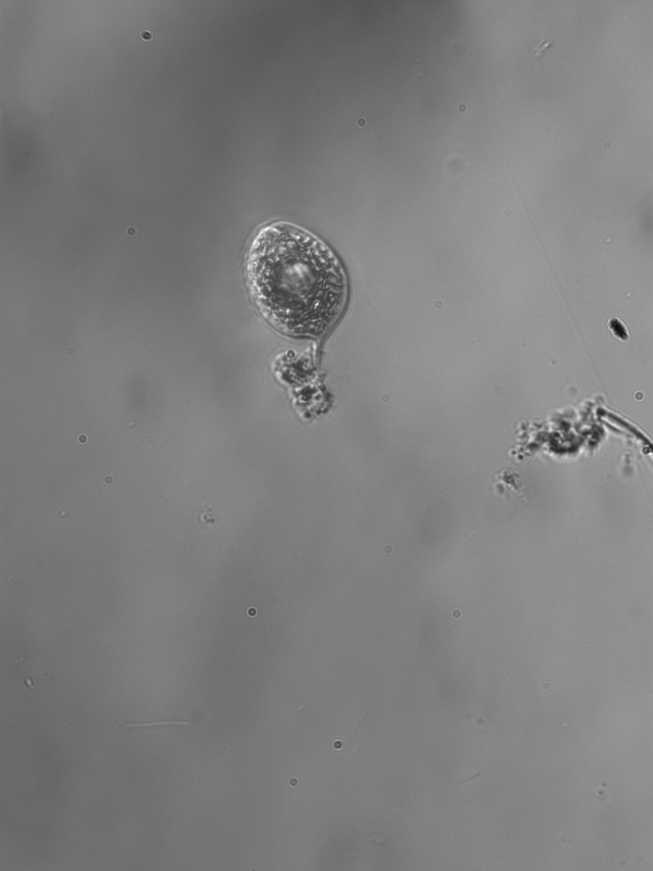
1
2
3
4
5
6
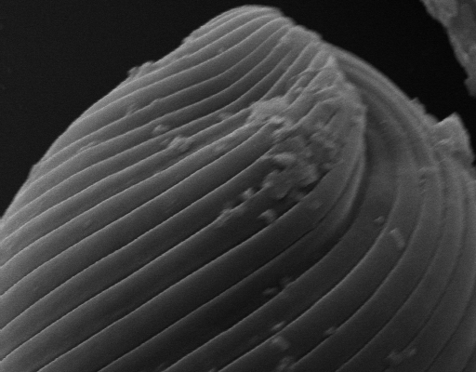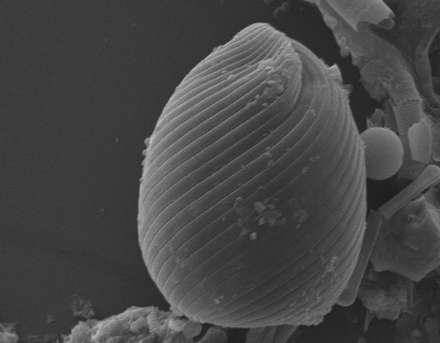
7
8

Figures 1-6: Light microscopic images of some euglenoids in Lekki lagoon (x400). Figure 1: Euglena limnophila var limnophila Lemm showing the paramylon body; Figure 2: E. acus Ehr.; Figure 3: Phacus sp., Figure 4: P. longicauda (Ehr) Dujardin; Figures 5 and 6: Phacus orbicularis Hubner, showing doughnut-like paramylon.; Figures 7and 8: Scanning electron microscopic images of E. gracilis Meister (motile cells showing pellicle without mucilage strand). Scale Bar =5µm

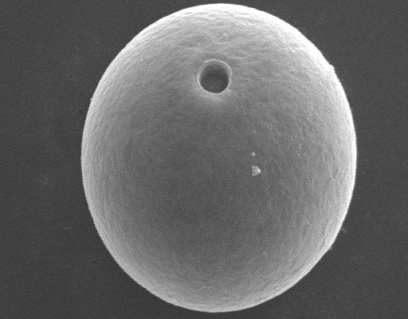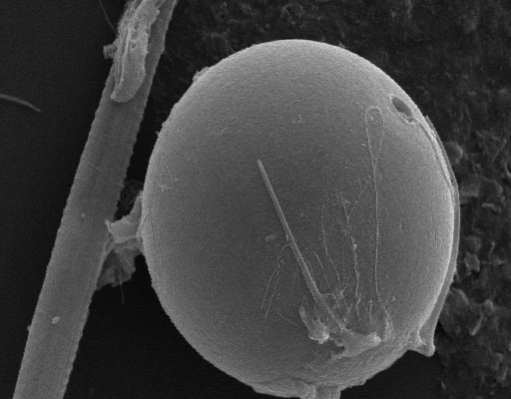
9
10
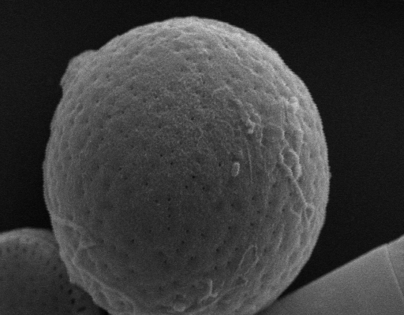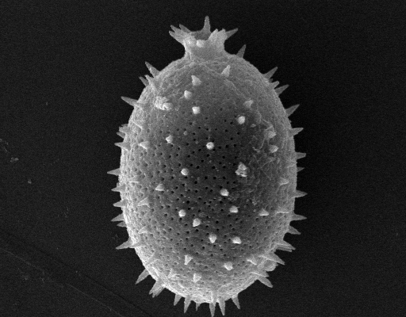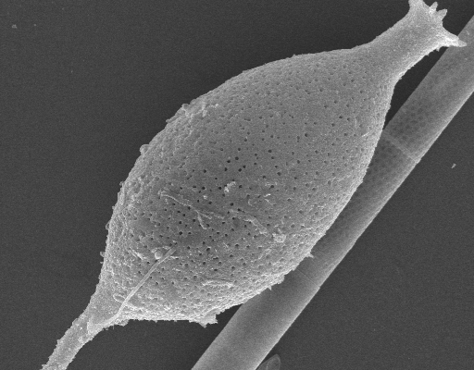
11
12
13
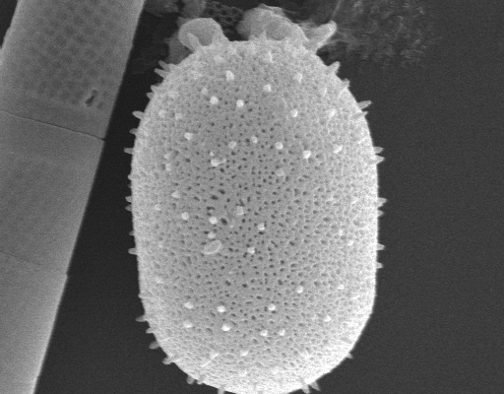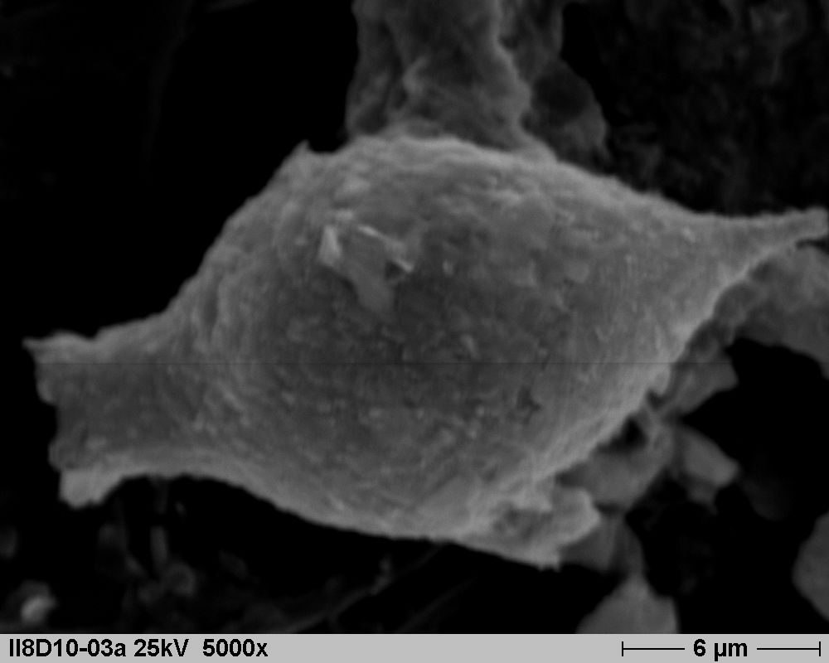
14
15

Euglenoids cell morphology and diversity at Lekki lagoon, Lagos.
Figures 9-15: Scanning Electron Micrograghs of some euglenoids; Figures 9 and 10: Trachelomonas volvocina var volvocina Ehrenberg, Figure11: Trachelomonas sp.; Figure12: Trachelomonas gibberosa Playfair; Figure 13: Trachelomonas armatus (Ehr.)Stein; Figure 14: Trachelomonas hispida (Perty) Stein and Figure 15: Strombomonas sp. Scale Bar = 5µm

Discussion
Lekki lagoon, a large expanse of shallow freshwater experiences a typical tropical climate with the two seasons exhibiting their marked effect. The shallowness of the lagoon observed in this finding conforms to Kusemiju (1973). The variation in physical and chemical parameters observed during the study period may be as a result of the influence of weather conditions. For instance, the rainy season occurring between June and October, characterized by low transparency and pH; increased total suspended solids, higher turbidity and increased flood water condition which might have initiated stressful environmental condition and these conform with Dart and Stretton (1980) who stated that variations in water temperature could cause alterations in the pH due to changes in ionization and increased solubility or precipitation of bottom deposits. Nwankwo and Onitiri (1992) also pointed out that it is possible that rainfall triggers off flood situations which usually increases total solids, reduces transparency and consequently light penetration and also dislodges attached algal forms.
The phytoplankton community and the physio-chemical parameters exhibited seasonal changes closely related to the pattern of rainfall. According to Egborge (1974) and Tezuka (1984), seasonal fluctuation in abundance of phytoplankton is influenced by changes in the physical and chemical properties of the water which themselves can be dependent on rainfall. Changes in seasonal cycles that were observed in this current study suggested that species composition was likely to be more influenced by fluctuations in the physico-chemical environment than by biological factors.
In this study, the Euglenophyceae recorded high percentage increase in the variety of species during the dry season and this suggested that this group has affinity for more eutrophic waters as earlier reported by Berg and Nygard (1929). According to Palmer (1969), Oliver and Dorris (1964) and (Morris 1967), some euglenoid species can tolerate various levels of organically polluted waters and therefore, can be used as indicators of organic pollution while Egborge (1973) reported that the euglenoids are not only planktonic but good indicators of polluted or meso-and eutrophic freshwater bodies. The observation of some euglenoids such as Euglena acus, E. viridis, E. gracilis, E. polymorpha, E. spirogyra var fusiformis, Phacus lemmermanii, P.longicauda, P. orbicularis, Trachelomonas armata var steinii, T. botanica var borealis, T. charkowensis var affine,T. hispida, T. hispida var coronata and T. rugulosa already implicated by some workers (Palmer 1992, Munawar 1972, Nwankwo 1995) as indicators of organic pollution is of great interest.

Acknowledgements
Adesalu T.A. is grateful to Fulbright exchange program scholarship, the University of Lagos for approving the study leave, Central Michigan and Bowling Green state Universities for various assistances. Thanks are also due to Prof O.T Ogundipe and Dr Akinsoji, my co-supervisor.

Corresponding author: Adesalu, T. A.
Department of Botany and Microbiology
University of Lagos, Akoka, Nigeria
E-mail: boseadesalu@yahoo.com

REFERENCES

Adesalu,T.A.and Nwankwo, D.I.(2005). Studies on the phytoplankton of Olero creek and parts of Benin river, Nigeria. The Ekologia.3(2):21-30.

Adesalu,T.A.and Nwankwo, D. I. (2009). A checklist of Lekki lagoon diatoms. International Journal of Botany (5) 2: 126-134.

Adesalu,T.A., Abiola, T.O and Bofia, T.O. (2008b). Studies on the epiphytic algae associated with two floating aquatic macrophytes in a sluggish non-tidal polluted creek in Lagos, Nigeria. Asian Journal of Scientific Research 1 (4): 363-373.

American Public Health Association (1998). Standard methods for the examination of water and waste water, 20th ed. American Public Health Association Incorporated, New York. 1270pp.

Barnes, R. S. K. (1980). Coastal lagoons, London. C. U. P. 106pp.

Berg, K. and Nygaard, G. (1929). Studies on the plankton in the Lake of Frederiksborg. Castle. Mem. Acad. Royale Science Lettr. de Denmark. 9: Bd 1:227–316.

Dart,R.K. and Stretton, R.J.(1980). Microbiological aspects of pollution control and environmental science. 6 Elsevier Scientific Publishers Amsterdam.

Egborge, A. B. M. (1973). A preliminary checklist of the phytoplankton of Oshun River, Nigeria. Freshwater Biology. 4: 569–572.

Egborge, A. B. M. (1974). The seasonal variation and distribution of phytoplankton in the river Oshun, Nigeria. Freshwater Biology. 4 (2): 177–191.

John, D. W and Robert G. S. (2003). Freshwater algae of North America, ecology and classification. 918pp.

Kadiri, M.O.(2000). Seasonal trend in the chemical limnology of a shallow Nigerian man-made lake. Acta Hydrobio.l, 42: 29-40.

Konrad, W. and Hindak, F. (2005). Atlas of Euglenophytes. 135pp.

Kusemiju, K. (1973). A study of catfishes of Lekki lagoon with particular reference to species of Chrysichthys walkeri (Bagridae) Ph.D Thesis University of Lagos, Nigeria.
Morris, I. (1967). Introduction to algae, Hutchinson and Co. Ltd. London.
Munawar, M. (1972). Limnological studies on freshwater pools of Hyderbad India II. The biocenose. Distribution of unicellular and colonial phytoplankton in polluted and unpolluted environments. Hydrobiologia, (36) 1: 105-128.

Nwankwo, D. I. (1995). Euglenoids of some polluted storm-water channels in Lagos, Nigeria. Tropical Freshwater Biology. 4: 29–39.

Nwankwo, D. I. and Akinsoji, A. (1988). Periphyton algae of eutrophic creek and their possible use as indicators. Nigerian Journal of Botany, 1: 47-54.

Nwankwo, D. I. and Akinsoji, A. (1992). Epiphyte community on water hyacinth, Eichhornia crassipes (Mart.) Solms in coastal waters of South-western Nigeria. Archiv fur Hydrobiologie. 124 (4): 501–511.

Nwankwo, D. I. and Onitiri, A. O. (1992). Periphyton (Aufwuchs) community on submerged aquatic macrophytes in Epe lagoon, Nigeria. Journal of Agriculture Science and Technology. 2 (2): 135–141.
Oliver, K.H. Jr. and Dorris, T.C. (1964). Causal factors of population variations of algae in a paper mill waste –water pond system.Tapii, (47) 1: 1-12.

Opute, F.I.(1991). A checklist of the freshwater, brackish and marine phytoplankton of the Warri/Forcados estuaries of southwestern Nigeria. Nigerian Journal of Botany, 4: 227-254.

Palmer, M.C. (1969). A composite rating of algae tolerating organic pollution, Journal of phycology, 5: 78-82.

Prescott, G. W. (1962). Algae of the Western Great Lake Area, revised ed. Wm. C Brown Co. Dubuque, IOWA. 977pp.

Texuka, Y. (1984). Seasonal variations in the dominant phytoplankton. Chlorophyll a and nutrient levels in the pelagic regions of Lake Biwa. Jap. J. Limnol. 45: 126–137.

Whitford, L. A. and Schumacher, G. J. (1973). A manual of fresh water algae. Spark Press, Raleigh, N.C .324pp.

Wujek,D.E., Adesalu, T. A. and Nwankwo ,D. I.(2003/2004).Silica-scaled chrysophyceae and synurophyceae (chrysophyta) from Nigeria II Lake Lekki. Tropical Freshwater Biology.12/13:99-103.

Wujek,D. E., Dziedzic, R.M., Kadiri, M.O., Adesalu,T.A. and Nwankwo,D.I.(2007). Identification, ecology and distribution of heliozoan scaled flagellates and scaled ciliates from Western Nigeria. Tropical Freshwater Biology. 16: 1-15.
.

.

69/2009

