Timber Resource Status Of Ehor Forest Reserve In Uhunmwode Local Government Area Of Edo State, Nigeria
Jane Ihenyen; Okoegwale E.E and Mensah J.K
Department of Botany,
Ambrose Alli University,
Ekpoma, Edo State
Nigeria
inejanet@yahoo.com

ABSTRACT
Five sample plots of 30m  30m were laid out in each of three selected compartments (81, 95 and 112) of 1.6 square kilometer within the Ehor Forest Reserve of Edo State, Nigeria. Fifty-four timber species were identified with compartment 81 having the highest number of species of thirty-four (34) and compartment 112 the least with thirty (30) species. Compartment 95 had thirty-three while the three compartments have eighteen species common to them. The following eleven species Afzelia africana, Albizia zygia, Bombax brevicuspe, Cordia millenii, Dacryodes edulis, Irvingia gabonensis, Khaya grandifoliola, Mansonia altissima, Milicia excelsa, Nauclea diderrichii, Terminalia ivorensis were represented by only one stand in the three compartments covering an area of 4.8 square kilometers. This translates into 0.002 stand/hectare. It was therefore deduced that these eleven timber species were under threat of extinction from the reserve and therefore need to be conserved for their values.

Keywords: Timber, threatened, extinction, conservation.
INTRODUCTION
Timber is wood in a form suitable for construction or carpentry, joinery or for reconversion to manufacturing purpose. Standing trees or felled trees capable of being converted for these purposes. In carpentry, a structural member (Anonymous 1973). According to Cunningham et al. (2005) timber accounts for about half of worldwide wood consumption. This exceeds the use of steel and plastic combined. It occurs in low density in most tropical forests hence large areas tend to be exploited diffusedly to extract a few prized logs. Yield of the most valuable timber species often decline owing to initial overcutting and failure to leave sufficient seed trees (Kellman and Tackaberry, 1993). There were 58 commercial timber trees in Nigeria (Anonymous 1973). Gill and Okoegwale (1991) added sixteen (16) more species.
In order to reduce pressure on the popular timber species, newer species are being added to the popular ones. For instance, Celtis zenkeri which was not regarded as economic is now being heavily logged and currently has become one of the popular timber species (Isichei, 1995). Ola-Adams and Iyamabo (1977), cited by Omoregbe (2004) reported that only seventeen species of timber were thought to be of economic importance in 1950 but by 1975 the number had increased to forty-seven (47). This increase is as a result of technological advancement in forestry leading to improvement and multipurpose utilization of the non-timber resources. As at now, the number of commercial species is much more than that of ten years ago.
This study was undertaken to investigate and document the number of timber species present in Ehor Forest Reserve in order to provide a baseline information on the current timber resource richness of the reserve.
MATERIALS AND METHODS
Study Location
Ehor Forest Reserve occupied an area of 76.8 square kilometers in Uhunmwode Local Government area of Edo State, Nigeria. It is located between latitudes 6⁰ 34’N and 6⁰ 38’N and longitudes 5⁰ 54’E and 5⁰ 58’E fifty-six kilometers north of the state capital, Benin-City. It is divided into forty-eight compartments of 1.6 square kilometers each. The Orhionmwon River runs through the reserve. It is surrounded by nine villages viz: Ohe, Eguaholor, Egbisi, Ugieghudu, Uhi, Iriwe, Erhue, Evbowe and Ekudo. There are no settlements within the reserve.
Survey Method
Three compartments based on their state of degradation were sampled. They were compartment 81 on the western end of the reserve which is the least degraded, 95 which is centrally located and the most degraded of the three compartments and 112 at the eastern end of the reserve (Fig 1). This is to have an adequate representation of the whole forest reserve. Five sample plots of 30m  30m were laid out in a randomized complete block design in each compartment using improvised wooden pegs. The timber trees in each plot were identified and the density of each species per compartments noted. The density was assessed by physically counting the number of stands for each species.
Plant identification was done by using Keay et al.(1964) and Hopkins (1974). The timber species were confirmed using Anonymous (1973) and Gill and Okoegwale (1991).

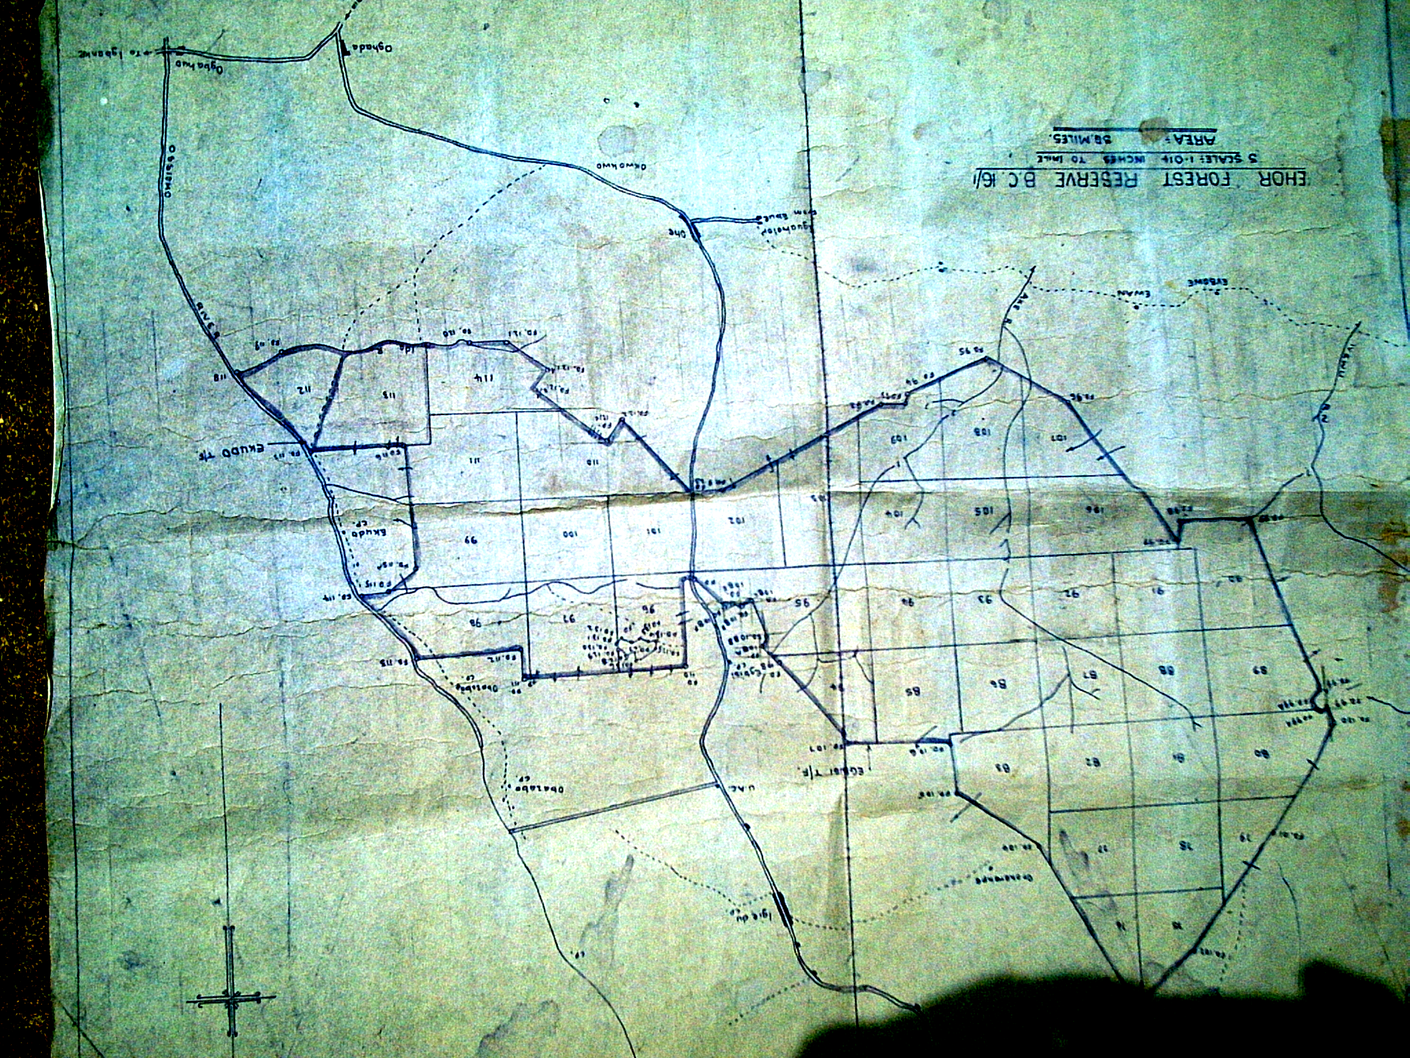
81
112
95

Fig. 1: Map of Ehor Forest Reserve showing Compartments of Study

RESULTS
Fifty-four timber species encountered in the reserve are presented in Table 1. Eighteen of them were common to the three compartments of study while seven (7), eight (8) and ten (10) were peculiar to compartments 81, 95 and 112 respectively (Table 2).
Compartments 81 and 95 have Alstonia boonei, Antiaris africana, Khaya ivorensis, Piptadeniastrum africanum and Triplochiton scleroxylon in common; 81 and 112 have Allanblackia floribunda, Ceiba pentandra, Nesogordonia papaverifera and Pterocarpus osun in common while 95 and 112 have Diospyros mesipiliformis and Hannoa Klaineana in common. Compartment 81 has the highest timber species of thirty-four (34) followed by 95 with 33 and 112 with 30 species. Celtis zenkeri had the highest density of 0.269 stand per hectare while ten (10) species had the lowest density of 0.002 stand per hectare.
TABLE 1: TIMBER SPECIES IN THE COMPARTMENTS OF STUDY
Timber species | Density/hectare
Afzelia Africana Sm. | 0.002
Albizia ferruginea (Guill & Perr.) Benth | 0.045
Albizia lebbeck (L.) Benth | 0.004
Albizia zygia (DC.) J.E. Machr. | 0.002
Allanblackia floribunda Oliv. | 0.006
Alstonia boonei De Wild. | 0.040
Antiaris africana Engl. | 0.013
Antiaris welwitschii Engl. | 0.042
Berlinia grandiflora (Vahl) Hutch. & Dalz. | 0.088
Blighia sapida Konig | 0.108
Bombax brevicuspe Sprague | 0.002
Bosqueia angolensis Ficalho | 0.054
Brachystegia nigerica Holye & A.P.D. Jones | 0.169
Canarium schweinfurthii L. | 0.023
Ceiba pentandra (L.) Garten | 0.004
Celtis zenkeri Engl. | 0.269
Chrysophyllum delevoyi De Wild | 0.015
Cleistoppolis patens (Benth.) Engl. & Diels, | 0.050
Combretodendron macrocarpum (P.Beauv.) Keay | 0.046
Cordia millenii Bak. | 0.002
Cylicodiscus gabunensis Harms | 0.006
Dacryodes edulis (G.Don) H.J. Lam | 0.002
Daniellia ogea (Harms) Rolfe ex Holl. | 0.094
Diospyros alboflavescens (Gurke) F. White | 0.045
Diospyros dendo Welw. Ex Hien. | 0.006
Diospyros mesipiliformis Hochst ex A. DC. | 0.017
Distemonanthus benthamianus Baill. | 0.006
Entandrophragma angolense (Welw.) C.DC | 0.013
Fagara macrophylla Engl. | 0.060
Funtumia elastica (Preuss) Stapf. | 0.056
Gossweilorodendron balsaminiferum (Verm.) Harms | 0.004
Guarea cedrata (A. Chev.) Pellgr. | 0.121
Hannoa klaineana Pierre & Engl. | 0.045
Irvingia gabonensis (Auby-Lecomte ex O. Rorke) Baill. | 0.002
Irvingia grandifolia Engl. | 0.004
Khaya grandifoliola C.DC | 0.002
Khaya ivorensis A.Chev. | 0.056
Lophira alata Banks ex Gaetnf. | 0.023
Lovoa trichilioides Harms | 0.006
Mansonia altissima A. Chev. | 0.002
Milicia excelsa (Welw.) C.C. Berg | 0.002
Musanga cecropioides R.Br | 0.142
Nauclea diderrichii (De Wild & Th. Dun.) Merrill | 0.002
Nesogordonia papaverifera (A.Chev.) R. Capuron | 0.023
Pachyelasma tessmannii (Harms) Harms | 0.006
Pentaclethra macrophylla Benth. | 0.140
Piptadeniastrum africanum, (Hook F.) Brenam | 0.027
Pterocarpus osun Craib | 0.006
Pycnanthus angolensis (Welw.) Warb. | 0.069
Ricinodendron heudelotii (Baill.) Pierre ex Pax. | 0.104
Sterculia oblonga Mast. | 0.035
Strombosia postulate Oliv. | 0.102
Terminalia ivorensis A. Chev. | 0.002
Triplochiton scleroxylon R. Schum. | 0.008

TABLE 2: TIMBER SPECIES ACCORDING TO THEIR DISTRIBUTION IN THE THREE COMPARTMENTS
Common to all Compartments | PECUILAR TO EACH COMPARTMENT OF STUDY
Common to all Compartments | Compartment 81 | Compartment 95 | Compartment 112
Antiaris welwitschii | Afzelia africana | Albizia ferruginea | Albizia lebbeck
Berlinia grandiflora | Cordia millenii | Canarium schweinfurthii | Albizia zygia
Blighia sapida | Cylicodiscus gabunensis | Chrysophyllum delevoyi | Bombax brevicuspe
Bosqueia angolensis | Diospyros alboflavescens | Combretodendron macrocarpum | Diospyros dendo
Brachystegia nigerica | Gossweilorodendron balsaminiferum | Dacryodes edulis | Irvingia gabonensis
Celtis zenkeri | Milicia excelsa | Lovoa trichilioides | Irvingia grandifolia
Cleistopholis patens | Pachyelasma tessmanii | Sterculia oblonga | Khaya Grandifoliola
Daniellia ogea |  | Terminalia ivorensis | Lophira alata
Distemonanthus benthamianus |  |  | Mansonia altissima
Entandrophragma angolense |  |  | Nauclea diderrichii
Fagara macrophylla
Funtumia elastica
Guarea cedrata
Musanga cecropioides
Pentaclethra macrophylla
Pycnanthus angolensis
Ricinodendron heudelotii
Strombosia postulata

DISCUSSION
Of the seventy-four documented timber species in Nigeria (Anonymous 1973; Gill & Okoegwale 1991) fifty-four were found in the Ehor Forest Reserve so the reserve could be said to be rich in timber species though low in density of such species. Species like Afzelia africana, Albizia zygia, Bombax brevicuspe, Cordia millenii, Dacryodes edulis, Irvingia gabonensis, Khaya grandifoliola, Mansonia altissima, Milicia excelsa, Nauclea diderrichii and Terminalia ivorensis were represented by only one stand. The results from the present investigations showed that these species were under threat of extinction from the reserve due to over harvesting. I gabonensis which also doubles as food crop was reported by Okafor (1980) as having a very low density of less than three stems per hectare in the forest. Almost thirty years later, the situation has degenerated. The density per hectare of these threatened timbers which are mostly the prized species translates to 0.002. Another timber which also doubles as food crop is D.edulis which has been domesticated in many communities in Edo State as a means of conserving the plant due to its depletion in the forest because of the frequency of its use.
Timber and its products play very important roles in our daily lives. In the house construction industry alone, it account for about 10-15% of the total cost of the building (Ratra and Panwar, 1980) so efforts should be made to conserve these timber species.

Conclusion
This study revealed that Ehor Forest Reserve is relatively rich in timber species though very poor in density. None of the timber species encountered translates to one stand per hectare. Celtis zenkeri was the most abundant with a total of 129 stands in the three compartments of study. This translates to 0.269 stands per hectare. Urgent steps therefore need to be taken to arrest the dwindling density of timber in our forests by restocking the forest with these timber species and domesticating those that double as food crops.
REFERENCES
Anonymous (1973): Nigeria Timber Standard. Technical Committee on Building and
Construction. Nigeria code of practice 2, 71 p.
Cunningham, P.W., Cunningham M.A. and Saigo, B. (2005). Environmental Science: A
global concern. 8th edition. McGraw Hill 600 p.
Gill, L.S. and Okoegwale, E.E. (1991): Nigeria timber 1: Their physical properties and
possible End-uses. Wood News 1 (3): 39-41.
Hopkins, B. (1974): Forest and Savanna. 2nd Edition, Heinemman Press, Ibadan. 154p.
Isichei, A.O. (1995): Omo biosphere reserve, current status, utilization of biological resources and sustainable management. South-south corporation programme on environmentally sound socio-economic development in the humid tropics. Working paper No11.
Keay, R.W.J., Onochie, C.F.A and Stanfield, D.P. (1964): Nigerian trees. Vols 1 and 2; Dept. of forest research, Ibadan. 334p and 495p.
Kellman, M. and Tackaberry, R. (1997): Tropical environments- the functioning and management of tropical ecosystems. Routledge publication London and New York. 594p.
Okafor, J.C. (1980): Edible indigenous woody plants in the rural economy of the Nigerian forest zone. Forest Ecology and Management 3:45-55.
Omoregbe, RU. (2004): Status of flora biodiversity and exploitation of biological resources in Sakponba Forest Reserve Edo State. M.Sc. Thesis. Ambrose Alli University, Ekpoma. 133p.
Ratra, R.S. and Panwar, S.K. (1980): Promotion of lesser-known species of timber. In (Kumar S Ed.) “ Testing of wood products, rationalization of methodologies and procedures”. India academy of wood science Dehra Dun, India pp 23-24.

