Engineering Geophysical Approach to Progressive / Sudden Collapse of Engineering
Structures in Lagos State, Nigeria.

Oyedele, K.F

Department of Physics, Geophysics programme, University of Lagos, Lagos, Nigeria

kayodeunilag@yahoo.com

Abstract

Every cubic meter removed during excavation, every unusual loading applied to a natural foundation bed, every pile driven into the ground, every construction operation in which the existing condition of the earth’s crust is affected is associated with geological features of some kind. Preliminary investigations of the relevant subsurface geology should therefore be of considerable value not only to the resident engineer on construction work but also to the contactor who is undertaking the work.

The subsurface engineering geophysical information available at the beginning of a job can be fully effective information during the construction operation as well as post construction works. This paper presents the need for engineering geophysical survey in engineering site characterization. Case studies are sited.

Keywords: Electrical resistivity, geophysics, geoelectric, statigraphy

1. Introduction
An engineering structure either undergoes progressive or sudden collapse when a primary structural element fails, resulting in the failure of adjoining structural elements. Foundation problems are caused by a combination of soil conditions, the weather, inadequate foundation maintenance and the geological features,

Symptoms of foundation problems include cracks in brick and sheetrock, windows that won’t open, doors that won’t close, cracks in the foundation, cracks in tile floors and many more. Sometimes some of these symptoms can simply be cosmetically repaired. Complete underpinning of the foundation may not be necessary. It takes an expert to properly diagnose true foundation problems. Just because you have some or all of these symptoms does not mean that you need foundation repair.
In many coastal areas of the world, Lagos as an example, the near surface soil is of expansive clay (Fitterman and Deszez-Pan, 2001). Expansive clay behaves differently than sandy soil. Sandy soil does not expand when it gets wet the water fills the air space between the grains of sand. Because of this, the soil volume doesn’t change and there is little movement of structures supported by the soil when the soil moisture conditions alternate between wet and dry.

Expansive clay soil expands when it absorbs water. Water becomes bound to the clay particles. As the soil goes through wet and dry periods, the soil expands and contracts. Structures sitting on top of the soil rise and fall with the soil. If this happened uniformly across the structures, damage to the foundation and finishes from soil movement would be limited.

Unfortunately, uniform shrinking and swelling doesn’t usually happen. The result is “differential” foundation movement, which causes cracking and distress in the foundation and finishes. Although there may be a number of layers and types of expansive clay or other soil under a particular structure, the shrinking and swelling process is usually limited to soil that is near enough to the ground surface to be affected by climatic conditions. Many engineers refer to these upper soil layers as the “active zone”, While the depth of the active zone depends on site and soil conditions. Commonly employed geophysical methods include seismic tomography, ground penetrating radar, electrical resistivity method, and electromagnetic method (Kontar and Ozorovich, 2006, Neil and Ahmed, 2006, Susan, 2004 and Oyedele , 2008).

2. Proposed Measures to be taken to prevent collapse of Engineering structures.

Since every engineering structure is seated on geological earth materials, therefore, it is imperative to conduct pre-construction investigation of the subsurface of the proposed site in order to ascertain the strength and the fitness of the host earth materials as well as the timed post-construction monitoring of such structure to ensure its integrity. Several geophysical methods besides geotechnical techniques are routinely used to image the subsurface of the earth which serve as aids in support of providing information on the precautionary measures to be taken in the prevention of progressive/ sudden collapse of engineering structures. Commonly employed geophysical methods include seismic tomography, ground penetrating radar, electrical resistivity method, electromagnetic method and gravity method (Table 1).
However, in terms of spatial resolution, cost effectiveness and target definition, ground penetrating radar and electrical resistivity methods ranked first and second respectively.
In an ideal situation, the following data must be readily available, adequately acquired and processed and rightly interpreted prior to the commencement of the engineering construction in an area.
- Geological data of the site area
- Geophysical data of the site area
- Borehole data of the site area
- Geotechnical data of the site area
Information obtained from the above data has a threefold practical value for engineering construction exercise. First, such information acts as a check on the assumptions made with regard to site conditions so that in the preparation of the final design for the work to be incorporated into the design before it is too late. Second, the revelation of the actual geology of the working site enables the contractor to check the suitability of construction plans and equipment. Third, if the geologic record is kept in a satisfactory manner, it may prove of inestimable value at some future time if further work has to be carried out at the same location, or if there are contract litigation.

Table 1: Most Commonly Used Geophysical methods for Geotechnical Studies

Geophysical Techniques | Measured Parameters | Physical Properties | Geotechnical Site Model
Ground Penetrating Radar (GPR) | Travel times and amplitudes reflected pulsed electromagnetic energy | Dielectric constant, magnetic permeability conductivity and EM velocity. | Geologic, material or structure profile.
Seismic Tomography (ST) | Travel times of reflected seismic waves | Density and elastic moduli, which determine the propagation velocity of seismic waves | Geologic profile
Electrical Resistivity (EP) | Earth resistance | Electrical Conductivity | Geologic/hydrogeolic profile.
Seismic Reflection (SR) | Travel times of reflected seismic waves | Density and elastic moduli which determine the propagation velocity of seismic waves | Geologic profile.
Electro magnetic (EM) | Response to electro magnetic radiation | Electrical conductivity and inductance | Geologic/hydrogeologic profile.

The engineering geophysical information that can be obtained from the methods highlighted above include some of the following:

- Detection of underground pipes, cables (metallic and non-metallic)
- Soil-bedrock interface, shallow geological investigations
- Mining development
- Mineral exploration
- Water table determination
- Cavities and voids (structures – dams, bridges, weirs, barrages, etc.)
- Ground contaminants (environments)
- Road investigations (layer thickness, subsidence)
- Rippability assessment in mines
- Slope stability studies
- Pipeline route studies
- Dam structure analysis
- Landfill
- Contamination source detection
- Identification of features like fault zones and voids
- Mapping of loose zones, sink holes, anomalous zones in structures, like dams
- Detailed study of old foundations
- Estimating clay/mineral content
- Mapping of contaminated plumes
- Locating buried well casings
- Landslide site evaluation

3. Engineering Geophysical Site Characterization

The application of suitable geophysical methods can provide useful information about the contrasts in physical properties of the subsurface which can be routinely applied to mining-related problems of a geotechnical nature. Geophysics can be an extremely powerful tool in subsurface mapping, and its effectiveness can be enhanced when there is strong collaboration between geologists and geophysicists from the planning through the interpretation stage. Geophysical data when properly acquired, processed and interpreted, can be translated into subsurface geologic models.

4. Field Application /Case study

4.1. Geologic setting
The study area is situated in Lagos (fig1). The surface geology is made up of the Benin formation (Miocene to Recent) and the recent littoral alluvial deposits. The Benin formation consists of thick bodies of yellowish (ferruginous) and white sands (Jones and Hockey, 1964). Multi-layer lithology have been classified by Longe et al, 1987, into three types namely admixtures of sand and clay, coarse sand and clay. The thickness varies from 8 to 35m.

4.2. Data acquisition and processing
The field data were acquired using Terrameter SAS1000 system. About twenty-four vertical electrical sounding (VES) using Schlumberger electrode array system were conducted. Only results for fourteen VES stations were presented. As a control measure to geographical data, one borehole was drilled to aid lithological delineation.

The acquired data is processed using WinGlink software programme. This is a powerful software package that was designed to read and store data acquired by different geographical surveys carried out in an area of interest, as well as other auxiliary information. By this technique, erroneous interpretations arising from manual techniques are eliminated. The processed data were presented in the form of 1-D resisitvty models, inferred sediments and contoured maps.

4.3. Results and discussion
Resistivity Curves
Figure 2 and 3 show representative samples of 1-D models resisitivity field curves obtained from the study area. Visual inspection of the field model curves shows a typical 3 to 5-layered case. The detailed stratigraphic sequence of the area is presented in Table 2.

Inferred sediments
The geoelectric section alongside with the drilled borehole was used to delineate the stratigraphic succession in the study area (table 2).

Beneath VES 1, the lithology consists of topsoil, medium sand, clay and coarse sand. Here the depths to sand layers range from 1.18 to over 5.57m while the average depth to clay layer is 5.57m. Beneath VES, 2 the lithology consists of topsoil, medium sand and coarse sand. The average depth to sand layer is greater than 18.09m. There is no clay layer in this zone as the current terminated in the third layer.

Beneath VES 3, the stratigrphy is made up of top soil, medium sand, clayey sand and coarse sand. The depths to sand layers range from 1.61 to over 17.04m while the depth to clayey sand is 17.604m. Beneath VES 4, the sediment is made up of topsoil, medium sand clayey sand and coarse sand. The depths to sand bodies range from 3.05 to over 21.95m. On the other hand, the depth to clayey sand layer is about 21.95m.

Beneath VES 5, the sediments consist of topsoil, medium sand, clay and coarse sand.
The depths to sand bodies range from 3.74m to over 10.55m, while the depth to clay layer is 10.55m. .The sediments beneath VES 6 consist of topsoil, medium sand, clay and coarse sand. The depths to sand bodies range from 1.62 to over 6.15m while the depth to clay layer is 6.15m. The stratigraphhy beneath VES 7 is made up of the topsoil, medium sand, clay and coarse sand. Here the depth to sand layers varies from 2.8m to over 11.03m while the depth to clay layer is 11.03. The lithology beneath VES 8 consists of topsoil, clayey sand, medium sand, clay and coarse sand. The depths to clay bodies range from11.0m to 39.09m while the depths to sand layers vary from 3.77 to 39.09m.

The stratigraphy beneath VES 9 is made up of topsoil, clay, medium sand, clay and coarse sand. The depths to clay layers vary from 7.05 to over 25.14m. The sediments beneath VES 10 consist of topsoil, clay, medium sand and clay. The depth to clay layers range from 4.69 to over 10.26m.

Beneath VES11, the sediments consist of topsoil, medium sand, clay and coarse sand and clayey sand. The depths to sand layers vary from 1.33 to 11.97m while the depth to clay layer is 3.43m. The lithology beneath VES12 consists of topsoil, medium sand, clayey sand, and coarse sand. The depths to sand body ranges from 1.87m to over 18.49m while the depth to clayey sand layer is 18.49m.
The sediments Beneath VES13, consist of topsoil, medium sand, clayey sand and clay .The depth to clay layer is over 23.64m while the depth to sand body is 2.1m. On the other hand, the lithology beneath VES14 is made up of topsoil, medium sand, clay coarse sand, and clay. The depths to clay layer range from 3.91 to over 16.22m while the depths to sand body vary form 1.54 to 16.22. On the whole the thicknesses of the sand layers vary from 0.80 to 28.09m while the thicknesses of the clay layers vary from 3.43 to 25.14m.

Contoured maps
The data in table 2 were used as input into the WinGLink software Programme to produce series of maps (Figs 4and 5).
Figures 4a and 4b show the isopach maps of sand bodies between 0 to 15m and 0 to 20m respectively. In figure 4a, the thicknesses of the sand bodies beneath VES 3,4,6,7,8,11,12,13 and 14 range from 1.18 to 3m. The thickness of the sand layers beneath VES 1,5, 9 and 10 vary from 3 to 6m, while the thickness of the sand body beneath VES 2 vary from 9 to 12. Figure 4c shows the isopach map of depths to freshwater layer which vary from 2 to over 22m. On the other hand, figures 5a to 5d show the isoresisitivity depth-slice maps at 5m, 10m, 20m and 30m respectively. On the whole, the resistivity values at these depths vary from 50 to 1000 ohm-m.

  - Conclusion
The application of suitable geophysical methods can provide useful information about the contrasts in physical properties of the subsurface which can be routinely applied to civil engineering-related problems of a geotechnical nature.The soil conditions at Gbagada area, Lagos State , Nigeria using Electrical resistivity survey technique revealed that the sediments consists of topsoil, medium sand, clay, clayey sand and coarse sand. Based on the results of the investigations, it is concluded that major parts of the area consist of clay and clayey sands at shallow depths and these might pose a serious threat to the survival of engineering structures in this type of environment if adequate care is not considered.

4.5. References
Fitterman, D.V and Deszez-Pan, M.(2001).Geophysical mapping of saltwater intrusion in everglades national park. First international conference on saltwater intrusion and coastal aquifers monitoring, modeling and management, morocco.

Hinze, W.J, (1990). The role of gravity and magnetic methods in engineering and environmental studies, in ward, S.H, editor, Geotechnical and environmental Geophysics, Vol.1: Review and tutorial: Society of Exploration Geophysics, 389p.

Jones, A.A and Hockey, R.A (1964). The geology of part of southern Nigeria. Geology survey. Nigeria. Bull. 31.10p.

Kontar, E.A and Ozorovich, Y.R. (2006).Geo-electromagnetic survey of the fresh/saltwater interface in the coastal southeastern Sicily, cont shelf Res. 26: 343-551p.

Longe, E.O Malomo, S. and Olorunniwo P. (1987). Hydrogeology of the Lagos metropolis journ. of Afr. Earth Sc. 6(2): 163-174p.

Neil, A. and Ahmed, I. (2006). A generalized protocol for selecting appropriate geophysical techniques. Dept of Geol. and Geophys. University of Missouri-Rolla. Rolla, Missouri. 19p.

Oyodele, K.F (2008). Effectiveness of the Electrical Resistivity Methods in Coastal Hydro geophysical studies. Journ. Env. Hydr. Vol. 16, paper 16.

Susan, E. P. (2006). The role of geophysics in 3-D mapping. Geological Survey of Canada, ON, KIA 0E8.

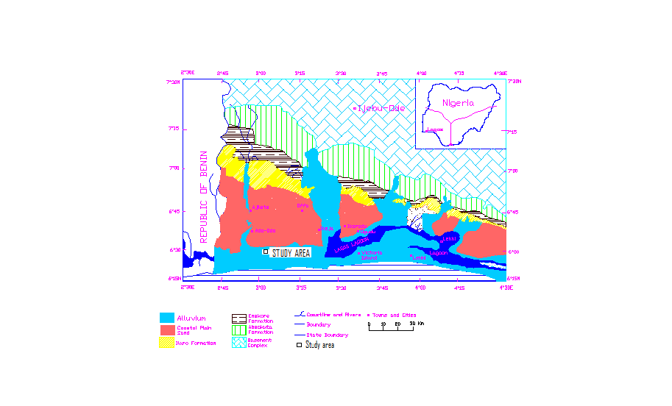
Fig 1: Geologic map of Lagos,( Adegoke,1969 )

Ves 1 ves2
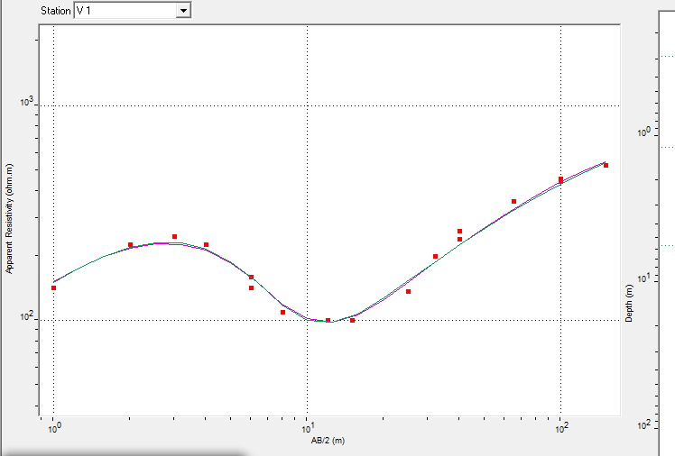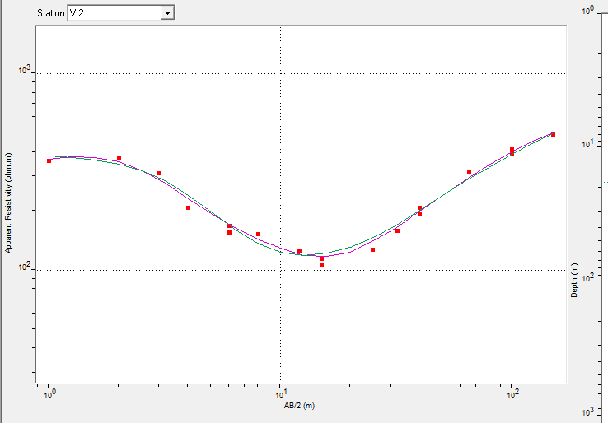

Ves3 ves4
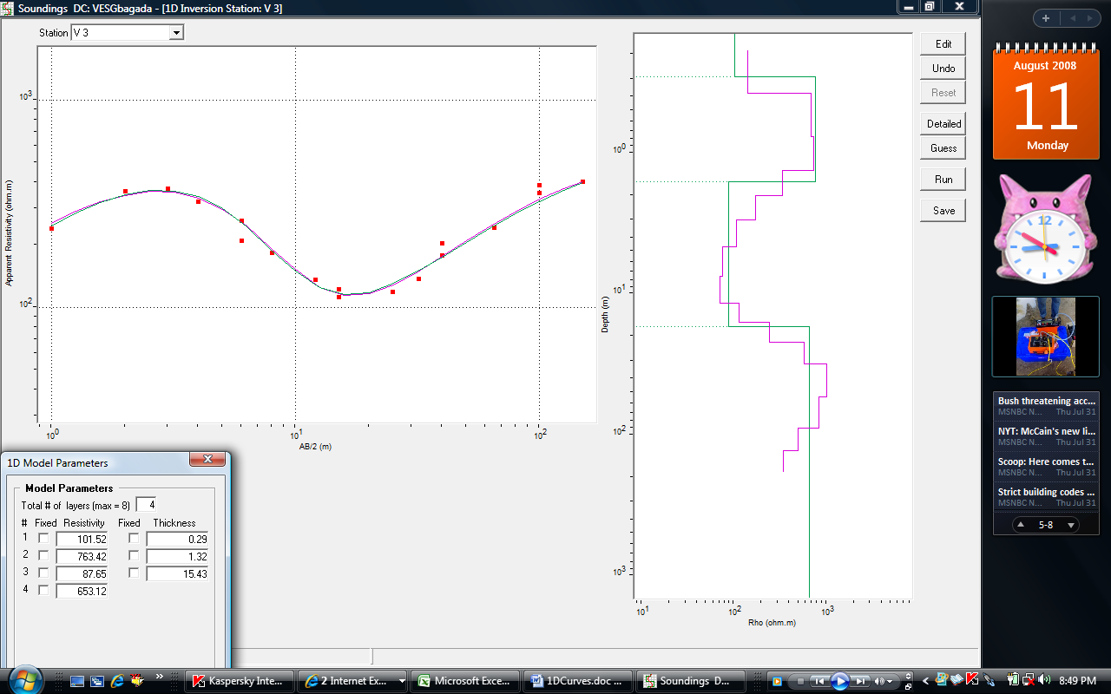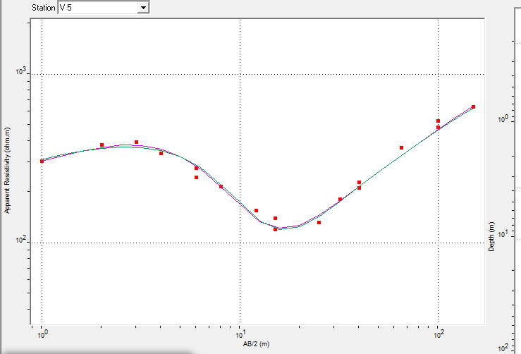

Ves5 ves6
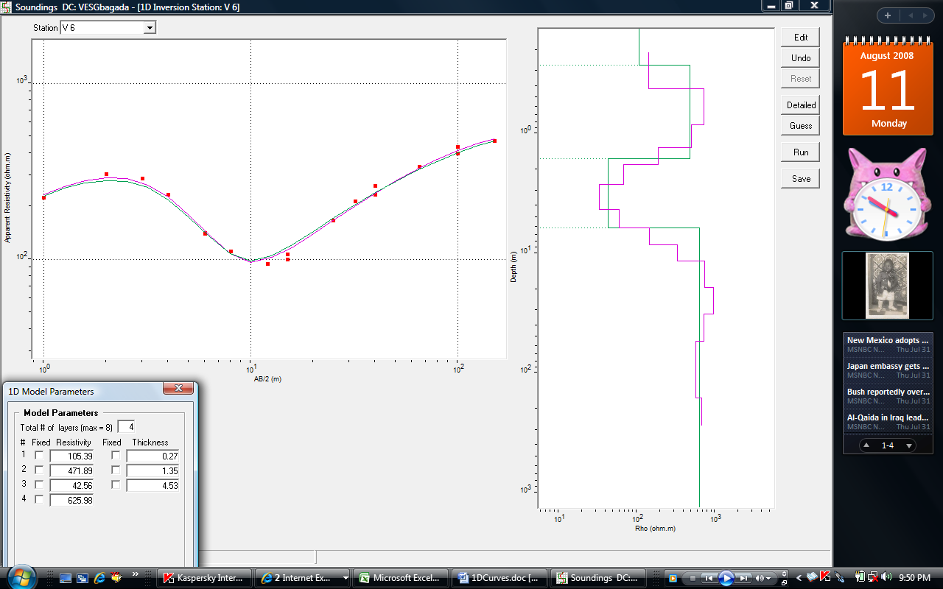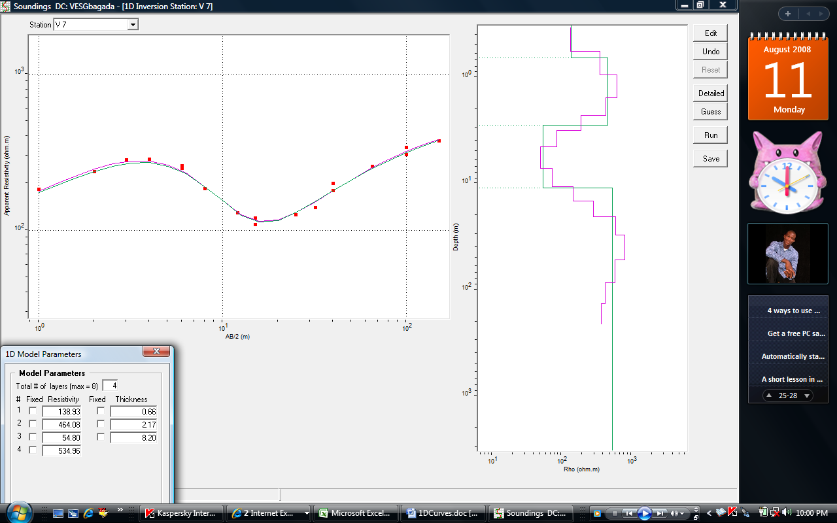

Fig 2: Representative of 1-D model resistivity curves

Ves7 ves8
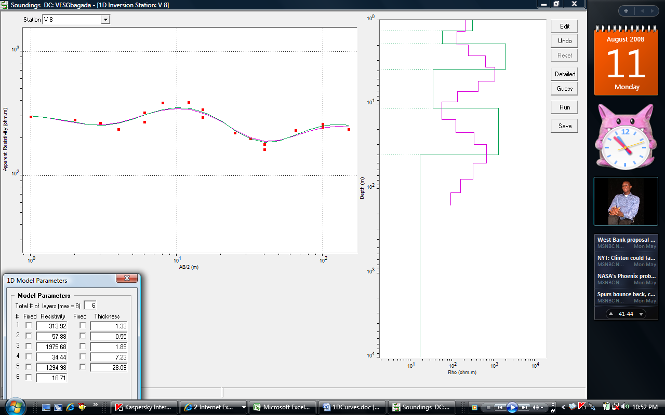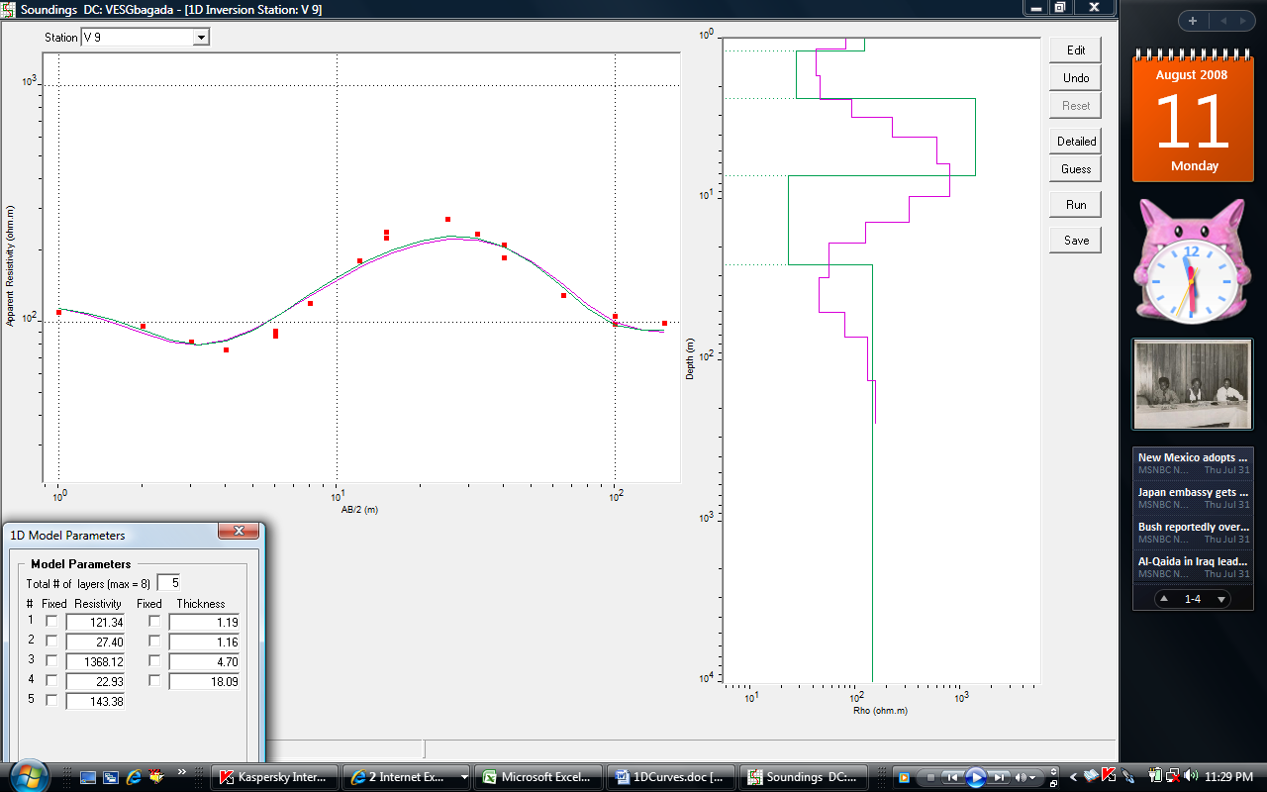

Ves9 ves10
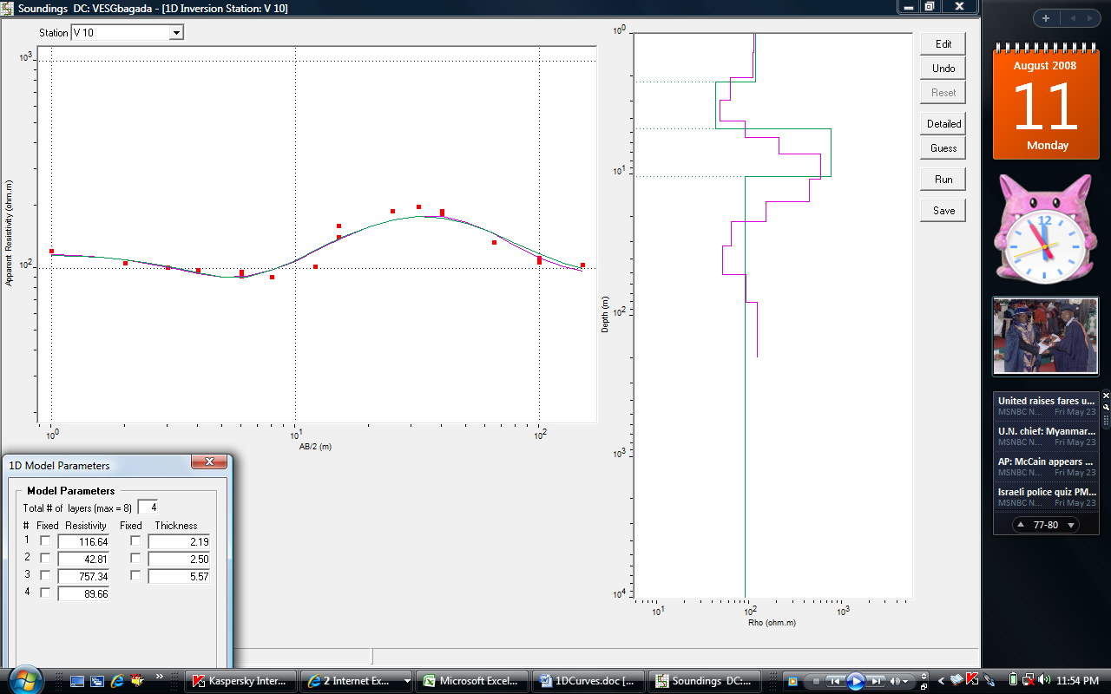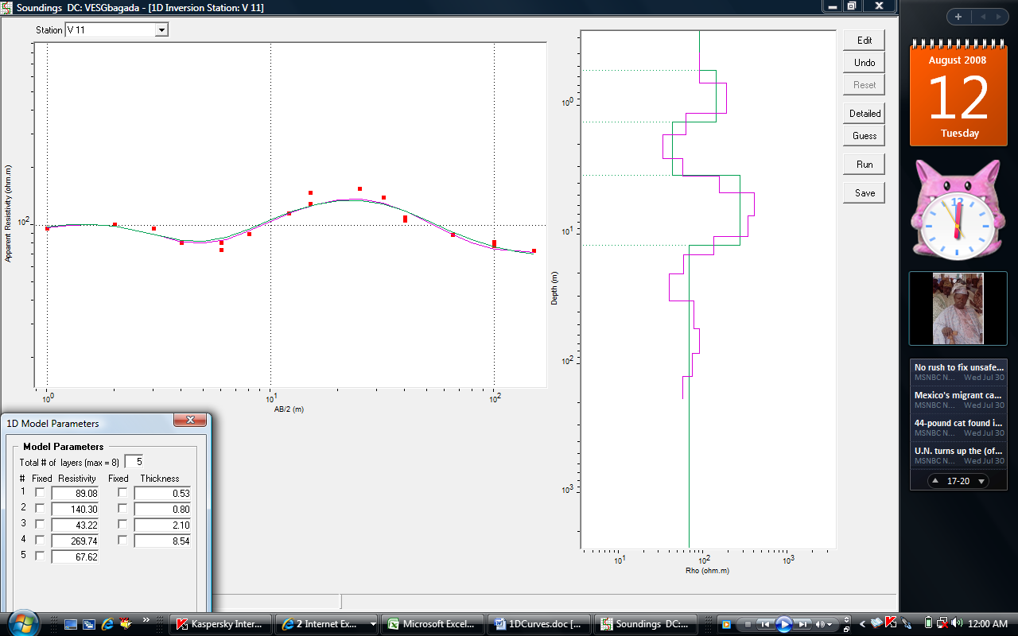

Ves11 ves12
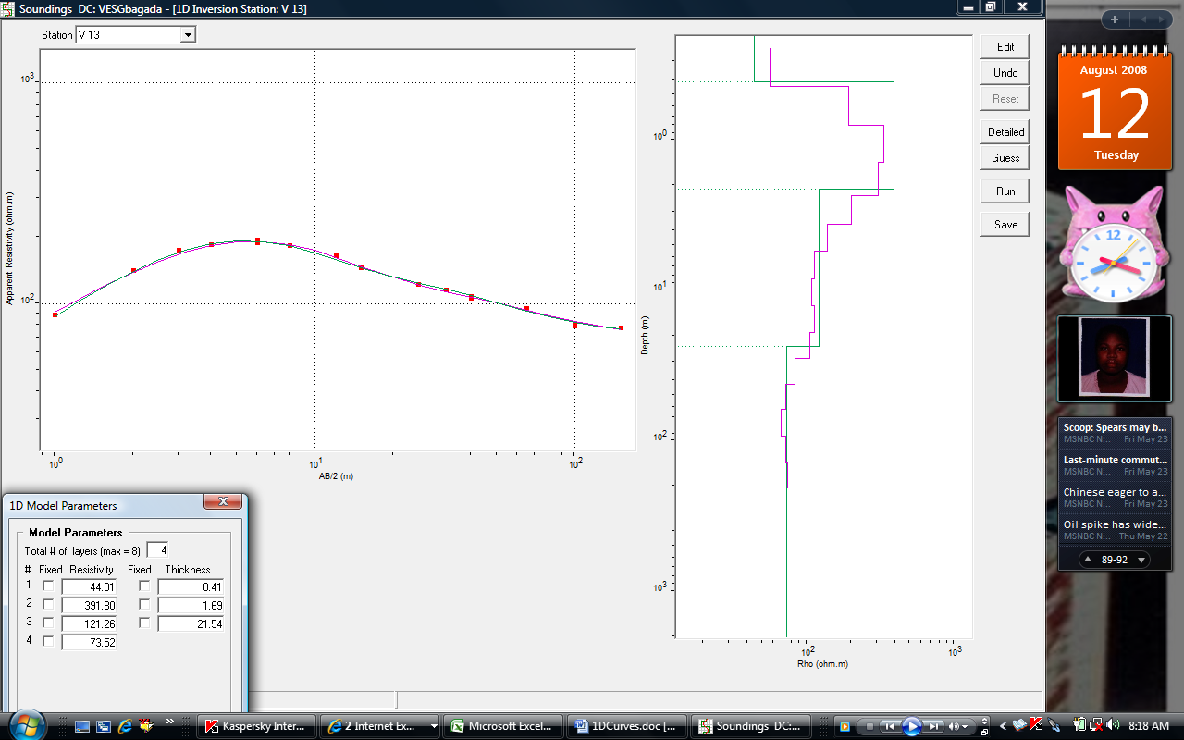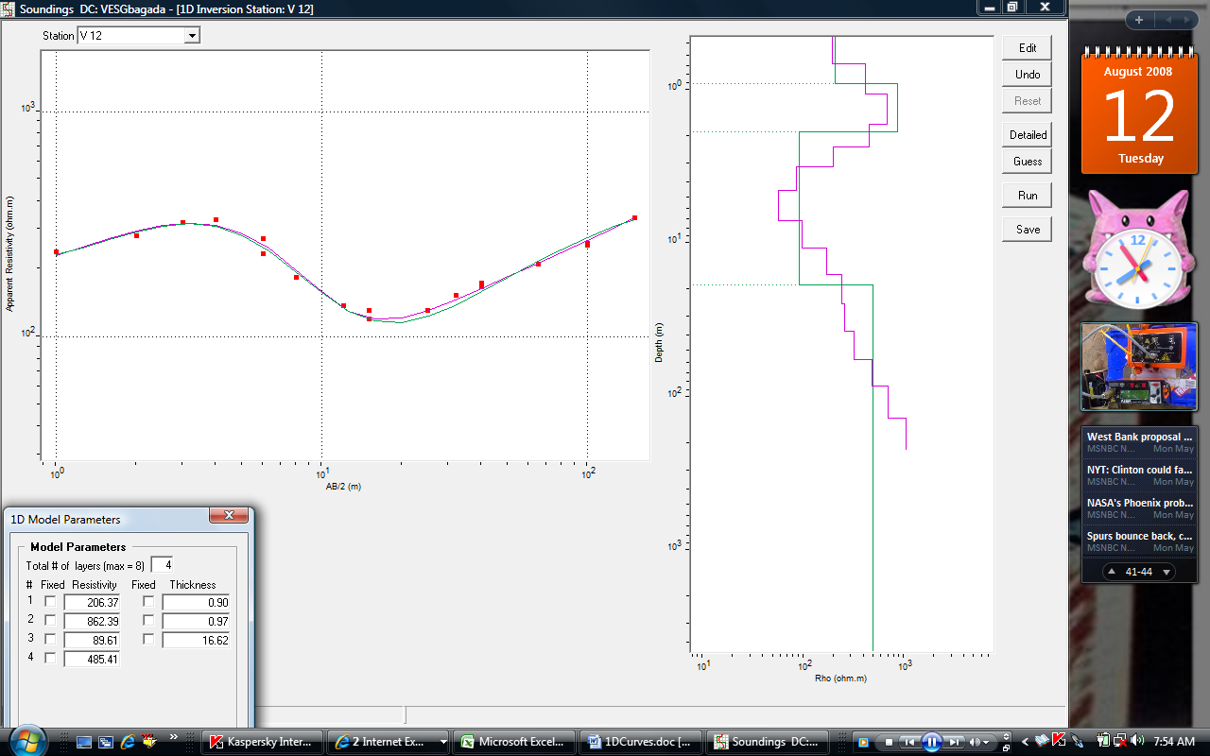

Fig 3: Representative of 1-D model resistivity curves

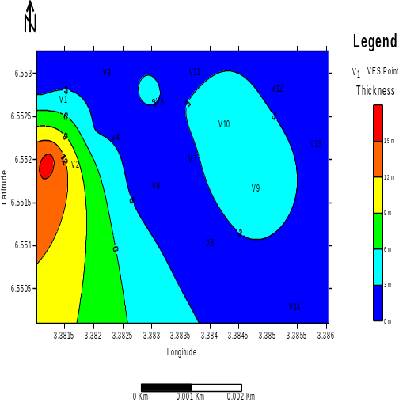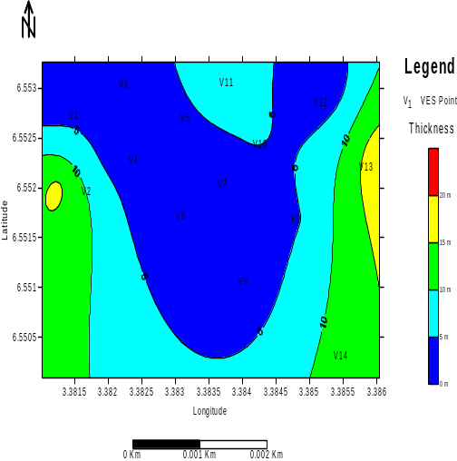
(a) : Sand Isopach Map between 0-15m (b) : Thickness of sand layer between 0 – 20 m

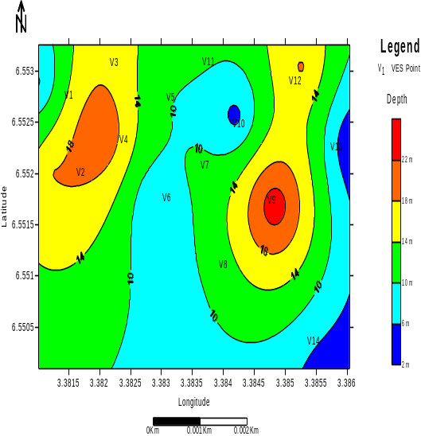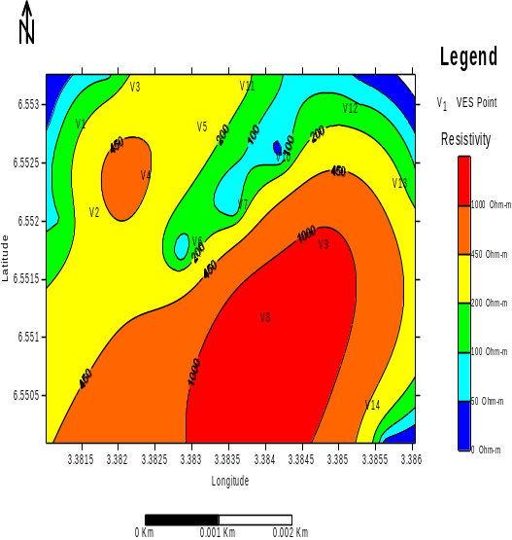
(c): Depth to Freshwater aquifer layer (d): Isoresistivity Depth-slice Map at 3 m

Fig 4: Contoured maps for sand bodies and depth to freshwater layers.

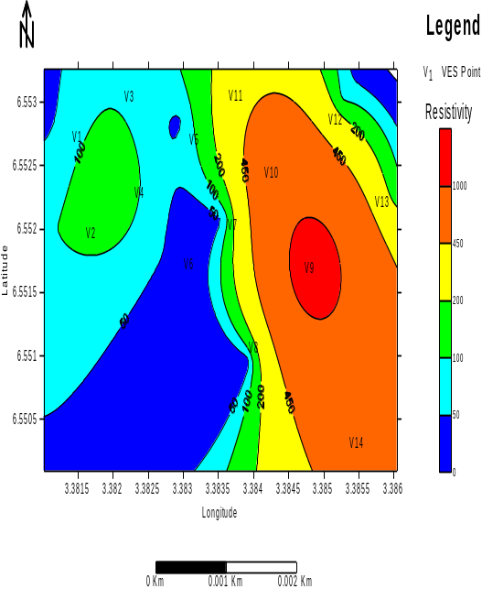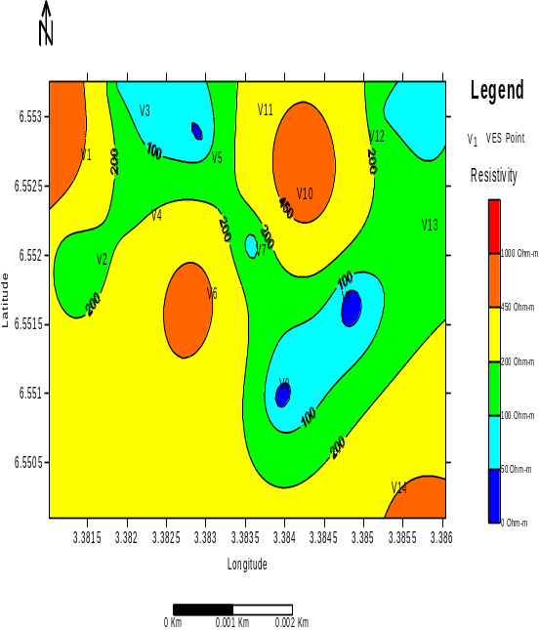
(a) : Isoresistivity Depth-slice Map at 5 m (b): Isoresistivity Depth-slice Map at 10 m

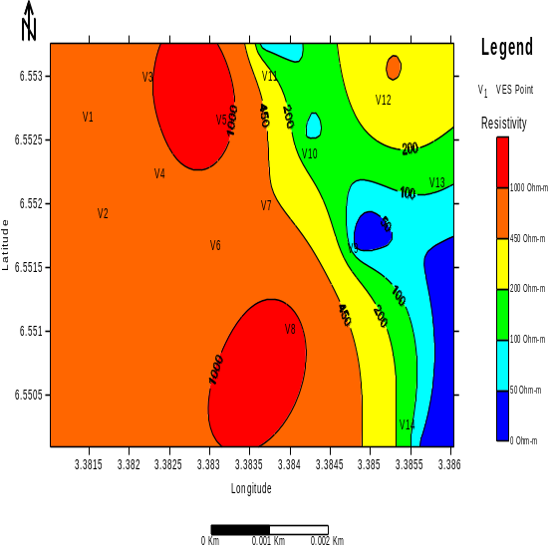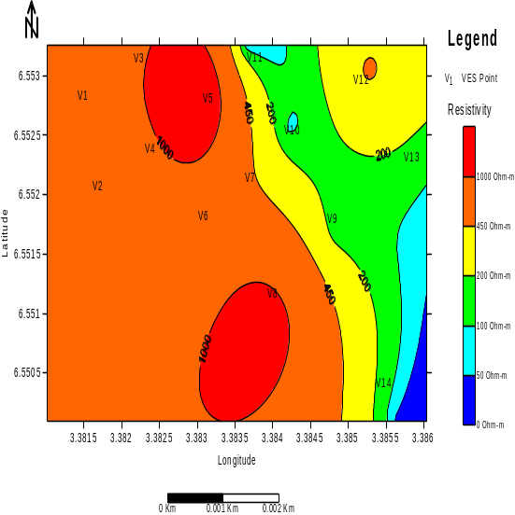
(c): Isoresistivity Depth-slice Map at 20 m (d): Isoresistivity Depth-slice Map at 30 m

Fig 5: Isoresistivity Depth-slice Map at 5m, 10m, 20m and 30m respectively.

Table 2: Measured parameters/Inferred sediments

VES Station | Layer | Resistivity | Thickness | Depth (m) | Lithology
VES Station | Layer | (Ohm-m) | (m) | Depth (m)
1 | 1 | 55.39 | 0.28 | 0.28 | Topsoil
1 | 2 | 742.85 | 0.9 | 1.18 | Medium Sand
1 | 3 | 32.98 | 4.39 | 5.57 | Clay
1 | 4 | 934.95 | - | - | Coarse Sand
2 | 1 | 388.14 | 1.94 | 1.94 | Topsoil
2 | 2 | 102.08 | 16.15 | 18.09 | Medium Sand
2 | 3 | 911.54 | - | - | Coarse Sand
3 | 1 | 101.52 | 0.29 | 0.29 | Topsoil
3 | 2 | 763.42 | 1.32 | 1.61 | Medium Sand
3 | 3 | 87.65 | 15.43 | 17.04 | clayey sand
3 | 4 | 653.12 | - | - | Coarse Sand
4 | 1 | 386.35 | 0.48 | 0.48 | Topsoil
4 | 2 | 666.95 | 2.57 | 3.05 | Medium Sand
4 | 3 | 155.25 | 18.9 | 21.95 | clayey sand
4 | 4 | 586.5 | - | - | Coarse Sand
5 | 1 | 158.46 | 0.2 | 0.2 | Topsoil
5 | 2 | 420.55 | 3.54 | 3.74 | Medium Sand
5 | 3 | 43.73 | 6.81 | 10.55 | Clay
5 | 4 | 1812.75 | - | - | Coarse Sand
6 | 1 | 105.39 | 0.27 | 0.27 | Topsoil
6 | 2 | 471.89 | 1.35 | 1.62 | Medium Sand
6 | 3 | 42.56 | 4.53 | 6.15 | clay
6 | 4 | 625.98 | - | - | Coarse Sand
7 | 1 | 138.93 | 0.66 | 0.66 | Topsoil
7 | 2 | 464.08 | 2.17 | 2.83 | Medium Sand
7 | 3 | 54.8 | 8.2 | 11.03 | clay
7 | 4 | 534.96 | - | - | Coarse Sand
8 | 1 | 313.92 | 1.33 | 1.33 | Topsoil
8 | 2 | 57.88 | 0.55 | 1.88 | clayey sand
8 | 3 | 1975.68 | 1.89 | 3.77 | Medium Sand
8 | 4 | 34.44 | 7.23 | 11 | clay
8 | 5 | 1294.98 | 28.09 | 39.09 | Coarse Sand
8 | 6 | 16.71 | - | - | clay
9 | 1 | 121.34 | 1.19 | 1.19 | Topsoil
9 | 2 | 27.4 | 1.16 | 2.35 | clay
9 | 3 | 1368.12 | 4.7 | 7.05 | Medium Sand
9 | 4 | 22.93 | 18.09 | 25.14 | clay
9 | 5 | 143.38 | - | - | Coarse Sand
10 | 1 | 116.64 | 2.19 | 2.19 | Topsoil
10 | 2 | 42.81 | 2.5 | 4.69 | clay
10 | 3 | 757.34 | 5.57 | 10.26 | Medium Sand
10 | 4 | 89.66 | - | - | Clay
11 | 1 | 89.08 | 0.53 | 0.53 | Topsoil
11 | 2 | 140.3 | 0.8 | 1.33 | Medium Sand
11 | 3 | 43.22 | 2.1 | 3.43 | clay
11 | 4 | 269.74 | 8.54 | 11.97 | Coarse Sand
11 | 5 | 67.62 | - | - | clayey sand
12 | 1 | 206.37 | 0.9 | 0.9 | Topsoil
12 | 2 | 862.39 | 0.97 | 1.87 | Medium Sand
12 | 3 | 89.61 | 16.62 | 18.49 | clayey sand
12 | 4 | 485.41 | - | - | Coarse Sand
13 | 1 | 44.01 | 0.41 | 0.41 | Topsoil
13 | 2 | 391.8 | 1.69 | 2.1 | Medium Sand
13 | 3 | 121.26 | 21.54 | 23.64 | clayey sand
13 | 4 | 73.52 | - | - | clay
14 | 1 | 90.81 | 0.62 | 0.62 | Topsoil
14 | 2 | 183.78 | 0.92 | 1.54 | Medium Sand
14 | 3 | 30.24 | 2.37 | 3.91 | clay
14 | 4 | 549.79 | 12.31 | 16.22 | Coarse Sand
14 | 5 | 47 | - | - | clay

5/28/2009

