DEVELOPMENT AND POWER PERFORMANCE TEST OF A SMALL THREE-BLADED HORIZONTAL-AXIS WIND TURBINE

K.R. AJAO (Ph.D.)
Department of Mechanical Engineering, University of Ilorin, Ilorin, Nigeria.
e-mail: ajaomeche@yahoo.com
&
I.K. ADEGUN (Ph.D.)
Department of Mechanical Engineering, University of Ilorin, Ilorin, Nigeria.
e-mail: kadegun2000@yahoo.com
Abstract
The parameterization, installation and testing of a locally developed three-bladed horizontal-axis wind turbine was carried out. The turbine blades were fabricated from Mansonia Altissima wood because of its availability, good strength, and resistance to both fatigue and soaking, with a rotor swept area of 3.65 metres and the blade angle of attack was experimentally determined to be 7⁰.
The turbine was installed on the roof top of University of Ilorin,Faculty of Engineering Central Workshop Building at a hub height of 14.9 metres from the ground level while the turbine generator was sourced locally. The direct current (d.c.) power output of the test turbine was measured at the battery bank terminal by a Power Analyzer and a direct current (d.c.) to alternating current (a.c.) inverter converts the d.c. power output to a.c. power and was measured by a digital Wattmeter.
An anemometer with a data logger installed on a meteorological tower (MET) measured the wind speed and direction over the test period. The cut-in wind speed, that is, the speed at which the wind turbine starts to produce power was determined to be 3.5 m/s. One minutes averages of wind speed and power output was used to determine the power curve for the wind turbine
Measured power increase consistently with increased wind speed and the power curve obtained compared fairly well with standard power curves.
Keywords: wind turbine, angle of attack, anemometer, data logger, cut-in wind speed, power curve.
1. Introduction
The development of wind turbines has made a significant contribution to human development and technological achievement through history. With an ever increasing demand for energy resources, and global concern about pollution and environmental damage arising from fossil fuels; wind turbines may begin to assert an ever increasing role during this century and beyond. Recent advances in technology have resulted in current improved wind turbine designs which are increasingly efficient, effective and reliable.
The conversion of wind energy to useful energy involves two processes: the primary process of extracting kinetic energy from the wind and conversion to mechanical energy at the rotor axis, and the secondary process of the conversion of such mechanical energy into useful electrical energy [1] depicted in Figure 1.
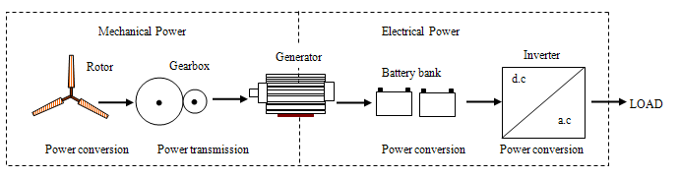

Figure 1. Conversion from Wind Power to Electrical power in a wind Turbine.
The major field of science involved in this process is aerodynamics, which needs meteorology (wind description) as an input and system dynamics for the interaction with the structure. The latter is important since all movement of the rotor blades, and the bending of the blades out of their plane of rotation, induces apparent velocities that can influence or even destabilize the energy conversion process [2].
The aerodynamic research for wind turbines has contributed significantly to the success of modern way of harnessing wind energy. For most unsolved problems engineering rules have been developed and verified. All of these rules have limited applicability, and the need to replace these rules by physical understanding and modeling is increasing. This is one of the reasons that the worldwide aerodynamic research on wind energy shows a shift towards a more fundamental approach, ‘Back to basics’ based on full scale experiments other than wind tunnel experiment and analytical modeling.
Simplified analyses of horizontal-axis wind turbine flows aimed at overall aerodynamic performance prediction developed for modern rotor theories are available in literature. There have, however, been few thorough tests of the adequacy of such analyses by direct comparison with actual measurements over a wide range of configurations and conditions [3].

1.1 Wind Power in Nigeria
Nigeria is blessed with a variety of renewable energy resources: solar, small scale hydro, biomass and wind. These resources are well distributed throughout the country. The annual average wind speed range from 3m/s to 7m/s increasing from South to North above the cut-in wind speed of 2.5m/s for most wind turbines [4]. Figure 2 below shows the distribution of annual average wind speed across Nigeria.

Figure 2. Distribution of annual average wind speed (m/s) at 10m height in Nigeria.(Adapted from [4])

The national access to grid distributed supply of electricity stand at about 40 percent with urban access accounting for over 80 percent of the present recoverable generation capacity of 4000 megawatt. Hence, a shortfall will occur in the medium term and the rural areas will be hardest hit.
The Nigerian power grid network is not very strong due to low generation, low spinning reserve and poor spread of source points in such a vast coverage. In order not to further weaken the grid system and save the huge cost of network extension, it is necessary to supply some areas from isolated power generators usually of renewable type. These include small hydropower stations, photovoltaic solar sources and wind power stations [5].
Adegoke and Anjorin [3] investigated the prospects of wind energy utilization in Nigeria by analyzing available wind data for Akure, Bauchi and Port Harcourt and observed that the average wind speed measured at 10metres height above the ground for Bauchi is 4.78m/s, Port Harcourt is 2.56m/s and that for Akure is 0.76m/s.
It was concluded that Bauchi favours the installation of wind turbines more than Port Harcourt and Akure and that the variation of annual mean wind speed is much lower for Port Harcourt than it is for Bauchi implying that wind turbines installed in Port Harcourt would function more regularly over several years.

2. Energy in the wind
Wind is merely air in motion. It is produced by the uneven heating of the Earth’s surface by energy from the Sun. Since the Earth’s surface is made of different types of land and water, it absorbs the Sun’s radiant energy at different rates. Much of this energy is converted into heat as it is absorbed by land areas, bodies of water and the air over these formations.
The air has mass, though its density is low, and when this mass has velocity, the resulting wind has kinetic energy which is proportional to 1/2[mass x (velocity)²]. The mass of air passing in unit time is 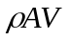 and the kinetic energy passing through the area in unit time (power available in the wind) is:
where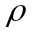 = Air density (approx.1.225 kg/m³ at sea level)
 = Velocity of wind (m/s)
 = Area through which the wind passes normally (m²).
This is the total power available in the wind (approx. 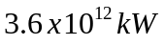) obviously, only a fraction of this power can actually be extracted.
The power extracted by a wind turbine can therefore be given as:
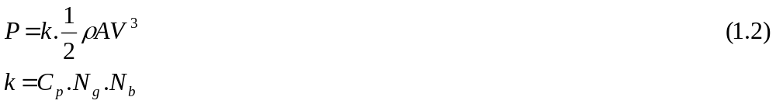
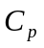 = coefficient of performance or power coefficient
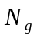 = Generator efficiency
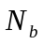= Gearbox/bearing efficiency
The torque generated by the wind turbine is:
where, 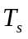 = mechanical torque at the turbine side
 = power output of the turbine
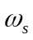 = rotor’s speed of the wind turbine
The power coefficient is the percentage of power in the wind that can be converted into mechanical power and the ratio of the blade tip speed to the wind speed is referred to as the tip-speed ratio (TSR).

 is radius of the wind turbine rotor.
Wind turbine operation is limited by its TSR, a larger wind turbine operates at a lower frequency [6]. Basically, rotor movement is a balance between the aerodynamic torque applied by the wind and the electrical torque applied by the generator. The power coefficient is a measure of the mechanical power delivered by the rotor to the turbine’s low-speed shaft. It is defined as the ratio of the mechanical power to the power available in the wind.
One of the most important points in the design of a wind-driven generator is the ‘rated wind speed’ i.e. the lowest wind speed at which full output is produced. At higher wind speeds the output is limited, by the controlling mechanism to this full rated value [7].
The cut-in wind speed is the speed at which the turbine start producing power and the cut-out wind speed is the speed at which the turbine must either stall or turn away from the wind direction to prevent damages that may occur as a result of turbulent wind [8].

3. Characteristics of Small Wind Turbines
All forms of wind turbine are designed to extract power from a moving air stream. The blades have an airfoil cross-section and extract wind by a lift force caused by a pressure difference between blade sides. When air passes over an airfoil section; it travels faster over the top of the blade than it does below it. This makes the air pressure above the blade lower than it is below. Due to the unequal pressures the blade experiences a lifting force [9]. For maximum efficiency, the blades often incorporate twist and taper.
The mechanical power produced by a rotor is purely a function of the blade geometry and the incident velocity. The design parameters that affect aerodynamic performance include blade pitch (angle of attack), taper, and twist distribution. For a given blade, its geometric shape is usually fixed, i.e. the aerodynamic shape, taper and twist distribution do not change. The for any fixed rotor geometry is a well-prescribed function of the blade tip speed ratio with a single maximum value.
The torque produced by the rotor can be controlled in two ways: changing the geometry by varying the blade pitch angle, or by changing the rotor’s rotational speed so that the rotor operates at the optimal blade tip speed ratio.
The angle of attack , is the angle between the incoming flow stream and the chord line of the airfoil. At low angles of attack, the dimensionless lift coefficient increases linearly with angle of attack and drag is reasonably small. Flow is attached to the airfoil throughout this regime. At an angle of attack of roughly 10⁰, the flow on the upper surface of the airfoil begins to separate and a condition known as stall begins to develop. The dimensionless lift coefficient peaks and the dimensionless drag coefficient increases as stall increases [8].
All wind turbines can be characterized as either Horizontal Axis Wind Turbines (HAWT) or Vertical Axis Wind Turbines (VAWT). In HAWT, the rotor spins about an axis horizontal to the earth’s surface. The rotor of a VAWT spins about an axis perpendicular to the Earth’s surface.
Vertical axis wind turbines are typically developed only for built environment. Changes in wind direction have fewer negative effects on this type of turbine because it does not need to be positioned into the wind direction. However, the overall efficiency of these turbines in producing electricity is lower than HAWT. VAWTs are categorized as Savonius or Darrieus types, according to the principle used to capture the wind flow. For the Savonius type, the wind pushes the blades, which implies that the rotation speed is always lower than the wind speed. Contrary to that, the shape of the rotor of the Darrieus type makes it possible for the rotor to spin faster than the wind speed.
Rotors of HAWT are placed on towers to position them where the wind speed is fastest and exhibits most power . A nacelle typically resides atop the tower and contains the support structure for the rotor, the rotor shaft, a gearbox and the electric generator. The gearbox is used to transform the low-speed high-torque power of the rotor to high-speed, low-torque power that can run the electric generator.
Small wind turbine need to be reliable, affordable and almost maintenance free. To meet these criteria, optimal turbine performance is sometimes sacrificed for simplicity in design and operation [10]. Thus, rather than using the generator as a motor to start and accelerate the rotor when the wind is strong enough to begin producing power, small wind turbines rely solely on the torque produced by the wind acting on the blades.
Furthermore, small wind turbines are often located where the generated power is required, which is not necessarily where the wind resource is best. In low or unsteady wind conditions slow starting potentially reduces the total energy generated. Also, a stationary wind turbine fuels the perception of wind energy as an unreliable energy source.
The main technical challenge in the design of a small wind turbine is to come up with a system configuration and control algorithm that maximizes wind energy production from the turbine and also provide favourable charging conditions for batteries. This task is complex because of the variability of the wind, which results in varying wind turbine power output. Ideally, the system configuration and its control should optimize the match between the wind turbine rotor and load, thereby allowing the maximum available power from the wind to be used, while at the same time charging the batteries with an optimum charge profile [11].
The generators of small turbines often cause a significant resistive torque that must be overcome aerodynamically before the blades will start turning. Furthermore, pitch control is rarely used on small wind turbine because of cost. Thus, it is not possible to adjust the turbine blade’s angle of attack to the prevailing wind conditions. This problem is particularly acute during starting.
A further major difference is that small turbines usually operate with varying shaft speed in an attempt to maintain maximum performance as the wind speed varies. Many large turbines run at constant speed as this allows the generator to maintain synchronicity with the utility grid.
The IEC 61400-2 (International Electrotechnical Commission) defines a small turbine as having a swept area less than 200m², which correspond to a power output of about 120kW. In addition, there is a further subdivision in that turbine of swept area less than 2m² (about 1.2kW) do not need to have their tower included in the certification process [12]. Clausen & Wood [13] have made a further subdivision as shown Table1 below.

Table 1. Operating parameters of small wind turbines.
Category | Power (kW) | Turbine  blade radius(m) | Maximum rotor speed  (rpm) | Generator type(s)
Micro | ≤1.2 | 1.5 | 700 | Permanent magnet (PM)
Mid-range | 1-5 | 2.5 | 400 | Permanent magnet or induction
Mini | 20-100 | 5.0 | 200 | Permanent magnet or induction

4. Wind Turbine Blade Geometry
In the beginning most wind turbine blades were adaptations of airfoil developed for aircraft and were optimized for wind turbine uses. In recent years development of improved airfoil sections for wind turbines has been on going. The prevailing tendency is to use NACA 63, NACA 44XX, NACA 230XX, NACA63-2XX series, NREL S809 and other airfoil cross-section that may have modifications in order to improve performance for special applications and wind conditions.
Wind turbines and aircrafts, though designed for different objectives, share similar aeroelastic problems. Its rotary blades couple with surrounding air and other system components to influence overall performance, vibration, loads and stability.
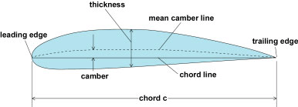
α
V_{R} = Relative Wind
V
ΩR
Ωr
V
=angle of attack
Figure 3. Wind Turbine Airfoil Nomenclature (Reproduced from [14])
Somers and Maughmer [15] carried out theoretical analyses of six airfoils- E387, FX63-137, S822, S834, SD2030 and SH3055 that are candidates for use on small wind turbines. The possession of both theoretical aerodynamic characteristics and wind tunnel test data for the same six airfoils provides the opportunity to compare the performance of wind turbine rotor.
In general, the maximum lift coefficient increases with increasing Reynolds number and the profile-drag coefficient and the width of the low-drag, lift-coefficient range decreases.

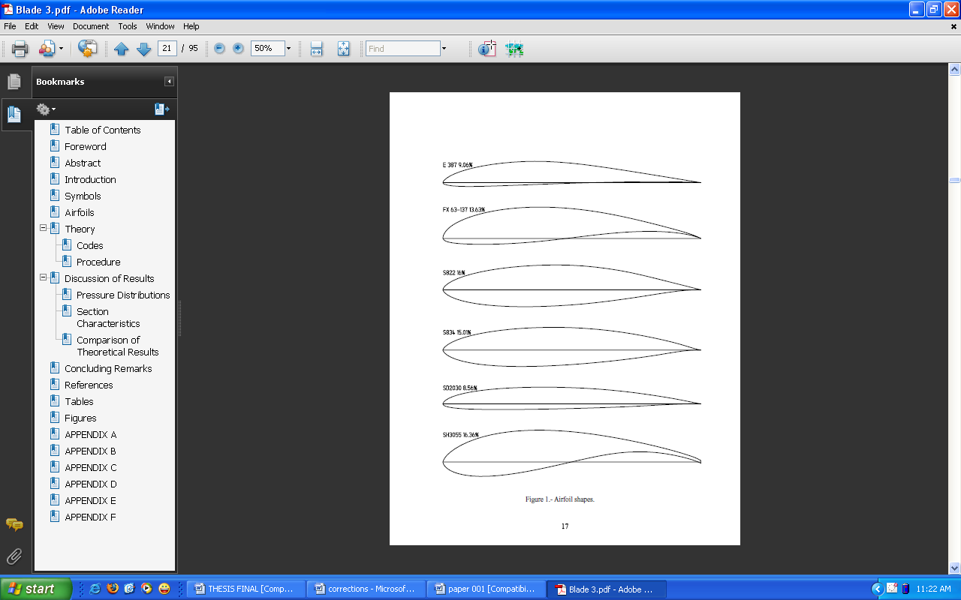
Figure 4 : Wind Turbine Airfoil shapes (Reproduced from [15] )

In the present research work, all blades were designed based on NREL S809 airfoil cross-section which is similar to linear taper blade plan form shown in Figure 5. The chord length and twist angle (relative to the rotor plane) tapering from approximately 0.14m and 13⁰ and the blade root to 0.06m and 2⁰ at the tip.
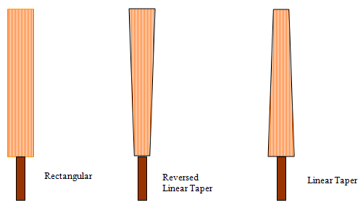
Figure 5. Types of Wind Turbine Blade Plan form (Reproduced from [1] ).

5. Power Performance Analysis
The wind turbine under test is installed on the roof top of University of Ilorin, Faculty of Engineering Central Workshop at about 14.9m from the ground. Ilorin, Nigeria is on latitude 8.5⁰N and the site average temperature and air density are 27⁰C and 1.21kg/m³ respectively [16].
The test turbine shown in Figure 6, has a rotor diameter of 2.15m and a rated power of 110watts at 10m/s. It is a three-bladed, upwind variable speed, horizontal axis having blade pitch angle (angle of attack) of 7⁰. It is permanent wind facing at 285⁰ of compass North.
The turbine uses an automobile alternator (generator) modified to higher rating to produce d.c. power output measured by a FEIGAO Power Analyzer .The output power is stored in two 12V d.c. batteries connected in parallel. The direct current power is converted to alternating current power by a 12V direct current to 220V alternating current inverter. The inverter output is then measured by a digital Wattmeter .
A Vortex D2 anemometer and another 1-wire anemometer installed at the tail boom of the wind turbine serves as the nacelle anemometers measuring wind speed at hub height and as a wind direction sensor respectively.
Installed at about 8.4m from the test turbine is a meteorological tower (MET). This is more than three rotor diameters from the test turbine in the measurement sector as required by the IEC standard. The MET tower carries an APRS anemometer at hub height transmitting wind data to a data logger housed inside the Data Centre shown in Figure 7. The data logger supports Secure Digital (SDTM) card up to 128MB where all the wind data are logged and later transferred to a compatible personal computer (PC) for analysis.
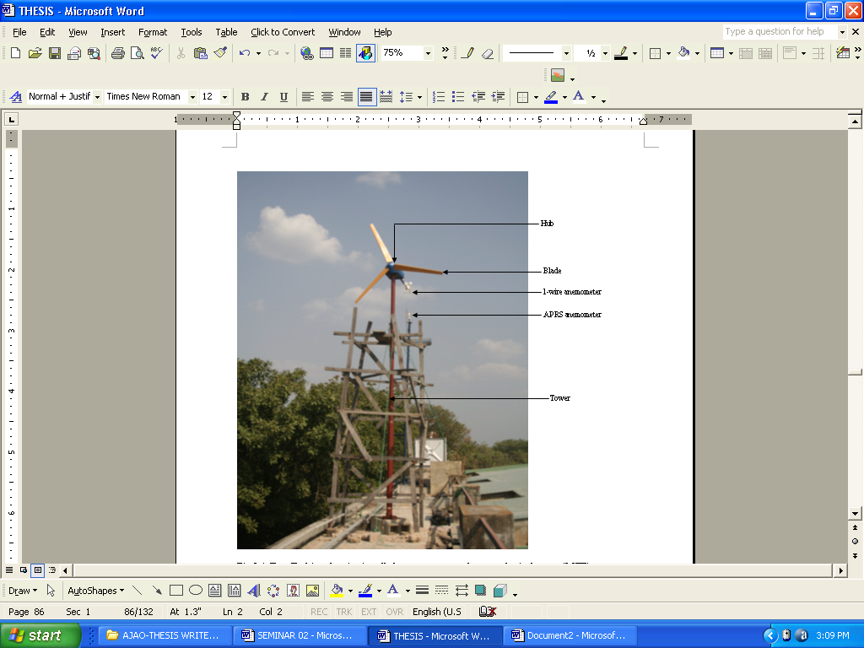
Figure 6. Test Turbine showing anemometers and Meteorological Tower (MET)
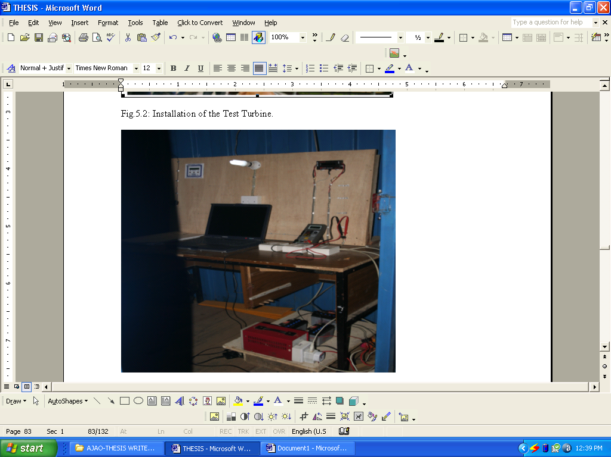
Figure 7. Data- gathering Centre showing installed equipment
6. Results and Discussion
6.1 Results
The data gathering for the power performance test commenced on 16th October, 2007 and ended on 5th February 2008 during the hamattan wind period. Wind speed measurement during the test period was obtained automatically by the APRS anemometer and data logger at a sample rate of one-minute. It measured and logged current wind speed (WS0), maximum wind speed (WG0), prevailing wind direction (DIR) and input voltage to the data logger among other useful data to a 128MB SD-RAM in a spread sheet format as shown in table 2.
Table 2. Wind speed measurement using APRS anemometer
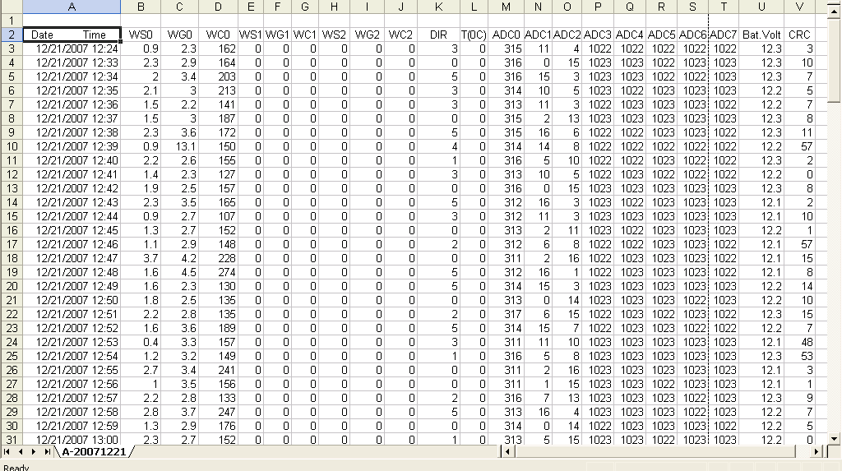
The data from the 1-wire anemometer, measuring the wind direction and that of the Vortex D2 anemometer measuring the wind speed in miles per hour (mph) only serve to confirm the correctness of the APRS anemometer data. This was done and confirmed satisfactory.
The direct current power produced by the test turbine during the “good wind” period was measured at the battery bank terminal just before the inverter by a Feigao Power Analyzer and logged automatically to the host laptop computer via a Com Port. The data being logged is displayed on the screen of the host computer by the PowerView software that accompanied this equipment. The PowerView software displays the real-time power in watts, maximum power, minimum power, current, amp-hour, watt-hour and plot the graphs of these values against time in seconds and also record the same data in a spreadsheet format and a sample is shown in Figure 8 below.

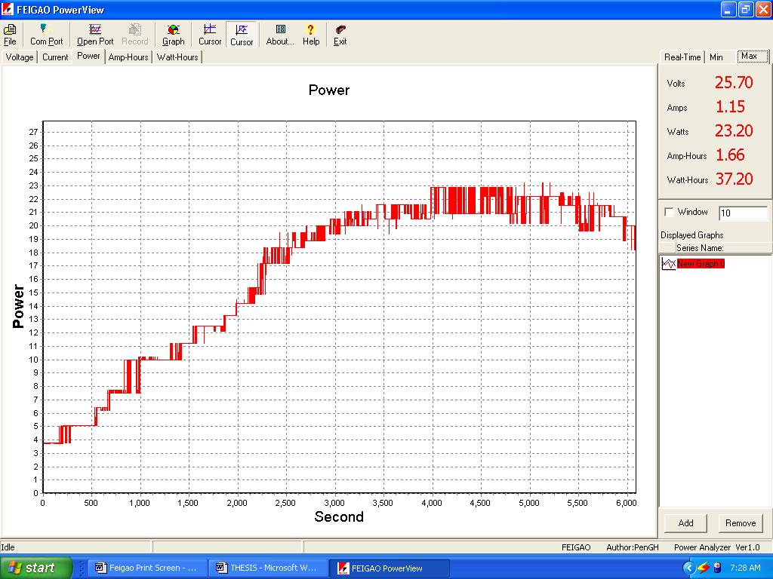
Figure 8. Test Turbine Power measurement using Power Analyzer
The digital wattmeter records the alternating current power produced, measured at the output terminal of the inverter and this data was recorded manually into a logbook because the equipment has no data logger. A bulb point load is connected to the terminal of the wattmeter during measurement.
All measuring equipments are connected to their sources via a control switch to aid the switching on and shutting off of the data gathering equipment in unfavourable conditions. On a weekly basis the data from the measuring equipment are gathered and analyzed and the test turbine and all equipment are also checked for damages.

6.2 Power Curves Analysis
The amount of power that a wind turbine produces depends on the wind speed at the time. The power curve describes the relationship between the wind speed and the power that the turbine generates.
6.2.1 Measured (d.c.) Power
Table 3 below shows the measured direct current (d.c.) power at site average air density (1.21 kg/m³) and normalized to the power at sea level air density (1.225 kg/m³). Normalization to sea level air density is done by multiplying measured power by the ratio of sea level air density to site average air density. Measured wind speed is also binned and normalized. The IEC standard requires at least three one-minute points per bin. This condition was met except for normalized wind speed of 18 m/s, 19 m/s and 20 m/s.

Table 3. Direct current (d.c.) power at site average air density and normalized to sea level air density.
Wind Speed  (m/s) | Normalized Wind  Speed (m/s) | Measured Power (d.c.)  at site average air density (W) | Power (d.c.) normalized  to sea level air density (W)
1 | 1.4 | 0 | 0
2 | 2.3 | 1.33 | 1.35
3 | 3.2 | 2.57 | 2.61
4 | 4.3 | 8.80 | 8.92
5 | 5.8 | 14.54 | 14.74
6 | 6.7 | 23.20 | 23.53
7 | 7.4 | 32.20 | 32.65
8 | 8.2 | 63.00 | 63.89
9 | 9.3 | 97.20 | 98.57
10 | 10.1 | 110.20 | 111.75
11 | 11.7 | 159.00 | 161.23
12 | 12.4 | 166.10 | 168.43
13 | 13.5 | 170.80 | 173.20
14 | 14.2 | 209.94 | 212.89
15 | 15.4 | 275.25 | 279.12
16 | 16.2 | 282.62 | 286.59
17 | 17.4 | 284.19 | 288.18
18 | 18.1 | 285.00 | 289.00
19 | 19.8 | 289.53 | 293.60
20 | 20.9 | 381.10 | 386.45

The power curves for the measured d.c. power at site average air density and normalized to sea level air density are shown in Figure 9 and Figure 10.
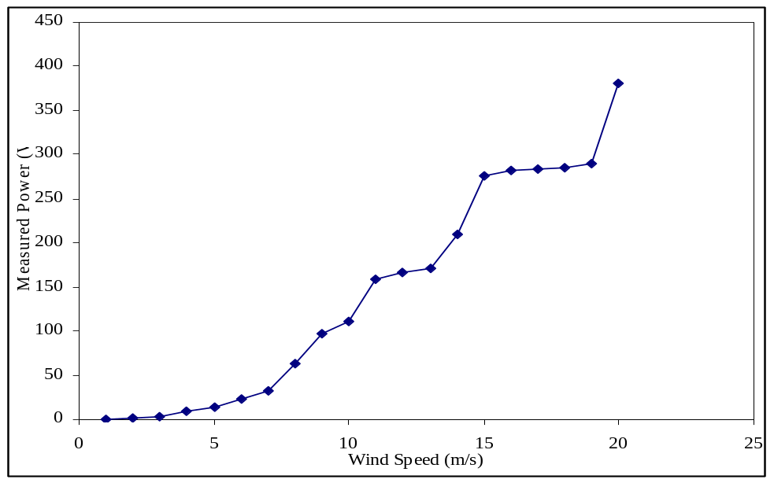
Figure 9. Direct current (d.c.) Power Curve at site average air density, 1.21kg/m³
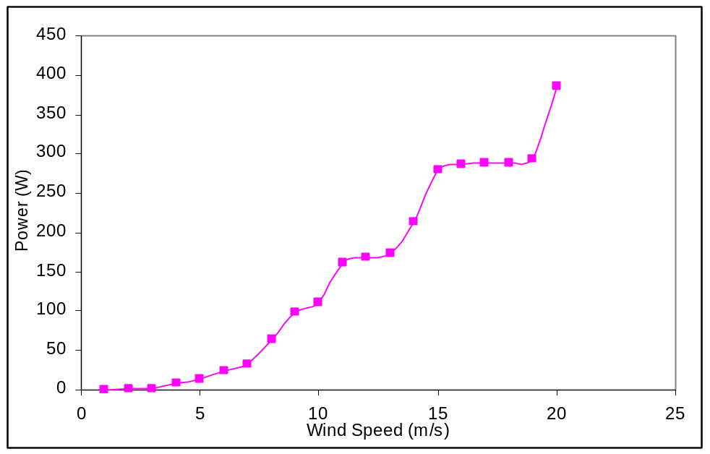
Figure 10. Direct current(d.c.) Power Curve at sea level air density, 1.225kg/m³
6.2.2 Measured (a.c.) Power
Table 4 below shows the measured a.c. power at site average air density (1.21 kg/m³) and normalized to the power at sea level air density (1.225 kg/m³). Normalization to sea level air density is done by multiplying measured power by the ratio of sea level air density to site average air density. Measured wind speed is also binned and normalized. The IEC standard requires at least three one-minute points per bin. This condition was met except for normalized wind speed of 18 m/s, 19 m/s and 20 m/s.
Table 4. Alternating current (a.c.) power at site average air density and normalized to sea level air density.
Wind Speed  (m/s) | Normalized Wind  Speed (m/s) | Measured Power (a.c)  at site average air density (W) | Power (a.c) normalized to  sea level air density (W)
1 | 1.4 | 0 | 0
2 | 2.3 | 10 | 10.12
3 | 3.2 | 10 | 10.12
4 | 4.3 | 16 | 16.20
5 | 5.8 | 20 | 20.25
6 | 6.7 | 23 | 23.29
7 | 7.4 | 31 | 31.38
8 | 8.2 | 52 | 52.64
9 | 9.3 | 93 | 94.15
10 | 10.1 | 97 | 98.20
11 | 11.7 | 138 | 139.71
12 | 12.4 | 146 | 147.81
13 | 13.5 | 150 | 151.86
14 | 14.2 | 153 | 154.90
15 | 15.4 | 153 | 154.90
16 | 16.2 | 240 | 242.98
17 | 17.4 | 245 | 248.04
18 | 18.1 | 248 | 251.07
19 | 19.8 | 254 | 257.15
20 | 20.9 | 305 | 308.78

The power curves for the measured a.c. power at site average air density and normalized to sea level air density are shown in Figure 11 and Figure 12.
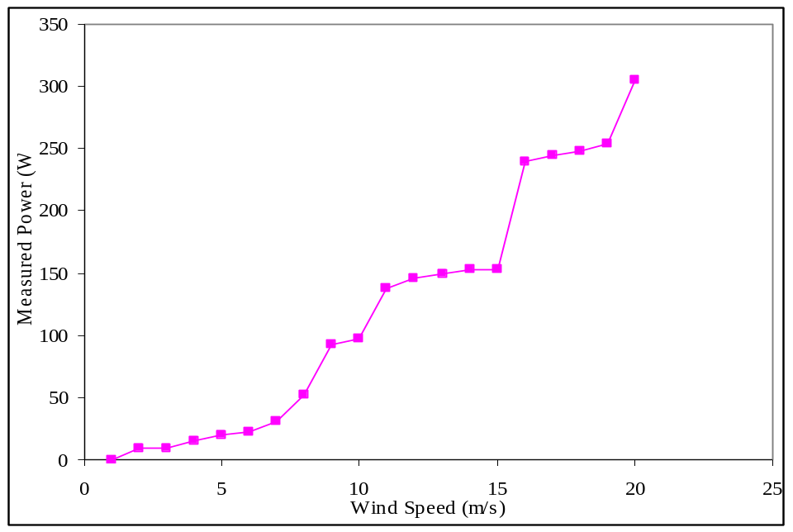
Figure 11. Alternating current (a.c.) Power Curve at site average air density, 1.21kg/m³
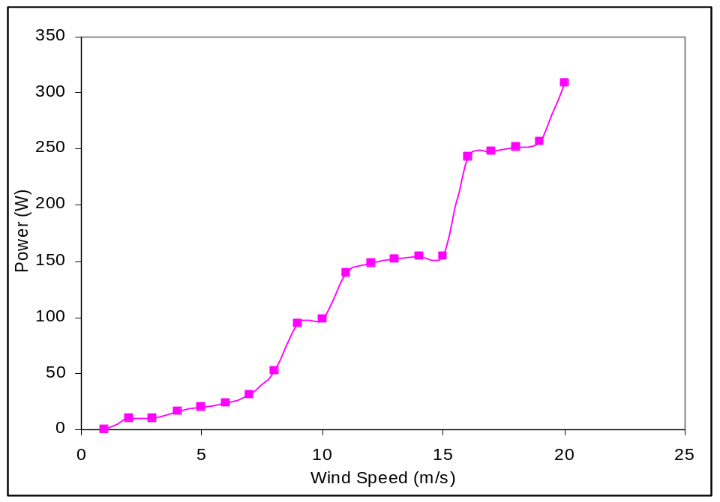
Figure 12. Alternating current (a.c.) Power Curve at sea level air density, 1.225kg/m³

6.3 Discussion
The result of the wind speed measurements indicated that the wind is an intermittent resource that is not available most of the time. The daily average wind speed is lower than the cut-in wind speed and for most part of the day the wind turbine is idling. Normalization to sea level air density has no significant effect on the result. The prevailing wind direction is recorded to be around 4⁰ of the compass North; the wind turbine though within the measurement sector can perform better if slightly turned towards 345⁰-5⁰ of the compass North.
Measured power increases consistently with increased wind speed. The average output power and the Annual Energy Power (AEP) of the test turbine was determined to be approximately 100Watts and 698Kilowatts respectively. The resulting power curve showed some discrepancies at certain wind speed but compared favourably with standard power curves.
With wind plants in the megawatts range, the topography of Nigeria can be put to advantage. For stability reasons, grid integration of such plants may not be advisable presently. However, the installation of small wind turbines in the kilowatts range in remote settlements in Nigeria is practicable and viable. Such settlements abound in the riverine areas of the South endowed with ocean wind and in the desert windy areas of northern Nigeria. In areas with low wind resources, a hybrid system with solar photovoltaic energy system is recommended. A balanced system provides stable outputs from these sources and minimizes the dependence of the power output on seasonal changes.

7. References
[1] Ajao K.R. “Development and Performance Assessment of a Small Horizontal-axis Wind Turbine”. Ph.D. Thesis, Department of Mechanical Engineering, University of Ilorin, Ilorin, Nigeria. August, 2008.
[2] Vermeer L.J, Sorensen J.N and Crespo A. “Wind turbine wake aerodynamics”. Progress in Aerospace Sciences 39, 2003, pp. 467-510.
[3] Adegoke C.O and Anjorin A.S. “Wind as an alternative energy source”. J.Sci.Engr.Tech 3(2), October 1996, pp. 511-524.
[4] Iloeje O.C. “Overview of Renewable Energy in Nigeria, opportunities for rural development and development of a renewable master plan”. Energy Commission of Nigeria, Presented at the Renewable Energy Conference “ENERGETIC SOLUTION” Conference, Abuja/Calabar, 21-26 November, 2004.
[5] Okafor N.F and Hofmann W. “Recent developments in wind energy conversion technology and their benefits to Nigeria’s power generation needs”. Proceedings of the 35th Annual Conference of Nigerian Society of Engineers, Abuja November, 2000, pp.190-200.
[6] Muljadi E and Green J. “Cogging Torque Reduction in a Permanent Magnet Wind Turbine Generator”. NREL/CP-500-30768, National Renewable Energy Laboratory, Golden Colorado, U.S.A, January, 2002.
[7] Golding E.W. The generation of electricity by wind power.E&F.N SPON Ltd, London, February, 1976.
[8] Jonkman J.M. “Modelling of the UAE wind turbine for refinement of FAST-AD”. NREL/TP-500-34755, National Renewable Energy Laboratory, Golden Colorado, U.S.A, 2003.
[9] British Wind Energy Association (BWEA), “Harnessing the energy of the wind”, available at www.BWEA.org, accessed on 2nd June, 2007.
[10] Andrew K.W. “Aspects of the Aerodynamics and Operation of a Small Horizontal Axis Wind Turbine”. Ph.D. Thesis, Department of Mechanical Engineering, University of Newcastle, Australia, September, 2005.
[11] Corbus D, Baring-Gould I, Drouilhet S, Gervorgian V, Jimenez T, Newcomb C and Flower L. “Small Wind Turbine Testing and Applications Development”. NREL/CP-500-27067, 1999.
[12] www.wind.newcastle.edu.au/notes.html. “Introduction to Wind Turbine Technology”. Accessed on 12th, February, 2007.
[13] Clausen P.D and Wood D.H. “Research and Development issues for Small Wind Turbines”. Renewable Energy 16, 1999, pp.922-927.
[14] Walt Musial, “Energy in the Wind”.KidWind Teacher’s Workshop,National Renewable Energy Laboratory, NREL, Golden Colorado,U.S.A, May, 2005.
[15] Somers D.M. and Maughmer M.D. “Theoretical Aerodynamic Analyses of Six Airfoils for Use on Small Wind Turbines”. NREL/SR-500-33295, June 2003.
[16] Lasode O.A, “An Improved Solar Cabinet Dryer with Convective heat Transfer”. Journal of Applied Science, Engineering and Technology, Vol.4 No.2; 2004, pp.32-39.

- Dr. K.R. Ajao is a Lecturer II in the Department of Mechanical Engineering, University of Ilorin, Ilorin, Nigeria.
E-mail: ajaomeche@yahoo.com
- Dr. I.K. Adegun, is a Senior Lecturer and the Ag. Head of Department of Mechanical Engineering, University of Ilorin, Ilorin, Nigeria. E-mail: kadegun2000@yahoo.com

5/22/2009

