Fig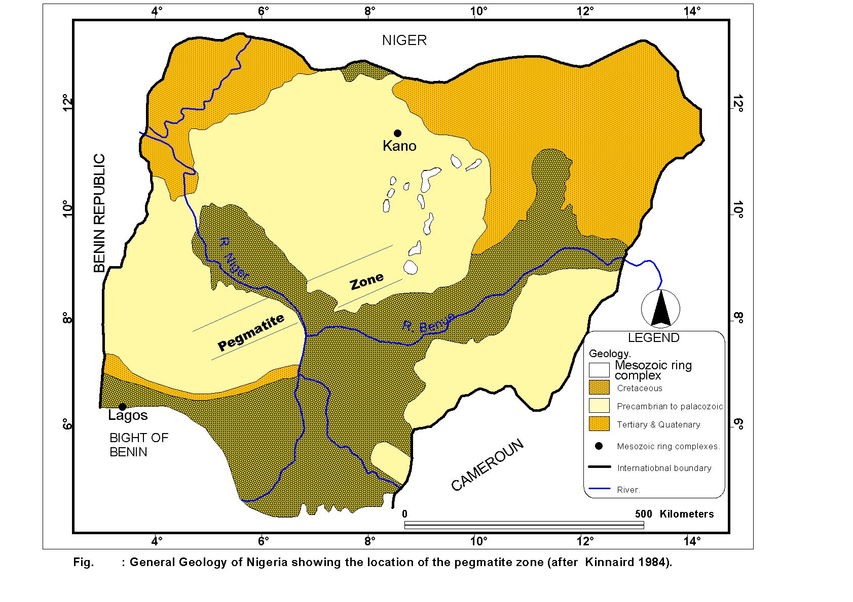
Fig1 General geological map of Nigeria showing location of pegmatite zone

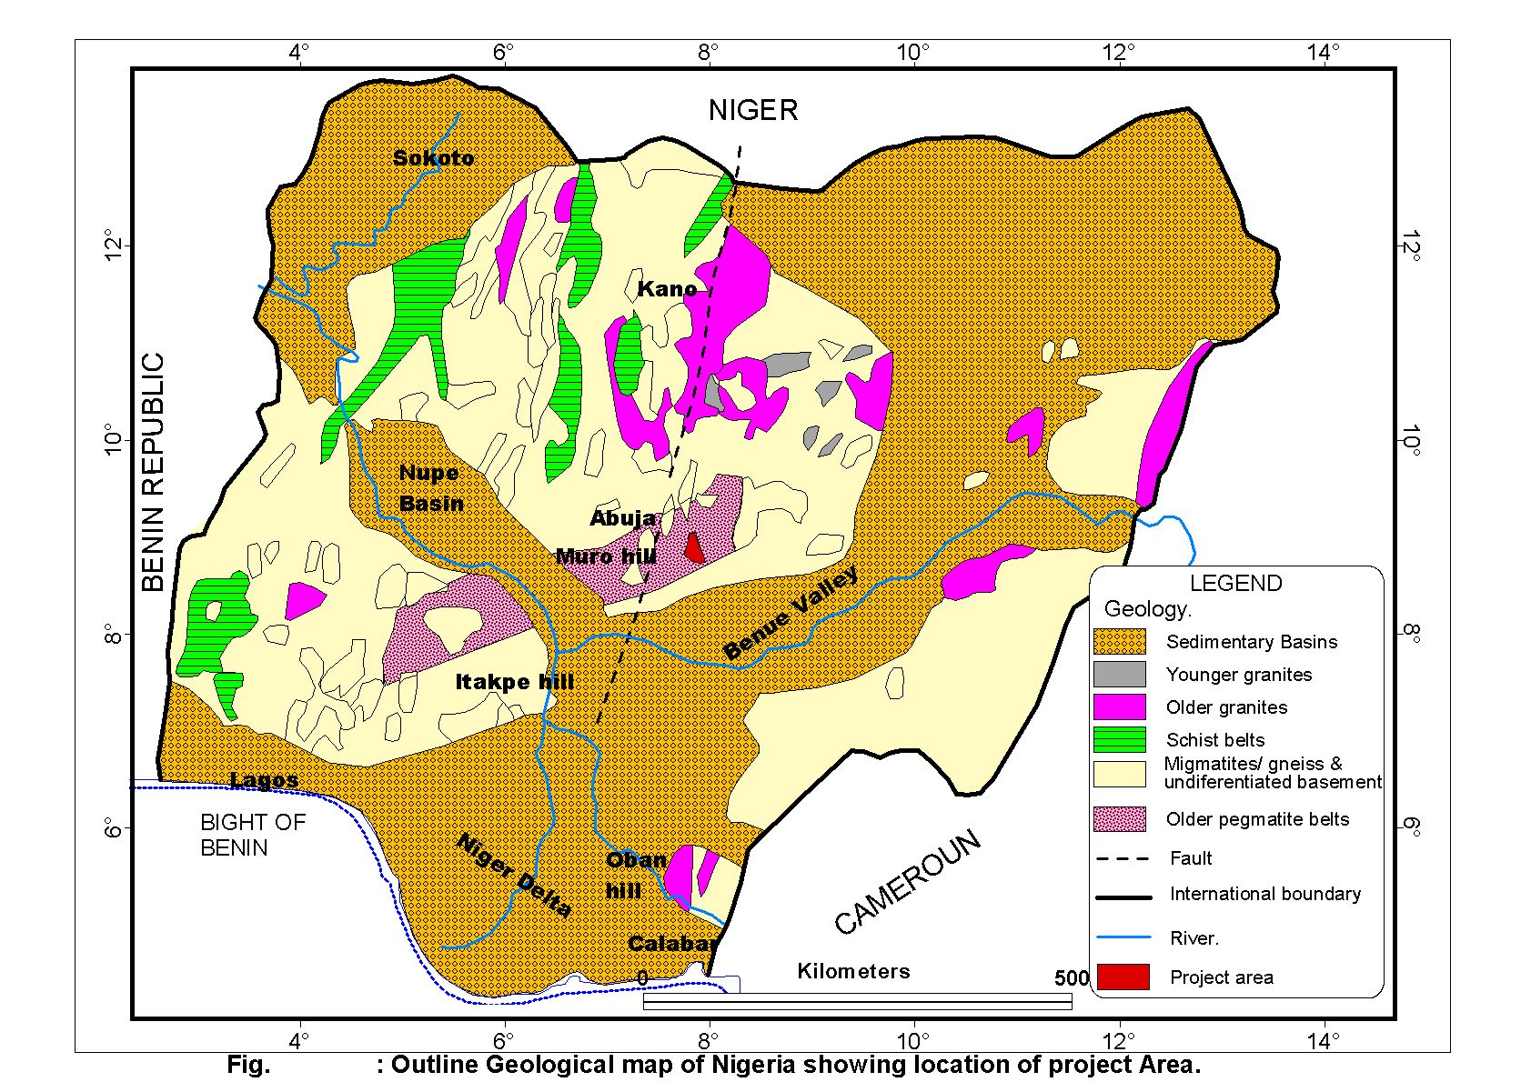
Fig 2 Outline Geological map of Nigeria showing location of project area

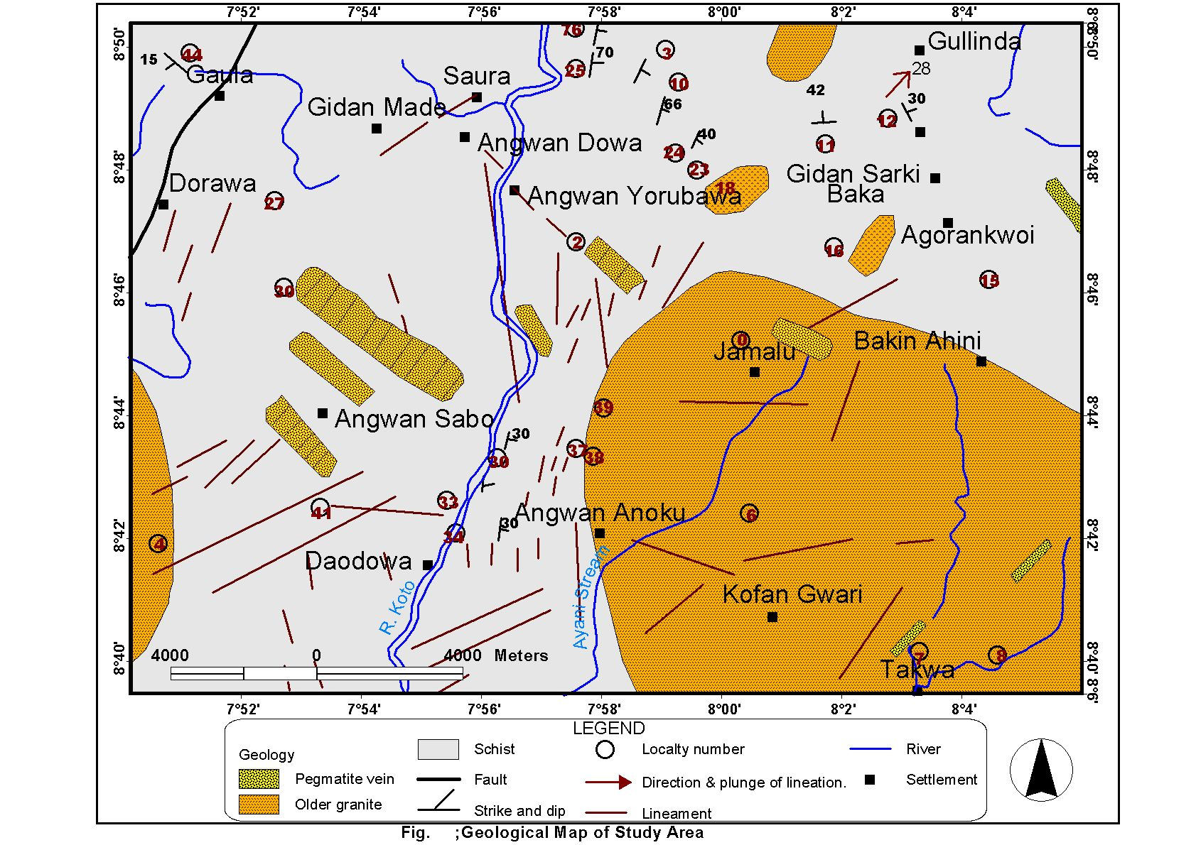

Fig 3 geological map of study area

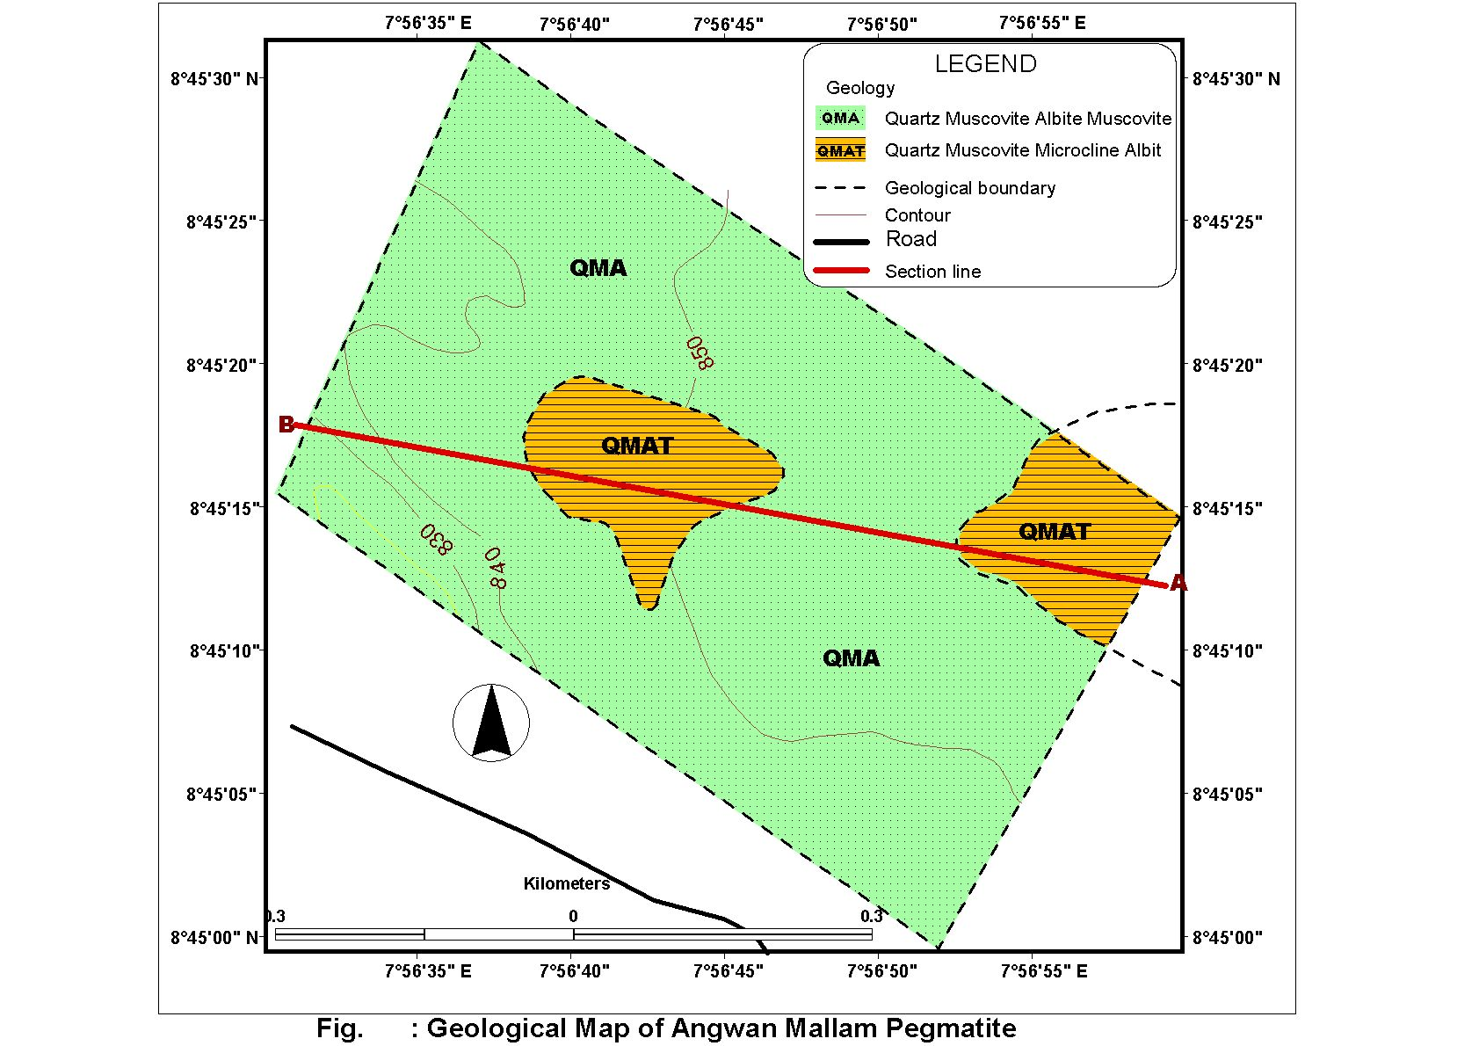

Fig 4 geological map of Agwan mallam pegmatite

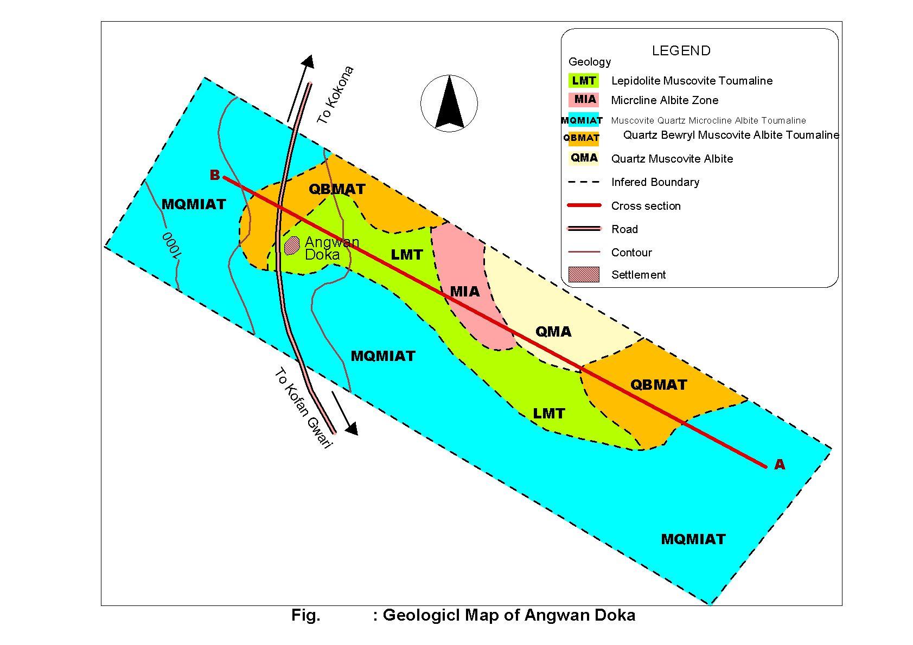

Fig 5 Geological map of Angwan Doka area

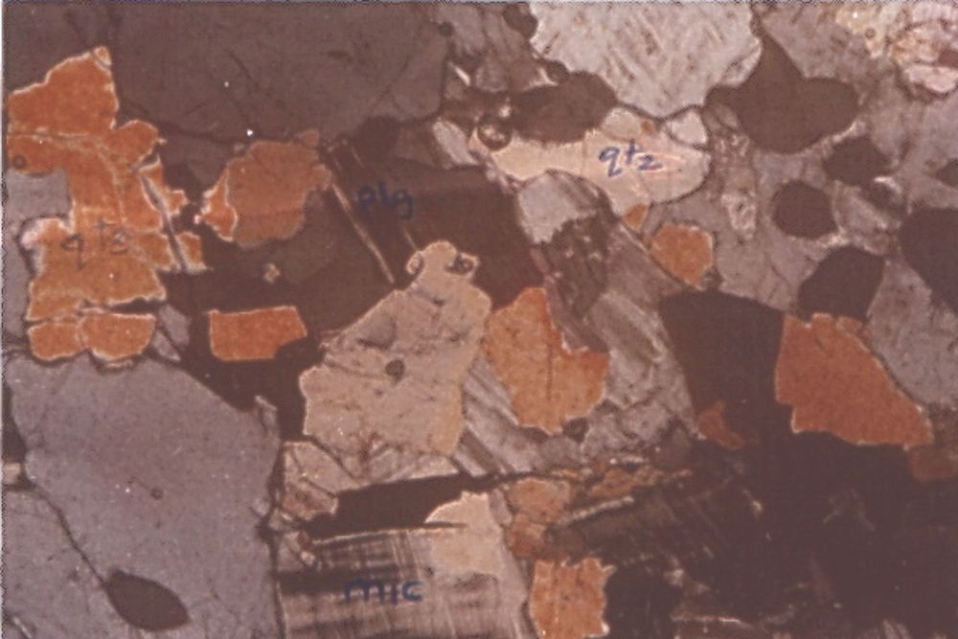

Fig 6

Photomicrograph of Quartz-Microcline Albite zone in transmitted light of the Agwan Mallam pegmatite body
Bar scale :2mm

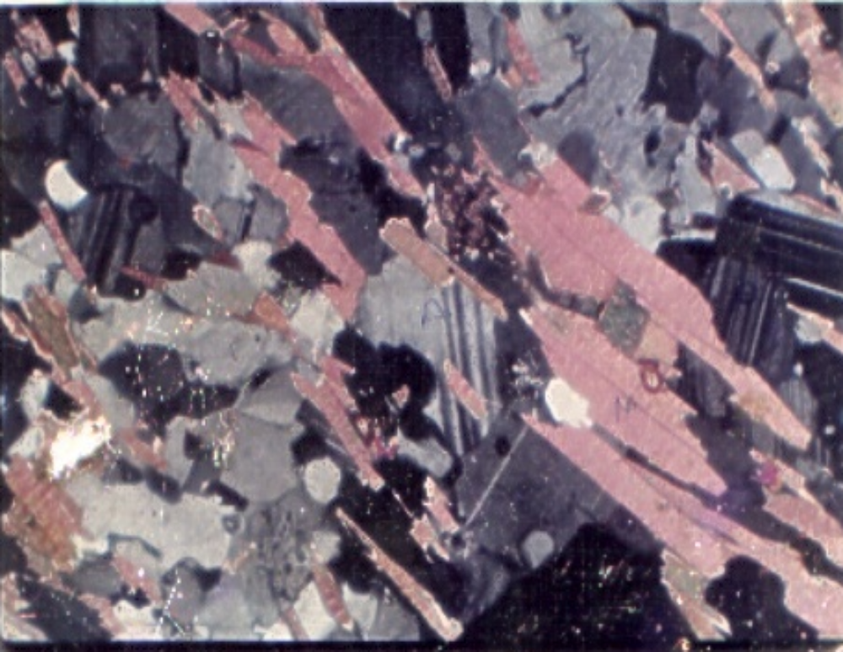

Fig 7

Photomicrograph of Quartz-Muscovite –Albite -Tourmaline zone of the Agwa Mallam pegmatite body
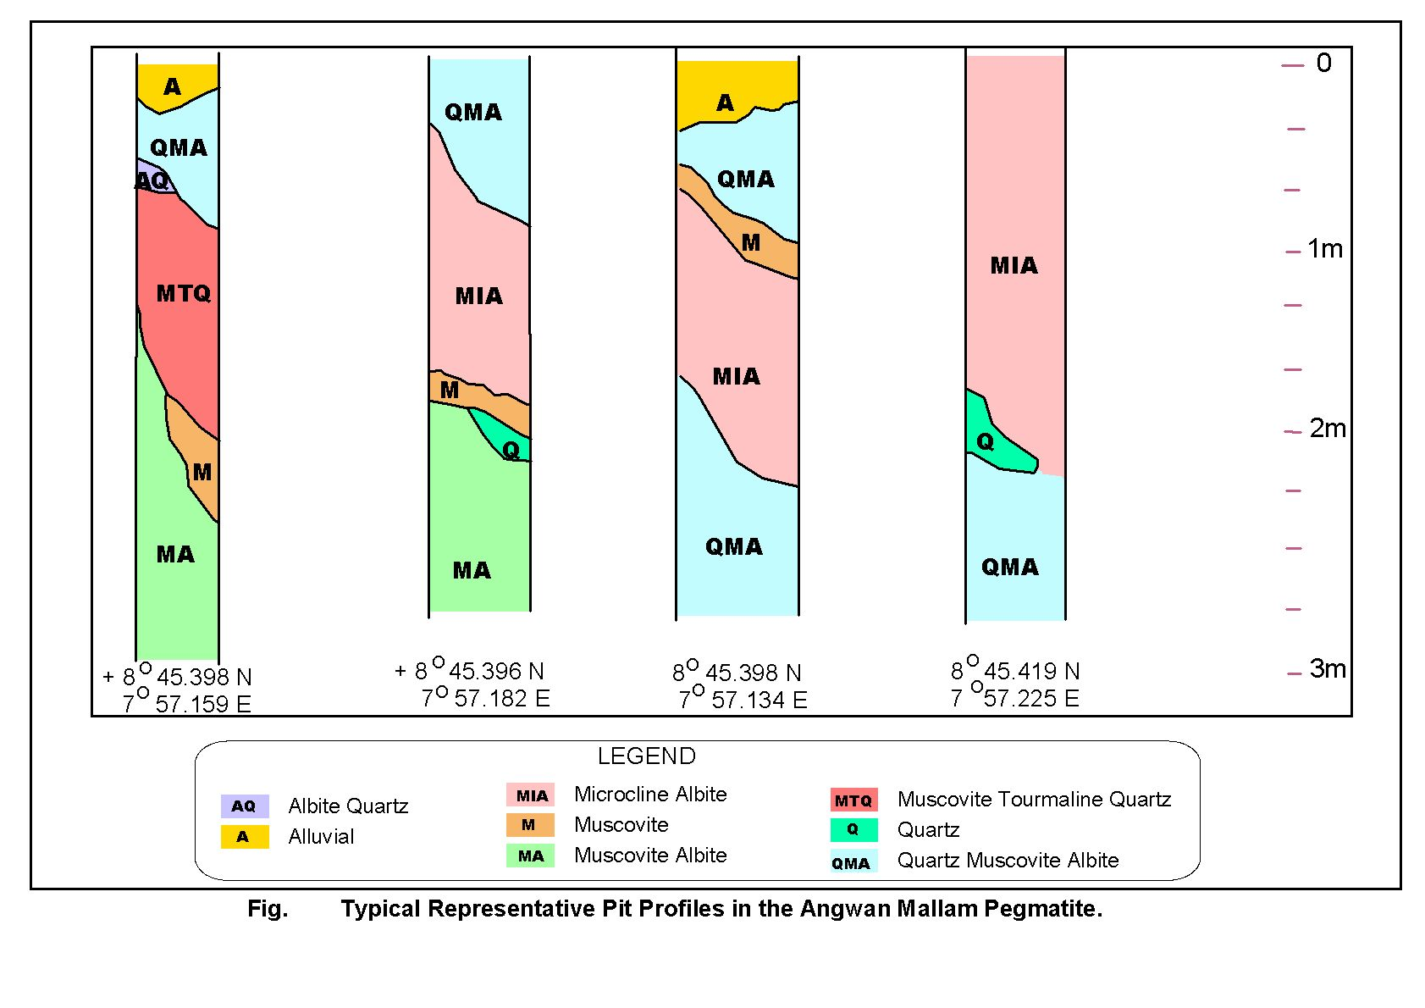

Fig 8 Typical representative pit profile of the Agwan Mallam pegmatite
Fig 9

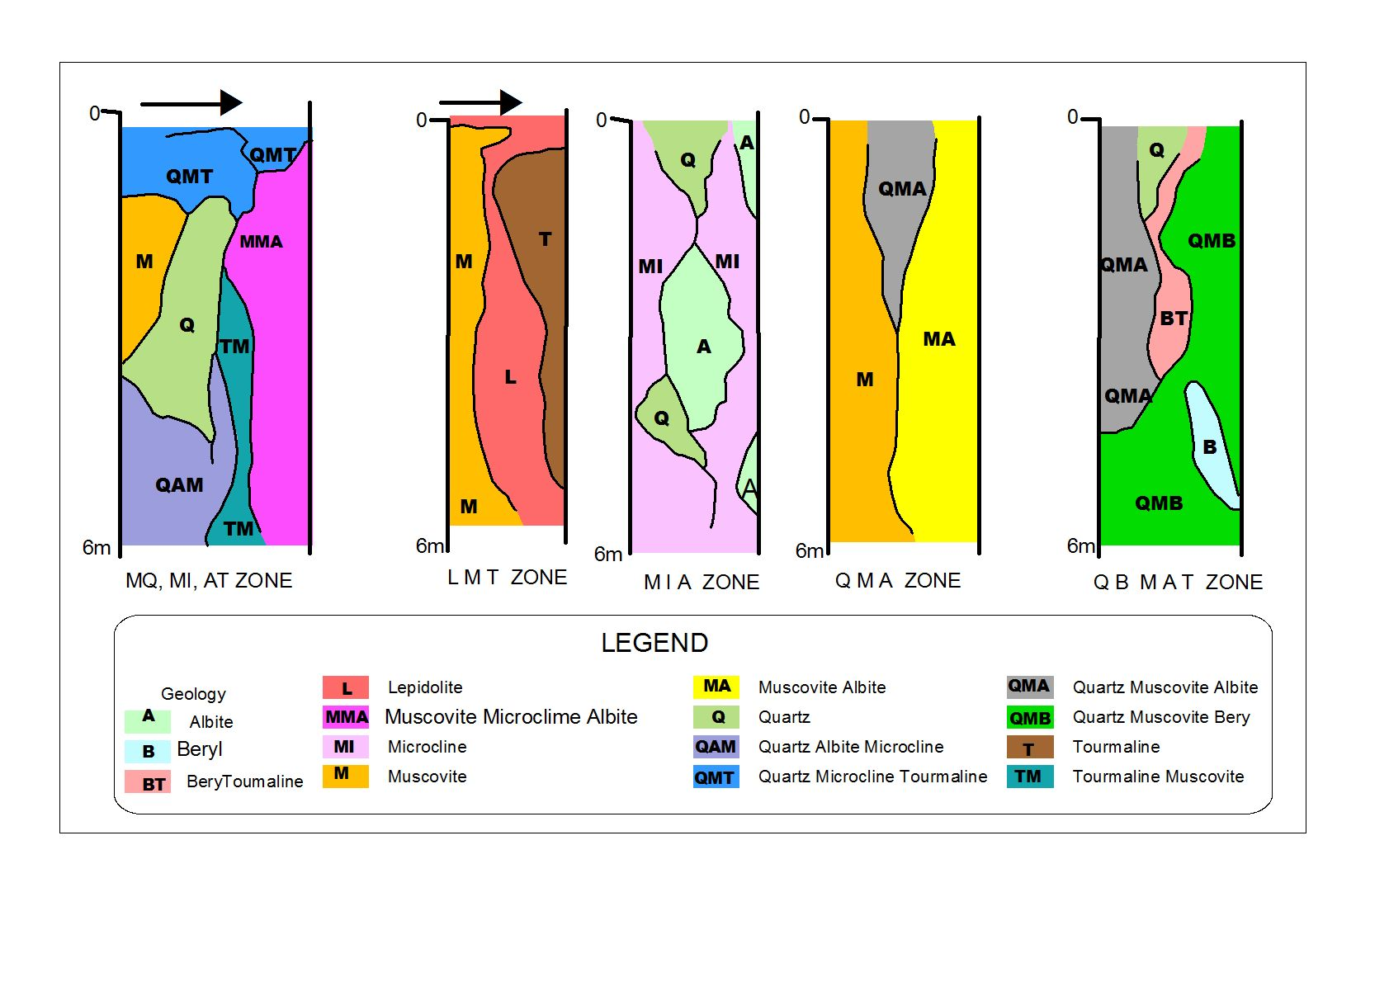Fig10 Typical representative pit profile of the Agwan Doka pegmatite body

