Gymnosperms Of Nainital
Poonam Tripathi¹, Lalit M. Tewari^{*2}, Ashish Tewari³, Sanjay Kumar⁴, Y.P.S. Pangtey⁵ and Geeta Tewari⁶
^{1,2*,4,5}Department of Botany, ³Department of Forestry, ⁶Department of Chemistry, D.S.B. Campus, Kumaun University, Nainital-India
* corresponding author, e-mail: l_tewari@rediffmail.com

Abstract
The Gymnosperms (gymno=naked; sperma=seeds; the terminology coined by Theophrastus) are a group of vascular plants whose seeds are not enclosed by a ripened ovary (fruit). In 1825 the Scottish botanist Robert Brown distinguished gymnosperms from the other major group of seed plants, the angiosperms, whose seeds are surrounded by an ovary wall. In the present study, 8 families of gymnosperms were identified which includes 15 species belonging to 14 genera. Pinus is represented by two species: Pinus roxburghii Roxb. And Pinus wallichiana A. B. Jackson. Cedrus deodara Roxb. Cupressus torulosa D.Don, Pinus roxburghii Roxb. Occurs in wild state while all others are grown as ornamental plants.

Key words: Gymnosperms, Nainital, naked ovule

Introduction
The Gymnosperms have been looked at differently, and have received varying degree of attention and treatment at the hands of botanists, at progressive period of time and in diverse geographical locations. These are common in Himalaya and the mountains of South and north India. These are the intermediates of the pteridophytes and the angiosperms. The gymnosperms have their ovules freely exposed before and after fertilization and not enclosed by any ovary wall. They are preferred by the gardeners and the plant lovers due to their gregarious looks, attractive foliage, heavy trunks and typical reproductive apparatus and are the chief ornamental plants. The wood is straight-grained, light for its strength, and easily worked. Wood of gymnosperms is often called softwood to differentiate it from the hardwood angiosperms (Chamberlain 1935, Dogra 1964, Dutta 1973, sahni 1986).
These are the most ancient seed plants which are believed to be arisen during the late Paleozoic (ca 265million year ago: Uniyal & Awasthi, 2000), most of them perished in due course of time and are now represented by the orders- Cycadales (living fossil), Ginkgoales (living fossil), Taxales, Coniferales, Gnetales [4 orders in Raizada & Sahni, 1958: order Taxales (family Taxaceae) not separated from Coniferales]. About 17 genera, 60 species (Singh & Mudgal, 1997), known to occur in India and according to Uniyal & Awasthi (2000) 48 sps. (Wild) known to occur in India out of 63 genera, 750 sps.in world.
The members of the order coniferales form a conspicuous group in north west and eastern Himalaya, the few members of which occur in the southern part. Although the family ginkgoaceae, araucariaceae and taxodiaceae are purely exotic but is successfully cultivated as well as naturalized in India (Beisnner and Hooker 1862-63, Biswas 1933, Arnold 1948, Sahni 1990, Uniyal & Awasthi, 2000). The Gymnospermous flora from Uttarakhand Himalaya are described by Hooker (1888), Duthie (1906), Osmaston (1927),Raizada and Sahni (1958), Chonnker and Bisht (1961), Gupta (1968), Singh & Mudgal (1997), Kalakoti (1983), Kalakoti and Pangtey (1984), Pandey & Pandey (1999) and Uniyal & Awasthi (2000).The thorough scrutiny of these literatures helped to present the census of the gymnospermous flora of the Kumaun. Although since the cretaceous period (144 to 66.4 million years ago) gymnosperms have been gradually displaced by the more recently evolved angiosperms, they are still successful in many parts of the world and occupy large areas of the earth's surface.
So main motives behind the selection of the present study are the following: -
- To explore the gymnospermic flora of Nainital region.
- To highlight the economic importance of gymnosperms as medicinal
Plants, ornamental utility and for miscellaneous uses.
- To provide constant impetus for further researches on gymnosperms.

Profile of Nainital
Nainital is a glittering jewel in the Himalayan necklace, blessed with scenic natural splendour and varied natural resources, dotted with lakes. There lie a large number of small lakes of which Lake Nainital is the largest. It is a pear shaped lake, approximately 2 miles in circumference, and surrounded by mountains. Other lakes (locally known as Tal) in the region are Bhimtal, Sattal, Naukuchiatal, Punatal, Khurpatal, Sukhatal, Sariatal, Malwatal and Lampokhara.Nainital has earned the epithet of ‘Lake District of India’. Nainital, of the hill towns in the state of Uttarakhand, occupies a unique place known for its salubrious climate and scenic beauty. The town is a popular health resort and attracts tourists round the year. Nainital is very rich in its diversified floras including trees, shrubs, herbs and grasses. Other high altitude spots of Nainital besides being famous tourist locations also conserve variety of wild fauna and flora. These include- China peak, Snow view, Tiffon top, The cliffs, Camel’s back, Cave garden, Governor house, Zoo (highest altitude zoo in Asia), Kilbury, Vinayak, Himalaya darshan, ARIES, Hanuman garhi etc.

Geographic location
According to the district gazetteer Nainital is situated at 29˚24'N latitude and 79˚28'E longitude in a valley of the Gagar range running east and west, which is bounded on the North by the Peak of China, which rises to a height of 8,568 feet continued by Alma peak [presently known as Snow view] and the Sher ka danda to the Eastern extremity, where the ridge descends almost to the level of the lake (Fig. 1).

On the west the rugged hill of the Deopatha rises to a height of 2438.09 meter, and on the South Ayarpatha attains an elevation of 2278.07 meter diminishing gradually towards the East. While the intervening portion between these two hills is a mass of rocks piled up loosely together which goes by the name of Handi- bandi and is formed of the transition limestone of Mussoorrie exhibiting everywhere vast rents. the eastern boundary is the lake find an exit forming the principal source of Ballia river [nala], which falls into the Gola consists of a series of gentle undulations formed by the debris of situated at a height of 1938 m from by the debris of surrounding hills. Thus Nainital is situated at a height of 1938 meters from sea level or 6360 feet above the sea level. The town has the famous lake to which it owes its name. The surface of this lake has an elevation of 1.935m above sea level. Maximum length and breadth being 1,434 m and 463 m respectively. The depth of this lake is said to range between a maximum 28 meters and a minimum of 6 meters.

Discovery of Nainital
The Britishers occupied Kumaun Garhwal in 1815 and E. Gardner was appointed as the Commissioner of Kumaun division (8 may 1815) and G.W. Traill his assistant. Later, Traill, who was very popular in Kumaun, was promoted as the Commissioner of Kumaun. He worked until 1830. He conducted the second revenue settlement of Kumaon in 1817, and it was during this period that he came to Nainital. He was the first European to have visited Nainital. However, rumours of the existence of the Nainital continued to reach British travelers. One of them, Barron decided to investigate deeper, and through threats and cajolery, he persuaded a guide to lead him to Nainital. The guide claimed to have never seen the place. Barron put a big stone on his head and told him he had to carry it to Nainital where there were no stones and that he had to be careful not to let it fall and break because he required it there. The guide with the view to relieving his load, soon admitted that there was no scarcity of stones at the spot, a fact which he could rot have known without having been an eyewitness to it. J.M.Clay, author of the book ‘Nainital’, which was published in 1928, is of the view that Barron came to Nainital in 1841. His visit was popularized through the newspapers ‘Englishman’ and ‘Agra Ukhbar’ .He has given a beautiful description of the lake and the surrounding area. His next visit was a year later in December 1842. By then about half a dozen sites had already either been applied for or granted, and Lushington, then Commissioner of Kumaon, had started to build a small house. Moreover the Commissioner had already planned out a bazaar on the site of the present Mallital. In 1842, Barron constructed a house, pilgrim lodge, for himself just above the present Nainital club. Nainital׳s peripheral tourist zone extends up to Mulwa Tal to the East where Bhimtal, Sattal and Naukachiatal have recently developed as tourist centers.

Mythology
Nainital is referred to in the ׳׳Manas Khanda’ of the ‘Skanda Purana’ as the Tri –Rishi Sarovar, the lake of the three sages, Atri, Pulastya and Pulaha who were reputed to have arrived here on a penitential pilgrimage, and, finding no water to quench their thirst dug a hole and siphoned water into it from Mansarovar ,the sacred lake in Tibet. The ancient Hindus believed that a dip in lake Nainital, is not lesser than Mansarovar and earned merit similar to a dip in the sacred lake. The second important mythological reference to Nainital is as one of the 64 ‘Shakti peeths’, i.e. centres of powers of the shakti cult. These centers were created wherever parts of the body of sati fell, when Lord Shiva was carrying around her corpse in grief. It is said that the left eye (nain) of Sati fell here, and this gave rise to the patron deity of the town ‘Nainital’, the lake of the eye.

Geology
Physiographically, the Kumaun Himalaya is divisible into-
(a) Outer Himalaya or Siwalik Hills (750 to 1200m altitude),
(b) Lower or lesser Himalaya which rise somewhat abruptly above the Siwalik hills
(upto4500m altitude),
(c) Main or great Himalaya (highest peak Nanda devi-7817m).
The great succession of the Nainital massif is divisible into lower Jaunsar group and
upper Munsyari group (K.S. Valdia, 1980).

Lithostratigraphic succession of the Nainital hills of the Krol belt, outer lesser Himalaya, Kumaon is as follows:-
Narain Nagar Member (=’Middle’ Tal)
Tal Fm Giwalikhet Member (= Lower Tal)

Sherwood Member (= Krol E)
Bisht College Member (a local facies)
Pashandevi Member (= Krol D)
MUSSOORIE GROUP Krol Fm Barapatthar Member (= Krol C)
Hanumangarhi Member (Krol B)
Manora Member (Krol A)

Blani Fm Kailakhan Slate (= InfraKrol)
Pangot Member (= Blaini)

Lariakanta Quartzite (= Nagthat Fm)
Jaunsar Bhumiadhar Fm (= Chandpur Fm)
Upper Betalghat Fm (= ”Mandhali” of Jaunsar Hills)
JAUNSAR GROUP
Jantwalgaon Limestone (lenticular)
Jaunsar Bhawali Quartzite
Lower Bhimtal Volcanics

-------- Salari Thrust ---------

Amritpur Granite (1900 ± 100m.y.)
↑ ---------- MBT ------------

Lower Siwalik

Rock: The different rock types occurring in the Nainital forest division could be classified in the following types:-
[1] Sedimentary rocks: As the name implies, are those rocks, which have been derived from the consolidation of sediments. These sediments are the products of erosion both mechanical and chemical from some pre-existing rock masses.
[2] Metasedimentary rocks: These rocks are formed when sedimentary rocks get metamorphosed.
[3] Igneous rocks: These rocks are formed from the solidification of very hot molten rock material called ‘magma’. Such rocks originate generally at depth but sometimes are formed on the crust of the earth.
Igneous rocks are categorized on the basis of percentage of silica present i.e.; acidic (>65%), intermediate (50-65%), basic (45-50%) & ultra basic (<45%).
Soil: It is either micaceous, sandy or red clayey depending on the rock type from which it has been derived. The schist, granite, phyllites have given rise to micaceous soils. The arenaceous i.e. sandy soil is characteristic of quartzite or sandstone.
At the riverbeds some terraces have a sandy soil. Terrace deposits are well developed in the banks of Kosi, west of Betalghat to the west of Khairna and also along the banks of Gola River.
Climatic conditions: With a range in altitude from about 305 meter [1000`] to over 2611 meter [8,000`] very diverse climatic conditions are naturally met. Winters are very severe at the higher elevations and snowfalls down to 1,524 meters [5000`] and occasionally lower but melts rapidly below. About 2,134 meters [7,000`] and even above this snow seldom stays long on sunny slopes.
Temperature: Nainital has temperate summers, maximum temp. +33˚C [99F and minimum temp. +10˚C [50F]. During winter Nainital receives snowfall between December and February with the temperatures varying between a maximum of 15˚C [59F] and a minimum of -3˚C [27F]. Severe frosts are usual from December to February and occur even in the lower valleys, which are frequently shrouded in mist in mornings.
In May and June the break of the monsoon the lower valleys are very hot and hot days experienced even up to 1,524 meters [5,000`] or more. The higher ridges are pleasantly cool even in June. The more pleasant time of the year, from the climatic point of view, is in October and November, when the air is clear, and there are no extremes of temperature at ordinary elevations.
Rainfall: The monsoon usually comes to an end about the middle of the September. November is the driest month. Winter rain usually being in the last weak of December and continue off and on until February but may last longer in wet years. During April and May, thunderstorms often accompanied by hail, are fairly frequent. The monsoon generally beings during June, though it is uncertain and may start before the end of may or delayed until July. There is often considerable rain before the monsoon properly sets in.
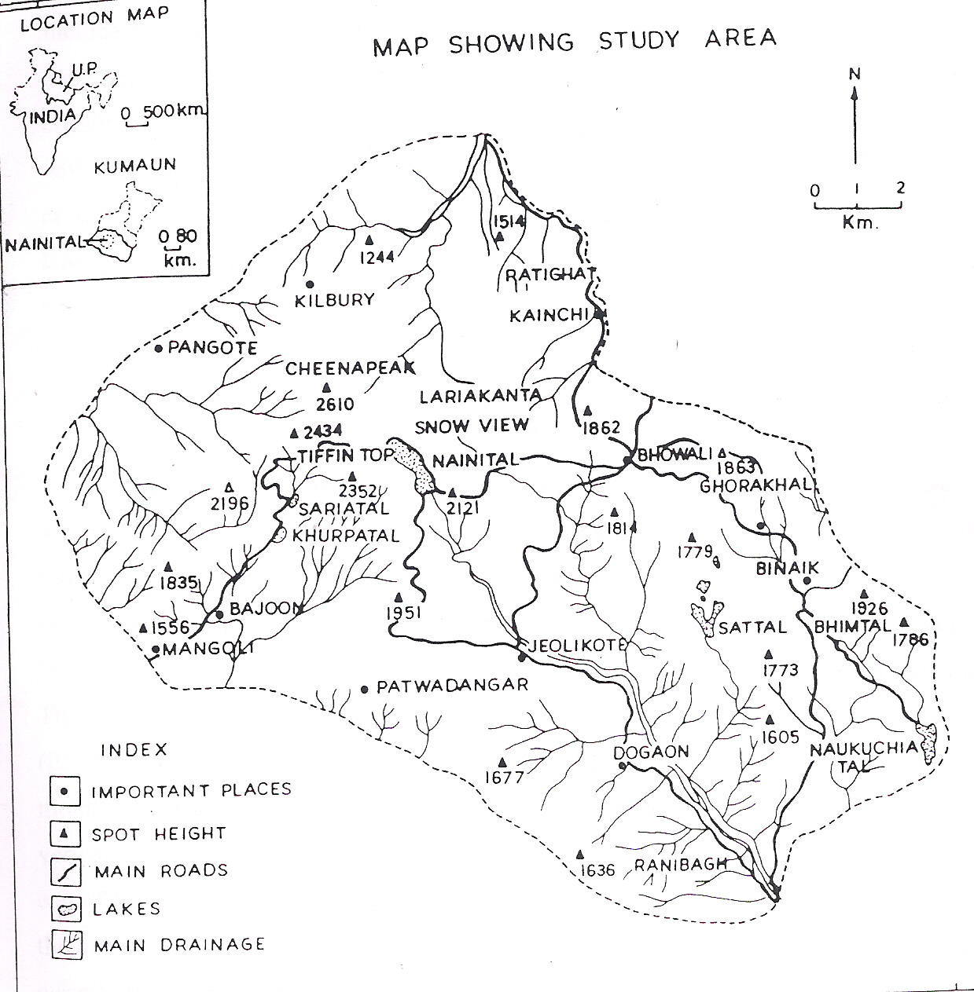

Fig. 1 Location map of Nainital

Forest vegetation
Forest in Naini Lake catchment shows a great deal of variation. It is composed of temperate genera. This is largely attributed to the differences in topography and changes in climatic conditions that prevail in this region. Predominantly composed of temperate genera, such as oaks: - Quercus leucotricophora A. Camus (banj oak), Quercus floribunda Lindl. Ex A.Camus (telonj), Quercus semicarpifolia Smith (kharsu), Cupressus torulosa D.Don (Cypress), Rhododendron arboreum Smith, (burans), Acer oblongum Wall. Ex DC. (Maple), Fraxinus micrantha Lingelsh. (Ash) and Cedrus deodara Roxb. (cedar), but in catchments of lower lakes at 1200-1400m altitudes tropical and subtropical plants such as species of Bauhinia variegata (Linn.)Benth. and Butea Roxb. And Pinus roxburghii Roxb. occur. Quercus Leucotricophora A.Camus (banj oak) forests are usually confined between 1500- 2400 m but also seen running down as low elevation as 1100 m in moist ravines and form a more or less distinct altitudinal zones. The soil is usually moist and has a high degree of atmospheric humidity throughout the monsoon period from mid June to mid September. All the oaks are good fodder and continuous unregulated lopping has converted or is still converting the more accessible forests into scrub. Depending on the local conditions, the scrub is either passing into grassland or giving place to a bushy secondary growth which usually consists of largely by the shrubs like Berberis aristata DC. B.asiatica Roxb., B.chitria Lindl. ,Spiraea canescens D.Don, Prinsepia utilis Royle , Pyracantha crenulata (D.Don)Roem and Rubus ellipticus banj oak forests are usually confined between 1500- 2400 m but also seen running down as low elevation as 1100 m in moist ravines. Some of the common associates of banj oak forests are Rhododendron arboreum Smith, Lyonia ovalifolia (Wall.)Drude, and Ilex dipyrena Wall. . The commonest shrubs which are usually found associated with banj oak forests are Berberis chitria Lindl., B. asiatica Roxb. ,Desmodium eleqans A.DC.,Indigofera heterantha Wall.ex Brandis. Besides Chimnobambusa falcuta (Nees.)Nakai. is often very abundant .Q. floribunda Lindl. Ex A.Camus (Telonj oak forests) lie between 2100 -2500m and occupy an intermediate zone between banj oak and kharshu oak forests to a large extent. It attains its maximum development on deep moist soils and especially where subsoil is limestone. The canopy is usually dense and there is a thick second storey consisting of partly evergreen and partly deciduous trees and shrubs of varying sizes.the commonest associates are: Quercus leucotricophora A. Camus, Betula alnoides Buch.Ham.ex D.Don., Carpinus viminea Wall. Ex Lindl. and Acer caesium Wall., while other common associates are Ilelx dipyrena Wall., Euonymus pendulus and Symplocos ramosissima Wallich ex G.Don,Gen. Hist. Shrubs commonly found in these forests are: Berberis asiatica Roxb ,B. aristata DC. , B. chitria Lindl. , Spires canescens D.Don, Prinsepia utilis Royle, Pyracanatha crenulata (D.Don)Roem and Boenninghausenia albiflora Hook. Kharshu oak forests occupy the highest zone among the oaks and found between 2400-2611m in hills area . the forests are usually dense .The common associates of kharsu oak forests are ; Rhododendron arboreum Smith, Ilex dipyrena Wall., Acer caesium Wall and A.mono.Maxim.Some of the shrubs found in the forests are: Rosa macrophylla Lindl., Salix babylonica Linn., Viburnum stellulatum Wall and V. cotinifolium D.Don. With these some other species like banj oak forests are usually confined between 1500-2400m but also seen running down as low elevation as 1100m in moist ravines. Common associates of banj oak forests are: Rhododendron arboreum Smith, Lyonia ovalifolia(Wall.)Drude and Ilex dipyrena Wall. . In fact Nainital is the part of the region where populations of these oaks are, centered. Rhododendron arboreum Smith, dominates the under canopy of these oak forests, but in moist pockets lauraceous species, such as Litsea umbrosa Nees. are common. Pinus roxburghii Roxb. forms almost pure crops on hill slopes, above 1000m, replacing oaks where fire, harvest of biomass and erosion are frequent. The pure pine forest is single layered, while in other forests at least two layers within tree canopy are distinguishable.
All these broad-leaved species and pine are evergreen with one-year leaf life span and constitute more than 70% of tree importance. Such broad-leaved evergreen forests do not show extensive domination anywhere else in the world. Deciduous species occur in the same number as broad-leaved evergreen species but seldom dominant. Cupressus torulosa D.Don, an evergreen cypress of several years of leaf-life span forms a stand on the steep and dry slope below china peak in Nainital. Bauhinia variegata Linn.(Benth.) species, a chief associate of Quercus leucotricophora A. Camus in Sattal catchment represents a transition stage between the winter deciduous species and evergreen species of this region, as this species bears some leaves during most of the winter season.

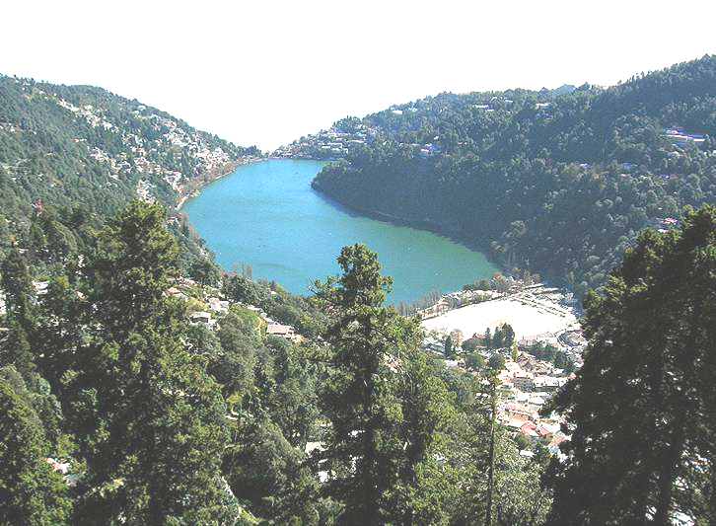
Profile of Nainital

Characteristic of gymnosperms
Gymnosperms are not in such an advanced position as angiosperms because:-
(1) They lack vegetative means of reproduction by means of cuttings, layering, etc., and are slow growers.
(2) Limited means of dispersal (only wind and by man) and their failure to grow in varied habitats (water).
(3) Absence of bisexuality which reduces the chances of self fertilization and more pollen is wasted as wind pollination is the main source of carriage of pollen grains
(4) Unprotected ovules and seeds.
(5) Absence of vessels (a few exceptions are there) in xylem and of companion cells in the phloem.

General features

Diversity in size and structure
Among the gymnosperms are plants with stems that may barely project above the ground and others that develop into the largest of trees. Cycads resemble palm trees, with fleshy stems and leathery, featherlike leaves. The tallest cycads reach 19 meters (62 feet). Zamia pygmaea Sims., a cycad native to Cuba, has a trunk less than 10 centimeters (four inches) in height. Of the gnetophytes, Ephedra Teurn.ex.L. (Joint fir) is a shrub and some species of Gnetum Linn. are vines, while the unusual Welwitschia Hooker has a massive, squat stem that rises a short distance above the ground. The apex is about 60 centimeters in diameter. From the edge of the disk-shaped stem apex arise two leathery, straps like leaves that grow from the base and survive for the life of the plant. Most gymnosperms, however, are trees. The conifers, redwoods (Sequoia) exceed 100 meters in height and, while Sequoiadendron (giant redwood) is not as tall, the trunk is more massive.

Importance of gymnosperms
Gymnosperms include mainly evergreen trees and shrubs, which are extremely captivating because of their graceful habit and attractive shapes. The conifers are greatly valued by garden lovers. Their wide range of shapes, colours, textures, and simple cultivation, make them pre-eminent specimens offering an all the year round appeal. They form the major component of any temperate forest of the world. Economically, gymnosperms are highly important particularly in forestry and horticulture, yielding timber, resins, essential oils, drugs and edible nuts.
Gymnospermous plants are widely used as ornamentals. Conifers are often featured in formal gardens and are used for bonsai. Yews and junipers are often low-growing plants cultivated for ground cover. Conifers are effective windbreaks, especially those that are evergreen. Cycads are used as garden plants in warmer latitudes, and some may even thrive indoors. Their leathery green foliage and sometimes-colorful cones are striking. Ginkgo is a hardy tree, and although it once approached extinction, it is now cultivated extensively and survives such challenging habitats as the streets of New York City. Some gymnosperms are weedy in that they invade disturbed areas or abandoned agricultural land. Pines and junipers are notorious invaders, making the land unusable.
Araucaria, and Podocarpus are important conifers of the Southern Hemisphere used for lumber. Aromatic wood of cedar is frequently used in the construction of closets or clothes chests and apparently repels cloth-eating moths. Most plywood is gymnospermous. Fibers of conifers make up paper pulp and may occasionally be used for creating artificial silk or other textiles. Conifers are frequently planted in reforestation projects. Conifer bark is often the source of compounds involved in the leather tanning industry. Bark is also used extensively as garden mulch. From conifer resins are derived turpentine and resin. Resins may also have medicinal uses. Many types of amber are derived from fossilized resin of conifers. Commercially useful oils are derived from such conifers as junipers, pines, hemlock, fir, spruces, and aborvitae. These oils serve as air fresheners, disinfectants, and scents in soaps and cosmetics. Seeds are often food sources. Pine seeds are a delicacy eaten plain or used as a garnish on bakery products
Synopsis of families
1. Araucariaceae: Trees with spirally arranged narrow or broad leaves with parallel veins. Dioecious or monoecieous. Male strobilli dense, cylindrical with numerous sporophylls. Cones sub globose to ovoid, generally large; with woody one seeded scales, without distinct bracts, falling when the seeds are ripe.
2. Cephalotaxaceae: Evergreen trees or shrubs. Branches opposite or whorled. Leaves spirally arranged, often spreading in two ranks, linear, pointed. Usually dioecious. Male strobilli axillary, sub-globose, sporophylls. With3-8 pollen-sacs. Ovules in pairs, only one ovule developing into an olive-like fruit (seed), long stalked, with a fleshy outer coat.
3. Cupressaceae: Trees or shrubs, adult leaves usually small, scale like, appressed, in opposite pairs, sometimes in threes, rarely linear. Buds not scaly. Cones small their scales mostly confluent with the bracts, somewhat fleshy but generally woody when ripe, each bearing a number of erect ovules.
4. Cycadaceae: Trunk cylindric sometimes branched, with terminal tufts of rigid, pinnate leaves. Male and female reproductive organs on separate plants, at the apex of trunk among the leaves, male in erect massive cones with thick scales. Female megasporophylls densely wooly in crowded whorls around the top of the trunk, each with pairs of large ovules on its edge.
5. Ginkgoaceae: Monotypic trees. Leaves deciduous, fan shaped, with parallel veins. Dioecious. Male strobillus catkin like; antherozoids motile. Female axis a long stalk with usually 2 terminal ovules. Fruit drupe like, orange yellow, woody shell of the seed surrounded by a fetid, pulpy coat.
6. Pinaceae: Trees. Leaves linear, flat or needle like, spirally arranged sometimes in 2 or more rows, or in tufts. Buds scaly. Monoecious. Cones mostly woody, with spirally arranged scales. Bracts separate from the scales. Seeds generally winged.
7. Taxaceae: Evergreen trees. Leaves spirally arranged, rarely opposite, flattened, needle like, linear, often in two ranks, male strobilli catkin-like. Female not cone like, with a single erect ovule or seed, partly or wholly covered by a fleshy, coloured aril. Foliage and seeds poisonous, but not the aril.
8. Taxodiaceae: Trees with narrow, linear or awl shaped leaves, spirally arranged, sometimes apparently 2 ranked. Buds not scaly. Monoecious cones mostly globose. Scales spirally arranged, leathery or woody, persistent, more or less fused with bracts. Seeds 2-6 to each scale, erect or inverted, winged or wingless.

Material and method
During the study whole area is surveyed thoroughly during 2007-08 and all the specimens are collected, identified and arranged to classification. The Herbarium was prepared following the method of Jain and Rao (1976). The literature was also studied for their characteristics and economic importance.

ARAUCARIACEAE (MONKEY PUZZLE FAMILY)
GENERA- ARAUCARIA Jussieu
Araucaria cunninghamii Sweet
English name- Hoop Pine
Hindi name- Bunya Tree
Distribution in Nainital: Around Govt. house, D.S.B. Campus, High court compound as cultivated.
General distribution and habitat: Australia, India (Nilgiri hills), New Caledonia, pacific islands to New Guinea, Polynesia, South America. These trees occur on drier sites in rainforests, in places that are rocky or have soils with relatively low fertility it is an emergent species in subtropical and tropical rainforest.
General description: A.cunninghamii Sweet is a tall tree growing 30-50 meters in height, with a straight, rough-barked trunk with circular "hoop" markings which give rise to the common name. Evergreen tree, Dioecious or monoecious, with relatively large pith in trunk and resin in cortex.
Bark: Gray-brown or dark grey rough, transversely split; crown tower-shaped when young, becoming flat topped with age; lateral branchlets dense, drooping, and almost pinnately arranged.
Leaves: Dimorphic spirally arranged or decussate, sessile, decurrent. Cones: Unisexual. Ovoid, Male cones cylindrical, to 5 cm long, terminal, solitary, spirally arranged, sessile; microsporangia 4-20. Female cones ovoid, can 10 cm long on long peduncles, solitary, terminal on branchlets, maturing in 2nd or 3rd year; the cone scales samara-like, thinly winged, bracts numerous, spirally arranged; ovulate scales degenerate or ligulate.
Seeds: With a narrow membranous wing on each side.
Uses: Cultivated for ornamental purposes in the garden. The wood is a pale yellow-brown colour with a fine texture and a straight grain making it useful for furniture, flooring, and panelling and, in the past, matchsticks and boxes.
Seed: Raw, cooked or ground into a powder. Starchy and delicious, it has the texture of a waxy boiled potato with the flavour of chestnuts. Large, it is an important food.

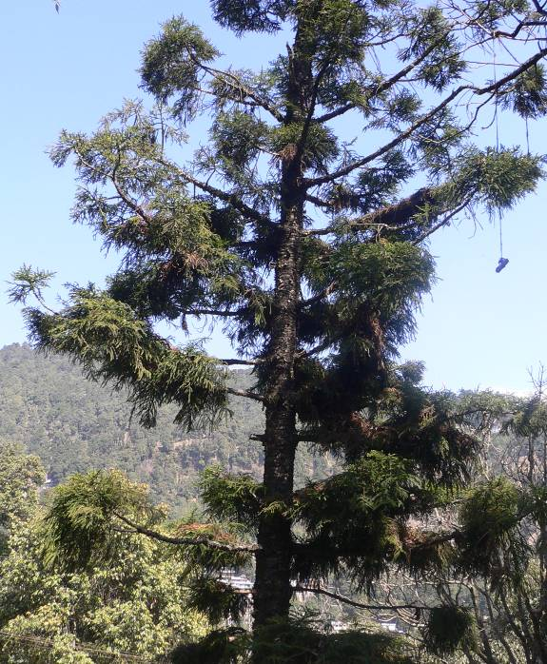
Araucaria cunninghamii sweet
CEPHALOTAXACEAE

GENERA: CEPHALOTAXUS Siebold & Zucc.ex Endl
Cephalotaxus griffithi Hook.f.
English name: Plum Yew or Cow Tail Pin
Hindi name: Tinya
Distribution in Nainital: D.S.B. Campus,as cultivated.
General distribution and habitat: Korea, China, Japan, Burma, Laos, Vietnam and India. Its center of distribution is in China, which holds portions of the native range of seven species. All species are highly shade tolerant, typically growing as understory trees or shrubs in humid temperate to subtropical broadleaf forests. Especially in limestone regions. Mixed with coniferous and broad-leaved forests, thickets and roadsides at elevations of 2000 - 3700 meters.
General description: Evergreen dioecious, rarely monoecious trees or shrubs about 20m tall, with a trunk to 20 cm cbh; usually multistemmed, with an open, loosely rounded crown.
Branches: Branches, shoots slightly pendant. Leafy branchlets obovate, obtriangular, or rectangular in outline, plane.
Bark: Bark dark red-brown, peeling in strips.
Leaves: Buds small, covered with pointed, glossy, red-brown scale-like leaves. Leaves almost horizontally spreading; blade deep green and glossy adaxially, linear-lanceolate, base cuneate or shortly attenuate, asymmetric, margin flat or very narrowly revolute when dry.
Cones: Pollen-cone capitula of 6-14 cones, distinctly pedunculate (peduncle 2-5 mm), or sessile to sub sessile (peduncle 0-2 mm), globose, 6-10 mm, bracts ovate, microsporophylls 6-16, each with 3 or 4 pollen sacs. Female cones borne 3-6 together; peduncle 3-12 mm and 1.5 mm. Aril yellow or green initially, turning purple when ripe. Mature into drupe-like structure with the single large nut-like seed.

Seeds:3.7cm. long, borne 3-4 together sometimes longer with a short apical point.

EdibleUses: Edible Parts: Fruit; Seed. Fruit- Fairly large, it is about 30mm x 15mm. The fruit is edible raw if fully ripe.

Medicinal Uses Cancer: Substances from the plant have shown anticancer activity.
Other Uses: Ground cover; Hedge. Some forms of this species are procumbent in habit and can be used as ground cover in shady places. Very tolerant of pruning, this plant makes a very good hedge in shady positions.
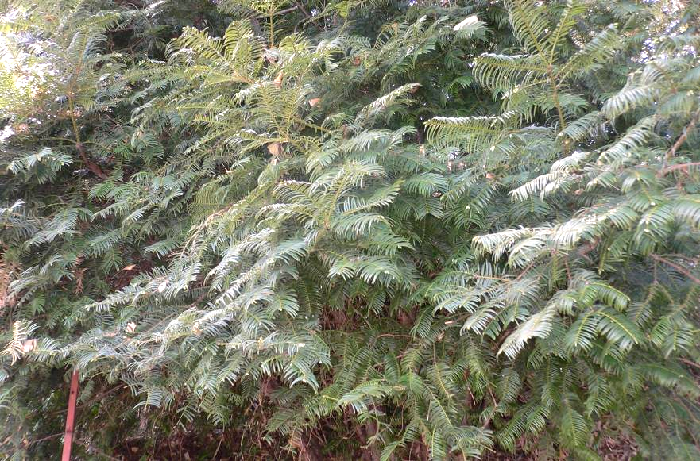
Cephalotaxus griffithi Hook.f.
CUPRESSACEAE (CYPRESS FAMILY)
GENERA-Biota (Linn.) Endlicher
Biota orientalis (Linn.) Endt.

English name- Green Giant {Biota}
Hindi name-Morpankhi
Distribution in Nainital: Cultivated as an ornamental plant in gardens and roadsides at many places in Nainital.
General distribution and habitat: North America, north Asia, India (planted commonly in gardens), eastern china. Grow in Steep dry rocky valley slopes.
General description: The Biota Green Giant is the fastest growing evergreen shrub or small bushy tree, 15-25feet high, often with several trunks to 6inches in diameter, much branched with dense cylindrical crown becoming thin and irregular at maturity, resinous and aromatic.
Bark: Brown to dark reddish brown, finely fissured, fibrous and becoming shreddy. Inner bark whitish, fibrous, with slightly resinous taste.
Branches: Short, brown, slender, becoming slightly rough, resinous.
Leaves: Paired or opposite in 4 rows, scalelike, short-pointed and pressed against twig.
Flowers: Monoecious.
Cones: Borne at ends of short twigs, male catkin ovoid with 3-6 pairs of stamens, Pollen is produced in small yellowish male cones 3/16 inch long on different twigs of the same plant. Female cones ovoid or oblong.
Scales: 8-12 thickened upwards.
Seeds: Winged or wingless.
Uses: edible uses: Seed: after removing the bitterness they can be eaten.
Medicinal uses: Antiasthmatic; Antibacterial; Antipyretic; Antitussive; Aperient; Astringent; Diuretic; Emmenagogue; Emollient; Expectorant; Haemostatic; Lenitive; Parasiticide; Sedative; Skin; Stomachic.
The leaves are antibacterial, antipyretic, antitussive, astringent, and diuretic, emmenagogue, emollient, expectorant, febrifuge, haemostatic, refrigerant and stomachic. Their use is said to improve the growth of hair. They are used internally in the treatment of coughs, haemorrhages, excessive menstruation, bronchitis, asthma, skin infections, mumps, bacterial dysentery, arthritic pain and premature baldness. The seed is Aperient, lenitive and sedative. The root bark is used in the treatment of burns and scalds. The stems are used in the treatment of coughs, colds, dysentery, rheumatism and parasitic skin diseases.
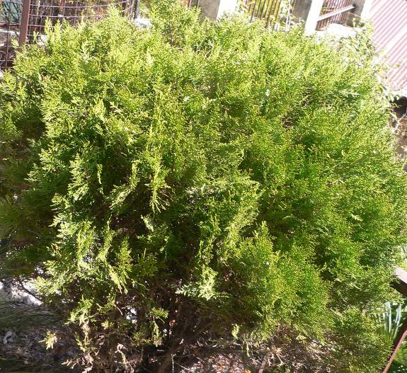
Biota orientalis (Linn.)Endt.

Genera: Cupressus Linn.

Cupressus torulosa D.Don
Common name:Himalayan Cypress
English name:Cypress
Hindi name :Surai
Distribution in Nainital: Kilbury road, Naina (Cheena peak) area, Hanumangarh area(planted) on degraded area, eastern slope of Govt. house, Snow view.
General distribution and habitat: China: in arid areas at 1500-2500 m, India (Kashmir to Arunanchal Pradesh), Nepal, Tibet, Pakistan, Bhutan. W. Himalaya at 1800-300 m on limestone substrates. It is a shade intolerant species, thriving in tropical and subtropical rainforests, where it prefers calcareous substrates.
General description: A large evergreen tree commonly 3.6 m in girth and 45m in height, with a pyramidal crown with horizontal or drooping branches.
Bark: Thick, grey brown or brown, peeling off in long thin strips.

Leaves: scale-like, triangular closely appressed, obtuse, dark green, often with a small dorsal furrow.
Flowers: Monoecious, male catkins 5-6mm long, often tinged purple, solitary at the tips of the branchlets.cones globose, woody, male cone sub globular, 5-6mm long. Female cones globose or elliptic, grouped on very short stalks, 10-20 mm across, green or purple when young, later turning dark brown, composed of 6-8(10) scales, with a small central depression and a small, triangular.
Scales: Woody and 6-10.
Seeds: Compressed 6-8 on each scale, pale brownish.
Uses: The plant is burnt as incense. The leaves are used. Wood - moderately hard, very durable. Used for general construction.
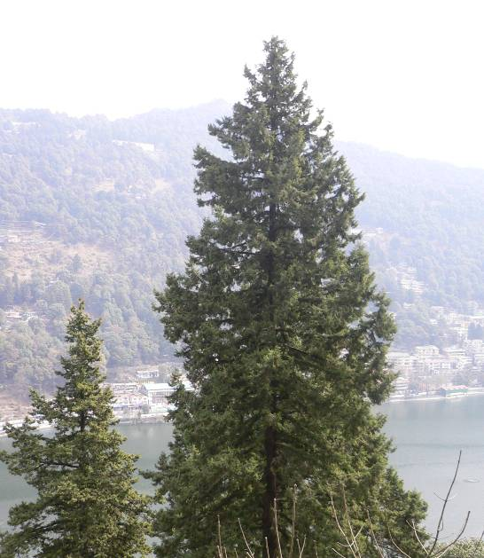
Cupressus torulosa D.Don

Genera: Juniperus Linn.
Juniperus communis Linn.
English: Common or Ground JuniperHindi: Jhora, Billa, Bhitaru
Distribution in Nainital- D.S.B. Campus, Govt. house, cultivated.
General distribution and habitat: Afghanistan, India (north-west Himalaya), temperate and sub arctic Asia, Europe, North Africa, North America. This is the most widespread conifer in the world.The plant prefers light (sandy), medium (loamy) and heavy (clay) soils, requires well-drained soil and can grow in heavy clay and nutritionally poor soils. The plant prefers acid, neutral and basic (alkaline) soils. It can grow in semi-shade (light woodland) or no shade. General description:It is a shrub or small tree, very variable and often a low spreading shrub, but occasionally reaching 10 m tall, Dioecious, multistemmed, decumbent or rarely upright; crown generally depressed.
Bark: reddish brown, fibrous, exfoliating in thin strips that of small branchlets (5-10 mm diam.) smooth, that of larger branchlets exfoliating in strips and plates.
Branches: spreading or ascending; branchlets erect, terete.
Leaves: Needle-like to narrowly lance-shaped, 5 - 12 mm long (sometimes to 15 mm), jointed at base, very prickly; whitish above, dark green below; in 3's but sometimes appearing silver when glaucous, spreading.
Flowers: dioecious, with male and female cones on separate plants, which are wind pollinated.
Fruit: female cones berry-like green ripening in 18 months to purple-black with a blue waxy coating; they are spherical, 4–12 mm diameter, and usually have three (occasionally six) fused scales, each scale with a single seed. The male cones are yellow, 2–3 mm long, and catkin-like; sexes on separate plants.
Edible Uses: Fruit, coffee, condiment, Tea. Fruit: Raw or cooked .A soft, mealy, sweet, resinous flesh. The fruit is often used as flavouring in sauerkraut, stuffings, vegetable pates etc, and is an essential ingredient of gin. The aromatic fruit is used as a pepper substitute. An essential oil is sometimes distilled from the fruit to be used as flavouring. The roasted seed is a coffee substitute. A tea is made by boiling the leaves and stems .A tea made from the berries has a spicy gin-like flavour.
Medicinal Uses: Antiseptic; Aromatherapy; Aromatic; Carminative; Tonic; Diaphoretic; Diuretic; Rubefacient; Stomachic; Juniper fruits are commonly used in herbal medicine; they are especially useful in the treatment of digestive disorders plus kidney and bladder problems, the fully ripe fruits are strongly antiseptic, aromatic, carminative, diaphoretic, strongly diuretic, rubefacient, stomachic and tonic. They are used in the treatment of cystitis, digestive problems, chronic arthritis, gout and rheumatic conditions.
Other Uses: Fiber; Fuel; Ground cover; Hair oil; Incense; Repellent; Resin; Strewing; Tinder. The essential oil distilled from the fruits is used in perfumes with spicy fragrances.
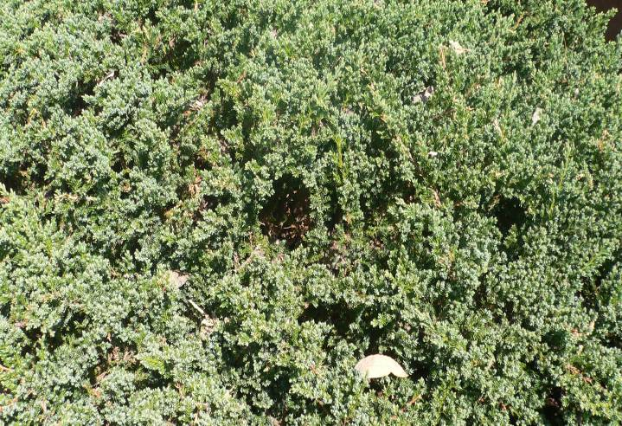
Juniperus communis Linn.

CYCADACEAE
GENERA- Cycas Linn.
Cycas revoluta Thunb.
English name: Sago palm (King Sago Palm)

Distribution in Nainital: D.S.B. Campus, Boat house garden.
General distribution and habitat: China, a rugged trunk, topped with whorled feathery leaves has lead to the common name "Sago Palm".Cycas revoluta Thunb. (Sago Cycad), is native to southern Japan. The subtropical C. revoluta Thunb. is native to the Far East and has been used as a choice container and landscape plant for centuries
General description: Cycas revoluta Thunb. one of the most primitive living seed plants, are very unusual and popular ornamentals. A slow growing palm- like dioecious tree or shrub 1.8to3m producing suckers. Trunk columnar unbranched, rarely forked clothed with old leaf bases, very low to subterranean in young plants, but lengthens above ground with age.
Leaves: 60- 150cm. long, petiole thick quadrangular; leaflets 9-18cm. long, less than 5mm. wide, sub-opposite, stiff terminating in a sharp pointed tip. NEW LEAVES emerge all at once in a circular pattern, thus grow out into a feather-like rosette, margin revolute, the basal leaflets become more like spines.
Cones: The male cone is pineapple shaped , apical cylindrical or ovoid oblong 8-40cm. long, 1.5-4cm. in diameter, shortly peduncled. Microsporophylls (stamens) lanceolate- cuneiform 2-3.8cm long, 11-17mm wide, truncate,woody, covered with pollen sacs beneath. The apical end is sterile, lower wedge shaped is fertile. Megasporophylls forming an apical crown in a rosette form, densely hairy, stalk longer than blade with 4-6 ovules that are covered with thick down; blade ovate lacinate nearly to the midrib with 12-18 linear curved spinous segments
Seeds: Seeds are brownish-red, the shape of a flattened marble, glabrous 1.5-3.5cm.long, apex emarginated, bright orange or yellow in colour. Pollination can be done naturally by insects or artificially.
Uses: Edible Uses Edible Parts: Seed; Stem. Seed - raw or cooked. They can be dried and ground into a powder then mixed with brown rice and fermented into 'date miso' or 'sotetsu miso. The heart or pith of the trunk is sliced and eaten baked or powdered.
Medicinal Uses: Astringent; Cancer; Diuretic; Emmenagogue; Expectorant; Tonic. The leaves are used in the treatment of cancer and hepatoma. The terminal shoot is astringent and diuretic. The seed is emmenagogue, expectorant and tonic. It is used in the treatment of rheumatism. Substances extracted from the seeds are used to inhibit the growth of malignant tumors.

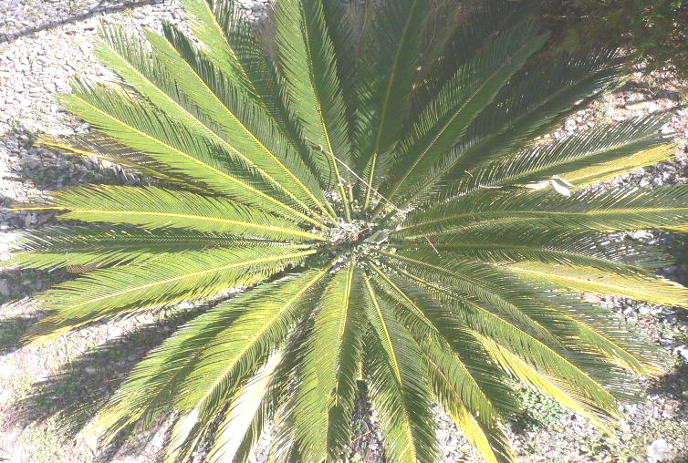
Cycas revoluta Thunb.

GINKGOACEAE
GENERA- Ginkgo Linn.
Ginkgo biloba Linn.
English: Maiden Hair Tree
Hindi name: Ginkgo (The living fossil)
Distribution in Nainital: Cultivated near Govt. house, around D.S.B. campus,Snow view area (old Govt. house).
General distribution and habitat- South East China, Japan .It grows on rich sandy soils .The plant prefers light (sandy), medium (loamy) and heavy (clay) soils and requires well-drained soil. The plant prefers acid, neutral and basic (alkaline) soils. It cannot grow in the shade. It requires dry or moist soil and can tolerate drought. It can tolerate atmospheric pollution.
General description: Ginkgo is an attractive and deciduous tree of pyramidal form. It is about 30m tall, with fan shaped deciduous leaves.
Bark: Light greyish brown with irregular ridges, eventually becoming deeply furrowed. Trunk pyramidal and sparsely branched.
Branches: Irregularly whorled or produced at indefinite intervals. Branchlets horizontal or drooping with spur like shoots.
Leaves: Alternate, simple, fan-shaped, 2 to 3 inches long and wide; parallel, fan-like venation petiole long, light green above and below.
Flower: Dioecious; tiny green male flowers appear in spring as pendulous catkins from shoots in pairs or in threes, each consisting of along stalk bearing on each side below. The apex, a naked. Female "cones" are 1 1/2 to 2 inch long peduncles, bearing 1 to 2 ovules, present in mid-spring. Ovule is surrounded at the base by a collar like rim.
Fruits: On female trees, the tan-orange oval fruits are pendulous from the spur shoots.
Seed: They have a silvery shine ("silver apricot/nut"). The ripened fleshy seed coat when falling on the ground and decaying has a 'disagreeable' odour (like rancid butter) as a result of the presence of butyric (butanoic) acid. Drupe-plum like, orange colour.
Use: Medicinal Uses and Indications
Based on studies conducted in laboratories, animals, and humans, many health care professionals may recommend Ginkgo Linn. for the following health problems:
Dementia and Alzheimer's disease: Ginkgo is widely used in Europe for treating dementia. Its use is primarily due to its ability to improve blood flow to the brain and because of its antioxidant properties. The evidence that Ginkgo may improve thinking, learning, and memory in people with Alzheimer's disease (AD) has been highly promising.
Eye problems :The flavonoids found in Ginkgo may help halt or lessen some retinal problems (that is, problems to the back part of the eye). Retinal damage has a number of potential causes, including diabetes and macular degeneration. Macular degeneration (often called age-related macular degeneration or ARMD) is a progressive, degenerative eye disease that tends to affect older adults and is the number one cause of blindness in the United States. Studies suggest that Gingko may help preserve vision in those with ARMD.
Memory Impairment: Ginkgo is widely touted as a "brain herb." Researchers recently reviewed all of the high-quality published studies on Ginkgo and mild memory impairment (in other words, people without Alzheimer's or other form of dementia), and concluded that ginkgo was significantly more effective than placebo in enhancing memory and cognitive function. Ginkgo is commonly added to nutrition bars, soft drinks, and fruit soothies to boost memory and enhance cognitive performance.
Other uses: In addition to these health problems, health care professionals may also recommend ginkgo for a variety of other ailments, including altitude sickness, asthma, depression, disorientation, headaches, high blood pressure, erectile dysfunction, and vertigo.
Edible Uses: Seed: Raw (in small quantities), or cooked [A soft and oily texture the seed has a sweet flavour and tastes somewhat like a large pine nut .The baked seed makes very pleasant eating, it has a taste rather like a cross between potatoes and sweet chestnuts .The seed can be boiled and used in soups, porridges etc .It needs to be heated before being eaten in order to destroy a mildly acrimonious principle .The seed is rich in niacin .It is a good source of starch and protein, but is low in fats .These fats are mostly unsaturated or monosaturated .An edible oil is obtained from the seed.

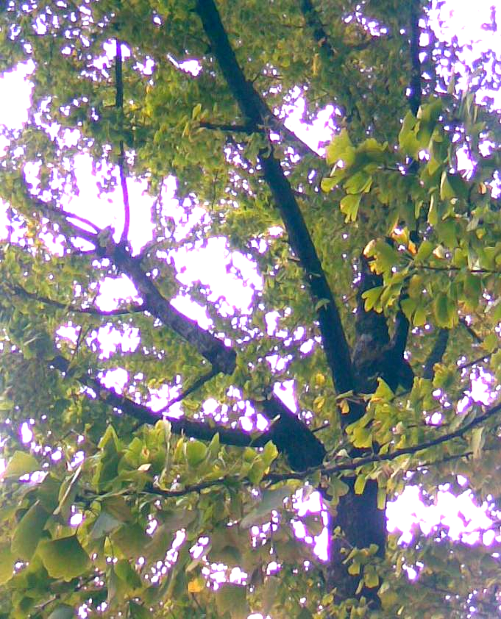
Ginkgo biloba Linn.

PINACEAE
GENERA- Abies Mill.
Abies pindrow Royle
English name: West Himalayan Fir or Low Level Fir
Hindi name: Raga or Righa
Distribution in Nainital: Lariakanta, east of Nainital, Snow view area on Zoo road.
General distribution:Afganistan, India (Western Himalaya), Nepal, Pakistan)Habitat and range.It grows at altitudes of 2,400-3,700 m in forests together with deodar cedar, blue pine and morinda spruce, typically occupying cooler, moister north-facing slopes.
General description: A large and evergreen tree with a dense conical columnar crown of dark green foliage, attaining a height of 45-60m and a girth of 2.5-4 m.
Branches: horizontal or drooping, whorled. The shoots are greyish-pink to buff-brown, smooth and glabrous (hairless).
Bark: smooth on young stem, dark grey, and rough with deep vertical furrows on old stems.
Leaves: variable two ranked, on opposite sides of a twig; needle like, flattened, lower surface with two pale powdery bands on either side of the midrib, tip notched.
Flowers: monoecious male catkins clustered; stamens with two linear pollen sacs. Female flowers in cones, which are solitary or in distant pairs, erect, dark purple. Ripe cones erect cylindrical.
Seeds: have long wings longer than the seeds.
Uses: Fuel; wood.
Wood: light, soft, not very durable. Used for house interiors, cases, furniture, water troughs and fuel. The wood is used for making matches and paper pulp.
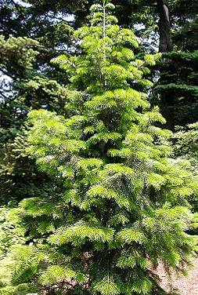
Abies pindrow Royle

GENERA- Cedrus Trew.
Cedrus deodara Roxb.
English name: Himalayan Cedar
Hindi name: Deodar, Diar

Distribution in Nainital: D.S.B. area, below China peak, Kilbury, Sher ka danda.
General distribution and habitat: cedar is native to the western Himalaya in eastern Afghanistan, northern Pakistan, Northwest and North-Central India, South Western Tibet and Western Nepal, occurring at 1500-3200 m altitude. It is commonly mixed with fir, deodar, blue pine and at higher elevation with Quercus semicarpifolia Smith., maple etc.
General description: an evergreen tree attaining a height of 250 feet and may spread to the diameter of 3m. It has a conical appearance when it is young and drooping branches in the end. Trees that are old attain round shape. Branches are arranged in horizontal manner and shoots are pedunculated.
Trunk is straight and thick. The branches that are on the top are smaller than the lower ones.
Bark: thick and rough in appearance and is greyish brown.

Leaves: 2.5-3.8cm long, dark green, sharply pointed, in tufts of 15-20.
Male and female flowers are often on separate trees, but some times on the same tree in which case they are on separate branches.
Cones: erect barrel shaped. Catkin solitary, at the ends of the branchlets, cylindric. Female cones solitary ovoid, green dark brown when mature, erect. Scales numerous fans shaped breaking from the stout woody axis.
Seeds: triangular with a broad wing.
Uses: It is widely grown as an ornamental tree, much planted in parks and large gardens for its drooping foliage. Cedar wood oil, extracted from the plant, is used for catarrhal conditions of the respiratory tract. It is an expectorant. It is also useful for ulcers and skin diseases.
In India, Cedrus deodara oil has been shown to possess insecticidal and antifungal properties and to have some potential for control of fungal deterioration of spices during storage.

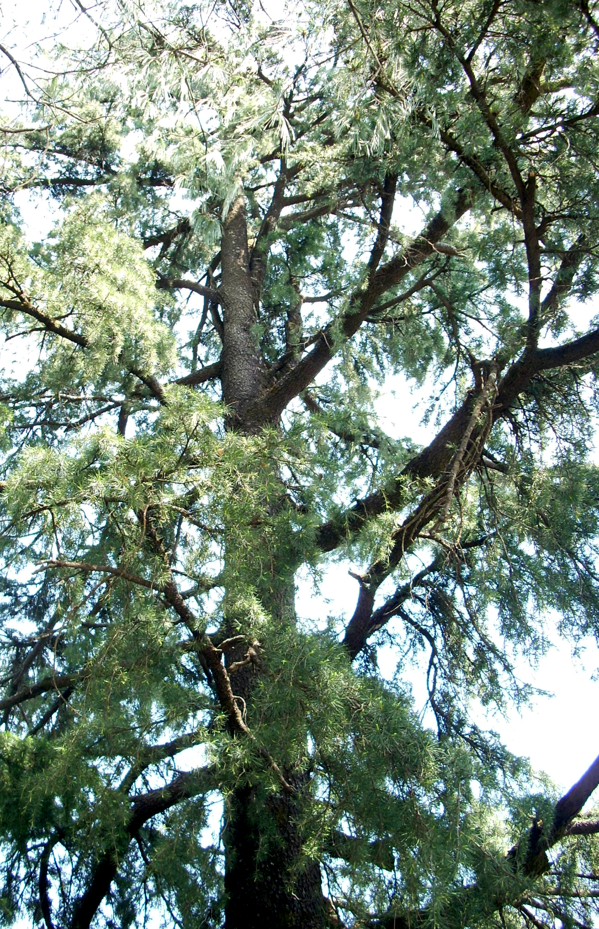
Cedrus deodara Roxb.

Genera- Picea Link.
Picea smithiana Wall.
English name:West Himalayan Spruce,
Morinda Spruce
Hindi name: Kala Chiulu
Distribution in Nainital: St. xaviers school, near Sherwood college, High court area, Ayarpatta .
General distribution and habitat: Usually found on N. and W. slopes inhabiting the drier upper areas often in association with silver fir or deodar, 2100 - 3600 meters from Afghanistan to Nepal. Restricted to subtropical high altitude, temperate, and boreal regions of the northern hemisphere.
General description: A very large evergreen tree with pendulous branches attaining a height of 60m and above and a girth up to 5.7m.
Branches: whorled with strong nodal pseudowhorls and additional scattered weaker internodal branches. Short (spur) shoots absent.
Bark: gray to reddish brown, Rough, cut by shallow furrows into small plates.
Leaves: borne singly and spirally around the branches, 4 sided and stiff, 2.5 to 3.8cm long, needle like with sharp points.
Flowers: monoecious, male catkins, solitary, erect, nearly sessile in the axils of upper leaves.
Cones: borne on year-old twigs. Pollen cones single or grouped, axillary, oblong, and yellow to purple; pollen shed in spring. Seed cones green to purple, maturing pale to dark brown in autumn, 4-8 months from pollination, usually shed at maturity, borne mostly on upper branches, pendent, ovoid to cylindric, sessile or terminal on leafy branchlets; scales persistent, elliptic to fan-shaped, thin, lacking apophysis and umbo; bracts included.
Seeds: dark grey or blackish, wing spoon shaped and light brown.
Uses: Edible Parts: Flowers; Inner bark; Seed; Seedpod.
Edible Uses: Condiment; Gum; Tea
Inner bark : dried, ground into a powder and then used as a thickener in soups etc or added to cereals when making bread. A refreshing tea can be made from the young shoot tip, rich in vitamin C .The bark is very water resistant and is used for roofing and making water troughs.
Wood: soft to moderately hard. Used in construction, shingles, crates, household purposes etc. It is also valued for its use in the pulp industry to make paper.
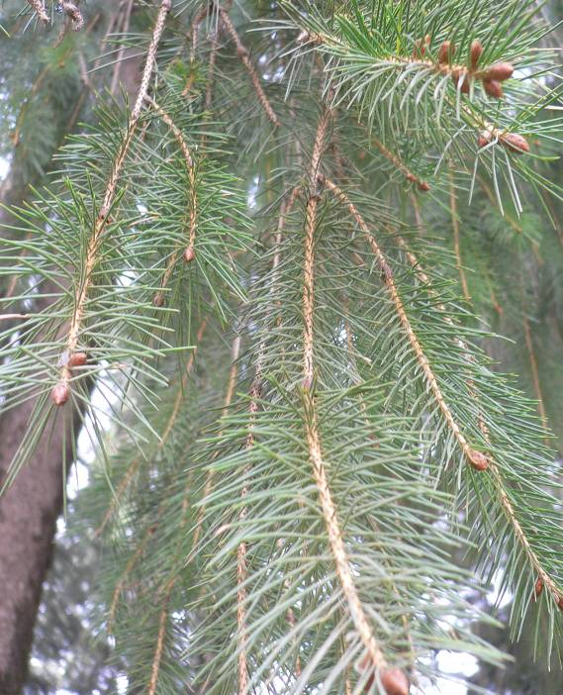
Picea smithiana wall.

Genera- Pinus Linn.
Pinus roxburghii Roxb.
English name: Pine (Himalayan long needle pine)
Hindi name: Chir
Distribution in Nainital: around kailakhan, pines, Hanumangarh, with occasional trees in Nainital catchment.
General distribution and habitat:Afganistan, Bhutan,India(North West Himalaya to Assam, Arunanchal pradesh(absent in Kashmir valley), Pakistan. The Chir Pine (Pinus roxburghii Roxb.) named after William Roxburgh, is native to the Himalaya. It generally occurs at lower altitudes than other pines in the Himalaya, from 500-2000 m, occasionally up to 2300 m.

General description: a large evergreen tree, nearly deciduous in dry localities, usually not exceeding 30m in height, rarely 55m.A girth of 3m have been recorded in favorable conditions. Branches up to middle age whorled, crown elongated to pyramidal shaped afterwards becoming spreading or umbrella shaped.
Bark: reddish-brown, thick and deeply fissured at the base of the trunk, thinner and flaky in the upper crown
Leaves: are needle-like, in fascicles of three, very slender, 20-35 cm long and distinctly yellowish green.
Flowers: are monoecious (individual flowers are either male or female, but both sexes can be found on the same plant) and are pollinated by Wind.
Scales: woody with a curved beak.
Cones: ovoid conic, 12-24 cm long and 5-8 cm broad at the base when closed, green at first, ripening glossy chestnut-brown when 24 months old.
Seeds: 8-9 mm long, with long membranous wing and are wind-dispersed.

USES: Edible Uses
Condiment, Manna, Seed
Seed: Raw or cooked. It has a strong flavour of turpentine and is only eaten as an emergency food. A sweet edible manna exudes from the bark and twigs it is actually a gum.Vanillin flavour is obtained as a by-product of other resins that are released from the pulpwood.
Medicinal Uses:Antiseptic; Diaphoretic; Diuretic; Rubefacient; Stimulant; Vermifuge. The turpentine obtained from the resin of all pine trees is antiseptic, diuretic, rubefacient and vermifuge. It is a valuable remedy used internally in the treatment of kidney and bladder complaints. It is also very beneficial to the respiratory system and so is useful in treating diseases of the mucous membranes and respiratory complaints such as coughs, colds, influenza and TB. Externally it is a very beneficial treatment for a variety of skin complaints, wounds, sores, burns, boils etc.
The wood is diaphoretic and stimulant. It is useful in treating burning of the body, cough, fainting and ulcers.

Other Uses
Charcoal, Dye, Herbicide, Ink, lightning,resins.
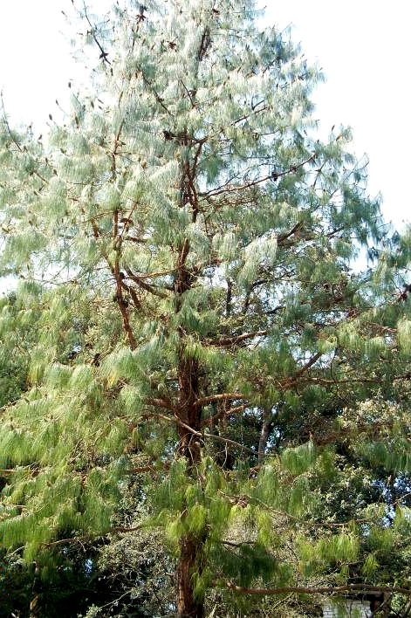
Pinus roxburghii Roxb.

Pinus wallichiana A. B. Jackson
English name: Himalayan Blue Pine.
Hindi name: Chilla, Chiulu
Distribution in Nainital: Sigri area (Kilbury) and Kilbury road, in D.S.B. campus.
General distribution and habitat- Bhutan, India (all along east and west Himalaya: Kashmir, Sikkim, Uttarakhand) Nepal, Pakistan. Found in valleys and foothills at elevations of 1800-3900 m, sometimes in pure stands but often in association with conifers including Cedrus deodara, Abies pindrow, Picea smithiana and Juniperus excelsa subsp. polycarpos, and with broadleaved species including Quercus semicarpifolia, Betula utilis, Acer and Ilex species.
General description- An evergreen Tree growing to 25m by 10m at a fast rate. Tree may reach 50 m height with straight trunk and short, down curved branches. Branches are longer in solitary trees, creating a dome-like crown.
Bark -Orange-brown to gray-brown; initially smooth but developing shallow fissures and flakey plates over time. Branches in regularly spaced whorls smooth. Young shoots glaucous, later turning pale grey-green, smooth, ribbed, and darkening with age.
Leaves- in bundles of 5, basal sheaths deciduous, 15-20 cm long, often curved at the base, slender, flexible, abaxial side green, ventral side with multiple bluish-white stomatal lines .
Flowers- monoecious (individual flowers are either male or female, but both sexes can be found on the same plant) and are pollinated by Wind. Catkin ovoid. Male strobilli on lower branches, often in dense clusters on younger twigs. Female cones in groups of 1-6, 20-30 cm long, erect when young but later pendant bluish-green when young, maturing to light brown with pale brown apophyses.
Seeds- bluish, acute at both the ends, compressed wings 3 times the length of seeds.
Uses- Seed - raw or cooked. It has a very resinous flavour and so is not much relished. The seed is quite small, to 7mm long. The honeydew from aphid infested leaves is eaten as manna. Vanillin flavouring is obtained as a by-product of other resins that are released from the pulpwood. The needles contain a substance called terpene, this is released when rain washes over the needles and it has a negative effect on the germination of some plants, including wheat.
Wood - Moderately hard, durable, highly resinous. Used in construction, carpentry etc. Good firewood but it gives off a pungent resinous smoke. The wood is rich in resin. It can be fractured and used as a torch.
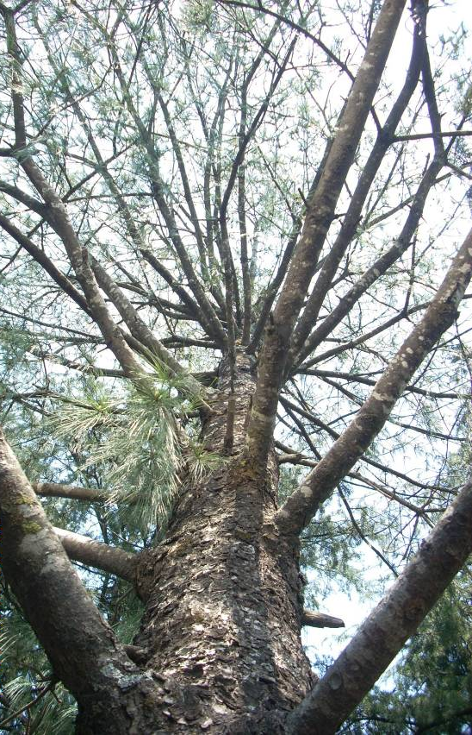
Pinus wallichiana A.B.Jackson

TAXACEAE (YEW FAMILY)
GENERA- TAXUS Linn.
Taxus baccata Linn.
English name: Common Yew
Hindi name: Thuner
Distribution in Nainital: In Botanic garden near Khurpatal (cultivated)
General distribution and habitat- Taxus baccata Linn. is a conifer native to Western, Central and southern Europe, NorthWest Africa, Afghanistan, India (Eastern and West Himalaya from Kashmir to Arunanchal Pradesh, Naga Hills, khasi hills Manipur), Myanmar, South West China, West Pakistan. Europe, including Britain, The plant prefers light (sandy), medium (loamy) and heavy (clay) soils, requires well-drained soil and can grow in heavy clay soil. It requires dry or moist soil and can tolerate drought.
General description: It is a small to medium-sized evergreen tree, growing 10-20 m (exceptionally up to 28 m) tall, with a trunk up to 2 m (exceptionally 4 m) diameter.
Bark: The bark is thin, reddish or scaly brown, coming off in small flakes aligned with the stem.
Leaves: lanceolate, flat, dark glossy green, 1-4 cm long and 2-3 mm broad, arranged spirally on the stem, but with the leaf bases twisted to align the leaves in two flat vertical rows. The leaves are highly poisonous.
Flowers: dioecious, male flowers in catkins which are subglobose and solitary in the leaf-axils, stamens about ten, pollen sacs 5-9,globose,arranged around the filament beneath the tip of the stamen. Female flowers solitary, axillary, each consisting of a few imbricate scales around an erect ovule, which is surrounded at the base by a membranous cup shaped disk.
Seed:4-7 mm long partly surrounded by a modified scale which develops into a soft, bright red berry-like structure called an aril.
Uses: Edible Uses Edible Parts: Fruit. Edible Uses: Tea.
Fruit: Raw Very sweet and gelatinous.

Medicinal Uses:
Antispasmodic;Cancer; Cardio tonic; Diaphoretic; Narcotic; Emmenagogue; Expectorant; Homeopathy; Purgative.
The yew tree is a highly toxic plant that has occasionally been used medicinally, mainly in the treatment of chest complaints. The plants contain the substance 'Taxol' in their shoots. Taxol has shown exciting potential as an anti-cancer drug, particularly in the treatment of ovarian cancers. All parts of the plant, except the fleshy fruit, are antispasmodic, cardio tonic, and diaphoretic, emmenagogue, expectorant, narcotic and purgative. The leaves have been used internally in the treatment of asthma, bronchitis, hiccup, indigestion, rheumatism and epilepsy.
Other Uses Fuel; Ground cover; Hedge; Incense; Insecticide; Wood

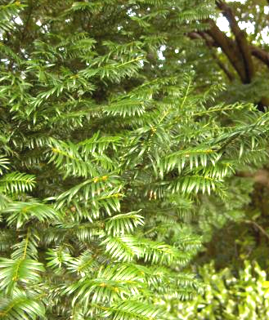
Taxus baccata Linn.

TAXODIACEAE (RED WOOD FAMILY)

GENERA- CRYPTOMERIA D. Don.

Cryptomeria japonica D.Don
English name: Japanese Cedar
Hindi name: Sugi

Distribution in Nainital: Govt. house planted
General distribution and habitat: Sugi [Japanese] is the national tree of Japan where it occurs naturally in pure and mixed stands. Also found in china, India (shillong, Darjeeling).It grows in forests on deep, well-drained soils subject to warm, moist conditions at elevations from below 1100 m to 2500 m.
General description: It is a very large evergreen tree, reaching up to 70 m (230 ft) tall and up to 300cm.in diameter with a conical crown and a straight, slender trunk.
Bark: reddish brown to dark gray, fibrous, peeling off in strips.
Leaves: persisting 4 or 5 years, needle-like, pale green, spirally arranged in 5 ranks, bright to blue-green foliage. Branches usually in whorls, horizontal or drooping, Shoots green, glabrous.
Flowers:Male and female flowers on different parts of the same branch. Cone solitary, brownish, globular.
Cones: male cones axillary toward apex of second-year branchlets usually crowded into a terminal, sessile, oblong raceme of 6-35, ovoid or ovoid-ellipsoid. Female cones are borne in groups of 1-6, terminal, solitary or occasionally aggregated, sessile, globose or subglobose, rosette like and resembling opening buds.
Seeds: dark brown, irregularly triangular, each edge narrowed into a rudimentary wing.

Uses: Medicinal Uses Depurative Oil and/or a resin from the plant is depurative and also used in the treatment of gonorrhoea.

Other Uses: Incense, Shelterbelt, Wood
The leaves are very aromatic and are used as incense sticks .A fairly wind-tolerant tree; it can be used in shelterbelt plantings. Wood - light, fragrant, fine grained. The wood is strongly rot resistant, easily worked, and is used for buildings, bridges, ships, lamp posts, furniture, utensils, and paper manufacture. Old wood that has been buried in the soil turns a dark green and is then much esteemed.
Cryptomeria japonica D.Don.

GENERA- Taxodium Rich.
Taxodium mucronatum Ten.
English- Marsh Cypress (Montezuma Bald Cypress)

Distribution in Nainital: cultivated at Govt. house garden ( gupta 1968)
General distribution and habitat: North America, India (Dehradun Forest Research Institute, cultivated) native to much of Mexico (South to the highlands of southern Mexico), and also southernmost Texas, USA. Cypress is primarily a riparian tree, growing along upland riversides, not in swamps or lakes. They are very drought-tolerant and fast-growing which has led to them being frequently cultivated there in parks and gardens. They favor climates that are rainy throughout the year or at least with high summer rainfall.

General description: the tree is large; semi evergreen with two types of branches1- the persistent branches with axillary buds, 2- the deciduous branches attached to the persistent shoots but without axillary buds.
Bark: The bark is green in young trees but turns brown and scaly in older trees.
Leaves: alternate, in 2 ranks or not. Adult leaves divergent to strongly appressed, linear or linear-lanceolate to deltate, generally flattened.
Cones:The plants are monoecious, with male and female cones generally appearing on different branches. Male cone is small, round structure, but becomes oblong at maturity and colour turns dark brown. Microsporophylls are spirally arranged on the cone axis and are surrounded by ovate scales. Female cones maturing and shattering in 1 season, nearly globose; scales falling early, 5-10, valvate, peltate, thin and woody
Seeds: 1-2 per scale, irregularly 3-angled, wingless.
Uses: The trees are especially prized for their wood, of which the heartwood is extremely rot and termite resistant. A biochemical called cypressene is believed to act as a natural preservative in the heartwood. Wood was much used in former days in southeastern USA for shingles. The shredded bark of these trees is used as a mulch.

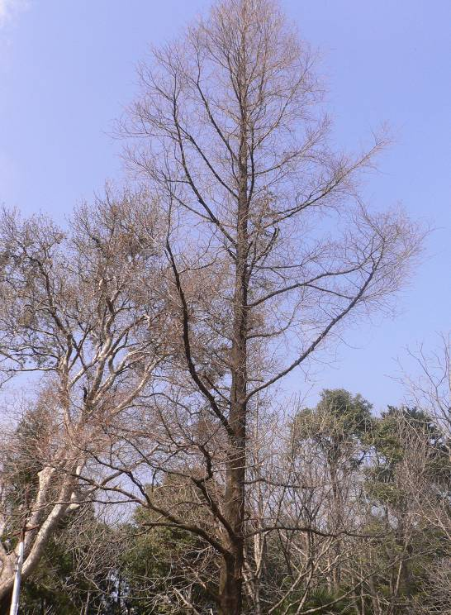
Taxodium mucronatum Ten.

Conclusion
The present study identified the presence of 15 species of 14 genera under 8 families. These are: Araucaria cunninghamii Sweet, Cephalotaxus griffithii Hook f., Biota orientalis (Linn) Endt, Cupressus torulosa D.Don, Juniperus communis Linn., Cycas revoluta Thunb., Ginkgo biloba Linn, Abies pindrow Royle, Cedrus deodara Roxb. , Picea smithiana wall, Pinus roxburghii Roxb., Pinus wallichiana A.B.Jackson, Taxus baccata Linn, Cryptomeria japonica D.Don , Taxodium mucronatum Ten.

Family | Genera | Species
Arucariaceae | 1 | 1
Cephalotaxaceae | 1 | 1
Cupressaceae | 3 | 3
Cycadeceae | 1 | 1
Ginkgoaceae | 1 | 1
Pinaceae | 4 | 5
Taxaceae | 1 | 1
Taxodiaceae | 2 | 2
Total 8 | 14 | 15

Most of the species belongs to higher altitude. In Nainital the dominance of these species occurs in Ayarpatha, Govt. house, Kilbury, China peak, Snow view, Sher ka danda. Cedrus deodara Roxb. Cupressus torulosa D.Don, Pinus roxburghii Roxb. Occurs in wild state while all others are grown as ornamental plants.

Acknowledgements
We extend thanks to Vice Chancellor, Kumaun University, Nainital and Head, Department of Botany, Kumaun University, Nainital for providing necessary facilities and encouragements.

REFRENCES

Arnold ,C.A . Classification of the Gymnosperm from the view point of palaeobotany. Bot. Gaz. 1948;110:2612.
Beisnner,G.and Hooker , J.D. Genera plantarum Kew 1862-63.
Biswas , K. The distribution of Wild Gymnosperms in the Indian Empire. J.Indian bot. Soc., 1933; 12(1): 24-27.
Chamberlain, C.J. Gymonsperm Structure and Evolution . Chicago 1935.
Chhonker, U.P.S. & N.S. Bisht.Gymnosperm flora of Nainital and adjacent region. Proc. India Sci.Cong. Abst1968; 3:273.
Dogra, P.D. Gymnosperm of India II. Chilgosa Pine ( Pinus gerardiana Wall.) Bull.Nat.Bot . Gdn.Lucknow 1964.
Duthie, J.F. Catalogue of plants of kumaun and adjacent portions of Garhwal and Tibet . compiled by R.Strachey London, lovell Reive and Co. Ltd 1906.
Dutta, S.C. An Introduction to Gymnosperm . Asia Publication House 1973.
Gupta, R.K. Flora Nainitallensis, Navyug publications New Delhi 1968:434-442.
Hooker J.D. The Flora of British India.London 1888;5:463-686.
Jain, S.K. and R.R. Rao. A hand book of field and Herbarium Method, New Delhi 1976.
Kalakoti , B.S.(1983). Flora of Nainital Hills Ph.D. thesis, Kumaun University Nainital.
Kalakoti, B.S.&Y.P.S.Pangtey. Additions to the flora of Nainital. J.Econ . & Tax. Bot 1984; 4: 193-195
Osmaston, A.E. A Forest flora for kumaun. Allahabad: Suprintendent, Government press, United Provinces 1927.
Pandey, B. & P.C. Pande. Ethonobotanical studies on Gymnospermic plants of Kumaun Himalayas. J.Econ. Taxon Bot. 1999; 23 (2): 253-256.
Raizada, M.B. & K.C. Sahni. Living Indian GYMNOSPERMS. I. Indian For. Res. (N S) Bot., 1958; 5:73-150.
Sahni, K.C. Gymnosperm in Encyclopedia of India national history General Edit. R.E. Hawkins, Oxford University press, Delhi 1986:129-134.
Sahni, K.C.Gymnosperms of India and adjacent countries. Bishen Singh and Mahendra pal Singh, Dehradun 1990.
Singh K.P., & V. Mudgal. Gymnosperms in Floristic diversity and conservation strategies in India, vol.1, Cryptogams and Gymnosperms. (ed. V. Mudgal and P.K. Hajra) Bot. Survey of India. 1997:443-472.
Uniyal, S.K. & A. Awasthi. Gymnosperms of Uttar Pradesh; an enumeration. Indian J. Forestry, 2000; 23(2): 228-231.

.4/16/2009

