Environmental Impact Assessment of Soil and Water Conservation Measures at Medego Watershed, Tigray, Northern Ethiopia

Kirubel Mekonen¹ and Gebreyesus Brhane^{1ab}

________________________________________________________________________
¹Pemanent address: Axum University, Faculty of Agriculture and Rural Development,
P. O. Box 287, Tel: 251- (0)34-775-3549; Fax: 034-775-1931; Axum, Ethiopia.
ªPresent address: ZEF Bonn, Center for Development Research, University of Bonn, Walter-Flex-Str. 3, D-53113 Bonn, Germany
^{b}Corresponding author: phone: ++49-(0)162-4722826; Fax: ++49-(0)228-73-5097;
e-mail: gebre042001@yahoo.com
Environmental Impact Assessment of Soil and Water Conservation Measures at Medego Watershed, Tigray, Northern Ethiopia

ABSTRACT
The immediate consequence of land degradation is reduced crop yield. To reduce land degradation due to water erosion in semiarid areas, SWC measures have been implemented substantially at community and individuals in Ethiopia. Assessing the impact of various physical and biological SWC implemented at Medego watershed, northern Ethiopia, from environmental effect (soil, surfaces and subsurface water vegetation, microclimate) point of view was the aim of this study. Primary and secondary data were collected at watershed level using semi-structured interviews. Respondents (90%) had positive response on the SWC implemented in the watershed. Almost all terraces are filled by soil, which rages from 0.2-1.3 m; increased in surface and subsurface water storage results in increase irrigation area (>100%); seedling survival rate (> 75%); increase in vegetation composition and coverage density and number of springs and shallow wells are some of the evidences for positive impact of SWC program at the watershed. However, SWC measures should be integrated with vegetation intensively while designing and implementing SWC measures to increase total biomass production and to have healthy environment in the degraded semiarid areas such as northern Ethiopia.

Key word: environment, impact, land degradation, Medego watershed, northern Ethiopia, SWC
Abbreviation: SWC, soil and water conservation

1. INTRODUCTION
Land degradation is a major cause of poverty in developing countries. In many areas of the semiarid, farming population has experienced a decline in real income due to demographic, economic, social and environmental changes. Land degradation is a result of several factors of both physical and socio-economic nature. The immediate consequence of land degradation is reduced crop yield followed by economic decline and social stress (Hurni, 1985; Hudson, 1992; Tilahun, 1996).

Soil erosion is source of land degradation that affects the physical and chemical properties of soils. Periodic low soil moisture due to erratic and poorly distributed rainfall, severe soil erosion and runoff loss of water and the resultant low soil fertility are the prominent causes for the low agricultural productivity in the semiarid areas (Tamirie, 1986; Heluf, 2003). Moreover, subsistence agriculture has extended into marginal lands due to increasing population which result in damaging the environment and threatening the long term viability of the economy and social development of the poor households in particular and the community in general (Muchow, 1990)[5]. Hence, soil and water conservation measures are called upon to alleviate both problems of erosion and drought, which are symptoms of two different extremes of rainfall conditions in Ethiopia.

The practices used to reduce soil loss and runoff to negligible amounts are usually based on a combination of practices that help to maintain soil infiltration rates at sufficiently high levels and on measures which help safe disposal of runoff water (Lal, 1977a; Lal, 1977b; Hudson, 1997). The practice of judicial soil and water conservation undoubtedly plays a significant role in increasing agricultural production in arid and semiarid areas where agriculture is hampered by droughts and low soil fertility and moisture (Tamirie, 1986; Heluf, 2003). Hudson (1992) also witnessed that the significance of soil and water conservation by integrating physical and biological conservation measures, mainly to over come soil erosion, maintaining fertility as well as moisture status of the soil, which enhance the productivity of the land at maximum level in the semi-arid areas. Thus, to curb the erosion problems in the semiarid areas of Ethiopia at watershed level, SWC have been implemented substantially as community base and individuals since the last two decades. However, little or no sufficient documented information has been available on the contribution of the different SWC measures implemented towards the intended goal of environmental rehabilitation at watershed level in the semiarid areas of Ethiopia.

Many types of SWC measures have been extensively practiced at watershed in Ethiopia in order to maximize the potential of the soil productivity and sustain the natural resources. Hence, the study at Medego watershed answered the research question, ‘does the soil and water conservation program undertaken in the watershed achieve the intended goal of minimizing environmental degradation?’ Therefore, this study could have profound significances to assess the impact of the existing SWC measures from environmental perspective at Medego watershed in order to get room for future improvement of its contribution on productivity. The specific objective of this study was setout to assess the role of soil and water conservation measures on environmental rehabilitation at Medego watershed, northern Ethiopia.

2. MATERIALS AND METHODS
2.1. Study area description
The study was carried out at Medego watershed in the administrative unit of Lalay-Maychew (Axum town) in Tigray region, northern Ethiopia (Figure 1) for one year duration, from August 2007 to July 2008. Its altitude ranges from 2000 to 2720 m above sea level; and geographically, it is bounded by latitudes N14º05.955’and 14º05.937’and longitudes E038º42.352’ and 038º42.333’. The total area of the watershed is about 1091.5 ha as delineated during the field study with the help of Geographical Positioning System (GPS).

Medego watershed is characterized by different landforms which are ranged from flat plains, undulating plains and rolling land to steep mountains and very steep escarpments. The description of the topography is adopted the slope capability classification made by Checkun (2002) and the slope ranges and its area coverage was recorded at field using clinometers and GPS as presented in Table 1. The geological setup of the watershed is originated from volcanic. However, alluvial deposits at flat lands are also found in the watershed. The soil type at Medego watershed is quite different along the slope. At steep slopes, coarse earth materials, gravels and boulder are dominated where as at flat plain, the largest portion of the study area is covered by loam soil and the smaller portion laid on clay and sandy soil texturally. The main soil types are cambisols on undulating plains and rolling land; lithosols on hilly and steep to very steep lands and vertisols are found on the flat plateau plains of the watershed (BoANR, 2007).

The number of households and total population at Medego watershed is 397 and 1537, respectively. The land holding size of most farmers in the study area is less than 1.3 ha. The watershed has uni-modal and erratic rain fall patterns. The rainy season is very short and extends from June to first week of September. The mean annual amount of rain fall ranges from 600 - 700 mm from historical rainfall data. The mean monthly temperature during the growing season ranges from 15 - 20 º C (BoANR, 2007).

According to the respondents, the farming system is principally crop oriented. Tef cultivation (Eragrostic tef) account for majority of the arable lands of all crops and followed by wheat (Triticum vulgare) crop. Other crops such as faba bean (Vicia faba), field pea (Pisum sativum), lentil (Lens culinaris), chick pea (Cicer arietinum), flax (Linum usitatissimum), barley (Hordeum vulgare) and maize (Zea mays) are also important crops in the farming system. Irrigation is also widely practiced at Medego watershed. In spite of the fact that there is high crop diversification in the watershed, it observed that there is still a room to improve the crop productivity. Although livestock rearing is an integral part of the farming system, the number of livestock in the watershed area is reduced from time to time due to animal feed shortage. According to farmers view, cattle are kept mainly for draught power and milking; goat and sheep are kept for live sale; and equines (donkey, mule, horse, camel) for transportation.

It was observed that the vegetation in general is sparse and has been overexploited for a long time and consists of shrubs and bushes of little economic value. The available vegetation species in the study area include seraw (Acacia etbaica), chea’ (Acacia abyssinica), acacha (Acacia decurrence) and Awhi (Cordia africana) on uncultivated land, and momona (Acacia albida), tambock (Croton machostachys), keyih bahrizaf (eucalyptus comoldulensis) and some ‘seraw (Acacia etbaica) on cultivated and marginalized areas. Leucena (Leuceana leucacephala), sesbania (Sesbania sesban) and other grasses are commonly found in the gully of the watershed.

2.2. Methodology
Primary and secondary data were collected at Medego watershed related to the impact assessment of SWC measures. Primary data were gathered from topographic transect walk, semi-structured questionnaire interview and observation. The approaches (Table 2) such as before and after, with and without SWC, down stream and upper stream, and comparison of indicators on environmental impact were included during data collection. The secondary data included climate, demographic and other related data were collected from Bureau of Agriculture and Natural resources at the administrative unit.

The rapid rural appraisal technique of the topographic transect walk method was employed for the assessment of the natural resource base of the watershed. In order to obtain as much information as possible, the transect walk was applied in two direction, east to west and south to north. In both directions, the transect walk started at the top edge of the watershed and went all the way across to the other end of the watershed. During the transect walk, observations and estimates of vegetation type and density, impact of the existing soil and water conservation measures, level of erosion before and after the SWC program, and levels of SWC measures were recorded. These were followed by recording land-use types, soil accumulation on terraces, and water and vegetation condition in relation to SWC measures and slope gradient. The transect walk also provided an opportunity for informal discussions with farmers working on their plots. An interview with farmers was carried out using a combination of Participatory Rural Appraisal (PRA) techniques including semi-structured questionnaire, and group discussions. The focus group discussion was also supplemented by secondary data from concerned experts of the bureau of agriculture.

The total sample size for the semi-structured interviews was forty (40) households in the watershed. A process of observation and informal participatory discussions with individuals and groups representing men and women from different socio-economic categories led to the formation of a set of focus groups. They met regularly the team for discussion for three consecutive days during holidays. Among the samples, three (3) women headed household were purposely involved through out the interview and discussions. These are the only women household head at the watershed. The distribution of men respondents households were fourteen (14), twelve (12) and eleven (11) from low, medium and high wealth status, respectively, according to local wealth criteria. They were selected randomly from each category. However, their economic status and sex difference did not show any significance difference in this study.

SWC measures in Ethiopia were broadly introduced by the government, mainly thorough massive food for work program following several droughts. Thus, discussions on how far the measures are truly contributed to the sustainability of the watershed environment was made with farmers, development agents and experts with the help of the aforementioned data collecting techniques. The objective of the semi-structured interview was to: assess the role of the existing SWC measures on environmental rehabilitation, and find out ways that improve its role in the watershed in particular and the semiarid areas in general. Potential and limitation of the existing soil and water conservation measures at the watershed should also be examined from environmental factors (soil, water, vegetation, micro climate) point of view.

Different field materials were used, such as GPS- located the latitude and longitude, elevation and delineated watershed area; tape meter- measured changes in soil depth accumulated within the SWC measures and wells water level; clinometers- measured slope gradient and digital camera- taken photographs related to the study. The data were analyzed using descriptive and qualitative statistics with the help of SPSS computer software.

3. RESULTS AND DISCUSSION
3.1. Experiences of land management and Approach to SWC in northern Ethiopia
It is a fact that environmental degradation has been a problem in Tigray region, northern Ethiopia. The land surfaces in the region is mainly a reflection of the past erosion processes. The main causes of soil erosion in the area among others were out lined by different researchers (Hurni, 1985; Kuru, 1986; Gebreselassie, 1996) and even witnessed by all respondents as over-cultivation, deforestation, over grazing, steep topography, high rainfall intensity, unwise land use and management. This is evident by the huge amount of soil loss by water erosion and very low productivity of the farm lands. Therefore, to rehabilitate the environment and enrich it to a meaningful level, a concerned effort on SWC program has been carried out by the bureau of agriculture and other non government organization under the umbrella of the Tigray Regional Government, northern Ethiopia.

In the SWC program, various types of physical and biological SWC measures have been undertaken in the study watershed. The activities are: catchments treatment as area enclosure, afforestation, trench; reclamation of big gullies using check dams, biological; moisture harvesting on farms and degraded grazing lands (soil, stone faced soil and trench bunds; and big trenches; and soil faced stone bund on hillside lands. According to the extension experts, SWC activities are planned using watershed approach through integrated watershed management. All conservation activities are planned and based on a participatory planning approach with the community. The watershed development areas are those areas selected to benefit the community from all program components implemented in an integrated manner.

Moreover, it was observed that the implementation of SWC is carried out in collaboration with the baitos (local councils), the Bureau of Agriculture and Natural Resources (BoANR) and the beneficiary rural community. It is implemented by a labor contribution of the farming community (free labor contribution) and using Food for Work (FFW). The woreda (sub-district) BoANR, the woreda administration, the baitos at tabia (village) level and the technical leader of the community are responsible for planning, implementation and providing administrative as well as technical support.

At the study watershed modalities have been already prepared to undertake SWC activities through FFW by the community, according to the development workers and experts of bureau of agriculture. These are: targeted beneficiaries are all able bodied persons living in the area, the community should be well organized into working groups- local term ‘Gujile’ consisting of about 10-15 beneficiaries. Payment is made according to the achievements and work done. This is agreed with the results described in Admassie (1985) and also with the modalities developed by BoANR, (2007). FFW is one of the important employment opportunities in the area to supplement the income and employment of the target population and women are a majority in implementing SWC activities using FFW. Men are engaged in other income generated activities in near by towns. Communities are also contributed free labor to the SWC activities annually. They provide 20 days per year free labor per adult contribution to community development initiatives. This is a typical experience in land management as related to sustainable development, in particular through raising the contribution and input of the community free labor.

3.2. Some Limitation of Implemented SWC at Medego Watershed
Most of the respondents (90%) had positive response on the check dams implemented in the gully of Medego watershed. They had been participating in transporting 0.25 m³ of stones per person to build the check dam. This was organized by food for work campaign program. According to the respondents, farmers were not only taking some incentives but also they have more commitment and awareness to rehabilitate as well as to stabilize the gully in order to reduce the amount of soil loss from cultivated land and stop the gully expansion.

In accordance to the observation conducted, some of the check dams constructed both in the up-stream and down-stream side had collapsed due to in appropriate design and less tendency to apply the physical and biological conservation measures in the up stream side of the gully in the watershed. Most of the respondents (80%) felt that the office of agriculture and rural development as well as food for work campaign program did not give due follow up and monitoring for the check dam once they have been constructed. They added that the check dams need regular maintenance. However, despite of the above some draw backs, farmers are benefited from the check dams in the gully and there is no more gully expansion at this time. Some of the interviewed farmers (30%) plant some cash crops like tomato, potato, onion, carrot and citrus fruits during dry season using irrigation from the water accumulated in the check dam floor. But the others do not have land plot near to the gully for irrigation but they are involved using shallow and deep wells due to increasing ground water.

The theoretical recommended spacing value of the check dam is 4.6m. But the spacing value from the field measurement is deviated from the recommended value, which is 30 to 80 m, even if the height and width of the check dam is correlated with recommended value. As a result of this, the amount of run-off comes from the upslope is not easily dissipated by the check dam and cause for collapsing some check dams. This also led to the formation of incision on the gulley floor. In accordance to personal observation, the check dam was not keyed very well, the spill way is too wide, lacks apron and head was apart from the wall of the gully. Data collected from the respondents and development agents showed that the check dam was constructed before 12 years ago. At that time; the check dam was technically designed with apron but the apron was buried by soil at this time (Figure 2A).

All the respondents also agreed on the point that farmers having farm land on flat plains of the watershed are more reluctant to construct SWC structures as compared to sloppy areas. Even they destroyed it after constructed by the community by FFW. The reason is that they fear for water logging on heavy rainfall events and space competition. Most SWC measures such as stone faced soil bund are filled with soil, no more capacity to hold additional soil (Figure 2B), so stabilizing the terraces using vegetation is timey important. Hence, awareness should be created on farmers how to increase overall biomass production by integrating grass species or fruit trees within the bunds, and crop yield improvement due to soil and moisture enhancement. The level of SWC measure at the watershed is rated by more than half of respondents as few at flat slope and moderate at high sloppy areas. The respondents rated the existing SWC measures at the watershed as intensive were few, and no respondent was rated the existing SWC level as very intensive (Table 3), which is consistent with the finding of Barbier (1995). This implies that there is still a room to implement intensively or very intensively SWC measures at Medego watershed.

3.3. Environmental Impact of SWC Measures at Medego Watershed

a) Soil conservation
The effect of soil erosion on soil properties and productivity vary by soil type, management and location or slope. This effect is by changing the chemical properties of soils (loss of organic matter, plant nutrients), and physical soil properties (change in soil structure, texture, bulk density, infiltration rate, root depth, water holding capacity) as indicated by different studies (e.g., Frye et al., 1982; Olson et al., 1999). Many past studies are more focus on the severity of soil erosion in north Ethiopia (Hurni, 1985, Hudson, 1992, Tamene 2005, Brhane and Mekonen, 2009), but less attention is given to the contribution made by development activities in tackling these problems. Therefore, this study is attempting in evaluating the impacts of the different SWC to environmental rehabilitation and there by biomass production at Medego watershed, northern Ethiopia. To minimize such effects, soil erosion has been getting a significant concern in Ethiopia in general and at Medego watershed in particular since the last two decades. This is for the fact that inappropriate land management practices coupled with intensive rainfall has resulted in gullies and poor soil fertility and thereby decreasing and even total failure of crop productivity. To minimize the effect of such problem of soil erosion, the government of the region and the country has given due attention to the implementation of SWC program at watershed level by mobilizing the community. As a result, the consequences of the measures are assessed in this study to look its impact on conserving soil, moisture, fertility and reducing soil and water erosion as compared to before/without the program (Table 4).

Documented data is not available before the implementation of SWC program at the watershed. The result of this study is based on the present improvements visually and field measurement besides to the information found from the respondents. According to the respondents, the age of most of the SWC measure at Medego watershed is 8-years and some of them are greater than 12-years. The amount of soil accumulated in SWC measures is encourageable which ranges from 0.2 m- 1.3 m which vary on different land use types and types of measures used. For example, the highest depth of soil is accumulated in check dams constructed in a gully. Formation of rills and inter-rills is reduced by more than 60% as compared to before the implementation of SWC measures on cultivated lands due to reduced slope gradient and length by SWC measures (Figure 2B) which reduce the amount and velocity of overland flow. Moreover, new gully formation or expansion is almost stopped (> 95%) in the watershed, and the diversity of plant and trees (vegetation) in the watershed is increasing from time to time from 10% on areas of marginal land to more than 87% in area closure or protected areas as indicated in table 4, and Figure 2A and 2C. The details of each type of land use type and the contribution of SWC on soil conservation, moisture improvement, soil fertility maintenance and improvement, and soil erosion reduction as compared to before the implementation of SWC measures is described in Table 4 .

Farmers also classified the watershed land into different levels of erosion according to degree of erosion (Table 5 and 6). Most respondents (above 90%) were evaluated as less soil erosion after the soil conservation structures were built as compared to before the implementation of SWC measures. According to 95% of the respondents (Table 5), severe soil erosion was observed on steep slopes before the implementation of SWC measures at the watershed where as, after massive implementation of SWC; all of the respondents agreed that the erosion level is less (Table 6). The observation on the levels of erosion by the respondents is agreed with the soil loss estimated in the watershed by Brhane and Kekkonen (2009). The respondents were also mentioned the most important causes and effects of soil erosion in the watershed in which deforestation and cultural practices were rated as the most important causes; and reduced productivity was by far the most frequently reported as the effect of erosion which is similar to what is indicated in Moges and Holden (2006).

b) Water resource development
As the result of the SWC measures such as check dams, the availability of water for traditional irrigation system has been increased. The same trend has also been observed by the community in the watershed on soil water available for rainfed crops. The water harvested while rehabilitating the gully using check dams and the different types of SWC measures in the watershed is the main source of irrigation water which is supplemented by shallow and deep ground water wells at the end of the dry season e.g., in April (Table 7). Traditional irrigation land is increased by more than 100% and farmers are getting more aware on the benefits of irrigation as a source of income at this time. Farmer in the area assured that surface and subsurface water (springs, shallow and deep well water) is increased from time to time, that is why the irrigated land is increased. The fact behind this is that the time for infiltration is high in presence of SWC measures and so soil moisture can increase at the root zone and then by deep-percolation to the ground water (Olson et al., 1999; Moges and Holden 2006). Thus, the contribution of SWC measures to livelihood is highly appreciated by increasing water resources in the study watershed (Medego).

C) Greenness of the Environment
After the construction of different SWC measures, especially, the check dams of the gully and in the upper stream of the watershed, the micro-climate of the area is getting improved (Figures 2a and 2C). In this case, according to the respondents, the hot and dry air that dominated the watershed has been replaced by moist and cool air. This is due to the fact that vegetation increases after the implementation of SWC measures in the watershed (Table 4), which directly indicate the improvement of available water and soil fertility in the area.

d) Impact of SWC measures on seedling survival
Farmers have full dedication and strong feeling to work hard towards environmental change by planting different trees besides to managing the naturally growing once. However, according to the respondents (93%), they were challenged on the low survival rate of the newly planted seedlings for many years. This challenge was gradually solved when SWC measures were practiced in the area. Seedling survival is affected both by soil moisture and soil fertility. As these factors are improved the survival rate is high, for example, at the study watershed the data in Table 8 indicates that survival rate is increasing from 53% to 88% on community plantation where as on individual plantation, from 72% to 89%. Such result reveals that communal lands which are used for community plantation are severely degraded as compared to individual owned lands. This is entirely agreed with the finding of Brhane (2000). To show the positive impact of SWC measures, the trend that showed the number of planted and their survival rate is increased from year to year at the watershed as depicted on Table 8.

4. CONCLUSIONS
The watershed area experienced intensive and erratic rainfall like in the other semiarid areas which, coupled with steep gradient slopes, caused erosive runoff and the development of deep gully. It is this high velocity runoff that is responsible for the high rate of soil transportation and environmental degradation at Medego watershed, northern Ethiopia. To reduce this effect, different SWC measures are implemented by the community with technical support from bureau of agriculture under the umbrella of the government of Ethiopia. In this study, the impact of these SWC on environmental factors (soil, water, vegetation and microclimate) was assessed as compared to before or with out SWC. Almost all terraces are filled by soil deposition, which rages from 0.2 to 1.3 m depth depending on the type of land use and slope; surface water storage increased; irrigation area highly expanded by more than 100%; seedling survival rate increased by more than 75%; vegetation composition and coverage density is being increased at all and number of springs and shallow wells is also increased, which are some of the evidences for the positive impact of the SWC program undertaken in the watershed. According to the respondents, the watershed looks green as compared to the bare land before the implementation of SWC measures. Hence, all the respondents agreed on the point that the level of erosion at Medego watershed is decreasing and implies that its impact on environmental degradation is decreasing from time to time. Despite of the above facts, there is a need to regulate and stop the soil loss in the watershed by all possible means in order to fully rehabilitate and bring into function the degraded environment of the watershed. To do so, technical supervision, follow up, local community capacity building and awareness and coming with alternative options of best management that give priorities on selected parts of a watershed should be incorporated while designing, implementing and maintenance of SWC measures in northern Ethiopia.

ACKNOWLEDGEMENTS
This research was conducted with the financial support provided by the Ethiopia Science and Technology Agency Research Support Program and cooperation from Axum University, Ethiopia. The authors thanks for the support.

List of Tables

Table 1. Land forms and their area coverage in Medego watershed, Lalay Maychew, north Ethiopia.

land forms/ features | Slope range (%) | Area coverage (ha)
Flat plains | < 2 | 200
Undulating plains | 2-8 | 300
Rolling land | 8-15 | 50
Hill to rolling | 15-30 | 290
Steep Mountains | 30-50 | 200
Very steep escarpment | >50 | 50
Flat, flood prone area | < 2 | 1.5
Total |  | 1091.5

Table 2. Ideal and operational indicators of SWC performance at Medego watershed, north Ethiopia.

Performance  criteria | Ideal indicators | Field level indicators used in this study
soil erosion | - measurement of erosion and  associated yield loss | - visual assessment of rill and gully erosion  (current only)
Measures taken  to arrest erosion | - inventory, adoption and  effectiveness of SWC practices | - visual assessment of SWC investments and  apparent effectiveness  -adoption of conservation-oriented agronomic  practices
Ground water  recharge | - measurement of ground water  levels, controlling for aquifer  characteristics, climate variation  and pumping volume | - approximate change in number of wells  -approximate number of wells recharged  - change in irrigated area  - change in number of seasons irrigated for  a sample of plots  -change in village level water adequacy  (domestic use etc.)
Soil moisture  retention | - time series, intra and inter year  variations in soil moisture,  - controlling for climate variation | - change in cropping patterns  - change in cropping intensity on plots  - relative change in yields (higher, same or lower)
Productivity of  non arable lands | - change in production from  revenue and forest lands  (actual quantities)  - wildlife habitat | - relative change in production of forest lands  (more, same or less than pre-program)  -extent of erosion and SWC  -change in wild life and migratory bird populations

Table 3. Level of existing SWC measures at different slopes according to the respondents at Medego
watershed, Northern Ethiopia.

Average slope (%) | Respondents (%) to the level of SWC measures (n = 80) |  |  |  | Total
Average slope (%) | few | moderate | intensive | Very intensive | Total
2 | 75 | 23 | 2 | 0 | 100
5 | 52 | 41 | 7 | 0 | 100
10 | 43 | 55 | 2 | 0 | 100
20 | 36 | 55 | 9 | 0 | 100
40 | 24 | 64 | 12 | 0 | 100

Table 4. Measured, observed and farmers evaluation of the impact of SWC measures on soil, moisture,
fertility and erosion reduction at Medego watershed, Tigray, Northern Ethiopia.
Land use type | Performance indicators
Land use type | Soil conserved | Moisture conservation | Soil fertility | Erosion reduction
Cultivated | terraces filled by soil by 0.2-0.7 m (figure 2) | Yield increased while the rainfall is erratic as before by 25% | Yield increment as fertilizer inputs decrease by 25% | Formation of rills and inter-rills decreased by 60%
Natural forest | soil deposition increased by (0.3-0.9 m) | Greenness of the watershed increased by 50% | Regeneration rate increased by 5-58% | expansion of gullies decreased by 95%
reforestation | erosion decreased by deposition 0.3-0.9 m soil depth | Survival rate increases by 55% | High survival rate (more than 55%) | Rainfall drops dissipated by canopies
grazing | Extent of erosion decreased by soil deposition up to 0.2-0.6 m | Growth length and species diversity of the grass species increase by 30% | Biomass of grass species increased by 65% | Time to infiltration is increased due to temporary water stored by SWC
Area closure | Extent of erosion decreased by soil deposition up to 0.3-1.2 m | Grass, trees and bush biomass and diversity increase by 18-87% | Grass, trees and bush biomass and diversity increase by 18-87% | No further erosion channels are created and expand
Some marginal land | Most terraces are not maintained but contributed to soil deposition up to 0.1-0.4 m | Plant species increased by 10% | Plant species increased by 10% | Low runoff
Gully | Check dams accumulated soil up to 0.4-1.3 m depth | Plant species increased in and around most part of the gully by 5-90% | Fast growth rate of plant species. | Almost no gully expansion or no new gully formation (fig 2)

Table 5. Levels of erosion before the implementation of SWC measures at different slopes from
respondents’ point of view at Medego watershed, Northern Ethiopia.
Average slope (%) | Respondents (%) to the level of erosion before SWC (n = 80) |  |  |  | Total (100%)
Average slope (%) | insignificant | slight | moderate | severe | Total (100%)
2 | 8 | 11 | 22 | 59 | 100
5 | 7 | 9 | 11 | 73 | 100
10 | 4 | 7 | 9 | 80 | 100
20 | 2 | 4 | 8 | 86 | 100
40 | 0 | 2 | 3 | 95 | 100

Table 6. Level of erosion after the implementation of SWC measures, according to the respondents at
Medego watershed, Northern Ethiopia.
Average slope (%) | Respondents (%) to the level of erosion after SWC (n* = 80) |  |  |  | Total (%)
Average slope (%) | less | same | more | More severe | Total (%)
2 | 92 | 6 | 2 | 0 | 100
5 | 97 | 2 | 1 | 0 | 100
10 | 98 | 2 | 0 | 0 | 100
20 | 100 | 0 | 0 | 0 | 100
40 | 100 | 0 | 0 | 0 | 100
* is number of respondents

Table 7. Water resources developed due to the impact of SWC measures at Medego watershed, northern
Ethiopia.
Performance criteria | indicators
Surface water storage capacity | Highly increased
Irrigated area | Increases by three to four times
Water levels in wells | Increased by 0.5-m to 2.5-m
Ground water recuperation rate | Increases as evidenced by large number of  springs and shallow wells in the watershed

Table 8. Inventory of approximation survival rates of seedlings planted at the administrative unit of Lalay
Maychew (includes Medego watershed), Northern Ethiopia.

Year | Afforestation/community  plantation |  |  | Individual plantation |  |  | Agro forestry plantation
Year | planted | Survived |  | planted | Survived |  | planted | Survived
Year | planted | No. | % | planted | No. | % | planted | No. | %
1993-1999 | 2599497 | 1366884 | 52.9 | 3716261 | 2672298 | 72.0 | 21822 | 17394 | 72.7
2000 | 695611 | 475696 | 68.4 | 594781 | 468593 | 78.7 | 14576 | 10728 | 73.6
2001 | 608899 | 420141 | 69.0 | 547004 | 421193 | 77.0 | 18117 | 16015 | 88.4
2002 | 579209 | 411239 | 71.0 | 396588 | 310132 | 78.2 | 96488 | 86743 | 89.9
2003 | 419811 | 335796 | 79.9 | 282070 | 237821 | 84.3 | - | - | -
2004 | 257312 | 210934 | 82.0 | 484481 | 428249 | 88.4 | - | - | -
2005 | 985778 | 867485 | 88.2 | 374188 | 333028 | 89.0 | - | - | -
Total | 6146117 | 4088175 |  | 6395373 | 4871314 |  | 51003 | 130880

Data not recorded

List of Figures

Figure 1. Map of Ethiopia with Medego watershed (study site) and Axum town indicated.

Figure 2A-2C. Showed watershed environmental change after implementation of SWC measures at Medego watershed, northern, Ethiopia. A) Stone bund around homestead filled with soil at the watershed. B) Check dam with out proper keying and apron (around the man standing) led to collapse the gully at the watershed. C) The effect of SWC measures on greenness and micro-climate improvement at Medego watershed after the implementation of SWC measures. (Photos by authors)

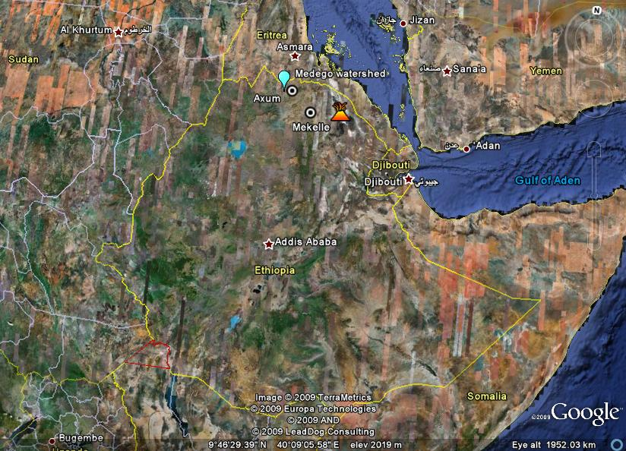
Figure 3. Map of Ethiopia with Medego watershed (study site) and Axum town indicated.

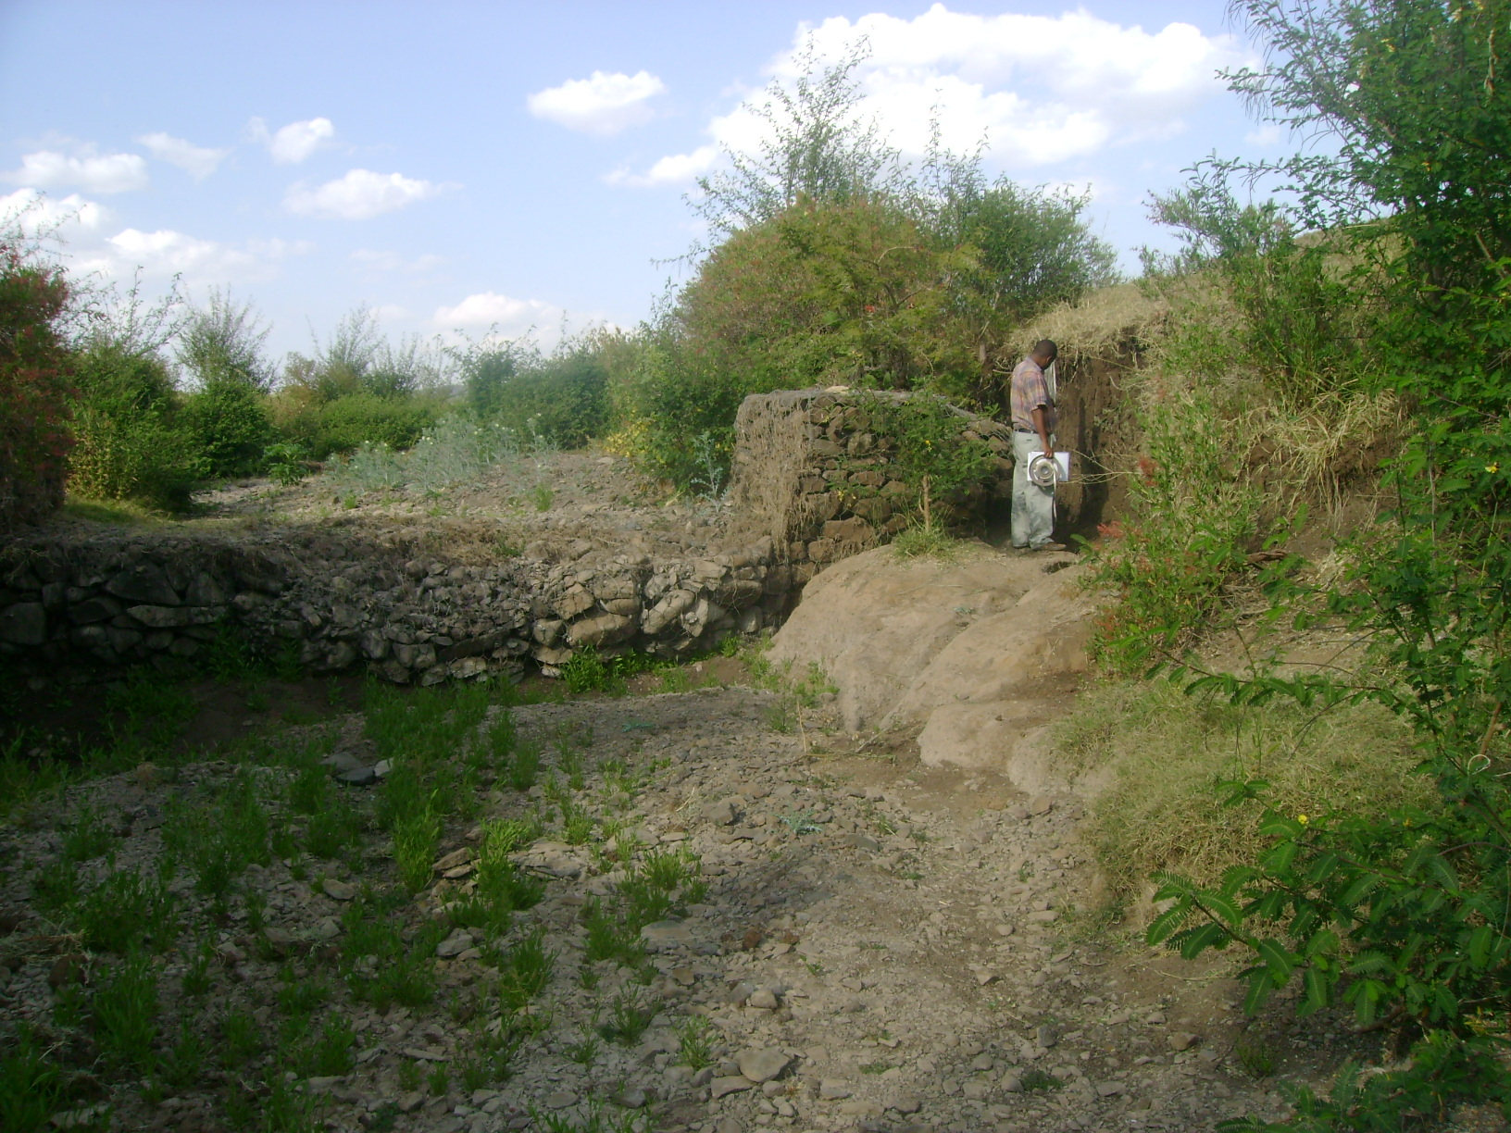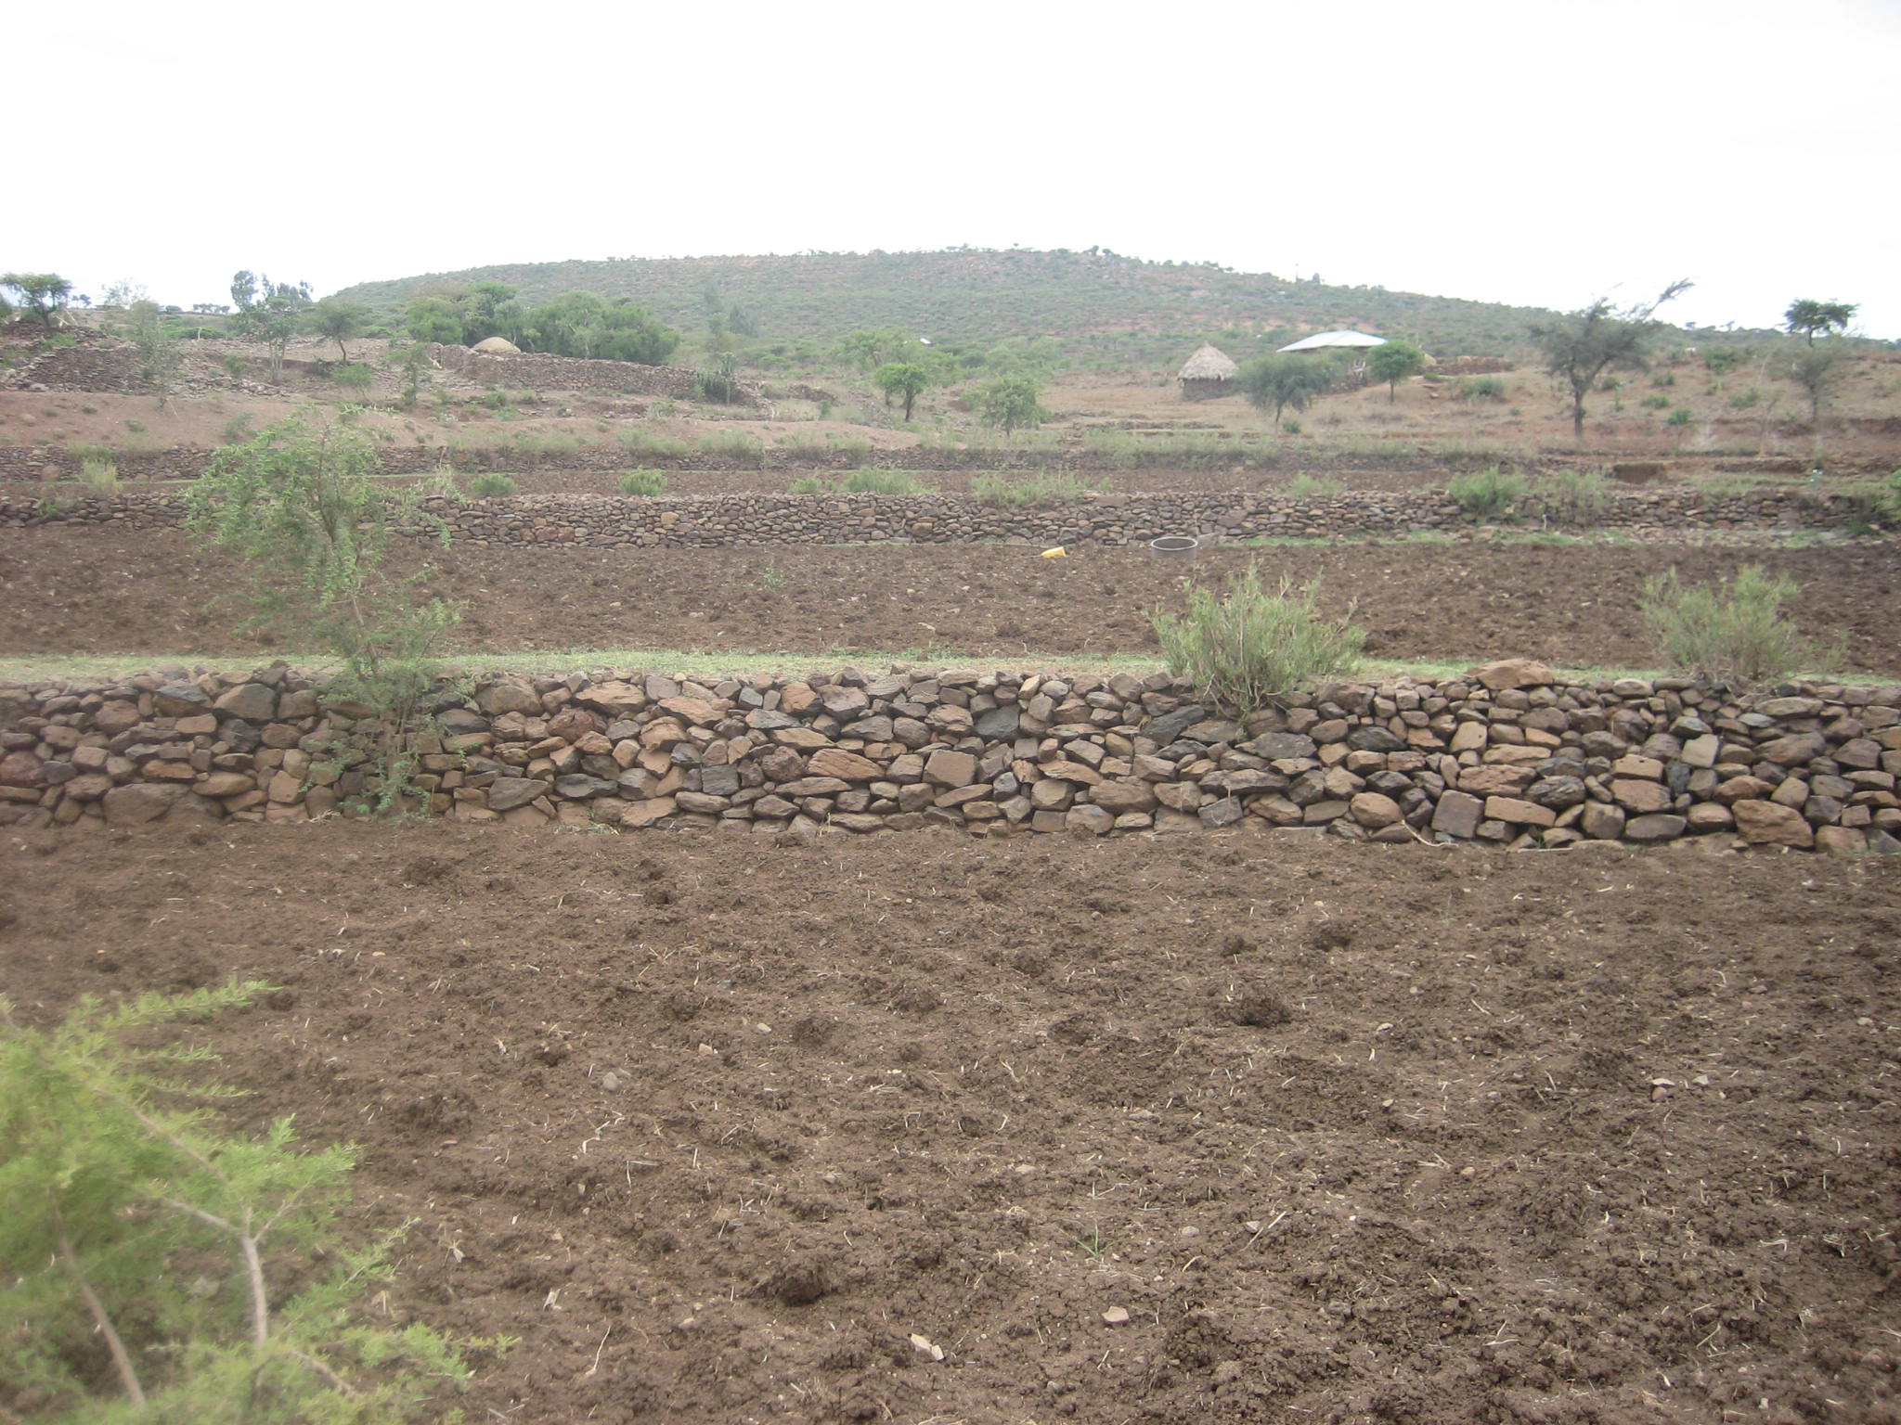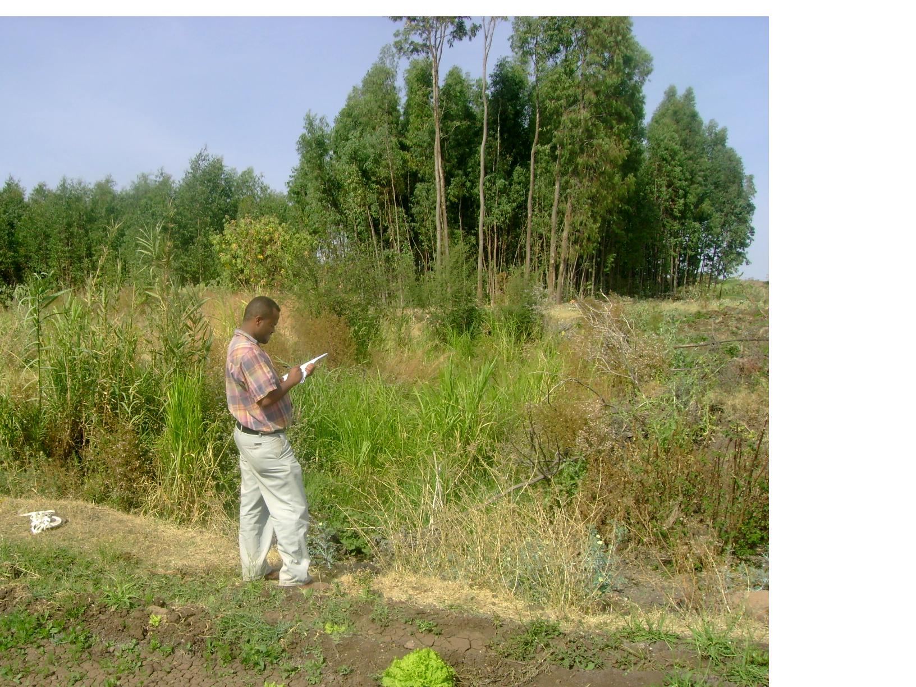
C)
A)
B)

Figure 4A-2C. Showed watershed environmental change after implementation of SWC measures at Medego watershed, northern, Ethiopia. A) Stone bund around homestead filled with soil at the watershed. B) Check dam with out proper keying and apron (around the man standing) led to collapse the gully at the watershed. C) The effect of SWC measures on greenness and micro-climate improvement at Medego watershed after the implementation of SWC measures. (Photos by authors)

REFERENCES
1. Admassie Y, Gebre S. Food-for-work in Ethiopia. A socio-economic survey. Institute of Development
Research (IDR), Addis Ababa University, Ethiopia. 1985:47.
2. Barbier EB, Bishop TB. Economic values and incentives affecting soil and water conservation in
developing countries. Journal of soil and water conservation, 1995;5(2):133-137.
3. Brhane G. Agroforestry as view of Land Degradation Management at Atsbi-Womberta Area, Northern
Ethiopia. Practical AttachmentReport, Mekelle University, Mekelle, Ethiopia. 2000:18.
4. Brhane G, Mekonen K. Estimating soil loss using Universal Soil Loss Equation (USLE) for soil
conservation planning at Medego watershed, Northern Ethiopia. Journal of American Science 2009;
5(1):58-69
5. Bureau of Agriculture and Rural Development (BoANR). Annual report. Tigrigna (local language)
version. Axum, Ethiopia. 2007:4-18.
6. Chekun T. Vetiver in the Rehabilitation of the Degraded ZegZeg Watershed in Ethiopia, Addis
Ababa, Ethiopia. 2002:68.
7. Frye WW, Ebelhar SA, Murduk LW, Blevins RL. Soil erosion effects on properties and productivity of
two Kentucky soils. Soil Sci. Socie. American Jou. 1982; 46:1051-1055.
8. Gebreselassie ED. Soil erosion hazard assessment for land evaluation. Soil Conservation Research
Program, University of Bern, Switzerland and the Ministry of Agriculture, Ethiopia. 1996:31-46.
9. Heluf G. Grain yield response of sorghum (sorghum bicolor) to tied ridges and planting methods on
Entisols and Vertisols of Alemaya area, Eastern Ethiopia highlands. Journal of Agriculture and Rural
development in Tropics and Subtropics 2003;104(2):113-128.
10. Hudson N. The factors determining the effect of soil erosion In: Greenland D, Lal R ed. Soil
conservation and management in the humid tropics. John Wiley and sons, Chichester , New York.
1977: 17-62.
11. Hudson N. Land Husbandry. B T Batsford Limited, London. 1992:86.
10. Hurni H. Erosion-productivity-conservation systems in Ethiopia. IV. International Conference on Soil
Conservation, Venezuela. 1985.
12. Kuru A. Soil erosion and strategic state policy: The case of Ethiopia. Publication of the Department of
Environmental Conservation at the University of Helsinki No. 7. Helsink. 1986:123.
13. Lal R. Soil conserving versus soil degrading crops and soil management for erosion control. In:
Greenland D, Lal R, ed. Soil conservation and management in the humid tropics. John Wiley and sons,
Chichester, New York. 1977a:81-95.
14. Lal R. Soil management systems and erosion control. In: Greenland D, Lal R, ed. Soil conservation
and management in the humid tropics. John Wiley and sons, Chichester, New York. 1977b:120-137.
15. Moges A, Holden Nm. Farmers perceptions of soil erosion and soil fertility loss in Southern Ethiopia.
Land Degradation and development 2006;18(2):534-554.
16. Muchow RC, Bellamy JA. Climatic risk in crop production: Models and management from semiarid
tropics and sub tropics. Proceedings International symposium on climatic risk in crop production, 2-6
July 1990, Brisbane, Australia. 1990:56.
17. Olson KR, Mokma DL, Lal R, Schumacher TE, Lindstrom MJ. Erosion impacts on crop yield for
selected soils of the North Central United States. In: Lal R, ed. Soil Quality and Soil Erosion. CRC
Press Boca Raton London New York Washington, D.C. 1999:259-284.
18. Tamene L. Reservoir siltation in the drylands of northern Ethiopia: causes, source areas and
management options (PhD Thesis, Ecology and Development Series 30, Center for Development
Research, University of Bonn). 2005:88.
19. Tamirie H. The role of improved soil, water and crop management practices in increasing agricultural
production in Ethiopia; paper presented at the national workshop on food strategies for Ethiopia. 8-13
December, Alemaya University of Agriculture, Ethiopia. 1986.
20. Tilahun Y. Impacts of conservation bunds on crop yields in Degua Tembien, Northern Ethiopia. MSc
Thesis, Agricultural University of Norway (NLH). 1996:53.

