Conventional Vis -a- Vis Biotechnological Methods of Propagation in Potato: A Review

Anoop Badoni* and J. S. Chauhan**
Seed Biotechnology Laboratory, Department of Seed Science and Technology,
Faculty of Agriculture, Chauras Campus, H. N. B. Garhwal University,
Srinagar- 246 174, Uttarakhand, India
*Research Scholar, Young Scientist (UCOST), **Assoc. Prof. and Head of Department
*For Correspondence: annabadoni@yahoo.co.in

ABSTRACT

The present review is based on the findings on in vitro culture of potato. Because of many problems in conventional method of potato cultivation, it is necessary to develop a suitable method of propagation through biotechnology, which is a better alternative. In all potato growing regions the availability of high quality tuber has been the most demanding over the conventional clonal propagation that favors disease build-up, which drastically reduces crop yield. However, the recent advances in tissue culture and the flexibility of organ development in potato, allows alternate methods of propagation through in vitro techniques. In the absence of chemical control of viral disease, meristem tip culture is the only effective method available till date to eliminate virus infections from potato cultivars. This technology has ensured greater availability of diseases free seed for cultivation, which ultimately helps in boosting overall potato production in the country. In view of the above, a protocol have developed for sterilization of explants and found the suitable hormonal combination with MS medium for in vitro shoot regeneration, multiplication and rooting in potato cv. Kufri Himalini. For development of sterilization protocol two important sterilant sodium hypochlorite and mercuric chloride compared with different durations of 2, 5 and 8 minutes. For shoot proliferation and rooting the sterilized explants were cultured on MS medium, supplemented with different hormonal combinations i.e. MSGN1 (0.1 mg/l GA₃ and 0.01 mg/l NAA), MSGN2 (0.1 mg/l GA₃ and 0.03 mg/l NAA), MSGN3 (0.1 mg/l GA₃ and 0.1 mg/l NAA), MSKN1 (0.01 mg/l Kinetin and 0.1 mg/l NAA), MSKN2 (0.001 mg/l Kinetin and 0.1 mg/l NAA) and MSKN3 (1 mg/l Kinetin and 0.1 mg/l NAA). The observations were recorded after 10, 20 and 30 days to observe the non-growing cultures, infected cultures, healthy cultures, length of stem and number of nods on stem. Result showed that amongst the two sterilants i.e. NaOCl and HgCl₂, NaOCl was found better for controlling the infection and had not any adverse effect on explants even in long duration. The lower concentration of auxin (0.01 mg/l NAA) with Gibberelic Acid (0.1 mg/l) was found best for the development of complete plantlets and for multiplication from meristem tips.

Keywords: Conventional, clonal, In vitro, multiplication, sterilization, and shoot regeneration

INTRODUCTION:

As a crop of high biological value for its protein and a substantial amount of vitamins, minerals and trace elements, potato is undoubtedly a very important crop in the country (Gebre and Sathyanarayana, 2001). The world population is likely to become 3,000 million by 2020 AD and more than 90% of this population would live in the developing countries under condition of extreme poverty and forced hunger (Khurana et al., 1998).
Potato in India is now grown over 1.3 million hectares with an annual production of 23.6 million tones (Directorate of Economics and Statistics, Ministry of Agriculture, Govt. of India, 2004-05). With the update of modern potato technologies, India now ranks 4th in area and 3rd in production of potato in the world. The productivity of potato in India is like better than the world average (166.3 quintals/hectare). By 2020 India will have a population of 1.3 billion bringing about a substantial pressure on land to produce more food. It is also estimated that by 2020 worldwide demand for potatoes would increase by 40 per cent as a result of increased urbanization, rise in per capita income and fast expanding tourism.

Conventional Methods for Propagation:
Conventional propagation of potato is done vegetatively using seed tubers and ensures uniformity of the crop in terms of growth and yield, but results in degeneration of the crop due to virus infection, the rate of degeneration varies from place to place and cropping to cropping season. The viruses are transmitted through different ways including planting infected tubers. If the seed stock is illmaintained or frequently replaced with fresh ones, the virus infiltration can reach up to 100% in 3 - 4 successive crop seasons resulting in almost half or one third yields. This is the major problem faced by seed producers.
The main problem of growing potato worldwide is economic losses due to late blight, which is caused by Phytophthora infestans which can destroy potato plants within two weeks in wet conditions. Blight can survive even under adverse conditions. The pathogen however, invades and infects potato in the field via zoosporangia, which disperse via soil water, rain splash and wind. Potato cultivars are tetraploid vegetatively propagated crop, which poses several problems in seed production. Generally tuber is used as a seed. Due to progressive accommodation of viral disease in seed stock, availability of good quality seed is a major constraint in potato production, which is approximately 50% of the total production cost. Besides high cost of seed potato, propagation is also characterized by low multiplication rate of only 4-6 times.

Selection of Variety:
The ICAR has identified Kufri Himalini for commercial cultivation in hill regions. Late blight has intensified over the few years, and resistance to the disease has been decreasing in existing varieties such as Kufri Jyoti and Kufri Giriraj. The new variety, with medium maturity of 110-120 days has been recommended for cultivation in the north- west and eastern hills during summer. Kufri Himalini provides a yield advantage of 10% over Kufri Jyoti and Kufri Giriraj. In the plains, its keeping quality is better than all the cultivars developed so far for hill regions (The Hindu, 2005).
Why Biotechnological Methods?
To large production of clonal material i.e., to produce the uniform, identical seed material of potato, micro propagation is the better alternative over to conventional propagation of potato. The in vitro propagation method is most suitable alternative to produce Microtuber seed material of potato. By using the technique, which involves low cost components, the large-scale clonal material can be achieved in short time duration. Use of micro propagation for commercial seed production has moved potato from test tubes to field (Wang and Hu, 1982). The advances are the being of the second “Green Revolution” in agriculture and are expected to make farming more efficient, profitable and environmentally safe (Dhingra et. al., 1992). Micro propagation is a sophisticated technique of regenerating plants using small pieces of plants (so called explants) that is proliferated on an artificial medium under sterile conditions. Importance of micro propagation lies in very fast clonal multiplication of vegetable crops. Micro propagation is used mainly for getting disease- free plants of superior vigour and productivity (Singh, 1997).

MATERIALS AND METHODS:

(i) Sterilization Protocol of explants:
The present study was carried out to standardize the sterilization procedure of explants of potato cv. Kufri Himalini. Two different chemicals i.e. Mercuric chloride (0.1%) and Sodium hypochlorite (1%) were used for study with duration of 2, 5 and 8 minutes. For obtaining sprouts, the tubers were cut into pieces and dipped in a solution of 0.1% bavistin for 2-3 minutes and sown in sand filled plastic pots followed with single wash in distilled water. These were grown under poly house following optimum cultural practices. The sprouts were ready for inoculation after 10-12 days of growth.
The sprouts of 0.5-1 cm. were collected from the mother plant of Kufri Himalini in water filled beaker and kept under running water prior to sterilization in the laminar airflow cabinet. The explants were surface sterilized with three selected timings of 2, 5 and 8 minutes. To evaluate the response of different chemicals, implantations of sterilized explants were done using without hormones MS medium. The observations were reporded on 10, 20 and 30 days for the non-growing cultures, infected cultures and healthy cultures.

(ii) In vitro shoot proliferation and rooting:
The present investigation was carried out with the objective; to study the effect of two hormonal combinations i.e. GA₃+ NAA and Kinetin + NAA with MS medium on shoot regeneration and multiplication using meristem tips of potato cv. Kufri Himalini.
For inoculation of explants different media with hormonal combinations were prepared properly. MS media supplemented with different combinations of GA₃+ NAA and Kinetin + NAA (Table-1), were autoclaved at 15 psi for 20 minute. The hot medium was immediately dispensed in to culture flask (30 ml medium in each flask) and covered with autoclaved cotton plug in Laminar Air Flow Cabinet. 12 replicates of each combination were taken for the study. To maintain an aseptic environment, all culture vessels, media and instruments used in handling tissues, as well as explants must be sterilized. After inoculation the cultures of different combinations were shifted to culture growth room at 25⁰ + 1⁰ c and 16 h photoperiod. Best combination of GA₃+ NAA and Kinetin + NAA with MS medium was selected on the basis of cultures growth performance i.e. length of stems and number of nodes on stem, after 35 days. The mean values of culture growth were calculated and the selected combination was used for sub culturing of plantlets also. The best combination of hormones with MS medium was selected and cultures showed higher growth were further sub-cultured on its parent medium by cutting it in to small pieces in a way that each subsection has at least 1-2 nodes.

TABLE-1: Different hormonal combinations used for shoot proliferation:

Symbol used | Hormones |  | Symbol used with MS medium  (full strength with 8 gm./l agar and 30 gm./l Sucrose)
Symbol used | GA₃ | NAA
GN 1 | 0.1 mg/l | 0.01 mg/l | MSGN 1
GN 2 | 0.1 mg/l | 0.03mg/l | MSGN 2
GN 3 | 0.1 mg/l | 0.1 mg/l | MSGN 3
 | Kinetin | NAA
KN 1 | 0.01 mg/l | 0.1 mg/l | MSKN 1
KN 2 | 0.001 mg/l | 0.1mg/l | MSKN 2
KN 3 | 1 mg/l | 0.1 mg/l | MSKN 3

RESULT AND DISCUSSION:

(i) Sterilization Protocol of explants:
In vitro propagation technique for potato involves various steps i.e. selection of explants, its sterilization and establishment and shoot proliferation and production of in vitro tubers. Beside the growth regulators, the culture conditions namely temperature, relative humidity and photoperiod also influence the growth and development process of in vitro cultures (Hussey and Stacey, 1981). The first condition for the success of a culture is asepsis. The maintenance of aseptic (free from all microorganisms) or sterile conditions is essential for successful tissue culture procedures. To maintain an aseptic environment, all culture vessels, media and instruments used in handling tissues, as well as explants itself must be sterilized. The importance is to keep the air, surface and floor free of dust. All operations should be carried out in laminar airflow sterile cabinet (Chawla, 2003).
Sterilization is the process of making explants contamination free before establishment of cultures. Various sterilization agents are used to decontaminate the tissues. These sterilants are also toxic to the plant tissues, hence proper concentration of sterilants, duration of exposing the explants to the various sterilants, the sequences of using these sterilants has to be standardized to minimize explants injury and achieve better survival (CPRI, 1992). Two different chemicals i.e. Mercuric chloride (0.1%) and Sodium hypochlorite (1%) were used for the present study to standardize the best sterilization protocol for in vitro culture of potato cv. Kufri Himalini.
In the present study NaOCl was always found better than HgCl₂ (Table-2; Plate-1). Sodium hypochlorite (NaOCl) for 8 minute (T3) was selected for suitable sterilization chemical after 5 minute of savlon wash, 30-second dip in ethanol and at last washed with double distilled water.
Mercuric chloride is a very strong sterilant (Gopal et al., 1998) disinfected the single nodal cuttings of 22 cultivars with a mixture of 0.1% Mercuric chloride and 0.1% Sodium lauryl sulfate for 5 minutes. Calcium hypochlorite being a mild sterilant has been used for potato. Nozeram et al., (1977) sterilized potato sprouts by dipping them in alcohol and a few drops of Teepol and then placed them in Calcium hypochlorite solution for 15-25 minutes. Sodium hypochlorite has turned out to be a better sterilant than calcium hypochlorite due to bleaching effects of the later and hence has been extensively used for potato sterilization. Amongst the two sterilants i.e. NaOCl and HgCl₂, NaOCl was found better for controlling the infection and it had not any adverse effect on explants even in long duration.

(ii) In vitro shoot proliferation and rooting:
Micro propagation is one of the finest ways of plant multiplication by in vitro techniques of plant tissue culture. Micro propagated plants are true to type and often show improved vigor and quality. Micro propagation is the alternative to conventional propagation of potatoes (Chandra and Birhwan, 1994, Naik and Chandra, 1994). In vitro propagation methods using meristem tips, nodal cuttings and micro tubers are more reliable for maintaining genetic integrity of the multiplied clones since de-differentiation and the subsequent organogenesis/ embryo genesis with the accompanying genetic changes have been reported (Wang and Hu, 1983).
Meristem culture provides a reproducible and economically viable method for producing pathogen free plants. As meristem tips are free from viruses, elimation and generation of virus free plants are possible through meristem culture (Jha and Ghosh; 2005). Lam (1977) studied the effect of auxin: Kinetin ratio in the nutrient medium for proliferation of tuber discs of cv. spunta and found that the addition of 0.2 mg/l NAA to the medium appeared to adjust the ratio to the points where normal plantlets with both shoots and roots were produced in a single step.
Different combinations of GA₃+ NAA and Kinetin + NAA with MS medium influenced in vitro shoot regeneration from meristem tip culture. Data for length of stem and number of nodes on stem were recorded after 35 days of growth in all the combinations. Shoot length in M.S. medium with GA₃ and NAA combination showed better result in comparison to M.S. medium with Kinetin and NAA (Table- 3; Fig.1; Plate-1).
The combination of Kinetin and NAA had consistently given good result for improving shoot length. The MSKN2 (0.001 mg/l Kinetin and 0.1 mg/l NAA) having low concentration of Kinetin and NAA and MSKN3 (1 mg/l Kinetin and 0.1 mg/l NAA) combinations having higher concentration of Kinetin (1 mg/l) and low concentration of NAA, responded the least mean shoot length and number of nodes. Low concentration of Auxin (0.1 mg/l NAA) plus moderate concentration of Cytokinine (0.01 mg/l Kinetin) showed good development of complete plantlets from meristem tips.
The combination of GA₃ + NAA showed best result for improving shoot length. The MSGN2 (0.1 mg/l GA₃ and 0.03 mg/l NAA) and MSGN3 (0.1 mg/l GA₃ and 0.1 mg/l NAA) combinations respectively having higher concentration of NAA (0.1 mg/l) responded the least mean shoot length and number of nodes. This could be attributed to the fact that higher concentration of NAA inhibit root and shoot growth (Pennazio and Vecchiati, 1976). Result showed that lower concentration of auxin (0.01 mg/l NAA) with Gibberelic Acid (0.1 mg/l GA₃) is best for development of complete plantlets from meristem tips with avoiding callus and satisfactory root formation. It can be concluded from the present findings that GA₃ + NAA (MSGN1) combination is best for shoot regeneration and multiplication of potato cv. Kufri Himalini in comparison to the combination Kinetin + NAA with M. S. medium.
Using the tissue culture technique of micro propagation, it is possible not only to reduce the number of field exposures but also to increase the rate of multiplication several times. Plant tissue culture comprises a set of in vitro techniques, methods and strategies that are part of the group of technologies called plant biotechnology. Tissue culture has been exploited to create genetic variability from which crop plants can be improved, to improve the state of health of the planted material and to increase the number of desirable germplasms available to the plant breeder. The culture of single cells and meristems can be effectively used to eradicate pathogens from planting material and thereby dramatically improve the yield of established cultivars. Large-scale micro propagation laboratories are providing millions of plants for the commercial ornamental market and the agricultural, clonally propagated crop market. According to the present study conclusion is that NaOCl for 8 minute was a best sterilant and for shoot proliferation and root formation the combination of GA₃ (0.1 mg/l)+NAA (0.01 mg/l) was found to be better.

REFERENCE:

Central Potato Research Institute, Shimla, 1992. Tissue Culture technique for potato health, conservation, micro propagation and improvement. CPRI, Shimla, pp 1-23
Chandra, R. and R. K. Birhman, 1994. In vitro micro propagation in relation to pedigree in potato, Journal of Indian Potato Association. 21:87
Chawla, H. S. 2003. Plant Biotechnology: Laboratory manual for plant biotechnology. Oxford & IBH Publishing Co. Pvt. Ltd. New Delhi
Dhingra, Naik, Chandra and Randhawa 1992. Tissue Culture Techniques for Potato Health, conservation, micro propagation and improvement; CPRI, ICAR, Himanchal Pradesh, India.
Gebre, Enadale and Sathyanarayana 2001. Tapioca- A new and cheaper alternative to agar for direct in vitro shoot regeneration and microtuber production from nodal cultures of potato. Afri. Cr. Sci. J. 9 (1): 1-8
Gopal, J., Minocha J. L. and Dhaliwal H. S. 1998. Microtuberization in potato (Solanum tuberosum L.). Plt. Cell. Rep. 17: 794-798
Hussey, G. and Stacey N. J. 1981. In vitro propagation of potato (Solanum tuberosum L.). Ann. Bot. 48(6): 787-796
Jha, T. B. and Biswajit Ghosh, 2005, Plant Tissue Culture: Applied and Basic. Universities Press (India) pvt. Lit.
Khurana, S. M. P., Chandr, R. and Upadhya, M. P. 1998. Preface In: Khurana, S. M. P., Chandr, R. and Upadhya, M. P. eds.Comprehensive potato biotechnology, Malhotra Publishing House, New delhi pp.- vii-viii.
Lam, S. L. 1977, Plantlet formation from potato tuber discs in vitro, Am. Pot. Journ. 54 (10): 465-468.
Naik, P. C. and R. Chandra 1994. Use of Tissue culture techniques in crop improvement with special reference to potato. CPRI, Shimla, pp. 110
Nozeran, R. B. andilho, Rossignol L. and Glenan S. 1977. Nouvelles possibilities etde multiplication rapie de clones sains de pomme de erre (Solanum tuberosum L.). C.R. Acad Sci. 285(1): 37-40
Pennazio, S., and M. Vecchiati 1976. Effect of naphthalene acetic acid on meristem tips development. Potato Research, 19(3): 232-234.
Singh, S. P. 1997. Principles of Vegetable Production; Agrotech Publishing Academy, Udaipur, India.

The Hindu 2005. 29 May, New Delhi, India
Wang, P. and Hu, C. 1985. Potato tissue culture and its application in agriculture, In: Li, P. H. (ed.), Potato Physiology, Academic Press Inc., U.S.A., pp-504-564
Wang, P. J. and C. V. Hu, 1982. In vitro mass tuberization and virus free seed potato production in Tiwan. Amer. Pot. Journ. , 59: 33-39.

TABLE-2 Observations of sterilization procedure:

Observations Sterilents and Duration (in Minutes)

Sodium hypochlorite Mercuric chloride

T1 T2 T3 T1 T2 T3

Non-growing cultures 8±2 4±2 5.6±1.5 5.66±1.1 8.66±0.5 8.66±1.5
Infected cultures 3.66±2.5 2.33±0.5 1.33±0.5 3.33±1.5 3.66±0.5 3.33±1.5
Healthy cultures 2±2 4.33±1.5 6±2 1.33±1.5 1.33±0.5 4.33±1.1

TABLE-3: Effect of different hormonal combinations on stem length and number of nodes:

Hormonal Combination Length of stem (cm.) Number of nodes on stem

MSGN 1 6.8 cm. ± 0.5 5.5 ± 0.5

MSGN 2 6.3 cm. ± 0.5 5.2 ± 0.6

MSGN 3 4.4 cm. ± 0.6 3.0 ± 0.7

MSKN 1 6.4 cm. ± 0.6 5.0 ± 0.7

MSKN 2 5.3 cm. ± 1.2 4.2 ± 0.8

MSKN 3 4.0 cm. ± 0.6 2.7 ± 0.7

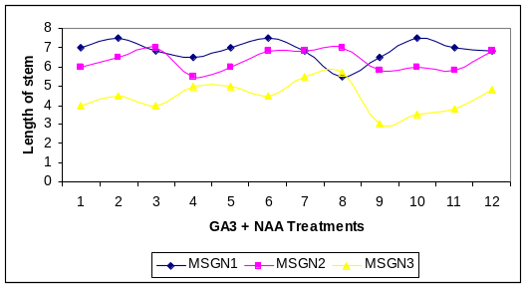(a)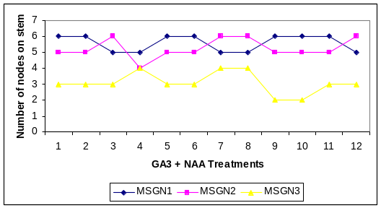(b)

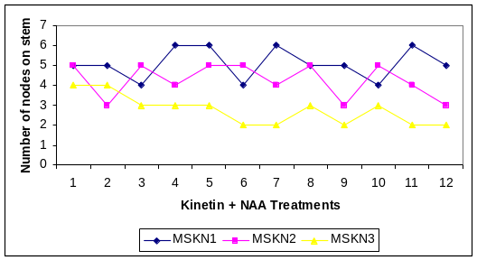(c)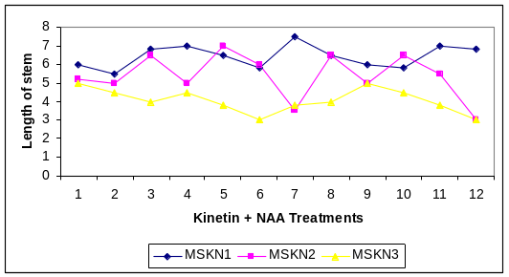(d)

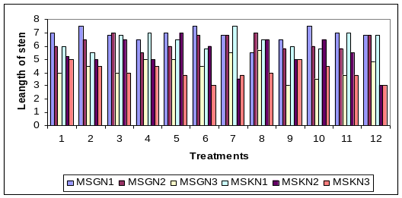(e)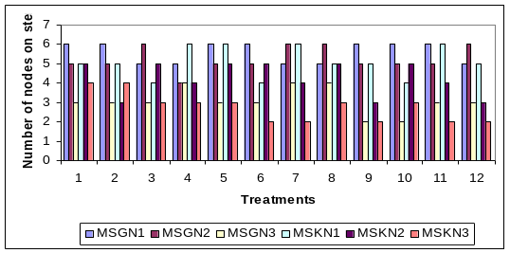 (f)

Fig. 1 (a) Length of stem, (b) Number of nodes, on GA₃+ NAA treatments, (c) Length of stem (d) Number of nodes on, Kinetin + NAA treatments, (e) Length of stem and (f) number of nodes on stem; Comparison between deferent treatments.

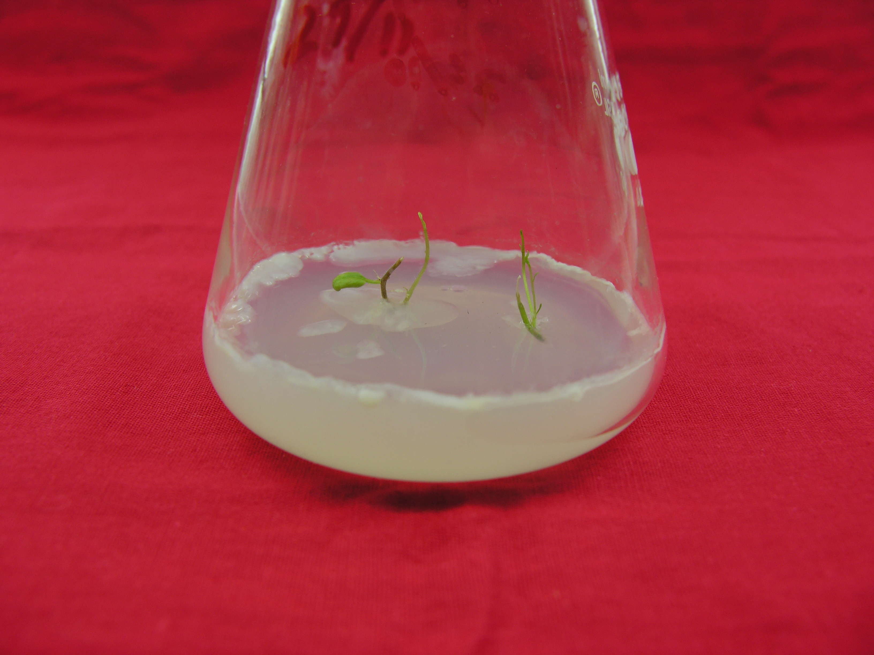(a)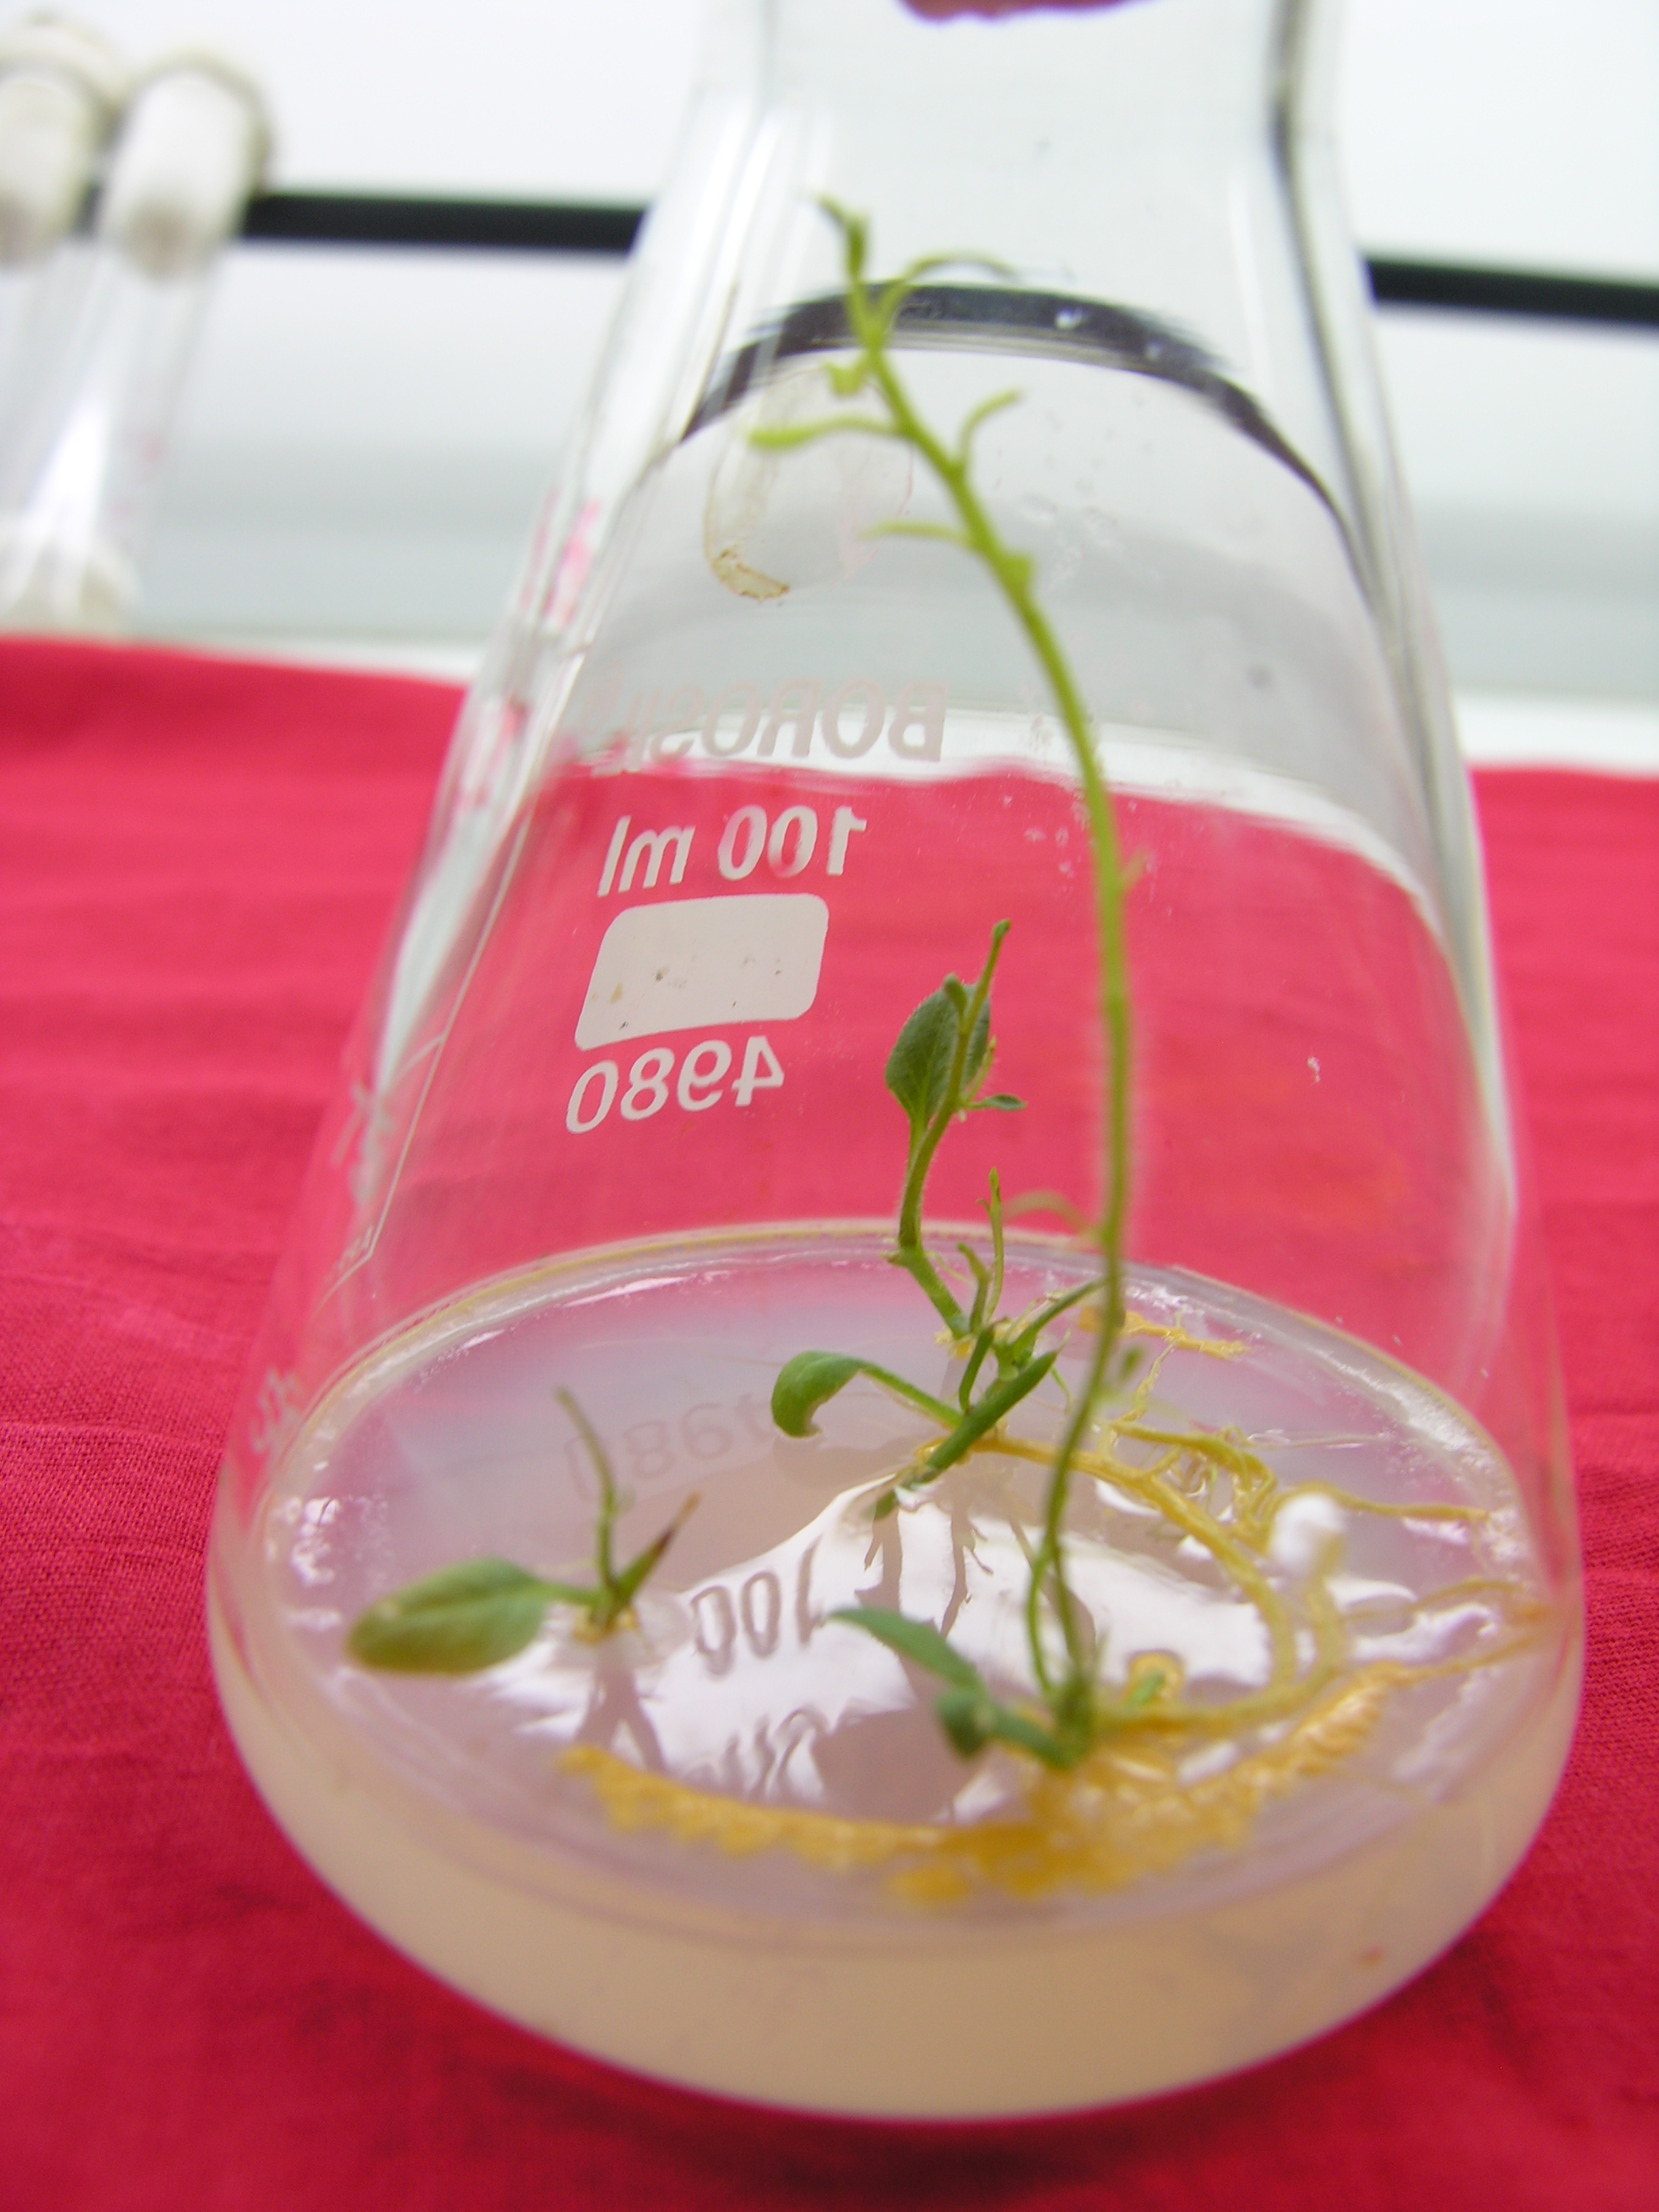(b)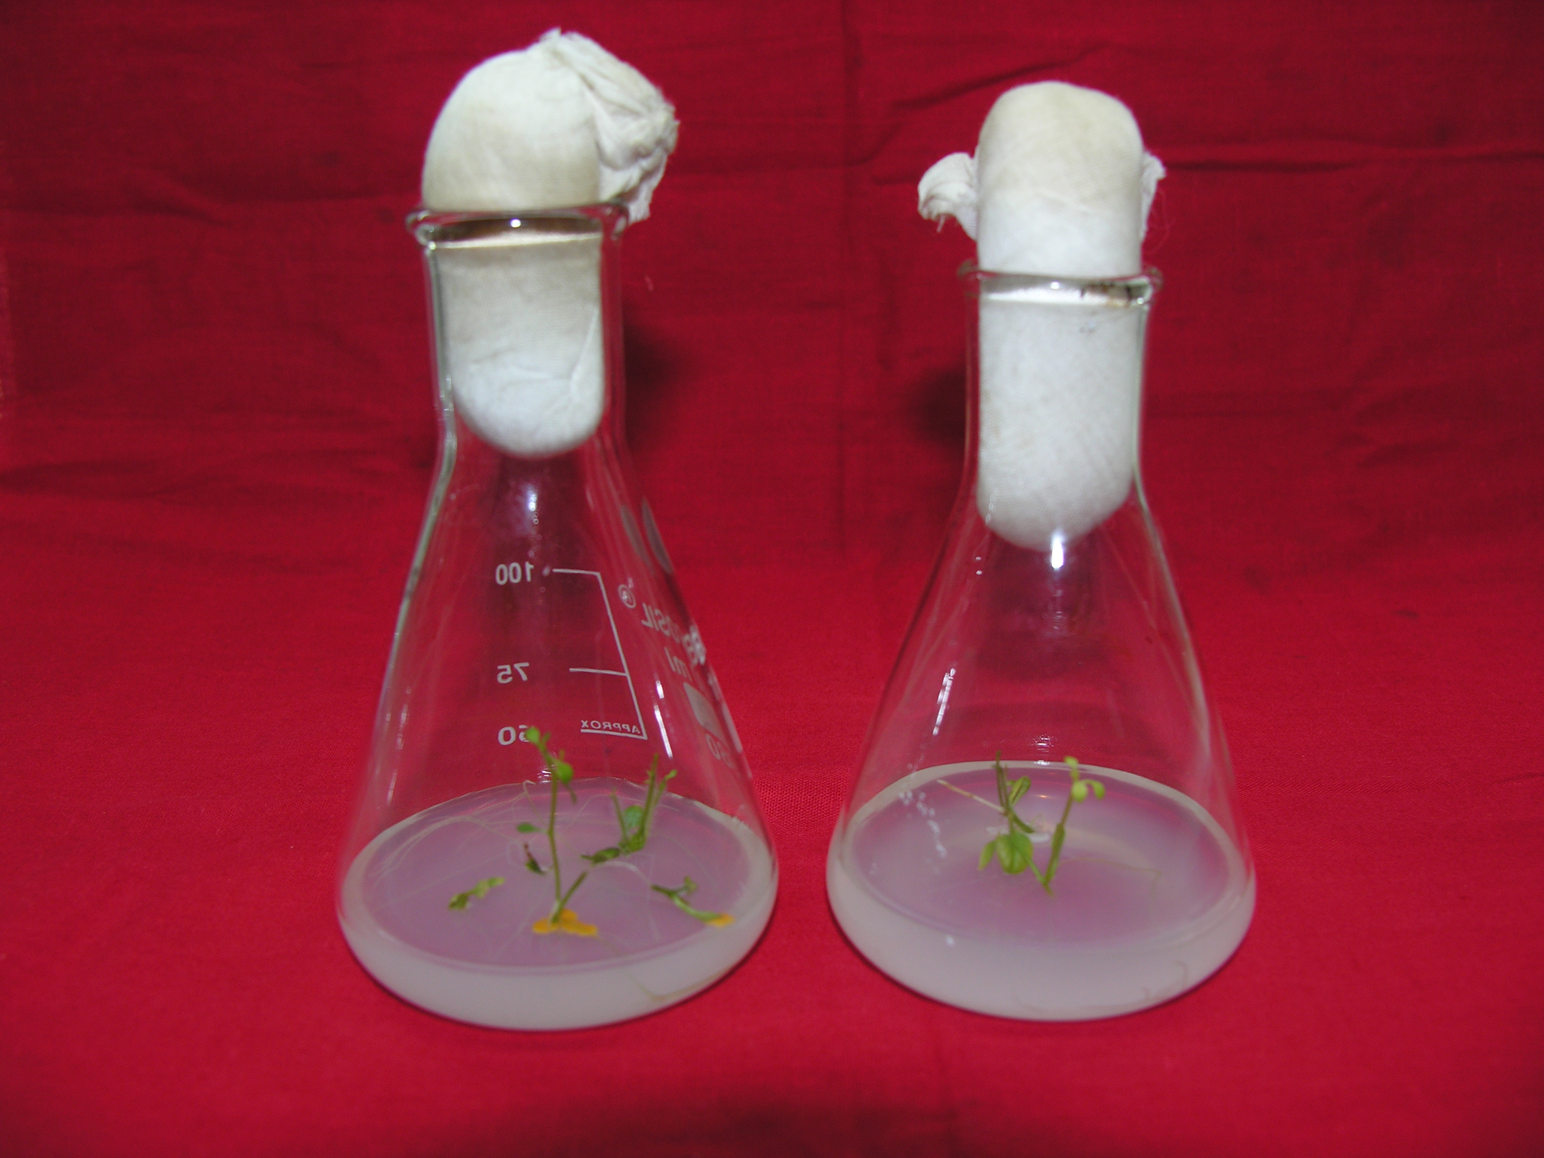(c)

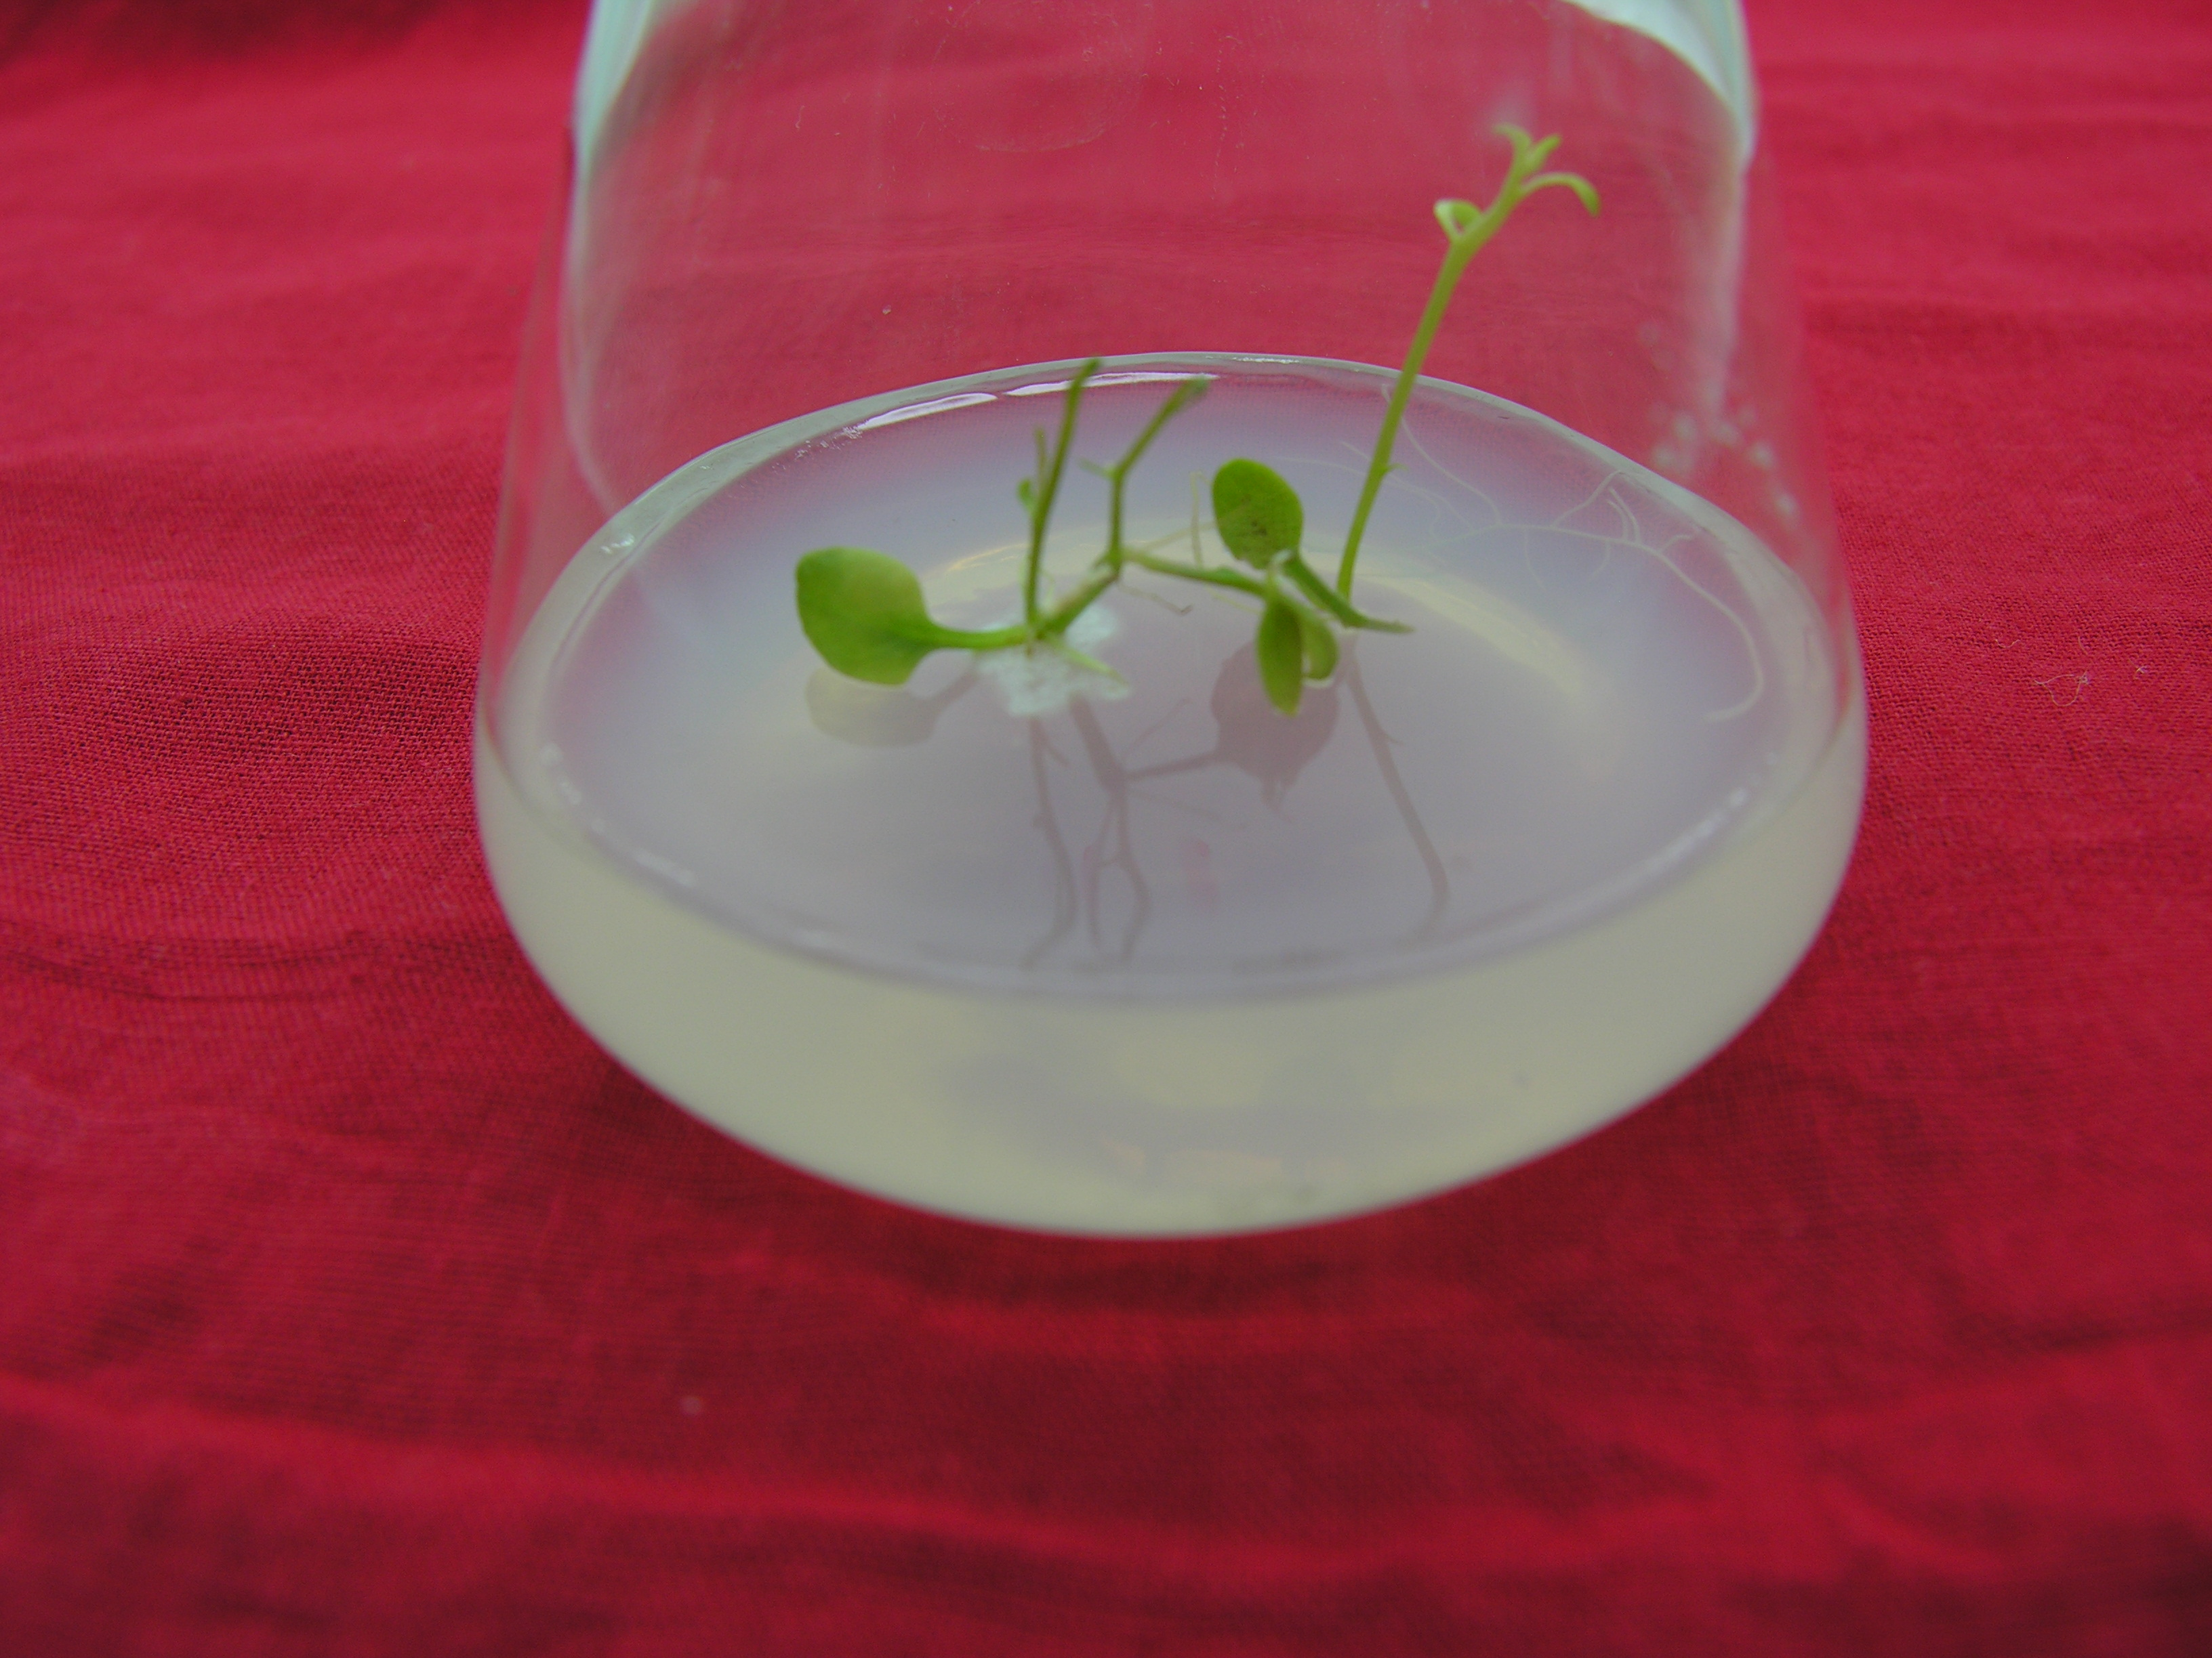 (d)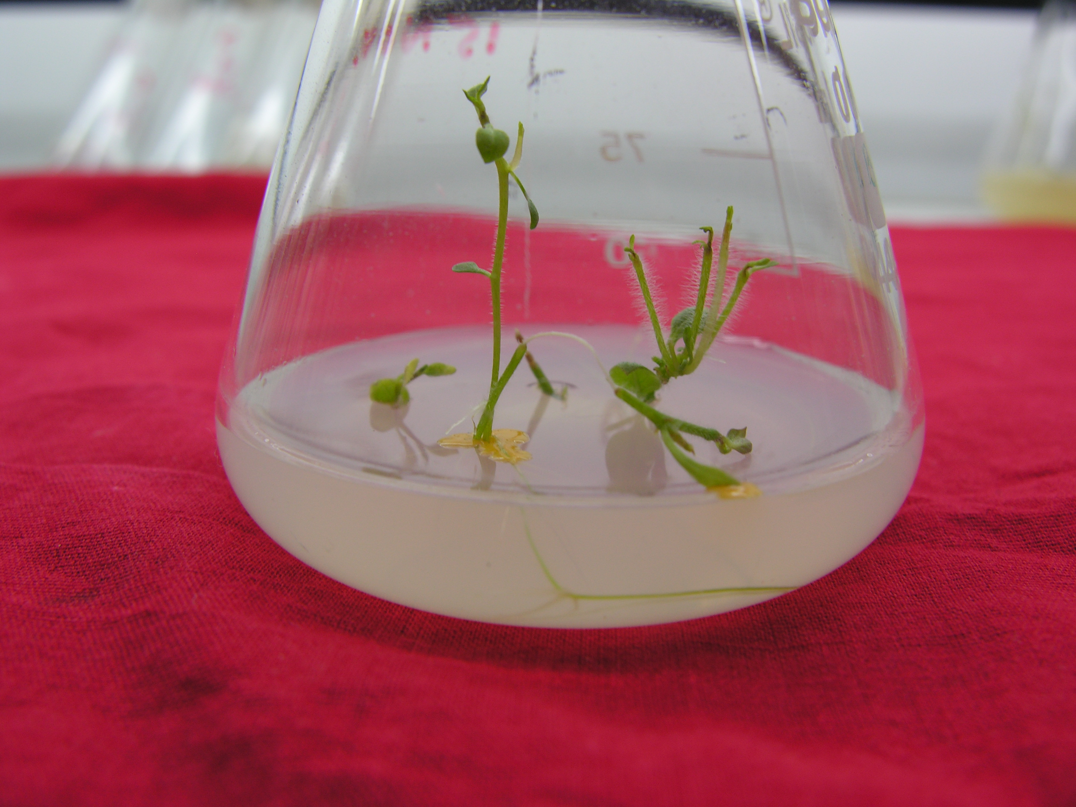(e)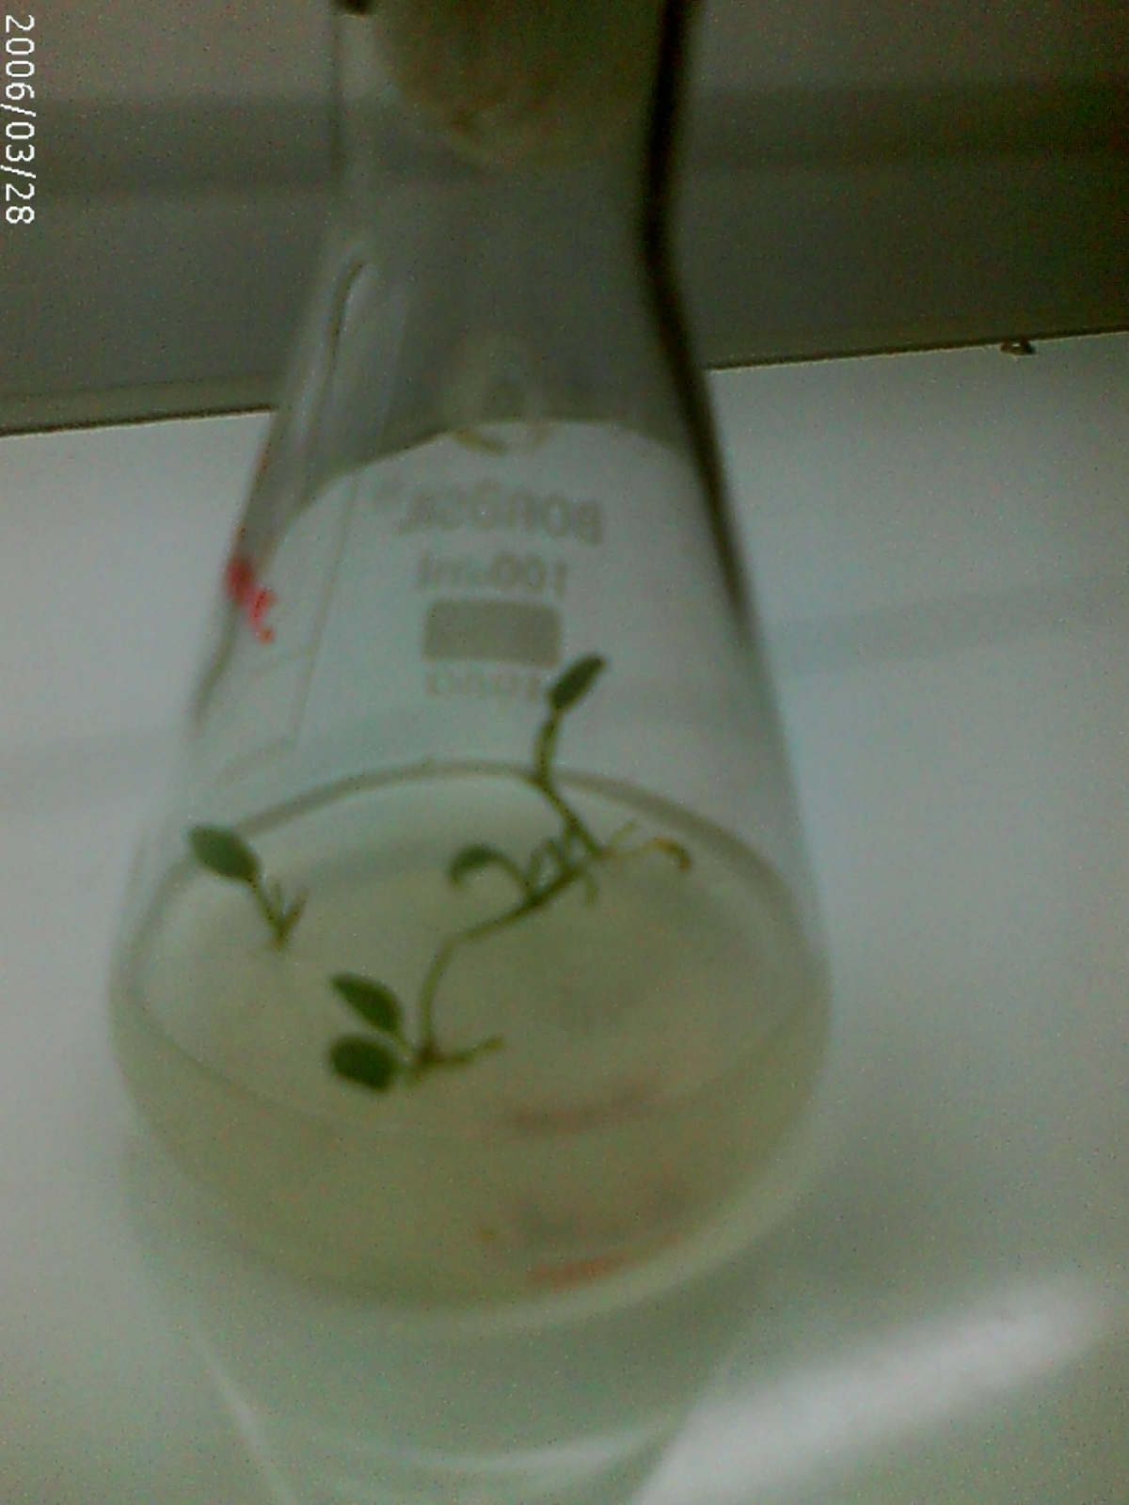(f)

Plate1: Tissue culture study on potato cv. Kufri Himalini; (a) and (b): infected shoot tips cultured on MSKN3 and MSKN1 media respectively (c) selected best plantlets of NaOCl chemical with 8 minute cultured on MSKN2 media (d) healthy culture of potato cultured on MSGN2 media (e) and (f) cultures on MSGN1 and MSGN3 media respectively.

3/27/2009

