Land use ⁄cover changes and their implications on rural livelihoods in the central zone of Korup national park, Cameroon

Innocent Ndoh Mbue¹, Ge Jiwen²*, Samake Mamadou³
^{1,3}School of Environmental Studies, China University of Geosciences, Hongshan District, 388 Lumo Road, Hubei Wuhan, 430074, P.R. China; Email: dndoh2009@gmail.com
²*Director, School of Ecology and Environmental Sciences, China University of Geosciences, Hubei Wuhan, 430074, P.R. China. Telephone: +862762493959

Abstract
This paper examines the changes in land use and cover types in the human inhabited central region of the Korup national park, Cameroon 22 years after the creation of the park in 1986, and how such changes have influenced agricultural and livelihoods sustainability in the region. Changes of land use and cover were measured through aerial photographs interpretations, while local perceptions and description of change were addressed through household interviews and field observations. The results of this study show that there have been variations over the years in terms of both the areas and spatial distribution of cultivated fields. Only 1.47% of the land remains unchanged, 31% has increased, while over 50% has decreased. Total cultivated land increased from 15% in the late 1986 to 35% in late 1990s. Around the same time too, water courses shrank by 12%. However, the magnitude and direction of change have been variable, including great heterogeneity in land-use patterns, as well as in the vegetation structure. The change can partly be explained by the increase human settlement, diversification to plantation and subsistence agriculture, natural regeneration as a result of the resettlement of one of the former villages in the park, and different natural changes in vegetation and water cover types. Furthermore, agricultural expansion into the natural forest, along watercourses, and human population and settlements partly explain these changes. Recent spatial and temporal changes in cultivated fields and other vegetation cover types can be attributed to the recent increase in prices agricultural and non timber forest products. The increase in the total cultivated areas and the resulting loss of biodiversity and ecosystem services causes great fear about the continuous existence of the park into the future and the livelihoods of the villagers.
Key words: land use and cover, livelihoods, Korup national park, biodiversity

1 Introduction
Healthy ecosystems are essential to the well-beings of a majority of the world’s poorest societies [Smith and Scherr, 2003; Sunderlin et al., 2007]. Unfortunately, over the years man has exploited the natural ecosystem for different land use types such as agriculture, infrastructural development and human settlements causing changes in the structure and function of natural ecosystems, degrading biodiversity and ecosystem services. The escalating loss in biodiversity especially resulting from land use/cover change is of concern due to its widespread implications for:
- environmental security and/or ecosystem functioning [Myers et al., 2000; Loreau et al., 2002],
- human well-being for all [Diaz et al., 2006],
- ethical reasons [Ghilarov, 2000], as well as
- sustainable development and poverty reduction.
Cameroon has a rich repository of flora and fauna. The rapid decline of biodiversity and threat to its habitat has been a cause of concern. The State has constituted areas of adequate ecological, faunal, floral, geomorphologic or natural significance as ‘Protected Areas’ (PA) for the purpose of protecting, propagating or developing wildlife or its environment. Establishment and management of protected areas together with conservation, sustainable use and restoration initiatives are central to Article 8 on "Insitu Conservation" of the Convention on Biological Diversity. Insitu Conservation is the conservation of ecosystems and natural habitats and the maintenance and recovery of viable populations of species in their natural surroundings. The Convention on Biological Diversity (CBD) defines protected areas as: "a geographically defined area which is designated or regulated and managed to achieve specific conservation objectives." Whereas, International Union of Conservation of Nature (IUCN) defines protected areas as: "areas of land and/or sea especially dedicated to the protection and maintenance of biological diversity, and of natural and associated cultural resources, and managed through legal or other effective means. “Protected areas(PA’s) are extremely significant in the conservation of the country’s natural and cultural resources. Their importance ranges from the protection of natural habitats and associated flora and fauna, to the maintenance of environmental stability of adjoining regions. They can provide opportunities and multiple values, which have ecological, economic, educational, recreational and social connotations. However, PA’s in the country, especially the korup national park of south western Cameroon, which is inhabited by man, is exposed to various conservation threats of human activities.

This paper examines the aspects of land-use ⁄ cover changes twenty-two years after the creation of the Korup national park (KNP), and analyses how such changes have influenced agricultural and livelihoods sustainability. Several factors are considered to have influenced landuse ⁄ cover patterns, and to have had significant impacts on the environment of central KNP, particularly through land degradation and biodiversity loss. The Korup region, for example, is recognized for its rich thick natural forest, housing valuable timber and non timber forest products, including wild animals. Furthermore, erosion and sedimentation processes have caused pronounced spatial differences in the quality of the land. This has led to considerable limitations on land use including the range of crops that can be grown. This study also reports spatial and temporal patterns and the magnitude of the land-use ⁄ cover changes that have occurred in the central region of KNP 22 years after the creation of the park in 1986. It also examines how these changes have influenced land-use strategies, agricultural production and local livelihoods. In addition, the study investigated the causes of the reported changes in land use ⁄ cover and how such changes influenced natural resources management strategies.

2 Methodology
2.1 Study area
The study area (1,260 km²) is located in Ndian Division, southwestern Cameroon, between latitudes 4° 54′ and 5° 28′ north; and longitudes 8° 42′ and 9° 16′ east of the equator, at the Cameroon-Nigerian border and is contiguous with the Oban National Park-Nigeria. This area was chosen because very little or no research had been carried out there because of its enclaved nature. The mean annual rainfall is in excess of 5000mm [Zimmermann, 2000]; temperatures range from 22 to 34⁰C, while relative humidity averages 87% throughout the year. The highest point is Mount Yuhan- a horst, reaching 1130m. Currently, four villages are located inside the Park and 31 other villages are within 3km of the park and have about 11,500 inhabitants [Schmidt, 2004]. Shifting cultivation forms the basis of the farming system. Economic activities include hunting, collection, processing and marketing of non-timber forest products.
There are three major drainage systems within Korup National Park. The north-eastern Park sector (40% of the total Park area) is drained by three major streams into the Bake-Munaya River, which flows north as a tributary of the Cross River. The central region (41% of the total Park area) forms a basin drained by the Ndian River flowing south. The western and south-western areas of the Park (19% of the total Park area) are drained by the Akpasang and Korup Rivers flowing generally southwards
2.2 Mapping of different land-use ⁄ cover types and changes
Mapping was performed by the interpretation of black and white aerial photographs taken in two different years 1986 and 2005. During the interpretation of the aerial photographs, land-use ⁄ cover types were delineated on the basis of the visual characteristics of tone, texture, size and shape. On the aerial photographs, eroded areas have a lighter tone, owing to the high reflectance associated with the presence of exposed soils and quartz gravels on the land surface [Young, 1976; Lillesand & Kiefer, 2000]. Areas covered by vegetation such as dense tree cover or woodlands have low reflectance and thus appear darker on the aerial photographs, and often show a coarse texture [Lillesand & Kiefer, 2000]. In contrast, cultivated areas could be identified in the photographs by their much smoother texture and regular shapes. The analysis of the aerial photographs from different periods enabled temporal changes in land-use ⁄ cover types to be measured. The overlay classifications from aerial photos were scanned, rectified and digitized in mapinfo professional geographic Information System (GIS) software [Johnson, 1996; MapInfo Corporation, 1996], and land-use maps were produced. The software used made it possible to link the polygons, lines and labels to the specific landuse ⁄ cover classifications and calculated the spatial statistics of each polygon. The numerical data analyses of the temporal and spatial changes in landuse ⁄ cover patterns were analyzed mainly, using descriptive statistics (e.g. means, range and percentages). Focus group discussions were undertaken at the initial stages of field surveys.
Interviews started with discussions with groups of farmers selected from all the administrative units of the study area. The discussions relevant to this particular study focused on historical and current changes in land-use ⁄ cover types including both causes and effects. Follow-up interviews were also carried out after the interpretation of the aerial photographs and involved discussions with key informants on selected features interpreted in the photographs.

Field work took place from February to June of 2008. Both household surveys and group discussions were carried out using open-ended questionnaire. Our focus was on land-use changes, trends in crop yields, socioeconomic status of the indigenous people, factors that local people perceived as having been responsible for the land-use /cover changes, and management effectiveness.
Village chiefs and sub-chiefs were contacted for most of our recall data. Other stakeholders included government and staff of Korup national park.
Our sample size was 95 (age:20-85 years; women:60; Men:35; average household size:4 people), drawn at random from three villages that make up the central region of the park.(20 from Ekundo-kundo; 35 from Erat, and 40 from Ekon1 villages).We adopted the probability proportional to the size-a multi-stage sampling methodology (Clustering, stratification and simple random sampling).
Interviews targeted the heads of households. The sample size and profile of respondents are presented in Table 1. Descriptive statistics (using excel) were used in analyzing the data from household interviews.
Table 1: Distribution of sample size of respondent households in the central zone of KNP.
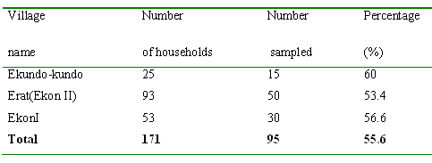
3 Results and Discussions
Major land-use ⁄ cover types
The identified land-use ⁄ cover types were: (i) dense forest (ii) cultivated areas (iii) human settlements, (iv) sand/stony rivers with fresh sand accumulations.
The dense forest area is defined as areas with >80% canopy cover.
3.1 Agricultural land-use ⁄ change patterns
A large part of the population in the central zone of KNP depends on agriculture for its livelihoods. Crop cultivation has thus become the dominant form of agricultural land-use. Most of the local crops include cassava, plantains, bananas, cocoyams, and yams. The high demand and profitability of cassava products (garri and fufu) has motivated many local people to increase land area for the cultivation of this crop. Recently, farmers (especially youths) are diversifying into palm plantation (Elaeis guineensis) following the high demand of red palm oil, which is used for cooking.
Between 1986 and 2005 the cultivated areas accounted for 30–42% of the total land area of region (Table 2), with fields scattered in almost all parts of the landscape, except on extremely steep slopes.
Table 2 Land cover change statistics of central korup from 1986 to 2000
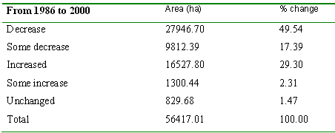
It can be observed from Table 2 that between 1986 and 2005, land cover decreased by over 50%. This could be attributed to the increased human settlement and conversion to farmlands (Fig.1).
(a)
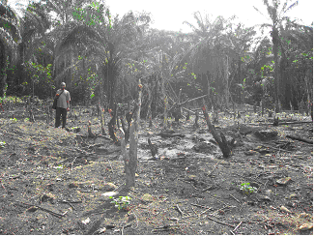
(b)
Figure 1: Forest conversion in the central zone of Korup national park, Cameroon-a main cause of land cover /ecosystem change (a) Human settlement; (b) Forest clearing using fire

By the same period too, some 31% of the total forest cover increased. The increase could be attributed to the recent investment in palm plantations by most villagers, especially the youths. In some other parts such as Erat (EkonII), cocoa cultivation is stepping up following the recent positive change in prices of this product. Forest regeneration following the resettlement of one of the villages (Ekundo-kundo) - a village that was once imbedded at the centre of the park is another reason for the increase in forest area. Only about 1.47% of the land remains unchanged.
The spatial distribution of fallow land had also changed considerably over the last two decades. While in the 1986, the fallow areas were scattered in most of the less intensely cultivated parts of the village, the fallow areas have become much fewer in recent years. Interviews with farmers indicated that spatial variations in soil quality and levels of degradation were important factors determining the locations of crop fields, although they can be found scattered in nearly all parts of the landscape. Field checks for this study also found some crop fields (illegal) in places deep inside the forest. These are areas protected under conservation.
3.3 Changes in sand rivers and other sand accumulations
Interpretation of the aerial photographs and ground truthing has indicated that the area of sand rivers shrunk steadily since 1986. Between 1986 and 2005, the decrease represented an annual shrinkage rate of about 1.2%. The size of the sand/pebbles Rivers in 2005 was about 12% smaller than in 1986. Most of the sand/stone/pebble Rivers and other sand accumulations decreased in total area coverage (Figure 2).

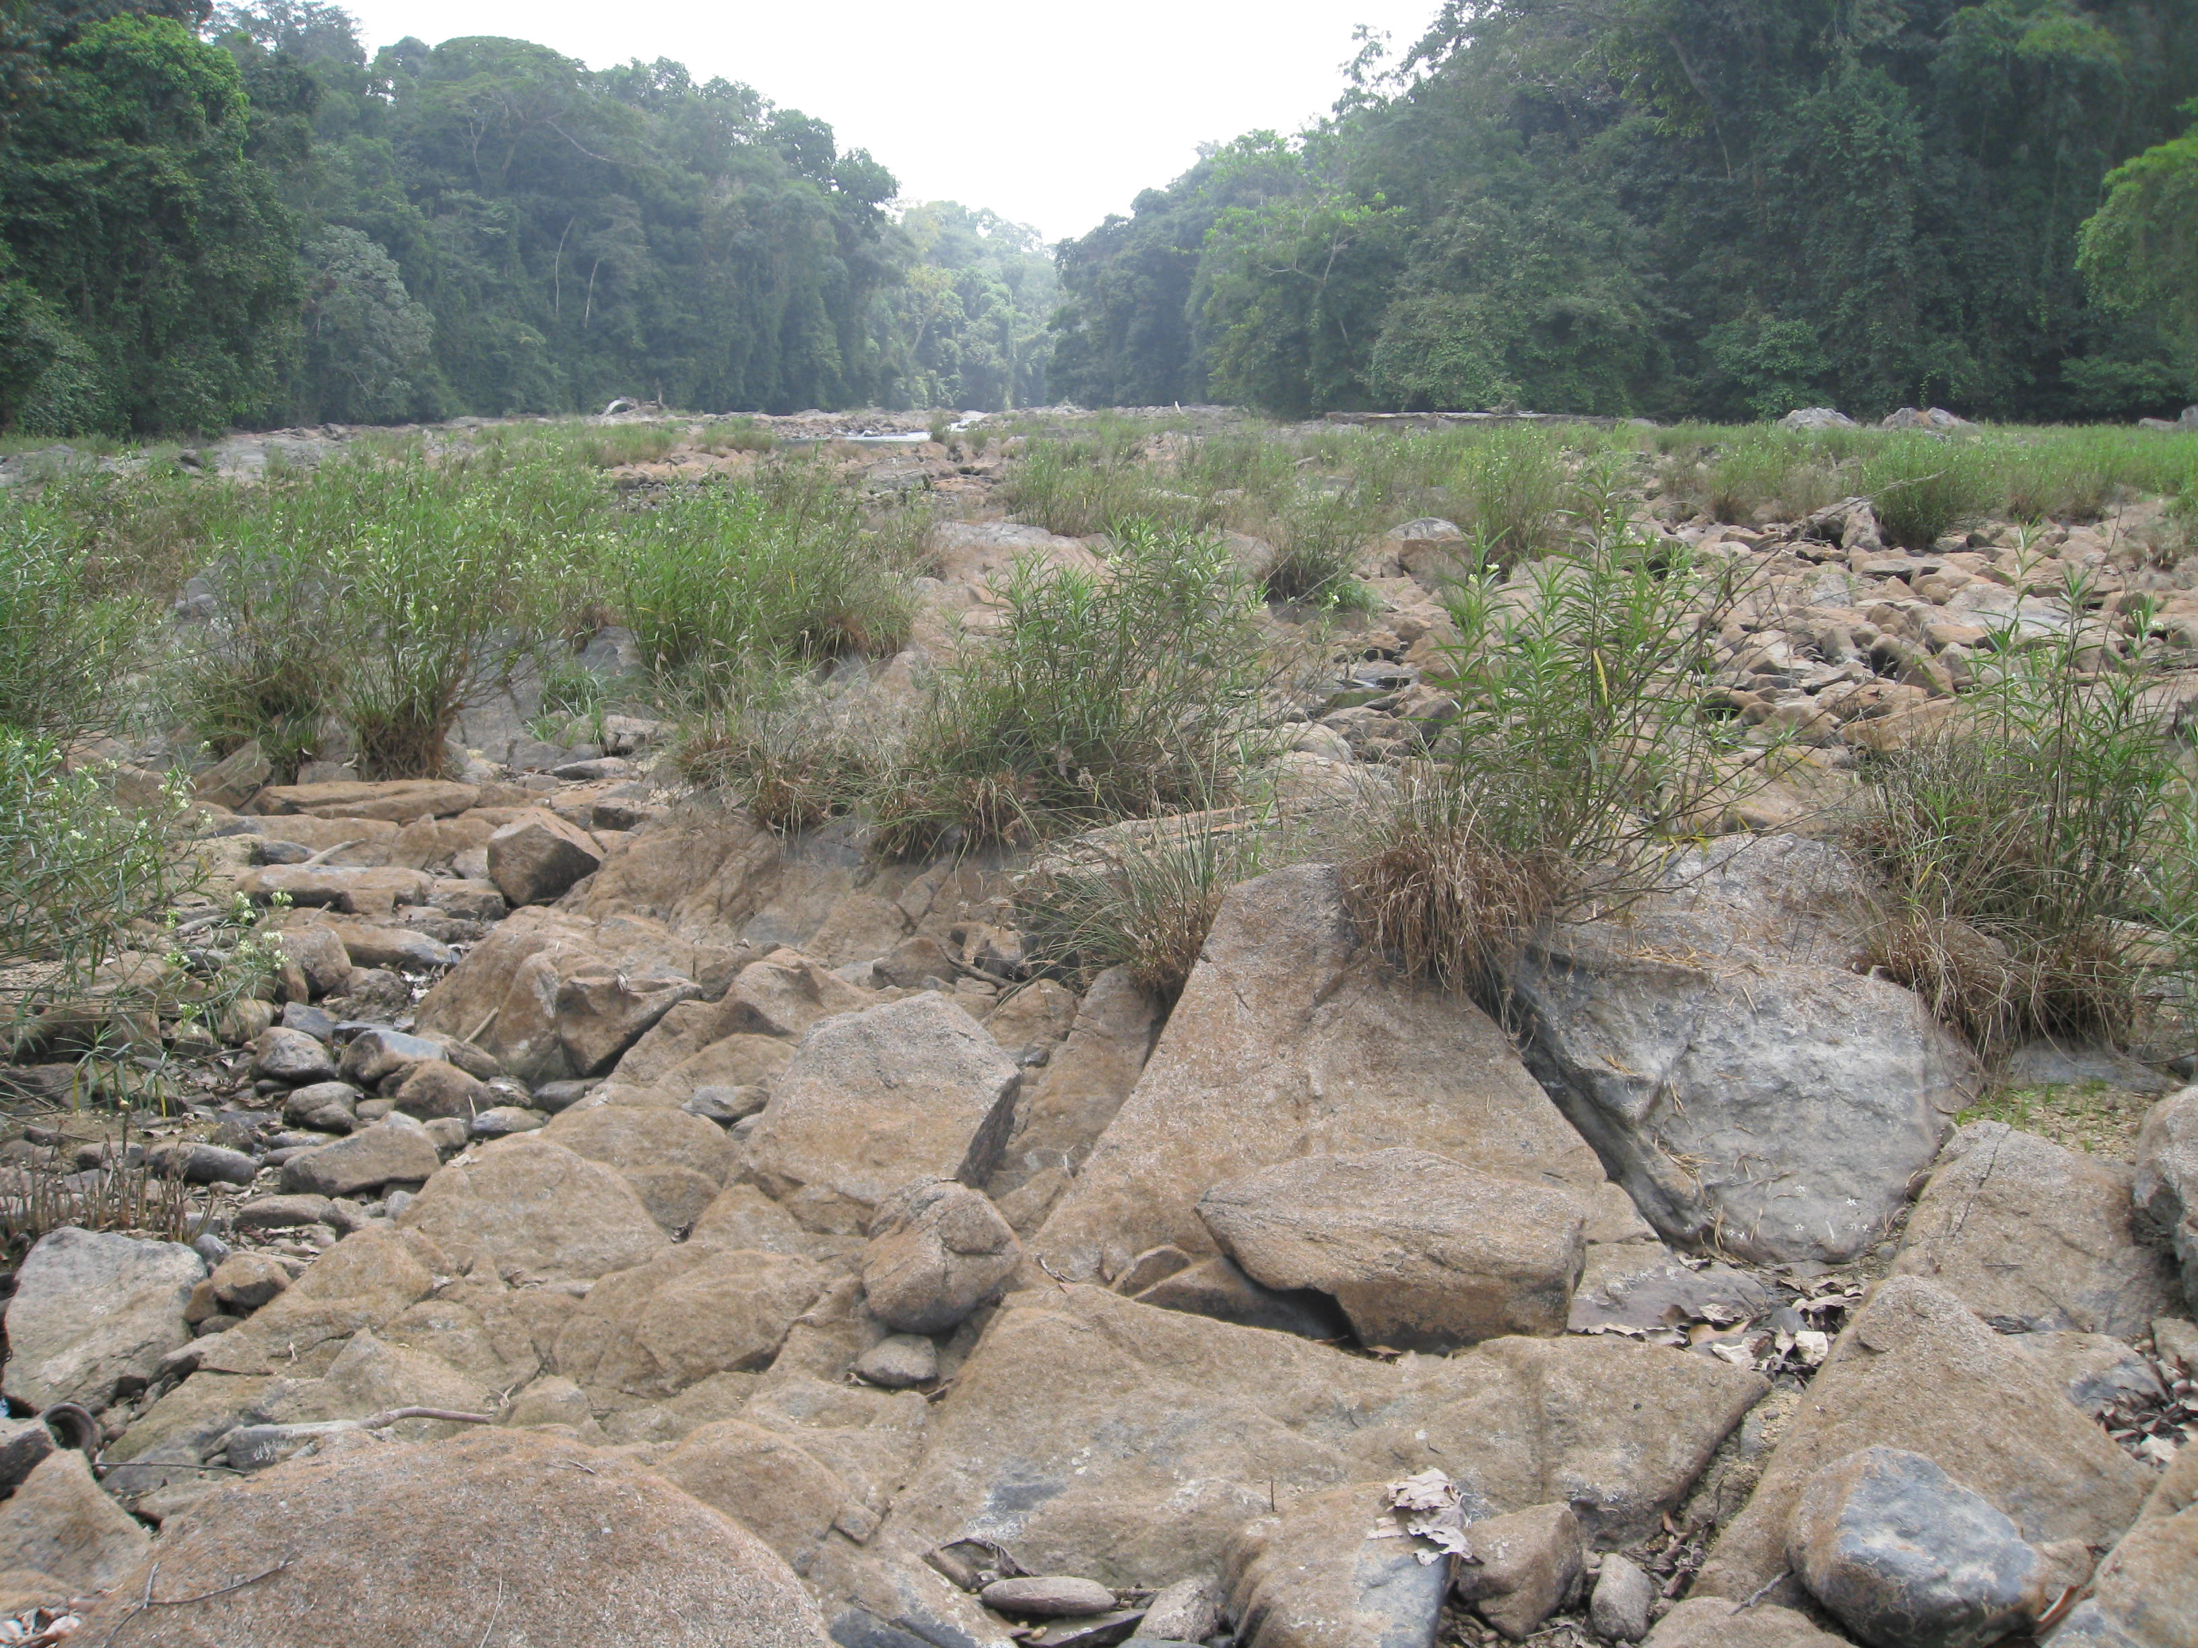
(a)
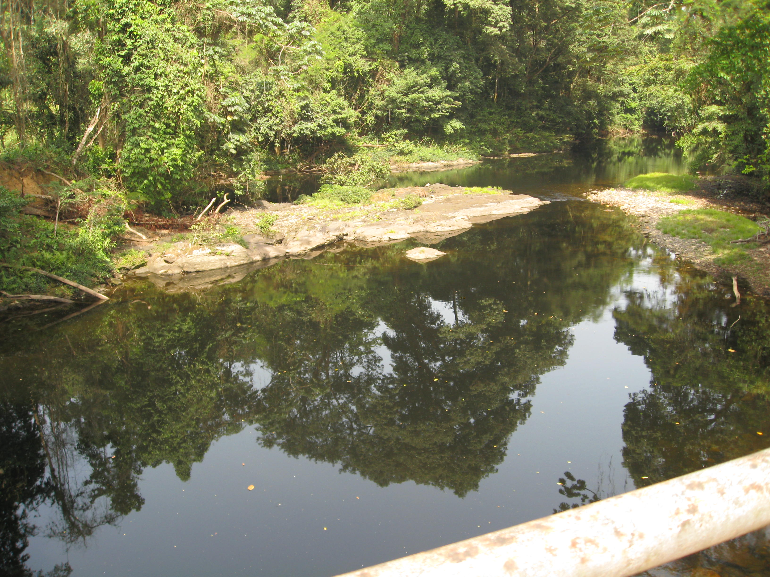
(b)
Figure 2: Picture showing shrinkages in river paths, threatening aquatic ecosystems. (a) is the main river draining the park while (b) is one of the main streams that drain the park.

Though these river paths are filled by rain water during the rainy season, recall data from village elders confirm that the rivers of the area have shrinked drastically in the past decades, long before the creation of the KNP in 1986.

4 Discussions
The findings of this study demonstrate the dynamics of central Korup’s ecosystem changes over the last few decades on both spatial and temporal scales. These changes are associated with land degradation, which has resulted in great heterogeneity in the landscape, leading to marked differences in the natural vegetation structure and the land-use patterns. The recent changes in land-use ⁄ cover patterns in the area have also been influenced by the creation of the park in 1986 that saw the resettlement of Ekundo-kundo village. Consequently, the former village area regenerated into a secondary forestland. The severe land degradation in the area especially as a result of the poor soils has caused limitations on the arable land use and on the range of crops that can be grown, while at the same time influencing other land-use ⁄ cover types. Recent researches on semiarid environments have shown that land degradation may lead to changes in the distribution of different types of vegetation cover, even when the total biomass is not necessarily changed [Tanser & Palmer, 1999]. In many instances land degradation results in increased runoff and soil redistribution within the area through erosion and sedimentation processes [Payton et al., 1992; Yanda, 1995]. This leads to spatial heterogeneity in soil ⁄ land properties that in turn influence agricultural productivity and the livelihoods of communities concerned. Though no studies on soil erosion in the area have been carried out, it can be explained that soil erosion dates a long way back in time, even to the late Pleistocene, when wetter climates prevailed.

The role played by humans in accelerating soil erosion must also be emphasized. The introduction and ⁄ or intensification of agriculture and the way it is being practiced is gradually accelerating erosion and degradation. As at now, no soil conservation initiative exists in the area. Monitoring of the nature reserve in the area is hardly done because of its inaccessibility.
The land-use history of most of the area has for a long time been influenced by land degradation, mainly through soil erosion and other natural processes (volcanicity). This has also influenced the landuse ⁄ cover types of the area. Despite the fact that region’s cropland has increased steadily since 1986 to date, the total areas cultivated is insignificant and do not correspond with the population growth, which grew by about threefold between 1986 and 2000s. This indicates that the agricultural land-use system of the area has somehow managed to adapt itself to the prevalent land degradation, thereby being able to sustain the livelihood of the increasing population.The plausible explanation of how the population has managed to sustain their livelihoods on the generally small infertile cultivated fields is possibly the practice of intensifying the use of the small cultivable land available, the rich non timber forest products and fauna of the forest. It should be recalled that hunting is the main activity in the area (even if it has now reduced because of the restrictions resulting from the creation of the park). Also, non timber forest products such as Irvingia gabonensis, Gnetum africanum are very high food and income generating resources in the area, contributing over 50% of total household income. This may mean that the observed changes in land-use ⁄ cover patterns have made agricultural production more sustainable than it used to be some 45 years ago.
It appears, however, that, although most of the severely degraded areas are yet to recover completely, the land-use system of the area has evolved to adapt to the prevailing degradation and seems to have enabled it to support larger populations today than ever before, and more than would be expected for such degraded/ infertile landscapes. The land-use history of most of the area has for a long time been influenced by land degradation, mainly through soil erosion. This has also influenced the landuse ⁄ cover types of the area. Despite the fact that farmland has increased steadily to date, the total areas cultivated does not correspond with the population growth, which grew by about one and a half fold between 1986 and 2005. This indicates that the agricultural land-use system of the area has somehow managed to adapt itself to the prevalent land degradation, thereby being able to sustain the livelihood of the increasing population. The plausible explanation of how the population has managed to sustain their livelihoods on the generally small cultivated fields is possibly the practice of intensifying the use of the small cultivable land available. This may mean that the observed changes in land-use ⁄ cover patterns have made agricultural production more sustainable than it used to be before the creation of the park

5 Conclusions
Numerous changes have occurred in the land-use ⁄ cover types and patterns of the central zone of KNP during the last 22 years, including settlement, cultivation and different natural vegetation cover types. However, the magnitude and direction of change have been variable, including great heterogeneity in land-use patterns, as well as in the vegetation structure. Recent changes seem to have been influenced by changes in prices of basic food items. The increase in the total cultivated areas since the creation of the park is causing great fears about the continuous existence of the park into the future and the sustainabilities of human livelihoods of the villagers. With increasing population, more of this land is being used for establishing homesteads and the effective cultivation areas are getting smaller. There has also been an expansion of areas under natural vegetation cover. Generally, the land use of the study area appears to have adapted to the degraded environment through intensification and diversification of the farming system. However, to sustain the present land-use ⁄ cover patterns and community livelihoods conservation efforts need to be reinforced.
The continued land degradation, if left unchecked, may lead to total degradation of the forest, especially as the population keeps growing. To reduce pressure on the nature reserve, the use of manure on farms, various intercropping patterns and on-farm soil conservation approaches, such as contour ridging and tree-planting, which together have contributed to increased land productivity and agricultural sustainability and diversification into agro-forestry practices is essential. Most importantly, the use of fire in clearing the forest has to be controlled. This is not only exposing the land to agents of erosion, but contributing to the release of greenhouse gases.

6 Acknowledgement

We thank the Chinese Scholarship Council for granting a scholarship and other facilities. We are also grateful to the Ministry of scientific Research of the Cameroon for granting us the research authority to carry out the research.

- Correspondence Author
Profesor Dr. Jiwen Ge, Director, Institution of Ecology and Environmental Sciences, China University of Geosciences, Hongshan District, 388 Lumo Road, Wuhan, 430074, China. E-mail: gejiwen2002@yahoo.com.cn

8. Submission date: March 18th, 2009

References
A.M. Ghilarov, Ecosystem functioning and intrinsic value of biodiversity, Oikos 90 (2000), pp. 408–412
Johnson, I. (1996) Understanding Maplnfo: A Structured Guide. Archaeology, University of Sydney, Sydney.

Lillesand, T.M. & Kiefer, R.W. (2000) Remote Sensing and Image Interpretation, 4th edn. John Wiley and Sons, Inc., New York, USA.
M. Loreau, S. Naeem and P. Inchausti, Editors, Biodiversity and Ecosystem Functioning: A Synthesis, Oxford University Press, Oxford, UK (2002).
Mapinfo Corporation (1996) MapInfo Professional: User’s Guide. Troy, New York, NY
Myers N, Mittermeier RA, Mittermeier CG et al. (2000) Biodiversity hotspots for conservation priorities. Nature 403, 853–8.
Payton, R.W., Christiansson, C., Shishira, E.K., Yanda, P. & Eriksson, M.G. (1992) Landform, soils and erosion in the northeastern Irangi Hills, Kondoa, Tanzania. Geogr. Ann. 74, 65–79.
Schmidt-Soltau, K. 2004. Stakeholder analysis for the Intervention of the German Financial Cooperation in the context of the Forest and Environment Sector Programme. Final report. MINEF, Yaoundé Cameroon
Smith, J., and Scherr, S. 2003. Capturing the value of forest carbon for local livelihoods. World Development 31(12): 2143-2160.
S. Díaz, J. Fargione, F.S. Chapin III and D. Tilman, Biodiversity loss threatens human well-being, PLOS Biology 4 (2006), pp. 1300–1305
Tanser, F.C. & Palmer, A.R. (1999) The application of a remotely sensed diversity index to monitor degradation patterns in a semi-arid, heterogeneous, South African landscape. J. Arid Environ. 43, 477–484.
Yanda, P.Z. (1995) Temporal and spatial variations of soil degradation in Mwisanga Catchment, Kondoa Tanzania. Dissertation No. 4, Department of Physical Geography, Stockholm University, Stockholm.
Young, A. (1976) Tropical Soils and Soil Survey. Cambridge Geographical Studies 9. Paperback edition. Cambridge University Press, Cambridge.
Zimmermann, 2000 Zimmermann, L., 2000. A comparative study of growth and mortality of trees in caesalp dominated lowland African rainforest at Korup, Cameroon

3/20/2009

