In Vitro Sterilization Protocol for Micropropagation of
Solanum tuberosum cv. ‘Kufri Himalini’

Anoop Badoni* and J. S. Chauhan

Seed Biotechnology Laboratory
Department of Seed Science and Technology
H. N. B. Garhwal University, Chauras Campus, Srinagar- 246 174
*For Correspondence: annabadoni@yahoo.co.in

ABSTRACT

For obtaining contamination free cultures the most important step is sterilization of explants. In the present study the sterilization procedure was standardize for potato cultivar Kufri Himalini. Comparison was done between two important sterilant sodium hypochlorite and mercuric chloride with three time duration 2, 5 and 8 minutes. After sprouting the sprouts of 0.5 to 1 cm. were taken for the study and treated by chemicals of surface sterilization with three selected timings i.e. 2, 5 and 8 minutes. Sterilized explants were inoculated on without hormones MS medium to evaluate the response of different chemicals. The observations were recorded regularly till to 30 days for the non-growing cultures, infected cultures and healthy cultures. Result showed that amongst the two sterilants i.e. NaOCl and HgCl₂, NaOCl was found better for controlling the infection and it had not any adverse effect on explants even in long duration. Sodium hypochlorite (NaOCl) for 8 minute (T3) was selected for suitable sterilization chemical after 5 minute of savlon wash, 30-second dip in ethanol and at last washed with double distilled water.

Keywords: Sterilant, contamination, surface sterilization and explants

INTRODUCTION:
In vitro propagation technique for potato involves various steps i.e. selection of explant, its sterilization and establishment and shoot proliferation and production of in vitro tubers. Beside the hormones, the culture conditions namely temperature, relative humidity and photoperiod also influence the growth and development process of in vitro cultures (Hussey and Stacey, 1981). The first condition for the success of a culture is asepsis. The maintenance of aseptic (free from all microorganisms) or sterile conditions is essential for successful tissue culture procedures. To maintain an aseptic environment, all culture vessels, media and instruments used in handling tissues, as well as explant itself must be sterilized. The importance is to keep the air, surface and floor free of dust. All operations should be carried out in laminar airflow sterile cabinet (Chawla, 2003).
Sterilization is the process of making explants contamination free before establishment of cultures. Various sterilization agents are used to decontaminate the tissues. These sterilants are also toxic to the plant tissues, hence proper concentration of sterilants, duration of exposing the explant to the various sterilants, the sequences of using these sterilants has to be standardized to minimize explant injury and achieve better survival (CPRI, 1992). Two different chemicals i.e. Mercuric chloride (0.1%) and Sodium hypochlorite (1%) were used for the present study to standardize the best sterilization protocol for in vitro culture of potato cv. Kufri Himalini.

MATERIAL AND METHOD:
The present study was carried out at Seed Biotechnology Laboratory, Department of Seed Science and Technology, H.N.B.Garhwal University, Srinagar Garhwal with the objective to evaluate the effect of different sterilants on explants in potato for in vitro culture. The ICAR has identified a new hybrid variety of potato- Kufri Himalini. Nearly 8% of the total area under Potato in the country lies in the hills, where potato is an important cash crop. This species is best for commercial cultivation in hilly regions. The new variety, with medium maturity of 110-120 days has been recommended for cultivation in the north- western and eastern hills during summer. It provides a yield advantage of over 10% over Kufri Jyoti and Kufri Giriraj. In the plains and its keeping quality is better then all the cultivars develop so far for hill regions.
For obtaining sprouts, the tubers were cut into pieces and were dipped in a solution of 0.1% Bavistin for 2-3 minutes and then sown in sand filled plastic pots followed with single wash in distilled water. These were grown under poly house following optimum cultural practices. The sprouts were ready for inoculation after 10-12 days of growth. The sprouts of about 0.5-1 cm. were collected from the mother plant of Kufri Himalini in water filled beaker and kept under running water prior to sterilization in the laminar airflow cabinet. For the experiment following treatments were used during the work:

T1 Sodium hypochlorite- 2 minutes
T2 Sodium hypochlorite- 5 minutes
T3 Sodium hypochlorite- 8 minutes
T4 Mercuric chloride- 2 minutes
T5 Mercuric chloride- 5 minutes
T6 Mercuric chloride- 8 minutes

The explants were surface sterilized with three selected timings of 2, 5 and 8 minutes. All glassware and instruments were thoroughly washed and dried at 80⁰C. Distilled water and glassware used for explants were autoclaved at 15 psi for 45 minutes. To evaluate the response of different chemicals, implantations of sterilized explants were done using without hormones MS medium. The cultures were placed in culture growth room. The observations were recorded regularly till to 30 days for the non-growing cultures, infected cultures and healthy cultures.

RESULT:
The present study was conducted to standardize the sterilization procedure of explants of potato cv. Kufri Himalini. Two different chemicals i.e. Mercuric chloride (0.1%) and Sodium hypochlorite (1%) were used for study with duration of 2, 5 and 8 minutes.

Effect on non-growing cultures:
On increasing the duration of HgCl₂ the mortality increased and was recorded higher in 8 minutes (T6) duration. HgCl₂ showed higher mortality rate (0.7, 0.9 and 0.9 in T4, T5 and T6 respectively) than those in NaOCl (0.8, 0.4 and 0.5). The lowest mortality rate (0.4) was observed in T2 (5 minute) duration of NaOCl (Fig.1).

Effect on Infection of cultures:
Result showed that with incensement of time the infection was decreases in both the chemicals. The infection was notably much lower in NaOCl with 8 minute duration (T3). The higher duration i.e. T6 (8 minute) of HgCl₂ showed lower infection (Plate-1a).

Effect on healthy cultures (overall survivals):
The data indicate (Table-1; Fig.1) that with the increase in duration of both the chemicals the survival rate was also increased. The survival obtained with 8 minute (T3) of NaOCl was significantly higher than all the duration of both the chemicals.

Suitable sterilization chemical:
While comparing the effect of HgCl₂ and NaOCl, the NaOCl was always found better than HgCl₂. Sodium hypochlorite (NaOCl) for 8 minute (T3) was selected for suitable sterilization chemical after 5 minute of savlon wash, 30 seconds dip in ethanol and at last washed with double distilled water (Plate-1b).

DISCUSSION:
Mercuric chloride is a very strong sterilant yet Gopal et al., (1998) disinfected the single nodal cuttings of 22 cultivars with a mixture of 0.1% Mercuric chloride and 0.1% Sodium lauryl sulfate for 5 minutes. Calcium hypochlorite being a mild sterilant has been used for potato. Nozeram et al., (1977) sterilized potato sprouts by dipping them in alcohol and a few drops of Teepol and then placed them in Calcium hypochlorite solution for 15-25 minutes. Roca et al., (1978) sterilized single node segments with 0.25% calcium hypochlorite for 5 minutes. Wang (1984) recommended that the shoot tip obtained from green house grown plants should be surface disinfected for 3 minutes by soaking in a calcium hypochlorite (or 10% commercial bleach) solution with a small amount of detergent (e.g. Tween- 20). According to Maroti et al. (1982) and Naik and Chandra (1993), ethanol is a mild surface sterilant recommended for initial general use.
Sodium hypochlorite has turned out to be a better sterilant than calcium hypochlorite due to bleaching effects of the later and hence has been extensively used for potato sterilization. Wescott et al.., (1977) and Goodwin et al.., (1980) disinfected the sprouts with Sodium hypochlorite in which available chlorine was sterilized single node cuttings of eight different cultivars in 1% aqueous sodium hypochlorite. Miller and Lipschutz (1984) surface sterilized excised shoot tips in 1% sodium hypochlorite solution containing 0.1% Tween-20 for 7 minutes with gentle shaking. Naik and Chandra (1993) recommended first rinsing of sprouts with 20% ethanol for 30 seconds followed by 10 minutes shaking with 25% sodium hypochlorite solution with 1-2 drops of Tween-20. Villafranca et al.., (1998) surface sterilized the sprouts with 1% sodium hypochlorite, 0.1% Tween-20 solutions for 5 minutes.
Amongst the two sterilants i.e. NaOCl and HgCl₂, NaOCl was found better for controlling the infection and it had not any adverse effect on explant even in long duration. There are a number of reports (Miller and Lipschutz, 1984; Naik and Chandra, 1993 and Villafranca, 1998) for steriliztion of potato sprouts and shoot tips with 1% NaOCl for 5-10 minutes. Gopal et al.. (1998) have reported the use of HgCl₂ for 5 minutes, it being a strong sterilant was used by them in combination with Sodium Lauryl Sulphate.
REFERENCES:

Chawla, H. S. (2003). Plant Biotechnology: Laboratory manual for plant biotechnology. Oxford & IBH Publishing Co. Pvt. Ltd. New Delhi
Central Potato Research Institute, Shimla (1992). Tissue Culture technique for potato health, conservation, micro propagation and improvement. CPRI, Shimla:1-23
Goodwin, P. B., Kim Y. C. and Adisarwanto T. (1980). Propagation of potato by shoot tip culture. Potato Res. 23:9-18
Gopal, J., Minocha J. L. and Dhaliwal H. S. (1998). Microtuberization in potato (Solanum tuberosum L.). Plt. Cell. Rep. 17: 794-798
Hussey, G. and Stacey N. J. (1981). In vitro propagation of potato (Solanum tuberosum L.). Ann. Bot. 48:6; 787-796
Maroti, M., Rudolf J., Bognar J. and Pozsar B. I. (1982). In vitro plantlets from potato shoot segments. Acta Bot. Acad. Sci. Hung. 28; 1-2: 127-132
Miller, S. A. and Lipschutz L. (1984). Potato in: Ammirato P.V., Evans, D., Sharp W. R. and Yamada Yasuguki (eds.), Handbook of plant tissue culture, New York. McMillan publishing company Vol. 3: 291-293
Naik P. S. and Chandra R. (1993). Use of tissue culture technique in crop improvement with special reference to potato. CPRI, Shimla.
Nozeran, R. B. andilho, Rossignol L. and Glenan S. (1977). Nouvelles possibilities etde multiplication rapie de clones sains de pomme de erre (Solanum tuberosum L.), C.R. Acad Sci. 285;1: 37-40
Villafranca, M. J., Vermendi J., Sota V. and Mingo-Castel A. M. (1998). Effect of physiological age of mother tuber and number of subcultures on in vitro tuberization of potato (Solanum tuberosum L.), Plt. Cell. Rep. 17 :787-790
Wescott, R. J., Henshaw G. G. and Roca W. M. (1977). Tissue culture and storage of potato germplasm: Culture initiation and plant regeneration, Plant Sci. Lett. 9:309-315

Table-1 Effect of sterilization on growth, infection and survival of culture:

Observations Treatments
T1 T2 T3 T4 T5 T6
Non-growing cultures 0.8 0.4 0.5 0.7 0.9 0.9
SD ± 1.8 AD= 5.8
Infected cultures 0.8 0.8 0.1 0.8 0.6 0.5
SD ± 1.7 AD= 5.0
Healthy cultures 0.4 0.8 1.6 0.5 0.5 0.6
SD ± 1.9 AD= 6.0

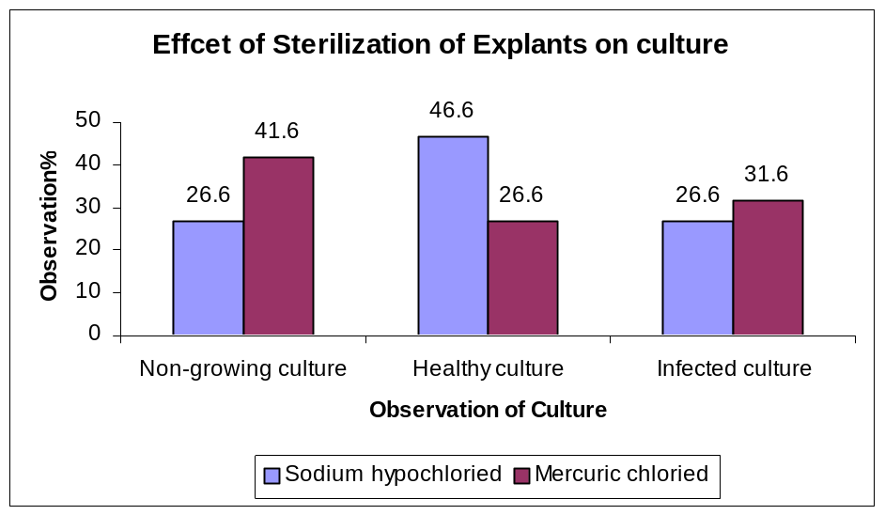

Fig.1 Effect of Sterilization on Culture

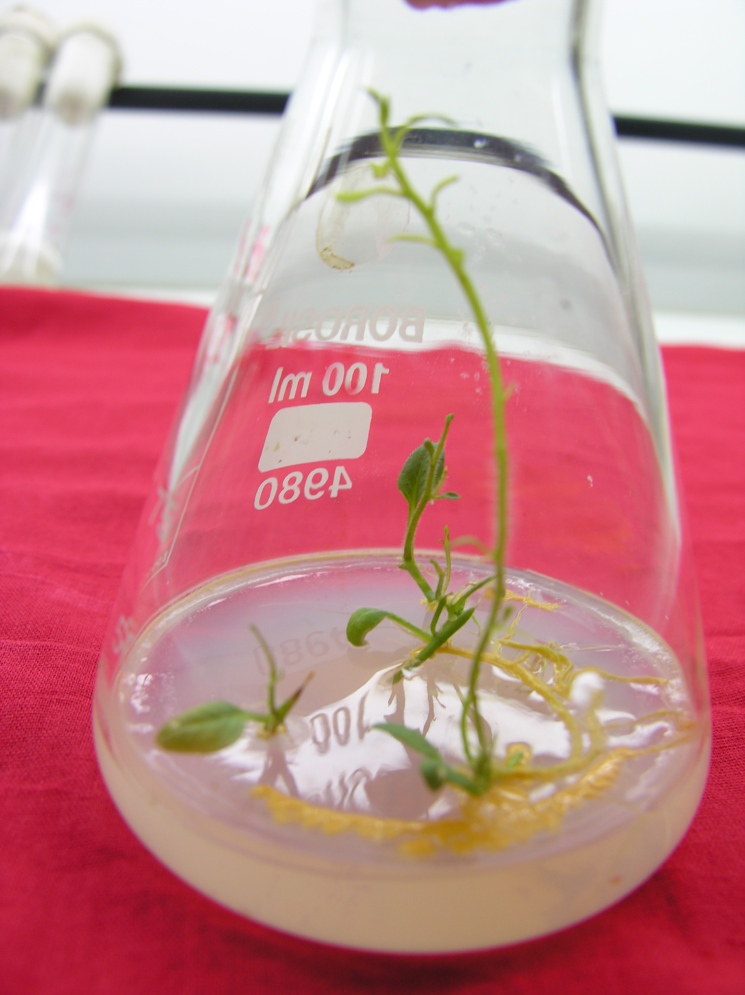 (b) 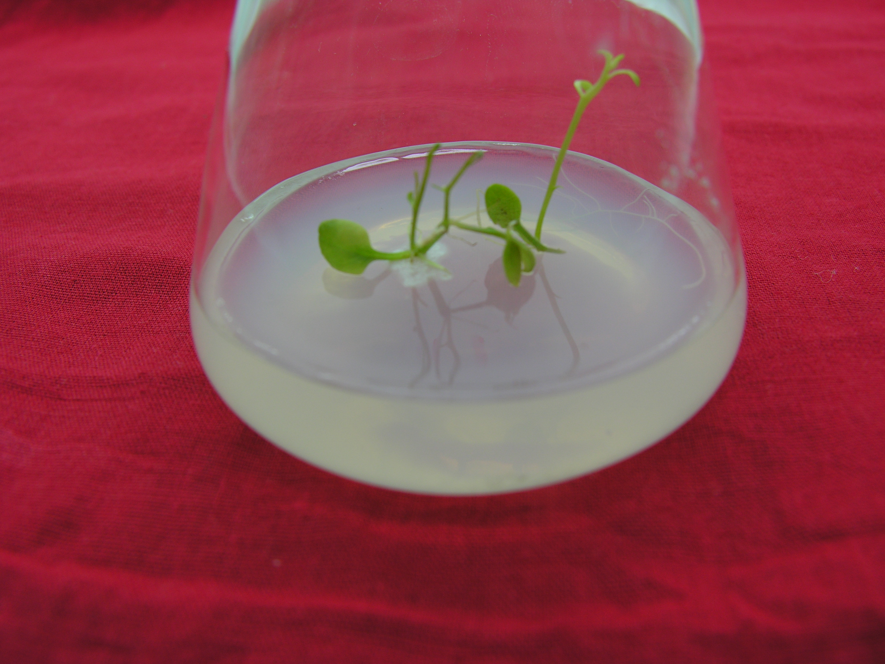 (d)

Plate 1: Sterilized explants after 30 days (a) infected shoot tips (b) selected best plantlet of NaOCl chemical with 8 minute

3/16/2009

