Residues of Organochlorine Pesticides in Vegetables from Deyang-Mianyang Agricultural Area of Chengdu Economic Region, Sichuan Province, China

Odhiambo Joshua Owago¹*, Shihua Qi¹, Xing Xinli¹, Zhang Yuan¹ and Muhayimana Annette Sylvie¹

¹School of Environmental Studies and MOE Key Laboratory of Biogeology and Environmental Geology, China University of Geosciences, Wuhan, 430074, China

* Corresponding author: C/o International cooperation Office, China University of Geosciences, Lumo Road 388, Wuhan, Hubei, 430074, P.R. China
Email: joowago@hotmail.com; Telephone: +86-27-67885985; Fax: +86-27-87515956

Abstract
A total of 32 vegetable samples collected from Deyang-Mianyang area of Chengdu economic region in the Sichuan Province, China were analyzed for 8 organochlorine pesticides (OCPs). The pesticides determined are: isomers of hexachlorocyclohexane (HCHs) i.e. α-HCH, β-HCH, γ- HCH (lindane) and δ-HCH; isomers/metabolites of dichloro-diphenyl-trichloroethane (DDTs); p,p¹-dichloro-diphenyl-dichloroethylene ( p,p¹-DDE), p,p¹-dichloro-diphenyl-dichloroethane ( p,p¹-DDD), p,p¹- and o,p¹-dichloro-diphenyl-trichloroethane ( p,p¹-DDT and o,p¹-DDT). Residues of HCHs were more prevalent in the samples than those of DDTs but the DDTs residues were more abundant. The OCPs residue levels in the vegetable samples were generally low (≤0.01-4.04 ng g-1 wet weight) except in one sample of capsicum (Capsicum annum L) whose determined concentrations (ng g⁻¹ wet weight) of o,p’-DDT (82.59), p,p’-DDE (61.41) and total DDT (148.44), exceeded the Chinese Extraneous Maximum Residue Limit (EMRL) of 50 ng g⁻¹for DDTs in foodstuffs according to the Chinese food standard (GB 2763-2005). This is indicative of a potential risk and hence concern for public health. Results of analysis of parent material/metabolite or isomer ratio suggested historical sources of DDTs and possible recent usage of dicofol and lindane in the area. Therefore, regulating dicofol and lindane uses would be expected to reduce if not eliminate vegetable OCPs contamination in the area. A deeper investigation is recommended especially of the levels of DDTs in Capsicum annum L.

Key words: Vegetables, Organochlorine pesticides, Chengdu Economic Region

1.0 Introduction
Persistent and lipid soluble organochlorine pesticides (OCPs) were widely used because of their effectiveness, broad spectrum activity, high residual biological activity and ease of formulation (Wang et al, 2005; Turusov et al., 2002). However, research and public concern regarding the hazards of their use led to their restrictions and bans in 1970s and 1980s. OCPs have been linked with serious health effects in humans and other living organisms including cancer, neurological damage, and birth defects (Marco and Kishimba, 2006).
In China, the production and use of dichloro-diphenyl-trichloroethane (DDTs) and hexachlorocyclohexane (HCHs) began in the 1950s and by the time of their ban in 1983, 4.9 million tons of technical HCH and 0.4 million tons of DDT had been produced. This accounted for 33% and 20% of the global output respectively (Hua and Shan, 1996). These insecticides were widely applied to agricultural production, forestry and public health (Li et al., 1998). Consequently these pollutants continue to be detected in potentially harmful quantities in the Chinese soil (e.g. Li et al., 2006; Wang X et al., 2006), air (Li, et al., 2007), water (Yang J et al., 2007; Zhou et al., 2006), in biota including foodstuffs (Guo et al., 2007; Yang, N. et al., 2006), and in humans (Lee et al., 2007, Poon et al., 2005).
Located in the South-western part of China (26⁰ 03’ – 34⁰ 19’N and 97⁰ 21’-108⁰ 31’E), Sichuan province occupies an area with a complex terrain. The altitude ranges from 200 meters above the sea level in the Sichuan basin to the east, to above 5000 meters above the sea level in the Qinghai-Tibet plateau to the west. Although Sichuan’s climate belongs to temperate and moist sub-tropical climate, because of the various landforms and effect of different trade winds there are various types of climates (Zhang, et al., 2006). This variation in types of climate not only provides an opportunity to cultivate a variety of crops but it is also conducive to the development of a myriad of pests, weeds and disease vectors hence attracting the use of pesticides. Indeed it is estimated that Sichuan produces over 20 billion kilograms of vegetables, accounting for 30% of the national urban consumption (Chen et al., undated). In addition the fertile Sichuan basin produces much of China’s grain (Hambarger, 2001). As regards pesticide use Sichuan was the one of the provinces with heaviest use of technical HCHs (Li et al., 1998). It was reported that DDT was used in Xinyang prefecture in the neighbouring Henan Province until the 1990s (Depang et al., 1996). Possibly the use persisted in Sichuan province as well.
Diet is an important source of exposure to pesticides. Previous surveys of OCP residues in foodstuffs including vegetables in China (Liu et al., 1995; Wang et al., 2002; Nakata, et al., 2002; Bai et al., 2006; Tao et al., 2005) reported generally low contamination. However, vegetables have been found to be a major component of the Chinese diet (Chen and Gao, 1993). Thus, even low residues spell high danger given the large quantities of these food substances consumed at a time. Indeed, very high concentrations of DDTs and HCHs were detected in human tissues from Shanghai, with the maximum values as high as 19,000 ng/g lipid weight (mean: 7,600 ng/g) and 17,000 ng/g (mean: 7,400 ng/g), respectively (Nakata et al., 2002). In view of their potential toxicity and persistent nature, there is pressing need for the control of OCPs and their regular monitoring in foodstuffs in order to ensure consumer safety.
Information is scanty about the levels of the OCPs residues in vegetables from Sichuan province. In this study, OCP residues in vegetables grown in Deyang-Mianyang area of the Chengdu economic region, Sichuan were determined. The purpose was to assess accumulation as a measure of environmental pollution and to evaluate if there was need for a deeper investigation. In addition to their dietary significance in China, vegetables were selected because they are the most widely distributed food plants in the study area.

2.0 Materials and Methods

2.1 Study Area and Sampling

Socio-economically, Sichuan province is divided into five sub-regions: Basin, hilly area, mountainous area around the basin, southwest mountainous area and the western plateau (ADB, 2006). The study area, Chengdu Economic Region, covering an area of about 60,000 square kilometers is located in the west east and includes parts of the basin, the hilly and the mountainous areas around the basin, which are characterized by high population densities and agricultural productivity. The actual sampling sites were within the areas administratively governed by Deyang and Mianyang prefectures or municipalities (Figure 1). Most of the area sits in a subtropical humid climate zone and has continental monsoon climate, which means no extreme temperatures in summer and winter. The annual temperatures averages about 15.7⁰C in Mianzhu (Deyang) area while annual precipitation average is about 1053mm (Beijing review online: http://www.bjreview.com.cn/special/sichuan_earthquake/txt/2008-06/24/content_129013.htm.) The alluvial deposits of the Chengdu plain including Mianzhu, Pengzhou, counties (main sampling areas) are mainly composed of sand, silt and clay. However, in the areas around Yanting, Northeastern part of the study area, the soil may be classified as purplish (Jiang et al., 2006). The main sampling areas fall within high-yielding vegetable production area of hilly mass of Sichuan basin and Chengdu plain as identified by Chen (undated).

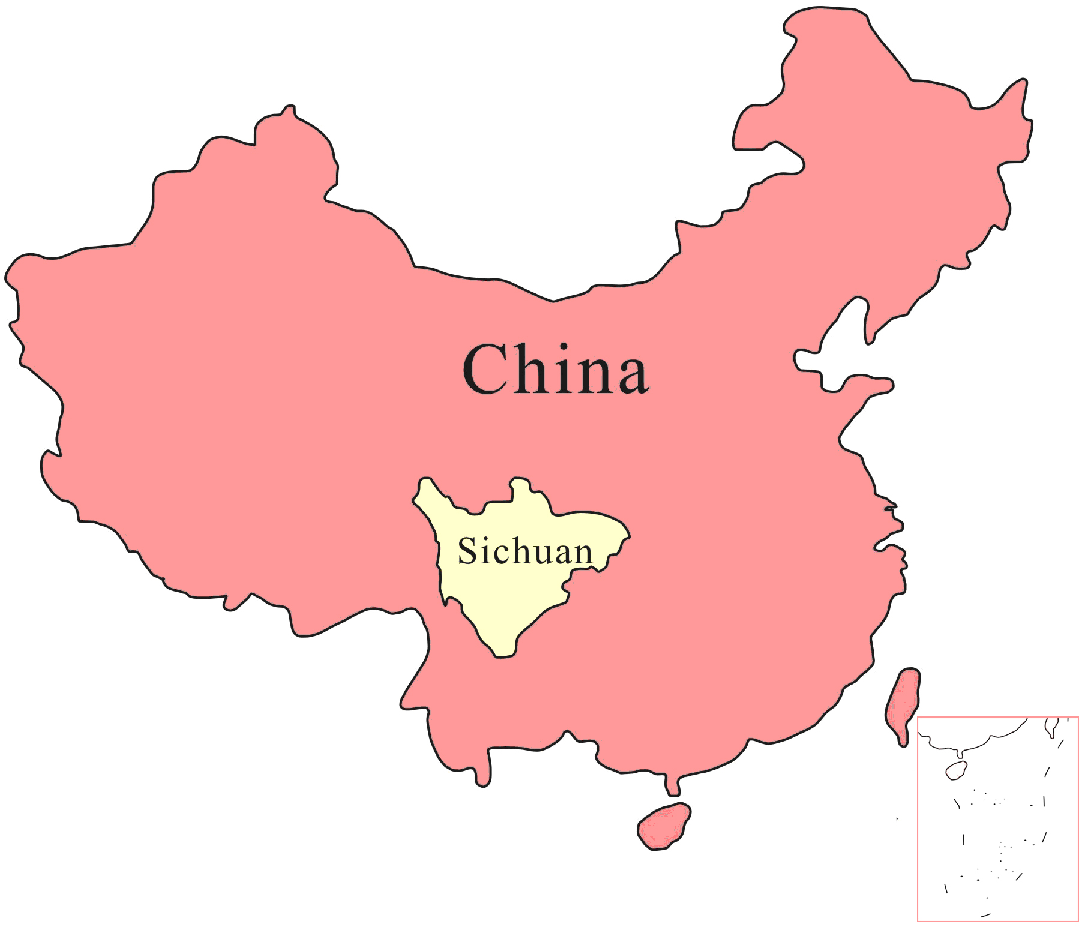
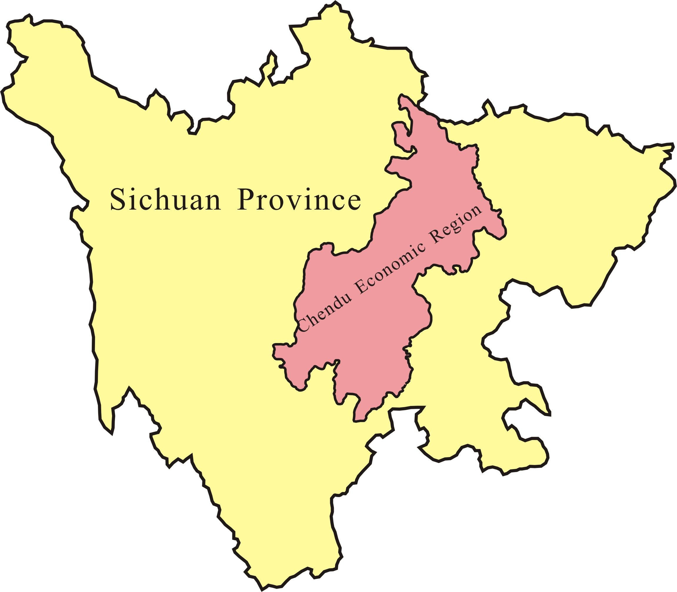

Figure 1
Map of the Chengdu Economic Region and its position in Sichuan Province and the position of Sichuan Province, People’s Republic of China. The locations of the sampling areas in Deyang and Mianyang Prefectures are indicated

Samples of various vegetables were collected directly from the fields to ensure that they originated within the study area. The samples were collected s on various dates in the months of June (Spring) and September (Autumn), the year 2007.The sampling sites were selected following the results of a soil OCPs survey (unpublished) that covered the entire Chengdu economic region. Crop samples were taken from the farmlands whose soils had been found with relatively elevated levels of OCPs (≥ 10 ng g⁻¹ dry weight). A global positioning system (GPS) instrument was used to locate sampling locations. Vegetables found growing on the sites or within the immediate vicinity were collected for laboratory analyses. Each sample was sealed in a clean polythene sampling bag, and immediately transported to the laboratory where they were kept refrigerated at 4⁰C until analysis.

2.2 Experimental

2.2.1 Extraction and Clean-up
Representative edible parts of each sample was cut into pieces (where possible) and blended. Approximately 15 g of the resultant mixture was weighed into a well tucked filter paper and mixed with anhydrous sodium sulfate. The mixture was spiked with 20 ng of 2,4,5,6-tetrachloro-m-xylene (TCMX) and decachlorobiphenyl (PCB209) as recovery surrogates before they were soxhlet extracted for 48 hours with dichloromethane and acetone (2:1 vv). The extract was concentrated to about 2 ml using a rotary evaporator and solvent-exchanged to n-hexane and transferred into a separatory funnel where about 3 ml of concentrated sulfuric acid (98%) was added with shaking (to remove lipids). The mixture was allowed to stand until two distinct layers were observed. Using a teat pipette, the lower turbid layer was sucked out and discarded. The lipid removal procedure was repeated 3 times and/or until only one clear layer remained.
The remaining layer was passed through a clean-up column (8 mm i.d.) containing 2:1 neutral silica gel in concentrated sulfuric acid and topped up with 3 cm neutral alumina in n-hexane. The sample extract was eluted three times with 30ml dichloromethane/hexane (2:3) mixture. The eluate was concentrated to about 0.5 ml before being transferred (using n-hexane) into a 2 ml screw cap cell bottle (Agilent Technologies USA) where it was concentrated further to 0.2ml under gentle stream of purified nitrogen gas at 40-45⁰C. The extracts were stored at -20⁰C, prior to GC-ECD analyses. Pentachloronitrobenzene (PCNB) was added as an internal standard before the analyses.

2.2.2 Instrumental Analysis

Concentrations of organochlorine pesticide residues were determined using HP 6890 gas Chromatograph (GC) system with a ⁶³Ni electron capture detector (ECD). A fused silica capillary column (HP-5, 30 mx 0.32 mm i.d. and 0.25µm film thickness) was used. The oven temperature was programmed from 100⁰C (equilibrium time 1 min) to 200⁰C at a rate of 4 min⁻¹; from 200⁰C to 230⁰C at a rate of 2 min⁻¹ and finally increased to 280⁰C at a rate of 8 min⁻¹ and held for 15 minutes with a total run time of 62 minutes. Nitrogen was used as carrier gas at flow rate of 2.5 ml/min in a constant flow mode. Injector temperature and the electron capture detector temperature were set at 290⁰C and 300 ⁰C, respectively. The injection volume was 2 µl. A six point calibration curve was established to quantify the target analytes.

2.2.3 Quality Assurance and Control
All analytical procedures were monitored using strict quality assurance and control measures. Chemicals used in the sample preparation and analyses were of high grade analytical standards obtained from Tedia Company, USA and J.T Baker, USA. Before use, neutral alumina, neutral silica gel and anhydrous sodium sulfate were soxhlet-extracted for 48 hours with dichloromethane and then baked for 12 hours in 250, 180 and 450⁰C respectively. Laboratory glassware were washed with concentrated sulphuric acid/potassium dichromate mixture, rinsed with distilled water and n- hexane then dried in the oven at 110⁰C overnight prior to use. With each set of samples analyzed, field and procedural blanks were run in sequence to check for cross contamination and interferences. None of the target compounds were detected in the blank samples. The method of detection limits (MDLs) of OCPs ranged from 0.005-0.01 ng g⁻¹ wet weight. The recovery rates of the surrogates, TMCX and PCB209 were 65±4% and 74±5% respectively. Each sample was analysed in duplicate and the average level for the duplicates was taken as the level for the candidate sample and was used in calculations. The relative standard deviation (RSD) for duplicate samples was 4%. A reporting limit of >0.01 ng g⁻¹ wet weight was taken for calculation purposes since some duplicate averages were below the MDLs. Levels below the reporting limit were taken as zero (0) in our calculations and included samples, which were not detected with the analytes.

- Results and Discussion

Table 1 gives the names of the vegetables sampled and the levels of OCPs in them. A total of 32 vegetables (leafy, fruity, root and beans) collected from various locations in the Deyang-Mianyang areas of the Chengdu Economic Region were analysed. The target organochlorine compounds were: isomers of hexachlorocyclohexane (HCH) namely α-, β-, γ- and δ-HCH (HCHs); p,p¹-dichloro-diphenyl-dichloroethylene ( p,p¹-DDE), p,p¹-dichloro-diphenyl-dichloroethane ( p,p¹-DDD), p,p¹- and o,p¹-dichloro-diphenyl-trichloroethane ( p,p¹-DDT and o,p¹-DDT), together expressed as DDTs. Values below the reporting limit of 0.01 were treated as zero in the calculations.

3.1 Levels of OCPs in Vegetables

Figure 2 gives the incidence of the pesticides in all the vegetable samples while the names and number of the sample as well as the determined residues levels given in Table 1. The largest proportion (59.3%) of the samples was leafy vegetables, followed by fruiting (18.9%), beans (12.5%) and roots & bulbs (9.4%), in that order.
Each of the samples was found to be contaminated with at least one of the pesticides investigated. The HCHs were detected in more samples than DDTs. This was expected since more HCHs were produced and used in China than DDTs (Hua and Shan, 1996). More over Sichuan was reported to be one of the provinces of China in which technical HCH was consumed in large amounts (Li et al, 1998). Lindane or γ-HCH (71.9%) was the most frequently detected HCH isomer suggesting its recent use in the area. Residues of α-HCH (65.6%) and β-HCH (65.6%) also occurred in more than 50% of all the samples.
As for the DDTs, residues of p,p’-DDE which is a metabolite of p,p’-DDT, was the most frequently detected having been determined in 90.6% of all the samples. It was followed by p,p’-DDD, another metabolite of p,p,’DDT with the parent materials (p,p’-DDT and o,p’-DDT) appearing in relatively fewer number of samples (Figure 2). This indicates older sources of DDT as opposed the recent usage.

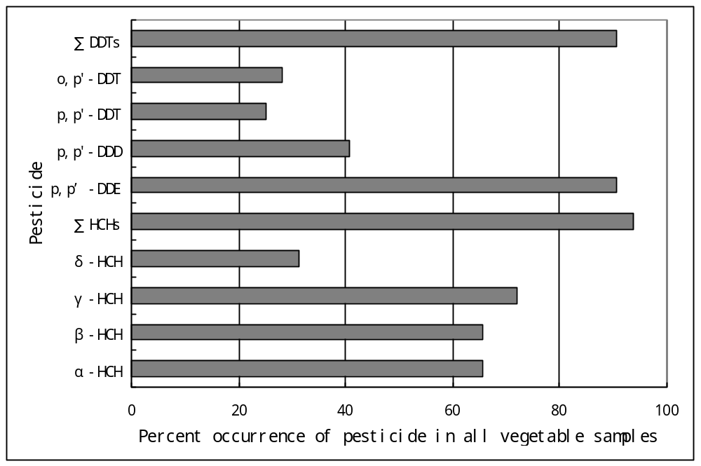
Figure 2
Percent occurrence of HCHs and DDTs in 32 vegetable samples from Deyang-Mianyang areas of the Chengdu Economic Region, Sichuan, China

The high frequencies of occurrence of ∑HCHs and ∑DDTs in the vegetables of the present study shows that the prohibition in 1983 of the agricultural uses of these pesticides in China, might had not been immediately effective in the Sichuan Province.
In terms of pesticide abundance based on average concentrations (Table 1) the average concentration of ∑DDTs was higher than that of ∑HCHs. DDT is less soluble in water than HCHs and so could be staying longer in the rhizosphere from where it is taken up by the plants.
The levels of DDTs and HCHs in vegetables were generally low except in capsicum whose levels of o,p’-DDT (82.59 ng g⁻¹ wet wt.), p,p’-DDE (61.41 ng g⁻¹ wet wt.) and ∑DDTs (148.44 ng g⁻¹), all exceeded the extraneous maximum residue limits (EMRLs) of 50 ng g⁻¹, as set forth by the Chinese ministry of public health (Chinese food standard, GB 2763-2005). This is indicative of a potential risk and concern for public health. Grouped according to physiological similarities of their edible parts, the vegetable ∑DDTs residue levels were in the order: Fruiting>root & bulbs>leafy>beans. Among the individual species, radish, cabbages, lettuce and spinach follow capsicum in that order but their average ∑DDTs levels were generally low (0.20-0.33 ng g⁻¹). The beans, onion and celery, having average ∑DDTs levels in the range of 0.02-0.03 ng g⁻¹ wet wt. were among the least polluted vegetables.

Table 1
Levels of organochlorine pesticide residues in cereals from Chengdu Economic region (ng g-1 wet wt.)

Vegetable (N) | α-HCH | β-HCH | γ-HCH | δ-HCH | ∑  HCHsª | p,p’-DDE | p,p’-DDD | p,p’-DDT | o,p’-DDT | ∑  DDTs^{b}
Lettuce (8) | 0.02 | 0.08 | 0.03 | 0.11 | 0.24 | 0.07 | 0.01 | 0.05 | 0.07 | 0.20
Cabbages (6) | 0.01 | 0.14 | 0.05 | <0.01 | 0.20 | 0.18 | 0.01 | 0.05 | 0.07 | 0.31
Colored amaranth (1) | 0.07 | 0.10 | 0.05 | <0.01 | 0.22 | 0.06 | 0.02 | <0.01 | <0.01 | 0.08
Spinach (3) | 0.01 | 0.06 | 0.05 | 0.04 | 0.15 | 0.05 | 0.03 | 0.04 | 0.08 | 0.20
Celery (1) | 0.01 | 0.09 | 0.06 | 0.03 | 0.19 | 0.03 | <0.01 | <0.01 | 0.03 | 0.06
All leafy (19) | 0.02  (0.09) | 0.10  (0.37) | 0.04 (0.10) | 0.06 (0.47) | 0.2 (0.57) | 0.10 (0.92) | 0.01 (0.06) | 0.05 (0.30) | 0.06 (0.06) | 0.22 (1.27)
Pumpkin (3) | 0.06 | 0.05 | 0.04 | 0.11 | 0.27 | 0.04 | <0.01 | 0.06 | <0.01 | 0.10
Eggplant (2) | 0.21 | <0.01 | 0.04 | <0.01 | 0.26 | 0.07 | <0.01 | <0.01 | <0.01 | 0.07
Capsicum (1) | 0.13 | 0.12 | 0.02 | <0.01 | 0.27 | 61.41* | 0.41 | 4.04 | 82.59* | 148.44*
All fruiting (6) | 0.12 (0.40) | 0.05  (0.15) | 0.04 (0.08) | 0.06 (0.29) | 0.26 (0.49) | 10.28 (61.41) | 0.07 (0.41) | 0.70 (4.04) | 13.76 (82.59) | 24.81 (148.44)
Radish (2) | 0.05 | 0.36 | 0.11 | 0.04 | 0.56 | 0.12 | 0.04 | 0.17 | <0.01 | 0.33
Onion (1) | <0.01 | 0.14 | 0.02 | <0.01 | 0.16 | 0.05 | <0.01 | <0.01 | <0.01 | 0.02
All root&bulbs(3) | 0.03 (0.09) | 0.29  (0.62) | 0.08 (0.19) | 0.03 (0.08) | 0.43 (0.98) | 0.10 0.22) | 0.04 0.09) | 0.11 (0.12) | <0.01 | 0.24 (0.64)
Horsebean (1) | <0.01 | 0.23 | 0.04 | <0.01 | 0.27 | 0.01 | 0.01 | <0.01 | <0.01 | 0.02
Haricot bean (2) | 0.02 | <0.01 | <0.01 | <0.01 | 0.02 | 0.03 | <0.01 | <0.01 | <0.01 | 0.03
Kidney bean | 0.05 | <0.01 | 0.03 | <0.01 | 0.08 | 0.03 | <0.01 | <0.01 | <0.01 | 0.03
All beans (4) | 0.03 (0.10) | 0.06  (0.23) | 0.02 (0.05) | <0.01 | 0.11 (0.27) | 0.02 (0.10) | <0.01 | <0.01 | <0.01 | 0.03 (0.04)
All vegetables (32) | 0.04 (0.40) | 0.10  (0.62) | 0.04 (0.19) | 0.05 (0.47) | 0.23 (0.98) | 2.00 (61.41) | 0.02 (0.41) | 0.17 (4.04) | 2.62 (82.59) | 4.81 (148.44)
* Residue level above the Chinese statutory Extraneous Maximum Residue Limit (EMRL) of 50 ng g⁻¹
Maximum levels in parentheses (all minimum values were below reporting limit of <0.01)
N= number of samples analysed
ΣHCHsª= α-HCH + β-HCH + δ-HCH + γ-HCH;
ΣDDTs^{b} = p, p’-DDE + p, p’-DDD + o, p’-DDT + p, p’-DDT

The HCHs average concentrations (ng g⁻¹ wet wt.) was in the order: γ-HCH ≈ α- <δ- <β-HCH (Table 1). Surprisingly, γ-HCH (lindane), which was the most frequently detected HCH isomer in vegetables had the lowest average concentration. This reflects a non intensive recent use of the insecticide, lindane, in the study area. β-HCH was the most abundant isomer in vegetables and this could be because the isomer is the most persistent i.e. the most resistant to transformation and has lowest volatility of all the HCH isomers (Willett et al., 1998). The vegetable groups were contaminated with HCHs in the order root>fruiting>leafy>beans. Radish had the highest average residual ∑HCHs followed by capsicum, horse bean and pumpkin (all with equal average concentration) suggesting that radish and capsicum could be better in the bioaccumulation of the OCPs than the other vegetables.
The ratio of metabolites to parent compound could be used as a rough estimate of the period of their application and could also be used to infer pollution sources (Wang F. et al. 2006). DDT is known to biodegrade to DDE under aerobic and to DDD in anaerobic conditions. Therefore the ratio of (DDE + DDD)/ DDT can be used to establish whether there are newer sources or that input occurred in the past. A high ratio indicates old inputs of DDT, which have largely been converted to metabolites DDE and DDD (Strandberg and Hites, 2001). At the same time one of the impurities of dicofol, α-chloro-DDT, could also degrade into p,p’-DDE in the environment (Cole and Metcalf, 1987; Brown et al., 1986). p,p’-DDT mainly comes from technical DDT wherein it is more abundant than o,p’-DDT while technical dicofol contained higher o,p-DDT than p,p-DDT as impurity in Chinese market (Yang et, al., 2008). The (p,p’-DDE + p,p’DDD)/p,p’-DDT ratios in present study were mostly zero (0) given that only 25.0% of the vegetable samples had p,p’-DDT levels greater than the reporting limit i.e ≥0.01ng g-1 (Figure 2). In addition 18.8% of the vegetable samples had their ratios below unity indicating sporadic use of DDT or inputs from other sources in the study area. Also, from the relatively higher abundance of p,p’-DDE and o,p’-DDT in vegetables than the other species of DDTs one can conclude that dicofol was recently used in the study area. Dicofol is a nonsystemic acaricide extensively used for the control of mites on cotton, fruit trees and vegetables (Yang et al., 2008).
The ratios of α -HCH to γ -HCH (lindane) can also be used to trace the source and use history of the HCHs. This ratio should be 4–7 for technical HCH, and nearly zero (0) for technical lindane (Iwata et al., 1995). In this study most of the samples had the ratio below unity. Accordingly, there were new lindane inputs in the region in the recent past. This is further indicated by the fact that γ-HCH (lindane) was the most frequently detected HCH isomer in vegetables, occurring in 71.9% of all the vegetables sampled.
Compared with previous studies in China and elsewhere, vegetable samples of the present study were in general less contaminated with DDTs and HCHs than reported in literature in recent years (Table 2).

3.2 Seasonality

A total of 17 vegetables were collected in spring and 15 in autumn 2007. As can be seen in Table 3 vegetables that were collected in autumn had higher OCPs levels than spring crops. This may be because mores pests were active during summer when the crops were grown and might have attracted the illegal use of some of the OCPs. It is also possible that the high temperatures in summer volatilized the OCPs that were in the soil from previous uses and that the edible parts of the crops trapped some of the evaporating pesticides.
Residues of β-HCH, γ-HCH (lindane) and hence ∑HCHs were more prevalent in spring samples than in autumn ones. The high incidence of lindane (94.1%), in the spring crops suggests that the pesticide was applied to the crops during the preceding seasons before the crops matured in spring. In southern China region, lindane was mainly used in summer as a seed dressing or a general insecticide (Yang Yet. al., 2007). However, the incidence of the DDTs was similar in both seasons, with degradation products p,p’-DDE and p,p’-DDD leading in prevalence especially in the winter crops. This further suggests historical rather than current sources of DDTs in the Sichuan province.

Table 2
Global comparison of ∑HCHs and ∑DDTs contents (ng g⁻¹ wet weight) in vegetables

Crop | Location | n | Year | HCH | DDT | Reference
Cabbage | Sichuan, China | 6 | 2007 | 0.20 | 0.31 | Present study
 | Tianjin, China | - | 2002 | 38.00 | 34.00 | Tao, et.al. (2005)
 | Malaysia | - | - | ND | - | Zawiyah et al. (2007)
 | Debrecen, Hungary | - | - | - | 19.30 | Hovánszki et al. (2007)
 | Agra, India | - | 2002-03 | 2.49 ª | 2.33 | Bhanti & Taneja (2005)
 | Gambia/Senegal | - | 2002 | 1.10 | 0.12 | Manirakiza et al., (2003)
 | Belarus | - | - | ND | 1.00 ^{b} | Barkatina et. al., (1999)
Celery | Sichuan, China | 1 | 2007 | 0.19 | 0.06 | Present study
 | Tianjin, China | - | 2002 | 40.00 | 32.00 | Tao et al. (2005)
 | Shanghai, China | 1 | 2000 | 1.70 | 2.50 | Nakata et al., 2002
 | Debrecen, Hungary | - | 2004 | - | 10.60^{b} | Hovánszki et al. (2007)
 | Malaysia | - | - | ND | - | Zawiyah et al. (2007)
Lettuce | Sichuan, China | 8 | 2007 | 0.24 | 0.20 | Present study
 | Malaysia | - | - | ND | - | Zawiyah et al. (2007)
 | Urban markets, Ghana | 60 | 2002 | 300 ª | 400 | Amoah et al., 2006
 | Gambia/Senegal | - | 2002 | 0.30 | 0.45 | Manirakiza et al. (2003)
Amaranth | Sichuan, China | 1 | 2007 | 0.22 | 0.08 | Present study
 | Nigeria | 11 | 1991-92 | 5.40 | 22.60 | Adeyeye & Osibanjo (1999)
Spinach | Sichuan, China | 2 | 2007 | 0.15 | 0.20 | Present study
 | Tianjin, China | - | 2002 | 43.00 | 102.00 | Tao, et al (2005)
 | Shanghai, China | 1 | 2000 | <0.03 | 0.14 | Nakata et al. (2002)
 | Agra, India | - | 2002-03 | 14.17 | 6.61 | Bhanti & Taneja (2005)
Eggplant | Sichuan, China | 2 | 2007 | 0.26 | 0.07 | Present study
 | Shanghai, China | 1 | 2000 | 0.09 | <0.03 | Nakata et al.(2002)
 | Malaysia | - | - | ND | - | Zawiyah et al. (2007)
 | Agra, India | - | 2002-03 | 6.40 ª | 8.44 | Bhanti & Taneja (2005)
 | Gambia/Senegal | - | 2002 | 0.30 | 5.10 | Manirakiza et al. (2003)
 | Nigeria | 11 | 1991-92 | 3.40 | 21.50 | Adeyeye & Osibanjo (1999)
Capsicum | Sichuan, China | 1 | 2007 | 0.27 | 148.44 | Present study
 | Malaysia | - | - | ND | - | Zawiyah et al. (2007)
Pumpkin | Sichuan, China | 3 | 2007 | 0.27 | 0.10 | This study
 | Agra, India | - | 2002-03 | 0.04 ª | ND | Bhanti & Taneja (2005)
 | Debrecen, Hungary | - | 2004 | - | 19.3 ^{b} | Hovánszki et al. (2007)
Radish | Sichuan, China | 2 | 2007 | 0.56 | 0.33 | Present study
 | Agra, India | - | 2002-03 | 6.15 | 8.44 | Bhanti & Taneja (2005)
 | Gambia/Senegal | - | 2002 | 0.30 | 1.44 | Manirakiza et al. (2003)
Onion | Sichuan, China | 1 | 2007 | 0.16 | 0.02 | Present study
 | Shanghai, China | 1 | 2000 | 0.15 | 0.07 | Nakata et al (2002)
 | Uzbekistan | - | 2001 | 15.00ª | 3.00^{b} | Muntean et al, (2003)
Note: Where more than one site was sampled, the site with highest level was taken for this comparison. * ng g-1 dw
ª mean level of γ-YCH; ^{b} mean value for DDE; ^{c} composite samples; ND=not detected; - Not available

Table 3
Concentration and the incidence of OCPs (ng g⁻¹wet wt.) in spring and autumn vegetables (2007) from Deyang-Mianyang , Sichuan

 | Spring Vegetables (N=17) |  | Autumn Vegetables (N=15)
Compound | Incidence (%) | Average  (min-max)ª | Incidence (%) | Average  (min-max)ª
α-HCH | 52.9 | 0.01 (0.01-0.07) | 80.0 | 0.08 (0.02-0.40)
β-HCH | 100 | 0.13 (0.05-0.37) | 26.7 | 0.07 (0.11-0.62)
γ-HCH | 94.1 | 0.05(0.02-0.10) | 40.0 | 0.03 (0.02-0.19)
δ-HCH | 29.4 | 0.02 (0.03-0.12) | 33.3 | 0.08 (0.06-0.47)
∑HCHs | 100 | 0.20 (0.02-0.47) | 86.7 | 0.25 (0.02-0.98)
p,p’-DDE | 100 | 0.08 (0.01-0.92) | 86.7 | 4.23 (0.01-61.41)
p,p’-DDD | 58.8 | 0.01 (0.01-0.06) | 33.3 | 0.04 (0.02-0.41)
o,p’-DDT | 35.3 | 0.05 (0.02-0.30 | 20.0 | 5.12 (0.19-82.59)
p,p’-DDT | 11.8 | 0.02 (0.06-0.29) | 46.7 | 0.36 (0.17-4.04)
∑DDTs | 100 | 0.15 (0.01-1.27) | 86.7 | 10.16 (0.10-148.44)
∑DDTs = p,p’-DDT + o,p’-DDT + p,p’-DDD + p,p’-DDE; ∑HCHs= α- + β- + γ- + δ-HCH

3.3 Temporal trends of OCPs residue concentrations in Chinese vegetables
In order to assess temporal trends of DDTs and HCHs concentrations in Chinese vegetables we compared the average values of this study with those of national survey in 1992 (Liu et al., 1995) and 2000 (Wang et al., 2002) and with the values of a survey in Shaanxi province in 2002 (Bai et al., 2006). Figure 3 illustrates the trend. As the figure shows, average DDT residues in vegetables increased from 1.00 ng g⁻¹ in 1992 to 4.81 ng g⁻¹ wet wt. in 2007. In contrast, the concentrations of the HCHs residues have decreased continuously since 1992. The increase in DDTs levels may have resulted from the use of dicofol (a DDT contaminated pesticide) on vegetables. The decreasing trend observed for HCHs indicates the ban for the use of technical HCH was effective and that there may be only isolated cases of persistent lindane use.

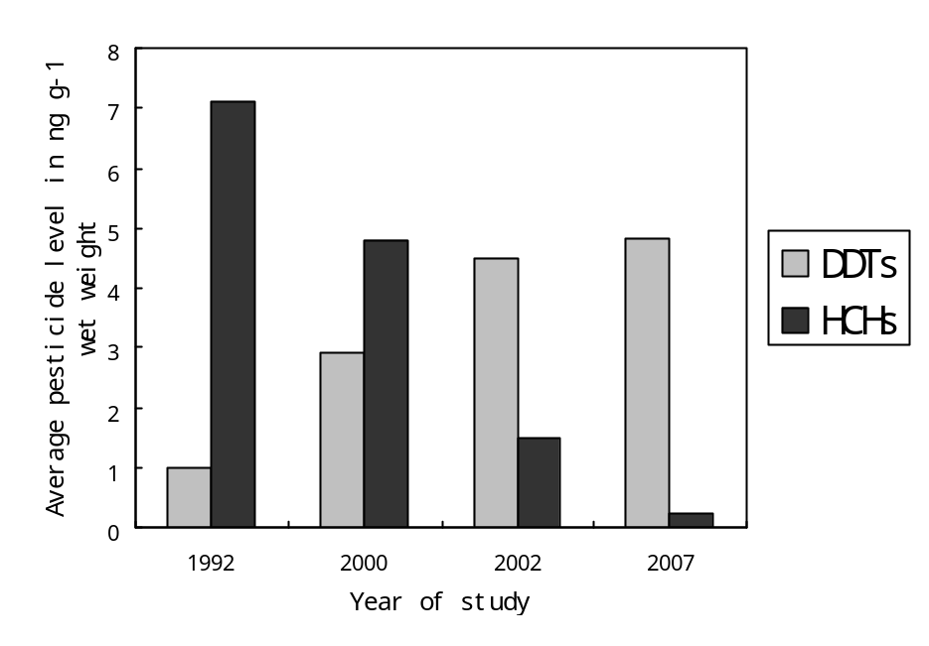
Figure 3
Historical trends of mean total DDTs and total HCHs concentrations (ng g⁻¹ wet weight) in Chinese vegetables during 1992, 2000, 2002 and 2007

5.0 Conclusions
Despite their ban more than two decades ago, HCHs and DDTs were still prevalent in the vegetable samples in this study area. However, most pesticide residues concentrations were lower than the Chinese national and international standards except for o.p’-DDT, p,p’-DDE and ∑DDTs in capsicum (Capsicum annum L), which were determined in concentrations exceeding the Chinese extraneous maximum residue limit (EMRL), indicating potential risks and concerns for public health. The levels were also lower than those reported for vegetables from many other countries. A comparison with previous findings indicated a continuous decline in HCHs concentrations and a gradual increase in DDTs in Chinese vegetables since 1992. Elimination of the agricultural uses of dicofol and agricultural and other sources of lindane would be expected to check OCPs pollution in the present study area and even in China. Although the levels were quite low a deeper investigation was necessary in order to establish the sources of OCPs especially in capsicum and radish with a view to preventing their contamination with OCPs for the consumer safety.

Acknowledgement

This study was part of the project financed by the Natural Science Foundation of China under Grant No. 40473043 and Geological Survey of Sichuan Province, People’s Republic of China. We thank Su Qiuke and the environmental organic Chemistry post graduate students of China University of Geosciences (Wuhan), who helped with the collection and /or extraction of the samples.

Correspondence to: Odhiambo Joshua Owago, International cooperation Office, China University of Geosciences, Lumo Road 388, Wuhan, Hubei, 430074, P.R. China
Email: joowago@hotmail.com; Telephone: +86-13720135523; Fax: +86-27-87515956

References

ADB (Asian Development Bank). People’s Republic of China, Western Roads Development Project (Sichuan): Technical Assistance Consultant’s Final Report Vol. IV supplementary appendix 14-Social Assessment, Project No. TA: PRC 4639, March, 2006.
Adeyeye A and Osibanjo O. Residues of organochlorine pesticides in fruits, vegetables and tubers from Nigerian markets. The Science of the Total Environment 1999; 231: 227-233.
Amoah P. Drechsel P., Abaidoo R C, Ntow W J. Pesticide and Pathogen Contamination of Vegetables in Ghana’s Urban Markets. Arch. Environ. Contam. Toxicol. 2006;50: 1–6
Bai Y, Zhou L, Li J. Organochlorine pesticide (HCH and DDT) rResidues in dietary products from Shaanxi Province, People’s Republic of China. Bull. Environ. Contam. Toxicol. 2006;76:422–428.
Barkatina E N, Pertsovsky AL, Murokh V I, Kolomiets ND. Organochlorine Pesticide Residues in Basic Food Products and Diets in the Republic of Belarus Bull. Environ. Contam. Toxicol. 1999;63:235-242.
Bhanti M. and Taneja A. Monitoring of organochlorine pesticide residues in summer and winter vegetables from Agra, India – a Case Study. Environmental Monitoring and Assessment 2005; 10: 341–346
Brown MA, Ruzo LO, Casida JE. Photochemical conversion of a dicofol impurity, R-chloro-DDT, to DDE, Bull. Environ. Contam. Toxicol. 1986;37: 791–796.
Chen J and Gao J. The Chinese total diet study in 1990 Part I. Chemical contaminants AOAC Intl 1993;76, 1193–1205.
Chen, Y., van Wijk M.S., Fu, X.H., Lin C., Zhang, X. An overview of vegetable production in Sichuan province, China. VEGSYS Research project no. PRO1 www.VEGSYS.nl. (undated). http://www.vegsys.nl/files/9f9e444ac40c06e16331d51eb1329c20.pdf accessed July 16, 2008.
Cole RB and Metcalf, R.L. Model ecosystem determination of the metabolic and environmental fate of tetrachloro-DDT, Bull. Environ. Contam. Toxicol. 1987;38: 96–103
Depang L, Leyuan S, Xili L, Xiance Y. A successful control programme for falciparum malaria in Xinyang, China. Trans R Soc Trop Med Hyg 1996;90:100–102
Guo JY, Zeng EY, Wu FC, Meng XZ, Mai BX, Luo XJ. Organochlorine pesticides in seafood products from southern China and health risk assessment. Environmental Toxicology and Chemistry. 2007; 26(6): 1109–1115.
Hamburger, J. Sea of pesticides surrounds China’s organic farms. Global pesticide campaigner 2001;11(3):6.
Hováanszki D, Prokisch J, Gyōri, Z. Case study: Testing of organochlorine pesticide contamination in a backyard garden. Cereal Research Communications 2007;35 (2): 493-496.
Hua X M and Shan Z J. The production and application of pesticides and factor analysis of their pollution in environment in China. Advances in Environmental Science 1996:4, 33–45.
Iwata H, Tanabe S, Ueda K, Tatsukawa R Persistent organochlorine residues in air, water, sediments, and soils from the Lake Baikal Region, Russia. Environ. Sci. Technol. 1995;29:792–801.
Jiang C, Wang Y, Zheng, X, Zhu B, Huang Y, Hao Q. Methane and Nitrous Oxide Emissions from Three Paddy Rice Based Cultivation Systems in Southwest China. Advances in Atmospheric Sciences, 2006;23(3): 415–424.
Lee SA , Daia Q, ZhengaW, Gao YT, Blair A, Tessari J D, Ji B T, Shu X O. Association of serum concentration of organochlorine pesticides with dietary intake and other lifestyle factors among urban Chinese women. Environment International 2007;33:157–163.
Li J, Zhang G, Guo L, Xu W, Li, X, Lee C SL, Ding A, Wan T. Organochlorine pesticides in the atmosphere of Guangzhou and Hong Kong: Regional sources and long-range atmospheric transport. Atmospheric Environment 2007;41:3889–3903.
Li X, Zhu Y, Liu X, Fu S, Xu X, Cheng H. Distribution of HCHs and DDTs in Soils from Beijing City, China Cheng. Arch. Environ. Contam. Toxicol. 2006;51: 329–336.
Li YF, Cai DJ, Singh A. Technical hexachlorocyclohexane use trends in China and their impact on the environment. Arch. Environ. Contam. Toxicol. 1998;35: 688-697.
Liu HZ, Chen HJ, Wang XQ. Chinese total diet study in 1992-pesticide residues. J. Hyg. Res. 1995;24:356-360 (in Chinese).
Manirakiza P, Akinbamijo O, Covaci A, Pitonzo R, Schepens P.Assessment of Organochlorine Pesticide Residues in West African City Farms: Banjul and Dakar Case Study. Arch. Environ. Contam. Toxicol. 2003;44:171–179.
Marco JAM and Kishimba MA. Pesticides and metabolites in cassava, eucalyptus,plum and cashew leaves and roots in relation to a point source in Kibaha, Tanzania. Chemosphere 2006;64: 542–548.
Muntean N, Jermini M, Small I, Falzon D, Fürst P, Migliorati G, Scortichini G, Forti AF, Anklam E, von Holst C, Niyazmatov B, Bahkridinov S, Aertgeerts R, Bertollini R, Tirado C, Kolb A. Assessment of Dietary Exposure to Some Persistent Organic Pollutants in the Republic of Karakalpakstan of Uzbekistan Environ. Health Perspect. 2003;111(10):1306-11.
Nakata H, Kawazoe M, Arizono K, Abe S, Kitano, T, Shimada, H., Li, W., Ding, X. Organochlorine Pesticides and Polychlorinated Biphenyl Residues in Foodstuffs and Human Tissues from China: Status of Contamination, Historical Trend, and Human Dietary Exposure. Arch. Environ. Contam. Toxicol. 2002;43: 473–480
Poon, B. H. T. Leung, C. K. M, Wong C. K. C., Wong M. H Polychlorinated Biphenyls and Organochlorine Pesticides in Human Adipose Tissue and Breast Milk Collected in Hong Kong Arch. Environ. Contam. Toxicol. 2005;49:274–282.
PRC (The People’s Republic of China). Unpub. National Implementation Plan for the Stockholm Convention on Persistent Organic Pollutants Part I. April, 2007 (http://www.pops.int/documents/implementation/nips/submissions/China_NIP_En.pdf accessed July 16, 2008)
Reischl A, Reissinger M, Thoma H, Hutzinger O. Accumulation of organic air constituents by plant surface: part IV. Chemosphere 1989;18:561–568.
Schonherr J.and Riederer, M. Foliar penetration and accumulation of organic chemicals in plant cuticles. Rev. Environ. Contam. Toxicol. 1989;108, 1–70.
Singh PK, Malik A., Sinha S. Persistent organochlorine pesticide residues in soil and surface water of northern Indo-Gangetic alluvial plains. Environ Monit Assess. 2007;125, 147–155.
Strandberg, B. and Hites, R.A. Concentration of organochlorine pesticides in wine corks. Chemosphere 2001;44:729–735.
Sun N, Hao L, Xue J, Jin H, Tian J, Lin R. Multi-residue analysis of 18 organochlorine pesticides in 10 traditional Chinese medicine by gas chromatography (GC). Journal of health sciences 2007;53(4):464-469.
Tao S, Xu F L. Wang X J, Liu W X, Gong Z M, Fang JY, Zhu YM. Luo Organochlorine Pesticides in Agricultural Soil and Vegetables from Tianjin, China Environ. Sci. Technol..2005; 39 (8), 2494 -2499.
Turusov V, Rakitsky V, Tomatis L. Dichlorodiphenyltrichloroethane (DDT): Ubiquity, persistence, and risks. Environ. Health Persp. 2002;110, 125–128.
Wang F, Bian YR, Jiang X, Gao HJ, Yu GF Deng J. Residual Characteristics of Organochlorine Pesticides in Lou Soils. with Different Fertilization Modes Pedosphere 2006;16(2):161-168.
Wang, MQ, Wang ZT, Bai DY, Ran L. Food contamination monitoring and analysis in 2000 in China. Chinese J. Food Hyg. 2002;14: 3-8 (in Chinese).
Wang T, Lu Y, Zhang H, Shi Y. Contamination of persistent organic pollutants (POPs) and relevant management in China. Environment International 2005;31: 813 – 821
Wang, X, Piao, X, Chen J, Hu J, Xu F, Tao S. Organochlorine pesticides in soil profiles from Tianjin, China. Chemosphere 2006; 64:1514–1520.
Willett KL, Ulrich EM, Hites, R.A. Differential toxicity and environmental fates of hexachlorocyclohexane isomers. Environ. Sci. Technol. 1998; 32, 2197–2207.
Yang J, Zhang W, Shen Y, Feng W, Wang X. Monitoring of organochlorine pesticides using PFU systems in Yunnan lakes and rivers, China. Chemosphere 2007;66: 219–225.
Yang N, Matsuda M. Kawano M. Wakimoto T. PCBs and organochlorine pesticides (OCPs) in edible fish and shellfish from China. Chemosphere 2006;63: 1342–1352.
Yang X, Wang S, BianY, Chen F, Yu G, Gu C, Jiang X. Dicofol application resulted in high DDTs residue in cotton fields from northern Jiangsu province, China. Journal of Hazardous Materials 2008;150: 92–98.
Yang Y., Li, D., Mu, D, (2007). Levels, seasonal variations and sources of organochlorine pesticides in ambient air of Guangzhou, China. Atmospheric Environment, doi:10.1016/j.atmosenv.2007.09.061.
Zawiyah, S. Che Man, Y.B., Nazimah, S.A.H., Chin, C.K. Tsukamoto, I., Hamanyza A.H., Norhaizan, I., (2007). Determination of organochlorine and pyrethroid pesticides in fruit and vegetables using SAX/PSA clean-up column. Food Chemistry 102, 98–103
Zhang, B., Zhang, S. Zhou. W., (2006). Investigation and Assessment of Landslides and Debris Flows in Sichuan Province of China by Remote Sensing Technique. Chinese Geographical Science 16(3), 223–228.
Zhou R., Zhu L., Yang K., Chen Y. 2006. Distribution of organochlorine pesticides in surface water and sediments from Qiantang River, East China. Journal of Hazardous Materials, 137(1), 68-75.

3/12/2009

