Performance Evaluation Of A Locally Fabricated Mini Cassava Flash Dryer

K.R. Ajao (Ph.D.)
Department of Mechanical Engineering, University of Ilorin, Ilorin, Nigeria
e-mail: ajaomech@unilorin.edu.ng
I.K. ADEGUN (Ph.D.)
Department of Mechanical Engineering, University of Ilorin, Ilorin, Nigeria
e-mail: kadegun2000@yahoo.com

Abstract
A mini cassava flash dryer was parameterized, developed and tested. The flash dryer is a mechanized way of drying cassava mash for mass production of cassava flour for flour mills, confectionery and pharmaceutical industries. The traditional method of producing cassava flour cannot give product of high quality and quantity for industrial usage because its mode of drying is dependent on climatic conditions and susceptible to contamination. After three passes of cassava mash through the flash dryer, the percentage of dryness achieved was 57.1%.

Keywords: Flash dryer, parameterized, mechanized, industrial uses, percentage of dryness.

1. Introduction
With an estimated population of 120 million people, a land mass of approximately 93,700 square kilometers and vast mineral and agricultural resources, Nigeria has substantial economic potential in its agricultural sector. However, despite the importance of agriculture in terms of employment creation, its potential for contributing to economic growth is far from being fully exploited. The sector’s importance has fluctuated with the rise and fall in oil revenue. Over the past 10 years, Nigerian agricultural sector has remained stagnant while the contribution of the manufacturing sector to the GDP has declined over the same period.
Although efforts at the political level have been intensified to increase the agricultural sector’s contribution to economic growth, there has been no significant impact on employment creation, or improvement in rural incomes. This is because growth in agriculture has been incapacitated by lack of adequate agro industries to spur demand for agricultural raw materials. While various programs have been designed to achieve sustainable agricultural growth, they have mainly focused largely on increasing farm productivity through the maximization of agronomic efficiency. Through the efforts by various agricultural research institutes, technologies for transforming smallholder agriculture have been developed for production through postharvest, but adoption of these remains low. Also, efforts to promote commercialization and agro enterprise development have not received adequate attention [1].
Nigeria is the largest producer of cassava in the world as shown in table 1 below. Its production is currently put at about 33.8 million tonnes a year [2]. Total area harvested of the crop in 2001 was 3.1 million ha with an average yield of about 11 t/ha. Cassava plays a vital role in the food security of the rural economy because of its capacity to yield under marginal soil conditions and its tolerance to drought. It is the most widely cultivated crop in the country; it is predominantly grown by smallholder farmers and dependent on seasonal rainfall. Rural and urban communities use cassava mainly as food in both fresh and processed forms. The meals most frequently eaten in the rural areas are cassava-based.
Cassava production is still carried out by manual labour using local simple farm implements such as hoes and knives in most parts of the country. There is a general absence of mechanized production to the local farmers who constitute the majority of the producers. Cassava roots are processed at household and cottage levels in the rural areas of the major cassava producing states by traditional methods handed down through time as cassava was adopted as food by the people. Processing at these levels involve mainly the production of garri, fermented and unfermented flour, as well as fufu(local delicacy) for both domestic consumption.
The processing of cassava roots into garri, flour and fufu are done involve peeling – grating (mashing) – dewatering/fermentation –sieving – frying – packaging. The process for production of flour involve peeling – cutting into pieces – sun drying – milling – sieving – packaging (for unfermented flour); peeling – cutting – steeping (soaking in water) and fermentation – (mashing) – sun drying –milling – sieving – packaging (for fermented flour). The process for fufu production is similar to fermented flour production except that the sun drying is omitted and the mash dewatered after sieving.
There was no indication of processing cassava root into chips and pellets for animal feeds in the country. Likewise, processing of cassava to value added products like alcohol, dextrins, glue, sweeteners, monosodium glutamate (MSG), modified starch etc are very low in the country and as at present, no bakery uses cassava flour for bread or biscuits [3].

Table 1: Production Levels of Cassava in Nigeria and other major Cassava Producing
Countries (Reproduced from [3] )

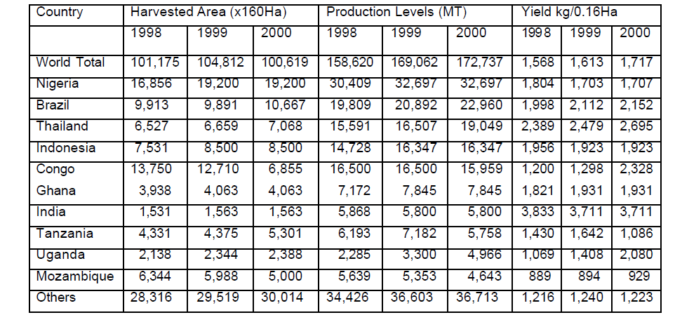

2. Cassava processing and utilization
Cassava is a very versatile commodity with numerous uses and by-products. Each component of the plant can be valuable to its cultivator. The leaves may be consumed as a vegetable, or cooked as a soup ingredient or dried and fed to livestock as a protein feed supplement. The stem is used for plant propagation and grafting. The roots are typically processed for human and industrial consumption.
In Nigeria, the consumption pattern varies according to ecological zones. Garri, a roasted granule is the dominant product and is widely accepted in both rural and urban areas. It can be consumed without any additives, or consumed with a variety of additives such as sugar, groundnut, fish, meat and stew. Fufu and Akpu, a fermented wet paste from cassava is also widely consumed throughout the country especially in the southern zones.
Estimates of industrial use of cassava suggest that approximately sixteen percent of cassava root production was utilized as an industrial raw material in 2001 in Nigeria. Ten percent was used as chips in animal feed, five percent was processed into a syrup concentrate for soft drinks and less than one percent was processed into high quality cassava flour used in biscuits and confectionary, dextrin pre-gelled starch for adhesives, starch and hydrolysates for pharmaceuticals, and seasonings [4].
Cassava processing operations in Nigeria can be described at 5 levels of capacity. The common terms used to describe these capacity levels are household (or cottage), micro, small, medium and large. Household level processing typically does not employ any outside labour. The household consumes virtually all of the processed products and sells a small amount to raise income for additional household needs. At present, most Nigerian processors fall within this category.
At the micro processing capacity the employment of one or two units of labour may take place while processing a variety of cassava products. This enterprise typically uses batch processing. Batch processing may take four hours per day and this would be sufficient for the owner/operator.
Nigeria has a few cassava processors in this category of operation. The small and medium processing operations typically employ three to ten workers and are very sparse at present.
Large scale cassava processing is virtually non-existent in Nigeria. Large-scale operations are enterprises employing 10-30 or more labourers. Large-scale operations would also have the capacity for large tonnage processing with wider marketing opportunities.
Medium to large scale cassava processing equipment and fabricators of this equipment are few and far between in Nigeria. Garri is the only product that is currently able to push the industry from a traditional to a semi-mechanized process. Table 2 below shows daily cassava processing capacity by product and scale of operation in Nigeria.

Table 2. Daily processing capacity by scale of operation and product (Reproduced from [4])
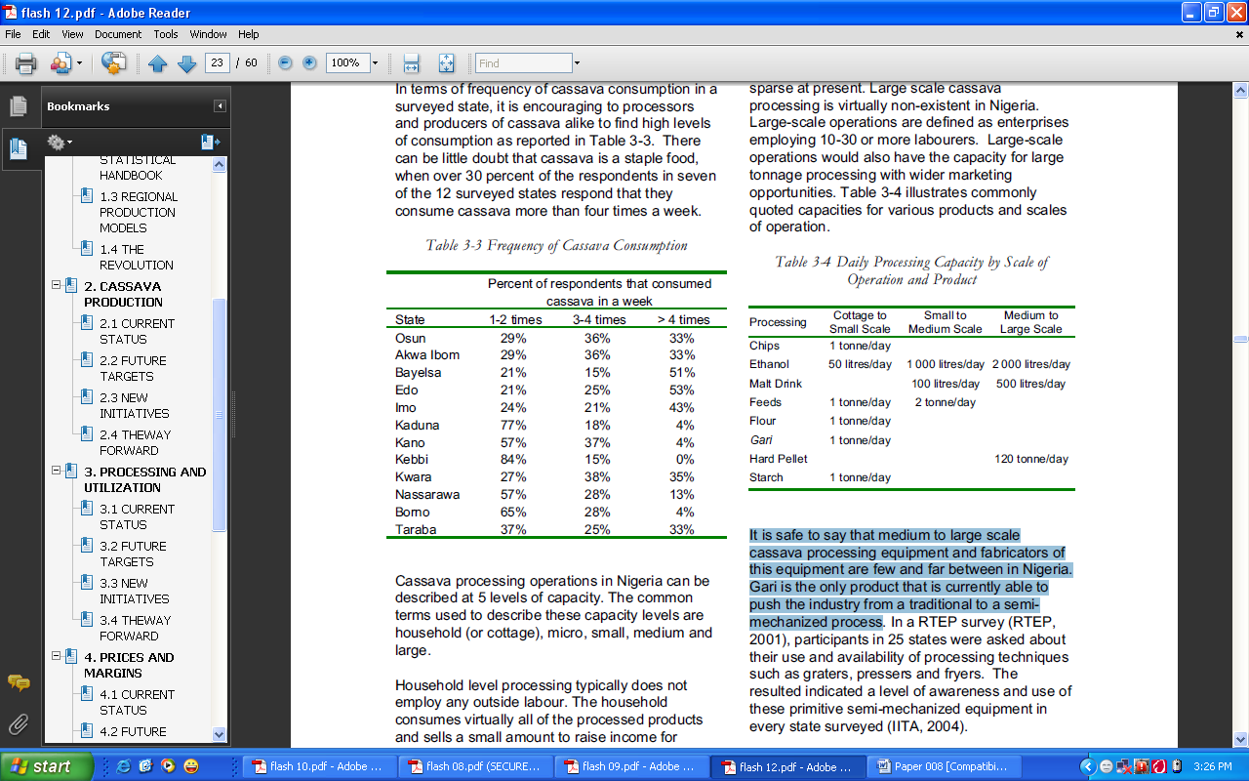
The need for innovative cassava processing technologies is enormous. Traditional cassava processing has a number of undesirable attributes. It is time consuming, provides low yields and lacks storage capacities. Time is spent peeling roots, washing, soaking, wet sieving and copiously adding water before pressing.

3. Cassava utilization in food industries
Most industrial processing of cassava is to produce starch and its by-products. Adhesives are made from cassava starch using simple technologies. These include gums made by gelatinizing starch by heat treatment without any additives and those made by adding different materials.
Starch is a polymer of glucose and hence it is the raw material for glucose. The hydrolysis of starch to glucose can be carried out by acid hydrolysis or enzyme hydrolysis. Starch is suspended in water approximately 25-30% solids, and sufficient HCL is added to bring it to a normality level of 0.01 – 0.02 HCL. It is heated in a converter under a pressure of 0.35kg/cm² for 15minutes and temperature range of 140-160⁰C [5]. Glucose syrup is used widely in the confectionery and pharmaceutical industries.
Fructose syrup has gained importance in view of the harmful effects of synthetic sweeteners. Fructose is four times sweeter than glucose and the conversion of glucose to fructose can be achieved by alkali or by the enzyme glucoisomerase. Maltose is a disaccharide formed from two glucose units and is a reducing sugar. It can be obtained commercially from starch by enzyme treatment.
The process of producing starch-based plastics involve mixing and blending starch with suitable synthetic polymers as stabilizing agents and suitable amount of appropriate coupling, gelatinizing and plasticizing agents.
The Federal Government of Nigeria put in place a policy of ten percent inclusion of High Quality Cassava Flour (HQCF) into wheat flour for Bakery and Confectionery. This policy created a huge demand for HQCF by flour millers. However the government could not properly enforce the compliance of this policy as a result of inadequate supply of HQCF. So also there was a glut of cassava root tubers as a result of insufficient cassava processing facilities.

4. Production of cassava flour using flash dryer
Drying is an energy-intensive process. A pneumatic dryer is used in various branches such as: in the chemical, ceramic, mining, and food industries for drying grains, tubers and their flours. Pneumatic drying can be classified as a gas-solid transport system which provides a continuous convective heat and mass transfer.
A typical example of a pneumatic dryer is the cassava flash dryer. It major components are the heating chamber, flash duct, cyclone and exhaust fan as shown in Figure 1 below. The lumps of wet cassava flour are fed into the flash dyer through the feeder. It enters the drying chamber having a 1000 Watts rated heater and an agitator operated by a 3kW electric motor breaks the lumps of cassava mash into smaller particles. For the drying of cassava residues the transport and heating media is hot air, which is available through direct heating. The large surface for heat and mass transfer, as well as the high turbulence and relative velocities lead to high drying rates.
The mixture of the cassava flour passes through the inlet line and then to the flash duct. In the flash duct, drying take place due to reduction in pressure and the larger space for the air and cassava flour to mix together. From the flash duct through the inlet line, the mixture of cassava flour and hot air enters the cyclone.
Due to large pressure drop in the cyclone, cassava flour drops by gravity and the dried product is then collected at the exit port while hot air proceeds through the exhaust line. Furthermore the dryer needs only a small installation area and impresses with low capital costs in comparison with other types of dryers.

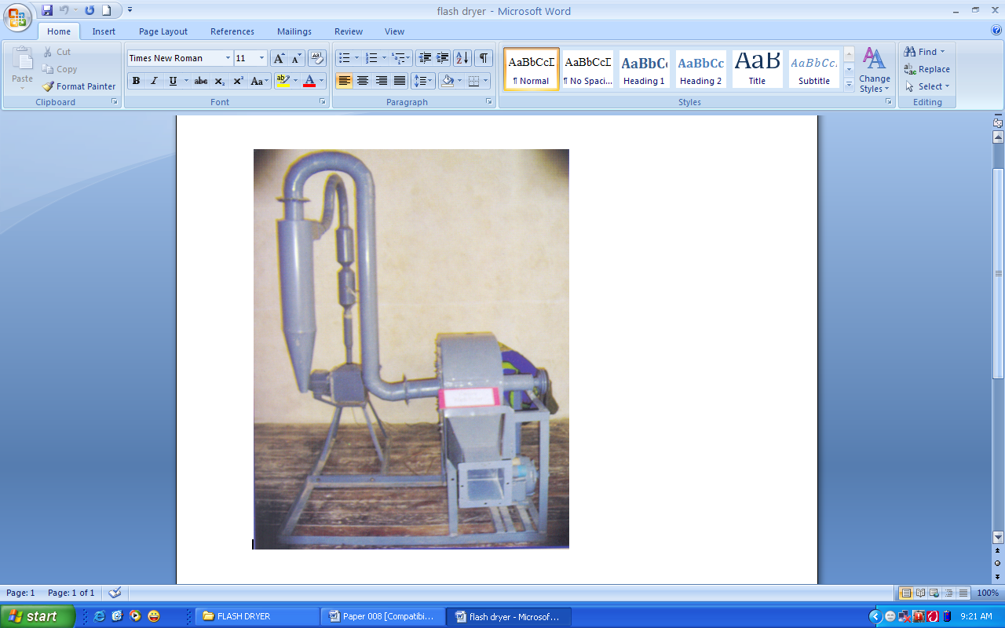
Flash Duct
Cyclone
Blower
Electric motor
Product out
Drying
chamber
Feeder
Figure 1: Locally fabricated mini cassava flash dryer

5. Experimental results and discussion
Pneumatic drying is generally described by the equations of convective heat transfer. The total energy input is necessary for: water evaporation, heating up the dry material and heat losses by radiation. The energy balance shows appropriate relations between the total provided energy, utilized energy, and heat losses in the drying process. The simplified drying system model is composed of four flows i.e. input and output of the drying mediums and the input and output flow of the drying material.
The calculation of the drying processes of a given flow rate of drying material leads to the necessary heat consumption. Therefore the calculation equation energetic balance for a drying process is given by [6]:

Where, 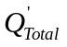 = Total heat supplied (kJ/s)
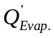= Heat for water evaporation
 = Heat for heating of drying material
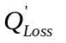= Heat loss
Where, = specific heat capacity of the material (kJ/Kg⁰K)
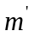= quantity of moist material before drying (kg/s)
,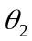= temperature of the material before and after drying (⁰C)
The quantity of drying air m³/s is given by
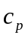= specific heat capacity of air (kJ/Kg⁰K)
= Air temperature at the inlet of the dryer (⁰C)
= Air temperature at the out of the dryer (⁰C)
Specific heat consumption in kJ/kg is given by:
Where, = quantity of evaporated water (kg/s).
During testing of the flash dryer, at the drying chamber temperature of 90⁰C, a sample of 125.6g of cassava mash is fed into the chamber through the feeder. Three passes of the sample was carried out and the percentage drying per pass is calculated:
Initial mass of cassava mash before drying 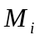= 125.6g
Mass of cassava flour after 1st pass = 58.7g
Percentage dryness after 1st pass 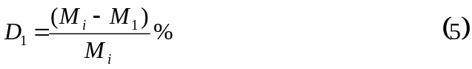
= 53.2%
Mass of cassava flour after 2nd pass 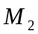= 55.3g
Therefore percentage dryness after 2nd pass 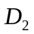= 2.7%
Mass of cassava flour after 3rd pass 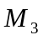= 53.3g
Percentage dryness after 3rd pass 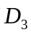 = 1.2%
Hence, 57.1% dryness was achieved after three passes of operation. The mass of cassava flour after the 3rd pass was then oven dried to remove the remaining moisture content of the flour.
Mass of cassava flour after oven drying 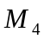= 41.2g
Percentage dryness after oven drying 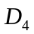 = 10.03%
The dryness curve for the drying operation in the flash dryer is shown in Figure 2 below.
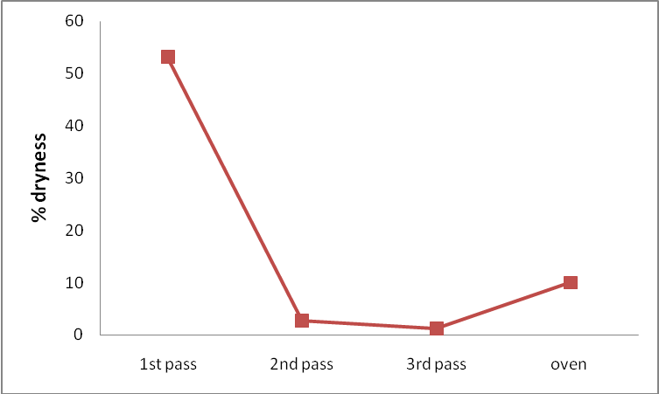
Figure 2. Dryness curve for cassava flour in the flash dryer

6. Conclusion
The parameterization, development and testing were carried out for a mini cassava flash dryer. The percentage of dryness achieved after three passes of cassava mash through the flash dryer was 57.1%. There is a greater need for improvement in component designing, assembly and testing over a period of time.
If cassava is processed and sold only at the primary level, the prospects for cassava as a source of income are limited. Nigeria has demonstrated the importance of cassava as more than a mere subsistence crop, and that a large volume industrial processing system can be developed around this crop. Value addition to cassava is a gradual process and long term survival will necessitate that higher value cassava flour be developed to meet local and international demands.

7. References
[1] IITA (International Institute of Tropical Agriculture). “Preemptive management of the virulent cassava mosaic disease through an integrated cassava development approach for enhanced rural sector economy in the south-south and south-east zones of Nigeria”. IITA, Ibadan, Nigeria, July, 2003.
[2] FAO. “Integrated cassava project”. Food and Agricultural Organization (FAO), December, 2006. Available at www.fao.org . Accessed on 12th December, 2008.
[3] Raw Materials Research and Development Council (RMRDC), Abuja. “Report On Survey Of Selected Agricultural Raw Materials In Nigeria”. October, 2004.
[4] T. P. Phillips, D. S. Taylor, L. Sanni & M.O. Akoroda. “A cassava industrial revolution in Nigeria: The potential for a new industrial crop”. FAO, 2004.
[5] C. Balagopalan. “Cassava Utilization in Food, Feed and Industry”. Journal of Scientific and Industrial Research. 1996.
[6] N. D. Tung & D. Steinbrecht. “Modeling a Combined Heat and Power Cogeneration system in Vietnam with a Fluidized Bed Combustor Burning Biomass”. Agricultural Engineering International: the CIGR Ejournal. Vol. X. December, 2008.

3/10/2009

