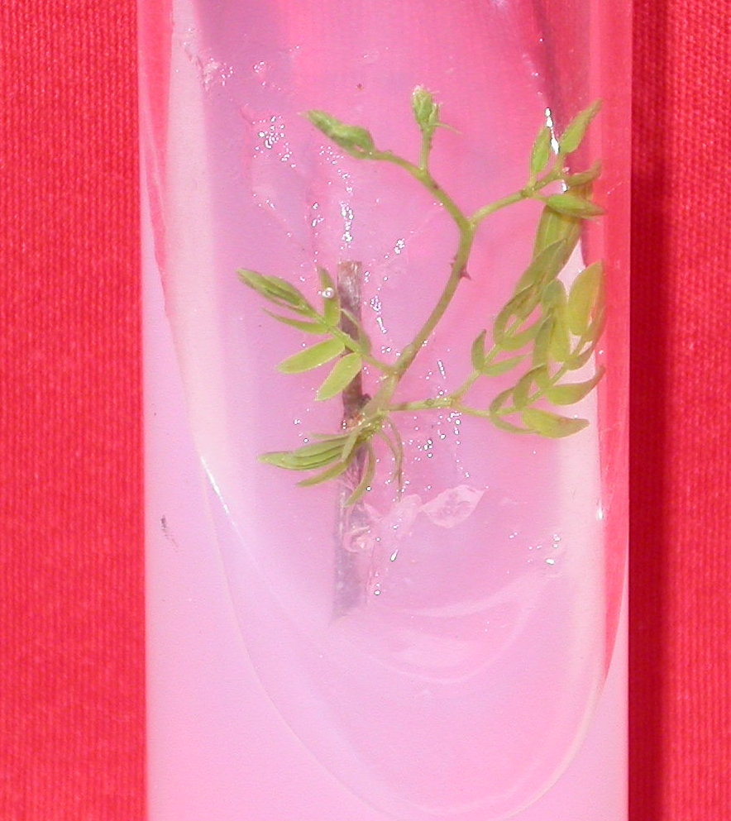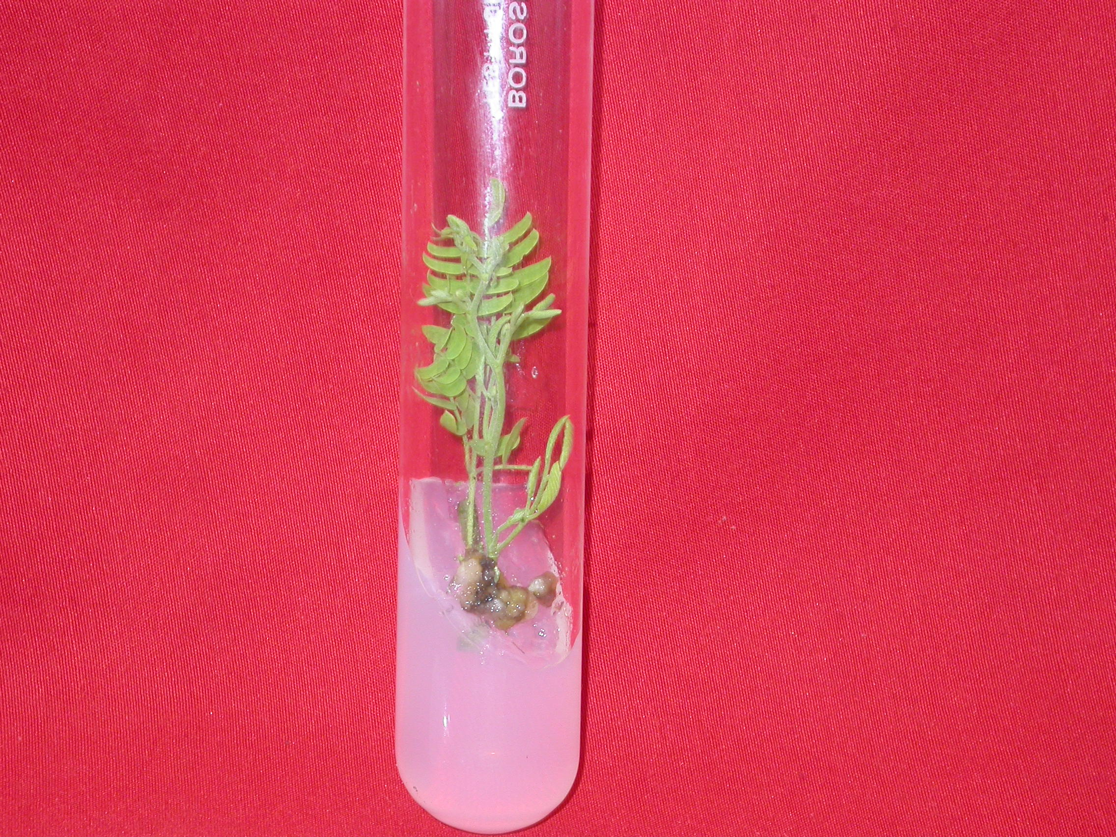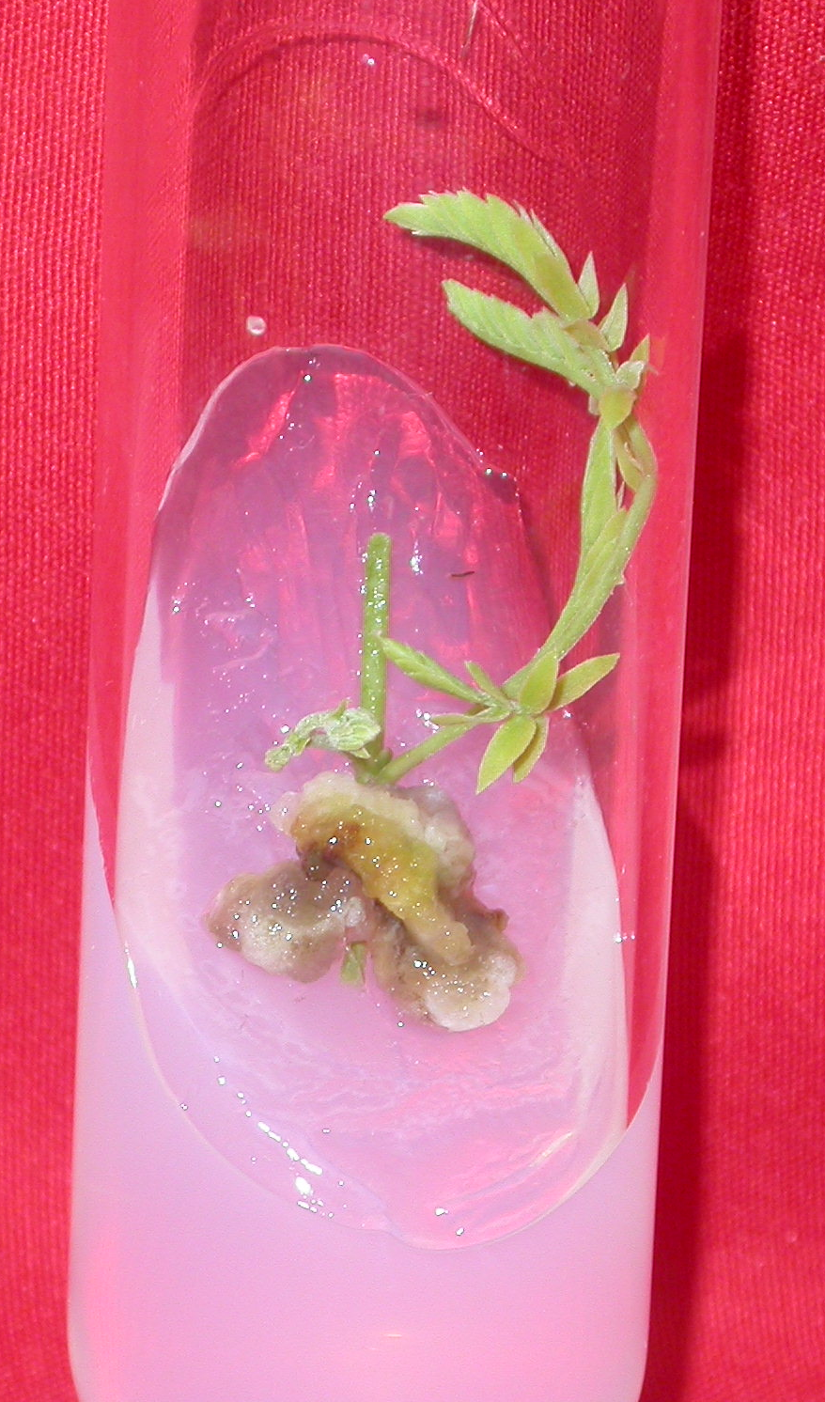
1…….....
2.
3

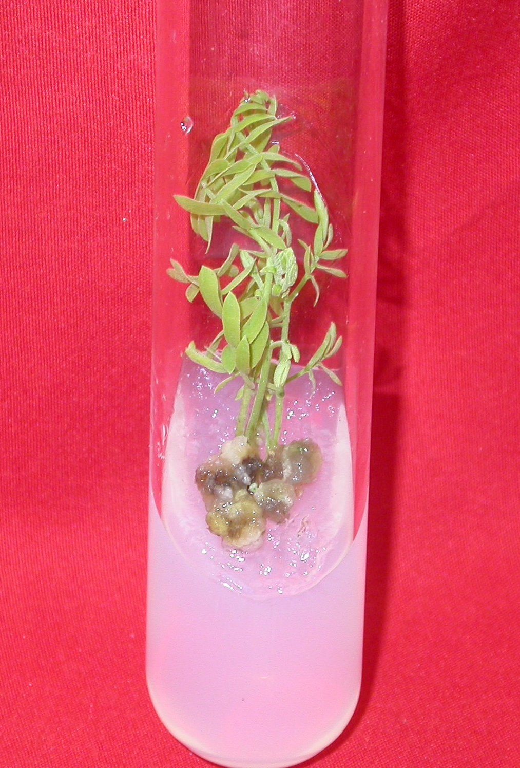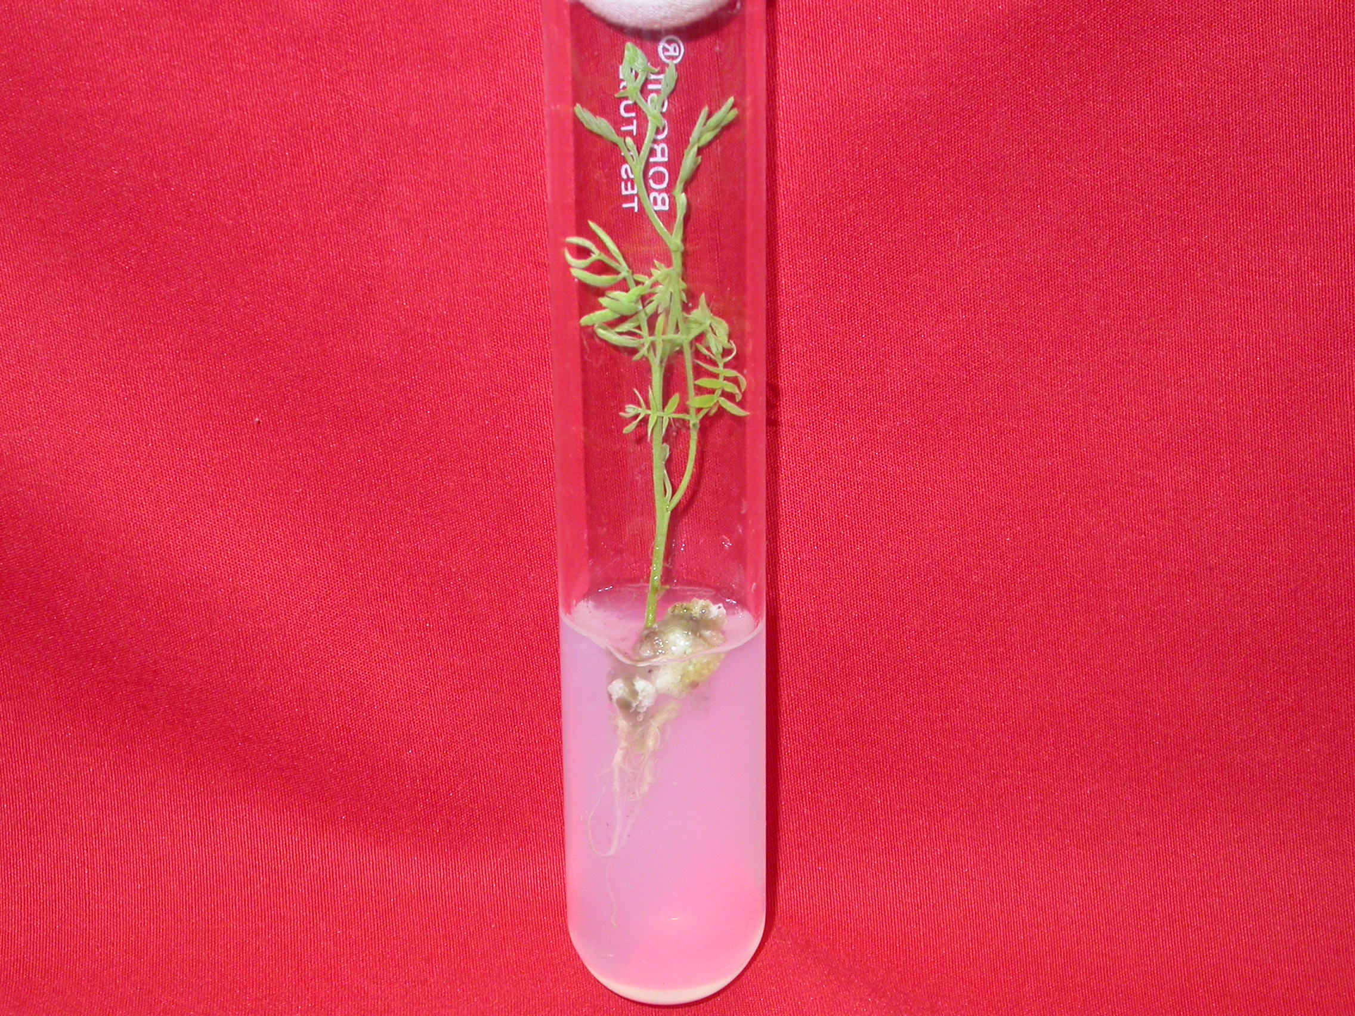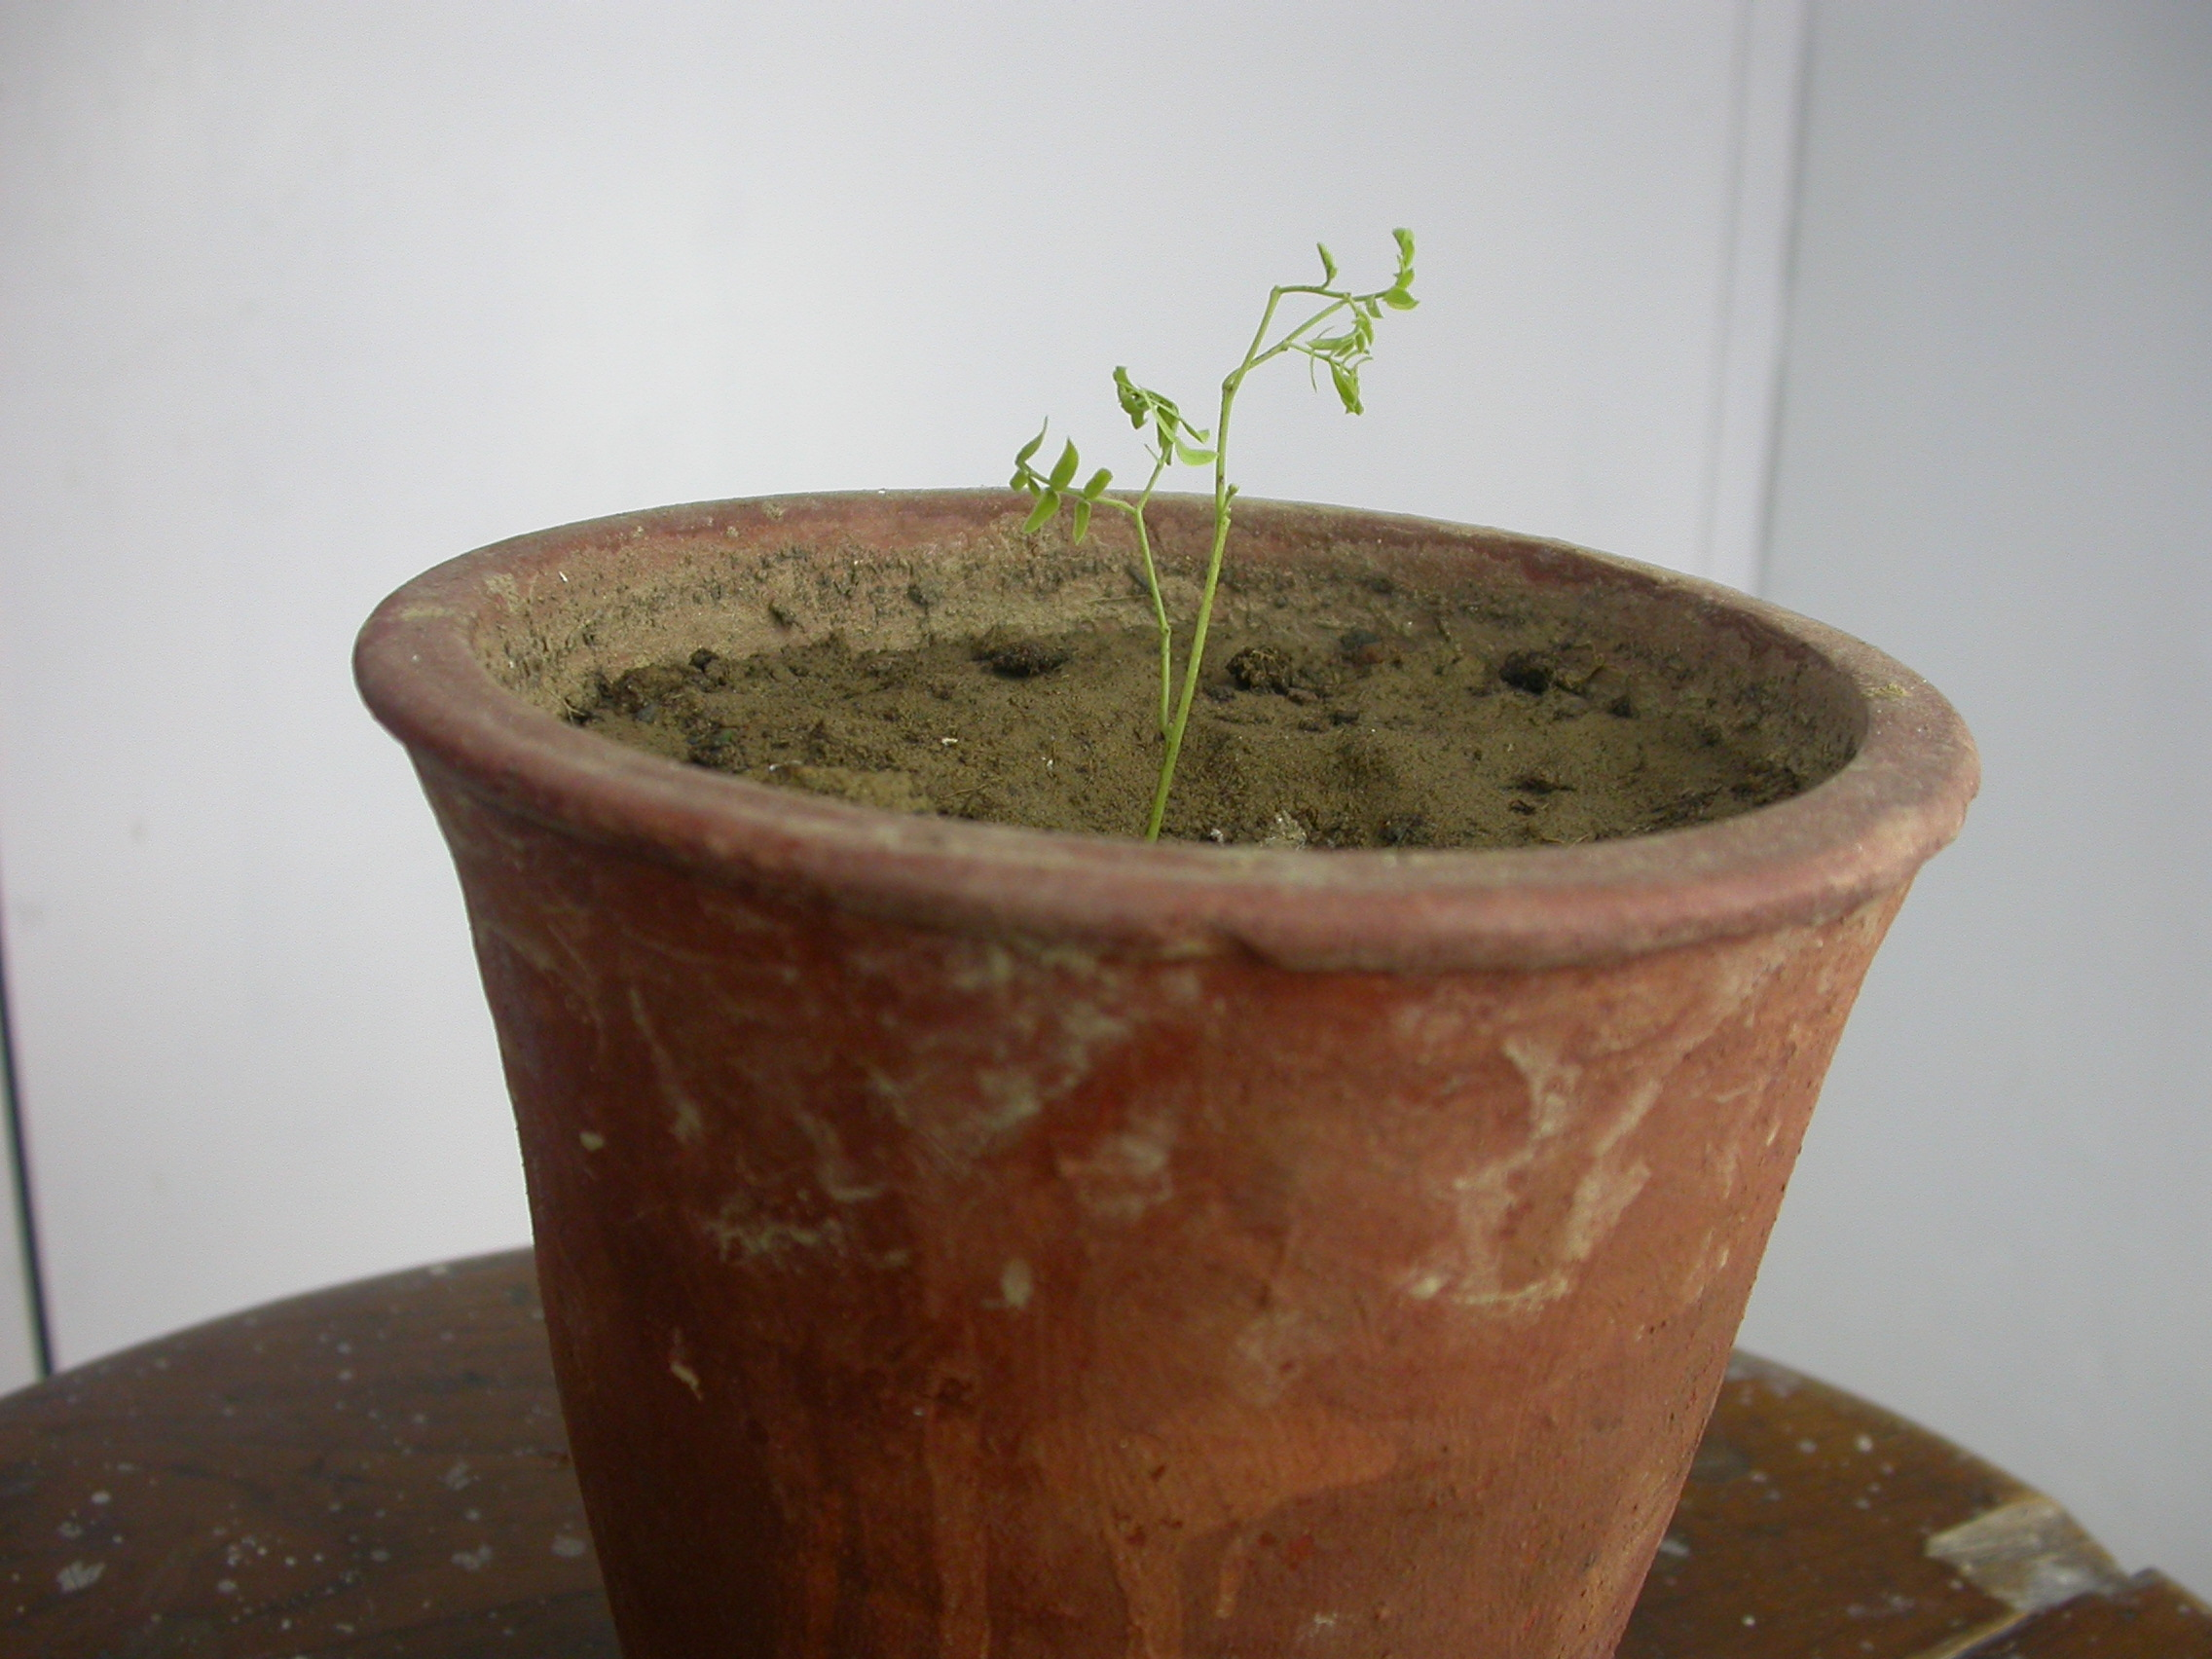
4
5.
6
1
3.
Fig.1 Shoot regeneration from nodal explant on MS +1.0 mg/l Kn.
Fig.2 Callus growth and shoots proliferation on MS+5.0 mg/l BAP.
Fig.3 Development of shoot and callus formation on MS+1 mg/l IAA.
Fig.4 Induction of multiple shoots and callus formation from nodal explant on MS + 5.0mg/l BAP+1.0 mg IAA.
Fig.5 Root formation from in vitro grown shoots on half strength MS + 3.0 mg/l IBA.
Fig.6 Establishment of in vitro grown plantlets under in vivo conditions.

