Microbial Desulfurization of Diesel by Desulfobacterium anilini

¹ Aribike D S, ¹A A Susu, ²S C U Nwachukwu & ³S A Kareem*
¹Department of Chemical Engineering, University of Lagos, Akoka Yaba Lagos Nigeria
²Department of Botany & Microbiology, University of Lagos, Akoka Yaba Lagos Nigeria
³Department of Chemical Engineering, Federal University of Technology Yola Nigeria

sakareem_1@yahoo.co.uk
* Correspondent author

ABSTRACT
The desulfurizing bacterium Desulfobacterium anilini was isolated and subsequently identified by the Department of Botany & Microbiology; University of Lagos, Nigeria. The effects of selective removal of sulfur-containing hydrocarbons in diesel using the Desulfobacterium anilini isolated from petroleum products-polluted soil was investigated in this study. They exhibited very high desulfurizing ability towards diesel at 30⁰C and normal atmospheric pressure. Gas chromatography analysis with a pulsed flame photoatomic detector revealed that the peaks of benzothiophene and dibenzothiophene in diesel significantly decreased after biodesulfurization. At the end of 72 hours, 82% of the analyzed sulfur in diesel was desulfurized by the organism.

INTRODUCTION
The availability of low-sulfur crude has decreased over the last decade as a consequence of the increasing reserves of heavy crude. Terrestrial oil or petroleum deposits, which often contain high levels of sulfurous hydrocarbons, are being increasingly employed for the production of fuels. The concentration of sulfur in crude oil is typically between 0.05 and 5% (by weight), although values as high as 13% have been reported (Rall, 1972). In general, the distributions of sulfur in crude oil increase along with the boiling point of the distillate fractions. As a result, the higher the boiling range of the oil, the higher the sulfur content will tend to be. Upon combustion, the sulfur in fuels can contribute to air pollution in the form of particulate materials and acidic gases, such as sulfur dioxide. To reduce sulfur-related air pollution, the level of sulfur in fuels is regulated, and to meet these regulations sulfur must be removed from fuels during the refining process.
Governments throughout the world have recognized the problems associated with these emissions and moved to reduce them through legislation. Regulations for the sulfur level in diesel oil have become increasingly strict and it was planned to reduce the level to 50 ppm by 2005 in the European Union and Japan. The sulfur content in diesel will probably be less than 10 or 15 ppm (w/w) in the United States and Europe by 2010 (Constanti et al, 1994). To meet regulated sulfur levels, petroleum fuels must be treated to remove organic sulfur.
This is accomplished mainly by hydrodesulfurization (HDS), which converts organic sulfur in the feed to hydrogen sulfide in the presence of a transition metal catalyst and hydrogen. The extent of desulfurization achieved by HDS is determined by the reaction conditions, with higher hydrogen pressures and temperatures giving greater sulfur removal (Speight et al, 1981). In middle distillate (diesel range) fractions, the sulfur that remains after aggressive HDS treatment is typically in the form of Dibenzothiophene (DBT) and its substituents compounds. The most refractory DBTs have substituents at the 4 and 6 positions, which are adjacent o the sulfur moiety and are believed to sterically hinder access of the sulfur atom to the catalyst surface (Kabe et al, 1992). As regulations on sulfur levels in fuels become stricter, more of the HDS-refractory compounds must be removed. As a result, HDS-refractory sulfur compounds represent a significant barrier to reaching very low sulfur levels in the middle and heavy distillate range fuels.
Early work on biodesulfurization focused on organisms that degrade DBT. The pathways involved relied on oxidation and mineralization of the DBT carbon skeleton instead of sulfur removal and thus reduced the fuel value of the desulfurized product (Kodama et al, 1970 & 1973). Recent studies focus on organisms that use a sulfur-selective oxidative pathway to remove sulfur from organic sulfur compounds and are capable of desulfurizing DBT and sterically hindered DBT compounds (Lee et al, 1995). A number of bacteria that use the sulfur-selective oxidative desulfurization pathway have been isolated (Campbell, 1993, Chang et al, 1998, Wang et al, 1994 & Grossman 1996). This pathway involves sequential oxidation of the sulfur moiety and cleavage of the carbon – sulfur bonds. This system consists of two monooxygenases, Dsz and DszC which sequentially oxidize DBT to DBT sulfone and 2-hydroxybiphenyl-2-sulfinic acid, an NADH-flavin mononucleotide oxidoreductase (DszD) which supplies the two monooxygenases with reduced flavin and a desulfinase (DszB) which converts 2-hydroxybiphenyl-2-sulfinic acid to the desulfurized end product 2-hydroxybiphenyl (Denome et al, 1994, Gray et al, 1996 & Piddington et al, 1995).
Previous work on sulfur oxidative pathway has focused on model compounds most especially DBT and little has been reported on the biodesulfurization of real refinery feeds limiting the ability to assess the commercial potential of biodesulfurization.
In this work, Desulfobacterium anilini was isolated and subsequently used to desulfurize diesel obtained from a fuel filling station in Lagos Nigeria.

MATERIALS AND METHODS
The microorganism Desulfobacterium anilini with the ability to desulfurize oil was isolated from oil contaminated soil by enrichment culture. It was suspended in 9 ml of 0.1M sulfur free phosphate buffer solution (pH 7.0) and 1 ml of diesel for the biodesulfurization experiment in a 100 ml Erlenmeyer flask (Rhee et al, 1998). The experiment was performed at 30⁰C with a moderate shaking of 180 rpm in a shaker incubator. Also, the growth of Desulfobacterium anilini in the experimental tube was monitored as described previously (Chukwu and Nwachukwu, 2005).
Thiophene, 2, 5 – dimethyl thiophene, benzothiophene and Dibenzothiophene were analyzed using gas chromatography 5890 Hewlett Packard, equipped with a pulsed flame photoatomic detector (PFPD).

RESULT AND DISCUSSION
Desulfobacterium anilini is a motile, oval to rod like, gram positive, non spore forming microorganism. Biochemical test has shown that it is capable of utilizing various kind of sugar as a source of carbon. However, it is unable to utilize lactose.
In the biodesulfurization experiment, the organism was suspended in a sulfur free phosphate medium and the fuels (diesel and kerosene) to which 2% glucose was added to serve as a source of carbon for the organisms. The addition of the glucose was done to serve as a source of energy since it is easier for the organism to utilize carbon in glucose which is in aqueous phase in which the organism is also suspended if available than in diesel which is oil.
Upon centrifugation of the reaction broth, the cells of Desulfobacterium anilini were observed at the interface of the fuel and the aqueous solution. The observation of the cells of Desulfobacterium anilini at the interface suggests that the organisms did not secret any emulsifier which may alter the molecules of the hydrocarbon in the fuels. Rather, it desulfurized the diesel by increasing its cell surface hydrophobicity so that its adherent capacity to the hydrocarbon is enhanced. Expectantly, the carbon frameworks of the fuel remain intact.
The GC analysis revealed that the fresh undesulfurized diesel contain 9.006 mg/l of benzothiophene and 157.031 mg/l of dibenzothiophene. No thiophene and 2, 5 – dimethyl thiophene were detected in diesel.

Figure 1: GC-PFPD Chromatograms for Diesel before Biodesulfurization.
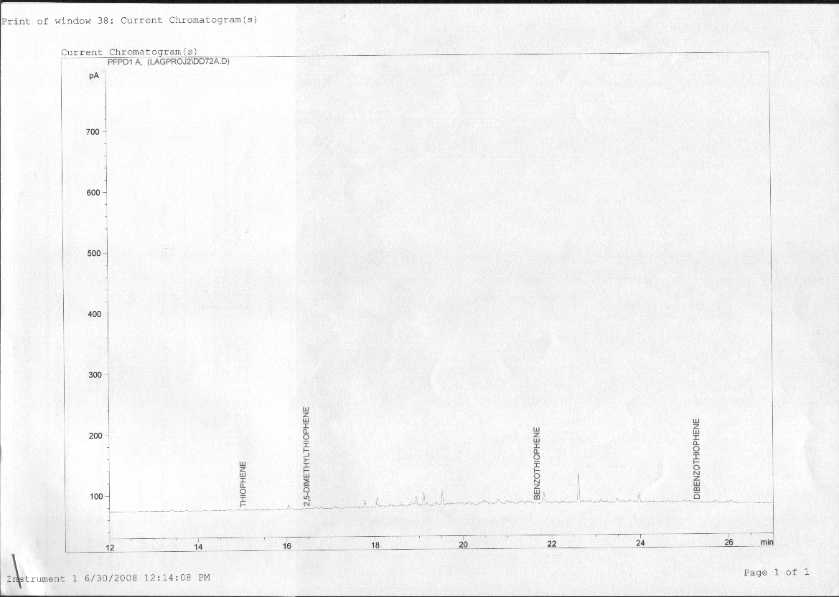

Figure2: GC-PFPD Chromatograms for Diesel 72 hours after Biodesulfurization by Desulfobacterium anilini

It is important to note that the sulfur compounds with retention times longer than 5 minutes nearly disappeared. Such characteristics of desulfurization by cells of Desulfobacterium anilini are opposite or complimentary to those of hydrodesulfurization, in which sulfur compounds with a shorter residence time are more easily desulfurized (Dzidic et al, 1988). Based on these results, cells of Desulfobacterium anilini are considered to have a sufficiently broad substrate specificity to desulfurize major organic sulfur compounds contained in diesel.
The concentration-time profiles for the biodesulfurization of benzothiophene and Dibenzothiophene in diesel by Desulfobacterium anilini are shown below:
Figure 3 below shows the concentration-time profile for the biodesulfurization of benzothiophene. It showed that Desulfobacterium anilini steadily desulfurized the benzothiophene decreasing its concentration to 1.681 mg/l at the end of 72 hours. This represents 81% biodesulfurization of this diesel component. Similarly, Figure 4 below shows that Desulfobacterium anilini also desulfurized dibenzothiophene steadily reducing its concentration to 28.318 mg/l at the end of 72 hours. This represents 82% biodesulfurization of this diesel component.
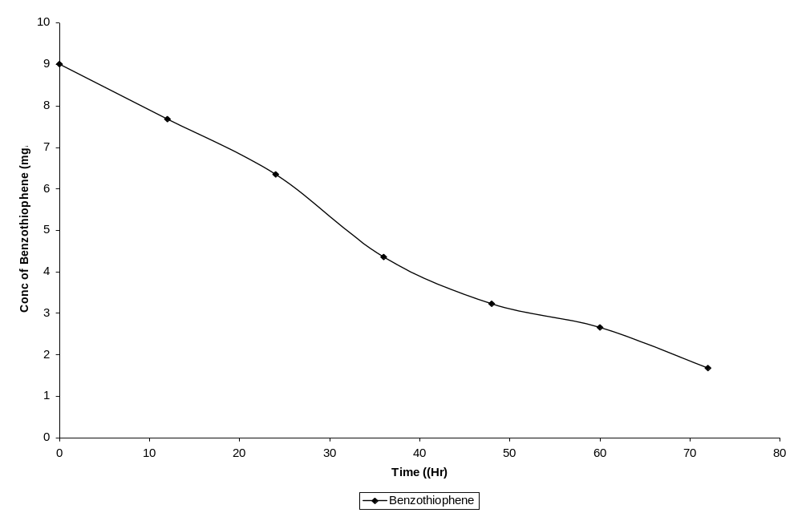
Figure 3: The Concentration-Time Profile of Benzothiophene Biodesulfurization by Desulfobacterium anilini
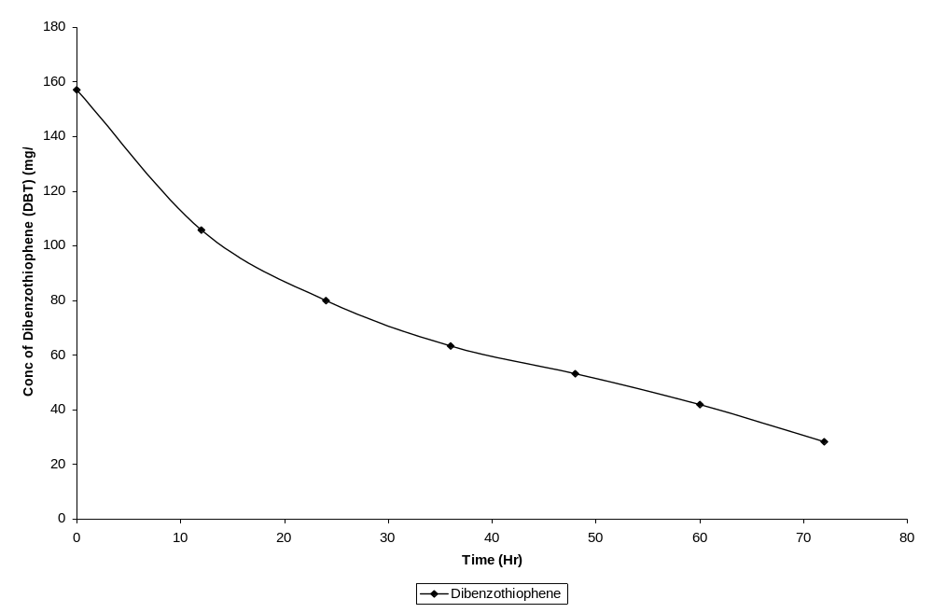
Figure 4: The Concentration-Time Profile of Dibenzothiophene Biodesulfurization in Diesel by Desulfobacterium anilini.
This is a remarkable feat at a reaction temperature of only 30⁰C, extremes of reaction conditions would have been employed in hydrodesulfurization to attain the same level of desulfurization if at all sulfur heterocycles like Dibenzothiophene would be desulfurized.
The extent of biodesulfurization of the benzothiophene and Dibenzothiophene is steadily rising as shown in figure 5 below.
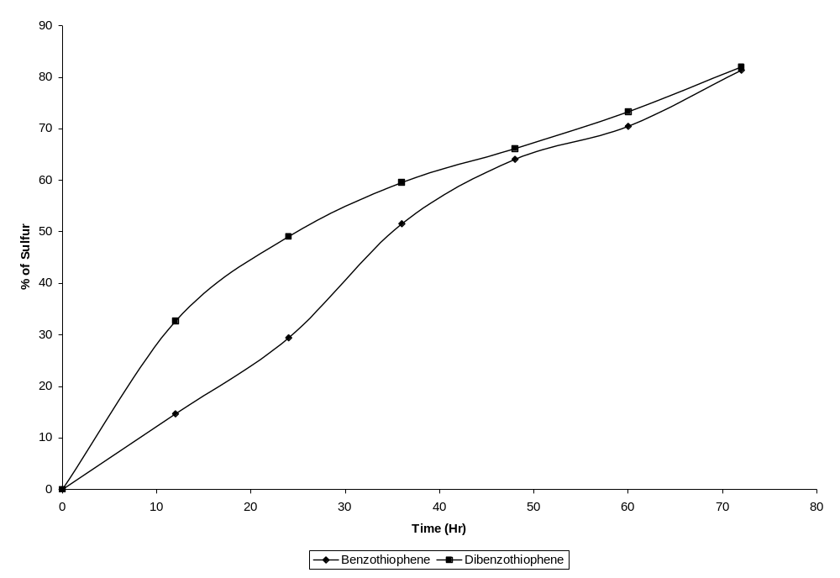
Figure 5: The Percentage Desulfurization -Time Profile of benzothiophene and dibenzothiophene Biodesulfurization by Desulfobacterium anilini

The first step in the biodesulfurization of these molecules is the transfer of the molecules from the oil to the cells. It appears that these molecules are transferred directly from the oil into the cells. Many microorganisms have been shown to metabolize many insoluble molecules in this fashion. The PASHs appear to partition to the water before being brought into the cell. The enzyme responsible for the first two oxidations are to reflect the reaction it catalyzes and has been coded DszC. It catalyzes the oxidation by transferring an electron from flavin mononucleotide (FMNH₂) to the organosulfur (the benzothiophene and dibenzothiophene) to produce FMN an oxidized (FMNH₂) and sulfoxides of benzothiophene and dibenzothiophene and also the oxidation of sulfoxides by transferring an electron from flavin mononucleotide (FMNH₂) to produce FMN an oxidized (FMNH₂) and the corresponding sulfones.
The first cleavage of the C-S bonds is catalyzed by sulfone monooxygenase (FMN H₂: XO₂ oxidoreductase); DszA codes this enzyme. It transfers another electron from FMNH₂ to XO_{2.} Where X is the organosulfur compound.
The production of sulfite & subsequently sulfate and an intact hydrocarbon molecule is the last reaction in the pathway. This is catalyzed by a desulfinase coded by the DszB gene and leads to the release of the sulfur as sulfite and the production of the corresponding hydroxyl phenyl.
In nature, the cell has achieved its goal. It has the sulfur it needs for metabolism. The sulfite can be reduced to sulfide and incorporated into sulfur-containing amino acids and vitamins necessary for growth.
It is worthy of note that this study focused on real fuel rather than modeled media of organosulfur compounds. This implies that the organism can survive in the fuel till it removes all the sulfur in it.
In conclusion, it has been confirmed that Desulfobacterium anilini could effectively desulfurize organosulfur compounds, benzothiophene and dibenzothiophene through a sulfur-specific degradation pathway with the selective cleavage of C-S bonds at ambient temperature and pressure conditions. Therefore, Desulfobacterium indolicum may be a useful desulfurizing biocatalyst possessing broad substrate specificity toward organosulfur compounds.

REFERENCES
Campbell I M (1993). An Orphaned Child Makes Good The Story Of US DoE/PETCs Foray Into Fossil Fuel Biodesulfurization. Am. Chem. Soci. Divi Petroleum Chem. Preprints 38(2): 275 – 278.
Chang, Y. K., S. K. Rhee, J. H. Chang and H. N. Chang, (1998), Desulfurization of Dibenzothiophene and Diesel Oils by a Newly Isolated Gordona sp. Strain, CYKS 1. Appl. Environ. Microbiol., 64, 6, 2327—2331.
Chukwu L O and S C U Nwachukwu (2005). Impact of Refined Petroleum Spills on Water Quality, Macro-Invertebrate and Microbial Communities of a Typical Aquatic Environment. J Environ. Biol. 26(3), 449 – 458.
Constanti M., A., Bordons and G. Jaume, (1994), Degradation of Dibenzothiophene by Pseudomanas putida Lett. in microbiol., 18, 107—111.
Denome S A, C Oldfield, L J Nash and K D Young (1994). Characterization of the Desulfurization Genes from Rhodococcus Sp. Strain IGTS8. J Bacteriol. 176: 6707 – 6716.
Dzidic I, M D Balicki, I A I Rhodes and H V Hart (1998). Identification and Quantification of Nitrogen and Sulfur Compounds in Catalytically Cracked Heavy Oils by Isobutene/CI GC/MS and GC Using Selective Detectors. J Chromatogr. Sci 26: 236 – 240.
Gray K A, O S Pogrebinsky, G T Mrachko, L Xi, D J Monticello and C H Squires (1996). Molecular Mechanisms of Biocatalytic Desulfurization of Fossil Fuels. Nat. Biotechnol. 14: 1705 – 1709.
Grossman M J (1996). Microbial Removal of Organic Sulfur from Fuels: A Review of Past and Present Approaches. Hydro Treating Technology for Pollution Control: Catalysts, Catalysis & Processes. In M L Occelli and R Chianelli (Ed). Marcel Dekker New York NY 345 – 349.
Kabe T, A Ishihara and H Tajima (1992). Hydrodesulfurization of Sulfur-Containing Polyaromatic Compounds in Light Oil. Ind. Eng. Chem. Res. 31: 1577 – 1580.
Kodama K., K. Umehara, K. Shimizu, Y. Minoda and K. Yamada, (1973), Microbial Conversion of Petro-Sulfur Compounds, Final Part, Isolation of Microbial Products From Dibenzothiophene And Its Proposed Oxidation Pathway. Agr. Biol. Chem. 37: 45 – 50.
Kodama K., S. Nakatani, K. Umehara, K. Shimizu, Y. Minoda and K. Yamada, (1970), Isolation and Identification of Products from Dibenzothiophene. Agr. Biol. Chem., 34(9) 1320 – 1324.
Kraweic S. and P. Wang, (1994), Desulfurization Of Dibenzothiophene To 2- Hydroxybiphenyl By Some Newly Isolated Bacterial Strains, Arch. Microbiol., 161, 266 – 271.
Laborde A and D T Gibson (1977). Metabolism of Dibenzothiophene by Beijerinckia Species. Appl. Environ. Microbiol. 34: 783 – 790.
Lee M K, J D Senius and M J Grossman (1995). Sulfur-Specific Microbial Desulfurization of Sterically Hindered Analogs of Dibenzothiophene. Appl. Environ. Microbiol. 61: 4362 – 4366.
Piddington C. S., B. R. Kuvacevich and J. Rambosek, (1995), Sequence and Molecular Characterization of a DNA Region Encoding The Dibenzothiophene Desulfurization Operon of Rhodococcus Sp. IGTS 8, Appl. Environ. Microbiol. 61, 468 – 475.
Rall H T, C J Thompson, H J Coleman and R L Hopkins (1972). Sulfur compounds in crude Oil. Bulletin 659. U S Bureau of Mines, Washington D C
Rhee S K, J H Chang, Y K Chang and H N Chang (1998). Desulfurization of Dibenzothiophene and Diesel oils by a Newly Isolated Gordona strain CYKS 1. Appl. Environ. Microbiol. 64(6), 2327 – 2331.
Speight J G (1981). The Desulfurization of Heavy Oils and Residua. Marcel Dekker New York NY
Wang P and S Kraweic (1994), Desulfurization of Dibenzothiophene to 2- Hydroxybiphenyl by Some Newly Isolated Bacterial Strains, Arch. Microbiol., 161, 266 – 271.

2/28/2009

