EPIDEMIOLOGY OF CHLAMYDIA BACTERIA INFECTIONS- A REVIEW

BY

*ADETUNDE, I.A; KODUAH, M; AMPORFUL, J.K; DWUMMOH – SARPONG, A
NYARKO, P.K; ENNIN, C.C; APPIAH, S.T
UNIVERSITY OF MINES AND TECHNOLOGY
FACULTY OF ENGINEERING
DEPT. OF MATHEMATICS
TARKWA. GHANA.

- Corresponding Author.
Email:Adetunde@gmail.com

ABSTRACT
In this paper we study the Chlamydia Bacteria Infections. The authors especially try to find the effect of these bacteria infections in human beings. We reviewed the existing models and outlined what Chlamydia causes.
Key Words: Chlamydia, Chlamydia trachomatis, Sexually transmitted diseases (STDs), pelvic inflammatory disease (PID), epididymitis, lymphogranuloma venereum, proctitis

INTRODUCTION
A lot of work has been reported dealing with Chlamydia. Relevant publications are Thylefors et al., (1995); Ward (1995); Aldous et al., (1992); Campbell and Kuo, (2003); Mathews et al.,(1999); Shaw et al., (2000); Hsia et al., (1997); Fields and Hackstadt (2000); Fields et al., (2003); Rockey and Matsumoto,(1999); Beagley and Timms, (200); Wilson et al., (2003); (2004); Yang and Brunham, (1998); Dreses – Werringloer et al., (2001) and Magee et al.,(1995) to mention but a few .
Chlamydia is a sexually transmitted disease caused by an organism called Chlamydia trachomatis, which is considered to be a type of bacteria. The National Institute of Allergy and Infectious Diseases estimate that the cost of Chlamydia infections and subsequent complications exceeds $2 billion annually.
Sexually transmitted diseases (STDs) are among the most common infectious diseases in the United States today, affecting more than 13 million men and women annually. Among the more than 20 STDs that have now been identified, chlamydia is the most frequently reported, with an estimated 4 million new cases each year. In Illinois, there were 50,559 cases of chlamydia reported in 2005. Most of these cases--71 percent--occurred among persons 15- to 24-years-old.
Chlamydia is known as a "silent" disease because 75 percent of infected women and at least half of infected men have no symptoms. If symptoms do occur, they usually appear within 1 to 3 weeks of exposure. Symptoms, if any, might include an abnormal vaginal discharge or a burning sensation when urinating. The infection is often not diagnosed or treated until there are complications.
The infection first attacks the cervix and urethra. The infection spreads from the cells of cervix to the uterus, to fallopian tubes, ovaries and cause pelvic inflammatory disease (PID). Some women may still have no signs or symptoms, which is why it is often transmitted from one sexual partner to another without either knowing. However, if they do have symptoms, they might have lower abdominal pain, pain in the lower pelvic region, low back pain, nausea, fever, pain during sex, pain on passing urine, frequency passing urine, bleeding between menstrual periods and an examination may show a yellowish pussy inflammation of the cervix. Women are often reinfected, meaning they get the STD again, if their sex partners are not treated. Reinfections place women at higher risk for serious reproductive health complications, including infertility. If untreated, chlamydia infection can cause serious reproductive and other health problems. Like the disease itself, the damage that chlamydia causes is often "silent", that is pelvic inflammatory disease (PID). This happens in up to 40 percent of women with untreated chlamydia. PID can cause:
- Infertility. This is the inability to get pregnant. The infection scars the fallopian tubes, keeping eggs from being fertilized.
- An ectopic or tubal pregnancy. This means that a fertilized egg starts developing in the fallopian tube instead of moving into the uterus. This is a dangerous condition that can be deadly to the woman.
- Chronic pelvic pain. Pain that is ongoing, usually from scar tissue.
Women who have chlamydia may also be more likely to get HIV, the virus that causes AIDS, from a person who is infected with HIV. Because of the symptoms associated with chlamydia, infected individuals have a three- to five-fold increase in the risk of acquiring HIV (the virus that causes AIDS) if exposed to the virus during sexual intercourse.
In people having anal sex with a partner who has chlamydia, the bacteria can cause proctitis, which is an infection of the lining of the rectum. The bacteria causing chlamydia infections can also be found in the throats of people who have oral sex.
In pregnant women, chlamydia infections may lead to premature delivery. Babies born to infected mothers can get infections in their eyes, called conjunctivitis or pinkeye, as well as pneumonia. Symptoms of conjunctivitis include discharge from the eyes and swollen eyelids, usually showing up within the first 10 days of life. Symptoms of pneumonia are a cough that steadily gets worse and congestion, usually showing up within three to six weeks of birth.
Men with symptoms might have a discharge from the penis and a burning sensation when urinating which may range from clear to pussy. Men might also have burning and itching around the opening of the penis or pain and swelling in the testicles/scrotum, or both.This can be a sign of epididymitis, an inflammation of a part of the male reproductive system located in the testicles. Both PID and epididymitis can result in infertility.
Untreated chlamydia in men typically causes infection of the urethra, the tube that carries urine from the body. Infection sometimes spreads to the tube that carries sperm from the testis. This may cause pain, fever, and even infertility.
Other complications include proctitis (inflamed rectum) and conjunctivitis (inflammation of the lining of the eye). A particular strain of chlamydia causes another STD called lymphogranuloma venereum, which is characterized by prominent swelling and inflammation of the lymph nodes in the groin.
Despite the availability of publications on the subject matter, very little had been done on the Chlamydia in developing Countries. Most recently Walraven et al., (2001) emphasized on the burden of reproductive - organ disease in rural women in The Gambia, West Africa. It was recently that Jorn et al., (2008) worked on Chlamydia trachomatis infection as a risk factor for infertility among women in Ghana, this is the first study that investigated the association between C. trachomatis infection and infertility among women in Ghana. In developing countries, data about the prevalence of Chlamydia bacterial infections and their complication, such as infertility, is very scarce because of the fact that reliability test assays are too expensive and too complex for routine use in resource – limited settings.

2 CLASSIFICATION OF CHLAMYDIA
Chlamydia are small Gram-negative cocci and are intracellular parasites. All three species; psittaci, pneumoniae, and trachomatis can cause respiratory tract infections. C psittaci and pneumoniae infections are more frequently found in older children and adults. C trachomatis is usually associated with ocular and genital infection as well as neonatal pneumonia. It rarely causes respiratory tract infections in normal healthy adults. The genus chlamydia comprises of 3 species - C psittaci, C trachomatis and the TWAR agent. C trachomatis is the most common member of the chlamydia genus known to infect man and is most common transmitted by the sexual route; an animal reservoir is not recognized. C psittaci is a zoonotic infection where avian species are the main natural hosts and man becomes incidentally infected. The TWAR agents were considered to be more closely related to C psittaci but now appears to be a single distinct species with no recognized animal reservoir.
- Chlamydia_Psittaci
Human C psittaci infection acquired from psittacine birds (parrots) is termed psittacosis. It is called ornithosis when contracted from other sources. These terms can be unhelpful, particularly when patients with proven C psittaci infection have no known bird or animal contact. C psittaci infection can be acquired from pet birds and also turkeys and ducks. There had been outbreaks associated with duck processing plants.
The incubation period is usually 7 to 10 days. Patients present with a rapid onset of headache, chills, fever and non- productive cough. All patients with community acquired pneumonia should therefore be questioned about recent foreign travel and bird contact. Respiratory symptoms can be absent and these patients may often present with CNS features. Infection may also be associated with other extrapulmonary manifestations such as abdominal pain, vomiting, headache, myalgia, fever, hepatitis, endocarditis and Stevens-Johnson syndrome.
- Chlamydia_Pneumoniae
Previously known as TWAR agents (Taiwan acute respiratory). Serological studies indicate that all C pneumoniae strains are very closely related and genetic studies have shown that they have more than 94% DNA homology with each other but less than 10% homology with the two other chlamydial species. The REA patterns of C pneumoniae isolates are similar to each other, but distinct from other chlamydial species. C pneumoniae infections are distributed worldwide and 20 to 70% of adults have serological evidence of previous infection. Infection is usually acquired by the respiratory route. C pneumoniae is rare in children less than 5 years of age and is most frequently found in schoolchildren and adults. Epidemics occur every few years. 70 to 90% of C pneumoniae infections are subclinical and reinfection may occur. C pneumoniae produces similar clinical symptoms to mycoplasma pneumoniae and respiratory viruses. There are reports linking C pneumoniae to myocardial and endocardial disease.
2.1 METHODS OF DIAGNOSING CHLAMYDIA
- Serology - the CFT is the most widely used method for diagnosing chlamydial infections in the UK. A result of 256 or more is consistent with are recent infection. The micro-immunofluorescence test can be used to distinguish between C psittaci and C pneumoniae species, as is the whole cell-inclusion immunofluorescence test.
- Culture - all chlamydial species can be grown in cell culture. Extreme care must be exercised with respiratory samples as C psittaci is a category 3 pathogen. C pneumoniae is the most difficult species to grow.
- Antigen detection - antigen detection techniques have been widely used to diagnose adult genital and ocular infections and neonatal C trachomatis infection. At present, sputum samples are not routinely submitted for chlamydial diagnosis. Some commercial assays can be used to detect chlamydia in sputum samples.
- PCR - increasing importance is being placed on molecular techniques to diagnose respiratory chlamydial infections accurately, because of difficulties in interpreting serological results and the problems associated with culture of C pneumoniae.
- Antibody Detection ;- Many methods have been employed for the detecting M pneumoniae antibodies in human serum. Methods used for the detection of rising titres of IgG are suitable for patients of all ages. However, methods used for detecting IgM are more suitable for use in younger patients, since IgM is found less frequently in patients experiencing re-infection (hence older patients).
- CFT is the mainstay of routine laboratory diagnosis of M pneumoniae infections. However, antibodies may not be detected by this method 7-10 days after the onset of symptoms and not all culture-positive patients develop CF antibody or a significant rise in titre. It is also very difficult to determine the significance of CFT titres obtained with single samples of serum, unless they are very high. Such high titres can be found many months after infection and so particularly in the months following periods of high incidence of M pneumoniae infection. Demonstration of a fourfold or greater rise in antibody titre is required to be reasonably sure of the diagnosis
2.2 INFECTIONS OF CHYLAMYDIA WITH THE COMPLICATIONS
.Chlamydia_Trachomatis
The chlamydia genus are antigenically diverse, possessing species, subspecies and type-specific antigens but share a common genus-specific lipopolysaccaride antigen (LPS). Within the C trachomatis species, numerous serotypes are recognized.
Serotypes Disease Complications
A-C Trachoma
1-3 Lymphogranuloma venerum
A-K
Male Non-gonococcal urethritis (NGU) Epididymitis
Post-gonococcal urethritis (PGU) Reiter's
Conjunctivitis sexually acquired
Proctitis arthritis (SARA)
Female Mucopurulent cervicites Salpingitis
Urethritis Perihepatitis
Conjunctivitis Endometritis
Proctitis Infertility
Ectopic Pregnancy
Neonates Conjunctivitis Pneumonia
C trachomatis (D-K) cause occulogenital infection and primarily infect the epithelium of the male urethra and the female cervix and urethra. Symptomatic genital infection, presenting as an urethritis, is common in males. Asymptomatic infection in females is much higher, with a reported incidence of approximately 60% in some groups.
A._Genital_Infection_in_Men
Genital C trachomatis infection in men usually presents as an urethritis which may occur concomittantly with a gonococcal infection.
Non-gonococcal_Urethritis_(NGU)
Non-gonococcal urethritis accounts for more than 100,000 cases reported each year by GUM clinics in England and Wales. It is estimated that 30 - 58% of these NGU cases are attributable to C trachomatis infection.
Post-gonococcal_Urethritis_(PGU)
This syndrome occurs in patients who have been infected with both N gonorrhoeae and C trachomatis. As antimicrobial therapy for N gonorrhoeae does not eradicate C trachomatis, post-gonococcal urethritis results from the replication of C trachomatis in the urethra. Isolation of C trachomatis in patients with N gonorrhoeae treatment ranges from 17.5 to 32%. In contrast, the detection rate of C trachomatis in patients treated for N gonorrhoeae infection with urethritis ranges from 38 to 88%.
Complications
A number of complications can arise following infection with C trachomatis. These include epididymitis, Reiter's syndrome, sexually acquired reactive arthritis (SARA), and possibly endocarditis.
There is convincing evidence that epidymitis in younger men (<35) is associated with C trachomatis infection and the organism has been demonstrated in epididymal aspirates. Approximately 50% of the estimated 500,000 annual cases of acute epididymitis in the United States are caused by C trachomatis infection.
The classical triad of Reiter's syndrome comprises of urethritis, conjunctivitis and arthritis. In Asia and Africa, it is primarily related to GI infections but whereas in North America and Europe, it is recognized as a sexually-acquired syndrome following C trachomatis infection. This syndrome is more common in males than females.
B._Genital_Infection_in_Women
In contrast to C. trachomatis infections in males, infection in the female is commonly asymptomatic. However, the consequences of female infection are far more serious. The organism infects and replicates within the epithelium of the cervix and urethra. An ascending infection with involvement of the upper genital tract can result in clinical or subclinical pelvic inflammatory disease (PID), presenting as endometritis, salpingitis or a perihepatitis (Fitz-Hugh Curtis Syndrome). Tubal damage may occur which may lead to infertility and ectopic pregnancy. C. trachomatis is the most important cause of PID in the developed world accounting for 25% - 50% of the one million cases in the U.S.A.
C. trachomatis is recovered from the cervix in 12% - 31% of women attending GUM clinics in the UK. The majority of infections are asymptomatic but C trachomatis has an important role in mucopurulent cervicitis. The recovery of C trachomatis from the cervix of pregnant women attending family planning clinics in the UK is much lower (3%), but is epidemiologically important in the light of the neonatal infections which occur at delivery. C trachomatis has been recovered from the cervix in 10% - 16% of women undergoing termination of pregnancy. This indicates the need to screen women prior to termination of pregnancy if PID following termination is to be avoided.
In addition to cervical infection in women, C trachomatis has also been isolated simultaneously from the urethra. In some cases, C trachomatis can also be isolated from the urethra only. The "acute urethral syndrome" presents as dysuria and frequency and occurs most commonly in young sexually active females.
Pelvic_inflammatory_Disease
C. trachomatis is the most important cause of PID in the Western world and the organism has been recovered from the cervix in 31% of cases. Canicular spread of C trachomatis from the lower genital tract gives rise to symptomatic or subclinical salpingitis. Definitive evidence for the role of C trachomatis in salpingitis has been demonstrated by the direct isolation of the organism from the fallopian tubes in 5% to 30% of women but not from the fallopian tubes of women without salpingitis. Risk factors for PID include the use of an IUD as well as termination of pregnancy in sexually active young women.
Infertility
The consequence of tubal damage may be infertility and the role of C trachomatis is now well recognized. Attempts to demonstrate C trachomatis in the endocervix of infertile women are usually unsuccessful because tubal damage has often occurred years earlier but serological tests are thought to be useful
Perihepatitis
N gonorrhoeae is well established as a cause of acute perihepatitis (Curtis-Fitz-Hugh Syndrome). Women present with right sided upper abdominal pain. There is now good evidence that C trachomatis is also involved. The precise incidence of this syndrome is unknown. The recovery of C trachomatis from endocervical swab is suggestive but not conclusive evidence of perihepatitis and treatment should nonetheless be instigated.
C._Conjunctivitis
Ocular infections caused by C trachomatis are common in sexually active individuals. Usually infection presents, after an incubation period of 1-2 weeks, as a follicular conjunctivitis which may be clinically indistinguishable from a viral infection. Laboratory diagnosis is essential to identify the causative agent.
D._Neonatal_Infection
The risk of neonatal infection at delivery may be more than 50% for pregnant women with active cervical infection. The most common clinical manifestation is neonatal conjunctivitis, which usually presents between the third and thirteenth day of life. The severity of the conjunctivitis may range from a mild "sticky eye" to severe inflammation and discharge and closure of the eye. Chlamydial opthalmia neonatorum is considered to be 3 to 5 times more common than gonococcal opthalmia neonatorum in the U.K. An untreated neonatal infection may lead to a severe pneumonitis between the fourth and twelve weeks of life.
MATHEMATICAL MODEL FORMULATION
According to Wilson (2004), we use the following notations and/or definitions for the human populations.

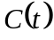: The number of concentration of free extracellular Chlamydia particles.
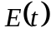: The number of non-infected individual mucosal epithelial cells (main host cell for Chlamydia).
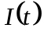: The number of Chlamydia- infected epithelial cells.
Assuming in the given population at time say ; , and denote what had been defined above.
We define the following parameters as follows:

P: is the number of chlamydial particles released from infected cells at a rate of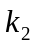 ,
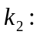is the rate infected cells burst,
: is the rate of clearance by macrophages,
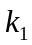: is the rate of epithelial cell infection, which may reduce the antibodies.
:is the rate at which epithelial are produced.
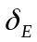: is the rate of epithelial cell natural death, and
: is the rate of clearance of infected cells due to cell- mediated immunity.

In view of the above, we have the following system of differential equations:

EQUILIBRIUM ANALYSIS: The governing system of equations of the model [(i.e. equation (1) to (3) demands that we investigate whether the diseases could attain a pandemic level or it could be wipe out. The equilibrium analysis helps to achieve this, thus we shall have two non – negative equilibrium points namely: the disease – free equilibrium which can also be refers to as the trivial steady state and the endemic equilibrium which can equally been refers to as non – trivial state.
Continuity of the right hand side of the system of equations (1) to (3) and its derivatives imply that the model is well posed. However, the system of equation (1) to (3) has trivial steady state when

and a non-trivial steady state is achieved when
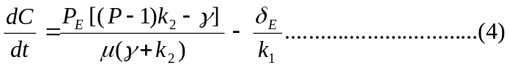
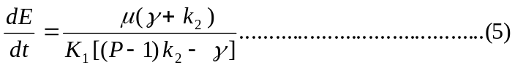

corresponding to clearance of infection and active disease respectively.
The basic reproduction ratio 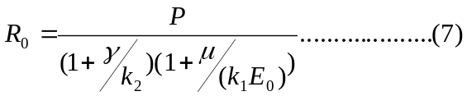
where 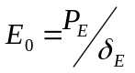.
The trivial steady state is asymptotically stable provided With these conditions we can minimize / clear the infection if and only if the following cases /conditions are satisfied according to Wilson. We shall now briefly emphasize on the three case as discussed by Wilson.
Case i: the macrophage engulfment of the Chlamydial particles occurs prior to host cell infection (). This has to do with tracking the distribution of antibiotics aggregating on Chlamydia particles based on the large number of binding sites and high antibody concentration for its neutralization.
Case ii: the cytotoxic immune response clears cell prior to lysis of the infected cell (). Here chlamydiae have a complex replicative cycle complicating the tracking of intracellular chlamydial particles. The response of chlamydial changes as the number of Cytotoxic T cells increases with time due to immune responsiveness. The assumption here is that the magnitude of the cell- mediated immune response t proportional to the number of replicating forms of Chlamydia particles within a host cell.
Case iii: the number of infectious Chlamydia particles released by an infected cell is reduced (P). Here the Chlamydia’s life cycle is initiated when the infectious, extracellular transmission cell, termed the elementary body (EB), attached to a susceptible host cell. The host cell internalized the EB, where, the EB undergoes morphological changes, reorganizing to the larger reticulate body (RB), the replicative form as Chlamydia. According to Wilson, at this stage, the RBs multiply 200-300 fold by binary fission. At 20 - 25 hours after infection, infectious EBs appears as the EB to RB conversion process is reversed. Some RBs continue to divide whilst others reorganize into EBs, resulting in asynchronous growth, until the host cell cannot support the multiplication any longer. The host cell burst, releasing the EBs, thereby initiating new cycles of infection. Depending on the strain of Chlamydia, the developmental cycle takes between 40 and 72 hours. The metamorphosis of EB to RB includes passage via an intermediate body. Under this case the chlamydial particle that has been induced into abnormal state by either pathway is refer to as an aberrant body. (AB). This case lead to modeling of the developmental cycle.
According to Wilson (2004) the developmental model cycle is given as:

In this model, he used 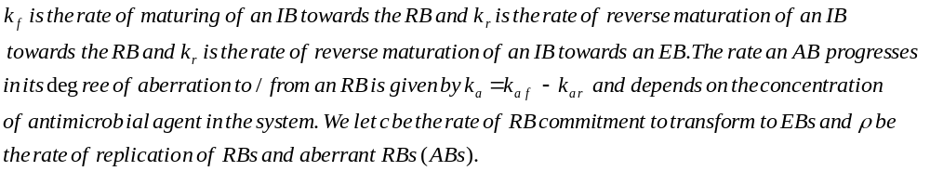
NUMERICAL ANALYSIS
The system of equations (1) to (3) was solved numerically using maple mathematical package. We give numerical simulation of the equilibrium and stability conditions of the governing equations of the model following Wilson (2004), below are some of the hypothetical parameters values used: :
The results of the numerical simulation are shown graphically in fig. (1) – fig. (6) below.

Figure 1
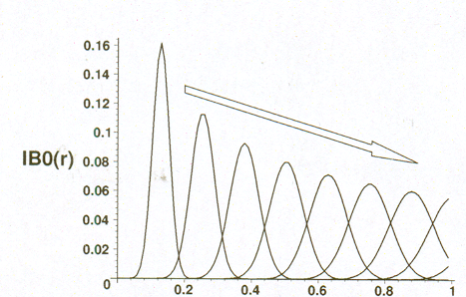

r

Figure 2

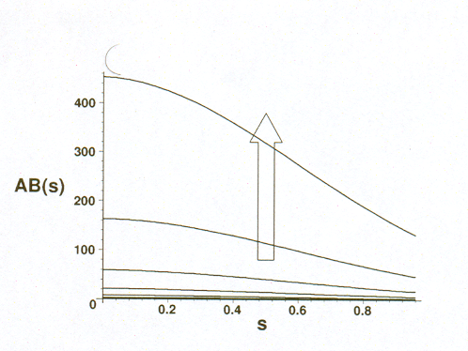

Figure 3

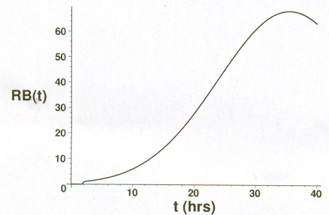

Figure 4

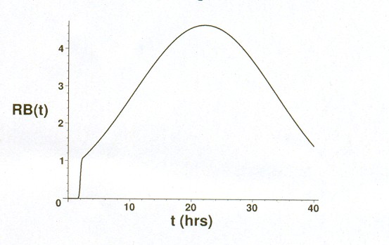

Figure 5

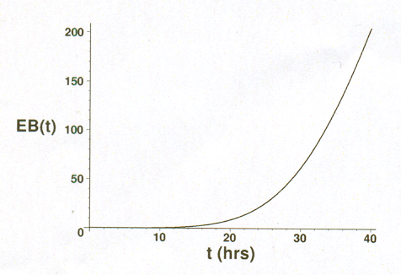

Figure 6

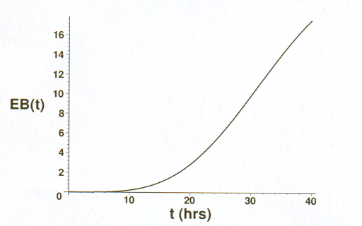

RESULTS
First of all the mathematical model described in the previous section( i.e equations (1) to (3) and particularly equations (8) to (11) that were arrived at by Wilson through his developmental Cycle models have been used to simulate the results shown in figures 1 to 6, by setting the initial conditions 
Using the Central – difference formulars for the derivatives in solving the system of equations ( ) to ( ). It was observed according to ( Wilson, Beagley and Timms) that figure 1 illustrate normal Chlamydial development (persistent AB_{s} been not induced) and persistent chlamydial development ( where 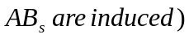.

DISCUSSION
Epidemiology of Chlamydia bacteria infections – A Review was presented to look into the mathematics models developed by Wilson to investigate the three cases stated in previous section, i.e humoral immunity, cell – mediated immunity and within host dynamics. Evidence shown, that most of the recorded chlamydial infection occurs as a result of long term inflammation which leads to fibrosis and scarring. With most of the research work conducted on the subject matter, very little application of it is found in Africa Countries, as the disease and other related problems of Chlamydial infections are now common around the world.

REFERENCES
- Ward, M.E (1995): The Chlamydia developmental Cycle in Pictures.
http:/www.chlamydiae .com/docs/biology/boil_devcycle.htm C207
- Wilson, D.P; Mathews.C;Wan and D.L.S.McElwain (2004): Use of a quantitative
gene expression assay based on micro-array techniques and a mathematical
model for the investigation of chlamydial generation time and inclusion size,
Bulletin of Mathematical Biology, Vol.66Issue 3 Pp 523- 537.
- Aldous, M.B; Grayston,J.T; Wang, S.P and Foy. H.M (1992): Seroepidemiology
of Chlamydia pneumoniae TWAR infection in Seattle families, 1966 – 1979.
Infect.Dis 166, 646
- Campell, L.A and Kuo,C.C.(2003): Chlamydia pneumoniae and
atherosclerosis.Semin.Respir.Infect.18, 48
- Mathew, S.A; Volp,K.M and Timms, P. (1999): Development of a quantitative
gene
expression of factors. FEBS Lett. 458,354.
- Hasia, R.C; Pannekoek, Y; Ingerowski,E; and Bavoil, P.M (1997): Type III
Secretion genes identify a putative virulence locus of Chlamydia, Mol.
Microbiol.25, 351.
- Rockey, D.D; Matsumoto, A. (1999): The Chlamydia development al cycle. In:
Brun, Y.V.,Shimkets, L.J. (Eds), Prokaryotic Development. ASM Press,
Washington,DC, Pp 403- 425.
- Fields, K.A; Mead, D.J; Dooley,C.A and Hackstadt, T. (2003): Chlamydia
trachomatis type III secretion: evidence for a functional apparatus during early –
cycle development, Mol. Microbiol.48,671
- Fields, K.A and Mead, Hackstadt, T. (2003): Evidence for Chlamydia
trachomatis CopN by a type III secretion mechanism, Mol. Microbiol.38,1048.
- Beagley, K.W. and Timms, P (2000): Chlamydia trachomatis infection:
incidence, health cost and prospects for vaccine development, J. of Reproductive
Immunology. 48: 47- 68, C209
- Dreses – Werringloer, U, Padubrin, I and Kohler, L (2001): Effects of Azithromycin and Rifampin on Chlamydia trachomatis Infection in Vitro, Antimicrob. Agents Chemother; 45: 30001 – 30008, C208.
- Magee, D.M; Williams, D.M; Smith, J.G ; Bleicker , C.A; Grubbs, B.G; Schacter, J and Rank, R.G (1995): Role of CD8 T Cells in Primary Chlamydia Infection,. Infect. Immun., 63: 516 – 521, C203.
- Wilson, D.P; Timms, P; and D.L.S.McElwain (2003): A mathematical model for the investigation of the Th1 immune response to Chlamydia trachomatis. Math. Biosci., 182: 27 – 44. C206.
- Yang, X and Brunham, R.C (1998) T lymphocyte immunity in host defence against Chlamydia trachomatis and its implication for vaccine development. Canadian J. Infect. Dis., 9: 99- 108. C203
- Shaw, E.I; Dooley, C.A; Fischer, E.R; Scidmore, M.A; Fields, K.A and Hackstadt, T (2000): Three temporal classes of gene expression during the Chlamydia trachomatis developmental Cycle. Mol. Microbiol. 37, 913.

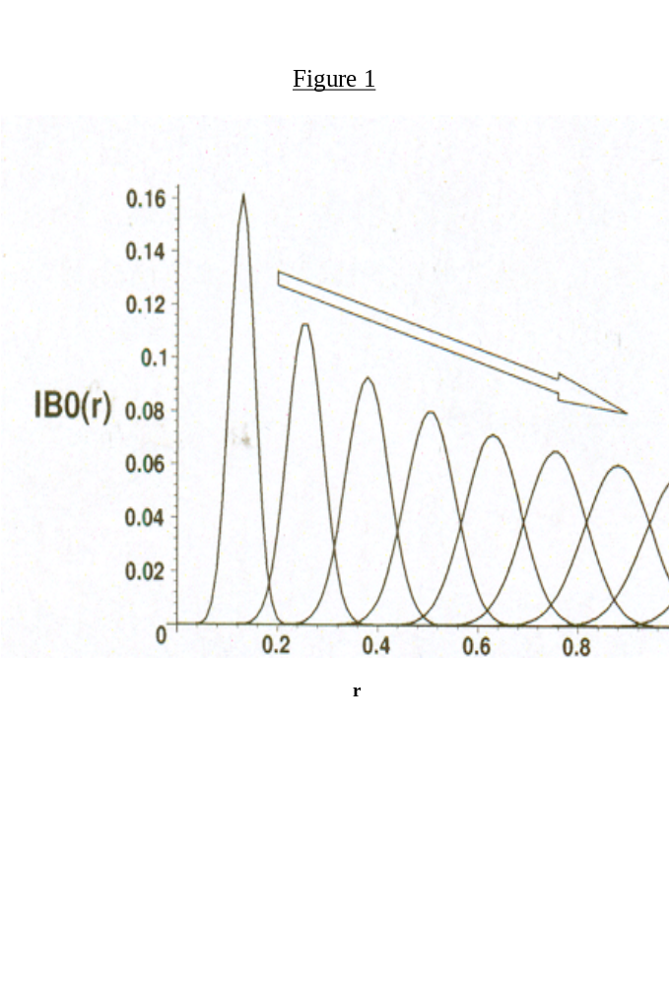
Figure 2

Figure 3

Figure 4

Figure 5

Figure 6

