Rapid Invitro Micropropagation of Sugarcane (Saccharum officinarum L.cv-Nayana) Through Callus Culture

Kambaska Kumar Behera ¹ and Santilata Sahoo¹
¹P.G. Deptt. of Botanty Utkal University , Vanivihar, Bhubaneswar, Orissa , India

Kambaska Kumar Behera (Ph.D)

C/o Dr (Mr’s) Santilata Sahoo (Reader)
P.G. Dept.of Botany UtkalUniversity,
Vanivihar,Bhubaneswar,751004,Orissa,India,
91+9937062620,91+9438485628,9337383490
Email: santi_bot_uu@yahoo.co.in, kambaska@yahoo.co.in

ABSTRACT
Standardization of protocol for induction of callus and regeneration of plantlets was established through invitro culture using young meristem of Sugarcane (Saccharum officinarum L.cv. Nayana) as an explant.The multiple shoot regeneration at various frequencies was observed by using different concentration and combination of growth regulators. The highest percentage of callus induction was observed in MS medium supplemented with 2.5 mg/l, 2-4 D. The best response in terms of multiple shoot induction was observed on MS medium with BAP 2.0 mg/l + NAA 0.5 mg/l. When invitro shoot lets were inoculated on to the half-strength MS basal media supplemented with 3.0 mg/l NAA, rooting was more profuse. Rooted shoots were transplanted in the green house for hardening and their survival rate was 90% in the field condition.
Key words: Callus culture, Growth regulators, Micro-propagation, Shoot regeneration, Saccharum officinarum L.(cv-Nayana), Young meristems

INTRODUCTION
Plant tissue culture techniques have become a powerful tool for studying and solving basic and applied problems in plant biotechnology. During the last thirty years, micro propagation and other invitro techniques have become more widely used in commercial horticulture and agriculture for the mass propagation of crop plants (George and Sherrington,1984 ; Dodds,1991 ; George,1993 ; Das et al.,1996). Sugarcane (Saccharum officinarumL.) is an important agricultural cash crop in tropical and subtropical region of the world and is the major source of sugar with respect to export product in many developing countries that accounts for more than 60% of the world’s sugar production (Guimarces and Sobral,1998). It is the only member of the family Gramineae belong to genus Saccharum in which invitro propagation are standardized and commercially viable. Varieties of sugarcane are highly heterogeneous and generally multiplied vegetatively by stem cutting. In tropical countries nodal sections of sugarcane with 2 or 3 nodes are commonly used as a planting material. Lack of suitable multiplication procedure and contamination by systemic diseases are the serious problem to multiply an elite genotype of sugarcane in the open field (Lal and Singh,1994). Invitro multiplication of sugarcane has received considerable research attention because of its economic importance as a cash crop. Micro propagation is currently the only realistic means of achieving rapid, large-scale production of disease-free quality planting material as seed canes of newly developed varieties in order to speed up the breeding and commercialization process in Sugarcane (Feldmenn et al.,1994 ; Lal and Krishna ,1994 ; Lee ,1987 ; Lorenzo et al., 2001 ; Krisnamurthi and Tlaskal ,1974). As a result of which plant regeneration through tissue culture technique would be a viable alternative for improving the quality and productivity in sugarcane. There are reports on tissue culture of sugarcane from different countries but the first attempts to regenerate plants through invitro technique were made on sugarcane by Naz (2003) and Heniz and Mee (1969). Standardization of protocols for invitro multiplication of sugarcane through callus culture, axillary bud and shoot tip culture have been reported by many authors (Barba et al.,1978 ; Nadar et al.,1978 ; Bhansali and Singh, 1984 ; Nagi ,1998 ; Anita et al., 2000). How ever, reports are scare on young meristem callus culture in sugarcane cultivar, Nayana of Orissa. The present communication demonstrates an effective high frequency regeneration method which allows for expedient multiplication of micro plants that are easily established ex vitro through callus culture of young meristem as an explant.

MATERIALS AND METHODS
Explant source : Healthy young meristems were collected by removing the leaf sheath from field grown plants of sugarcane (Saccharum officinarum L. cv- Nayana) maintained in the P.G. Department of Botany Utkal University and brought to the laboratory and cut into thin smaller pieces of 1.0 to1.5 cm length .The explants were washed thoroughly under running tap water for 20-30 minutes followed by bavistin 0.2% for 10 minutes and then washed with sterile distilled water and transferred to laminar air flow cabinet. The young meristem explants were treated with 70 % alcohol for 30 second to one minute, followed by another treatment in 0.1% (w/v) mercuric chloride (HgCl2) for another 5 minutes. Finally, the young meristem cuttings were washed thoroughly 3 to 5 times with sterile distilled water before the inoculation in to sterilized nutrient agar media pre-packed in culture tubes. All the above operations were performed under aseptic conditions in laminar airflow cabinet.
Culture medium and condition: The young meristem cutting explants were inoculated on sterilized semisolid basal MS medium (Murashige and Skoog’s ,1962) supplemented with different concentrations and combinations of different plant growth regulators.
Callus induction: For callus induction different range of concentration of auxins are tried individually such as 2,4-D (0.5-4.0 mg/l), IBA (0.5-4.0 mg/l) and NAA (0.5-4.0mg/l) with MS basal medium.
Shoot regeneration Medium: White friable calli were cultured on MS medium supplemented with different combinations and concentrations of BAP, Kinetin (0.5- 4.0mg/l) and IBA, NAA (0.1-1.0mg/l) for multiple shoot regeneration either individually or in combination.
Rooting medium: Elongated micro shoots measuring about 5-6 cm in length were excised from culture tube and transferred to half-strength (1/2 MS) MS medium supplemented with different concentrations of IBA,NAA and IAA (0.5-3.0mg/l) either individually or in combinations.
Environmental condition: The pH of the medium was adjusted to 5.8 before gelling with
Agar (6g/l bacteriological grade, Qualigens , India ) and prior to autoclaving for 20 min at120 º C and at 15 lbs psi pressure. Sugar was added at the concentration of 30 gm/l. Molten medium of 20 ml was dispensed into the culture tube and plugged with nonabsorbent cotton wrapped in one layer of cheesecloth. All the cultures were incubated
in a growth room with a 16h photoperiod except callus culture (cool, white fluorescent light -30μmol m⁻²S⁻¹) and the temperature was maintained at 25 ± 3⁰C with 70-80% relative humidity in the culture room. Each treatment consisted of 10 replicates and repeated thrice. For better callus induction just after autoclaving the culture tube containing semisolid sterilized media should positioned , such a manner as if the inside semisolid media in the culture tube should spread to maximum to wards one side only. At the time of inoculation 2 to 3 explant per culture tube was used. For callus induction experiment culture tubes were kept under 20, 25 and 30 º C in complete dark or light/dark condition with 16/8 h light/dark photoperiod with 140μmol m⁻²S⁻¹ light from cool, white fluorescent lamps.
Acclimatization and transfer of plantlets to soil: Plantlets with well-developed roots were removed from the culture medium. Washed the roots gently under running tap water and were transferred to plastic trays for hardening which contain autoclaved garden soil, farmyard manure and sand (2:1:1). The harden plantlets in the plastic trays were covered with porous polyethylene sheets for maintaining high humidity and were kept under shade in a net house for further growth and development. All were irrigated with 1/8 MS basal salt solution devoid of sucrose and inositol every 4 days for two weeks. After 30 days the plantlets were transplanted in to the soil in field condition.
Statistical Analysis: Experiments were set up in a Randomized Block Design (RBD) and each experiment usually had 10 replicates and was repeated three times. 20 to 30 explants were used per treatment in each replication. Observations were recorded on the percentage of response of callus formation, percentage of response of shoots, number of shoots per callus, shoot length, percentage of response of roots, roots per shoot and root length respectively. The treatment means were compared using Duncan’s Multiple Range Test (DMRT) at a 5% probability level according to Gomez and Gomez (1976).

RESULTS AND DISCUSSION
Callus Induction: Callus induction was observed within two weeks, after inoculation of the explants on MS medium containing different concentrations of IBA, NAA and 2 ,4-D (0.5-4.0 mg/l). Although in all concentrations of 2,4-D the callus induction was triggered, but more profuse callus induction was observed at 2.5 mg/l of 2,4-D with full potential of callus regeneration from the explant of the cultivated varieties, Nayana. On this media composition the explants produced creamy white callus. The percentage of callus induction was 100 % (Table-1). Such type of calli has also been reported by Khan et al. (1998) and Khatri et al., (2002). Begum et al., (1995) found 3.5 mg/l of 2,4-D produced highest percentage of callus induction from leaf base explant in Bangladesh Nagabari variety of sugarcane. Islam et al.(1982) also reported that 0.5-5.0 mg/l of 2,4-D showed callus induction from leaf tissue on MS medium.The concentrations NAA at 2.0 and 3.0 mg/l produced small amount (20-30%) of callus with grayish globular and hardy in nature. On second sub-culture the calli were turned into non-regenerable callus in NAA combination media (Fig.B,Table-1) with reduced callus weight where as in IBA+ MS basal media composition explant does not showed any remarkable callusing. The cultivated variety Nayana produced poor callus in lower concentration of 2, 4-D and did not at all in 0.5-1.0 mg/l of hormonal combination with MS basal media . All these studies indicated that the sugarcane variety Nayana require higher concentration of 2,4-D for callus induction(Fig.A,Table-1).

Regenaration of Microshoots:Various concentration of cytokinin (BAP and Kinetin) and auxins , (IBA,NAA) were used in different concentration and combinations for shoot
regeneration.During this investigation shoot formation was highly influenced by concentrations and type of the growth regulators used in the experiment. Among different concentrations and combinations for shoot multiplication , best performance was showed on MS medium supplemented with BAP(2.0mg/l) + IBA (0.5mg/l) (Table-2).On this combination 92 % of explant produced shoots .The number of usable shoots was 12.4 ± 1.90 with average length of the shoots 6.2 ± 0.37 cm of the cultivated variety Nayana. The second best performance was found on MS medium supplemented with BAP (2.0mg/l) + IBA(1.0mg/l) in which average number of usable shoots was 10.5 ± 1.31 with mean length of the shoot 4.0 ± 0.61cm (Fig.C&D,Table-2).Islam et al.(1982) also reported the positive effects of BAP+IBA combination on shoot formation in sugarcane. It was also observed that BAP+NAA combination showed effective result but not superior than BAP+IBA combination. However, combinations of high level of cytokinin and a low level of auxin were essential for differentiation of adventitious shoot in sugar cane young meristem callus of the variety Nayana than individual concentration of cytokinin. All these studies concluded that regeneration potential of callus was specific and genotype dependent phenomenon and at the same time it parallel with the hormonal concentration and combinations (Maretzki and Nickell ,1973 ; Maretzki, 1987). It was also observed that callus derived from different auxins showed different regeneration potential.Callus induction, proliferation and regeneration potential in sugarcane exhibited synchrony to each other (Geetha and Padmanadhan , 2001).

In vitro rooting and acclimatization: Different types of auxins were used at different concentrations and combinations to regenerate adventitious roots. Among them NAA and IBA was found to be comparatively better response than IAA for profuse rooting. NAA+IBA combination showed positive result.Best rooting was observed 1/2 strength of MS medium supplemented with 2.5mg/l NAA(Table-3) and the highest number roots per micro shoots were13.4 ±1.5 ,which take only 8-10 days for initiation of root primordial with average root length 4.0 ± 0.94 cm for the variety Nayana found in Orissa (Fig.E,Table-3).According to Lal and Singh (1994) root can be easily induced on culture shoots by their transfer to another medium with or without NAA ,where optimal growth were observed with 1/2 strength of MS medium . Baksha et al., (2002) used 5.0 mg/l NAA for best rooting response in half strength MS medium. Sabaz et al., (2008) used 1.0 mg/l IBA as the best root initiating growth hormone with highest number of 41 roots per plant. Gosal et al.,(1998) obtained rooting on liquid MS medium containing NAA (5 mg/l) and 70 g/l sucrose. Ali and Afghan (2001) observed only 6 - 7 roots after 3 weeks on MS medium containing 2.0 mg/l IBA and 6% sucrose. Baksha et al., (2002) also got rooting response at 0.1 - 0.5 mg/l IBA along with 0.5 - 2.0 mg/l BAP but these were of poor quality. These findings also agree well with the previous findings of Nadar and Heinz (1977). Alam et al.,(2003) reported best rooting response at 2.5 mg/l IBA with 16 number of roots/explant having 1.1 cm root length. Mamun et al.,(2004) obtained best results of rooting on MS medium supplemented with auxins (NAA + IBA) 0.5 mg/l for each one. We also found that 0.5mg/l NAA+2.5 mg/l IBA was the second best feasible rooting response with 11.3±1.08 number of roots and 3.7 ± 0.47 cm of root length. The plantlets with well developed shoot and roots after acclimatization were successfully transplanted in soil with 85% acclimatization of survivability potential.(Table-3, Fig.F). It is difficult to release a new variety of sugarcane by the conventional breeding method for the genetic behavior of sugar cane .More over also it takes long times to release a stable variety. Thus tissue culture technique can plays an important role in this regard for supply of disease free quality planting material in a year round basis and true to true types of the mother plant.
ACKNOWLEDGEMENTS:-Authors are thank full to Prof. Manaranjan Kar HOD P.G, Deptt. of Botany, Utkal University, Vanivihar, Bhubaneswar for his supportive encouragement for smooth completion of the work.
REFERENCE
Alam, R., Mannan, S.A., Karim, Z. and Amin, M.N.2003. Regeneration of sugarcane (Saccharum officinarum L.) plantlet from callus. Pak. Sugar J. 18: 15-19. Ali K, Afghan S (2001) Rapid multiplication of sugarcane through micropropagation technique. Pak. Sugar J. 16(6): 11-14.
Anita, P., Jain, R.K., Schrawat, A.R and Punia, A. 2000. Efficient and costeffective micropropagation of two early maturing varieties of sugarcane (Saccharum spp.). Indian
Sugar, 50: 611-618.
Baksha, R., Alam, R., Karim, M.Z., Paul, S.K., Hossain, M.A., Miah, M.A.S and Rahman, A.B.M.M. 2002. In vitro shoot tip culture of sugarcane (Saccharum officinarum) variety LSD28.Biotechnology, 1(2-4): 67- 72.
Barba, R.C., Zomora, A.B., Mallion, A.K., and Linga, C. K. 1978. Sugarcane tissue culture research proc. ISSC T.,16 :1843-1864.
Begum, S., Hakim, L and Azam, M.A.1995. Efficient regeneration of plants from leaf base callus in sugarcane. Plant Tissue Cult, 5:1-5.
Bansali, R.R and Singh, K.1984. Callus and Shoot formation from leaf of sugarcane in tissue culture. Phytomorphol, PP : 167-170.
Das, S., Jha, T.B and Jha S.1996. Strategies for improvement of Cashewnut through Tissue Culture. In: Plant Tissue Culture. Islam AS (ed.) Oxford and IBH Publishing Co. Pvt. Ltd, pp. 1-7.
Dodds, J.H.1991. In vitro methods for conservation of plant genetic resources. Book, published by Chapman and Hall, London.
Feldmenn, P., Sapotille, J., Gredoire, P and Rott, P.1994. Micro propagation of sugarcane. In: Teisson C, ed. In vitro culture of tropical plants. France: CIRAD: 15-17.
George, E.F and Sherrington, P.D. 1984. Plant propagation by tissue culture. Handbook and directory of commercial laboratories. Exegenetics Ltd., Basingstoke, Hants, England, pp. 444-447.
George, E.F.1993. Plant propagation by tissue culture. Part 1. The Technology. Exegetics Ltd., Edington, wilts, England, pp. 89-91.
Geetha, S and Padmanadhan, D. 2001. Effect of hormones on direct somatic embryogenesis in sugarcane. Sugar Tech., 3: 120-121.
Gomez, K.A and Gomez, A.A. 1976. Statistical procedures for agricultural research with emphasis on rice. Los Banos, Philippines: International Rice Research Institute.
Gosal, S.S., Thind, K.L and Dhaliwal, H.S.1998. Micropropagation of sugarcane. An efficient protocol for commercial plant production. Crop Improv. 2: 167-171.
Guimarces, C.T. and Sobral, W.S. 1998. The Saccharum complex: relation to other andropogoneae. Plant Breed. Rev., 16: 269-288.
Heniz, D.J and Mee, G.W.1969.Plant differentiation from callus tissue of saccharum species.Crop Sci ., 9 : 346-348.
Islam,A.S., Begum, H.A and Haque, M.M., 1982.Regeneration of Saccharum officinarum for disease resistant Varieties . Proc. Int . Cong .Plant Tissue and Cell Culture, 5 : 709-710 .
Khatri, A., Khan, I.A., Javed, M.A., Siddiqui, M.A., Khan, M.K.R., Khanzada, M.H., Dahar, N.A and Khan, R. 2002. Studies on callusing and regeneration potential of indigenous and exotic sugarcane clones. Asian J. Plant Sci ., 1(1): 41-43.
Khan, I.A., Khatri,A., Ahmed, M., Siddiqui, S.H., Nizamani, G.S., Khanzada, M.H., Dahar, N.A and Khan, R.1998. In vitro mutagenesis in sugarcane. Pak. J. Bot., 30: 253-261.
Krisnamurthi, M and Tlaskal, J. 1974. Fiji disease resistant. Saccharum officinarum L. var. Pindar subclone from tissue culture. Proc. ISSCT, 15:130-137.
Lal, N and Singh, H.N.1994. Rapid clonal multiplication of sugarcane through tissue culture : Plant Tissue Cult., 4 :1-7.
Lal, N and Krishna, R.1994. Sugarcane and its problems: Tissue culture for pure and disease free seed production in sugarcane. Indian sugar, 44: 847-848.
Lee, T.S.G.1987. Micropropagation of sugarcane (Saccharum spp.) Plant Cell Tissue Org. Cult. 10: 47-55.
Lorenzo,J.C., Ojeda, E., Espinosa, A and Borroto C.2001. Field performance of temporary immersion bioreactor derived sugarcane plantys. In vitro cell Dev. Biol., Plant, 37: 803-806.
Maretzki, A. 1987.Tissue culture: Its prospects and problems In: Sugarcane Improvement through breeding. (Ed.) D.J. Heinz. Elsevier Science Publisher B.V. pp. 343-384.
Maretzki, A and Nickell, L.G.1973. Formation of protoplasts from sugarcane cell suspensions and the regeneration of cell cultures from protoplasts. In: Protoplastes et Fusion de Cellules Somatiques Vegetales. Colloq. Int. C. N. R. S. 212: 51-63.
Mamun, M.A., Skidar, M.B.H., Paul, D.K., Rehman, M.M and Islam, M.2004. Invitro micropropagation of some important sugarcane varieties of Bangladesh. Asian J. Plant Sci. 3(6): 666-669.
Murashige, T and Skoog, F. 1962. A revised medium for rapid growth and bioassays with tobacco tissue culture. Physiol. Plant., 15: 473-479.
Nadar, H.M., Soepraptop, S., Heniz, D.J and Ldd, S.L. 1978. Fine structure of sugar cane (Saccharum Spp.) callus and the role of auxin in emberyogenesis . Crop Sci .18 :210-216.
Nadar, H.M and Heniz, D.J.1977). Root and shoot development from sugarcane callus tissue. Crop Sci ., 17 :814-816.
Nagai, C.1988. Micropropagation of sugarcane. Laboratory methodology: Annual Report 1988. Experimental Station, Hawaiian Sugar Planters' Association pp. A34-A37.
Naz,S.2003.Micropropagation of promising varieties of sugarcane and their acclimatization response. Activities on Sugar Crops in Pakistan. In: Proc. Fourth Workshop Res. & Dev., 1-9.
Sabaz, A.K., Rashid, H., Fayyaz, C.M., Chaudhry, Z and Afroz, A.2008. Rapid micropropagation of three elite Sugarcane (Saccharum officinarum L.) varieties by shoot tip culture. AJB 7 (13), pp. 2174-2180.

Table.1.The effect of different concentrations of auxin and 2,4-D on callus induction on young meristem explants of sugarcane varieties Nayana of Orissa.

Treatments | Hormone | Hormonal supplements, mg/l | No.of explant showed callusing | % of explant with callus induction
Treatments | IBA
T1 |  | 0.5 | 0 | 0
T2 |  | 1.0 | 0 | 0
T3 |  | 2.0 | 0 | 0
T4 |  | 2.5 | 0 | 0
T5 |  | 3.0 | 0 | 0
T6 |  | 4.0 | 0 | 0
 | NAA
T7 |  | 0.5 | 0 | -
T8 |  | 1.0 | 2 | -
T9 |  | 2.0 | 10 | 20
T10 |  | 2.5 | 30 | 30
T11 |  | 3.0 | 20 | 25
T12 |  | 4.0 | 0 | -
 | 2,4-D
T13 |  | 0.5 | 20 | 25
T14 |  | 1.0 | 30 | 30
T15 |  | 2.0 | 50 | 40
T16 |  | 2.5 | 90 | 100
T17 |  | 3.0 | 70 | 60
T18 |  | 4.0 | 30 | 20

[No callusing : poor callusing =20-50%,considerable callusing =51-85%, Intensive callusing = 86-100%.]

Table.2.Effect of the cytokinin (BAP,Kn) and the auxin(IBA , NAA) at different concentration and combination in MS medium on shoot regeneration from the callus tissue.

Treatments | Hormonal supplements, mg/l | % of explant produced shoots | No.of shoot/  explant | Average length of the shoots
 | BAP
T1 | 0.5 | 15 | 2.8 ± 0.90 | 3.5 ± 0.84
T2 | 1.0 | 30 | 3.1 ± 0.51 | 3.6 ± 0.77
T3 | 1.5 | 40 | 3.5 ± 0.47 | 3.7 ± 1.16
T4 | 2.0 | 45 | 4.2 ± 0.65 | 4.0 ± 0.47
T5 | 2.5 | 50 | 4.5 ± 0.94 | 5.2 ± 0.24
T6 | 3.0 | 30 | 4.1± 0.51 | 3.4 ± 0.75
T7 | 4.0 | 20 | 3.2 ± 0.47 | 2.5 ± 0.47
 | Kn
T8 | 0.5 | 12 | 2.0 ± 0.47 | 3.1 ± 0.89
T9 | 1.0 | 42 | 3.0 ± 0.81 | 2.9 ± 0.04
T10 | 1.5 | 45 | 3.2 ± 0.82 | 3.0 ± 0.47
T11 | 2.0 | 48 | 2 .1 ± 0.44 | 3.5 ± 0.40
T12 | 2.5 | 60 | 4.5 ± 0.70 | 4.4 ± 0.28
T13 | 3.0 | 40 | 3.8 ± 0.56 | 4.0 ± 0.47
T14 | 4.0 | 17 | 1.2 ± 0.32 | 2.0 ± 0.47
 | BAP+IBA
T15 | 0.5+0.1 | 40 | 3.0 ± 0.81 | 2.2 ± 0.47
T16 | 0.5+0.2 | 65 | 4.0 ± 0.94 | 3.1 ± 0.47
T17 | 0.5+0.5 | 25 | 3.2 ± 0.47 | 3.0 ± 0.94
T18 | 0.5+1.0 | 15 | 3.5 ± 0.62 | 2.8 ± 0.89
T19 | 1.0+0.1 | 50 | 4.2 ± 0.47 | 3.2 ± 0.47
T20 | 1.0+0.2 | 69 | 5.2 ± 0.37 | 3.5 ± 0.16
T21 | 1.0+0.5 | 40 | 3.2 ± 0.43 | 2.1 ± 0.04
T22 | 1.0+1.0 | 30 | 3.0 ± 0.47 | 2.0 ± 0.23
T23 | 2.0+0.1 | 45 | 3.3 ± 0.61 | 3.4 ± 0.29
T24 | 2.0+0.2 | 61 | 3.4 ± 0.65 | 2.9 ± 0.28
T25 | 2.0+0.5 | 92 | 12.4 ± 1.90 | 6.2 ± 0.37
T26 | 2.0+1.0 | 75 | 10.5 ± 1.31 | 4.0 ± 0.61
 | BAP+NAA
T27 | 0.5+0.1 | 45 | 2.0 ± 0.47 | 2.0 ± 0.47
T28 | 0.5+0.2 | 50 | 3.2 ± 0.29 | 4.5 ± 0.94
T29 | 0.5+0.5 | 57 | 3.8 ± 0.82 | 4.2 ± 0.8
T30 | 0.5+1.0 | 60 | 4.1 ± 0.73 | 3.0 ± 0.84
T31 | 1.0+0.1 | 67 | 5.3 ± 0.53 | 4.3 ± 0.32
T32 | 1.0+0.2 | 36 | 5.0 ± 0.94 | 4.0 ± 0.94
T33 | 1.0+0.5 | 25 | 2.2 ± 0.74 | 2.0 ± 0.23
T34 | 1.0+1.0 | 40 | 3.2 ± 0.74 | 2.5 ± 4.0
T35 | 2.0+0.1 | 35 | 3.4 ± 0.61 | 2.3 ± 0.16
T36 | 2.0+0.2 | 33 | 3.2 ± 0.47 | 3.0 ± 0.23
T37 | 2.0+0.5 | 90 | 8.2 ± 0.95 | 7.5 ± 1.02
T38 | 2.0+1.0 | 75 | 4.6 ± 0.24 | 5.5 ± 0.47

BAP = 6-Benzyal aminopurine : Kn= Kinetin : IBA= Indole3-butyric acid : NAA = α-naphthalene acetic acid : IAA= indole 3-acetic acid.
[10 replicates/treatment; repeated thrice. Means are calculated by Duncan’s multiple range test at the significance level of 5%]

Table.3.Effect of different auxins on root formation of the invitro grown micro-shoots cultured on ½ strength MS medium.

Treatments | Auxin supplements, mg/l | % of microshoots rooted | No of roots/microshoots | Average length of roots(cm) | Days to emergence of roots
 | IBA
T1 | 0.5 | 20 | 3.2 ± 0.47 | 1.9 ± 0.45 | 15-20
T2 | 1.0 | 25 | 3.5 ± 0.61 | 2.1 ± 0.41 | 15-20
T3 | 1.5 | 60 | 5.3 ± 0.32 | 2.3± 0.32 | 11-14
T4 | 2.0 | 72 | 8.2 ± 0.84 | 2.5 ± 0.23 | 10-12
T5 | 2.5 | 82 | 10.5 ± 0.70 | 3.4 ± 0.65 | 10-12
T6 | 3.0 | 46 | 4.6 ± 0.65 | 1.8 ± 0.09 | 10-15
 | NAA
T7 | 0.5 | 20 | 3.2 ± 0.65 | 0.9 ± 0.45 | 12-15
T8 | 1.0 | 40 | 3.8 ± 0.47 | 1.0 ± 0.29 | 12-15
T9 | 1.5 | 65 | 5.2 ± 0.74 | 1.5 ± 0.23 | 10-12
T10 | 2.0 | 79 | 8.3 ± 0.28 | 3.4 ±0.47 | 10-12
T11 | 2.5 | 85 | 11.2 ± 1.5 | 4.0 ± 0.94 | 8-10
T12 | 3.0 | 55 | 5.1 ± 0.47 | 2.0 ± 0.47 | 10-15
 | IAA
T13 | 0.5 | 0 | 0 | 0 | 0
T14 | 1.0 | 15 | 2.2 ± 0.33 | 0.75 ± 0.04 | 10-18
T15 | 1.5 | 20 | 3.2 ± 0.65 | 0.8 ± 0.12 | 10-17
T16 | 2.0 | 25 | 1.5 ± 0.23 | 1.0 ± 0.43 | 10-15
T17 | 2.5 | 30 | 2.2 ± 0.16 | 2.5 ± 0.47 | 10-15
T18 | 3.0 | 50 | 5.6 ± 0.57 | 1.5 ± 0.23 | 12-15
 | NAA+IBA
T19 | 0.5+0.5 | 0 | 0 | 0 | 0
T20 | 0.5+1.0 | 40 | 5.2 ± 0.61 | 2.3 ± 0.37 | 10-17
T21 | 1.0+1.0 | 52 | 5.8 ± 0.61 | 3.2 ± 0.89 | 10-15
T22 | 1.5+0.5 | 60 | 6.4 ± 0.71 | 1.4 ± 0.28 | 15-17
T23 | 0.5+1.5 | 48 | 5.3 ± 0.74 | 1.2 ± 0.33 | 10-17
T24 | 2.0+0.5 | 50 | 6.4 ± 0.92 | 1.9 ± 0.14 | 10-12
T25 | 0.5+2.0 | 75 | 10.4 ± 0.67 | 3.5 ± 0.47 | 12-14
T26 | 2.5+0.5 | 60 | 6.7 ± 0.96 | 2.5 ± 0.89 | 10-12
T27 | 0.5+2.5 | 82 | 11.3 ± 1.08 | 3.9 ± 0.47 | 10-15
T28 | 3.0+0.5 | 40 | 5.2 ± 1.01 | 3.2 ± 0.61 | 15-17
T29 | 3.0+1.0 | 35 | 4.2 ± 0.37 | 3.0 ± 0.80 | 15-17
T30 | 1.0+3.0 | 30 | 3.3 ± 0.47 | 2.8 ± 0.49 | 15-17

[10 replicates/treatment; repeated thrice. Means are calculated by Duncan’s multiple range test at the significance level of 5%]

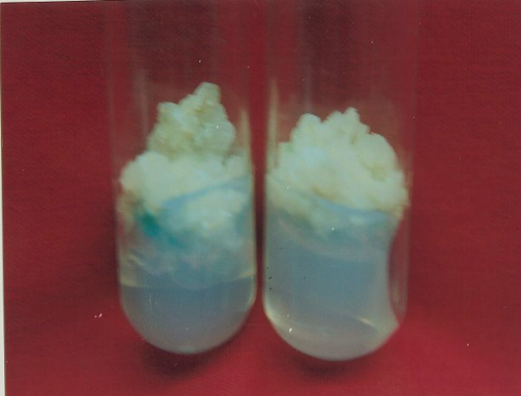  A | 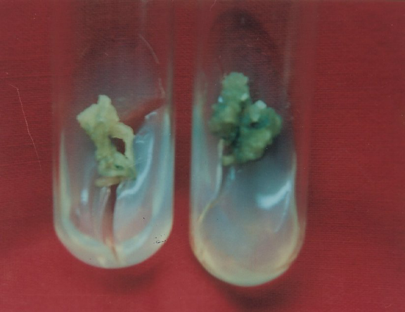  B
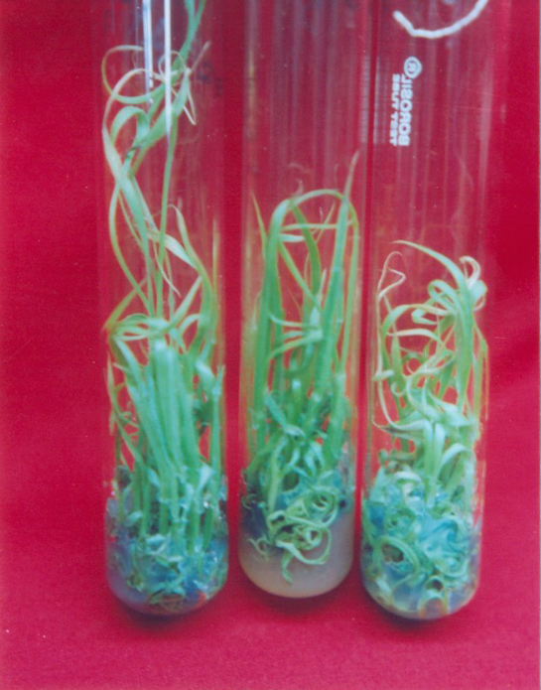  C | 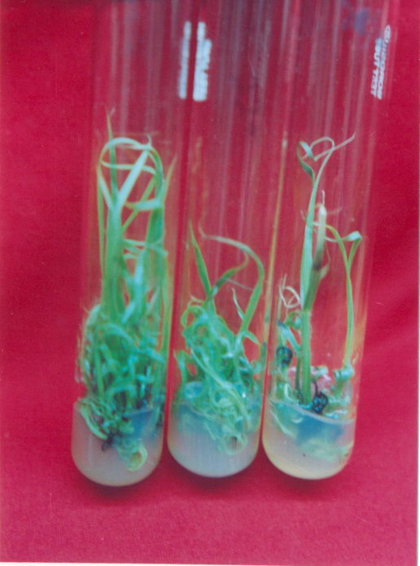  D

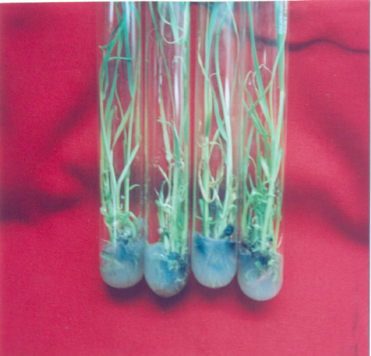  E | 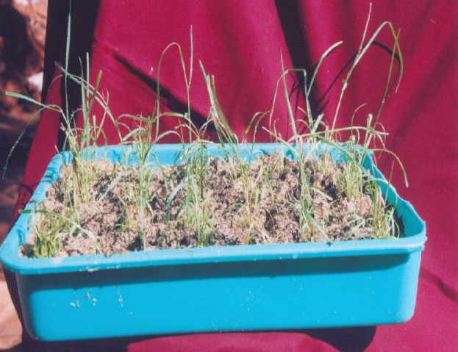  F
Fig.(A-F) Invitro callus regeneration and plant establishment of Saccharum officinarum L.(cv-Local, Nayana) (A) Callus regeneration in MS+2.5mg/l 2,4-D (B) Callus regeneration in MS+2.5mg/l NAA (C&D) Multiple shoot emergence from callus tissue in MS+2.0mg/l BAP+0.5mg/l IBA (E) Micro shoots rooted in 1/2MS+NAA(2.5 mg/l).(F)Hardening of rooted plant lets in plastic trays.

2/25/2009

