Species Richness in an Oak Forest of Indian Himalaya with reference to Canopy Gap.

Neelam Dhaundiyal ¹, Pragya Agarwal ² Mukund Kumaiyan ³ and Pankaj Sah ⁴

¹Department of Forestry, Kumaun University, Nainital, Uttarakhand, India.

² Department of Botany, Kumaun University, Nainital, Uttarakhand, India.

³ Sherwood College, Nainital, Uttarakhand State, India.

⁴ Department of Applied Sciences, Higher College of Technology (HCT), Muscat, Sultanate of Oman.

Authors for Correspondence:

pankaj@hct.edu.om

drpankajsah1@gmail.com

mkumaiyan@gmail.com

pragya_ntl@yahoo.com

Abstract: The continuous anthropogenic disturbances are responsible for creating gaps of various sizes in forest canopies. The creation of gaps, both directly and indirectly, influence species richness and other vegetational parameters of a forest. In the present study, a total of 66 plant species were reported from all the three canopies of oak forest. The lowest species number (27) was recorded in closed canopied forest while medium canopied forest contained greatest richness (44). This indicates that the opening of canopy increase number of different plant species which belongs to the group of species present in closed as well as open canopied forest. The medium canopied forest maintained greater species richness compared to open and closed canopied forests. Tree species richness was present as open > medium > close, while highest shrub and herb richness were recorded in medium canopied forest.

Keywords: Species Richness, Oak Forest, Canopy, Himalaya.

Introduction: Biodiversity is the “variation of life at all levels of biological organization” (Gaston and Spicer, 2004). The Summit defined “biodiversity” as “the variability among living organisms from all sources, including, ‘inter-alia’, terrestrial, marine, and other aquatic ecosystems, and the ecological complexes of which they are part: this includes diversity within species, between species and of ecosystems.” Biodiversity is considered an important aspect of ecosystem energy because it allows building complex trophical networks and it functions as insurance for ecosystem stability and resilience (Gaston and Spicer, 2004).
Biodiversity is not distributed evenly on earth. It is consistently richer in the tropics and in other localized regions such as the California Floristic Province. As one approach Polar Regions, generally finds fewer species. Flora and fauna diversity depends on climate, altitude, soils and the presence of other species. In the year 2006, large numbers of the Earth's species are formally classified as rare or endangered or threatened species; moreover, most scientists estimate that there are millions more species actually endangered which have not yet been formally recognized.
Diversity at all organisation levels, ranging from genetic diversity with population to the diversity of ecosystems in landscapes, contributes to global diversity. In addition, effects of species richness on function of ecosystems and species diversity influence the resilience and resistance of ecosystems to environmental changes (Chapin et al., 2000).
Species diversity is an important concept, and one of the major attributes of a natural community. Communities exhibit a property in which they vary enormously and this property is named diversity (Pielou 1975). According to Whittaker (1977) species diversity can be defined as on several scales from a point or microenvironment to a region, but the essential evolutionary questions treat number of species in communities, landscapes and regions. Diversity has often been related to various community attributes such as productivity (Margalef, 1968; Singh and Mishra, 1969; Auclair et al., 1976), structure (Goff and Zedler, 1968; Auclair and Goff, 1971; Bazzaz, 1975), stability (Watt, 1965; Woodwell and Smith, 1969; Johnson et al., 1975), niche structure (Johnson, 1977), and evolution (Pianka, 1966; Slobodkin and Sanders, 1969; Tramer, 1974; Auclair et al., 1976).
Biodiversity at all hierarchical levels is impacted upon by disturbance of an ecosystem in terms of maintenance and restoration (McNaughton, 1989; Walker, 1989; Pickett and Parker, 1994). Changes, such as, of land use, in resource use, increased biotic invasions, reduction in species number and creation of stress, have a direct impact on biodiversity through habitat destruction and resource over exploitation and indirect impact through their effect on the composition of the atmosphere and the climate (Heywood 1995). In areas influenced by humans many species have been purged (Chapin III et al. 2000). Factors, such as, the available pool of species, the physical characteristics of the land, soil fertility, climate and disturbance regime characteristics, control the vegetation dynamics of forests system (Gauthier et al. 2000). Understanding and managing the disturbance regimes of a landscape under past natural or semi-natural conditions is one of the foundations of conservation of biodiversity in forest landscapes (Spies and Turner 1999). The chronic disturbances and fragmentation, both natural and manmade, are major threats to biodiversity in the Himalayan region (Singh, 1998).
Material and Methods: The study was conducted during years 2005 and 2006. The study area was Ayarpatta (Fig.1.), located on the west hill of Nainital town, India. Three canopy covers were selected for the vegetation analysis and the status of leguminous shrub was also observed in the forest. The canopy cover was determined with the help of Densitometer, an instrument for measuring forest cover with density level 12”-18” in front of body and at elbow height. So that firstly, we have selected Ayarpatta site and determined canopy cover. On each site four readings were taken with the help of Densitometer per location facing North, East, South and West, and averaged. Assumed four equal spaced dots in each square of gird and systematically count dots equivalent to quarter square canopy opening multiply the total count by 1.04 to obtain percent of overhead area which would not be occupied by canopy. After measuring the canopy cover, the area was divided into three canopies cover, viz. open canopy (<30%) medium canopy (<30-60%) closed canopy (>60%).

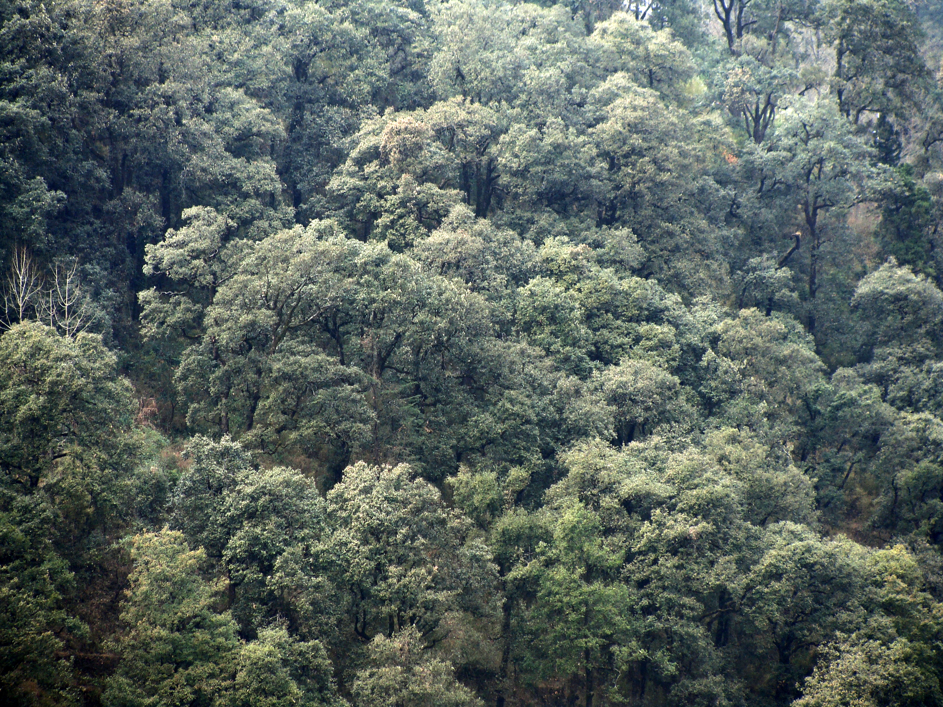
Fig 1. (A). Ayaarpatta Closed Canopied Oak (Quercus leucotrichophora) forest.
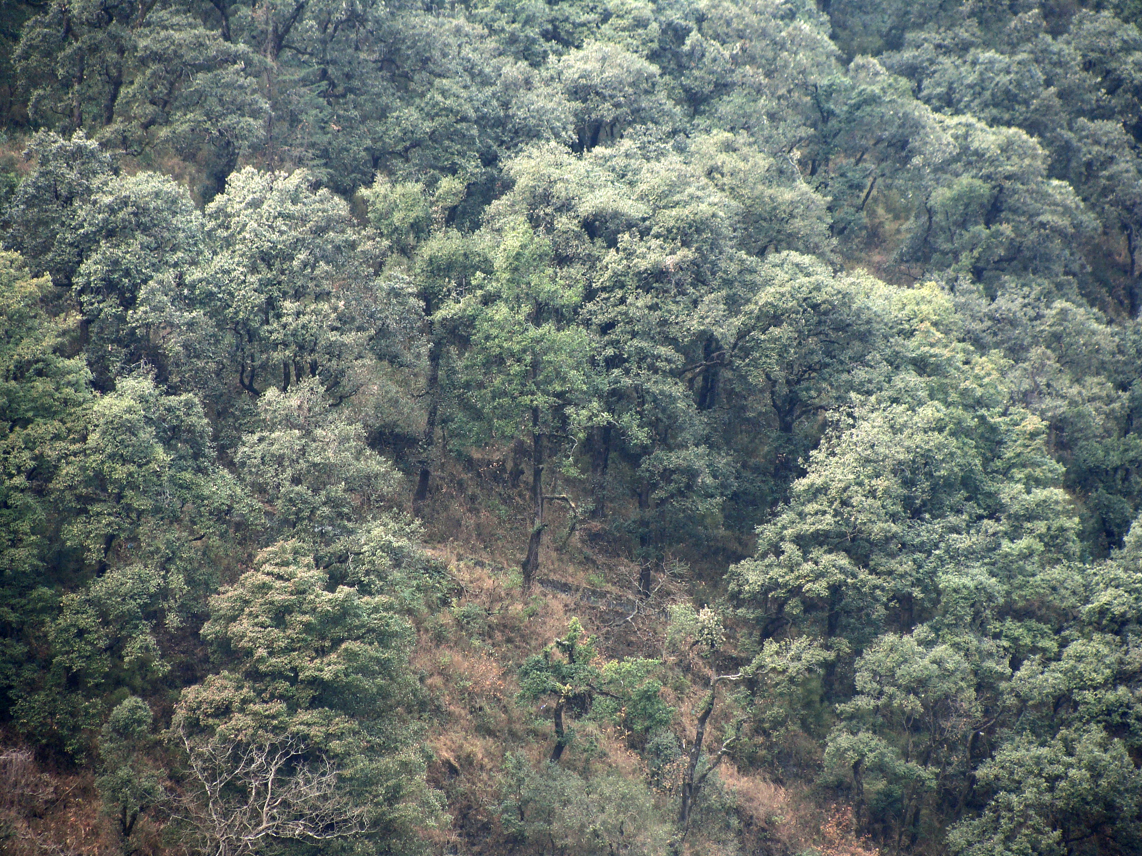
Fig. 1.(B). Ayarpatta Open Canopied Oak (Quercus leucotrichophora) forest.

After through reconnaissance, tree, shrub and herb species were identified with the help of plant taxonomist, floras (Polunin and Stainton, 2006) and listed from all the forest sites. All the three vegetation layer i.e. tree, shrubs and herbs were analysed for each canopy cover. Tree layer was analysed in ten, 10×10 m quadrats, shrubs were analysed by placing ten, 5×5 m quadrats and herbs by ten, 1×1 m quadrats, randomly. Species richness was determined as the number of species per unit area (Whitaker 1972, 1975). The herbs were analysed during peak growing season (August-September). Circumference at breast height (cbh 1.37 m) was taken to determine the tree basal area as, c²/4.
Cover of leguminous shrubs was taken by taking five replicate plants in each canopy cover. The length (L) and width (W) of the canopy was measured and the product (L x W) is considered as the shrub cover (m²/ plant). Tree basal area of a species was the multiple of mean tree basal area and density while total cover of a leguminous shrub species was the multiple of mean cover and density. Total basal area was sum of the basal area of all species. The vegetation data were quantitatively analyzed for Abundance, Density and Frequency (Curtis and McIntosh 1950). The distribution pattern of different species was studied using the ratio of abundance to frequency (Whitford 1949).
Results: Overall species richness of the study area was 66, out of which 6 were trees, 21 shrubs and 39 herbs (Table 1). In open canopied forest, total species richness was 31; in medium canopied 44; and in close-canopied forest were 27 (Fig. 2). Cornus macrophylla and Quercus leucotrichophora were common in all the canopy covers while Berberis asiatica, Desmodium elegans and Indigofera heterantha were the common species in shrub layer and Anemone vitifolia, Arthraxon prionodes, Carex nubigena, Commelina benghalensis, Gallium rotundifolium and Valeriana wallichii herbs were common in all the canopies (Table 1).
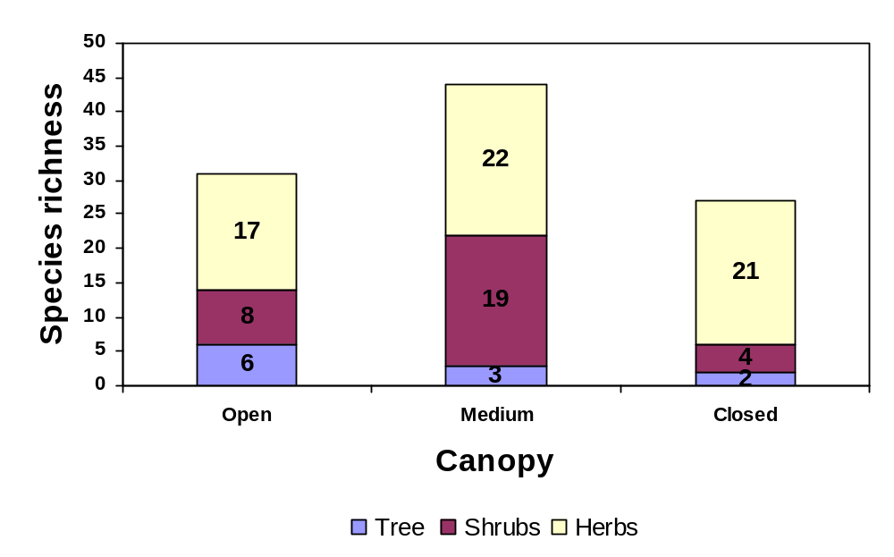
Fig. 2 Species richness for different canopy covers.
Tree richness varied from 2 to 6, it was maximum in open canopied forest and minimum in closed canopied forest. Shrubs richness varied from 4 to 19, it was maximum in medium canopied forest and minimum in closed canopied forest. Herbs richness varied from 17 to 22, which was the maximum in medium canopied and minimum in open canopied forest.
Discussion: The continuous anthropogenic disturbances are responsible for creating gaps of various sizes in forest canopies. The creation of gaps, both directly and indirectly, influence species richness and other vegetational parameters of a forest. In the present study, a total of 66 plant species were reported from all the three canopies of oak forest. The lowest species number (27) was recorded in closed canopied forest while medium canopied forest contained greatest richness (44). This indicates that the opening of canopy increase number of different plant species which belongs to the group of species present in closed as well as open canopied forest. The medium canopied forest maintained greater species richness compared to open and closed canopied forests. Tree species richness was present as open > medium > close, while highest shrub and herb richness were in medium canopied forest. Nath et al. (2005) reported that tree and shrub richness decreased from low to high disturbance regimes while medium disturbance favouring high herb richness, but overall species richness was greater in low disturbances in a tropical wet evergreen forest and reverse was reported in subtropical and temperate forests of Uttaranchal (Table 2). Again, the shrub species declined from low disturbance to high disturbance in tropical wet evergreen forest while it was higher in medium disturbed sites in sub-tropical forest, except as reported by Kumar and Ram (2005), which showed almost similar trend as reported in the present study but slightly increased in tropical wet evergreen forest. Khera et al. (2001) reported that shrubs and herbs richness varied with disturbance level.
Table 1 Presence (+) and absence (-) of different species in banj oak (Quercus leucotrichophora) forest.
Tree | Open canopy | Medium canopy | Closed canopy
Aesculus indica, Calebr. | + | - | -
Cornus macrophylla, Wall | + | + | +
Picea smithiana, Boiss. | + | - | -
Pinus roxburghii, Sarg. | + | - | -
Quercus floribunda, Lindl. | + | + | -
Quercus leucotrichophora, A. Camus | + | + | +
Total | 6 | 3 | 2

Shrubs | Open canopy | Medium canopy | Closed canopy
Artemisia Linn. | - | + | -
Berberis asiatica, Roxb | + | + | +
Colquhounia coccinea, wall. | - | + | -
Debregeasia longifolia, Wedd. | - | + | -
D. falcata | + | - | +
Desmodium elegans, DC | + | + | +
Deutza stamininea, R. Brown | + | + | -
Drapanostachyum falcatum | - | + | -
Gerardiana heterophylla (Vahe) Decne. | - | + | -
Indigofera heterantha wall. Ex Brandis | + | + | +
Inula cuspidate, Clarke | - | + | -
Asminum humile, Linn. | - | + | -
Myrsine africana, Linn. | - | + | -
Plectranthus japonicus (Burm. Fil) Koidz | - | + | -
Pyracantha crenulata, (D. Don) M. Roem. | + | - | -
Rosa brunanii, Lindley | + | + | -
Rubus ellipticus, Sm. | + | + | -
Rumex hastatus D.Don | - | + | -
Sarcococca hookeriana, Baill. |  | + | -
Smilax vaginata, Decsne. | - | + | -
Urtica dioica, L. | - | + | -
Total | 8 | 19 | 4

Herbs | Open canopy | Medium canopy | Closed canopy
Achyranthes bidentata (Blume) | - | - | +
Anemone vitifolia Buch. Ham. Ex DC | + | + | +
Arisaema tortuosum (wall.) Schott | - | - | +
Arthraxon prionodes, (Steud.) Dany. | + | + | +
Arundinella setosa, Trin. | - | + | +
Aster asperculus. Nees. | + | + | -
Boennuinghaysenia albiflora (Hook) Reichb | - | + | -
Calamintha umbrosa, Banth. | - | - | +
Carex cruciata Wahlenb. | - | - | +
Carex nubigena Tiloch and Taylor | + | + | +
Cnicus falcuoneri Hook. F. | - | + | -
Commelina benghalensis L. | + | + | +
Cyperus niveus Retz | - | - | +
Dipsacus mites D. Don. | - | + | -
Erigeron karvinskianus DC | - | + | +
Gallium aparina L. | - | + | +
Gallium rotundifolium L. | + | + | +
Geranium nepalenense, sweet. | + | + | -
Gerbera gossypina (Royle) G. Beauv. | + | - | -
Goldfussia dalhousieana, Nees. | + | - | -
Hebernaria latilabris (Lindl.) Hook. Fit. |  | - | +
Hederra Linn. | - | - | +
Hedychium spicatum Buch. Ham. ex. 1.E. Smith | - | - | +
Impatiens balsamina, L. | - | + | +
Ophipogon intermedius, D.Don | - | + | -
Oplismenus compositus (L.) P. Beauv. | - | + | -
Parthenium histophorous, L. | - | - | +
Pilea scripta (Buch. Ham ex D.Don) wedd. | - | + | +
Plantago major Linn. | - | - | +
Salinum wallichianum (DC.) raizada and Saxena | + | - | -
Scutellaria angulosa Benth. | + | + | -
Swertia ciliata (G.Don) Burtt |  | - | -
Thalictrum foliolosum DC. Nees | + | - | -
Thalliictrum neurocarpum | - | + | -
Valeriana wallichii DC. | + | + | +
Vitis himalayana Brandis. | + | + | -
Unidentified sp. 1 | - | + | -
Unidentified sp. 2 | + | - | -
Unidentified sp. 3 | + | - | -
Total | 17 | 22 | 21

Table 2. Comparison of species richness in different disturbance levels in oak forest.
Vegetation  layer | Richness |  |  | Authors
Vegetation  layer | L | M | H
Tree | 50 | 20 | 18 | Nath et al., (2005)
Tree | 5 | 6 | 10 | Arvind and Ram (2005)
Tree | 6 | 7 | 9 | Khera et al (2001)
Tree | 2 | 3 | 6 | Present study
Shrubs | 27 | 22 | 14 | Nath et al., (2005)
Shrubs | 12 | 19 | 21 | Arvind and Ram (2005)
Shrubs | 15 | 19 | 16 | Khera et al (2001)
Shrubs | 4 | 19 | 8 | Present study
Herbs | 23 | 31 | 29 | Nath et al., (2005)
Herbs | 27 | 35 | 41 | Arvind and Ram (2005)
Herbs | 34 | 29 | 24 | Khera et al (2001)
Herbs | 21 | 22 | 17 | Present study

Note: L=Low disturbances, M=Medium disturbances, H=High disturbances

References:
Anderson, F.1970. Ecological studies in a Scandian woodland and meadow area, southern Sweden II. Plant biomass. Primary production and turnover of organic matter. Bot. Nitofer, 123:8-51.
Auclair, A.N, Bouchard, A. and Pajaczkowski, J. 1976. Plant standing crop productivity relations in Scripus Equisetum. Wet Land Ecology. 5: 941-952.
Auclair, A.N. and Goff, F.G. 1971. Diversity relations of Upland forests in the Western great lakes area. Amer. Nat. 105: 499-528.
Bazzaz, F.A. 1975. Plant species diversity in old fields successional ecosystems in southern Illinois. Ecology. 50: 485-488.
Behera M.D., Kushwant S.P.S. and Roy P.S.2002. High plant endemism in an Indian hot spot eastern-Himalaya. Biodiversity and Conservation, 11:669-682.
Chapin III F.S., Zavaleta E.S., Eviner V.T., Naylor R.L., Vitousek P.M., Reynolds H.L. et al.2000. Consequences of changing biodiversity. Nature 405:234-242.
Chapin, F.S, A.D. McGuire, J. Randerson, R. Pielke, D. Baldocchi, S.E. Hobbie, N. Roulet, W. Eugster, E. Kasischke, E.B. Rastetter, S.A. Zimov and S.W. 2000. Running. Arctic and boreal ecosystems of western North America as components of the climate system. Global Change Biology 6 (Suppl. 1): 211-223.
Chaturvedi, D.P and Singh, J.S. 1987. The structure and function of pine forest in Central Himalayan I. Dry matter dynamics Annals of Bot.60: 337-252.
Cottam, G and Curtis, J.T. 1956. The use of disturbance measures in Phytosociological sampling. Ecology, 35:451-460.
Curtis, J. T. 1959. The vegetation of Wisconsin: An ordination of plant communities. University Wisconsin Press, Madison, Wisconsin.
Curtis, J. T. and McIntosh, R.P. 1950. The interrelations of certain analytical and Synthetic Phytosociological characters. Ecology, 31:434-455.
Dhar V., Rawal R.S. and Samant S.S. 1997. Structural diversity and representative ness of forest vegetation in a protected area of Kumaun Himalaya, India: implication for conservation. Biodiversity and Conservation 6:1045-1062.
Gaston, K.J. and Spicer, J.I. 2004. Biodiversity: an introduction. 2nd Edition. Blackwell Publishing.
Gauthier S., Grandpre L.D. and Bergeron Y.2000. Differences in forest composition in two boreal forest eco regions of Quebec. Journal of vegetation Science 11:781-790.
Goff, F.G. and Zedler, P.H. 1968. Structural gradient analysis of upland forest in the Western Great Lakes area. Ecol. Monogr. 38: 65-86.
Heywood V.H.ed.1995. Global Biodiversity Assessment. UNEP Cambridge University Press, Cambridge, UK.
Jacot K.A., Luscher M., Suter J., Nos berger and U.A. Hartwing.2005. Significance of legumes for the distribution of plant species in grassland ecosystem at different altitude in the Alps. Plant Ecology 180:1-12.
Johnson, E.A. 1977. A multivariate analysis of the niche of plant population in raised bags. II. Niche Width and overlap. Can. J. Bot. 55: 1211-1220.
Johnson, H.B., Vasek F.C. and Yonkers, T.1975 Productivity, diversity and stability relationship in major forest roadside vegetation. Bull. Torrey Bot . Club . 102:106-115
Khera, N., Kumar, A., Ram, J. and Tewari, A. 2001. Plant biodiversity assessment in relation to disturbances in mid elevational forest of central Himalaya, India Tropical Ecology 42:83-95.
Kumar A. and Ram J. 2005. Anthropogenic disturbances and plant biodiversity in forest of Uttaranchal, Central Himalaya. Biodiversity and Conservation 14:309-331.
Margalef, D.R. 1968. Perspective in ecological theory. University of Chicago Press, Chicago.
Margalef, D.R. 1972. Homage to Evelyn Hutchinson, or why is there an upper limit to diversity . Trans Connect .Acad. Arts Sci., 44:211-235.
McNaughton, S.J. 1989.Ecosystem and Conservation in the twenty- first century. In: Western D. and Pearl M.C. (eds.) Conservation for the Twenty- first Century. Oxford University Press, Oxford, UK, pp.109-120.
Myers, N., Mittermeier, R.A., Mittermeier, C.G., da Fonseca, G.A.B. and Kent, J. 2000. Biodiversity hotspots for conservation priorities. Nature 403:853-858
Nath P.C., Arunachalam, A., Khan M.L, 2005. Vegetation analysis and tree population structure of tropical wet evergreen forest in and around Namdapha National Park, northeast India. Biodiversity and Conservation 14:2109-2136.
Newbould P J 1967 Methods for estimating the net primary production of forests. IBH Hand Book No. 2 Black Well Scientific publications. Oxford and Edinburgh 172 p.
Phillips, E.A. 1959. Methods of vegetation study. Henry Holt and Co. Inc., New York.
Pianka, E.R. 1966. Latitudinal gradient in species diversity: a review of concepts. Am. Nat. 100: 33-46.
Pickett S.T.A. and Parker V.T. 1994. Avoiding the old pitfalls: opportunities in a new discipline. Restoration Ecology 2:75-79.
Pielou, E.C. 1975. Ecological diversity. Wiley-Interscience New York. 165pp.
Ralhan P.K., Saxena A.K. and Singh J.S. 1982. Analysis of forest vegetation at and around Nainital in Kumaun Himalaya. Proceedings of Indian Science Academy, 48:122-138.
Rathore S.K.S., Singh S.P, Singh J.S. and Tewari A.K. 1997.Chnges in forest cover in a central Himalayan catchment: inadequacy of assessment based on forest area alone. Journal of Environmental Management 49:265-276.
Rawat, Y.S. and J.S. Singh 1988.structure and function of oak forest in Central Himalaya. I. Dry matter Dynamics. Annals of Botany, 62:397-411.
Saxena A.K. and Singh J.S. 1982. A phytosociological analysis of woody species in forest communities of a part of Kumaun Himalaya Vegetation 50:3-22.
Saxena A.K., Singh S.P. and Singh J.S.1984. Population structure of forests of Kumaun Himalaya: implication for management. Journal of Environmental Management 19:307-324.
Schmit, M.D.C. and D.F. Grigal, 1981. Generalized biomass estimation equation for Betula Papyrifera, Marsh Canadian Journal of for forest research 11:837-840.
Silori, C.S. 2001. Status and distribution of anthropogenic pressure in the buffer zone of Nanda Devi Biosphere Reserve in western Himalaya, India. Biodiversity and conservation 10:1113-1130.
Singh S.P., Adhikari B.S and Zobel D.B.1994. Biomass productivity, leaf longevity and forest structure in the central Himalaya. Ecological Monograph, 64:401-421.
Singh S.P. 1998.Chronic disturbance, a principal cause of environmental degradation in developing countries (Editorial).
Singh, J.S. and Mishra, R. 1969. Diversity, Dominance, Stability and net production in the grasslands at Varanasi India. Can. J. Bot. 47: 425-427.
Singh, J.S. and Singh, S.P. 1986. Structure and function of Central Himalayan oak forests Proceedings of Indian National Science Academy 96:156-189.
Singh, J.S. and Singh, S.P. 1987. Forest vegetation of the Himalaya. Botanical Review 52:80-192.
Singh, JS and Singh, SP 1992. Forests of Himalaya: Structure,
Functioning and Impact of Man. Gyanodaya Prakashan, Naini Tal, India. 294 pp.
Slobodkin, L.B. and Sanders, H.L. 1969. On the contribution of environmental predictability of species diversity. Brookhaven Symp. Biol. 22: 82-95.
Spies T. and Turner M.1999. Dynamic forest mosaics. In: Hunter Jr. M.L. (ed) maintaining biodiversity in forest ecosystem. Cambridge University press, Cambridge, UK, pp.95-160.
Tiwari, A.K., Saxena A.K. and Singh, J.S. 1985. Inventory of forest biomass for Indian Central Himalaya: Concept and strategies. Central Himalayan Environmental Association and Gyanodaya Prakashan, India, pp.236-247.
Tramer, E.J. 1974. On latitudinal gradient in avian diversity condor 76:123-130.
Upreti, N.J., Tewari, J.C and Singh, S.P. 1985. The oak forest of Kumaun Himalaya: Composition, diversity and regeneration. Mountain Research and Development 5:163-174.
Valdiya, K.S. 1988. Geology and Natural Environment of Nainital Hills. Kumaon Himalaya, Gyanodaya Prakashan, Nainital, 155.
Walker, B.1989. Diversity and stability in ecosystem Conservation. In: Western D. and Pearl M.C. (eds.) Conservation for twenty- first century. Oxford University Press, Oxford, U.K, pp.121-130.
Watt, K.E.F. 1965. Dominance and diversity in land plant Communities Science, N.Y. 147:250-260
Whitford, P.B. 1949. Distribution of woodland plants in relation to succession and clonal growth. Ecology, 30: 199-208.
Whittaker, R.H. 1972. Evolution and measurement of species diversity. Taxon. 21: 213-251.
Whittaker, R.H. 1975. Communities and ecosystems. Macmillan Publishing Co., New York.
Whittaker, R.H. 1977. Evolution of species diversity in land communities. In Hecht, M.K., W. C. Steere and B. Wallace (Eds.) Evolutionary Biology, Vol. 10. Plenum Publishing Corporation.
Woodwell, G.M and Smith, H.H. 1969 . Diversity and stability in ecological systems. Book haven Symposia in Biology 22, 246p.
Zobel, D.B. and Singh, S.P. 1997. Himalayan forests and ecological generalizations. BioScience 47:735-745.

1/27/2009

