Chlorophyll a dynamics and environmental factors in a tropical estuarine lagoon.

*Onyema, I.C. and Nwankwo, D.I.

Department of Marine Sciences, University of Lagos, Akoka.
*e-mail: iconyema@gmail.com

Abstract.
The chlorophyll a dynamics and environmental factors of the Iyagbe lagoon, Lagos was investigated for 2 years (Oct., 2004 - Sept., 2006). The environmental indices reflected seasonal changes related to rainfall distributive pattern and tidal seawater incursion. Air temperature (26 - 34°C), surface water temperature (26 - 33°C), total dissolved solids (90 - 25,000mgl⁻¹), transparency (22 - 231cm), sulphate (20.8 - 1140mgl⁻¹), silica (0.9 - 6.0mgl⁻¹), dissolved oxygen (4 - 5.6mgl⁻¹), conductivity (110 - 40850 S/cm), salinity (0.06 - 35.1%), chloride (20.5 - 15,015mgl⁻¹), pH (6.7 - 8.42), acidity (3.8 - 44mgl⁻¹), alkalinity (15.3 - 30mgl⁻¹), total hardness (18 - 6875mgl⁻¹), calcium (10 - 720.1mgl⁻¹) and magnesium (1.4 - 900mgl⁻¹) recorded increased values in the dry than wet season. On the other hand chemical oxygen demand, biological oxygen demand, total suspended solids(18 - 2310mgl⁻¹), nitrate (3.3 - 59.8mgl⁻¹), phosphate (0.01 - 1.68mg), copper (0.001 - 0.079mgl⁻¹), zinc (0.001 - 0.015mgl⁻¹) and iron (0.06 - 1.08mgl ⁻¹) recorded higher values in the wet season. Values for chlorophyll a were higher in the dry than wet season for the lagoon. Positive correlation coefficient was recorded between chlorophyll a and salinity, total dissolved solids, alkalinity, pH, conductivity total hardness, chloride, transparency, acidity, nitrate, sulphate, calcium and magnesium levels. Recorded chlorophyll a values places the Iyagbe lagoon between the mesotrophic and eutrophic status. It is suggested that increasing tidal influence associated with reduced rain events may have encouraged elevated salinities and created conditions for the development of more algal cells, hence higher chlorophyll a records.

Keywords: Physico-chemical factors, brackish, microalgae, hydroclimatic factors, Nigeria.
Introduction
Lagoons are ecologically and economically important aquatic ecosystems in South-western Nigeria. They provide natural food resources rich in protein which includes an array of fish and fisheries. They are also important in water transportation, energy generation, exploitation and exploration of some mineral resources including sand (FAO, 1969; Kirk and Lauder, 2000; Onyema et al., 2003, 2007; Chukwu and Nwankwo, 2004; Onyema, 2008a). Lagoons also inadvertently serve as sinks for the disposal of both domestic, municipal and industrial wastes in the region. There are nine lagoons in South-western Nigeria namely: Yewa, Ologe, Badagry, Iyagbe, Lagos, Kuramo, Epe, Lekki and Mahin lagoons from the west to the east (FAO, 1969, Webb, 1958a; Nwankwo, 2004b; Onyema, 2008).

Furthermore, chlorophyll a is an essential plant pigment and concentrations of it could be used to reflect algal biomass and hence, level of primary production. Chlorophyll a can be an effective measure of trophic status (Lee, 1999). However, elevated chlorophyll a concentrations often indicate poor water quality and low levels often suggest good conditions (Ogamba, et. al., 2004). According to Lee (1999), higher Phytoplankton biomass would directly reflect in a higher level of chlorophyll a in such regions. One method to determine the amount of plant materials present in a water sample is to filter out the phytoplankton, count the cells and multiply the number counted by the average mass per individual cell (Sverdrup et al., 2006). A less tedious method is to extract the chlorophyll from a sample of phytoplankton and determine the concentration of pigment present. Hence chlorophyll concentration can be used to estimate the total quantity of plant material or biomass (Sverdrup et al., 2006).

The immense ecological significance of phytoplankton diversity studies especially in relation to aquatic trophic relationships cannot be understated (Smith, 1950; Lee, 1999; Nwankwo, 1984, 2004a). Coastal areas are generally more productive than the open oceans because rivers and land run-offs supply nutrients along coasts and adjoining estuarine systems. With regard to the annual rates of global primary production and productivity, Lagos offshore falls under the high productivity category ( = 300gC/m²/yr) (Sverdrup et al., 2006).

Determination of primary production in the Lagos lagoon has primarily been by biomass estimation using cells number of phytoplankton (Nwankwo, 2004). With regard to chlorophyll a in Nigeria, there exist a report by Kadiri (1993) on the Ipkoba reservoir in Benin and another by Ogamba et al., (2004) on chlorophyll a levels and variations in the Niger Delta region. Hence studies in Nigeria using chlorophyll a method are limited.

At present, there is no report on any of the nine lagoons of South-western Nigeria with regard to the chlorophyll a method of estimation. The aim of this study was to investigate the seasonality in chlorophyll a concentration and relate findings to environmental factors in the Iyagbe lagoon.

Materials and Methods
Description of Study Site
The Iyagbe lagoon (Fig 1) is located in Lagos state, Nigeria and is one of the nine lagoons in South-western Nigeria (Webb, 1958a; Nwankwo, 2004b; Onyema, 2008a). It is located between Latitude 6⁰ 26’N Longitude 3⁰ 19’ E and Latitude 6⁰ 23’N Longitude 3⁰ 06’ E (Webb, 1958a; Onyema, 2008a,b). It is majorly made up of the Porto-Novo and Badagry creeks. The Iyagbe lagoon is centered about the town of Iyagbe (Webb, 1958a). The lagoon is shallow at some point especially in the Badagry creek arm and is open all year round via the Lagos harbour to the sea (Webb, 1958b; Webb and Hill, 1958; Sandison, 1966; Sandison and Hill, 1966). Like all parts of South-western Nigeria, the Iyagbe lagoon is exposed to two distinct seasons namely the wet (May – October) and the dry season (November – April) (Nwankwo, 2004b; Sandison and Hill, 1966). The harmmattan, a short season of dry, dusty North-East Trade winds are experienced sometimes between November and January in the region reducing visibility and lowering temperatures (Onyema et al., 2003). Dense rain forest zone vegetation preceded by littoral mangrove assemblages is the common macrofloral assemblages especially in areas with reduced anthropogenic influence. The lagoon deposits are varied, and are reflected in the pattern and type of vegetation in the region. Most of the Iyagbe lagoon area away from the Tin can Island and Apapa Ports are colonized by a recognizable riparian mangrove swamp community especially where man made structure are absent. These mangrove environments are inhabited by amphipods, polychaetes, isopods, barnacles, oysters, periwinkles, nematodes, fiddler crabs, sea cucumbers, mangrove crabs, mudskippers and shrimps among others (Sandison and Hill, 1966; Onyema, 2008b). The notable macro-floral species in the area include Rhizophora racemosa, R. harrisoni, Avicennia germinans, Phoenix reclinata, Raphia hookeri, Elaeis guineensis, Acrotiscum aureum and Cocos nucifera (Akinsoji et al., 2002).
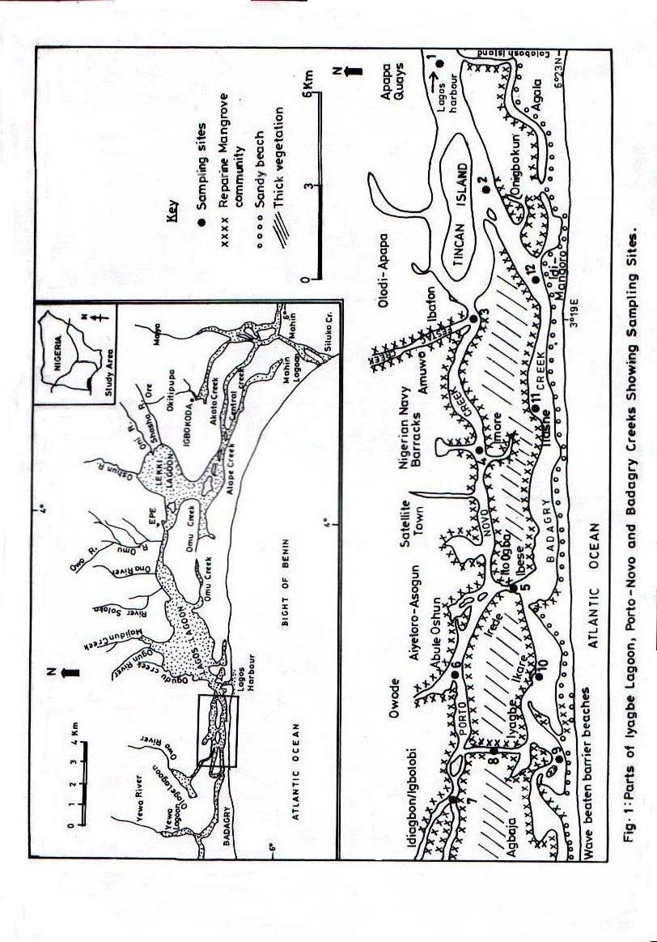
Collection of samples.
Collection of water samples
Twelve sampling stations were selected to cover the lagoon area and for the collection of samples. Table 1 shows the G.P.S. location, names and number of sampling stations. Monthly surface water samples was collected for twenty-four consecutive months (October, 2004 – September, 2006) for physico-chemical characteristics analysis using 500ml plastic containers with screw caps. Collection of samples from the stations was always between 10 and 15hr each time. Water samples were collected just a few centimeters below the water surface at each of the twelve stations. The plastic containers was then labeled appropriately and transported to the laboratory immediately after collection for to further analysis. Water samples for Dissolved Oxygen was collected also in 50cl bottles and fixed on site with white and black ampoules.

Table 1: G.P.S. location and station name of sampled areas in the Iyagbe lagoon.
Station No. | Station name | G.P.S. locations
Station 1 | Calabash Island | Latitude 6º 25¹.987 N, Longitude 3º 23¹.400 E
Station 2 | Tin-can Island | Latitude 6º 25¹ .833 N, Longitude 3º 21¹ .532 E
Station 3 | Ibafon | Latitude 6º 25¹ .964 N, Longitude 3º 19¹ .244 E
Station 4 | Imore | Latitude 6º 25¹ .755 N, Longitude 3º 19¹ .915 E
Station 5 | Ito-ogba | Latitude 6º 25¹ .409 N, Longitude 3º 14¹ .624 E
Station 6 | Abule-oshun | Latitude 6º 26¹ .134 N, Longitude 3º 13¹ .224 E
Station 7 | Idiagbon / Igbolobi | Latitude 6º 26¹.214 N, Longitude 3º 11¹ .826 E
Station 8 | Iyagbe | Latitude 6º 25¹ .603 N, Longitude 3º 11¹ .990 E
Station 9 | Agbaja | Latitude 6º 24¹ .473 N, Longitude 3º 12¹ .744 E
Station 10 | Ikare | Latitude 6º 24¹ .632 N, Longitude 3º 13¹ .705 E
Station 11 | Ilashe | Latitude 6º 24¹ .676 N, Longitude 3º 16¹ .938 E
Station 12 | Idimangoro | Latitude 6º 24¹ .717 N, Longitude 3º 19¹ .307 E
Table 2 below presents the methods / device used in estimating the various environmental factors for this study with corresponding references.
Table 2: Summary of environmental factors and method/device used for their estimation.

 | Parameter/ Unit | Method / Device | Reference(s)
1 | Air temperature (ºC) | Mercury – in – glass thermometer | Nwankwo (1984)
2 | Water temperature (ºC) | Mercury – in – glass thermometer | Onyema (2008)
3 | Transparency (cm) | Secchi disc method | Onyema (2008)
4 | Depth (cm) | Graduated pole | Brown (1998)
5 | Rainfall (mm) | Acquired from NIMET, Oshodi, Lagos
6 | Total Dissolved Solids (mgL⁻¹) | Cole Palmer TDS meter
7 | Total Suspended Solids ( mgL⁻¹) | Gravimetric method | APHA (1998)
8 | Chloride ( mgL⁻¹) | Argentometric method | APHA (1998)
9 | Total hardness (mgL⁻¹) | Titrimetric method | APHA (1998)
10 | pH | Electrometric / Cole Parmer Testr3
11 | Conductivity (µS/cm) | Philip PW9505 Conductivity meter
12 | Salinity (‰) | HANNA Instrument | APHA (1998)
13 | Alkalinity (mgL⁻¹) | Titration method | APHA (1998)
14 | Acidity (mgL⁻¹) | Titration method | APHA (1998)
15 | Dissolved oxygen (mgL⁻¹) | Titration method | APHA (1998)
16 | Biological oxygen demand (mgL⁻¹) | Incubation and Titration | APHA (1998)
17 | Chemical oxygen demand (mgL⁻¹) | Titration method | APHA (1998)
18 | Nitrate – nitrogen (mgL⁻¹) | Colorimetric method | APHA (1998)
19 | Phosphate – phosphorus (mgL⁻¹) | Colorimetric method | APHA (1998)
20 | Sulphate (mgL⁻¹) | Turbidimetric method | APHA (1998)
21 | Silica (mgL⁻¹) | Colorimeter (DR2010) | APHA (1998)
22 | Calcium (mgL⁻¹) | Titrimetric method | APHA (1998)
23 | Magnesium (mgL⁻¹) | Titrimetric method | APHA (1998)
24 | Copper (mgL⁻¹) | Atomic Absorption Spectrophotometer  Perkin Elmer 5000 AAS | Perkin Elmer Application methods (2002)
25 | Iron (mgL⁻¹) | Atomic Absorption Spectrophotometer  Perkin Elmer 5000 AAS | Perkin Elmer Application methods (2002)
26 | Zinc (mgL⁻¹) | Atomic Absorption Spectrophotometer  Perkin Elmer 5000 AAS | Perkin Elmer Application methods (2002)
27 | Chlorophyll a (µg/L) | Florometric method | APHA (1998)
Correlation Coefficient Values (r)
The Pearson correlation coefficient (r) (Ogeibu, 2005) for the relationship between the different environmental parameters and chlorophyll a were obtained using the formula:
r = n(∑XY) – (∑X) (∑Y)
√(n(∑X² -(∑X)²] [n∑Y² – (∑Y)²
Where
r = Coefficient of correlation
X and Y = Variables under consideration

Results.
The minimum and maximum values obtained for the estimates of environmental factors, their means and standard deviation are presents in Table 3. Also in Table 3 is whether each parameter recorded higher values in the wet or dry season for the two (2) years of study.

Air temperature values ranged between 26 and 34⁰C throughout the sampling period. Whereas the lowest value estimated was 26⁰C (September, 2006), the highest value obtained was 34⁰C recorded in March of the same year. The lowest surface water temperature estimated was 25⁰C (September, 2005) and the highest value obtained was 33⁰C (May, 2005). Transparency was between 11 (March, 2006) and 280cm (December, 2004). Total dissolved solids ranged between 90 and 25000mg/L with the lowest value recorded in September, 2005 and the highest value in April, 2006. Total suspended solids values ranged between 18 (February, 2005) and 2310mg/ L (August, 2005). Rainfall volumes showed both monthly changes and varied from one year to the next. In the first year the highest rainfall volume was recorded in June 2005 (330mm) and the least was in February 2005 (8.9mm). In the second year the highest rainfall was in June 2006 (315.7mm) and the least in January 2006 (6.0mm). Recorded chloride values were between 20.5 (October, 2005) and 17710mg/L (April, 2006). Whereas the lowest value estimated for total hardness was 18mg/L (July, 2006) whereas the highest value obtained was 6875mg/L (December, 2005). Hydrogen ion concentration (pH) values ranged between 6.7 (June, 2006) and 8.42 (February, 2006) throughout the sampling period. Whereas the lowest conductivity estimated was 110µS/cm and recorded in October, 2004, the highest value obtained was 33092µS/cm recorded in April, 2006.

Salinity value ranged between 0.06 (October, 2004), and 35.1º/_{oo} (April, 2006). Alkalinity values were between 18 (August, 2006) and 311.2mg/L (February, 2005). Acidity estimates ranged between 3.8 and 60mg/L (November, 2005 and January, 2006) respectively.

Dissolved Oxygen values ranged between 4 (September, 2005) and 5.6mg/L (January, 2006) throughout the sampling period. Biological Oxygen Demand values ranged between 2 (March, 2005) and 22mg/L (September, 2006) throughout the sampling period. Chemical oxygen demand ranged between 8 ( March, 2005) and 211mg/l (Feburary, 2006). Nitrate-nitrogen values werebetween 3.3 (November, 2005) and 59.8mg/L (June, 2006) whereas Phosphate-phosphorus recorded between 0.01mg/L (January, 2006) and 1.68mg/L (August, 2005). Sulphate values ranged between 20.8 (October, 2005) and 1160mg/L (January, 2006) throughout the sampling period. Silica values fell between 0.9 (August, 2005) and 6.0mg/L (September, 2006). Calcium levels were between 10mg/L in October, 2005 and 720.1mg/L in November, 2004. Magnesium estimates were between 1.4mg/L in July, 2006 and 981.1mg/L in January, 2005 and Copper values was between 0.001 (May through July 2005) and 0.09mg/L (August, 2005). Iron levels ranged between 0.06 and 1.08mg/L (October 2004). Zinc values ranged between 0.001 and 0.015mg/L (August, 2005).

Chlorophyll a values were between 4.2 and 55 μg/L. whereas the lowest value estimated was in June, 2005, the highest value obtained was recorded in November 2005. Chlorophyll a values showed a positive relationship with salinity (r = 0.21), transparency (r = 0.24), chloride (r = 0.21), total dissolved solids (r = 0.22), water temperature (r = 0.18), air temperature (r = 0.09), pH (r = 0.23), conductivity (r = 0.23), acidity (r = 0.10), alkalinity (r = 0.27), calcium (r = 0.17), magnesium (r = 0.27), nitrate (r = 0.11), chemical oxygen demand (r = 0.03), iron (r = 0.05) and sulphate (r = 0.20). A negative relationship existed between chlorophyll a and biological oxygen demand (r = -0.16), zinc (r = -0.02), copper (r = -0.04), total suspended solids (r = -0.07) and phosphates (r = -0.13) estimates. Table 4 shows the Seasonal variation in Chlorophyll a values at the different stations in the Iyagbe lagoon from Dec., 2004 to Nov., 2006, Table 5 tabulates the Pearson correlation co-efficient matrix of environmental characteristics. Fig. 2: Seasonal variation in some environmental factors at four selected station each and chlorophyll a at the Iyagbe lagoon from Dec., 2004 to Nov., 2006. Stations represented were selected based on their importance as confluence points and areas exposed to possible anthropogenic stresses or not. Furthermore, Fig. 3 shows the Pearson correlation coefficient between chlorophyll a and environmental factors.

Table 3: A summary of the minimum, maximum and mean / standard deviation estimate values for environmental factors from the Iyagbe lagoon (December, 2004 – November, 2006).

 | Parameter/ Unit | Minimum  value | Maximum value | Mean value ± S.D. | Higher values reported in the ….
1 | Air temperature (ºC) | 26 | 34 | 30.07 ± 1.98 | Dry season
2 | Water temperature (ºC) | 26 | 33 | 29.42 ± 1.81 | Dry season
3 | Transparency (cm) | 22 | 231 | 102.42 ± 51.47 | Dry season
4 | Total Dissolved Solids (mgL⁻¹) | 90 | 25000 | 8467.65 ± 6641.66 | Dry season
5 | Total Suspended Solids (mgL⁻¹) | 18 | 2310 | 172.48 ± 259.01 | Wet season
6 | Rainfall (mm) | 6 | 315.7 | 141.83 ± 116.87 | Wet season
7 | Chloride (mgL⁻¹) | 20.5 | 15015 | 6316.55 ± 24167.13 | Dry season
8 | Total hardness (mgL⁻¹) | 18 | 6875 | 2035.82 ± 1485.42 | Dry season
9 | pH | 6.7 | 8.42 | 7.40 ± 0.28 | Dry season
10 | Conductivity (µS/cm) | 110 | 40850 | 13208.59 ± 10418.71 | Dry season
11 | Salinity (‰) | 0.06 | 35.1 | 14.43 ± 18.10 | Dry season
12 | Alkalinity (mgL⁻¹) | 15.3 | 330 | 74.32 ± 74.25 | Dry season
13 | Acidity (mgL⁻¹) | 3.8 | 44 | 11.80 ± 7.48 | Dry season
14 | Dissolved oxygen (mgL⁻¹) | 4 | 5.6 | 4.67 ± 0.23 | Dry season
15 | Biological oxygen demand (mgL⁻¹) | 2 | 22 | 7.15 ± 3.52 | Wet season
16 | Chemical oxygen demand (mgL⁻¹) | 8 | 89 | 30.21 ± 21.08 | Wet season
17 | Nitrate – nitrogen (mgL⁻¹) | 3.3 | 59.8 | 10.54 ± 8.37 | Wet season
18 | Phosphate – phosphorus (mgL⁻¹) | 0.01 | 1.68 | 0.26 ± 0.29 | Wet season
19 | Sulphate (mgL⁻¹) | 20.8 | 1140 | 279.71 ± 232.16 | Wet season
20 | Silica (mgL⁻¹) | 0.9 | 6.0 | 2.63 ± 0.91 | Dry season
21 | Calcium (mgL⁻¹) | 10 | 720.1 | 188.49 ± 130.05 | Dry season
22 | Magnesium (mgL⁻¹) | 1.4 | 900 | 333.36 ± 264.92 | Dry season
23 | Copper (mgL⁻¹) | 0.001 | 0.079 | 0.003 ± 0.001 | Wet season
24 | Iron (mgL⁻¹) | 0.06 | 1.08 | 0.29 ± 0.25 | Wet season
25 | Zinc (mgL⁻¹) | 0.001 | 0.015 | 0.002 ± 0.002 | Wet season
26 | Chlorophyll a (µg/L) | 4.2 | 55 | 19.63 ± 7.90 | Dry season

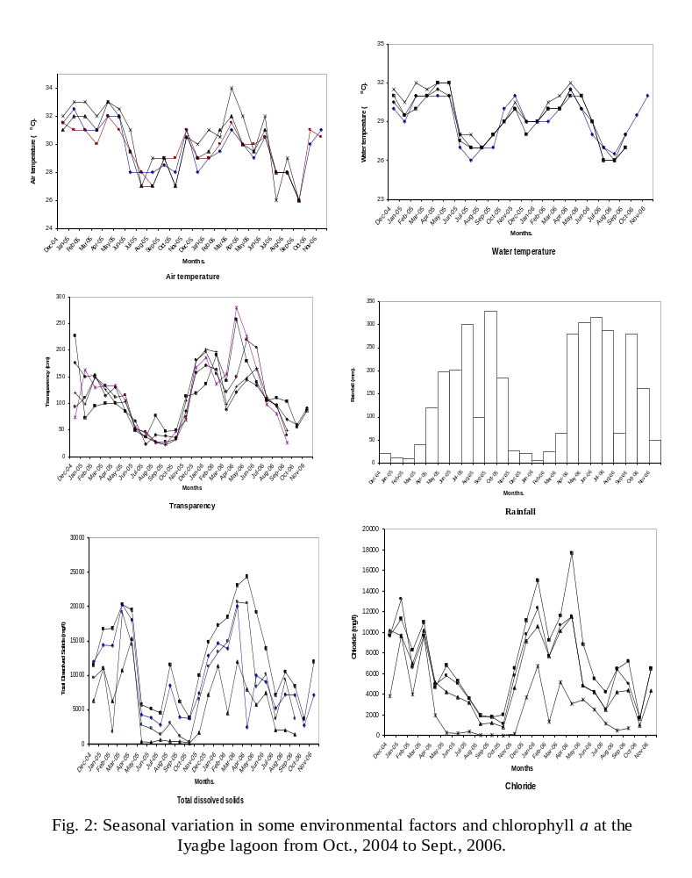
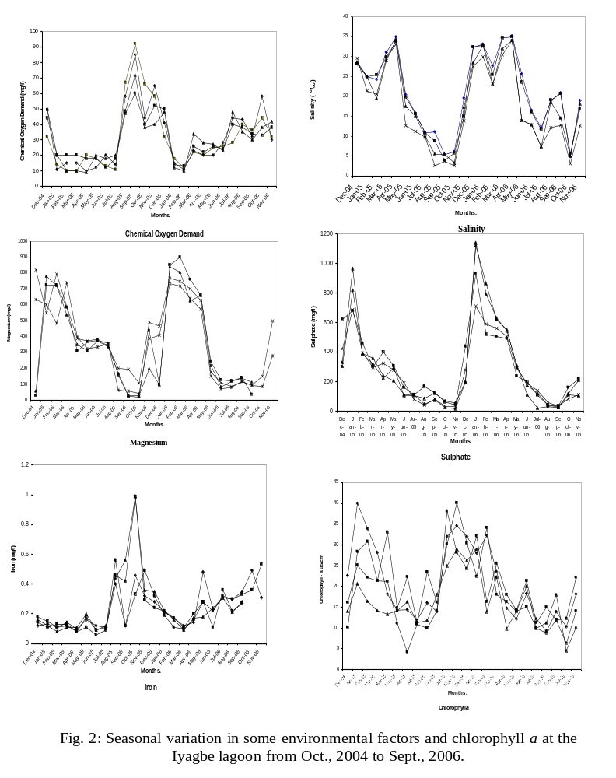
Fig 3: Pearson correlation coefficient between chlorophyll a and environmental factors.

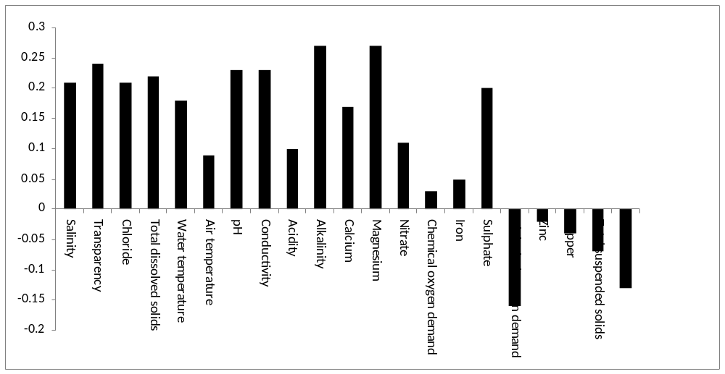
Table 4: Seasonal variation in Chlorophyll a values at the different stations in the Iyagbe lagoon, (Dec., 2004 – Nov., 2006).

 | 2004 | 2005 |  |  |  |  |  |  |  |  |  |  |  |  |  | 2006
 | Dec. | Jan. | Feb. | Mar. | Apr. | May. | Jun. | Jul. | Aug. | Sept. | Oct. | Nov. | Dec. | Jan. | Feb. | Mar. | Apr. | May. | Jun. | Jul. | Aug. | Sept. | Oct. | Nov.
Calabash Island | 22.6 | 40 | 33.9 | 28.1 | 18.2 | 14.3 | 14.4 | 12 | 16 | 14 | 32 | 34.6 | 32 | 28 | 32.2 | 23.6 | 14.8 | 12.2 | 18.3 | 12.2 | 9.3 | 14 | 10.3 | 18.2
Tincan Island | 10.2 | 28.4 | 30.8 | 21.3 | 33.1 | 14.8 | 22.3 | 11.3 | 23.4 | 16.2 | 30.1 | 40.1 | 30.3 | 22.4 | 34.1 | 18 | 16.3 | 14.1 | 15.1 | 10 | 8.8 | 12 | 12.3 | 22.1
Ibafon | 14.1 | 22.3 | 33.4 | 20.8 | 30 | 20.1 | 18.3 | 14.9 | 20.1 | 14.3 | 32.1 | 33.2 | 26 | 15.2 | 30.8 | 20.1 | 20.2 | 18.8 | 15.3 | 10.8 | 12.1 | 18 | 14.2 | 11
Imore | 11.3 | 30.1 | 33.1 | 16.9 | 28.1 | 16.3 | 11.4 | 12.2 | 18.2 | 18.1 | 24 | 36 | 20.1 | 22 | 16 | 14.2 | 21.6 | 16.2 | 20 | 25 | 16.3 | 20 | 16.8 | 8.6
Ito-Ogba | 19.2 | 22.4 | 28.6 | 14.8 | 20.1 | 14.1 | 16.3 | 16.4 | 12.6 | 11.3 | 33.2 | 30.8 | 22 | 18.9 | 14.2 | 22.3 | 25 | 20.1 | 32.3 | 22.6 | 28.1 | 13 | 14.2 | 11.3
Abule Oshun | 18 | 21.3 | 15.1 | 18.3 | 20.6 | 15.2 | 19.2 | 14.4 | 10.7 | 18.3 | 34.1 | 26.1 | 20.3 | 30.2 | 21.3 | 26.1 | 28.1 | 21.6 | 30.6 | 18.4 | 15.2 | 16 | 11.1 | 10.3
Idiagbon | 11.3 | 20.8 | 15.9 | 21.2 | 14.4 | 14.8 | 18.3 | 12.3 | 12.3 | 21.3 | 30.2 | 24.2 | 24.6 | 26.3 | 20.6 | 23.2 | 22.3 | 24.1 | 22.8 | 19.3 | 14.3 | 21 | 6.6 | 9.6
Iyagbe | 12.1 | 21.2 | 20.3 | 15 | 21.3 | 16.3 | 16.2 | 14.2 | 14.1 | 10.2 | 39 | 50.1 | 22.9 | 24 | 13 | 28.4 | 33.2 | 23.8 | 22.4 | 10.2 | 12.1 | 16 | 4.9 | 8.3
Agbaja | 14.8 | 22.3 | 16.2 | 18.1 | 16.8 | 14.1 | 14.8 | 18.6 | 10 | 16.3 | 33.3 | 22.6 | 33.6 | 33.4 | 14.2 | 20.1 | 29.3 | 20.6 | 28 | 16.8 | 16.3 | 11 | 18.2 | 9.4
Ikare | 10.3 | 24.4 | 18.1 | 16.3 | 17.1 | 21.2 | 11.3 | 10.1 | 16 | 12.1 | 34 | 55 | 38.1 | 26 | 23 | 29.2 | 25.3 | 26.5 | 24.3 | 14.1 | 18.8 | 20 | 10 | 8.6
Ilashe | 16.2 | 25.1 | 22.1 | 21.3 | 21.2 | 11.1 | 4.2 | 10.9 | 10 | 14.2 | 38.1 | 28.1 | 24.2 | 32.1 | 16.3 | 25.6 | 18.1 | 14.3 | 21.3 | 11.2 | 15 | 12 | 6.3 | 14.1
Idi-Mangoro | 14.1 | 20.6 | 16.4 | 14.2 | 13.4 | 14.2 | 16.3 | 11.3 | 11.8 | 18.1 | 25 | 29 | 26.3 | 29 | 14 | 22.3 | 9.8 | 14.1 | 20 | 10 | 11.3 | 18 | 4.6 | 10.2
Table 5: Pearson correlation co-efficient matrix of environmental characteristics at the Iyagbe lagoon, Lagos (December, 2004 – November, 2006).
 | Air temperature | Water temperature | Transparency | T.D.S. | T.S.S. | Chloride | Total hardness | pH | Conductivity | Salinity | Alkalinity | Acidity | D.O. | B.O.D. | C.O.D. | Nitrate | Phosphate | Sulphate | Silica | Calcium | Magnesium | Copper | Iron | Zinc | Chlorophyll a
Air temperature | 1
Water temperature | 0.77 | 1
Transparency | 0.34 | 0.40 | 1
T.D.S. | 0.35 | 0.39 | 0.54 | 1
T.S.S. | -0.18 | -0.22 | 0.38 | 0.22 | 1
Chloride | 0.06 | 0.10 | 0.20 | 0.17 | -0.08 | 1
Total hardness | 0.39 | 0.41 | 0.55 | 0.62 | -0.19 | 0.20 | 1
pH | 0.27 | 0.32 | 0.43 | 0.46 | -0.19 | 0.16 | 0.60 | 1
Conductivity | 0.40 | 0.44 | 0.57 | 0.96 | -0.25 | 0.17 | 0.64 | 0.49 | 1
Salinity | 0.38 | 0.45 | 0.57 | 0.88 | -0.29 | 0.17 | 0.73 | 0.48 | 0.89 | 1
Alkalinity | 0.34 | 0.26 | 0.41 | 0.28 | -0.16 | 0.14 | 0.54 | 0.71 | 0.33 | 0.28 | 1
Acidity | 0.13 | 0.10 | 0.42 | 0.33 | -0.24 | 0.13 | 0.38 | 0.48 | 0.33 | 0.32 | 0.64 | 1
D. O. | -0.13 | -0.07 | 0.19 | 0.18 | -0.26 | 0.22 | 0.08 | 0.10 | 0.17 | 0.20 | 0.06 | 0.18 | 1
B.O.D. | -0.39 | -0.45 | -0.38 | -0.36 | 0.37 | -0.14 | -0.46 | -0.25 | -0.40 | -0.45 | -0.31 | -0.36 | -0.05 | 1
C.O.D. | -0.25 | -0.26 | -0.18 | -0.26 | 0.45 | -0.07 | -0.15 | -0.09 | -0.29 | -0.27 | -0.16 | -0.26 | -0.20 | 0.57 | 1
Nitrate | -0.01 | -0.04 | 0.25 | 0.18 | 0.20 | 0.22 | 0.27 | 0.33 | 0.15 | 0.18 | 0.34 | 0.45 | 0.14 | -0.07 | 0.11 | 1
Phosphate | -0.25 | -0.24 | -0.32 | -0.28 | 0.50 | -0.08 | -0.31 | -0.13 | -0.32 | -0.37 | -0.26 | -0.29 | -0.07 | 0.54 | 0.36 | 0.00 | 1
Sulphate | 0.46 | 0.37 | 0.50 | 0.53 | -0.18 | 0.15 | 0.60 | 0.56 | 0.55 | 0.57 | 0.67 | 0.58 | 0.16 | -0.40 | -0.23 | 0.49 | -0.30 | 1
Silica | -0.18 | -0.14 | 0.12 | -0.01 | -0.36 | -0.04 | -0.19 | -0.16 | 0.02 | 0.04 | -0.17 | 0.03 | 0.12 | 0.02 | -0.08 | -0.24 | -0.16 | -0.17 | 1
Calcium | 0.41 | 0.43 | 0.33 | 0.49 | -0.15 | 0.11 | 0.64 | 0.38 | 0.52 | 0.56 | 0.27 | 0.14 | 0.18 | -0.35 | -0.16 | 0.07 | -0.24 | 0.35 | -0.09 | 1
Magnesium | 0.45 | 0.43 | 0.46 | 0.64 | -0.18 | 0.21 | 0.77 | 0.60 | 0.67 | 0.66 | 0.60 | 0.52 | 0.14 | -0.51 | -0.30 | 0.32 | -0.34 | 0.70 | -0.16 | 0.52 | 1
Copper | -0.23 | -0.29 | -0.20 | 0.08 | 0.59 | -0.04 | -0.10 | 0.01 | -0.11 | -0.17 | -0.04 | -0.12 | -0.04 | 0.38 | 0.34 | 0.20 | 0.53 | -0.08 | -0.31 | -0.10 | -0.12 | 1
Iron | -0.21 | -0.16 | -0.35 | 0.44 | 0.11 | -0.10 | -0.38 | -0.21 | -0.47 | -0.48 | -0.28 | -0.31 | -0.08 | 0.43 | 0.22 | -0.12 | 0.37 | -0.44 | -0.26 | -0.33 | -0.44 | 0.21 | 1
Zinc | -0.11 | -0.19 | -0.27 | -0.11 | 0.16 | -0.07 | -0.13 | 0.01 | -0.14 | -0.15 | -0.03 | -0.16 | -0.02 | 0.46 | 0.24 | -0.03 | 0.37 | -0.06 | -0.25 | -0.09 | -0.14 | 0.43 | 0.27 | 1
Chlorophyll a | 0.09 | 0.18 | 0.24 | 0.22 | -0.07 | 0.12 | 0.33 | 0.23 | 0.23 | 0.21 | 0.27 | 0.10 | 0.09 | -0.16 | 0.03 | 0.11 | -0.13 | 0.20 | -0.18 | 0.17 | 0.27 | -0.04 | 0.05 | -0.02 | 1

Discussion
The characteristics of environmental factors from this study shows clearly that the Iyagbe lagoon experiences environmental gradients likened to a tropical estuarine aquatic environments from year to year (Hill and Webb, 1958; Webb, 1960; Sandison and Hill, 1966; Kjerfve, 1994; Kirk and Lauder, 2000). Furthermore environmental factors of the lagoon exhibited seasonal changes that were closely related to the distributive pattern of rainfall of the region. For instance during the wet season, reduced levels for air and water temperatures, transparency, salinity, pH, total dissolved solids, conductivity, chloride, total hardness, sulphate, calcium, magnesium, acidity, total dissolved solids and alkalinity were recorded. Conversely, in the dry season the values for these parameters increased. Reduced rain events and its associated input of floodwaters from rivers, creeks, adjoining wetlands and the effect of tidal seawater incursion probably lead to this trend of environmental gradients. Reduced phytoplankton densities as reflected in chlorophyll a values in the wet season may be linked to the low water clarity which reduces the amount of light getting to planktonic algal component for photosynthesis. Higher chlorophyll a values recorded in the dry season is a pointer to improved water clarity at this time which probably allowed greater light penetration. According to Suzuki et al. (2002), low chlorophyll a values reflecting limited phytoplankton growth in an investigation of a Mexican lagoon were associated to dark water which reduced light penetration into the lagoon considerably.

Pearson correlation co-efficient showed positive correlation between chlorophyll a values, salinity, total dissolved solids, alkalinity, pH, conductivity, total hardness and chloride values among others. The flushing of planktonic algal forms towards the sea during the rains by flood waters and hence dilution, could also account for the low chlorophyll a values (phytoplankton densities) recorded at such times. The range of chlorophyll a values for the Iyagbe lagoon was between 12 and 55µg/l i.e between the mesotrophic and eutrophic productivity status (Suzuki et al., 2002, APHA, 1998). Furthermore, Ogamba et al., (2004) reported a chlorophyll a range of 0.15 – 37.4µg/l for the wet season and 0.10 and 40.28µg/l for the dry season in the Elechi creek in the Niger delta. Kadiri (1993) also reported a range of 4.20 – 35.20 mgm⁻³ for chlorophyll a for the Ikpoba reservoir in Benin.

Kadiri (1993) reported on the seasonal changes in the chlorophyll a situation of a shallow reservoir in Benin, Nigeria. Higher cloud cover situations attributed to the rainy season have been noted to impair chlorophyll a estimates (Kadiri, 1993) and phytoplankton biomass (Nwankwo, 1988) in some parts of the country. On the other hand, increases in insolation usually noted in the dry season likely encourage higher productivity, as recorded for this study. Furthermore, Onyema et al. (2003, 2007), are of the view that higher insolation, increased hydrological stability and marine situation are important encouraging factors for primary production in the Lagos lagoon. According to Kadiri (1993) seasonal fluctuation in abundance of phytoplankton is influenced by changes in the physical and chemical properties of the water which themselves can be dependent on rainfall. Similarly, sainfall and salinity are known to regulate the occurrence and distribution of biota in the Lagos lagoon and its associated creeks (Nwankwo and Onyema, 2003; Nwankwo, 2004).

Besides the ample availability of nutrients in this region, values for chlorophyll a were comparatively low especially in the wet season which likely indicated limited phytoplankton production. Similarly, Dissolved oxygen levels throughout the period of study were comparatively higher in the dry season than the wet season. It is possible that higher primary productivity necessarily resulted in higher chlorophyll a value and revealed a similar trend in dissolved oxygen values, since oxygen is a by-product of photosynthesis. It is possible to infere that chlorophyll a values from this study were largely determined by the trend and continuum of environmental characteristics of the lagoon which varies tidally and seasonally.

I.C. ONYEMA Ph.D.
Dept. of Marine Sciences
Faculty of Science
University of Lagos, Akoka.
Lagos, Nigeria.
iconyema@yahoo.com.au, iconyema@gmail.com
+2348023446934, +2348060442323

9/2/2008
References.
American Public Health Association. (1998): Standard Methods for the Examination of Water and
Waste Water. 20th ed. APHA New York. 1270pp.
Akinsoji, A., John, A. and Adekanye, M. (2002): Aquatic macrophytes of three selected sites in Lagos,
Southwest Nigeria. Journal of Science, Technology Research and Development. 2(1): 9 – 15.

Brown, C.A. (1998): Distribution and population dynamics of an estuarine population of Aloidis trigona Hinds (Bivalvia). Acta. Hydrobiol. 40(4): 227 – 237.

Brown, C.A. and Oyenekan, J.A. (1998). Temporal variability in the structure of benthic macrofauna communities of the Lagos lagoon and harbour, Nigeria. Pol. Arch. Hydrobiol. 45(1): 45 – 54.

Chukwu, L. O. and Nwankwo, D. I. (2004): The impact of land based pollution on the hydro-chemistry and macrobenthic community of a tropical West African Creek. The Ekologia. 2 (1-2): 1 – 9.

F.A.O. (1969): Fisheries Survey in the Western and Mid-Western Regions of Nigeria. FAO/Sf: 74/NIR 6. 142pp.

Kjerfve, B. (Ed.) 1994: Coastal lagoon processes. Elsevier Oceanography Series 60. Elsevier, Amsterdam. 577pp.

Kirk, R.M. and Lauder, G.A. (2000): Significant coastal lagoon systems in the South Island, New Zealand. Coastal processes and lagoon mouth closure. Science for conservation.146: 47 p.

Kadiri, M.O. (1999): Phytoplankton distribution in some coastal waters of Nigeria. Nigeria Journal of Botany.12 (1): 51 – 62.

Lee, R.E. (1999): Phycology. Cambridge University Press, New York. 614pp.

Nwankwo, D.I. (1984): Seasonal changes of phytoplankton of Lagos lagoon and the adjacent sea in relation to environmental factors. Ph.D. Thesis, University of Lagos. 447pp.

Nwankwo, D.I. (2004b). The Microalgae: Our indispensable allies in aquatic monitoring and
biodiversity sustainability. University of Lagos Press. Inaugural lecture seris. 44pp.

Ogamba, E.N. Chindah, A.C., Ekweozor, I.K.E. and Onwuteaka, J.N. (2004): Water quality of phytoplankton distribution in Elechi creek complex of the Niger delta. Journal of Nigerian Environmental Society. 2(2): 121 – 130.
Ogbeibu, A.E. (2005): Biostatistics: A practical approach to reseach and data handling. Mindex
Publishing Company limited, Benin city, Nigeria.264pp.

Onyema, I.C. (2008a): Phytoplankton biomass and diversity at the Iyagbe lagoon Lagos, Nigeria.
University of Lagos, Akoka. Department of Marine Sciences. 266pp

Onyema, I.C. (2008b): A checklist of phytoplankton species of the Iyagbe lagoon, Lagos. Journal of Fisheries and Aquatic Sciences. 3(3): 167 – 175.

Onyema, I.C. and Nwankwo, D.I. (2006): The epipelic assemblage of a polluted estuarine creek in
Lagos, Nigeria. Pollution Research. 25 (3): 459 – 468.

Onyema, I.C., Otudeko, O.G. and Nwankwo, D.I. (2003): The distribution and composition of plankton around a sewage disposal site at Iddo, Nigeria. Journal of Scientific Research Development.7: 11-26.

Onyema, 1.C., Okpara, C.U., Ogbebor, C.I. Otudeko, O. and Nwankwo, D.I. (2007): Comparative
studies of the water chemistry characteristics and temporal plankton variations at two polluted sites along the Lagos lagoon, Nigeria. Ecology, Environment and Conservation. 13: 1 – 12.

Sandison, E.E. (1966). The effect of salinity fluctuation on the life of Balanus pallidus strusburi (Darwin) in Lagos Habour, Nigeria. Journal of Animal Ecology. 35: 365 – 378.

Sandison, E.E. and Hill, M.B. (1966): The distribution of Balanus pallidus Strusburi (Darwin), Gryphaea gasar (Adanson) Dautzenbergi, Mercierella enigmatica farvel and Hydroides uncinata (Philippi) in relation to salinity in Lagos Harbour and adjacent creek. Journal of Animal Ecology. 38: 235-258.
Suzuki, M.S., Figueiredo, R.O., Castro, S.C., Silva, C.F., Pereira, E.A., Silva, J.A. and Aragon, G.T. (2002): Sand bar opening in a castal lagoon (Iquipari) in the Northern region of Rio De Janeiro state: Hydrological and hydrochemical changes. Braz. J. Biol., 62 (1): 51 – 62.

Sverdrup, K. a., Duxbury, A. B., and Duxbury, A. C. (2006): Fundamentals of Oceanography 5th ed.
New York: McGraw Hill Companies, Inc. 342. pp.

Webb, J.E. (1958a): The Ecology of Lagos lagoon. 1: The lagoons of the Guinea Coast. Philosophical Transaction Royal Society London. Ser B: 241-283.

Webb, J.E. (1958b): The life history of Branchiostoma nigeriense Webb. Philosophical Transaction Royal Society London. Ser B:335-354

Webb, J.E. (1960): Biology in the tropics. Nature. London. 188(4151): 617 - 619.

Webb, J.E. and Hill, M.B. (1958): On the Reactions of Branchiostoma nigerence Webb to its environment. Philosophical Transactions of the Royal Society of London. Ser B. 241: 355-391.

