Design investigation of a magnetic hollow cathode discharge for general laboratory applications

Djamel Boubetra¹, Hartmut Kerkow²
¹LMSE Centre Universitaire de Bordj Bou Arreridj, Algeria
²Alt Karow 17 HUB Berlin, Germany
E-Mail :boubetra@gmail.com

Abstract: We present in this work a model of design gas discharges with cold and magnetic hollow cathode, which can be useful for the experiments of sputtering and perforation of the layers solid bodies. It would use the physical principle of crossing electrical and magnetic fields so to increase the ionization way electrons and to guarantee a long maintenance of the discharge. This arrangement has potential application in a wide variety of laboratory research and development projects.
Keywords: magnetic hollow cathode, sputtering, plasma

1. Introduction
The magnetic hollow cathode (MHC) is an element for the construction of gas discharges arrangement for different purposes, which are still functional with relatively gas pressures (Boubetra, 2007), the MHC has been studied in order to improve the life-time of a discharge and of an ion source for an implanter (Tonegawa et al., 1986) and it would used for an Penning ion source (Joshua, 2008).

2. Experimental and results
It’s consists of the magnetic hollow cathode, the cylindrical anode and a (anti-cathode), those simultaneous is the magnetic pole piece of the magnetic field in anode region. The potential of the anti cathode could be selected in voltage range between 200V and 1kV, concerning the anode is freely, without the ion stream would have changed considerably. The polarity of the two magnetic fields to each other had crucial influence on the shape of the plasma in the anode region. Were the fields antivalent, then arose a strong bundling of the plasma, this can be explained with the fact that the magnetic flux lines penetrate inside the used hollow cathode and to be pushed by the permanent magnet.
A strong magnetic scattering field develops directly under the cover of the hollow cathode, there takes place a strong gas reinforcement of discharge, and all electrons from this range are collected by participation of the outside field in the plasma production and transferred into anode region. Special characteristic for this field geometry is the low gas pressure; witch can be lowered up to 0,1Pa.
Against it if the two magnetic fields are positioned in series, then the plasma is transferred into the Anode region according to the cross section of the hollow cathode opening.
In the anti cathode develops an even glowing seam, for its distance becomes larger with increasing suction tension for the ions (space charge layer). In this field arrangement the spraying installation must be operated with somewhat higher gas pressures, which shows that the gas reinforcement is not so effective for this magnetic field arrangement.
In fig. 2 is to shown 200μm thick Si-disk, which was also bombarded in different times with Ar-Ions. The sample were perforated after two hours radiation, after four hours the hole diameter rose of 2mm to 4mm, from which a certain radiation not homogeny in outer zone is to be read off, with the arrangement of parallel magnetic field was tried a homogeneous demolition , however the homogeneity of the demolition was not satisfying because the deviation were over a sample diameter more than 10%, also attempts were to tested by a sample shift a diagonal cross section not very successful and only by accident one could receive an edge sharp edge at evaporated films.
The power conversion at the samples was substantial by the high ion current density of several 100mA/cm², the sample heating up played a large role with the attempts sometimes then it came also to bubbling at the surface, which resulted from current charges of the sample by to high loss rates.
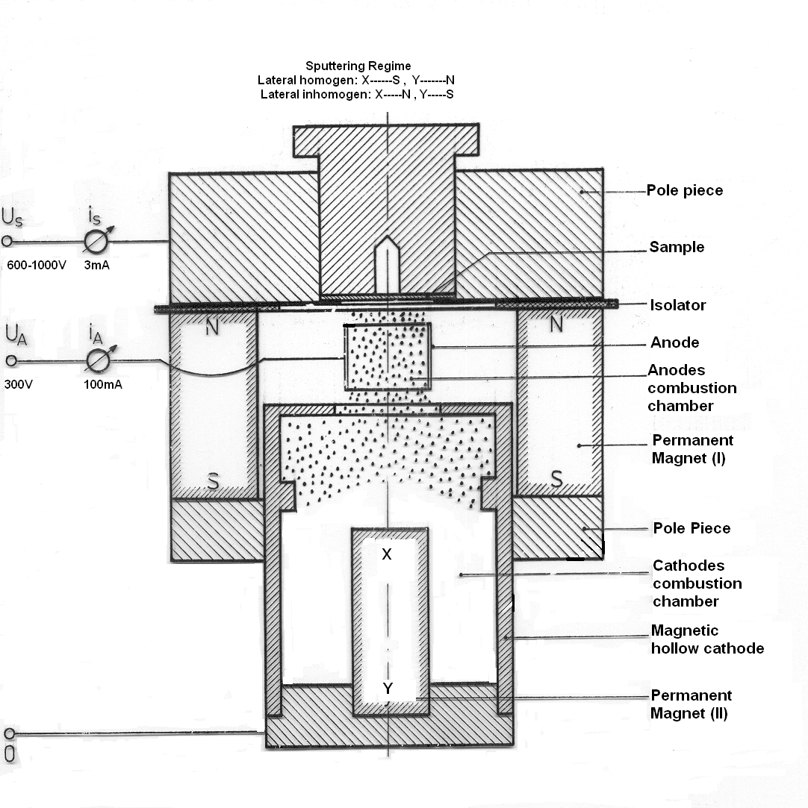
Figure 1: Sputtering arrangement with magnetic hollow cathode
The form of the plasma is determined by the polarity of the two magnetic fields to each other. If the magnetic fields of the hollow cathode and the anode region are arranged against each other for plasma focusing, then a focal spot develops on the Anticathode and/or anode. If the magnetic fields lie parallel to each other, then the plasma is transferred wide into the anode region.

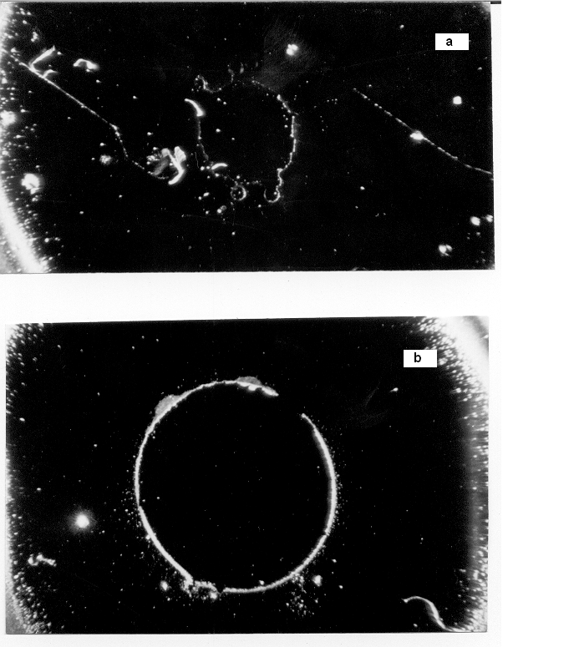

Figure.2. Photography of perforation by sputtering from 200μm thick Si samples
a) after 2h/5mA/800V - ion bombardment
b) after 4h/5mA/800V–ion bombardment

Conclusion:
By use this arrangement with crossed electrical and magnetic fields the gas pressure can be reduced likewise according to the extension of the ionization ways by the circulation of the electrons in the magnetic field , This leads then to a smaller gas need for the maintenance discharges and a decrease the gas load of the recipient in the vacuum installation This magnetic hollow cathode is an element with which one different ion source types can realize like Penning ion source, sheet ion source and duoplasmatron.

Acknowledgments
This work was supported in part by the Company Antar Trade Condor BBA, Algeria.

Correspondence to:
Dr. Boubetra Djamel
LMSE, Centre Universitaire Bordj Bou Arreridj
El Anasser 34265, Algeria
boubetra@gmail.com

References
- Boubetra, Dj., J.of American Sci. 3(4), 15-19, (2007).
- Tonegawa, A. et al., Vacuum, Vol. 36, Issues 1-3,15-18, (1986).
- Tonegawa, A. et al., NIM B Vol. 6 Issues 1-2, 129-132, (1985)
- Joshua, L.R., Plasma Sources Sci. Technol.17 035009 (7pp) (2008)

