Synthesis and characterization of aromatic polyether dendrimer / poly(2-hydroxy ethyl methacrylate) copolymer as nano drug carriers
Mohammad Reza Saboktakin*, Abel Maharramov, Mohammad Ali Ramazanov
Department of Chemistry, Baku State University,Baku, Azarbaijan
* E-mail : saboktakin123@yahoo.com

Abstract
Highly branched , functionalized polymers have potential to act as efficient drug carrier system.The aromatic polyether dendrimers are spherical, highly ordered,multibranched,nanometer-sized macromolecules having positively charged ether groups on the suface at physiological conditions.In this study , we synthesized a kind of dendrimer / poly(2-hydroxy ethyl methacrylate) nanocomposite for oral drug delivery . The aromatic polyether dendrimer (generation 2,hyperbranched polyether with -CH₂OH functionality, 3,5-Dihydroxybenzoic acid core) was prepared from generation 2,hyperbranched polyether dendrimer with -COOCH₃ form in excellent yield .FTIR ,NMR and DSC studied suggest that monomer predominantly forms a complex with polyether dendrimers because of the ionic interaction between the –CH₂OH end groups of dendrimer and the –OH group of 2-hydroxy ethyl methacrylate monomer .

Keywords:poly(2-hydroxyethylmethacrylate),polyetheric dendrimer,nanocomposite,carrier system.

Introduction

The most important characteristic of any drug is efficacy. This characteristic may often reduced because of the inability to deliver the drug to the specific cells or tissues[1,2].After administration,the drug may pass through different physiologic barriers and /or pathways,decreasing the actual amount drug that reaches the site.In the search for an ideal carrier system ,the dendrimers may have significant potential. Dendrimers are synthetic macromolecules with a well-defined globular structure[3] . The need for advanced materals with improved and new properties for a variety of technological applications has created a demand for both new forms of matter and for polymers that have highly controlled molecular architectures[4,5].The established approach to dendritic macromolecules has traditionally involved a divergent process in which growth is started from a polyfunctional core and continued outwards in a stepwise manner that affords larger and larger macromolecules as the process is continued[6]. The fundamental attribute of the convergent approach is that it begins at what will be the periphery of the molecule,proceeding inwards[7]. It is this feature more than any other that allows for unparalled control over molecular architecture [8]. Figures 1,2 show the structure of the generation 1 and 2 hyperbranched aromatic polyether dendrimer[9,10].

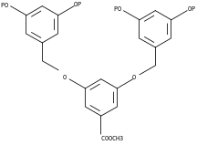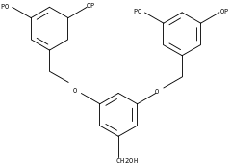

Figure 1 –Aromatic polyether dendrimers structure(1 generation)

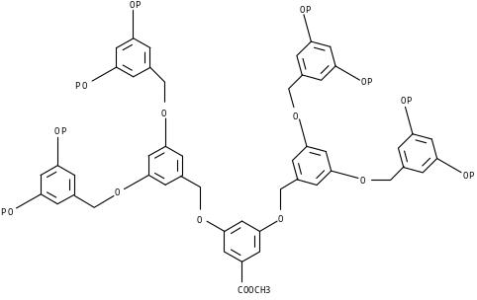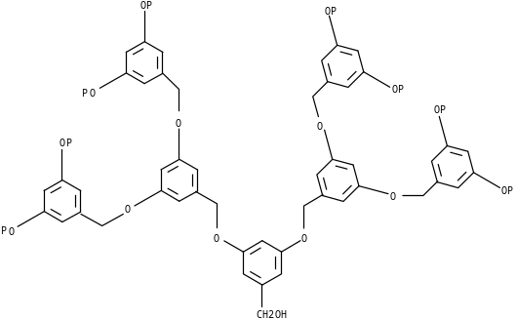

Figure 2 –Aromatic polyether dendrimer structures(2 generation)

We investigate the potential of dendrimers amd hyperbranched polymers as drug carrier system using poly(2-hydroxy ethyl methacrylate),since the methodologies for evaluation of the cellular activity of dendrimer are well known[11,12].In this paper ,we explore the interaction of the poly(2-hydroxy ethyl methacrylate), with aromatic polyetheric dendrimer . the nature of the interaction was characterized by FT-IR and ¹H-NMR spectroscopy. Figures 3,4 show schematic synthesis method of polyether dendrimer -poly(2-hydroxy ethyl methacrylate) conjugate[13,14].
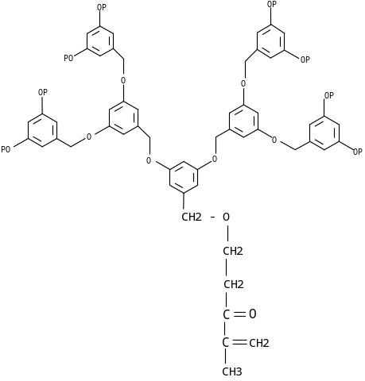
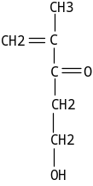

+

schematic representation
polyether dendrimer 2-Hydroxy ethyl methacrylate
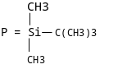 monomer

Figure 3 –Schematic synthesis of 2-Hydroxy ethyl methacrylate conjugated with polyether dendrimer .

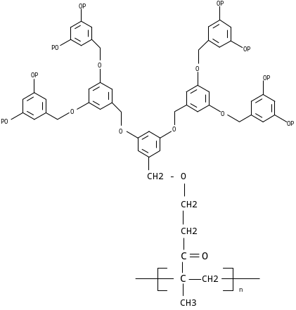

Figure 4 –Schematic synthesis of 2-Hydroxy ethyl methacrylate / polyether dendrimer copolymer.

Experimental part
All reactions were performed under an atmosphere pressure . All reagents and solvents , unless otherwise specified,were obtained from Merck Chemical Co.. Melting points were obtained on a Mel-Temp melting point apparatus . G2 polyether dendrimer and 2-Hydroxy ethyl methacrylate were obtained from Aldrich chemical company.¹H- NMR spectrum were recorded on a 400 MHz spectrometer , But were referenced to tetramethylsilane. Analytical TLCs were run on commericial Merck plates coated with silica gel GF250(0.25mm thick). Fourier transfer infrared(FTIR , Bruker )spectroscopy was used to identified the polymer surface.Specta were obtained in the wave number range of 400-4000 cm⁻¹ . Spectra of samples were recorded from KBr in 1:10 (wt/wt) ratio.

Preparation of 3,5-bis(3,5-bis(3,5-bis(t-butyldimethylsilyloxy) benzyloxy)benzyloxy)benzyl alcohol.
A mixture of the G2-COOCH₃ dendrimer(AB8, heptamer) ( 0.8 g ,0285 mmol) in dry THF (100 ml) and dropwise to a suspension of LiAlH₄ (2.5 g , 60 ml) in dry THF (50ml) .After reflux for 1h , the solution was treated with aqueous NaOH (1M,15ml) ,filtered and evaporated. The residue was chromatographed on silica gel with dichloromethane as the eluent to give the heptameric alcohol as a colorless glass(0.768 g ,96%).R_{f} = 0.91 ,  _{max}(KBr)/cm⁻¹ 3053, 2960,2932,2860,1544 ;  _{H} (CDCl3) 0.1(s,48H,CH3), 0.9(s,72H, t-Bu), 1.60( t,1H,OH),4.62(d,2H,CH2OH), 4.68(s,8H,CH2O-),4.88(s,4H,CH2O-),6.14(t,4H,J2,4H 3nd gen. Ar), 6.21(t, 2H, J2, 2/4-H 2nd gen.Ar),6.41(d,8H,J2, 2/6-H 3nd gen. Ar) , 6.41(d,4H,J2,2/6H 2nd gen. Ar).Found : C,76.4% ; H,6.8% , C₁₇₇H₁₈₈O₁₅Si₈)

Preparation of 3,5-bis(3,5-bis(3,5-bis(t-butyldimethylsilyloxy) benzyloxy)benzyloxy)benzyl alcohol dendrimer and 2-hydroxy ethyl methacrylate conjugate.
A mixture of the G2-CH2OH dendrimer(AB8, heptamer) ( 0.17 g ,0.279 mmol) , 2-Hydroxy ethyl methacrylate ( 0.176 g ,0.127 mmol) , diethyl azo dicarboxylate( 0.05 g ,0.317 mmol) triphenyl phosphine ( 0.083 g ,0.317 mmol) was dissolved in dry THF .The reaction mixture was stirred for 24 h in the dark ,then evaporated using rotaevaporator to emove methanol . The traces were dried under vacuum in order to remove methanol completely .To these traces , deionized water was added . residue was chromatographed on silica gel with dichloromethane- petroleum ether (3:1) as the eluent to give the pure conjugate. The 2-Hydroxy ethyl methacrylate –dendrimer conjugate obtained was in the form of a yellow powder(R_{f} = 0.92 , 68.1%).

Preparation of 3,5-bis(3,5-bis(3,5-bis(t-butyldimethylsilyloxy) benzyloxy)benzyloxy)benzyl alcohol dendrimer and 2-hydroxy ethyl methacrylate copolymer.
A mixture of the 2-Hydroxy ethyl methacrylate - G2-CH2OH dendrimer(AB8, heptamer) conjugate ( 4.83 g ,0.37 mmol) , azo bis isobutyronitryle (AIBN) ( 61m g ,0.37 mmol) , DMF (10 ml) at 612 ˚C for 24 h was stirred for 24 h. The mixture was then filtered through PTFE membrane(Millix Millipore) of pore size 200nm ,and then lypophilized to remove water.After approximately 180 min, the sample were sprayed into a liquid nitrogen bath cooled down to 77° K, resulting in frozen droplets. These frozen droplets were then put into the chamber of the freeze-dryer. In the freeze-drying process, the products are dried by a sublimation of the water component in an iced solution. The 2-Hydroxy ethyl methacrylate –dendrimer copolymer obtained was in the form of a white powder(m.p. 253-254 ˚C, 73.0%).

Results and discussion
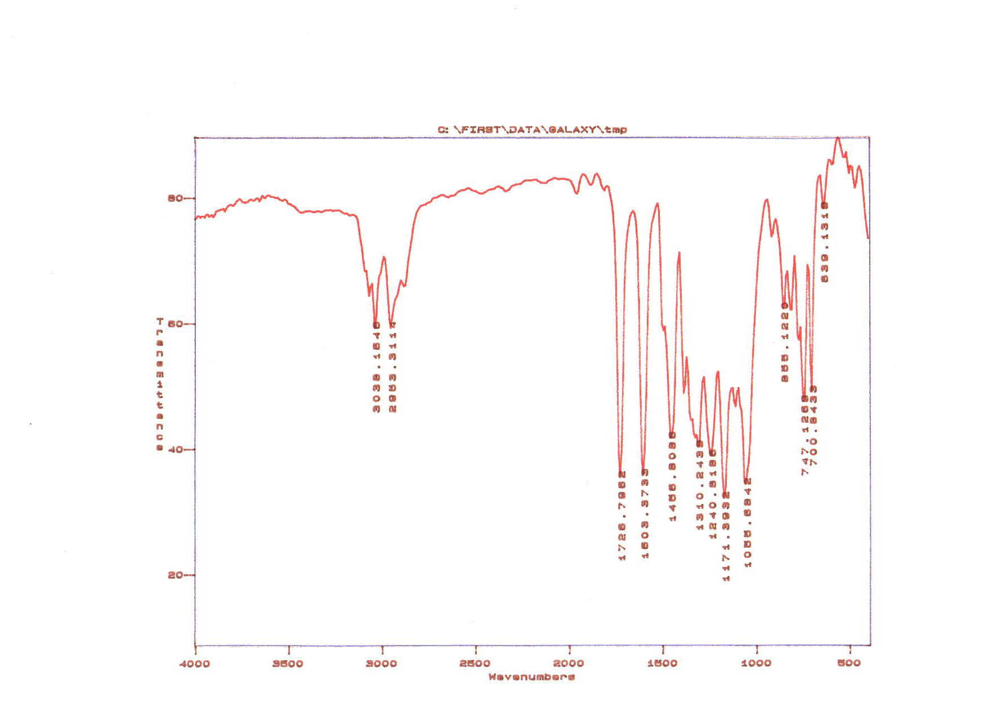
Figure 5 shows the FT-IR spectrum of the G2-COOCH₃ dendrimer(AB8, heptamer) where the % of transmittance is plotted as a function of wave number (cm⁻¹). The characteristic FT-IR peaks at 3078 , 3053 ,2961,1718 cm⁻¹ are due to the presence of =CH bond stretching vibrations , the aliphatic CH bond in protect groups (t-butyldimethylsilyloxy) and carbonyl (C=O) group ,respectively.

Figure 5- FT-IR spectrum of [G2] –COOCH₃ Dendrimer

Figure 6 shows the FT-IR spectrum of the G2-CH₂OH dendrimer(AB8, heptamer) .The characteristic FT-IR peaks at 3408,2960,2932,2860,1544 cm⁻¹ are due to the presence of OH phenolic group , the aliphatic and aromatic =CH bond in protected methyl groups and C=C bond of aromatic group ,respectively.

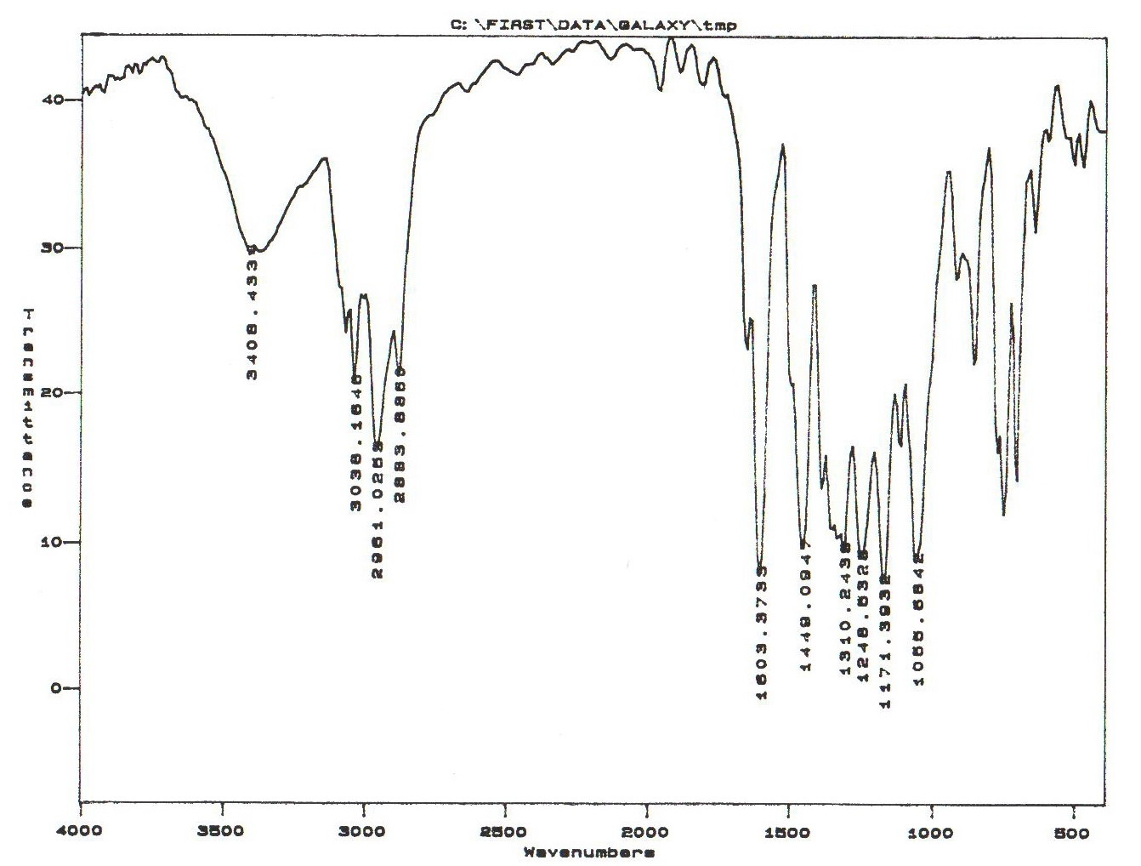

Figure6- FT-IR spectrum of [G2] – CH₂OH Dendrimer

Also, figure 7 shows the FT-IR spectrum of the G2-CH₂OH dendrimer(AB8, heptamer)/ poly(2-hydroxy ethyl methacrylate) nanocomposite.The characteristic FT-IR peaks at 3408,2960,2932,2860,1544,1726cm⁻¹ are due to the presence of OH phenolic group , the aliphatic and aromatic =CH bond in protected methyl groups and C=C bond of aromatic group and carbonyl (C=O) group of 2-hydroxy ethyl methacrylate,respectively.
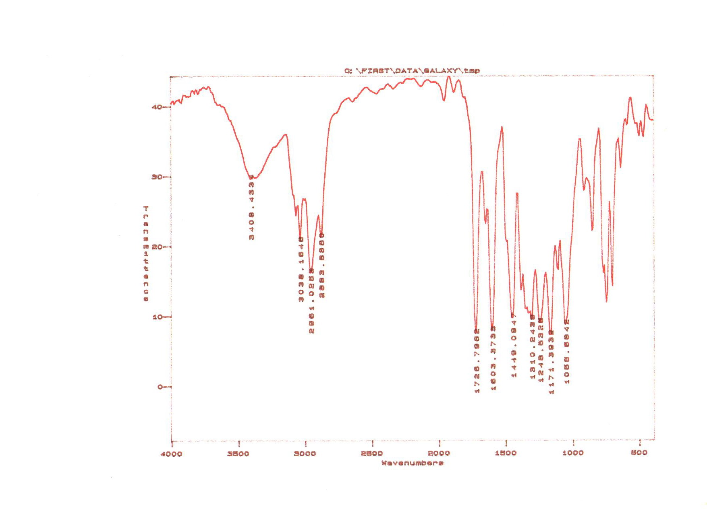

Figure7- FT-IR spectrum of [G2] – CH₂OH Dendrimer/poly(2-hydroxy ethyl methacrylate) copolymer
Figure 8 shows the SEM of aromatic polyether dendrimer / poly(2-hydroxy ethyl methacrylate) copolymer that synthesized by chemical reaction. This copolymer is very sensitive to the temperature that due to the intractionelectron and sample . Scanning electron micrography images were obtains from a diluted solution of the copolymer particle . The white spots are poly(2-hydroxy ethyl methacrylate) nano particles .The SEM image shows the presence of poly(2-hydroxy ethyl methacrylate) spherical particles in polyfunctional dendrimeric matrix, which are homogenenously distributed throughout the copolymers ,which is also confirmed from ¹H-NMR studies[15].
The ability of the dendrimer to form a complex with 2-hydroxy ethyl methacrylate monomer depends on the core- suface groups of dendrimer ,electrostatic interactions between the dendrimer and the monomer , and the ability of the drug to form a conjugate with the dendrimer through chemical bonding . Therefore , it is possible to manipulate the incorporation process for a given monomer by appropriate selection of the dendrimer and the surface functionality.One might expect that the 2-hydroxy ethyl methacrylate with the carboxylic group may form a complex with surface OH groups of polyether dendrimer.
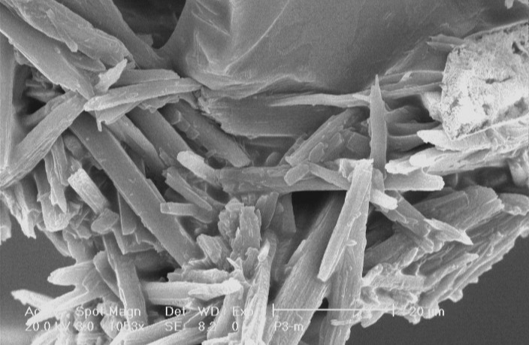
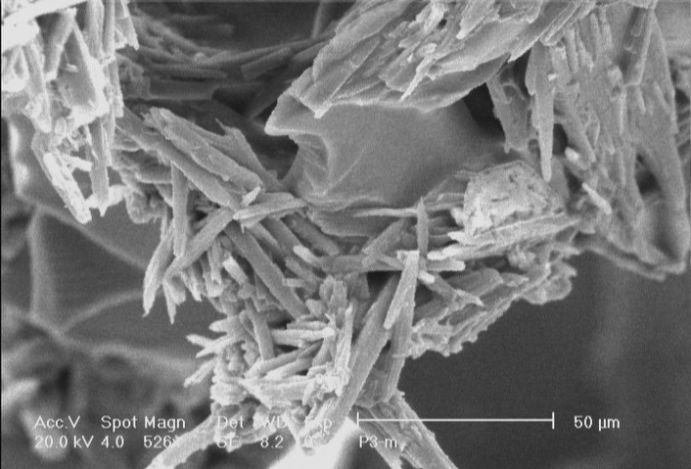

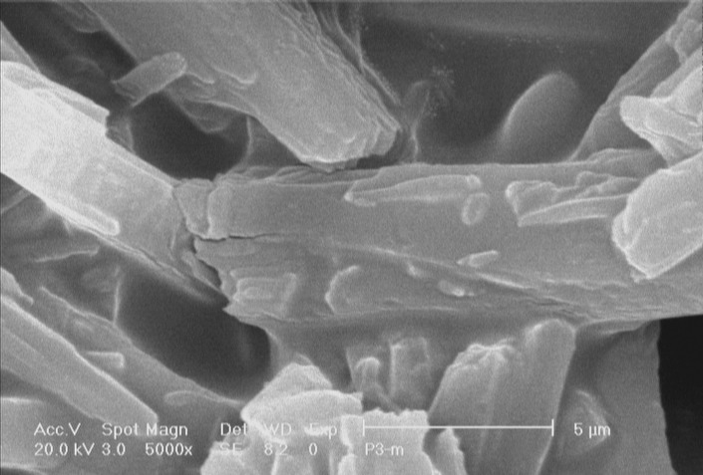
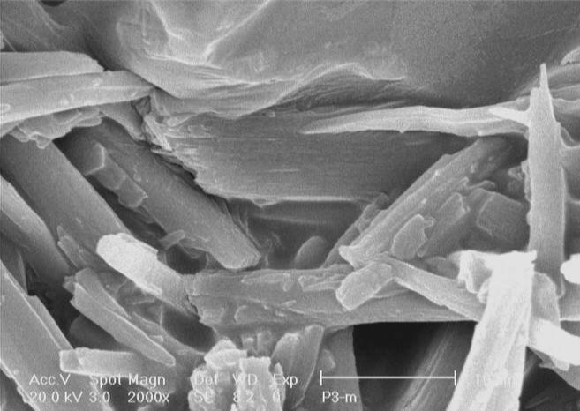

Figure 8- SEM of [G2] – CH₂OH Dendrimer/2-hydroxy ethyl methacrylate copolymer

Figure 9 shows the 400 MHz ¹H-NMR spectrum of of [G2] – CH₂OH Dendrimer/2-hydroxy ethyl methacrylate conjugate in which three regions can be seen. The silane group 48 and 72 protons are in the regions of 0.37 and 0.85 ppm ,respectively . The resonance of CH₂ protons (c group) , CH₂ ,4 protons (d group), CH₂ 8 protons (Heptamer protons ) , benzylic protons of heptamer( a group) , vinylic CH₂ protons are 4.09, 4.15 , 4.27, 4.86,5.66 ppm ,respectively.
The resonances for the aromatic protons of the monomer units at dendrimer occur in the region 6.73 ppm separate resonances are observed in the appropriate ratio for each layer of monomer units . The solvent peak occur in the region 7.51 ppm .
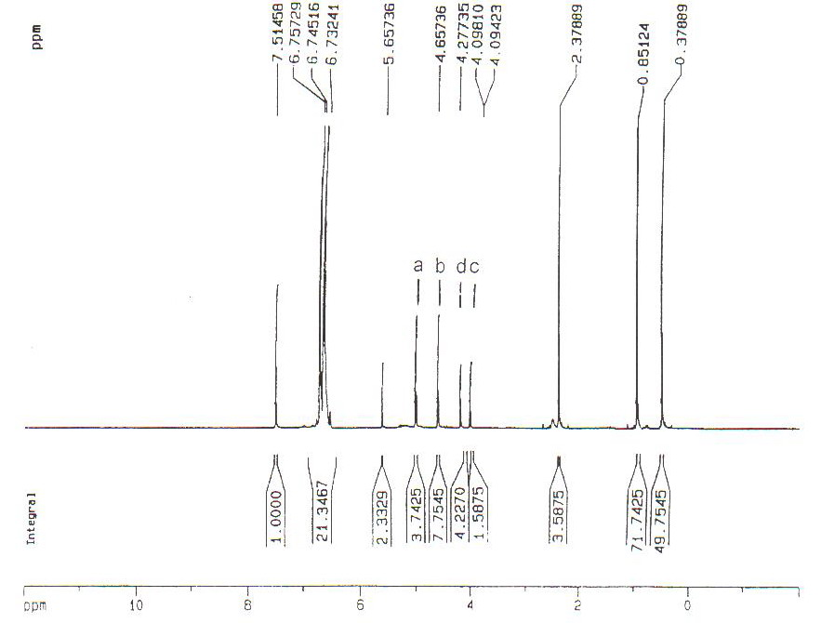

figure9- 400MHz ¹H-NMR spectrum of [G2] – CH₂OH Dendrimer/2-hydroxy ethyl methacrylate conjugate(CDCl₃ ).

Figure 10 shows the 400 MHz ¹H-NMR spectrum of of [G2] – CH₂OH Dendrimer/poly(2-hydroxy ethyl methacrylate)nanocomposite in which three regions can be seen. The silane group 48 and 72 protons are in the regions of 0.10 and 0.85 ppm ,respectively . The resonance of methyl group , polymer CH₂ protons, CH₂O protons, CH₂ 8 protons (Heptamer protons ) , CH2 protons of heptamer( a group) , are 1.68 , 2.27 , 4.17 , 4.65, 4.79 ppm ,respectively. The resonances for the aromatic protons of the monomer units at dendrimer occur in the region 6.28-6.32 ppm separate resonances are observed in the appropriate ratio for each layer of monomer units . The DMSO peak occur in the region 3.34-3.48 ppm .

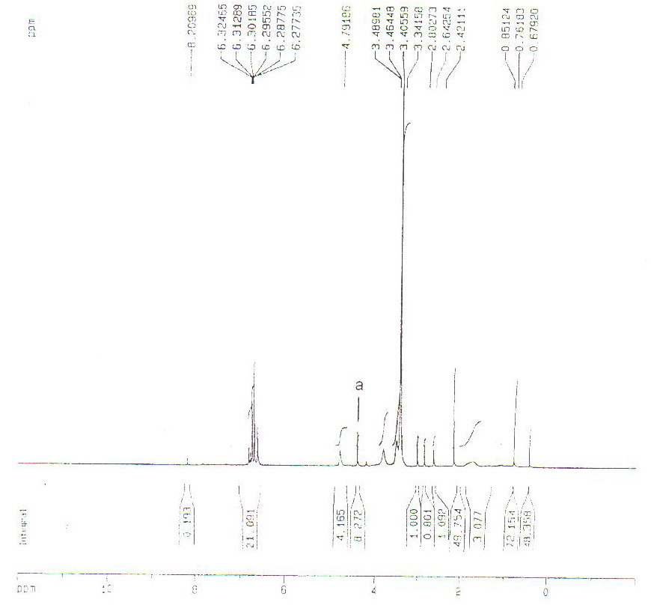

Figure10- 400MHz ¹H-NMR spectrum of [G2] – CH₂OH Dendrimer/poly(2-hydroxy ethyl methacrylate ) copolymer (DMSO-d6).

The thermal behavior of a polymer is important in relation to its properties for controlling the properties of copolymer. in. The glass transition temperature (Tg) was determined from the DSC thermograms. The values are given in Table1. The higher Tg values probably related to the nanocomposite size, which would decrease the flexibility of the chains and the ability of the chains to undergo segmental motion, which would increase the Tg values. On the other hand the introduction of a strongly phenolic OH group can increase the Tg value because of the formation of internal hydrogen bonds between the polymer chains.

Table 1. DSC data and composition of copolymer
Nanocomposite | Molar composition of monomers in the feed  Dendrimer (gr) / 2-HEM*(gr) AIBN (gr) | g (º C)
1 | 4.83 0.06 | 126

* : 2-Hydroxyethyl methacrylate

Conclusions:
The ability of the dendrimer to form a copolymer with 2-hydroxy ethyl methacrylate monomer was explored using aromatic polyether dendrimer as model base polymer.The nature of 2-hydroxy ethyl methacrylate -dendrimer interaction were explored using FT-IR , ¹H-NMR and SEM. Our studies suggest that the aromatic polyether dendrimer may predominantly form a conjugate with the -OH group of 2-hydroxy ethyl methacrylate .This nanocomposite is stable in deionized water and methanol and can be use as drug carrier system .Current studies are exploring the complexation/conjugation ability of these dendrimers to a wide variety of drugs carrier .

Acknowledgment:
The authors Wish to thank prof. M.Allahverdiev(from Baku State University) for Valuable discussions.

References
- Koller,C. ; Pugin,B. ;Togni,A.; J. Am. Chem. Soc., 1998 ,120, 10274.
- Percec,V.; Hirokwa,Y.;Ohtake,K. ; Soai,K.; Tetrahedron,1997,53,4033.
- Duan,R. G.;Miller,L.L.; Tomalia,D.A.; J. Am. Chem. Soc., 1995 ,117, 10783.
- Hiroshi,I.;Ludmark,S.B.;Nguyen,C.V.; J. Am. Chem. Soc., 2000 ,112, 2415.
- Womer,C.;Mullhaupt,R.; Angew.Chem.,Int.,Ed.;1993,32,1306.
- Tomalia,D.A.;Naylor,A.M.; Angew.Chem.,Int.,Ed.;1998,37,2361.
- Newkome,G.R.;Lin,X. J. Org. Chem., 1997,62,6283.
- Leon, J.W.; Kawa,M.;Frechet,J.M.; J. Am. Chem. Soc., 1996 ,118, 8847.
- Wooly,K.L.;Hawker,C.J.; Frechet,J.M.; J. Am. Chem. Soc., 1997 ,119, 53.
- Saboktakin,M.R.,Maharramov,A.,Ramazanov,M.A.,The Journal of American Science,2008,4(1),48-52.
- Saboktakin,M.R.,Maharramov,A.,Ramazanov,M.A.,The Journal of American Science,2007,3(4),45-51.
- Hawker,C.J.; Frechet,J.M.; J. Am. Chem. Soc., 1990 ,112, 7638.
- Aravind,M.K.;Micelli,J.N.;Kauffman,R.E.,J. Chromatogr.,1984,308,350.
- Zhuo,R.X.;Du,B.,Lu,Z.R.; J. Control. Release, 1999,57,249.
- Milhem,O.M.;Myles,C.; McKeoewn,N.B., Attwood,D., Int. J. Pharm.,2000,197,239.

