INFINITE-TIME and SPACE-TIME

John L. O’Sullivan
Independent Researcher
Email: johnlosullivan@att.net

ABSTRACT:
This report will show why photons have duality as a wave and as a particle and will show the origin of atoms and cause of gravity and offer a solution in graphic form that otherwise has remained a mystery. The theory is based on scientific deduction and deemed valid conceptually as outlined in the illustrations giving an understanding of Pi and infinity as it relates to mass in the electro-magnetic and gravitational field. [The Journal of American Science. 2008;4(4):1-4]. (ISSN: 1545-1003).

INTRODUCTION:
The electromagnetic field is comprised of electromagnetic waves in the opposite direction resulting in standing waves where direction is relative to the source of energy as the waves are without end. The wave duality provides for both the electromagnetic and gravitational forces. A photon is a standing wavelet focused like a particle where the speed of light is relative to infinity and mass is part of infinity. A photon has duality as a wave and as a particle [1]. Energy is equal to frequency of the photons based on Planck’s constant.

REPORT:
Electro and magnetic wavelets expand into larger wavelets from the antinodes (displacement) energy of standing waves at twice the wave amplitude of the smaller wave giving distance to the field. The wavelets increase in amplitude to a level causing stress energy from expansion resulting in a coupling link of electro photons to fuse having a strong nuclear force in an open atom with a nuclei and electron(s). The electro field coupling is perpendicular to the inside magnetic field coupling, therefore, the electro link will fuse as the weaker of the two from energy expansion. Atom identity is determined by the life cycle duration of the electro coupling that became mass. Like the life cycle of a star [2], a field coupling having a longer duration to expand will fuse as a lighter atom such as a hydrogen atom. Direction of energy is relative to the source energy of mass and field energy. The field expands into larger wavelets from the displacement energy of standing waves and the energy from mass propagates on the wavelets.

From the field illustration Fig.1a the black-red (dark color) are the electro wavelets perpendicular to the page and brown-green (light color) are the magnetic wavelets on the same plane as the page. The transverse wavelets in the figure must be visualized in three dimensions and the expansion of the wavelets must be visualized in a cone or spiral form. The atom is depicted at center when an electro field coupling link fused from expansion. The coupling link between the open circles is the e coupling constant, like 137.0359 [3]. Due to the expansion of the standing wavelets in a spiral cone (energy displacement of standing waves into larger wavelets), the base or space between the circles give the necessary amplitude for the photons and electron(s) to interact as a coupling and the apex or dead center between the circles in the cone is the nuclei fused in time at much shorter wavelengths. The field wavelets are endless in time; hence the circles are open regardless of the size of the spiral wavelets in the wavelength spectrum.

Moving two steps from center and squaring, there are four complete light color circles to the square Fig.1a. On three steps from center and squaring, there are nine complete light color circles to the square and so forth in the inverse-square distance of the magnetic field where the hypotenuse of each square alternate between the electro and magnetic wavelets.

Energy forms matter from an electro coupling link giving a point center to the magnetic circle of photons where the ratio of the diameter in the magnetic circle to its circumference is infinite. Gravity forces come from the magnetic wavelets around the atom Fig.1a which is an inward attraction force at the nodes that help conserve the energy Fig.1b.

The magnetic photon wavelets will adjust gravity forces for any kind of atom as the field tends to restore the coupling that became mass to its original state. The atom and gravity are united and comply with the inverse-square distance and the constant G. It follows that the accumulation of mass includes the accumulation of gravity as the photon wavelets interact with other field electrons via constructive and destructive wavelet interference from the wavelength spectrum.

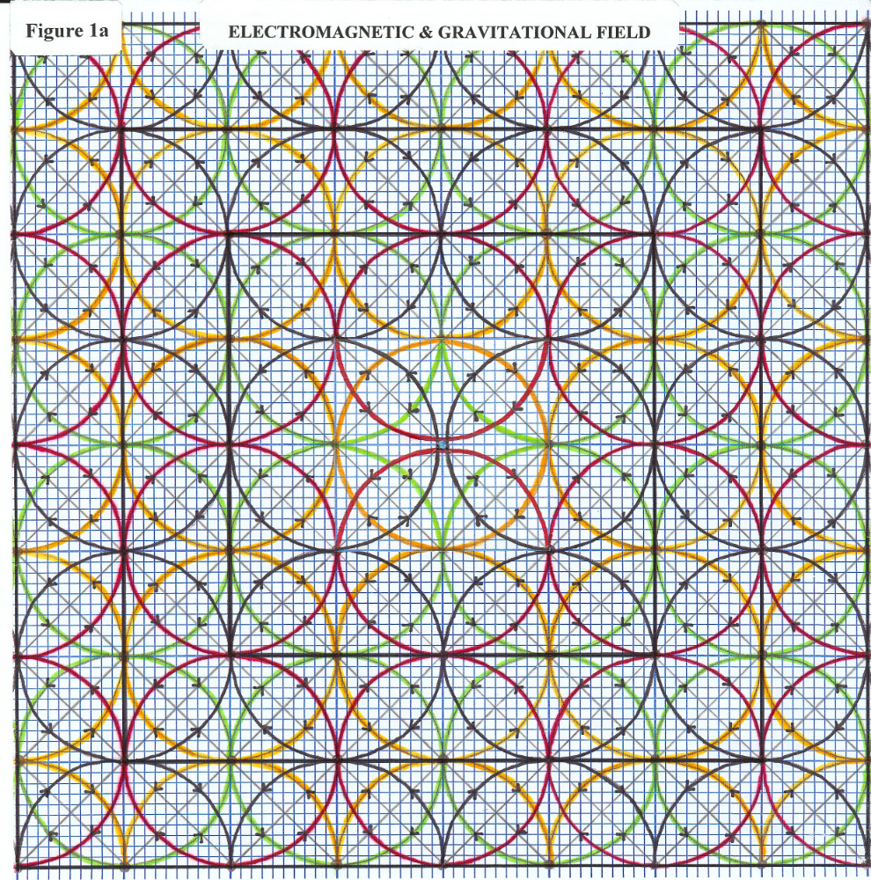

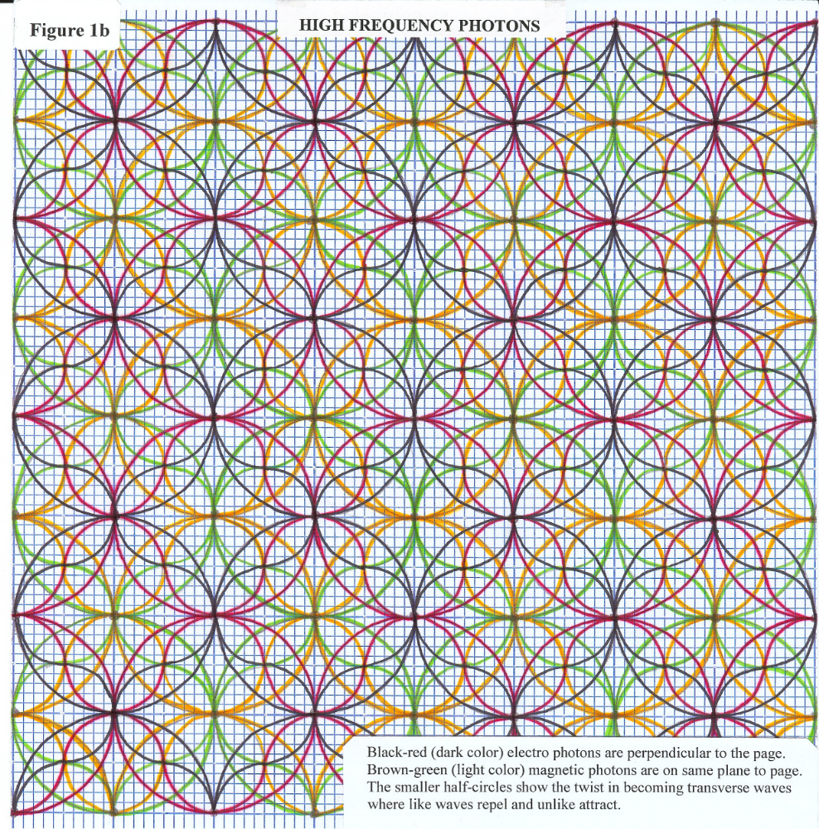

CONCLUSION:
Left Side Right Side
Einstein’s Equation: E = MC²

Expanded Equation: E = C = ∞ = Open Circle = MC²

Zero times anything equal zero given mass on the right side of the equation. Zero does not apply on the left side of the equation because there is no mass. As follows:
With Mass 0 x Mass = 0 (on the right side of the equation).
With Mass 0 x C = 0 (on the right side of the equation).
Without Mass 0 x C = ∞ (on the left side of equation, since zero does not apply).
Without Mass E = ∞ (on the left side of equation, since zero does not apply).
Therefore E = C = ∞ (on the left side of the equation).

Infinity is the field without mass Fig.1b. Infinity is the open circle without mass Fig.1b. Infinity is on the left side of the equation because infinity is not a number. Mathematics has no application on the left side of the equation because there is nothing to measure or count. Photons are counted on the right side of the equation with mass because C is finite (general relativity). Photons are not counted on the left side of the equation because C is infinite (no relativity). In essence, the speed of light is relative to infinity because the speed of light is coming from the same energy.

The idea of speed is relative to moving from point A to B. If there was no point A and B, the waves would be fixed or standing relative to infinity. Moving from point A to B in the field is the propagation of the standing waves at the value of C relative to mass. For mass, C² is the offset to the inverse square distance of the field. If there was no mass, there would be no need for C² and E would equal hf or C. If there was no mass, there would be no circle center for a diameter as a ratio to the open circumference.

Time is relative only when mass is created where C is finite. Time is without mass in the form of photons always moving. Time is the act of joining the three spatial dimensions together as part of time itself. An observer is part of time and part of infinity from the same source of energy where the speed of light is the same for all observers. General Relativity indicates that everything is connected within the context of curved space-time and motion of mass [4].

Energy-time is a universal constant for time, mass and gravity in a changing field of photons. From the universal constant of energy-time, the vacuum in free space is part of infinity. From this it can be concluded that energy in the form of photons is responsible for time, mass and gravity where energy is equal to the reality of forming mass in infinite time.

ILLUSTRATIONS, color or grayscale:
Figure 1a, Electromagnetic & Gravitational Field.
Figure 1b, High Frequency Photons.

References:
[1] Hawking, S., The Illustrated A Brief History of Time, Bantam Books, (1996), p104.
[2] Ibid, p105.
[3] Feynman, R.P., QED, The Strange Theory of Light and Matter, Princeton University Press
(1988), p129.
[4] Ibid, Hawking, S., p40.

