Gene Transfer Enhanced by Increased Ambient Temperature, UV Laser and Gene Gun

Ma Hongbao *, George Chen **, Jenny Young ***, Cherng Shen ****

Department of Bioengineering, Zhengzhou University, Zhengzhou, Henan 51001, China, mahongbao2000@yahoo.com, 01186-156-1769-1256

** Mechigan State University, East Lansing, MI 48824, USA, chengu@msu.edu

*** Brookdale Universit Hos[ital and Medial Center, Brooklyn, NY 11212, USA, arbook@gmail.com

**** Department of Electrical Engineering, Chengshiu University, Niaosong, Taiwan 833, Republic of China, cherngs@csu.edu.tw, 011886-7731-0606 ext 3423

Received December 27, 2007

Abstract
Background: Several techniques are currently used to transfer genes into various cells, tissues and organs. Although gene therapy is a potential therapeutic approach for arterial restenosis and angiogenesis, the efficiency of transfection is low regardless of the technique used. Methods: Rat heart muscle cells were cultured in medium 199 with 10% FBS and human aorta smooth muscle cells were cultured in F12K medium. Human interleukin-2 gene was transfected into rat heart cells and swine growth hormone gene was transfected into human aorta smooth muscle cells by calcium phosphate coprecipitation at various temperatures: 23ºC, 37ºC and 43ºC. Transfected interleukin-2 and swine growth hormone expressions were detected using an indirect ELISA. With the self-design CO₂ propelled gene gun (200 psi, distance 3 cm with 400 mesh nylon screen) using tungsten particle (600 nm diameter) coated with plasmid expressing anti-ampicillin gene, the plasmid with anti-ampicillin gene was transferred into E. coli cells. GFP gene was transferred by UV excimer laser (XeCl₂, 308 nm). Results: The heated cultured rat myocytes had a significantly higher expression of the transfected interleukin-2 gene. Ambient temperature rise to 43ºC for up to 30 min provided greater transient transfection of the interleukin-2 gene when compared to ambient temperatures at 37ºC and 23ºC (p<0.01). The greatest effects occurred within 10 min of incubation and persisted up to 30 min. Laser and gene gun enhanced gene transfection. Conclusions: These results suggest that even a few degrees of ambient temperature rise can significantly increase gene transfer into cells. Gene gun and laser help gene transfer. These may be of value in gene therapy.

Key Words: calcium phosphate coprecipitation; gene gun; gene transfer; laser; lipofection; temperature

Abbreviations: ATCC, American Type Culture Collection; E. coli, Escherichia coli; ELISA, enzyme-linked immunosorbent assay; IL, interleukin; TNF, tumor necrosis factor; CRP, C-reactive protein; MCP, monocyte chemoattractant protein

1. Introduction
Gene therapy can be defined as the deliberate transfer of DNA for therapeutic purposes (Selkirk, 2004). There is a further implication in that it involves only specific sequences containing relevant genetic information. Transplantation procedures involving bone marrow, kidney and liver are not considered a form of gene therapy. The concept of transfer of genetic information as a practical clinical tool arose from the gene cloning technology developed during the 1970s (Bechtel, 1979). Without the ability to isolate and replicate defined genetic sequences it would be impossible to produce purified material for clinical use. The drive for the practical application of this technology came from the biotechnology industry, with its quest for complex human biomolecules produced by recombinant techniques in bacterial. Within a decade, pharmaceutical-grade insulin, interferon, interleukin (IL) and tumor necrosis factor (TNF), C-reactive protein (CRP), and monocyte chemoattractant protein (MCP) were all undergoing clinical trials. The next step was to obtain gene expression in vivo efficiently. Genetic disorders were the obvious first target for such therapies. Abortive attempts were made in the early 1980s to treat two patients with thalassaemia (Temple, 1982). These experiments were surrounded by controversy as the pre-clinical evidence of effectiveness was not adequate and full ethical approval had not been given.
The electrical conductance change in the nasal epithelium after insertion of the cystic fibrosis trans-membrane regulator gene is a good example. Gene electrotransfer is an efficient and reproducible nonviral gene transfer technique useful for the nonpermanent expression of therapeutic transgenes. Ferreira et al established optimal conditions for the electrotransfer of reporter genes into mesenchymal stem cells isolated from rat bone marrow by their selective adherence to tissue-culture plasticware. In their study, the electrotransfer of the lacZ reporter gene was optimized by adjusting the pulse electric field intensity, electric pulse type, electropulsation buffer conductivity and electroporation temperature. LacZ electrotransfection into MSCs was optimal at 1500 V/cm with pre-incubation in Spinner's minimum essential medium buffer at 22ºC (Ferreira, et al, 2008).
Laser-mediated gene transfection has received much attention as a new method for targeted gene therapy because of the high spatial controllability of laser energy. It was reported that both in vivo and in vitro that plasmid DNA can be transfected by applying nanosecond pulsed laser-induced stress waves, and it was found that change in ambient temperature in a specific range resulted in drastic change in transfection efficiency for NIH 3T3 cells, and cellular heating increased transfection efficiency for nonmalignant cells, while heating decreased transfection efficiency for malignant cells (Terakawa, et al, 2006).

2. Materials and Methods
2.1 Rat heart muscle cells were primarily cultured
- Adult rats (180 – 250 g) were used in this experiment.
- Rat was sacrificed by decapitation with a decapitator.
- Rat heart was moved out and left atrium was isolated under sterile controlling.
- Tissue was transferred to a fresh sterile phosphate buffered solution (PBS) and rinse.
- Transfer to a second dish and dissect off unwanted tissue such as fat or necrotic material and chop finely with crossed scalpels to about 1 mm cubes.
- Transfer by pipette (10 – 20 ml with wide tip) to a 15-ml sterile centrifuge tube.
- Wash by resuspending the pieces in PBS, transfer the chopped pieces to the trypsinization flask, and add 1 ml trypsin solution (0.25%) per 100 mg tissue. Incubate the tissue in trypsin solution for 12 hours at 4ºC then wash with PBS for 3 times.
- Add 1 ml trypsin solution (0.25%) per 100 mg tissue, with 1 mg/ml elastase and 1 mg/ml collagenase then stir at about 200 rpm for 30 min at 36.5ºC.
- Allowing the pieces to settle, collect supernatant, centrifuge at approximately 500 g for 5 min, resuspending pellet in 10 ml medium with 10% serum (FBS) (Gibco BRL Life Technologies, Inc., Grand Island, NY, USA), and store cells on ice.
- Add fresh trypsin to pieces and continue to stir and incubate for a further 30 min. Repeat steps 6 – 8 until complete disaggregation occurs or until no further disaggregation is apparent.
- Collect and pool chilled cell suspensions, and count by hemocytometer.
- Dilute to 10⁶ per ml in growth medium and seed as many flasks as are required with approximately 2 x 10⁵ cells per ml or set up a range of concentrations from about 10 mg tissue per ml.
- Put into CO₂ incubator with 36.5ºC.
- The culture medium used was Medium 199 with 10% FBS. All the solutions used contain 0.1 mg/ml of anti-biotic ampicillin (Sigma Chemical Co., St Louis, MO, USA).

2.2 Bacteria culture (Sambrook, 1989; Frederick, 1992)
- Growth of Escherichia coli (E. coli): Dissolve E. coli in 0.3 ml LB plus tetracycline (2 mg/ml) medium, transfer it into a tube containing 5 ml LB plus tetracycline (2 mg/ml) medium, 37ºC overnight. Freeze the E. coli (amplify in several tubes before freeze to get more samples) for storage.
- Harvesting E. coli:
- Streak an inoculum across one side of a plate using sterile technique. Resterilize an inoculating loop and streak a sample from the first streak across a fresh part of the plate, then incubate at 37ºC until colonies appear (overnight).
- Transfer a single bacterial colony into 2 ml of LB medium containing tetracycline (2 mg/ml) in a loosely capped 15-ml tube. 37ºC overnight with vigorous shaking.
- Pour 1.5 ml of the culture into a microfuge tube. Centrifuge at 12,000g for 30 seconds at 4ºC in a microfuge. Store the remainder of the culture at 4ºC.
- Remove the medium by aspiration.
- Lysis of E. coli:
- Resuspend E. coli pellet in 100 μl of ice-cold Solution I (50 mM glucose, 25 mM Tris-Cl, pH 8.0, 10 mM EDTA, pH 8.0)
- Add 200 μl of freshly prepared Solution II (0.2 N NaOH, 1% SDS), inverting the tube rapidly 5 times. Do not vortex. Store at 4ºC.
- Add 150 μl ice-cold Solution III (5 M potassium acetate 60 ml, glacial acetic acid 11.5 ml, H₂O 28.5 ml), gently vortex, store on ice for 3-5 min.
- Centrifuge at 12,000 g for 5 min, 4ºC. Transfer the supernatant to a fresh tube.
- Add 2 volumes of ethanol, mix by vortex, and keep at room temperature for 2 min.
- Centrifuge at 12,000 g for 5 min at 4ºC.
- Remove supernatant and any drops of fluid adhering to the walls of the tube.
- Rinse the pellet of DNA with 1 ml of 70% ethanol at 4ºC, then remove supernatant and any drops of fluid adhering to the walls of the tube.
- Redissolve the DNA in 50 μl of TE (pH 8.0) containing DNAase-free pancreatic RNAase (20 μg/ml). Vortex briefly. Store at -20ºC.

2.3 Purification of plasmid
- Transfer the DNA solution to a 15-ml Corex tube, and add 3 ml of an ice-cold solution of 5 M LiCl. Mix well, and then centrifuge at 10,000 rpm for 10 min at 4ºC.
- Transfer the supernatant to a fresh 30-ml Corex tube. Add an equal volume of isopropanol. Mix well. Recover the precipitated DNA by centrifugation at 10,000 rpm for 10 min at room temperature.
- Decant supernatant carefully, and invert the open tube to allow the last drops of supernatant to drain away. Rinse the pellet and the walls of the tube with 7% ethanol at room temperature. Drain off the ethanol entirely.
- Dissolve the pellet in 500 μl of TE (pH 8.0) containing DNAase-free pancreatic RNAase (20 μg/ml). Transfer the solution to a microfuge and store at room temperature for 30 min.
- Add 500 μl of 1.6 M NaCl containing 13% (w/v) polythylene glycol (PEG 800). Mix well. Recover the plasmid DNA by centrifugation at 12,000g for 5 min at 4ºC.
- Remove supernatant. Dissolve the pellet of plasmid DNA in 400 μl of TE (pH 8.0). Extract the solution once with phenol, once with phenol:chloroform, and once with chloroform.
- Transfer the aqueous phase to a fresh microfuge tube. Add 100 μl of 10 M ammonium acetate, and mix well. Add 2 volumes (∼1 ml) of ethanol, and store at room temperature for 10 min. Recover the precipitated plasmid DNA by centrifugation at 12,000g for 5 min at 4ºC.
- Remove the supernatant. Add 200 μl of 70% ethanol at 4ºC. Vortex briefly, and then centrifuge at 12,000 g for 2 min at 4ºC.
- Remove the supernatant, and store the open tube on the bench until the last visible traces of ethanol have been evaporated.
- Dissolve the pellet in 500 μl of TE buffer (pH 8.0). Measure the OD_{260 nm} of a 1:100 dilution (in TE, pH 8.0) of the solution. Calculate the concentration of the plasmid DNA: 1 OD_{260 nm} = 50 μg of plasmid DNA/ml. Store the DNA in aliquots at -20ºC.

2.4 Gene transfer with lipofection method
With lipofection method (Lipofectamine Reagent, #18324-012, Invitrogen Corporation, Carlsbad, CA, USA), GFP gene were transferred into WB-S cells, as the positive control.

2.5 Gene transfer enhance by high temperature
Human interleukin-2 (IL-2) gene cloned in plasmid pBR322 inserted in E. coli were bought from American Type Culture Collection (ATCC, Rockville, MD, USA). Rat heart muscle cells were cultured in medium 199 with 10% FBS and human aorta smooth muscle cells were cultured in F12K medium. ∼2×10⁷ rat heart muscle cells suspended in 0.2 ml medium were seeded into a tissue culture chamber. 48-72 hours later, remove medium and add 0.2 ml fresh medium, then add 0.5 μg of plasmid in 0.05 ml calcium phosphate-HEPES-buffered saline, pH 7.0. Human interleukin-2 gene was transfected into rat heart cells and swine growth hormone gene was transfected into human aorta smooth muscle cells by calcium phosphate coprecipitation at various temperatures: 23ºC, 37ºC and 43ºC separately. Transfected interleukin-2 and swine growth hormone expressions were detected using an indirect ELISA.

2.6 Gene transfer enhanced by gene gun
With the self-design CO₂ propelled gene gun (200 psi, distance 3 cm with 400 mesh nylon screen) using tungsten particle (600 nm diameter) coated with plasmid expressing anti-ampicillin gene, the human interleukin-2 (IL-2) gene with anti-ampicillin gene cloned in plasmid pBR322 was transferred into E. coli cells. Human IL-2 gene was transferred into rat heart muscle cell, and interleukin-2 was measured by indirect ELISA. Transfected IL-2 expression was detected using an indirect ELISA.

2.7 Gene transfer enhanced by laser
Human aorta smooth muscle cells were cultured in F12K medium containing 2 mM glutamine, 10 mM HEPES, 10 mM TES, 50 ng/ml ascorbic acid, 10 μg/ml insulin, 10 μg/ml transferrin, 10 ng/ml sodium selenite and 30 μg/ml endothelial cell growth supplement, FBS 10% (Gibco BRL Life Technologies, Inc., Grand Island, NY). GFP gene was transferred by UV excimer laser (XeCl₂, 308 nm excimer laser, Spectranetics CVS-300TM, Spectranetics, Colorado Springs, CO) was used with a 2.0 mm diameter optical fibers, 45 mJ/mm² and 25 Hz for 0.5, 1, 2, 3, 5 min respectly, and incubated overnight at 37ºC for the GFP gene expression. ∼2×10⁷ rat heart muscle cells suspended in 0.2 ml medium were seeded into a tissue culture chamber. Human IL-2 gene was transfected into rat heart cells and swine growth hormone gene was transfected into human aorta smooth muscle cells by calcium phosphate coprecipitation enhanced by laser. Four hours (or other time length) later, change medium. Transfected swine growth hormone and human IL-2 gene expressions were detected using an indirect ELISA.

2.8 Detection of interleukin-2 and swine growth hormone expressions
12-48 hours after the addition of plasmid and incubation, the amount of interleukin-2 and swine growth hormone expression were measured with the indirect enzyme-linked immunosorbent assay (ELISA) in medium. Antibody of anti-interleukin-2 (human) and swine growth hormone expression were gotten from Sigma (Sigma Chemical Co., St Louis, MO, USA).

3. Results
3.1 Gene transfection mediated by lipofection
With lipofection method (Lipofectamine Reagent, #18324-012, Invitrogen Corporation, Carlsbad, CA), we successfully transferred GFP gene into WB-S cells and expressed the GFP gene in the WB-S cells (Figure 1), as the positive control. This lipofection gene transfer method can be an alternative choice in the gene transfer execution in the gene transfer studies.
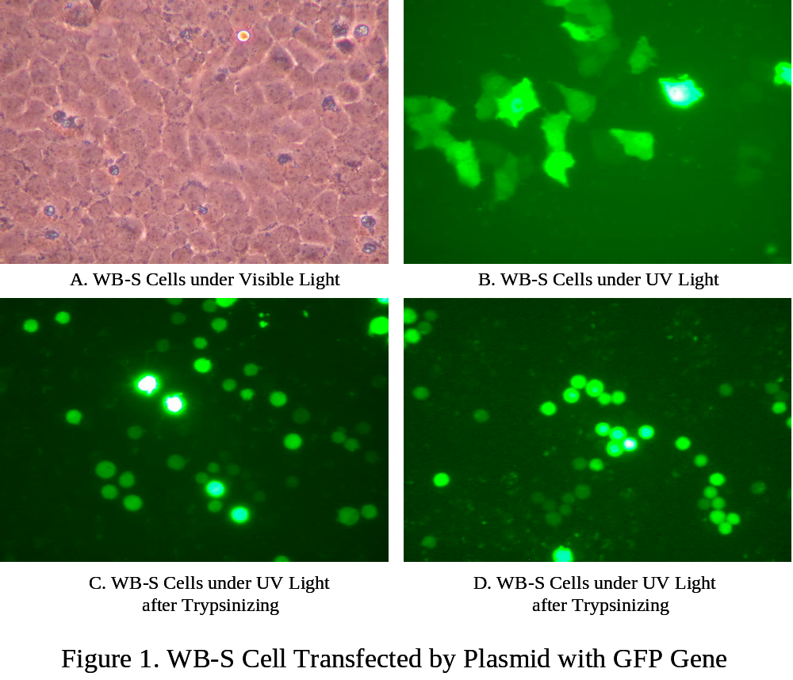
3.2 Increased temperature enhances gene transfer
Incubated the human interleukin-2 gene with the rat heart muscle cells, it got positive results for the human interleukin-2 gene transferred to rat cells. At the beginning of the incubation, there was the same background for the interleukin-2 measurement (p=ns). The elevated temperature from 23ºC to 37ºC then to 43ºC significant increased the gene transfer product expression (p<0.01) (Figure 2). The greatest effects occurred within 10 min of incubation and persisted up to 30 min. There was significant different interleukin-2 expression for 37ºC then to 43ºC only after 3 min incubation. The results suggest that even a few degrees of ambient temperature rise can significantly increase gene transfer into cells. This may be of value when using gene therapy with transfection procedures.
The heated cultured human aorta smooth muscle cells had a significantly higher expression of the transfected swine growth hormone gene. Incubated the swine growth hormone gene and human smooth muscle cells under the different incubation temperature of 23ºC, 37ºC and 43ºC, the transfection increased with the temperature elevation (p<0.01) (Figure 3). These results suggest that even a few degrees of ambient temperature rise can significantly increase gene transfer into cells. This may be of value when using gene therapy with transfection procedures.

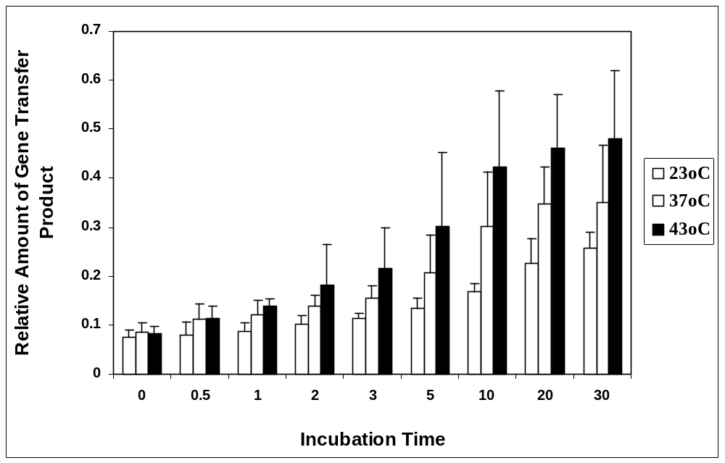
Figure 2. Increase in ambient temperature enhances human interleukin-2 gene transfer into rat heart muscle cells

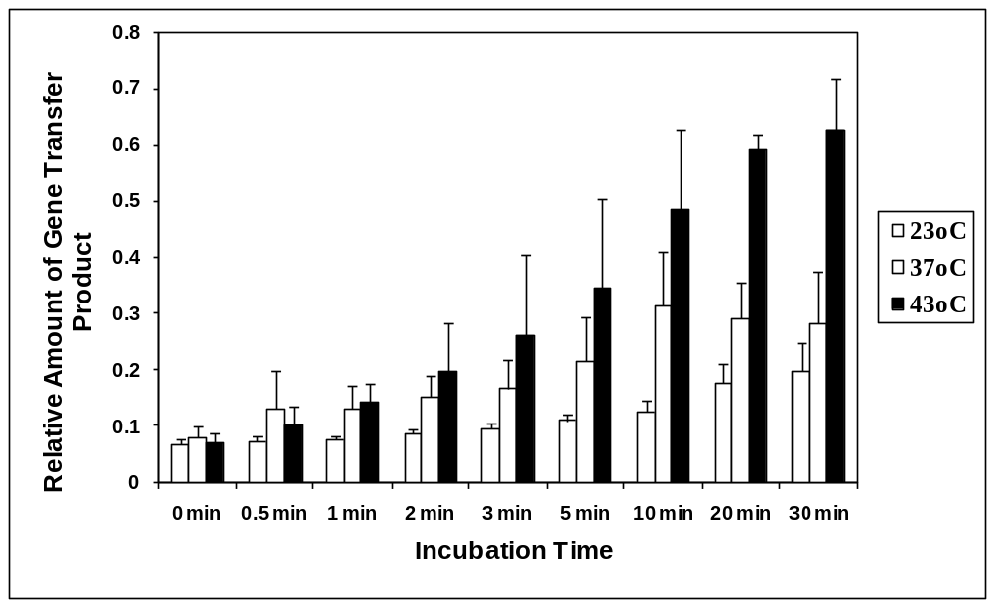

Figure 3. Increase in ambient temperature enhances swine growth hormone gene transfer into human smooth muscle cells

3.3 Gene gun enhanced gene transfer
With the self-design CO₂ propelled gene gun, the plasmid with anti-ampicillin gene was high efficiently transferred into E. coli cells. The gun technique can be used to enhance the gene transfer (human IL-2 gene transferred into rat heart muscle cell, and IL-2 was measured by indirect ELISA) (Figure 4).

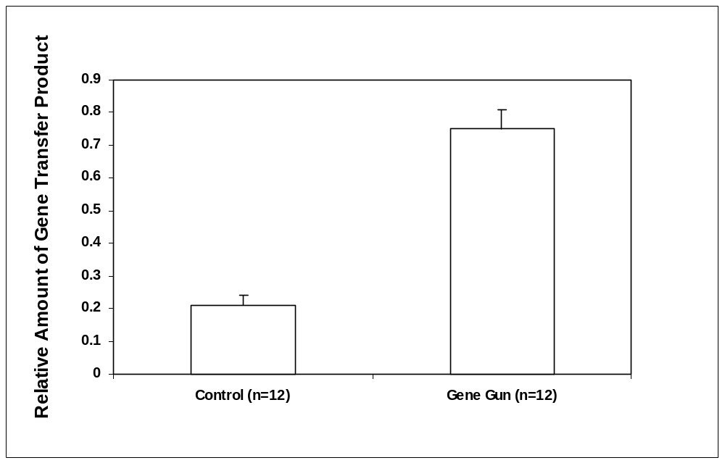
Figure 4. Gene gun enhanced gene transfer (human IL-2 gene transferred into rat heart muscle cell, and IL-2 was measured by indirect ELISA)

3.4 Laser enhanced gene transfer
There was a significant GFP gene transfected into cell by lasing 3 min and long than 3 min. There was no GFP gene expression if the lasing time was less than 3 min. This shows that UV excimer laser enhanced the gene transfer when lasing energy get a certain amount. Swine growth hormone gene was transfected into human aorta smooth muscle cells, and swine growth hormone was measured by indirect ELISA) (Figure 5).
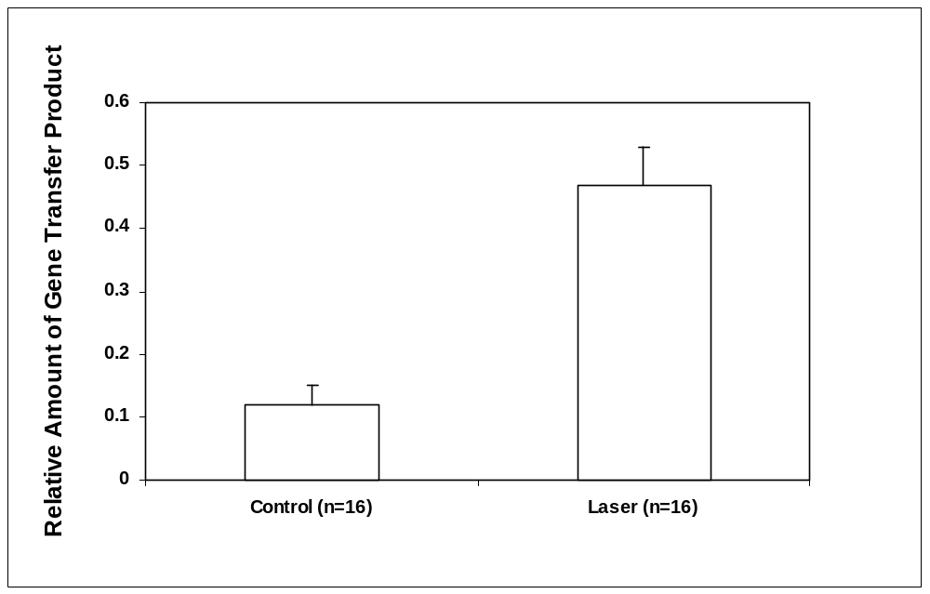
Figure 5. Laser enhanced gene transfer (swine growth hormone gene expression was detected using an indirect ELISA.

4. Discussions
Several techniques are currently used to transfer genes into culture cells and into various tissues and organs. These include electroporation, lipofection, calcium phosphate coprecipitation and DEAE-dextran, etc. It was successful to transfer human artificial chromosome vectors into stem cells (Oshimura, et al, 2008). It was reported that genetic modulation of heart failure using the SERCA-2a gene was associated with improvement in cardiac function and exercise capacity as well as improvements in heart-failure associated inflammatory markers (Gupta, et al, 2008). Gene therapy has delineated putative mechanisms of disease in animal models of erectile dysfunction (Bivalacqua and Strong, 2008). Although gene therapy is a potential therapeutic approach for arterial restenosis following angioplasty, the efficiency of transfection is low regardless of the vector used. Beside the reported results, our data show that when cultured human aorta smooth muscle cells and endothelial cells and the perfused rat aorta artery in a chamber were heated at 45ºC or 50ºC for up to 1 or 2 hours, transient transfection by calcium phosphate coprecipitation of a plasmid expressing human growth hormone was enhanced. Transfection of human interleukin-2 gene and swine growth hormone gene into the human smooth muscle cells and rat artery were also enhanced by heating. The results of our study suggest that the relatively low efficiency of gene transfer into tissues for therapy might be increased by short periods of heating during transfection. Also, the gene gun and laser could be an effective technique to practice gene transfer.

Correspondence to:
Ma Hongbao
Department of Bioengineering
Zhengzhou University
Zhengzhou, Henan 51001, China
mahongbao2000@yahoo.com
01186-156-1769-1256

References
Ausubel FM, Brent R, Kingston RE, Moore DD, Seidman JG, Smith JA, Struhl K. Short Protocols in Molecular Biology, Second Edition, pp. 1.1-1.27, Greene Publishing Associates, New York 1992.
Bechtel J Jr, Boring JR 3rd. Antibiotic-resistance transfer in Yersinia enterocolitica. Am J Clin Pathol 1979;71:93-6.
Bubenik J. Interleukin-2 therapy of cancer. Folia Biol (Praha) 2004;50(3-4):120-30.
Matsui T, Rosenzweig A. Targeting ischemic cardiac dysfunction through gene transfer. Curr Atheroscler Rep 2003;5:191-5.
Sambrook J, Fritsch EF, Maniatis T. Molecular Cloning, second edition, pp. 1.21-1.52 and 18.60-18.74, Cold Spring Harbor Laboratory Press, New York 1989.
Selkirk SM. Gene therapy in clinical medicine. Postgrad Med J 2004;80(948):560-70.
Temple GF, Dozy AM, Roy KL, Kan YW. Construction of a functional human suppressor tRNA gene: an approach to gene therapy for beta-thalassaemia. Nature 1982;296:537-40.
Terakawa M, Sato S, Ashida H, Aizawa K, Uenoyama M, Masaki Y, Obara M In vitro gene transfer to mammalian cells by the use of laser-induced stress waves: effects of stress wave parameters, ambient temperature, and cell type. J Biomed Opt. 2006;11(1):14-26.
Ferreira E, Potier E, Logeart-Avramoglou D, Salomskaite-Davalgiene S, Mir LM, Petite H. Optimization of a gene electrotransfer method for mesenchymal stem cell transfection. Gene Ther. 2008;15(7):537-44.
Oshimura M, Katoh M. Transfer of human artificial chromosome vectors into stem cells. Reprod Biomed Online. 2008;16(1):57-69.
Gupta D, Palma J, Molina E, Gaughan JP, Long W, Houser S, Macha M. Improved Exercise Capacity and Reduced Systemic Inflammation After Adenoviral-Mediated SERCA-2a Gene Transfer. J Surg Res. 2008;145(2):257-65.
Hongbao Ma, Cheng Chi, George S. Abela. Increased ambient temperature enhances human interleukin-2 gene transfer into cultured myocytes. Journal of Investigative Medicine 2004;52:79.
Hongbao Ma, Cheng Chi, George S. Abela. Increase in ambient temperature enhances gene transfer into human smooth muscle cells. FASEB Journal 2004;18(8):C293.
Bivalacqua TJ, Strong TD. The use of gene transfer technology to study the pathophysiology of erectile dysfunction. J Sex Med. 2008;5(2):268-75.

